**Limited effects of predators and generalist herbivores on plant-herbivore interaction network in early tropical secondary forest.**

Piotr Szefer, Kenneth Molem, Austin Sau, Martina Vasutova, … & Vojtech Novotny

**Abstract**

[Trello]

**Key words:** tri-trophic interactions, plant-arthropod herbivore networks, intermediate predation, succession, interaction networks, top down effects, cascading effects, tropical secondary forest.

**Introduction**

The dynamics of species in food webs is a combined outcome of their limitation by resources (bottom-up effects), natural enemies (top-down effects of pathogens, parasites and predators), and competition.

Control mechanisms were studied for a long time, and recently suggested that top-down and bottom-up control might be a false dichotomy.

Predators can affect the abundance and diversity of their prey, including herbivores, and, through cascading effects, also control the composition of plant communities. […].The impact of predators depends also on the species traits of herbivores and plants. Unfortunately,, our understanding of the mechanisms governing top-down effects on insects and cascading effect on plants is limited as such effects can be evaluated only from observations over a period of time or manipulative experiments, rather than a snapshot description of a food web.

by the number of types of habitats studied, conditional of herbivore impacts on land (Jia et al., 2018). They found higher variability of effects from tropical forest (because of lower number of studies?)

In our previous study we concluded that herbivores, but not predators, control diversity, richness and composition of vegetation during secondary rainforest succession (Szefer, Molem, Sau, & Novotny, 2020). The **lack of cascading effect might indicate either the lack of top-down effects of predators on herbivores, or a compensation by herbivores.** The response by herbivores to predation pressure may depend on host specificity of predators and/or herbivores, as well as on species traits of host plants. Are specialists more affected than generalists? From my analysis I saw that with higher (I decided for now to use all plant species presented for herbivores – all species present in the experiment. To differentiate it from PDI I called it a **resource use breadth**) **resource use breadth** (calculated on site using PDI index) there is more positive response (log ratio) to predator removal (weighted by abundance, better estimation with more individuals – how this is *calculated? Total abundance? Or initial abundance*?). Inraguild predation and responses of herbivores may depend on their plant specificity (Bosc, Roets, Hui, & Pauw, 2018). Recently proposed synthesis, tri-trophhic interaction hypothesis adds to the above mechanism by predicting some interactive effects (Mooney et al., 2010).

[VN] What herbivores are doing? Are they controlled by plants? Especially during rapid early succession?

~~The initial succession of rainforest vegetation tends to be dominated of highly specialized pioneer life-history strategy, characterized by high production and dispersal of small seeds capable of surviving in a soil seed bank, and seedlings and saplings maximizing their growth rate at the expense of anti-herbivore defences and their life-span (ref). It has been assumed that early successional vegetation is structured primarily by competition among plants. This vegetation often suffers high rates of herbivory, but it was though that they were compensated by rapid growth in resource-rich environment (ref). Our study has shown that herbivores, but not their predators, did impact the species richness and composition of successional vegetation (Szefer et al. 2020). Here we examine the impact of predators on herbivore communities and the mechanisms that lead to the lack of their effects on the vegetation.~~

~~[VN] The succession theory postulates that~~ **~~herbivore communities are limited by dispersal to unpredictable and ephemeral resources, rather than competition~~** ~~(ref). This is particularly true for initial succession stages dominated by herbaceous, often annual plants, with herbivores characterized by broad host ranges, high dispersal ability and short generation times (Novotny 1994, 1995). The~~ **~~secondary rainforest vegetation represents a more permanent resource relative to the generation times of insect herbivores (Leps et al. 2001)~~**~~. This higher apparency (sensu Herms & Mattson 1992)~~ **~~opens thus opportunities for competition that however have not been examined in tropical herbivores~~**~~.~~

[VN] Herbivore species forming early successional communities on tropical forest vegetation are not predominately generalist as their counterparts on Temperate zone herbaceous vegetation (Leps et al 2001, Redmond et al 2019, Novotny 1994). However, there is a minority of broadly generalist species present in rainforest herbivore communities. In theory, these species have a large proportion of local vegetation available to them as food resource, but they rarely become dominant in herbivore communities in terms of abundance or biomass. Both on individual plant species and vegetation overall, specialists tend to dominate these herbivore communities (Novotny et al. 2002, 2004). **It is possible that generalist species are less well adapted to each particular host plant species, unable to compete with specialist herbivores, or more vulnerable to predators than specialists feeding on the same plant** (**Bernays** xxx).

Here we examine this problem by introducing a particularly generalist herbivore species **at the densities likely to introduce or increase inter-specific competition between herbivore species**.

We expect that modularity might increase in interaction networks (Augustyn, Anderson, & Ellis, 2016). “how herbivores affect dominance hierarchies between plant species is scarce, more preferred species in the feeding experiments were those that increased in cover after herbivore exclusion in the field, whereas less preferred ones decreased” (Kempel et al., 2015). little is known how generalists affect plant community composition and herbivore community itself. “In communities deficient in intermediate predators (low values of ln[IP:H+]), vertebrate insectivores had relatively weak effects on intermediate predators, herbivores and plants ([Fig. 2](https://www.pnas.org/content/107/16/7335.long?utm_source=TrendMD&utm_medium=cpc&utm_campaign=Proc_Natl_Acad_Sci_U_S_A_TrendMD_0" \l "F2) and [Table S4](http://www.pnas.org/content/vol0/issue2010/images/data/1001934107/DCSupplemental/st06.doc)). In contrast, in communities with a high relative abundance of intermediate predators (high values of ln[IP:H+]) trophic cascades were strong, with strong negative effects of vertebrate insectivores on both intermediate predators and herbivores and strong positive effects on plants”(Mooney et al., 2010). 3.

[VN] Here we **manipulate the vertebrate predators (birds and bats) and examine their effects on arthropod intermediate show that in lowland tropical forest**, top down and cascading effects of key vertebrate predators are limited both in strength and in scope. Interestingly, we still **do not know whether tropical insect herbivore communities partition niches tightly, or is there a room for some more species**. If yes, then we could conclude that they are limited… Possible effect of generalists on food web structure was hypothesized but never tested.

[VN] With some simplification, we can consider vertebrate predators as top and insect predators as intermediate, with potentially important effects of intra-guild predation by vertebrate on arthropod predators, and also with a potential for compensation between these two groups of predators. In particular, **intermediate arthropod predators, with their short generation time in the tropics, should be able to respond quickly to changes in the abundance of vertebrates**.

In both primary and secondary tropical forests plant-herbivore interaction networks are highly specialized and vary greatly in space (Redmond et al., 2019), which suggests that interaction networks are structured by general rules of community assembly, and less by classic successional processes, which result in increase in complexity. Despite that their structural properties are preserved throughout space […] and time (Villa-Galaviz, Boege, & del-Val, 2012). . But see (Martins, Medina, Lewinsohn, & Almeida‐Neto, 2020). It has been sugested (Martins et al., 2020) that structural stability of plant-herbivore network may be caused by replacing species with similar functional roles in the network or because interaction probability are given by species’ relative abundances.

My hypothesis:

There is constant influx of herbivorous insects from the surrounding primary forest. Because of stronger defenses of primary tropical forest species, herbivores are restricted more by their ability to digest and assimilate plant tissues.

In gaps **plant identity doesn’t matter much**, because of low variability in plant quality, and low fidelity of herbivores to these species. (i.e. they all can be easily consumed by any herbivore). **[Why then herbivores are not thriving in gaps??? Maybe they are not as nutritious as they are thought?]** Herbivory loads would be dependent on plant biomass, passive capturing of interactions based on plant “apparency”. New thing here is our test of community packing. Herbivores seems to be limited by their own ability to consume food, or maybe by the available young leaves, which might be only food for generalist. Plants might be then limited by their resources (is that true for early secondary vegetation? Probably resources are abundant). Moreover

~~[VN] I would propose standard not very innovative hypotheses – going with the~~ **~~standard top-down control by vertebrate predators decreases abundance of herbivores, and also (due to competition) abundance of IP predators~~**~~. The more interesting question is the~~ **~~effect on diversity of herbivores (and IP predators):~~**

~~A)~~ **~~decreased abundance of herbivores leads to decreased species richness (diversity-abundance relationship),~~**

~~B) predators focus on~~ **~~more common herbivores~~** ~~and~~ **~~absolute increase herbivore diversity by J-C effect~~** ~~(assuming there is competition in herbivore communities so that decline in dominant species frees space for additional species), or~~

~~C)~~ **~~no additional species, but lower abundance~~** ~~especially of common herbivore species means an increase in diversity indices (also IP predators)~~

~~[VN] Alternately it i~~**~~s possible to postulate that no effect of predators on herbivores is expected~~**~~, because herbivores~~ **~~compensate for predation~~** ~~(either by local breeding or immigration) – this however assumes some degree of competition by herbivores (otherwise the high local breeding or immigration would happen even without mortality due to predation). The same for IP predators.~~

~~[VN] We also need~~ **~~hypotheses for adding generalist herbivores~~** ~~– there they are expected to reduce other herbivores either by direct competition or via~~ **~~decline in food quality~~** ~~since the~~ **~~plants suffering higher herbivory will invest more in induced defenses~~**~~; the lack of effect would indicate lack of competition or compensation (by higher growth) by plants. The effect on herbivore diversity –~~ **~~decrease in species diversity connected with decrease in abundance of herbivores~~**~~. Here unlike with predators that may~~ **~~disproportionately focus on common prey~~** ~~the effects of generalist herbivore on others is not supposed to be density-dependent; instead it may be higher/lower on certain plant species as~~ **~~Oribius is not perfectly generalist.~~**

**Materials and methods**

*Study sites*

The experiment was conducted in the tropical rainforest surrounding Wanang village (145°5′32″E, 5°14′26″S) located in the Wanang Conservation Area in the Ramu River basin, Madang Province, Papua New Guinea. The climate in the region is humid, with a mild dry season from July to September. Annual rainfall averages ~3500 mm and the mean annual temperature is 26°C (McAlpine, Keig, & Falls 1983). The study was conducted in abandoned food gardens created during slash-and-burn subsistence agriculture within the primary forest matrix. Old gardens can be considered a promising model system for manipulating biotic factors during succession. They are created by clearing patches of primary (and sometimes secondary) forest, usually larger than the average size of a canopy gap (Arihafa & Mack, 2013). After clearance, felled trees are burned to fertilize the soil, gardens are planted with mixed crops, and after a few harvests (typically after three years) they are abandoned and left for spontaneous forest regeneration. Old gardens have open canopies and mostly undisturbed seed banks from the surrounding forest, which is required for initiation of secondary growth. The lack of tillage and the lack of pesticide or fertilizer use during cultivation make soil properties and microbial biomass practically indistinguishable from those in naturally created forest gaps (Kukla et al., 2019). Usually the structure of regenerating forests resembles that of the nearby natural forest tree gaps (Richards, Walsh, Baillie, & Greig-Smith, 1996), suggesting a natural course of regeneration. Besides increased nutrient availability, gardens should not differ from primary forest gaps in soil conditions and seed bank composition (Kukla et al., 2019). In particular, variation in seed rain is expected to be small among gardens enclosed within the primary forest matrix, which should allow for a natural course of regeneration (Chazdon, 2003; 2014). Abandoned food gardens in a primary rainforest matrix thus represent an excellent study system for experimentation with secondary succession, enabling a high degree of control over the initial soil and environmental conditions among replicated experimental sites.

*Experimental design*

Within a radius of 3 km from the village, we selected six experimental gardens (blocks) 3-5 years old, each covering an area of approximately 400 m2, separated by a minimal distance of 200 m. To ensure unified conditions for the initial succession within each block, we cleared all aboveground vegetation and removed all the rocks and dead wood so that bare soil covered ≥95% of each plot. We also removed, without tillage, all tree stumps and tree roots from the top 30 cm of soil to prevent re-sprouting. These preparations were shown to have little effect on the seed bank and soil conditions (Chazdon, 2014). Within each of the six blocks, six 5x5 m experimental plots were established, resulting in 36 experimental plots in total. Individual plots were separated by 1 m gaps. We also cleared 3 m wide margins around each (approximately rectangular) block to minimize the effects of the surrounding forest edge on micro-climatic conditions within the plots. A control plot and five experimental treatments were randomly assigned within each block according to a randomized design (Fig. S1, Supporting Information). The following treatments were applied continuously for 12 months:

1. Control (C) was sprayed weekly with an appropriate amount of water to simulate application of water solution of pesticides and fungicides. In order to account for the possible effect of fencing used in I, P, H1 and H2 treatments (see below) a 50 cm high dummy plastic fence with a 10-20 cm gap left between the ground and the lower edge of the fence was built to allow easy access for crawling insects, lizards and rodents (Fig. S1 C, Supporting Information).

2. Exclusion of pathogenic fungi (F). Contact fungicide mancozeb (12.5 g soluble powder per 5l, commercial name: Mancozeb 80%) was applied on above ground plants according to manufacturer instructions at weekly intervals in order to reduce infections by a wide range of fungal pathogens. A dummy fence was also used, as in C.

3. Exclusion of insects (I). To achieve both systemic and non-systemic protection, we applied two types of broad-spectrum insecticides: lambda-cychalothrin (5 ml per 5l, commercial name: Thunder 0.25%) and imidacloprid (1.5ml per 5l, commercial name: Mustang 24%). Because of intensive vegetation growth, insecticide applications were repeated every week according to the manufacturer’s instructions. The plot was surrounded by a 50 cm high plastic fence that continued 20 cm below the ground. Insect glue (tanglefoot) was repeatedly applied on the top of the fence to prevent insect colonization.

4. Exclusion of predatory ants, insectivorous birds, and bats (P). A transparent fishing net (1.5-2.0 cm mesh size) was secured over the plot to protect vegetation from foraging birds and bats. Ants, as key invertebrate predators were reduced by poisonous tuna baits (permethrin 0.5%) exposed in monthly intervals in enclosed traps. This way, the baits were accessible to ants but not to flying insects. This method resulted in a 91.2% average decrease in ant abundance from secondary forest (Klimes, Janda, Ibalim, Kua, & Novotny 2011). The plot was surrounded by a plastic fence (as in treatment I) to prevent ants from re-colonizing the plot. Mesh size was chosen so that it would allow for any wind dispersed and larger seeds to fall through the netting. Additionally, every week all litter-fall potentially containing seeds and insects was collected from the top of the exclosure and randomly placed inside the experimental plot.

5. Increased herbivory – moderate level (H1). We used locally common, highly polyphagous, and flightless *Oribius* *sp.* weevils to increase herbivory pressure within the plot. Weevils from this genus were previously documented from the local secondary vegetation and their wide polyphagy was established by feeding tests (Fig. S2, Supporting Information). Every two weeks, 25 weevils were collected in surrounding forest, starved for 24 hours and released into the plot to sustain their population size. Plots were additionally protected from predators with exclosures (see treatment P) and fenced off, with insect glue applied to the top of the fence to prevent weevils from dispersing to the remaining plots.

6. Increased herbivory – high level (H2). The same treatment as above was applied, but with 125 *Oribius sp.* weevils introduced every two weeks per plot.

Having six experimental treatments, organized in six blocks allowed us to achieve 80% of statistical power for the effect sizes of approximately 15% shift in baseline descriptor value (Appendix A.6, Supporting Information)

*Sampling*

After 12 months of undisturbed growth, the complete above-ground vegetation from all 36 plots was destructively sampled. In each plot, all plant species were sorted and identified to species and weighed with 1 g accuracy. During sampling all the stems with diameter at breast height (DBH) ≥1 cm were counted to evaluate woody plant abundance. Leaf area was calculated by randomly sampling leaves from the pool of all leaves for each species at a given plot until 50x50 cm area (“leaf frame”) was filled. The frame was then photographed and processed using ImageJ software (Schneider, Rasband, & Eliceiri 2012). Herbivory, defined as a proportion of leaf area loss due to insect feeding, was obtained by comparing leaf area measured to the total estimated area for intact leaves. Leaf frame samples were then oven dried and weighed, and leaf dry matter content (LDMC g dry mass /g wet mass) was recorded. The specific leaf area (SLA, in cm2 g-1) was calculated as a ratio of leaf area to its dry mass. To evaluate community functional trait composition the community-weighted mean (CWM) was used for LDMC and SLA in the analysis. CWM's are average trait values where each species’ contribution is weighted by its biomass.

For all herbivore species we evaluated the Paired Difference Index (PDI) based on all sites sampled during our experiment. We normalised samples for comparisons (normalized = TRUE) (Poisot, Lepennetier, Martinez, Ramsayer, & Hochberg, 2011).

We evaluated diet switching abilities of species...

**Results**

**A.** **There is no evidence for top-down control of herbivores by vertebrate predators, and cascading effect on plant communities.**

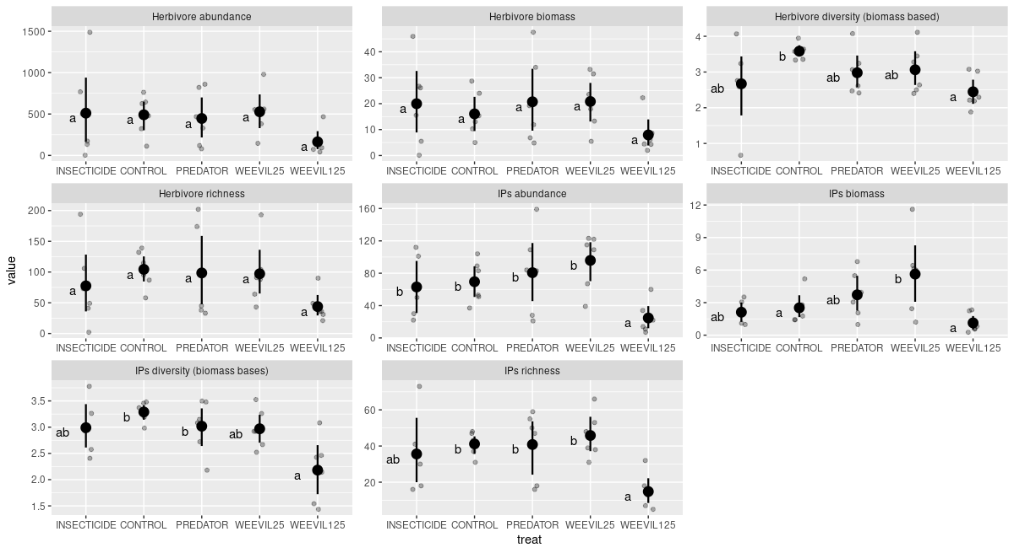**1. Plot: Comparison of abundance, diversity, richness of IP, Herb, [and plants?] in C,P,W125,I (?)(with all pairwise differences tested!) [should I add also the same graph for plants? Wouldn’t that repeat the results from our previous paper?]**

We didn’t find difference in abundance, biomass, and community composition of herbivores, intermediate predators nor plants in exclosure plots– [evidence for a lack of effect]:

Herbivores, which are controlled by predators, should have lower abundance in control plots (negative log of C/P ratio).

Looking at community composition the there was no significant difference between control and predator plot. Using Control, Predator, Weevil 25 and Weevil 125 we found that for the plant community (no treatment significant), that the conditioned variance was relatively high, nearly as high as unconstrained variance. This suggests that there was high variability between sites, that was partially explained by their location, and treatments had little effect on vegetation.

Inertia Proportion

Total 0.44489 1.0000

Conditioned 0.22448 0.5046

Constrained 0.04089 0.0919

Unconstrained 0.17953 0.4035

Because of a lack of effects of exclosure treatment in further analyses of possible top-down control we used **predator plots as our experimental controls**, because of the presence of exclosure, that might have some side effects on herbivore and invertebrate communities.

**2. Plot of I/C/P/W1/W2 for the insect community with pairwise comparisons between categories (plant effect removed in pRDA)** [***https://rdrr.io/cran/BiodiversityR/man/multiconstrained.html***](https://rdrr.io/cran/BiodiversityR/man/multiconstrained.html)

*Effect of vegetation on herbivores (and IPs?) pRDA with treatment effect (and block? → Condition(treatment + block) removed.*

*Main pPCA axes of vegtation change: PC1, PC2, PC7, PC10:*

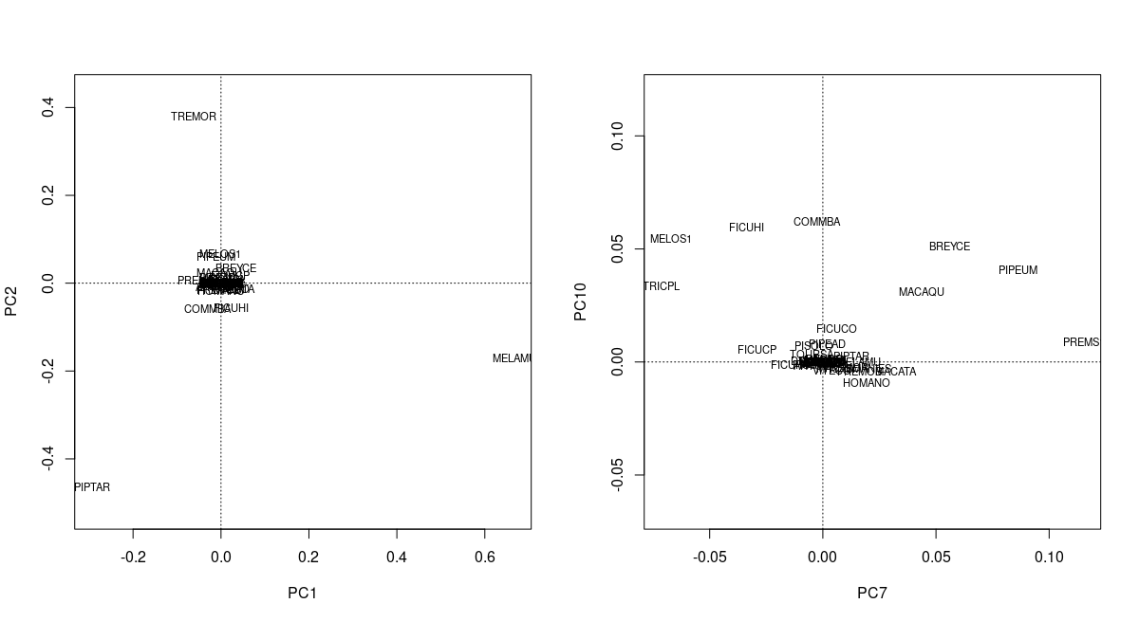

There was no effect of any pPCA axis nor IP community descriptors (abundance, richness, biomass, diversity) on herbivorous communities based on their biomass. For herbivore **abundance** I found that four pPCA axes of vegetation variability were significantly affecting herbivore community composition. These axes were used in pRDA that evaluates effect of PREDATOR, CONTROL, WEEVIL25 and WEEVIL 125 on herbivore community.

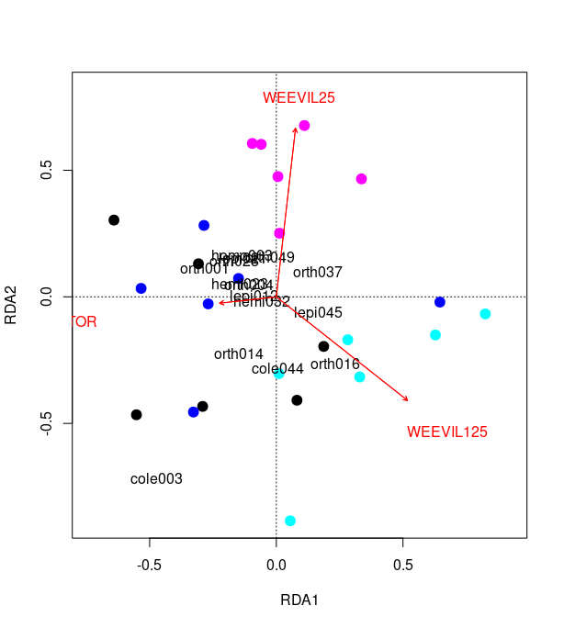

Final pRDA: There was **no difference between control plot and predator plot**. However **both levels of herbivore additions resulted in change in herbivore community composition [characterized by reduction of abundnance of most of herbivore orders]. And w25 and w125 also differed [based on permutation tests, with changed basis for ordination]**. Few herbivorous species, which abundance change in response to the treatments are labeled in ordination graph. This shows that we were able to increase the abundance of our Oribius sp. (cole001). When “cole001” is removed as an induced change in the herbivore community we get only marginal effect of W25 but still significant effect of W125

Is there an effect of predators on IP community? - perform similar analysis.

What are some of the likely effects

**3. Plot: log response ratios of plants vs herbivores, herbivores vs IPs, IPs vs plants.** (supplement, same plots but broken into families) *[I don’t think I should also break plants into species, because even if I would be able to find species, which are in C and P plots, then their context varies in a way, that makes impossible to ascribe any effect to the treatment – this plant species context can be also characterized in the supplement].* (Upper – biomass, lower – abundance) Herbivores were both positively and negatively affected by predator removal. Plants were more often (in 4 cases) and stronger (maximal magnitude of log ration was nearly 3) positive effect on their biomass. There was a trend...

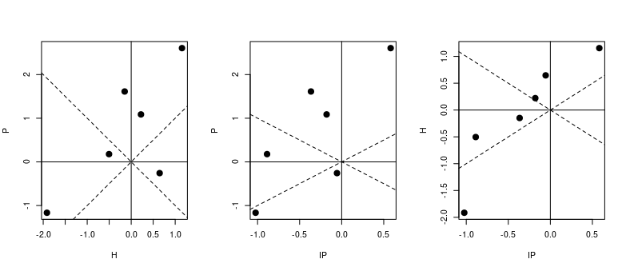

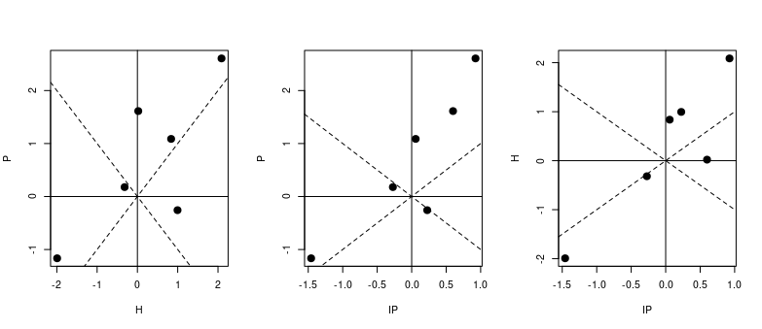

There might be no effect of predators on general community descriptors but we might expect to see cascading effect on plants. This can be explored using log-ratio responses of herbivores and plants to removal of their top, vertebrate predators. Effect of predators on IP is generally negative.

~~[VN] These graphs show a general tendency for a~~ **~~coordinated response –~~** ~~either plants, herbivores and IP predators~~ **~~all respond negatively, or they all respond positively~~**~~, and either they all respond a little or they all respond a lot, creating thus general positive trends in all these graphs. Further, the response can be either positive or negative in any of these groups~~

~~[VN] This suggests to me that the treatment which is being measured –~~ **~~predators~~** ~~– does not have strong (or any) effect, and that~~ **~~some other underlying variability is jointly affecting the entire community.~~** ~~I attach an Excel with a few such graphs generated by~~ **~~simple models~~** ~~– having 10 plots with a~~ **~~carrying capacity~~** ~~defined for each [either ranging from 1 to 10, or the same for each plot], and then the abundance of plants derived from that carrying capacity with some random noise, and the~~ **~~herbivores derived either from plant abundance~~** ~~(again with random noise) or~~ **~~directly from the carrying capacity.~~** ~~When the half of the plots is randomly assigned to a “treatment” and log effects ratios calculated, they tend to generate similar graphs as those above.~~

None of herbivore/intermediate predator biomass was affected by exclosure. Upper biomass, lower abundance. **I need to perform better tests for significance !. [bio_log_ratio.R]**

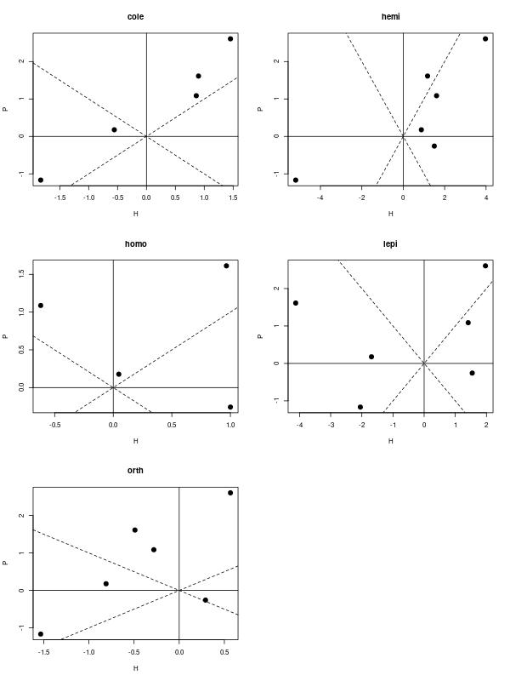

**Majority of insect orders seem to react to changes in plant biomass more than to predators.**

**B. In order to state, that predators have no effect on herbivore community we need to rule out various form of possible compensation:**

1. Change in size structure **coupled with reduction/increase in abundance**. Predators may be using mainly IPs, and not herbivores as prey (that would maybe cause shift in opposite direction – towards larger individuals, because IPs would feed more intensively on smaller prey). For **arachnids (no change in the number of individuals)** , **Orthoptera** (no change in ind no) and **Coleoptera** (neither) there was shift in body size distribution towards larger individuals, and for **Hemiptera** and **Lepidoptera** towards smaller individuals in the exclosure.

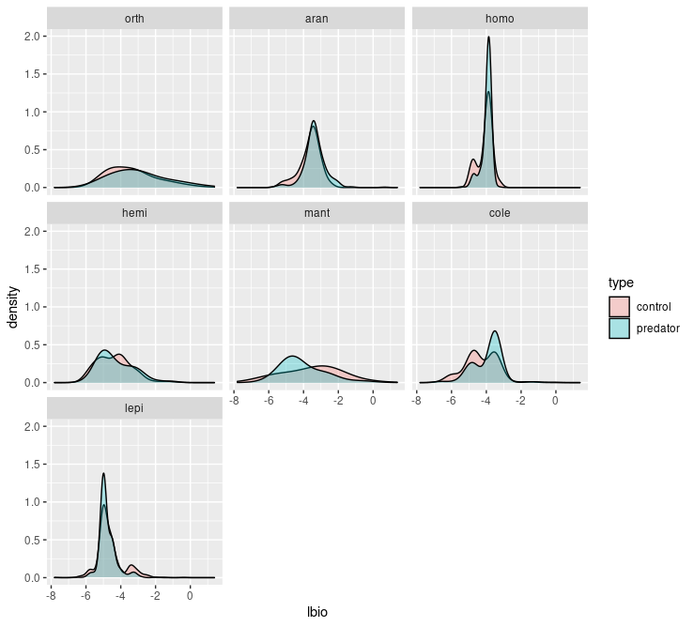

**Plots: [3] Biomass of an average individual: Shift in size structure of herbivores and IPs. Linear mixed effect (random intercept for blocks) model for logarithm of body size.**

There might be no effect for mantoids because of high number of smaller juveniles… seems like these were numerous in predatory exclusion plots… however, there is no difference in abundance.

2. Decrease in abundance/biomass in one group could be compensated by increases in other groups.

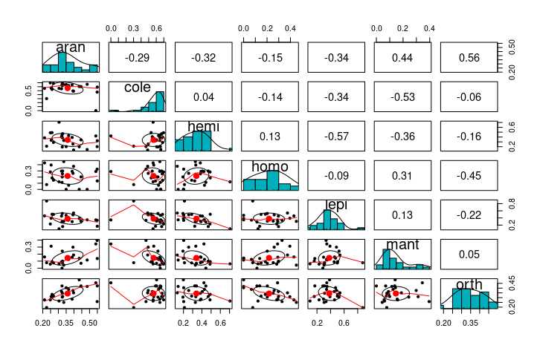

**Plot [4] Paired correlation plots for all insect families based on Hellinger transformed abundance**. I dont think this represents true correlations. I think pPCA plot is better suited for this, as it partials out variation explained by treatment and block prior to evaluating correlations.

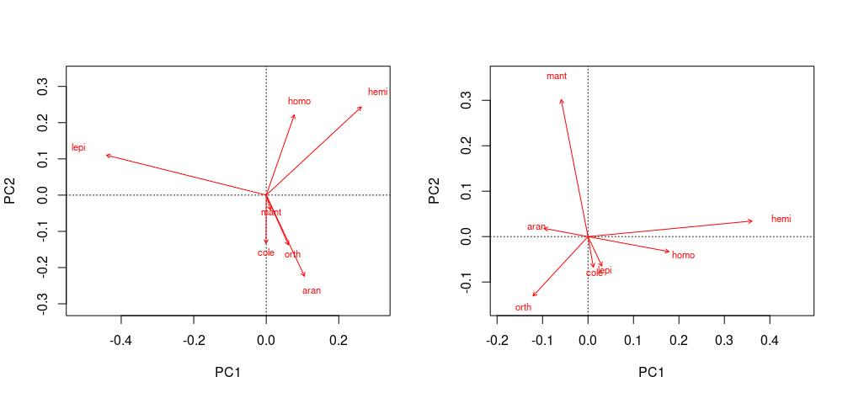

**Plot [4b] Linear correlations in abundances between insect groups: abundance (left) and biomass (right) (pPCA on site/species matrix conditioned on block+treatment in case treatment changes character of the correlation)**.

We see that coleoptera, orthoptera and arachnids are correlated, these also showed increase in average individual size in predator exclosure plot. Increase in their abundance is correlated with decrease in abundnace of hemiptera and homoptera. Lepidoptera are increasing in numbers whenever general abundance of the rest of the groups decrease.

**Ordination for insect orders rather than morpho-species**:

*Abundance*: Ordination based on insect orders shows significant difference between control and weevil125 plot. In general all herbivore orders are decreasing there. However the effect is gone after removing the effect of invertebrate predator richness and PC2 of plants (PIPTAR → MELAMU → TREMOR variation). This suggest that the herbivore communities are driven by changes in plant community composition more than by other factors.

*Biomass*: There is no effect of weevil125 conditioned only on block. Selection of conditional variables revealed, that only intermediate predator richness significantly affected biomass. Including that variable in pRDA analysis we get significant reduction of herbivore biomass.

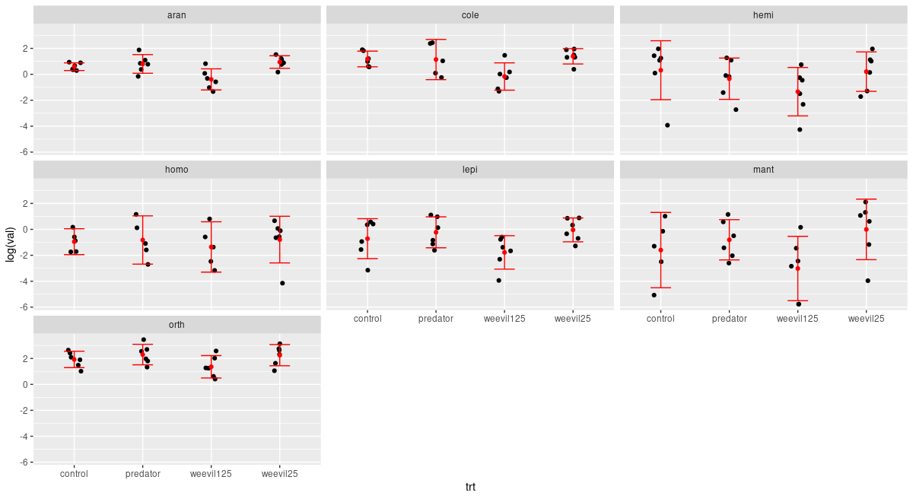

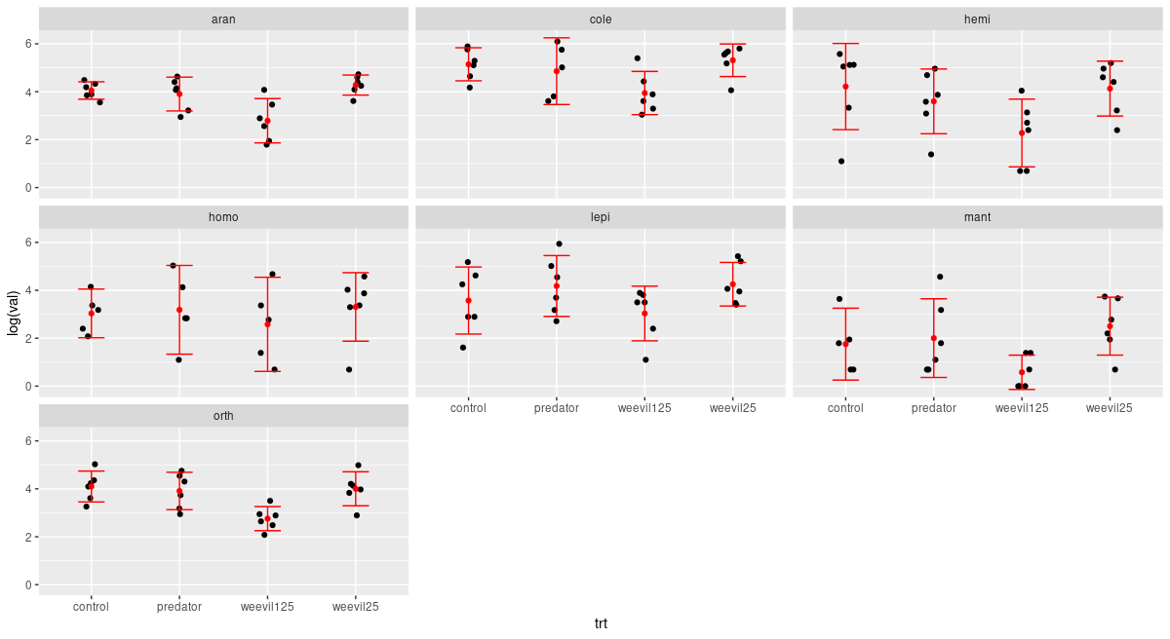**Run the tests**: for now it is only good to see that according to pRDA community is degenrating.

Therefore, I conclude that generalist herbivores didn’t caused any directional change in plant community composition. Nevertheless, they decreased total biomass of plants, caused a degeneration of herbivore and intermediate predator community.

Hypothesizing possible mechanisms:

1. Community seems not to be “packed”. Low levels of herbivore increase didn’t affect the community (plant, herbivore, ip’s).:

- Insecticide treatment would have a most random composition of insects. Nevertheless, we didn’t found any differences between these treatments and the control (based on the network modularity analysis: measures niche partitioning within the community (Augustyn et al., 2016) ).

2. What is going on in these modules? Cole001 seems to attach to each module but are not changing interaction within these modules. Maybe, however, they are changing only within the modules to which they attach. In general, we found that each plant species is its own module.

3. **If community is controlled by predators TTI should apply in natural system** *[could predictions of TTI hypothesis mask effects of predator removal on the food chain (whole community) level?]*: we should be able to observe **decrease in generalists abundance and increase in specialists abundance.** If there was a change in plant quality (as a community weighted mean of my only trait that measures quality: water content). These can be tested only on a subset of herbivore species we performed additional tests of the TTI hypothesis: no effect on individual species PDI *[I don’t think this is of any use. We have nearly perfect relationship between herbivores’ abundance and the number of plant species utilized]*, when focus only on species, for which we have data in P and C treatment plots, therefore, estimated diet breadth range had no effect on individual species response.

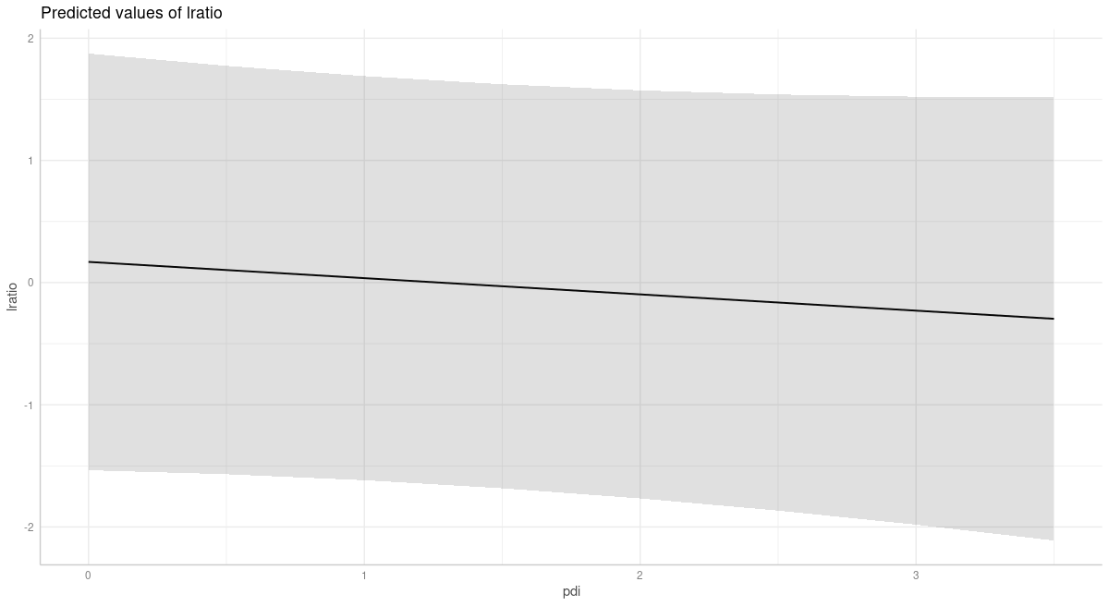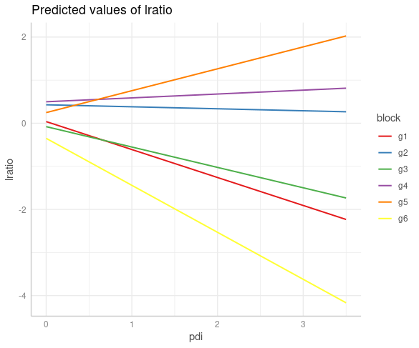

**Plot [X]** uncorrelated random intercepts and slopes with abundance as a weighting factor! Log ratio dependence on herbivore species specialization.

More specialized insects (PDI close to 1) are not positively affected by predators in control plots (log ratio as log[c/p]). There is significant if only random effect of block is included. But this might be related to plant community composition etc…. might be problematic to test with limited data. When random slope for each garden is included we see that it varies from positive to negative. I used nlme package and fitted random slope model and it showed no significant dependence of log-ratio on pdi. This result **confirms again no effect of predtaors.** Second plot is from lmer and ggeffects.

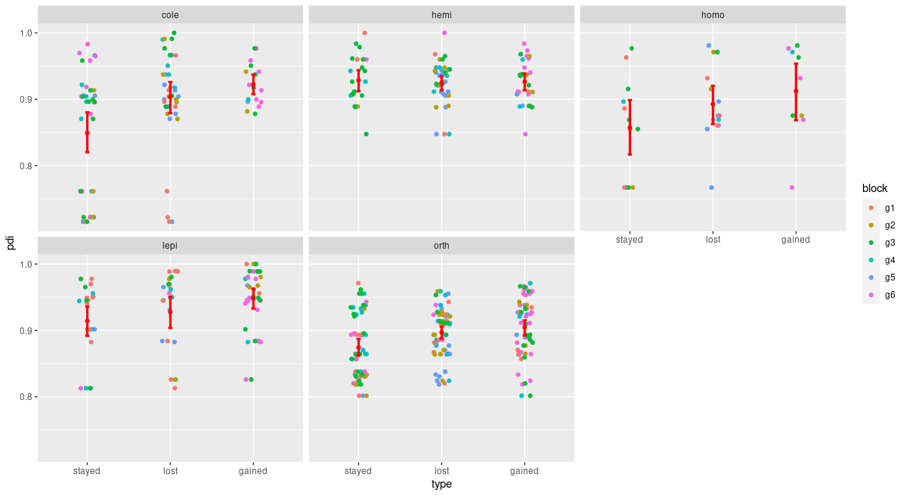

**Plot [X] PDI values for species which were lost gained or stayed after applying predator treatment to control plot**. **Responses are specific to herbivore order**. Removed species with abundance lower than 10 individuals.

**C. If there is a limited cascading and top-down effect by predators control to what extend herbivores control plant populations.**

Hypothesized effect of predators on herbivore community focuses on reducing interspecific competition: **from Ponisio**: *“competitive or ecological release, increases population niche breadth by increasing among-individual variation ([Bolnick et al., 2010](https://www.frontiersin.org/articles/10.3389/fevo.2019.00103/full" \l "B13))”*. If we have such a limited effect of predators, inter-specific competition should drive herbivore communities. Herbivores may compete exploitatively for resources. To what extend these can also affect plants is unclear. Different feeding modes from Schmitz... We showed in our previous paper, that herbivores had positive effects on plant diversity, community and trait composition. We also showed that there was no significant increase (despite some increase visible) in plant biomass. This suggests that bottom-up control of herbivores by plants might be stronger (this is what log ratio plots would suggest). Also, no effect of predator removal on plants might suggest absolute food limitation, where all available resources are eaten by hrebivores, that are limited only by its avilability. When more food becomes available, it is being divided between present herbivore individuals. In this case predation only increase per capita share of plant resources for surviving herbivores – ecosystems like this should be largely “brown” (Schmitz 2010). Why IPs would then be affected so strongly?

Maybe not much is actually available for herbivores...

What is going on within herbivore community when weevils are added? Are they competing more strongly for resources? Hypotheses about herbivores on plants: Insecticide didn’t strongly increase **productivity** on our plots. This suggests, that herbivores are more restricted by their ability to digest and assimilate food and that community might not be saturated. Increased intra-specific competition should lead to increased modularity of plant-herbivore networks (Augustyn et al., 2016). This is not the case in our data (not for abundance nor biomass based networks). No increase compared with predator plot was observed for W125 and W25. PDI plots:

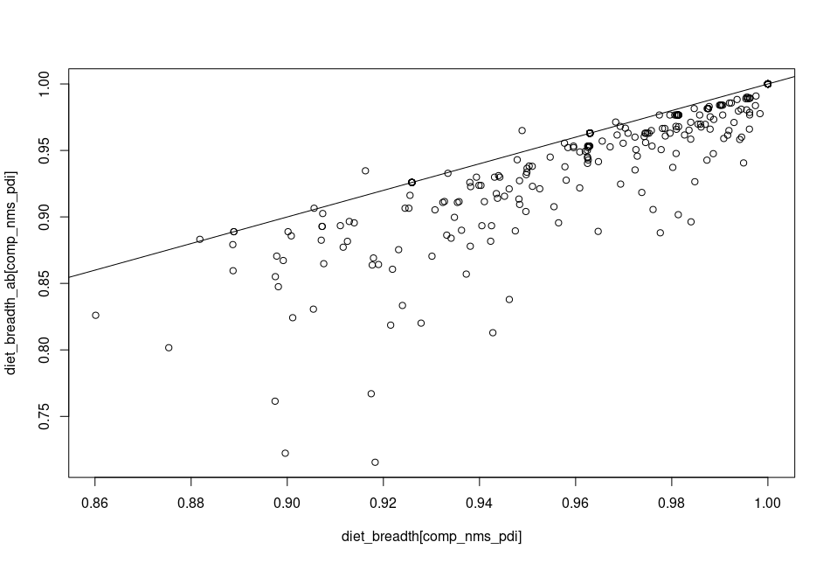**plot [x] PDI values calculated based on abundance vs based on biomass. Line is slope 1 and intercept 0 [pdi.R]**

**Fig [X] network descriptors for putative interaction networks based on herbivore abundances on plants. [still need to check significance for some of these]**

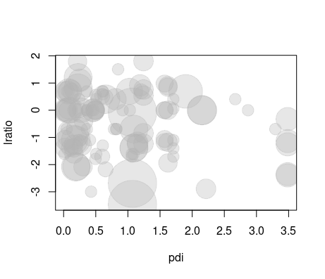

Fig [X] S**imilariliy no effect on PDI when comparing predatory plot with W125 plot. Size of circles is proportional to individual species’ abundance.**

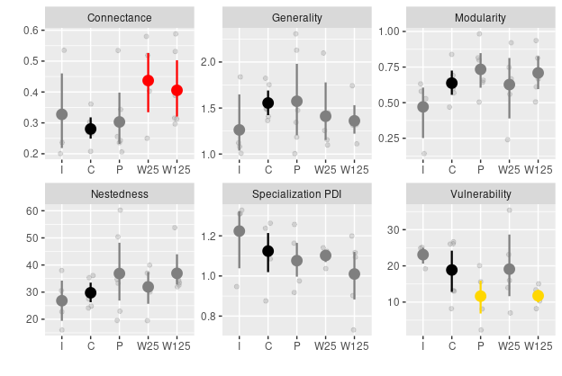Fig [X] **Network descriptors for putative interaction between plants-herbivores. Experimentally manipulated weevil species was removed form all networks before the analyses. Red color indicates significance at the**

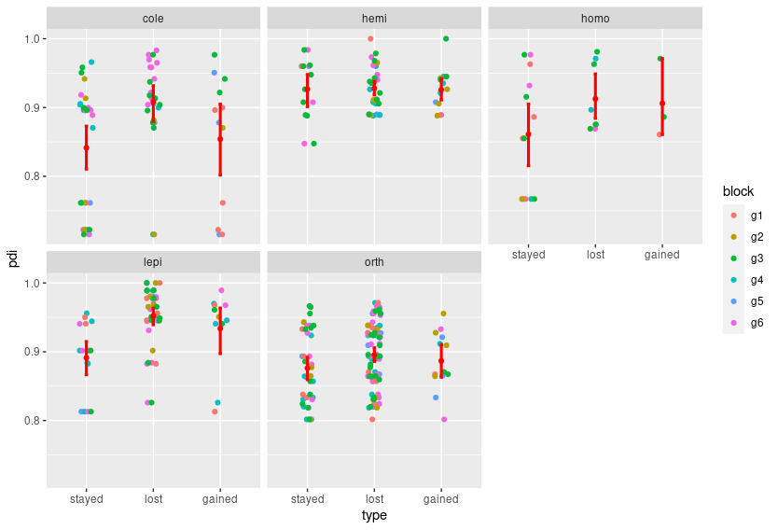

**Plot [X] PDI values for species which were lost gained or stayed after applying weevil 125 treatment to predator plot**. **Responses are specific to herbivore order**. Species for which abundance was higher than 10 ind.

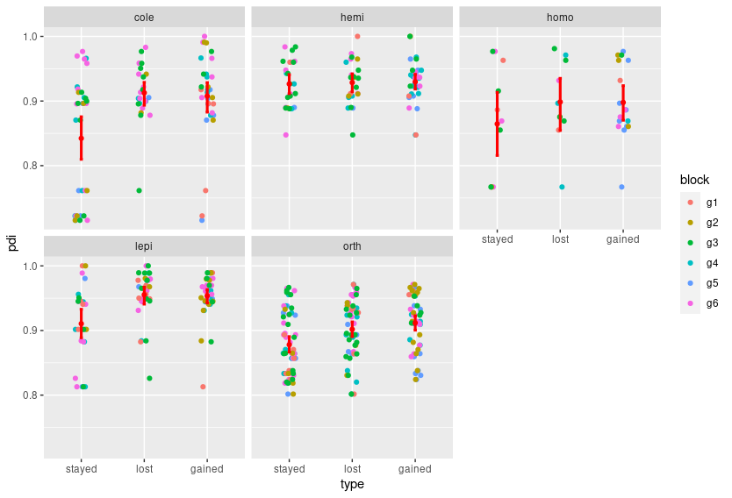**Plot [X] PDI values for species which were lost gained or stayed after applying weevil 25 treatment to predator plot**. **Responses are specific to herbivore order**.

We test whether addition of generalist herbivores affected herbivore and IP invertebrate predator community. Questions asked here may concerning: A) to what extent insect community is controlled by plant community () B) saturation of herbivore community: would adding significant amount of herbivores force some changes in it, would some groups be affected more strongly than others. Comparison of P, I, and W125 plots (however the state of the community at the moment of sampling in case of biomass might not represent the effect well. [what type of results I expect here?].

**Plots []: log ratio of P/W125 for biomass,**

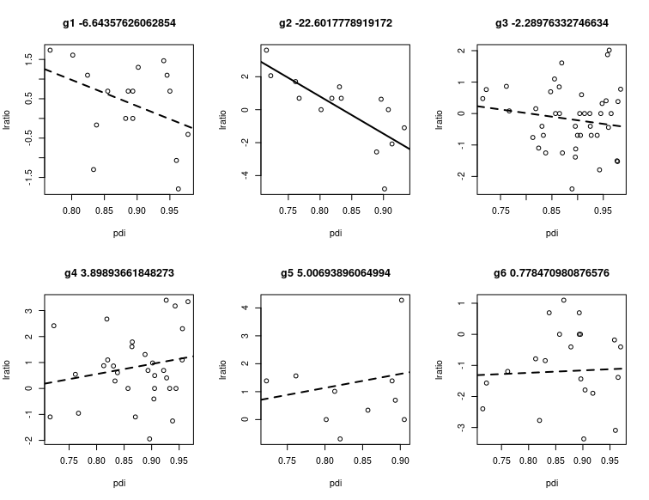**Plot[X] PRED/CONT log ratio vs PDI for individual gardens.**

**Plot []: Insect community I,P,C,W1,W2 / P, W1,W2** [should that be with or without IPs? Definitely the effect of vegetation would have to be removed, however, there were no significant PC axes. 1. Effect of vegetation on herbivore community composition [PCs from the plant community on the Herbivore community]. 2. Effect of the treatment on the herbivore community composition **I/P/W25/W125** or **P/W25/W125** [with plant effect removed]]

**Plot [] Ordination with IP effect removed.**

**Plot [] How IPS are affecting herbivore species community? Log ratio plots and ordination.**

We showed in our previous work, that insects affected plant community composition. Predators had an effect on plant community assembly process. To what extent herbivores are able to control plant biomass.

Addition of generalist – would it change the insect community composition? There was no effect on plants other than decease in biomass – no richness no diversity, what does that men?

**Discussion**

Reduced abundance and biomass of Intermediate predators caused by high addition of generalist herbivores may suggest control indirectly through “brown” chains. Spiders may feed on detritivores more thatn on herbivorous species. We didn’t find any effect on IPs.

Recently proposed Tri-Trophic Interaction (TTI) hypothesis suggests that top-down effects of top predators on insect herbivore are modified mainly by plant quality, and herbivore diet breadth. It predicts, that **generalist herbivores perform worse** on low quality food and predict that they would experience **stronger negative top-down effect by predators**.

However, in complex communities mobile herbivores should be able to switch to other resources, therefore **mitigate negative effect of predators on their abundance**. However, effects of these interactions were studied mostly in isolated and/or simplified systems despite their potential implications for plant-herbivore interaction networks in nature. In context of a diverse plant community, competition and possible **resource shifts** caused by intensified competition or predator pressure we may expect to see spectrum of responses of herbivores species to the predator exclusion. Moreover, negative effects of predtorWe present results of **putative plant-herbivore interaction networks** analysis subjected to exclusion of top predators. We look for contingent and/or emergent effects in the prediction of the TTI hypothesis and we evaluate how processes at the individual food chains level influence plant – herbivore network structure and [**probably impossible to infer**] how these processes translate into food web level patterns (direct and indirect effect on trophic levels)

**Describe results step by step once again**:

Is biomass of a plot a better description of the herbivory load than species identity? I compared models for species richness, diversity, abundance and biomass containing either only plant biomass or plant identity, and to each model I added missing species identity or species biomass and compared their performance. If these two components are important this would suggest that biomass itself is not enough to predict richness, abundance and diversity of herbivorous communities. Both biomass and species identity are important in predicting species abundance. However species identity can becomes negligible in some treatment plots. But this might not be a good approach as some species tend to occur at lower abundances. Maybe it would be better to test whether there are differences in species’ abilities to accumulate species: see if there is a significant interaction between species identity and biomass.

For biomass interaction of species and biomass was not significant, however in some cases we based our estimations on only three observations. Nevertheless, it suggests that species identity might have limited importance in the early successional communities, at least in case of the biomass. Qualitatively similar effects were shown for herbivores abundance.

In case of richness random effect of block was significant, nor the interaction term. Biomass of plants predictably increased richness, but this relationship was significantly higher only for Pipturus argenteum.

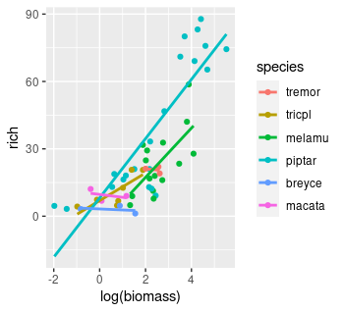

Significance of random effect in case of richness and its lack in case of biomass suggests that plots accumulate herbivores based on biomass, but richness most probably depend on local site properties.

What about the treatment? We were not able to find any relationship between accumulation slopes and treatment.

There is large variability in plant community composition, that was not explained by treatment, by local site conditions

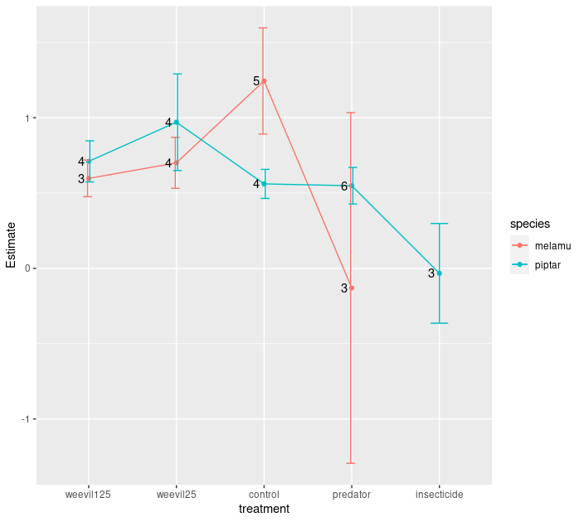

**Figure X.** Estimated slopes and their standard errors of ***logged plant biomass vs logged invertebrate abundance (individual accumulation curve on log-log plot)***, for two most prevalent plant species: *Melanolepis multiglandulosa* and *Pipturus argenteum*. Cole 001 removed from the analysis.

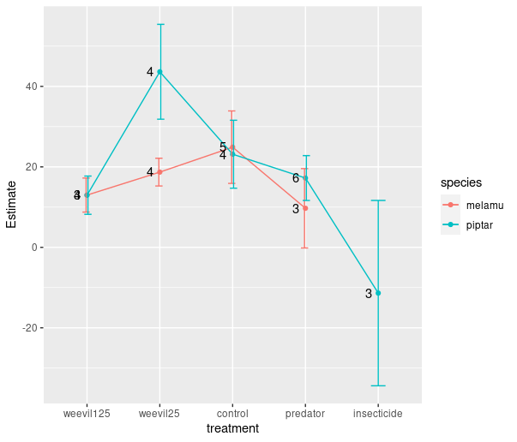

**Figure X.** Estimated slopes and their standard errors of ***logged plant biomass vs invertebrate richness (individual accumulation curve)***, for two most prevalent plant species: *Melanolepis multiglandulosa* and *Pipturus argenteum*. Cole 001 removed from the analysis.

I would like to have a variable that would indicate whether and to what extent a species was modifying its diet in response to the predator treatment (rda coordinates?). I guess PDI can serve as this.

Bayesian model with interaction **(abundance/biomass (or log ratio) = quality*pdi*size [maybe instead of family] + random_element?).** Family can be a random effect? I don’t think it should be. We want to evaluate predictive power of family and not to give it a random variability.

**Basic test for TTI**: bayesian model with interaction ( abundance/biomass [or log-ratio] = quality*pdi*db + random_element). I don’t think I have enough data.

2. How to test, whether some other effects can be important, are there some emergent patterns? Intermediate predation? Competition?

3. TTI hypothesis predicts that generalists should be more strongly affected by predation at the low quality plants. However, in a diverse plant community they can switch resources easily (depending on their mobility). Therefore, I would need to check how often generalists (estimated from our data) would stay within the plot more often than specialists. The latter would more often disappear and show up on the predator treatment plot. But this graph might be flawed in the sense that “specialists” might be less abundant [analysis needs to be revised with abundance being a weighting factor].

However, this relationship is not present in our data. [resource_switching.R ] Call:

glm(formula = totbio ~ db, family = gaussian(link = "log"), data = anip)

Deviance Residuals:

Min 1Q Median 3Q Max

-0.2045 -0.1782 -0.1536 -0.0728 9.2065

Coefficients:

Estimate Std. Error t value Pr(>|t|)

(Intercept) -2.615 1.250 -2.092 0.0365 *

db 1.029 1.319 0.780 0.4353

Birds, bats and ants are key predators in successional forest in the tropics (Morrison and Lindell, 2012) and cause top-down control over their pray. Predating risk shapes insect herbivore communities and may cascade down to plants. In diverse insect herbivores top down effects are stronger than bottom up (Vidal and Murphy 2017)

During succession bottom-up and top down forcing may switch ()

***Abdala-Roberts et al 2019: “There is a fundamental need within the species interactions perspective to place three‐species TTIs in a broader community context.”***

Both bottom up and top down exist but there is a considerable variation in trophic regulation (Leroux and Loreau, p 20)

However, strength and direction of top-down and cascading effects within food-webs can be modified by interactions with the environment, species’ properties and other species in the community both competitors or natural enemies (*Species characteristics which may affect the strength of trophic cascades (for the model): host plant quality (defended vs. undefended, on defended plants cascading effect of carnivores on plants was reduced, because herbivores do not feed on defended plants), trophic control (relative/absolute), control switching under different condition (does not relate to my experiments),* ***diet breadth*** *(herbivore feeding mode, sap feeders and specialists – no cascading effects, not to include them in the assessment of the strength of the top down effect.), natural enemies,* ***resource selection by insects****, stoichiometry and herbivore resource use,* ***defenses reduce the amount of biomass that can be eaten by herbivores****, because they need to maintain low concentration of toxins (citation…) - conversion efficiency, herbivores change their* ***behavior*** *in response to predation, intermediate predators can subsidize on detrital chains, predator hunting mode, prey habitat domain,* ***smaller herbivores (chewers) have lower abilities to digest and assimilate low quality food. This results in higher mortality rates. They have higher foraging effort and thus higer growth rates***). Different hunting modes of predators, **abundance of intermediate predators**, **plant specificity**, **herbivores’ diet breadth** (Singer et al. 2014), (apparent trophic cascades for intermediate predators) or ecosystem productivity can modify the strength of cascades and be important for the shapes of the food pyramids (top-heavy, bottom heavy).

Few of the above factors were tested explicitly and became highly infuential hypotheses used to explaining experimental results (). *EFH – enemy free hypothesis predicts, that in the absence of predators herbivores should increase their habitat domain.* ***Increased generality of the network****. The tri-trophic interaction hypothesis (TTI, Mooney, Pratt and Singer 2012) considers interactions between plant quality, herbivore diet breadth, and predation on herbivore performance. Enemy free in tropics was doubtfull at least for Ficus (Novotny et al., 1999). [The TTI hypothesis predicts that dietary specialist herbivores (as compared to generalists) should escape predators and be competitively dominant due to faster growth rates, and that such differences should be greater on low quality (as compared to high quality) host plants.] - but fails to predict cooexistence of generalists and specialist herbivores on the same host plants (which seems to be common).* Enemy free hypothesis focus on predator avoidance and predicts that fear of predation keeps population of herbivores at specific level (). Physiological efficiency hypothesis assumes that specialists are better adapted to their food than generalists and utilize their hosts better (). Slow-growth/high-mortality (SGHM) hypothesis predicts that “herbivore development on a poor quality host plants will be relatively slow extending the duration of juvenile phases that are the most vulnerable to natural enemies” (). Recently proposed synthesis extends predictions of the previous hypotheses to also predict the strength of the possible cascade (Mooney, Pratt, & Singer 2012).

However, in case of predator-insect herbivore-plant food chains ecosystems top down and cascading effects are usually being studied based on the total abundance [***need to check that***] of herbivores and plants and usually in controlled, simplified systems (Schmitz … , Bucher et al 2015) and not in complex natural environment. Different feeding guilds of herbivores may have different responses to predators. Never tested in complex systems in the field [?]. These were studied without consideration to the complex trophic interactions of herbivores and plants, despite producing hypotheses which have implication for plan herbivore interactions. For example (EFH) [*EFS hypothesis and succession… we showed in our previous work that insects would affect the traits. Predators does not affect traits but species composition (from our results only randomness). For lepidoptera (Singer et al. 2014 Herbivore diet breadth mediates the cascading effects...)*] , suggests, that the network generality should be reduced, as species would not explore full range of their habitat domain, and would be forced to feed on least preferred hosts (Schmitz). The effect of top down control was studied for single group in experimental conditions and not included different plant species (Singer et al. 2014). [*Will plant functional characteristic help to explain the strength of the cascade? Maybe tropic cascades are stronger for some plant species that for others?*]

Size, specialization…. Generally or only on selected plant species where comparison is allowed. Should I use offset to correct for the plant biomass?

On the other hand Schmitz (2010, Resolving Ecosystem Complexity) – community detection methods - envisioned network as a collection of food chains, suggesting that this might reduce the complexity of the interactions. We would like to test whether breaking the food web into smaller compartments can be beneficial and explain the combined effect of apex predators.

Responses of the ecosystem to manipulations can be complex. It has been shown that mortality is higher in the smallest sized groups of insects in the grassland (check that Ovadia and Schmitz 2002). This situation might be different in systems where main predators are birds. This suggests a shift in the size structure of herbivores.

*[Is it possible that intra-guild predation modifies the effects. Because of intensified IGP there could be no increased damage on leaves when top predator are removed. Yes… for vertebrate predators effects predicted by theory does not hold. It is possible however, that there might be important overlooked role of the detrital channels providing energy to intermediate predators (see some conclusions from Schmitz’s book). ]* Recent meta analysis showed that apex predators reduce both intermediate predators and herbivores equally, and that they effects are positively correlated i.e. strong effects on herbivores when strong effect on intermediate predators (Effects of vertebrate predators on of IP:H should be positively correlated as in Mooney et al. 2010.). Expectation: Intraguild predation dampens the strength of the trophic **cascades** (Mooney et al. 2010). Intra-guild predation (bird bats and ants) enchances biodiversity and functioning in complex ecosystems (Wang, Broose and Gravel 2019, Ecology)

If TTI operate in complex communities top-down and cascading effects of the top and intermediate predators should be able to affect plant herbivore i**nteraction networks**. Bosc et al. (2018) studied the effects of apex predators on top-down and cascading effects on diverse herbivore community and showed srong effect of insectivorous birds on spiders. There was no overall effect on herbivore abundance. There was some evidence for EFS hypothesis where specialists were less affected by top predators than generalist. However, because of the difficulties in estimating diet breadth (inferred from co-occurence of plants and herbivores) it didn’t provide strong support for EFS hypothesis presented there. Our treatment of adding generalist herbivores could help answer some questions regarding role of generalists in these systems. Moreover in their evaluation of the effects they used abundance instead of biomass of individual species. Biomass could be more important than abundance (Bosc et al. 2018 used abundance of IGP). This may cause misinterpretation of the results as one of the important effects of apex predators like birds is that they can affect the size structure of the insect community.

How diets were changing!

Did size structure change?

Mooney, Pratt and Singer 2012: TTI dietary specialist herbivores should escape predators and be competitively dominant due to faster growth rates and such differences should be greater on low quality host plants.

Experiment contradict these predictions though -

*Advantages we have on the above paper: t****rophic interactions, biomass, individual plant communities, actual specificity calculated in the field (should I use all sites? - I think yes, even if species was forced to use least preferred host plant by some treatments it still counts!), generalist addition treatments****.*  [*My advantage: body sizes… and plant herbivore “interactions”.*] (Karp and Dailey 2014; Ritchie and Johnson for clues where to find this info). Plant-herbivore interactions shape community dynamics (Burkepile and Parker 2017).

Here we present an experimental study of the effects of birds bats and ants effects on plant – herbivore interaction networks and intermediate arthropod predators during community assembly in secondary successional tropical rain forest.

(MacArthur and MacArthur 1961), which suggests that birds recognize the structure rather than type of the vegetation. However, such neat convergences in species densities of plants, insects, and desert lizards do not occur, which suggests that these groups may not always be saturated with species (Whittaker 1969, 1970, 1972; Pianka 1973). [<http://www.zo.utexas.edu/courses/bio373/chapters/Chapter18/Chapter18.html>].

**References**

**Where does this randomness come from?**

I have examined turnover (Bray-Curtis **dissimilarity** index broken into balanced and gradient component) in herbivore and IPs community composition. Within each block I examined plant species which were present in both control and treatment plots. For these species I calculated insect community turnover caused by the treatment (within species turnover). Next I compared insect community on a given plant species in a control plot with insect community on all other species in the treatment plot within a given garden. This allowed to see how **within** species turnover compares with **between** species turnover [***switch these names in the code, not done properly***].

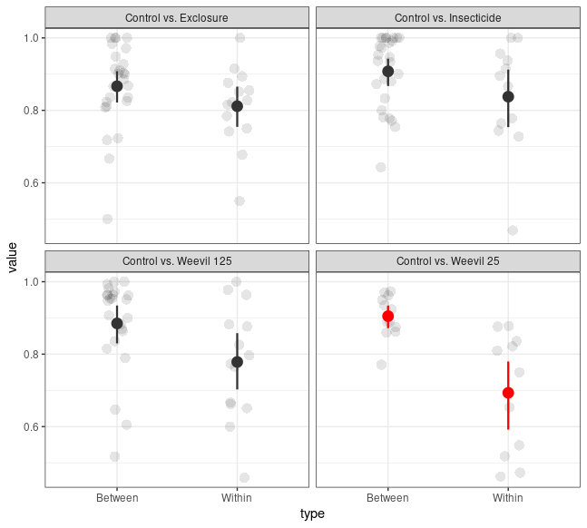  
Figure 1: Herbivore species turnover rates calculated for plant species present in both control and a given treatment plot (Within) in a given experimental block, and for species in the control plot vs all other species in a treatment plot (Between). Turnover is based on Bray-Curtis dissimilarities. Mean and bootstrapped 95% CIs are shown. Grey points indicate empirical values. **Only Control vs Weevil 25 was significantly different**.

I.e. I wanted to see how dissimilar are communities on the same plant species compared with other species present in the same garden. If values of turnover within species are comparable with ones between species, this might suggest, that randomness in invertebrate community composition doesn’t stem from the plant species community. If turnover within plant species in low, this suggest, that plant species are influencing their community, and if there is randomness in herbivore community composition it Is probably primary caused by plant community composition.

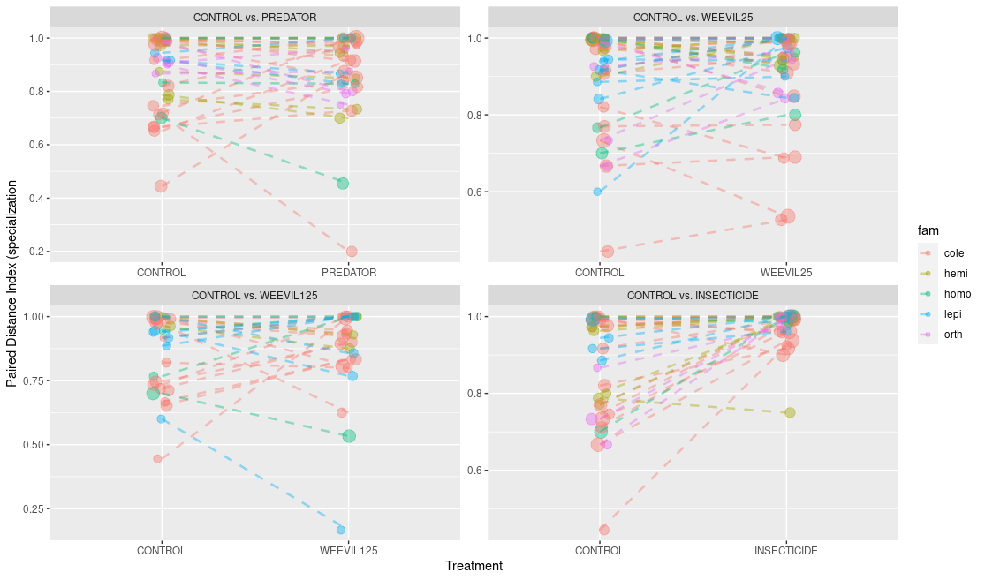

**Fig X.** Comparison of species’ realized PDI values under treatments. Only herbivores with abundance higher than or equal to five in treatment and control plot. Logarithm of abundance is indicated by point size. Colors represent different morpho-species within gardens. Statistical significance was tested based on within garden, between species log ratios. We used linear mixed models to test for statistically significant difference of log ratios from zero. Significant are: PREDATOR: nothing; **WEEVIL 25: Lepidopera increase, Orthoptera increase (marginally ~ 0.07)**; WEEVIL 125: nothing; INSECTICIDE: **Orthoptera increase, Coleoptera, Hemiptera and Homoptera marginally increase (0.055, 0.09, 0.07 respectively)**