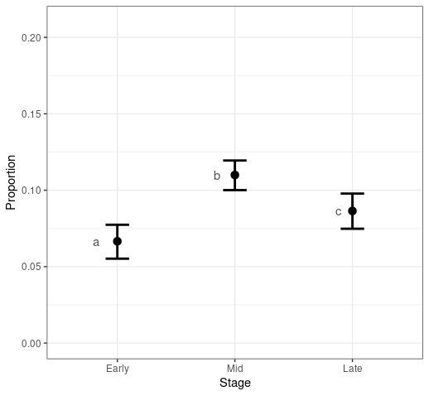

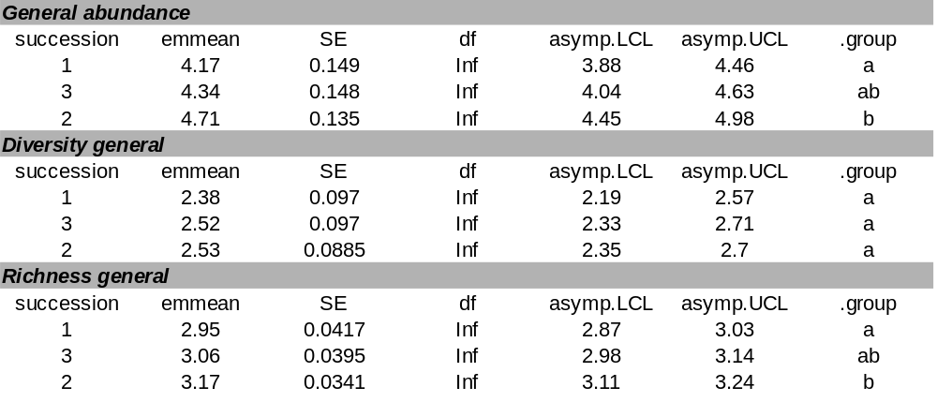
Table SX. Results of linear nad generalized linear modles for the descriptors fo rthe cumulative Aculeate community Table SX. Variance explained by fixed and random effect of the beta GLM model of species turnover rates depending on Aculeata group.
Random effects |  | Explained variation
Component | Variance | Fixed | Random
Balanced | 0.019 | 6.56% | 1.90%
Gradient | 0.021 | 0.12% | 2.11%
Bray-Curtis | 0.019 | 7.57% | 1.93%

