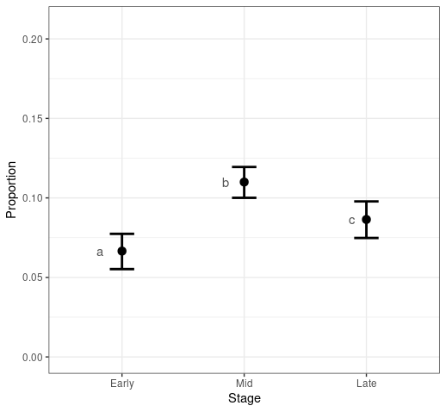

**Fig. SX. Proportion** of rare and/or endangered species in the cumulated Aculeata community at different stages of succession. Dots and whiskers represent average values and 95% CIs respectively. Latin letters represent statistical significance at ***α=*0.05** level, adjusted for multiplicity (Tukey correction).