Table SX. Average values and their asymptotic 95% CIs for linear and generalized linear models for diversity (Shannon’s Index), abundance, and species richness for the cumulated Aculeata community at different successional stages.

|  |  |  |  |  |  |  |
| --- | --- | --- | --- | --- | --- | --- |
| General abundance | | | | | | |
| Stage | Mean value | Standard Error | DF | Lower CL | Upper CL | Significance |
| 1 | 4.17 | 0.149 | Inf | 3.88 | 4.46 | a |
| 3 | 4.34 | 0.148 | Inf | 4.04 | 4.63 | ab |
| 2 | 4.71 | 0.135 | Inf | 4.45 | 4.98 | b |
| Diversity general | | | | | | |
| Stage | Mean value | Standard Error | DF | Lower CL | Upper CL | Significance |
| 1 | 2.38 | 0.097 | Inf | 2.19 | 2.57 | a |
| 3 | 2.52 | 0.097 | Inf | 2.33 | 2.71 | a |
| 2 | 2.53 | 0.0885 | Inf | 2.35 | 2.7 | a |
| Richness general | | | | | | |
| Stage | Mean value | Standard Error | DF | Lower CL | Upper CL | Significance |
| 1 | 2.95 | 0.0417 | Inf | 2.87 | 3.03 | a |
| 3 | 3.06 | 0.0395 | Inf | 2.98 | 3.14 | ab |
| 2 | 3.17 | 0.0341 | Inf | 3.11 | 3.24 | b |

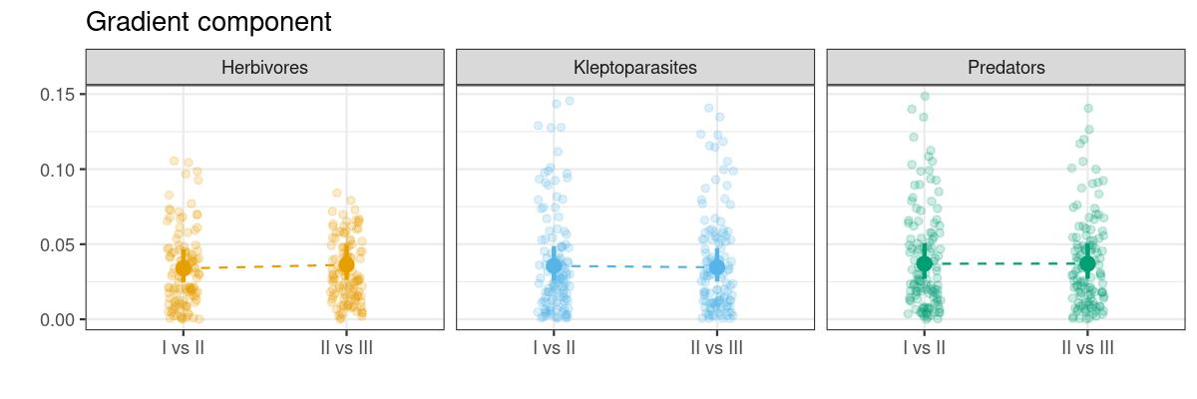**Fig. SX.** Mean and 95% CIs for the gradient component of ß – diversity for the three trophic Aculaeta groups at two transitional stages I vs II and II vs III. Dashed lines indicate lack of statistical significance of the mean differences. Points represent empirical values.