**Conservation value of Aculeata communities in sand quarries changes during ecological succession**

Lucyna Twerda, Piotr Szeferb,*, Anna Sobieraj-Betlińskaa, Piotr Olszewskic

a*Department of Environmental Biology, Kazimierz Wielki University, Ossolińskich 12, 85-093 Bydgoszcz, Poland.*

*bFaculty of Science, University of South Bohemia, Branišovská 1760, 370 05 České Budějovice; Biology Centre, Institute of Entomology, Czech Academy of Sciences, Branišovská 1160/31, 370 05 České Budějovice, Czech Republic.*

c*Department of Ecology and Biogeography, Copernicus University, Lwowska 1, 87-100, Toruń, Poland.*

*Corresponding author at: Faculty of Science, University of South Bohemia, České Budějovice, Czech Republic; Biology Centre, Institute of Entomology, Czech Academy of Sciences, České Budějovice, Czech Republic.

E-mail addresses: l.twerd@ukw.edu.pl (L. Twerd), szefer85@gmail.com (P. Szefer), anna.sobieraj@ukw.edu.pl (A. Sobieraj-Betlińska), thecla@wp.pl (P. Olszewski).

**Abstract**

Sand quarries that are used occasionally and not subjected to rehabilitation are important biodiversity banks in both anthropogenic and semi-natural landscapes. However, their value for biodiversity preservation can change due to dynamic successional processes. We determined the responses of three Aculeata guilds: herbivores (Apiformes), predators (Crabronidae, Sphecidae), and parasites (Apiformes, Chrysididae, Crabronidae) to successional transformations in 32 sand quarries, in chronosequence of spontaneous succession: 0-15 years (early succession), 5-10 years (middle succession), and 10-15 years (late succession). Responses to successional changes in vegetation differed depending on the trophic guild. Values of community indices for herbivores and parasites reached the highest complexity at the middle stages of succession, whereas for predators, they remained stable. The arrival of new speciessignificantly affected the community structure of all three Aculeata guilds, although dominance structure did not change. However, only for predator species, turnover increased at the later successional stages. This was manifested by the rapid accumulation of new and rare species. In contrast, β-diversity of parasites decreased, and in the case of herbivores, it remained constant throughout the successional stages. Predators were also characterized by high numbers of species, present at all successional stages. We highlight that various patterns of species exchange can generate conservational values of sand quarries and provide information about preferences of predatory, herbivorous (pollinating), and parasitic Aculeata, including rare and threatened species, in respect of stages of ecological succession. The collected information will allow a more deliberate selection of protective measures through the implementation of suitable management strategies to facilitate the preservation of these valuable habitats.

**Keywords:** Apiformes; Chrysididae; Sand quarry; Species turnover; Spheciformes, Succession

**1. Introduction**

Abandoned sand quarries and gravel pits can be colonized by various groups of species, including some threatened and rare taxa (Tropek et al., 2010; Heneberg et al., 2013, 2016; Twerd et al., 2019a). Hence, many publications provide evidence for the high conservation value of post-mining sites as habitats for numerous orders of arachnids (Tropek and Konvicka, 2008; Tropek et al., 2010) and insects (Brändle et al., 2000; Lenda et al., 2012; Lönnberg and Jonsell, 2012; Tichanek and Tropek, 2015; Harabiš, 2016; de Smedt and van de Poel, 2017), including bees and other aculeates (Krauss et al., 2009; Seitz et al., 2019; Twerd et al., 2019a, 2019b). Insect communities on post-mining sites present high conservation value but will undergo spontaneous ecological succession, which affects species richness and abundance. However, most studies have neglected the fact that successional processes can markedly influence their conservational value.

Temporal variability of insect communities during succession is, along with their abundance and species diversity, an important criterion of ecosystem value (Corbet, 1995; Asaad et al., 2017). In general, species richness and diversity of insect communities are expected to increase over time, but responses of individual species are often highly specific (Schowalter, 2012). In contrast, the dynamics of trophic guilds (e.g., herbivores, predators, and parasites) can show more predictive patterns (Siemann et al., 1999) and is of high importance from the standpoint of the whole ecosystem (Christensen, 1995). For example, in the case of pollinators, habitat age has no effect on species abundance and diversity in limestone quarries (Krauss et al., 2009), but this may not be the case for other trophic guilds, such as predators, which depend strongly on the structural complexity of the ecosystem. In general, the proportion of herbivores in the community may decrease in favor of increasingly diverse and abundant predators and parasites (Corbet, 1995; Siemann et al., 1999).Hymenopterans in sand quarries do not necessarily follow the general predictions of classic successional theories advocating a continuous increase in diversity and abundance (Odum, 1969; Brown, 1984). ￹According to general predictions, the abundance and diversity of aculeate Hymenoptera should increase over time, and there might be fewer rare species at the initial stages of succession (Gathmann et al., 1994; Corbet, 1995). ￹ In contrast, Bogusch et al. (2015) recorded maximum species diversity and also the highest proportion of species of conservation interest in early post-fire successional stages for bees and wasps. ￹However, bees and wasps are good ecological indicators (Vieira et al., 2011; Nieto et al., 2014; Rasmont et al., 2017; Odanaka and Rehan, 2019￹), and thus, their communities dynamically respond to even small changes in their environment. This is due to their high nesting and food requirements (Müller et al., 2006; Ricketts et al., 2008), resulting in a strong relationship with available floral resources (Alanen et al., 2011). ￹Therefore, contrary to the above predictions, early successional stages of abandoned fields harbor diverse Hymenoptera communities because of a high abundance of annual plants (Parrish and Bazzaz, 1979; Alanen et al., 2011; Tscharntke et al., 2011; Roberts et al., 2017). ￹This also affects rare species, which can aggregate in the community because of a large variability of microhabitats (Tropek et al., 2010). Numbers of hymenopteran pollinator species (including rare ones) generally decrease with increasing ￹of plant cover (Rutgers-Kelly and Richards, 2013; Hendrychová and Bogusch, 2016). This is thought to be mainly driven by changes in vegetation characteristics, such as species richness ￹or pollination strategies (Gathmann et al., 1994; Losapio et al., 2016). However, recent observations have shown that responses of specialized oligolectic bees to successional processes may be more complex (Twerd et al., 2019a). ￹On the other hand, late successional stages are predicted to harbor more diverse parasite and predator communities (Losapio et al., 2016), which can boost numbers of rare species in older quarries.

Important aspects of community change may be missed when focusing only on species numbers, in particular raw numbers of rare species. Conservational value will generally change in the course of succession. However, temporal changes in the abundances of some persistent species may reflect their important ecosystem value (Harvey et al., 2017), and rare species may contribute little to functional diversity within ecosystems (Jain et al., 2014, but see Lyons et al., 2005). Therefore, from the conservational standpoint, estimates of shifts in contributions of individual species as well as species turnover for different trophic guilds in the course of succession in sand quarries are needed.

In this study, we tested the hypothesis that the conservational value of sand quarries, based on the aculeate Hymenoptera community, changes due to successional processes. We expected a continuous increase in abundance and species diversity for Aculeata communities, but supposed that the detailed patterns would depend on the life history of individual trophic groups of aculeates. Herbivores (pollinators) were expected to be the most diverse/abundant at the early and/or middle stages of succession. In contrast, communities of predators and parasites would change more slowly, with the accumulation of rare species at later stages of succession. We predicted that changes in β-diversity would be caused mainly by the arrival of new species. Species turnover would differ between groups presenting diverse trophic guilds: decreasing for herbivores (pollinators) and increasing for parasites and predators. The guilds with more rapid changes in the balanced component of β-diversity would include higher numbers of rare species and of species characteristic of individual stages of plant succession. In contrast, fewer species were expected to show continuous changes in abundance in the course of succession.

2. Material and methods

*2.1. Study sites*

Field research was conducted in the Podlasie region (NE Poland), in the immediate vicinity of extensive woodlands of Białowieża Forest and Knyszyn Forest. This area is rich in natural deposits of sand and gravel, which result mostly from glacial and fluvioglacial or, albeit rarely, fluvial accumulation (Siliwończuk, 1985). As much as 69% of the deposits have never been exploited or their extraction was stopped, while the other 31% are exploited permanently or periodically.

This study was conducted in 32 periodically exploited or abandoned sand quarries (0.64 –7.4 ha) (Table A.1, Fig. 1) subjected to spontaneous succession. The investigated sites varied in stages of ecological succession and were covered mostly with synanthropic herbaceous vegetation. Synanthropic plant species included e.g. *Anchusa officinalis* L., *Ballota nigra* L., *Daucus carota* L., *Echium vulgare* L., *Lamium purpureum* L., and *Leonurus cardiaca* L*.* The dominant grass species in those habitats were *Calamagrostis epigejos* (L.) Roth, *Elymus repens* (L.) Gould, and *Poa pratensis* L., while among woody species, *Pinus sylvestris* L. was the most abundant one. Sand quarries were not mown throughout the study.

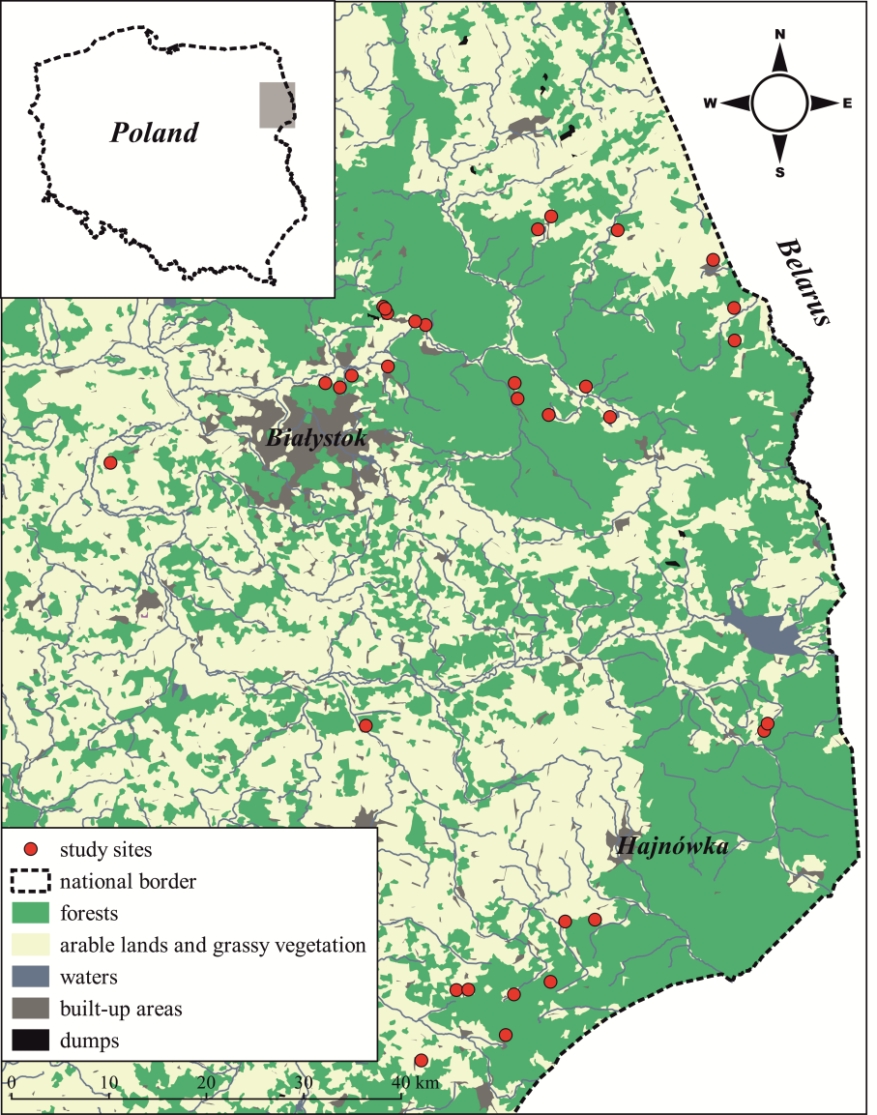

**Fig. 1.** Location of the study sites (sand quarries).

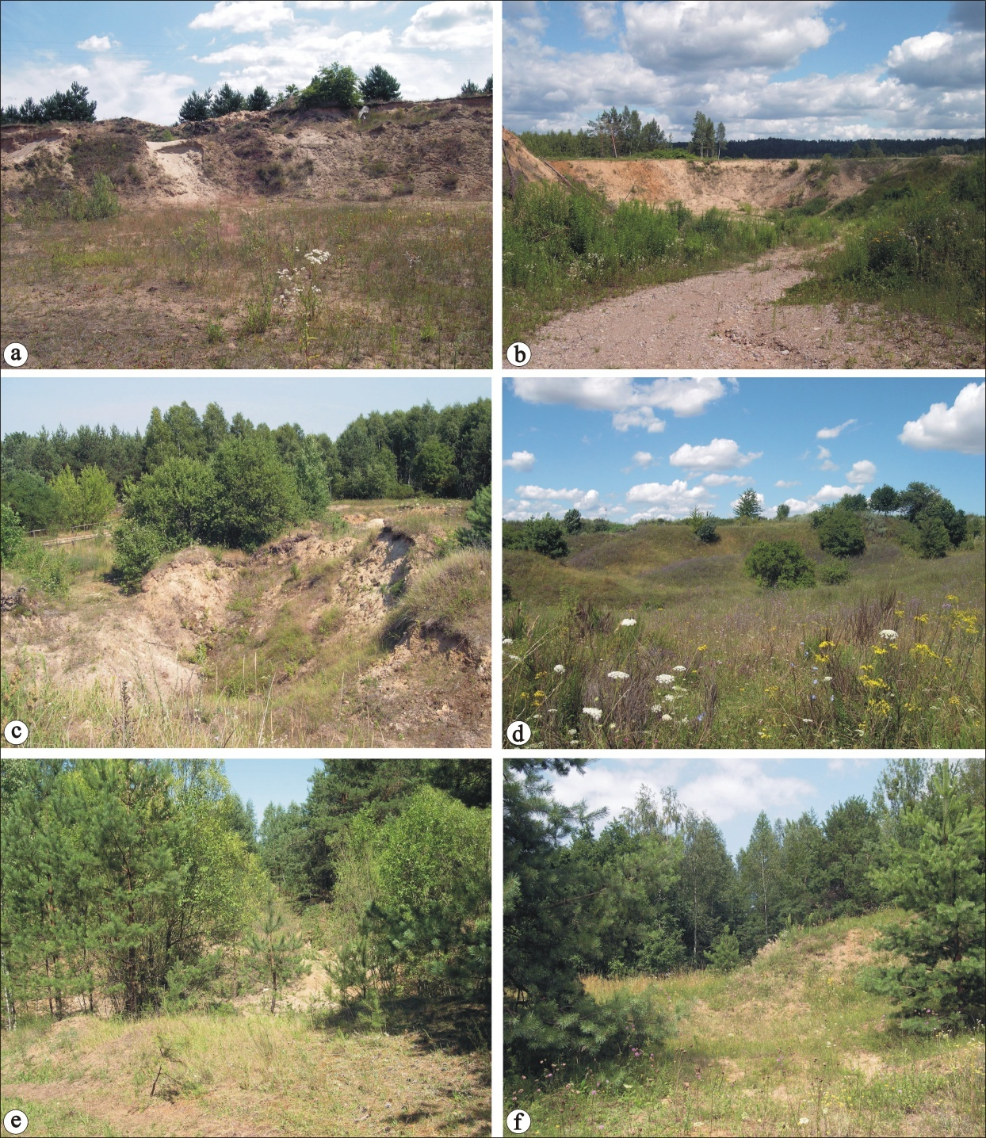

**Fig. 2.** Representative photographs of stages of plant succession in sand quarries: a, b = early succession; c, d = middle succession; e, f = late succession.

The analyzed sand quarries were divided into three groups, depending on the stage of plant succession (Table A.2., Fig. 2), namely stage I: 0–5 years, i.e., early succession (initial colonization by plants – 10 sand quarries): bare soil ≥ 55% of the area, herbaceous vegetation 20–45% of the area, 0% of woody vegetation; stage II: 5–10 years, i.e., middle succession (sward formation – 12 sand quarries): bare soil 6-40% of the area, herbaceous vegetation 35-80% of the area, woody vegetation ≥ 5%; stage III: 10–15 years, i.e., late succession (development of woody vegetation – 10 sand quarries): bare soil < 5% of the area, herbaceous vegetation 15–40% of the area, woody vegetation ≥ 60%. Percentage contributions were estimated in relation to the total area of the sand quarry (Table A.1).

This study is a continuation of a project concerning the importance of sand quarries for wild bees, which was initiated in 2015. The material used here was collected in 2008, 2015–2016 (Twerd et al., 2019a, 17 sites), and in 2017 (15 sites). Research was conducted after obtaining oral consent from managers of the land and in accordance with applicable law.

*2.2. Insect sampling*

The insects were collected when the weather was favorable for Aculeata activity, i.e., with no or little wind (< 3 on the Beaufort scale) (Krauss et al., 2009). During field research, the temperature was always above 16°C, and never exceed 25°C. Because the phenological periods in Eastern Poland are delayed by about 2 weeks in relation to the central part of the country, sampling was conducted in May and July to obtain the fullest possible number of both spring and summer species. During spring, sampling was conducted over one week (2015, 2016) and two consecutive weeks in 2017, while during summer it was conducted over two (2015, 2016) and three consecutive weeks in 2017.In 2015 we explored sand quarries located near Hajnówka (on the edge of the Białowieża Forest), in 2016 near Białystok, and in 2017 near Supraśl (on the edge of the Knyszyn Forest). In each sand quarry, the insects were caught along transects; each transect was 200 m long and 1 m wide (Banaszak, 1980) passing parallel through the study area. They occupied both the edges and the central part of the sand quarry. During the sampling process, each transect was walked slowly and insects were collected with an aerial net. Each of two researchers surveyed one transect for 30 minutes and collected the selected group of Aculeata (Apiformes, Crabronidae and Sphecidae, Chrysididae). The transects were visited in a random order throughout the season to cover the entire period of Aculeata activity during the day. The number of transects was adjusted to the size of sand quarries, in three categories: 0.5–1.0 ha (no more than 4 transects), 1.0–3.0 ha (no more than 8 transects), > 3.0 ha (no more than 12 transects). Information about numbers of surveyed transects, depending on site area, is presented in Table A1. To avoid self-replication, the sampled quarries were spaced more than 1.5 km apart. Data were pooled per site for further analysis. The collected specimens were pinned and identified to the species level by L.T. and P.O. Due to the high probability of confusion in the identification of *Bombus terrestris* and *B. lucorum* (*B. cryptarum*, *B. lucorum*, *B. magnus*) (Wolf *et al.*, 2010) and the indistinguishability, by morphological features, of bumble bee species from the *Bombus lucorum*-complex group (Bossert, 2015), occurrence data of these species are included in this study together as *Bombus* Latreille, 1802 = *Terrestribombus* Vogt, 1911. Species names followed Bitsch and Leclercq (1993), Skibińska (2004), Puławski (2020), Wiśniowski (2015), and Kuhlmann et al*.* (2020) (Table A.2). We identified the status of threatened bee and wasp species according to the most recent editions of the Polish Red Lists provided by Banaszak (2004), Celary (2004), Skibińska (2004), and Wiśniowski (2015).

The Aculeata were divided into three groups representing diverse trophic guilds (= life histories): herbivores (Apiformes), parasites (Apiformes, Chrysididae, Crabronidae), and predators (Crabronidae and Sphecidae). The group of herbivores was composed of bees, i.e., aculeates completely biologically linked with flower forage: imagines feed mostly on nectar, while larvae are fed with nectar and pollen. However, numerous bee species have adopted a parasitic way of life (Michener, 2007). Predators were represented by species of the families Crabronidae and Sphecidae (digger wasps). Most females of digger wasps hunt for insects or spiders as food for larvae, but there are some species of genera *Nysson*, *Brachystegus* and some other(Crabronidae) that have lost their hunting instinct, becoming specialized in entering the nests of other species and laying their eggs on their host victims (Bohart and Menke, 1976). Adult digger wasps feed mainly on nectar and aphid secretions, sometimes on their hosts (Blösch, 2000). Cuckoo wasps (Chrysididae) are a group of wasps that develop during the larval stage as parasites or parasitoids of mainly other hymenopterans (Paukkunen et al., 2015).

*2.3. Statistical analysis*

All analyses were performed in the R statistical environment (R Core Team, 2019). We used generalized linear models (GLMs) to assess differences in species diversity (Shannon index), species number, and Aculeata community abundance. Error distribution for abundance was investigated with the use of a negative binomial model in the MASS package (Venables and Ripley, 2002); for species number, we used Poisson distribution. To study interactions between individual groups of aculeates at individual stages of succession, we conducted a post-hoc test with Tukey correction for multiplicity in the emmeans package (Lenth, 2019).

To verify if plant succession was responsible for changes in community structure of Aculeata, we performed redundancy analysis (RDA) with successional stage as an explanatory variable. Prior to the analysis, the matrix of abundance was subjected to Hellinger transformation (Legendre and Cáceres, 2013). To identify the species most strongly reacting to the stages of succession, we fitted the abundance of individual species to the defined RDA model, using the envfit function of the vegan package (Oksanen et al., 2019). The number of species with significant vs. non-significant responses in each group was summarized in a 3 x 2 contingency table, and the homogeneity of the contingency table was then tested with likelihood-ratio chi-square statistic (G2). To better understand the underlying relationships between species responses and trophic groups, we further decomposed the above table following the rules of partitioning in Agresti (2012). Partitioning steps can be found in a supplementary R code (http://tiny.cc/aryzsz).

We calculated the rates of species exchange (β-diversity) on the basis of the transformed abundance matrices and assessed the character of changes in community structure between stages of succession for individual Aculeata groups. We used Bray-Curtis (BC) dissimilarity as a measure of β-diversity. According to Baselga (2013), we adopted the subdivision of β-diversity into two components: associated with changes in dominance structure of species (gradient component) and associated with arrival of new species (balanced component). We calculated both components for all possible pairs of sites at stages I and II as well as II and III. For comparisons of two successional stages, a site from an earlier stage was used as a random factor to account for local differences in community composition. For statistical analysis, we adopted an additional assumption concerning the permissible values of β-diversity, i.e., that no two stages can be completely different (BC = 1) or completely identical (BC = 0), and therefore, empirical values of β-diversity equal to 0 or 1 were replaced by 0.001 and 0.999, respectively. This allowed us to use the beta distribution in the statistical analysis. Statistical significance of changes in mean components of β-diversity for stages of succession and individual groups of species were calculated using the *glmmTMB* package (Brooks et al., 2017), and components of β-diversity were calculated using the *codyn* package (Hallett et al., 2019).

To determine the strength of association of species with successional stage, we calculated indicator values (IndVal) for each Aculeata species (Dufrêne and Legendre, 1997). The significance of IndVals was confirmed by a Monte Carlo test with 9,999 permutations. We summarized the results in a 3 x 3 contingency table for three successional stages and the three trophic groups. As above, we used the G2 statistic to test for homogeneity, and individual partitioning steps can be found in a supplementary R code.

To calculate the probability of an individual belonging to any category of vulnerability for each trophic group at all three stages, we used binomial distribution with a logit link function. As above, the post-hoc Tukey test was used to assess statistical significance.

**3. Results**

*3*.*1*. *Wasp and bee species composition*

In total, we recorded 8,230 individuals of 272 species of Aculeata (Table A.3). In respect of species richness, 51.47% (140 species) were herbivores, 25.37% (69 species) were predators, and 23.16% (63 species) were parasites. Expected species richness (Chao 1 estimator) was calculated for groups of Aculeata differing in trophic guilds and for Aculeata found at individual stages of succession (Fig. A.1 and A.2). W przypadku roślinożerców, zaobserwowaliśmy 93.19% rzeczywistej liczby gatunków, 90.36% w przypadku kleptopasożytów, a w przypadku drapieżców 80.34%. Z kolei w przypadku I stadium sukcesji zaobserwowaliśmy 77.86% rzeczywistej liczby gatunków, 86.07% w przypadku II stadium, a w przypadku III stadium 78.77%.

Simultaneously, 20.22% of the recorded species were threatened or rare (Table A.3); herbivores accounted for 9.93% (19.29% of the group), predators for 4.78% (18.84% of the group), and parasites for 5.51% (23.81% of the group) of all recorded species.

*3*.*2*. *Patterns in community characteristics*

Total species richness (χ2 = , *p* < 0.001) and abundance (χ2 = , *p* = 0.019) of Aculeata significantly increased with successional changes. In contrast, overall diversity (Shannon index) did not change (Table A.5). This pattern was primarily due to a significant increase in abundance and species richness in parasites and herbivores at the middle stage of succession (Table A.6, Fig. 3). In the case of predators, we did not detect any changes in overall values of community indices. Species richness, abundance, and diversity were generally highest for herbivores and lowest for parasites. At the middle stage of succession, the indices for parasites and predators were similar, and at the late stage, the diversity of predators was similar to that of herbivores.



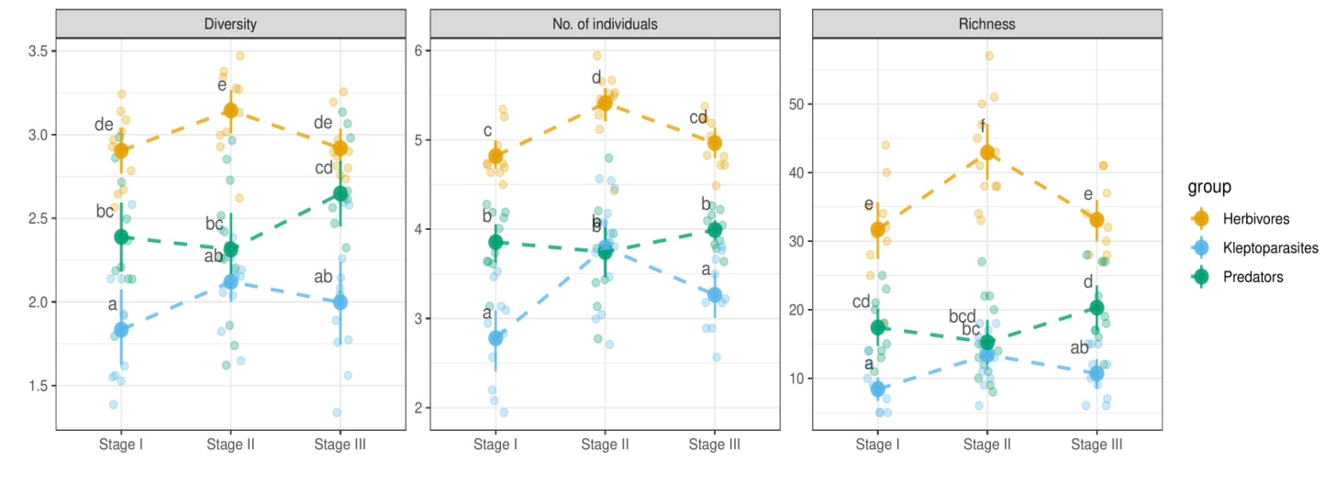

**Fig. 3. Diversity (Shannon index), abundance, and species richness of Aculeata at the three distinguished stages of succession. Abundance was subjected to logarithmic transformation to better visualize the differences among groups. Transparent points denote empirical values, whereas solid points are means. Different letters represent** statistical significance at ***α =* 0.05, adjusted for multiplicity (Tukey correction).**

*3*.*3*. *Community structure as a response to successional transformation*

Successional stages significantly affected the structure of aculeate communities (permutation test, 999 replications, *F* = 2.47, *p* < 0.001), and the RDA model explained 14.58% of the variation (adjusted *R*-square). Among 272 species of Aculeata, 55 (20.2%) significantly responded to successional transformation. In this group, contributions of herbivores and predators were similar (38.2 and 43.6%, respectively), while parasites accounted for 18.2%. The species that most strongly reacted to successional transformations are listed in Supplementary Table A.7 and displayed in Figure 4. The analysis of 272 species, summarized in a 3 x 2 contingency table, revealed significant relationships between the Aculeata group and the number of species significantly responding to the RDA model (*G*2 = 11.223, df = 2, *p* = 0.004). Herbivores and parasites had similar low-percentage contributions of species significantly reacting to the successional stages (15 and ~16%, respectively, *G*2 = 0.025, df = 1, *p* = 0.873). Predatory species had a significantly higher (nearly 35%) percentage of species that significantly reacted to successional stages (*G*2 = 11.197, df = 1, *p* < 0.001).

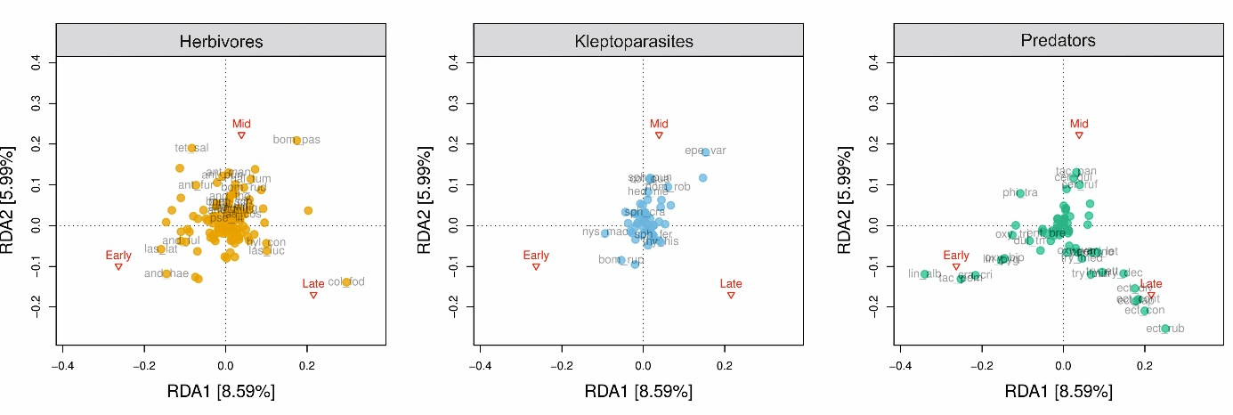**Fig. 4. Plot of redundancy analysis (RDA) ordination with stage of succession as a discrete explanatory variable. For better visualization, the points are marked separately for individual trophic guilds.** **Abbreviations for species names are included in Table A.3 in Supplement.**

*3*.*4 Changes in ß-diversity in the course of successional transformation*

Species turnover (the balanced component of ß-diversity) for herbivorous aculeates was stable (lack of significant differences between stages I and II and between II and III), but differed for predators and parasites. For predators, species turnover increased, whereas for parasites, it decreased (Tables A.4 and A.8, Fig. 5). In contrast, changes in dominance structure (gradient component) were small and similar for all three guilds of Aculeata (Fig. A.3).



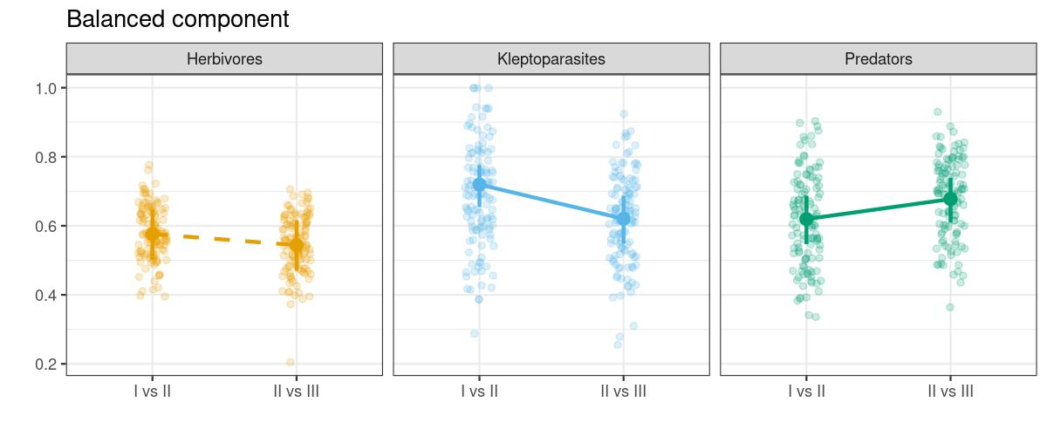**Fig. 5.** Means and 95% confidence intervals (CIs) for the balanced component of ß-diversity (species turnover) for the three trophic Aculeata guilds at two transitional stages: I vs. II and II vs. III. Solid lines indicate statistical significance of the mean differences at ***α =* 0.05**. Points indicate empirical values.

*3*.*5*. *Species characteristic of individual successional stages*

We identified 41 indicator species, including 15 herbivores, 21 predators, and 5 parasites (Table 1). Most of the indicator species were characteristic of the middle stage of succession (17 species), compared to 10 in the early stage and 14 in the late stage. In the middle stage, herbivorous species prevailed (58.8%), whereas predators dominated in the early and late stages (80.0 and 71.4%, respectively) (Table 1). We evaluated the original 3 x 3 contingency table of 41 indicator species and found significant relations between successional stage and trophic group (*G*2 = 15.453, df = 4, *p* = 0.004). Herbivorous and parasitic species had similar patterns of characteristic species throughout the successional stages, with the highest proportion of indicator species in the middle stage (*G*2 = 1.243, df = 2, *p* = 0.537). In contrast, for predators, the proportion of indicator species was significantly higher in the early (*G*2 = 4.640, df = 1, *p* = 0.031) and late successional stages (*G*2 = 9.569, df = 1, *p* = 0.002).

**Table 1.** Associations of individual species of Aculeata with successional stages: I = early, II = middle, and III = late.

|  |  |  |  |  |
| --- | --- | --- | --- | --- |
| Stage | Aculeata | Species | *IndVal* | *p* |
| I | Predator | *Crabro cribrarius* | 0.77 | < 0.001 |
| Predator | *Tachysphex pompiliformis* | 0.76 | < 0.001 |
| Predator | *Oxybelus bipunctatus* | 0.66 | < 0.001 |
| Predator | *Lindenius pygmaeus* | 0.63 | 0.001 |
| Predator | *Lindenius albilabris* | 0.62 | 0.016 |
| Herbivore | *Andrena haemorrhoa* | 0.56 | 0.004 |
| Predator | *Oxybelus trispinosus* | 0.47 | 0.011 |
| Herbivore | *Andrena fulva* | 0.41 | 0.031 |
| Predator | *Diodontus tristis* | 0.40 | 0.011 |
| Predator | *Entomognathus brevis* | 0.30 | 0.048 |
| II | Parasite | *Epeolus variegatus* | 0.65 | < 0.001 |
| Herbivore | *Bombus pascuorum* | 0.60 | < 0.001 |
| Herbivore | *Tetraloniella salicariae* | 0.57 | 0.031 |
| Predator | *Cerceris quinquefasciata* | 0.52 | 0.018 |
| Herbivore | *Andrena dorsata* | 0.51 | 0.028 |
| Parasite | *Sphecodes puncticeps* | 0.50 | 0.002 |
| Parasite | *Hedychrumniemeali* | 0.50 | 0.001 |
| Herbivore | *Megachile maritima* | 0.50 | 0.038 |
| Predator | *Tachytespanzeri* | 0.48 | 0.004 |
| Herbivore | *Anthidium punctatum* | 0.47 | 0.015 |
| Herbivore | *Bombus ruderarius* | 0.47 | 0.047 |
| Herbivore | *Halictus tumulorum* | 0.46 | 0.039 |
| Herbivore | *Anthophora furcata* | 0.43 | 0.032 |
| Herbivore | *Andrena thoracica* | 0.42 | 0.007 |
| Predator | *Cercerisruficornis* | 0.40 | 0.019 |
| Herbivore | *Anthidium manicatum* | 0.40 | 0.016 |
| Parasite | *Coelioxys quadridentata* | 0.33 | 0.028 |
| III | Predator | *Ectemnius rubicola* | 0.88 | < 0.001 |
| Predator | *Ectemnius confinis* | 0.88 | < 0.001 |
| Predator | *Ectemnius dives* | 0.78 | < 0.001 |
| Predator | *Ectemnius continuus* | 0.72 | < 0.001 |
| Predator | *Trypoxylon deceptorium* | 0.70 | < 0.001 |
| Predator | *Ectemnius lapidarius* | 0.68 | < 0.001 |
| Predator | *Trypoxylon attenuatum* | 0.56 | 0.003 |
| Predator | *Pemphredon lethifer* | 0.54 | 0.002 |
| Predator | *Trypoxylon minus* | 0.52 | 0.006 |
| Herbivore | *Colletes fodiens* | 0.51 | 0.037 |
| Predator | *Pemphredon inornata* | 0.50 | 0.002 |
| Herbivore | *Lasioglossum lucidulum* | 0.39 | 0.027 |
| Herbivore | *Hylaeus confusus* | 0.36 | 0.027 |
| Parasite | *Thyreus histrionicus* | 0.30 | 0.046 |

Only statistically significant indicator values are shown (*IndVal* > 0.25).

*3*.*6*. *Rare and threatened species at individual successional stages*

Rare and threatened species jointly accounted for 20.22% of all species. This concerned mostly herbivores (19.29% of the group) and parasites (23.81% of the group). For the cumulated Aculeata community and for herbivores, the probability of recording rare and threatened species was highest in stage II (Fig. A.4). For predators, probability values were highest in stages II and III, and for parasites, no significant differences between the stages were found (Table 2, Fig. 6).

**Table 2.** Parameter values for the binomial generalized linear models (GLM) evaluating the proportion of individuals belonging to rare and endangered species at different successional stages and depending on the Aculeata trophic group. Successional stages: I = early, II = middle, and III = late.

|  |  |  |  |  |  |  |
| --- | --- | --- | --- | --- | --- | --- |
| Stage | Trophic guild | Proportion | *N* | SE | Lower 95% CL | Upper 95% CL |
| I | Herbivores | 0.074 | 1,275 | 0.007 | 0.059 | 0.088 |
| II | 0.109 | 1,478 | 0.006 | 0.097 | 0.120 |
| III | 0.054 | 2,822 | 0.006 | 0.042 | 0.065 |
| I | parasites | 0.075 | 174 | 0.020 | 0.033 | 0.111 |
| II | 0.085 | 272 | 0.011 | 0.061 | 0.105 |
| III | 0.114 | 615 | 0.019 | 0.075 | 0.151 |
| I | Predators | 0.045 | 489 | 0.009 | 0.026 | 0.062 |
| II | 0.142 | 541 | 0.015 | 0.112 | 0.170 |
| III | 0.161 | 564 | 0.016 | 0.129 | 0.191 |

CL = confidence limit

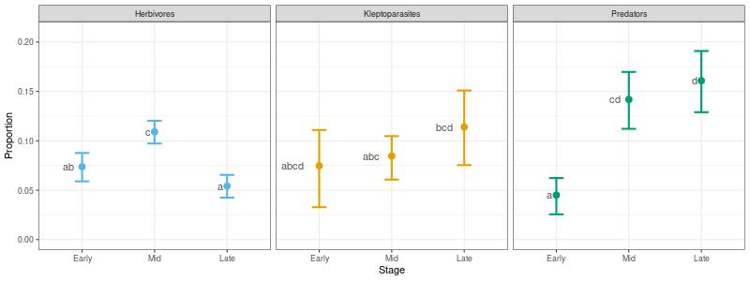**Fig. 6.** Proportion of rare and/or threatened species in the Aculeata community for different trophic guilds at different successional stages. Dots and whiskers represent predicted mean values and 95% CIs, respectively. Different letters represent statistical significance at ***α =* 0.05,** adjusted for multiplicity (Tukey correction).

**4. Discussion**

*4.1 Conservation value of sand quarries*

Our results confirm that sand quarries, gradually colonized by plants, are important habitats for various guilds of Aculeata with different life histories (Apiformes, Spheciformes, and Chrysididae). The high conservation potential of such sites is confirmed by the fact that about 20% of the species recorded przez nas are rare or threatened. Udział ten jest zbliżony do wartości wykazanych w innych siedliskach wczesnosukcesyjnych, takich jak: sandpits (24% bees and wasps) (Heneberg et al., 2013), off-road motorcycle circuits (18.9% bees and wasps) (Heneberg et al., 2016), brown coal spoil heaps (21.7% bees and wasps) (Hendrychová and Bogusch, 2016), soda dumping grounds (20.3% wasps; 20% bees) (Twerd et al., 2017; Twerd, 2020), and ugory (19.5% wasps) (Szczepko, 2013), (14.2% bees) (Twerd and Sobieraj-Betlińska, 2020). Potwierdza to coraz częściej docenianą rolę siedlisk antropogenicznych dla zachowania bioróżnorodności błonkoskrzydłych. Przy czym, such habitats are subject to dynamic processes of ecological succession, which markedly influence their value for biodiversity preservation.

*4.2. Sukcesja jako proces wpływający na strukturę zgrupowań*

In our study, the Aculeata community reached the highest diversity level at the middle stage of succession. The sites in the late stage were characterized by the lowest values of the analyzed characteristics; this pattern was primarily due to a significant increase in abundance and species richness of herbivores and parasites. This is consistent with previous studies (Steffan-Dewenter and Tscharntke, 2001; Potts et al., 2003; Rutgers-Kelly and Richards, 2013) in which Apiformes richness was proportional to bee food resources and tended to increase in the first years of successional transformation, followed by a decline.

The availability of bee forage plants and the presence of suitable nesting sites are factors determining bee occurrence in the environment (Ricketts et al., 2008; Ritchie and Johnson, 2009). In the case of herbivores, this can be associated with modification of habitat structure, linked with the colonization of the substrate at the first stage of succession and the appearance of new bee food plant species. The major reasons for the decline in bee diversity in wooded habitats include simplification of vegetation structure, loss of food resources, and disappearance of suitable nesting sites (Winfree et al., 2007). The studied sites were mostly covered with synanthropic vegetation, also ruderal species, which attests to a high level of human impact (Twerd et al., 2019a) as such species often colonize transformed and degraded sites (Kuzmič and Šilic, 2017).

Another important factor is the rate of succession, depending on substrate type. Succession on fertile and moist soils is fast, whereas on poor, dry, and sandy soils such as quarries, succession is generally slower (Ejrnaes et al., 2003).

*4.3. Species turnover and trophic guilds during succession*

We found that the arrival of new species, rather than changes in their dominance structure, significantly affected species exchange in communities of all three Aculeata groups. This significantly affected the occurrence of rare and threatened species, których największy udział wykazaliśmy w pośrednim i wczesnym stadium sukcesyjnym. Wpłynęło to na wartość ochronną badanych siedlisk, która była najwyższa w tym okresie. In our study, the rate of species turnover for herbivores seemed to remain constant throughout successional stages, with a higher proportion of rare species in the middle stage of succession. This pattern was possibly due to highly specialized oligolectic bees, usually associated with ruderal plant species, which dominated at the sites in the middle stage of succession (Twerd et al., 2019a). In the case of parasitic communities, their species turnover slowed down in the course of succession, possibly following the patterns of their hosts (i.e., mainly wild bees).

In the case of predators, we did not detect any changes in values of community characteristics. Dokładnie odnieść się do bogactwa, liczebności i różnorodności

We found, however, that changes in the community structure of predators accelerated at the later stages of succession, and this was mainly driven by the rapid accumulation of new and rare species. This resulted from the simultaneous presence of species preferring open habitats, e.g., *Cerceris arenaria* (L., 1758), *Lindenius albilabris* (F., 1793), and *Philanthus triangulum* (F., 1775), as well as stenotopic species associated with wooded habitats, e.g., *Ectemius continuus* (F., 1804) and *E. rubicola* (Dufour and Perris, 1840). Many of them are rare and threatened with extinction in Poland, e.g., *Bembecinus tridens* (F., 1781), *Harpactus laevis* (Lat., 1792), and *Lestica alata* (Panzer, 1797). A similar relationship was observed during research on the attractiveness of another type of anthropogenic habitats, namely Solvay process waste beds rich in calcium (Twerd et al., 2017). The cited study showed that the most favorable stage of succession in the waste beds was their colonization by woody vegetation, as the bee community included then species characteristic of open habitats as well as stenotopic species associated with wooded habitats (Twerd et al., 2017). In the present study, this was possible because the analyzed sand quarries are exploited only periodically. Because of the small scale of exploitation of the sand quarries, they are subject to spontaneous succession. As a result, various microhabitats are formed within them, including both bare sandy soil and areas colonized by vegetation, including forest communities. Besides, in some of the sand quarries, exploitation ceased in 2006; the sites were not rehabilitated and were only subject to spontaneous succession. At present, they are dominated by *Pinus sylvestris.* In this case (late stage of succession), the proportion of herbaceous vegetation reached 15–40%, while that of woody vegetation exceeded 60%. Anyway, in most such sand quarries, part of deposits remained uncovered. This was due to the fact that when industrial exploitation ceased, the local inhabitants often started to use them illegally, which does not allow complete colonization by plants. However, this creates conditions for the coexistence of species with different habitat preferences and thus increases the conservation value of these sites (Kerbiriou et al., 2018).

Communities of herbivores, in contrast to parasites and predators, greatly differed among the successional stages, which leads us to infer that random factors play a significant role in their variability (Ponisio et al., 2017). On the other hand, in contrast to our expectations, predator communities maintained some degree of structural coherence, in spite of the faster species turnover rate. This is reflected in a relatively high number of persistent species, present in all stages of succession suggesting that these species are keystone species in trophic networks (Piraino et al., 2002). From the conservation standpoint, special attention is paid to rare and threatened species. However, they do not necessarily perform an important function in ecosystems, and their increased contribution to the community can be due to habitat size (Krauss et al., 2009) and the proximity of natural habitats (Novák and Konvička, 2006). The role of rare species in the communities is still unclear, but our study assessed changes taking place in Aculeata communities and suggests that the overall variability of communities should be taken into account, with numbers of rare and threatened species, when determining protection priorities.

**6. Conclusions**

Spontaneously colonized sand quarries can play an important trans-regional role in nature conservation as favorable sites for rare insect species and as substitute habitats for threatened species in Europe. However, their protective values for individual taxa and groups differing in life history vary widely, and therefore, a multi-taxon approach is needed for the development of adequate management plans for such sites. The problem of the simultaneous protection of species with different ecological requirements can be solved by allowing spontaneous succession in abandoned mines. Because of species substitution, which takes place during natural succession, active protection measures must also be implemented. Such measures should aim at the maintenance of a mosaic of habitats in various stages of successional transformation.

**Acknowledgments**

This work was supported by the Polish Minister of Science and Higher Education within the program “Regional Initiative of Excellence” in 2019-2022 [Grant No. 008/RID/2018/19].

**Data availability**

Codes written for results are available at GitHub at http://tiny.cc/aryzsz.

**References**

Agresti, A., 2012. Categorical Data Analysis (3 edition). Hoboken, NewJersey, Wiley.

Alanen, E.-L., Hyvönen, T., Lindgren, S., Härmä, O., Kuussaari, M., 2011. Differential responses of bumblebees and diurnal Lepidoptera to vegetation succession in long-term set-aside. J. Appl. Ecol. 48(5), 1251–1259. https://doi.org/10.1111/j.1365-2664.2011.02012.x.

Asaad, I., Lundquist, C.J., Erdmann, M.V., Costello, M.J., 2017. Ecological criteria to identify areas for biodiversity conservation. Biol. Conserv. 213(B), 309–316. https://doi.org/10.1016/j.biocon.2016.10.007.

Banaszak, J., 1980. Studies on methods of censusing the numbers of bees (Hymenoptera, Apoidea). Pol. Ecol. Stud. 6, 355–365.

Banaszak, J., 2004. Pszczoły (Apidae), in: Bogdanowicz, W., Chudzicka, E., Pilipiuk, I., Skibińska, E., Fauna of Poland - characteristics and checklist of species. 1 Warszawa: Muzeum i Instytut Zoologii PAN, pp. 358–362.

Baselga, A., 2013. Separating the two components of abundance-based dissimilarity: balanced changes in abundance vs. abundance gradients. Methods Ecol. and Evol. 4(6), 552–557. https://doi.org/10.1111/2041-210X.12029.

Bitsch, J., Leclercq, J., 1993. Faune de France79. Hyménoptères Sphecidae d'Europe Occidentale. Volume 1. Generalites – Crabroninae. Paris.

Blösch, M., 2000. Die Grabwespen Deutschlands. Tierwelt Deutschlands 71; Goecke & Evers, Keltern.

Bogusch, P., Blažej, L., Trýzna, M., Heneberg, P., 2015. Forgotten role of fires in Central European forests: critical importance of early post-fire successional stages for bees and wasps (Hymenoptera: Aculeata). Eur. J. For. Res. 134, 153–166. https://doi.org/10.1007/s10342-014-0840-4.

Bogusch, P., Bláhová, E., Horák, J., 2020. Pollen specialists are more endangered than non-specialised bees even though they collect pollen on flowers of non-endangered plants. Arthropod-Plant Interac. 14, 759–769. https://doi.org/10.1007/s11829-020-09789-y.

Bohart, R.M., Menke A.S., 1976. Sphecid wasps of the world. A generic revision. University of California Press, Berkeley.

Bossert, S., 2015. Recognition and identification of bumblebee species in the *Bombus lucorum*-complex (Hymenoptera, Apidae) – A review and outlook. Dtsch. Entomol. Z. 62(1), 19–28. https://doi.org/10.3897/dez.62.9000.

Brändle, M., Durka, W., Altmoos, M., 2000. Diversity of surface dwelling beetle assemblages in open-cast lignite mines in Central Germany. Biodivers. Conserv. 9, 1297–1311. https://doi.org/10.1023/A:1008904605567.

Brooks, M.E., Kristensen, K., van Benthem, K.J., Magnusson, A., Berg, C.W., Nielsen, A., *et al*., 2017. glmmTMB balances speed and flexibility among packages for Zero-inflated Generalized Linear Mixed Modeling. R J. 9(2), 378–400. https://doi.org/10.32614/RJ-2017-066.

Brown, V.K., 1984. Secondary Succession: insect-plant relationships. BioScience 34(11), 710–716. https://doi.org/10.2307/1309664.

Celary, W., 2004. Złotolitkowate (Chrysididae), in: Bogdanowicz, W., Chudzicka,E., Pilipiuk, I., Skibińska, E., Fauna of Poland - characteristics and checklist of species. 1 Warszawa: Muzeum i Instytut Zoologii PAN, pp. 350–351.

Christensen, V., 1995. Ecosystem maturity – towards quantification. Ecol. Model. 77(1), 3–32. https://doi.org/10.1016/0304-3800(93)E0073-C.

Corbet, S.A., 1995. Insects, plants and succession: advantages of long-term set-aside. Agric. Ecosyst. Environ. 53(3), 201–217. https://doi.org/10.1016/0167-8809(94)00581-X.

De Smedt, P., Van de Poel, S., 2017. Succession in harvestman (Opiliones) communities within an abandoned sand quarry in Belgium. Belg. J. Zool. 147(2), 155–169.  
https://doi.org/10.26496/bjz.2017.13.

Dufrêne M., Legendre P. 1997. Species assemblages and indicator species: the need for a flexible asymmetrical approach. Ecol. Monogr. 67(3), 345–366. https://doi.org/10.1890/0012-9615(1997)067[0345:SAAIST]2.0.CO;2.

Ejrnæs, R., Hansen, D.N., Aude, E., 2003. Changing course of secondary succession in abandoned sandy fields. Biol. Conserv. 109(3), 343–350.https://doi.org/10.1016/S0006-3207(02)00160-X.

Gathmann, A., Greiler, H.-J., Tscharntke, T., 1994. Trap-nesting bees and wasps colonizing set-aside fields: succession and body size, management by cutting and sowing. Oecologia 98, 8–14. https://doi.org/10.1007/BF00326084.

Hallett, L., Avolio, M., Carroll, I., Jones, S., MacDonald, A., Flynn, D., *et. al*., 2019. codyn: Community dynamics metrics. Available at: https://doi.org/10.5063/F1N877Z6, R package version 2.0.3, <URL: https://github.com/NCEAS/codyn>, Accessed date: 18 June 2020.

Harabiš, F., 2016. High diversity of odonates in post-mining areas: Meta-analysis uncovers potential pitfalls associated with the formation and management of valuable habitats. Ecol. Eng. 90, 438–446. https://doi.org/10.1016/j.ecoleng.2016.01.070.

Harvey, E., Gounand, I., Ward, C.L., Altermatt, F., 2017. Bridging ecology and conservation: from ecological networks to ecosystem function. J. Appl. Ecol. 54(2), 371–379. https://doi.org/10.1111/1365-2664.12769.

Hendrychová, M., Bogusch, P., 2016. Combination of reclaimed and unreclaimed sites is the best practice for protection of aculeate Hymenoptera species on brown coal spoil heaps. J. Insect Conserv. 20, 807–820. https://doi.org/10.1007/s10841-016-9912-8.

Heneberg, P., Bogusch, P., Řehounek, J., 2013. Sandpits provide critical refuge for bees and wasps (Hymenoptera: Apocrita). J. Insect Conserv. 17, 473–490. https://doi.org/10.1007/s10841-012-9529-5.

Heneberg, P., Bogusch, P., Řezáč, M., 2016. Off-road motorcycle circuits support long-term persistence of bees and wasps (Hymenoptera: Aculeata) of open landscape at newly formed refugia within otherwise afforested temperate landscape. Ecol. Eng. 93, 187–198. https://doi.org/10.1016/j.ecoleng.2016.05.026.

Heneberg, P., Hesoun, P., Skuhrovec, J., 2016. Succession of arthropods on xerothermophilous habitats formed by sand quarrying: Epigeic beetles (Coleoptera) and orthopteroids (Orthoptera, Dermaptera and Blattodea). Ecol. Eng. 95, 340–356. https://doi.org/10.1016/j.ecoleng.2016.06.022.

Jacobs, H.-J. 2007. Hymenoptera III. Die Grabwespen Deutschlands. Ampulicidae, Sphecidae, Crabronidae. Bestimmungsschlüssel, in: Blank, S.M., Taeger, A. (Hrsg.): Die Tierwelt Deutschlands und der angrenzenden Meeresteile nach ihren Merkmalen und nach ihrer Lebensweise. Begründet 1925 von Friedrich Dahl. 79. Teil. – Goecke & Evers, Keltern.

Jain, M., Flynn, D.F., Prager, C.M., Hart, G.M., DeVan, C.M., Ahrestani, F.S., *et al*., 2014. The importance of rare species: a trait-based assessment of rare species contributions to functional diversity and possible ecosystem function in tall-grass prairies. Ecol. Evol. 4(1), 104–112. https://doi.org/10.1002/ece3.915.

Kerbiriou, C., Parisot-Laprun, M., Julien, J.F., 2018. Potential of restoration of gravel-sand pits for bats. Ecol. Eng. 110, 137–145. https://doi.org/10.1016/j.ecoleng.2017.11.013.

Krauss, J., Alfert, T., Steffan‐Dewenter, I., 2009. Habitat area but not habitat age determines wild bee richness in limestone quarries. J. Appl. Ecol. 46(1), 194–202. https://doi.org/10.1111/j.1365-2664.2008.01582.x.

Kuhlmann, M., Ascher, J.S., Dathe, H.H., Ebmer, A.W., Hartmann, P., Michez, D.,*et al.*2020. Checklist of the western palaearctic bees (Hymenoptera: Apoidea: Anthophila). Available at: http://westpalbees.myspecies.info/, Accessed date: 18 May 2020.

Kuzmič, F., Šilic, U., 2017. Alien species in different habitat types of Slovenia: analysis of vegetation database. Period. Biol. 119(3), 199–208. https://doi.org/10.18054/pb.v119i3.5183.

Legendre, P., Cáceres, M.D., 2013. Beta diversity as the variance of community data: dissimilarity coefficients and partitioning. Ecol. Lett. 16(8), 951–963. https://doi.org/10.1111/ele.1214.

Lenda, M., Skórka, P., Moroń, D., Rosin, Z.M., Tryjanowski, P., 2012. The importance of the gravel excavation industry for the conservation of grassland butterflies. Biol. Conserv. 148(1), 180–190. https://doi.org/10.1016/j.biocon.2012.01.014.

Lenth, R., 2019. Emmeans: estimated marginal means, aka least-squares means. R package version1.4.3.01. Available at: https://CRAN.R-project.org/package=emmeans, Accessed date: 18 August 2020.

Lönnberg, L., Jonsell, M., 2012.Sand pits as habitats for beetles (Coleoptera): does area affect species number and composition? [Biodivers. Conserv.,](https://link.springer.com/journal/10531) 21(3), 853–874. https*://*doi*.org/*10.1007*/*s10531*-*012-0225-2.

Losapio, G., Gobbi, M., Marano, G., Avesani, D., Boracchi, P., Compostella, C., *et al*., 2016. Feedback effects between plant and flower-visiting insect communities along a primary succession gradient. Arthropod-Plant Interact. 10, 485–495. https://doi.org/10.1007/s11829-016-9444-x.

Lyons, K.G., Brigham, C.A., Traut, B.H., Schwartz, M.W., 2005. Rare Species and Ecosystem Functioning. Conserv. Biol. 19(4), 1019–1024. https://doi.org/10.1111/j.1523-1739.2005.00106.x.

Michener, C.D., 2007. The bees of the word. Johns Hopkins University Press, Baltimore and London.

Müller, A., Diener, S., Schnyder, S., Stutz, K., Sedivy, C., Dorn, S., 2006. Quantitative pollen requirements of solitary bees: Implications for bee conservation and the evolution of bee–flower relationships. Biol. Conserv. 130(4), 604–615. https://doi.org/10.1016/j.biocon.2006.01.023.Nieto, A., Roberts, S.P.M., Kemp, J., Rasmont, P., Kuhlmann, M., García Criado, M., *et. al*., 2014. European Red List of Bees. Publication Office of the European Union, Luxembourg. http://dx.doi.org/doi:10.2779/77003.

Novák, J., Konvička, M., 2006. Proximity of valuable habitats affects succession patterns in abandoned quarries. Ecol. Eng. 26(2), 113–122. https://doi.org/10.1016/j.ecoleng.2005.06.008.

Odanaka, K.A., Rehan, S.M., 2019. Impact indicators: Effects of land use management on functional trait and phylogenetic diversity of wild bees. Agric. Ecosyst. Environ. 286, 106663. https://doi.org/10.1016/j.agee.2019.106663.

Odum, E.P., 1969. The strategy of ecosystem development. Science 164(3877), 262–270. https://doi.org/10.1126/science.164.3877.262.

Oksanen, J., Blanchet, F. G., Friendly, M., Kindt, R., Legendre, P., McGlinn, D., *et al*., 2019. vegan: Community Ecology Package (Version 2.5-5). Available at: https://CRAN.R-project.org/package=vegan, Accessed date: 18 July 2020.

Parrish, J.A.D., Bazzaz, F.A., 1979. Difference in Pollination Niche Relationships in Early and Late Successional Plant Communities. Ecology 60(3), 597–610. https://doi.org/10.2307/1936080.

Paukkunen, J., Berg, A., Soon, V., Ødegaard, F., Rosa, P., 2015. An illustrated key to the cuckoo wasps (Hymenoptera, Chrysididae) of the Nordic and Baltic countries, with description of a new species. ZooKeys 548, 1–116. https://doi.org/10.3897/zookeys.548.6164.

Piraino, S., Fanelli, G., Boero, F., 2002. Variability of species’ roles in marine communities: change of paradigms for conservation priorities. Mar. Biol. 140, 1067–1074. https://doi.org/10.1007/s00227-001-0769-2.

Ponisio, L.C., Gaiarsa, M.P., Kremen, C., 2017. Opportunistic attachment assembles plant–pollinator networks. Ecol. Lett. 20(10), 1261–1272. https://doi.org/10.1111/ele.12821

Potts, S.G., Vulliamy, B., Dafni, A., Ne'eman, G., Willmer, P., 2003. Linking bees and flowers: how do floral communities structure pollinator communities? Ecology 84, 2628–2642.https://doi.org/10.1890/02-0136.

Prach, K., Lencová, K., Řehounková, K., Dvořáková, H., Jírová, A., Konvalinková, P. *et al*., 2013. Spontaneous vegetation succession at different central European mining sites: a comparison across seres. Environ. Sci. Pollut. Res. 20, 7680–7685. https://doi.org/10.1007/s11356-013-1563-7.

Pulawski, W.J., 2020. Catalog of Sphecidae. California Academy of Sciences, San Francisco. Available at: http://researcharchive.calacademy.org/research/entomology/entomology_resources/hymenoptera/sphecidae/genera/index.html, Accessed date: 6 September 2020.

Rasmont, P., Devalez, J., Pauly, A., Michez, D., Radchenko, V., 2017. Addition to the checklist of IUCN European wild bees (Hymenoptera: Apoidea). Ann. Soc. Entomol. France 53(1), 17–32. https://doi.org/10.1080/00379271.2017.1307696.

R Core Team, 2019. R: A language and environment for statistical computing. R Foundation for Statistical Computing, Vienna, Austria. Available at: https://www.R-project.org/, Accessed date: 18 August 2020.

Řehounková, K., Řehounek, J., Prach, K., (Eds.) 2011. Nearnatural restoration vs technical reclamation of mining sites in the Czech Republic, Faculty of Science USB, Ceske Budejovice.

Ricketts, T.H., Regetz, J., Steffan‐Dewenter, I., Cunningham, S.A., Kremen, C., Bogdanski, A., *et al.*, 2008. Landscape effects on crop pollination services: are there general patterns? Ecol. Lett. 11(5), 499–515. https://doi.org/10.1111/j.1461-0248.2008.01157.x.

Ritchie, E.G., Johnson, C.N., 2009. Predator interactions, mesopredator release and biodiversity conservation. Ecol. Lett. 12(9), 982–998. https://doi.org/10.1111/j.1461-0248.2009.01347.x.

Roberts, H.P., King, D.I., Milam, J., 2017. Factors affecting bee communities in forest openings and adjacent mature forest. For. Ecol. Manag. 394, 111–122. https://doi.org/10.1016/j.foreco.2017.03.027.

Rutgers-Kelly, A.C., Richards, M.H., 2013. Effect of meadow regeneration on bee (Hymenoptera: Apoidea) abundance and diversity in southern Ontario, Canada. Can. Entomol. 145(6), 655–667. <https://doi.org/10.4039/tce.2013.42>.

Schowalter, T.D., 2012. Insect Responses to Major Landscape-Level Disturbance. Annu. Rev. Entomol. 57, 1–20. https://doi.org/10.1146/annurev-ento-120710-100610

Seitz, N., van Engelsdorp, D., Leonhardt, S.D., 2019. Conserving bees in destroyed landscapes: the potentials of reclaimed sand mines. Glob. Ecol. Conserv. 19, e00642. https://doi.org/10.1016/j.gecco.2019.e00642.

Siemann, E., Haarstad, J., Tilman, D., 1999. Dynamics of plant and arthropod diversity during old field succession. Ecography 22(4), 406–414. https://doi.org/10.1111/j.1600-0587.1999.tb00577.x.

Siliwończuk, Z., 1985. Geologiczno-złożowe warunki występowania kruszywa naturalnego w Polsce. Pr. Inst. Geol. 113. Warszawa.

Skibińska, E., 2004. Osy (Vespoidea),in: Bogdanowicz, W., Chudzicka,E., Pilipiuk, I. Skibińska, E., Fauna of Poland - characteristics and checklist of species. 1 Warszawa: Muzeum i Instytut Zoologii PAN, pp. 351–358.

Steffan-Dewenter, I., Tscharntke, T., 2001. Succession of bee communities on fallows. Ecography 24(1), 83–93. https://doi.org/10.1034/j.1600-0587.2001.240110.x.

Szczepko, E., 2013. Ekologia grzebaczowatych (Hymenoptera, Apoidea, Spheciformes) odłogów w Kampinoskim Parku Narodowym. Wydawnictwo Uniwersytetu Łódzkiego, Łódź.

Tichanek, F., Tropek, R., 2015. Conservation value of post-mining headwaters: drainage channels at a lignite spoil heap harbour threatened stream dragonflies. J. Insect Conserv. 19, 975–985. https://doi.org/10.1007/s10841-015-9814-1.

Tropek, R., Kadlec, T., Karesova, P., Spitzer, L., Kocarek, P., Malenovsky, I., *et al*., 2010. Spontaneous succession in limestone quarries as an effective restoration tool for endangered arthropods and plants. J. Appl. Ecol. 47(1), 139–147. https://doi.org/10.1111/j.1365-2664.2009.01746.x.

Tropek, R., Konvicka, M., 2008. Can quarries supplement rare xeric habitats in a piedmont region? Spiders of the Blansky les Mts, Czech Republic. Land Degrad. Dev. 19(1), 104–114. https://doi.org/10.1002/ldr.817.

Tscharntke, T., Batáry, P., Dormann, C.F., 2011. Set-aside management: how do succession, sowing patterns and landscape context affect biodiversity? Agric. Ecosyst. Environ. 143(1), 37–44. https://doi.org/10.1016/j.agee.2010.11.025.

Twerd, L., Banaszak-Cibicka, W., Sandurska, E., 2019a. What features of sand quarries affect their attractiveness for bees? Acta Oecol. 96, 56–64. https://doi.org/10.1016/j.actao.2019.03.005.

Twerd, L., Krzyżyński, M., Waldon-Rudzionek, B., Olszewski, P., 2017. Can soda ash dumping grounds provide replacement habitats for digger wasps (Hymenoptera, Apoidea, Spheciformes)? PLoS ONE 12(4), e0175664. https://doi.org/10.1371/journal.pone.0175664.

Twerd, L., Sobieraj-Betlińska, A., Banaszak, J., 2019b. Complementary use of various types of anthropogenic habitats by *Scolia hirta* (Hymenoptera: Scoliidae) and *Scolia sexmaculata*. Environ. Entomol. 48(6), 1499–1510. https://doi.org/10.1093/ee/nvz132.

Twerd, L. 2020., Ecology of wild bees (Hymenoptera: Apoidea: Apiformes) in the conditions influence of the soda industry. Wydawnictwo Uniwersytetu Kazimierza Wielkiego w Bydgoszczy.

Twerd, L., Sobieraj-Betlińska, A., 2020. Wild bee (Apiformes) communities in contrasting habitats within agricultural and wooded landscapes: implications for conservation management. **Agric. For. Entomol. 22(4), 358**–372. https://doi.org/10.1111/afe.12391.

Venables, W.N., Ripley, B.D., 2002. Modern applied statistics with S. Springer, New York.

Vieira, L.C., Oliveira, N.G., Gayubo, S.F., 2011. On the use of Apiformes and Spheciformes (Insecta: Hymenoptera) populations as a management tool. Biodivers. Conserv. 20,519–530. https://doi.org/10.1007/s10531-010-9962-2.

Westerfelt, P., Weslien, J., Widenfalk, O., 2018. Population patterns in relation to food and nesting resource for two cavity-nesting bee species in young boreal forest stands. For. Ecol. Manag. 430: 629–638. https ://doi.org/10.1016/j.forec o.2018.08.053.

Winfree, R., Griswold, T. Kremen, C., 2007. Effect of human disturbance on bee communities in a forested ecosystem. Conserv. Biol. 21(1), 213–223. https://doi.org/10.1111/j.1523-1739.2006.00574.x.

Wiśniowski, B., 2015. Cuckoo-wasps (Hymenoptera: Chrysididae) of Poland. Diversity, identification, distribution. Ojców National Park, Ojców.

Wolf, S., Rohde, M., Moritz, R.F.A., 2010. The reliability of morphological traits in the differentiation of *Bombus terrestris* and *B. lucorum* (Hymenoptera: Apidae). Apidologie 41, 45–53.https://doi.org/10.1051/apido/2009048.

**Fig. 1.** Location of study sites (sand quarries).

**Fig. 2.** Representative photographs of stages of plant succession in sand quarries: a, b = early succession; c, d = middle succession; e, f = late succession.

**Fig. 3. Diversity (Shannon index), abundance, and species richness of Aculeata at the three distinguished stages of succession. Abundance was subjected to logarithmic transformation to better visualize the differences among groups. Transparent points denote empirical values, whereas solid points are means. Different letters represent** statistical significance at ***α =* 0.05, adjusted for multiplicity (Tukey correction).**

**Fig. 4. Plot of redundancy analysis (RDA) ordination for stage of succession as a discrete explanatory variable. For better visualization, the points are marked separately for individual trophic guilds. Abbreviations for species names are included in Table A.3 in Supplement.**

**Fig. 5.** Means and 95% confidence intervals (CIs) for the balanced component of ß-diversity (species turnover) for the three trophic Aculeata guilds at two transitional stages: I vs. II and II vs. III. Solid lines indicate statistical significance of the mean differences at ***α =* 0.05**. Points indicate empirical values.

**Fig. 6.** Proportion of rare and/or threatened species in the Aculeata community for different trophic guilds at different stages of succession. Dots and whiskers represent predicted mean values and 95% CIs, respectively. **Different** letters represent statistical significance at ***α =* 0.05,** adjusted for multiplicity (Tukey correction).

**Table 1.** Associations of individual species of Aculeata with successional stages: I = early, II = middle, and III = late.

**Table 2.** Parameter values for the binomial generalized linear models (GLMs) evaluating the proportion of individuals belonging to rare and endangered species at different successional stages and depending on the Aculeata trophic guild. Successional stages: I = early; II = middle, and III = late.