jSUPPLEMENT

Impact of biotic factors on pioneer tropical forest succession change with elevations

Piotr Szefer, Austin Sau, Kenneth Molem, Jonah Philip, …, (the rest of the team), and Vojtech Novotny
Figure S.1 Number of species along elevational gradient predicted by quadratic poisson regression. Grey ribbon represents the bootstrapped prediction intervals. Grey points indicate empirical observation from three elevational sites. Adjusted R2 = 0.6215113.
Table SX. Results of rda for treatments at each eleavational site
Treatment | Df | Variance | F | Pr(>F)
Wanang
f | 1 | 0.020686 | 1.4439 | 0.149
h | 1 | 0.020196 | 1.4097 | 0.144
p | 1 | 0.016540 | 1.1545 | 0.306
i | 1 | 0.029773 | 2.0782 | 0.024
Numba
f | 1 | 0.008364 | 1.3126 | 0.169
h | 1 | 0.007622 | 1.1962 | 0.256
p | 1 | 0.009006 | 1.4134 | 0.128
I | 1 | 0.014922 | 2.3418 | 0.002
Residual | 32 | 0.203902
Yawan
f | 1 | 0.028587 | 4.9377 | 0.001
h | 1 | 0.006964 | 1.2028 | 0.251
p | 1 | 0.003796 | 0.6557 | 0.840
I | 1 | 0.012803 | 2.2114 | 0.010
Residual | 32 | 0.185265

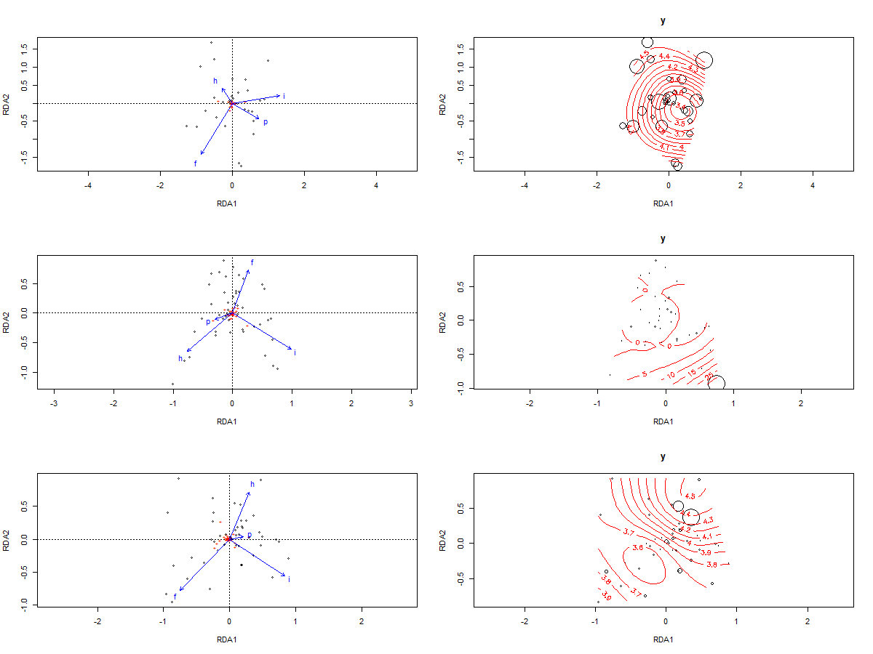
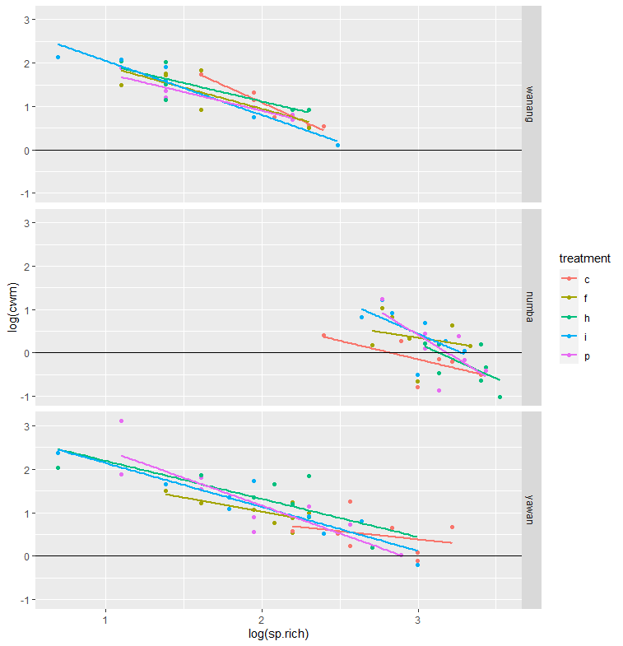
Figure CWM SLA.SPRICH. See whether this is also present in felling

log(cwm)
Predictors Estimates CI p
(Intercept) 4.33 1.88 – 6.77 0.001
fsite [numba] -2.11 -5.73 – 1.52 0.251
fsite [yawan] -2.54 -5.94 – 0.85 0.139
treatment [f] -1.42 -4.12 – 1.27 0.295
treatment [h] -1.57 -4.15 – 1.01 0.230
treatment [i] -1.01 -3.63 – 1.62 0.446
treatment [p] -1.75 -4.45 – 0.95 0.201
sp rich [log] -1.62 -2.80 – -0.44 0.008
fsite [numba] * treatment
[f] 2.17 -3.37 – 7.71 0.437
fsite [yawan] * treatment
[f] 1.96 -1.98 – 5.91 0.324
fsite [numba] * treatment
[h] 3.72 -2.92 – 10.37 0.268
fsite [yawan] * treatment
[h] 2.96 -0.56 – 6.48 0.098
fsite [numba] * treatment
[i] 2.43 -3.04 – 7.91 0.379
fsite [yawan] * treatment
[i] 2.45 -1.11 – 6.02 0.174
fsite [numba] * treatment
[p] 6.59 0.54 – 12.64 0.033
fsite [yawan] * treatment
[p] 3.79 0.17 – 7.41 0.041
fsite [numba] * sp rich
[log] 0.83 -0.64 – 2.30 0.265
fsite [yawan] * sp rich
[log] 1.15 -0.31 – 2.61 0.121
treatment [f] * sp rich
[log] 0.64 -0.75 – 2.03 0.364
treatment [h] * sp rich
[log] 0.80 -0.50 – 2.10 0.222
treatment [i] * sp rich
[log] 0.36 -0.97 – 1.68 0.593
treatment [p] * sp rich
[log] 0.78 -0.58 – 2.14 0.255
(fsite [numba] *
treatment [f]) * sp rich
[log] -0.73 -2.85 – 1.40 0.499
(fsite [yawan] *
treatment [f]) * sp rich
[log] -0.82 -2.66 – 1.02 0.377
(fsite [numba] *
treatment [h]) * sp rich
[log] -1.42 -3.70 – 0.87 0.221
(fsite [yawan] *
treatment [h]) * sp rich
[log] -1.26 -2.83 – 0.32 0.116
(fsite [numba] *
treatment [i]) * sp rich
[log] -0.63 -2.71 – 1.45 0.548
(fsite [yawan] *
treatment [i]) * sp rich
[log] -0.93 -2.54 – 0.67 0.249
(fsite [numba] *
treatment [p]) * sp rich
[log] -2.21 -4.41 – -0.01 0.049
(fsite [yawan] *
treatment [p]) * sp rich
[log] -1.64 -3.28 – -0.01 0.049
Random Effects
σ2 0.12
τ00 st.gard 0.04
ICC 0.24
N st.gard 22
Observations 108
Marginal R2 / Conditional R2 0.768 / 0.823

Table SLA CWM.SPRICH. Results of a linear mixed effect model
Predictors | Estimates | CI | p
(Intercept) | 1.97 | 0.83 – 3.10 | 0.001
fsite [numba] | 0.56 | -1.12 – 2.24 | 0.508
fsite [yawan] | -1.19 | -2.76 – 0.38 | 0.136
treatment [f] | -0.48 | -1.71 – 0.76 | 0.446
treatment [h] | -0.42 | -1.61 – 0.76 | 0.476
treatment [i] | -0.07 | -1.28 – 1.15 | 0.915
treatment [p] | -0.63 | -1.87 – 0.61 | 0.316
sp rich [log] | -1.12 | -1.67 – -0.57 | <0.001
fsite [numba] * treatment[f] | 1.23 | -1.33 – 3.80 | 0.341
fsite [yawan] * treatment[f] | 1.72 | -0.09 – 3.54 | 0.062
fsite [numba] * treatment[h] | 0.63 | -2.45 – 3.72 | 0.684
fsite [yawan] * treatment[h] | 1.60 | -0.01 – 3.22 | 0.052
fsite [numba] * treatment[i] | 0.91 | -1.63 – 3.45 | 0.477
fsite [yawan] * treatment[i] | 0.60 | -1.04 – 2.25 | 0.468
fsite [numba] * treatment[p] | 2.78 | -0.03 – 5.60 | 0.053
fsite [yawan] * treatment[p] | 1.77 | 0.10 – 3.43 | 0.038
fsite [numba] * sp rich[log] | -0.04 | -0.72 – 0.64 | 0.906
fsite [yawan] * sp rich[log] | 0.47 | -0.21 – 1.14 | 0.174
treatment [f] * sp rich[log] | 0.26 | -0.38 – 0.90 | 0.421
treatment [h] * sp rich[log] | 0.25 | -0.34 – 0.85 | 0.400
treatment [i] * sp rich[log] | -0.01 | -0.62 – 0.61 | 0.983
treatment [p] * sp rich[log] | 0.30 | -0.32 – 0.93 | 0.336
(fsite [numba] *treatment [f]) * sp rich[log] | -0.57 | -1.55 – 0.41 | 0.252
(fsite [yawan] *treatment [f]) * sp rich[log] | -0.66 | -1.50 – 0.19 | 0.127
(fsite [numba] *treatment [h]) * sp rich[log] | -0.29 | -1.35 – 0.76 | 0.582
(fsite [yawan] * treatment [h]) * sp rich[log] | -0.74 | -1.46 – -0.02 | 0.044
(fsite [numba] * treatment [i]) * sp rich[log] | -0.28 | -1.25 – 0.68 | 0.558
(fsite [yawan] * treatment [i]) * sp rich[log] | -0.13 | -0.87 – 0.61 | 0.730
(fsite [numba] * treatment [p]) * sp rich[log] | -1.03 | -2.05 – -0.01 | 0.048
(fsite [yawan] * treatment [p]) * sp rich[log] | -0.60 | -1.35 – 0.15 | 0.118

Random Effects
σ2 0.03
τ00 st.gard 0.01
ICC 0.33
N st.gard 22
Observations 108
Marginal R2 / Conditional R2 0.926 / 0.950

Table SX: Results of the GLS model for the relationship between SL A and richness.

lsla.d
Predictors | Estimates | CI | p
(Intercept) | 2.14 | 0.91 – 3.37 | 0.001
sp rich [log] | 0.54 | -0.02 – 1.11 | 0.061
fsite x [numba] | -0.96 | -2.46 – 0.54 | 0.208
fsite x [yawan] | 0.56 | -0.98 – 2.11 | 0.475
treatment x [f] | 1.04 | -0.27 – 2.35 | 0.119
treatment x [h] | 1.02 | -0.26 – 2.30 | 0.120
treatment x [i] | 1.46 | 0.09 – 2.83 | 0.037
treatment x [p] | 0.93 | -0.47 – 2.33 | 0.191
sp rich [log] * fsite x[numba] | 0.06 | -0.57 – 0.69 | 0.856
sp rich [log] * fsite x[yawan] | -0.23 | -0.87 – 0.42 | 0.490
sp rich [log] * treatmentx [f] | -0.53 | -1.19 – 0.12 | 0.111
sp rich [log] * treatmentx [h] | -0.47 | -1.09 – 0.14 | 0.131
sp rich [log] * treatmentx [i] | -0.67 | -1.34 – 0.01 | 0.052
sp rich [log] * treatmentx [p] | -0.45 | -1.14 – 0.25 | 0.209
fsite x [numba] *treatment x [f] | -0.61 | -2.51 – 1.30 | 0.532
fsite x [yawan] *treatment x [f] | 0.03 | -1.79 – 1.85 | 0.972
fsite x [numba] *treatment x [h] | -1.06 | -3.15 – 1.04 | 0.323
fsite x [yawan] *treatment x [h] | -0.44 | -2.00 – 1.13 | 0.583
fsite x [numba] *treatment x [i] | -2.62 | -4.61 – -0.62 | 0.010
fsite x [yawan] *treatment x [i] | -0.25 | -1.92 – 1.42 | 0.770
fsite x [numba] *treatment x [p] | 1.18 | -0.83 – 3.18 | 0.249
fsite x [yawan] *treatment x [p] | -0.23 | -1.91 – 1.45 | 0.789
(sp rich [log] * fsite x[numba]) * treatment x[f] | 0.55 | -0.24 – 1.35 | 0.173
(sp rich [log] * fsite x[yawan]) * treatment x[f] | -0.06 | -0.91 – 0.78 | 0.881
(sp rich [log] * fsite x[numba]) * treatment x[h] | 0.49 | -0.30 – 1.29 | 0.225
(sp rich [log] * fsite x[yawan]) * treatment x[h] | 0.22 | -0.48 – 0.91 | 0.539
(sp rich [log] * fsite x[numba]) * treatment x[i] | 1.30 | 0.48 – 2.13 | 0.002
(sp rich [log] * fsite x[yawan]) * treatment x[i] | 0.17 | -0.59 – 0.93 | 0.658
(sp rich [log] * fsite x[numba]) * treatment x[p] | -0.12 | -0.95 – 0.70 | 0.768
(sp rich [log] * fsite x[yawan]) * treatment x[p] | 0.14 | -0.64 – 0.92 | 0.716

Observations 1287
R2 0.028
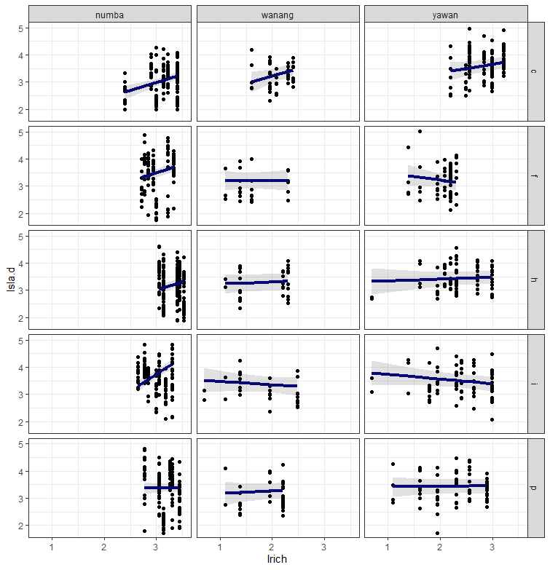
Figure SX. Relationship between SLA and species richnes on a plot [make a new one with the predict function!!!!]. It is
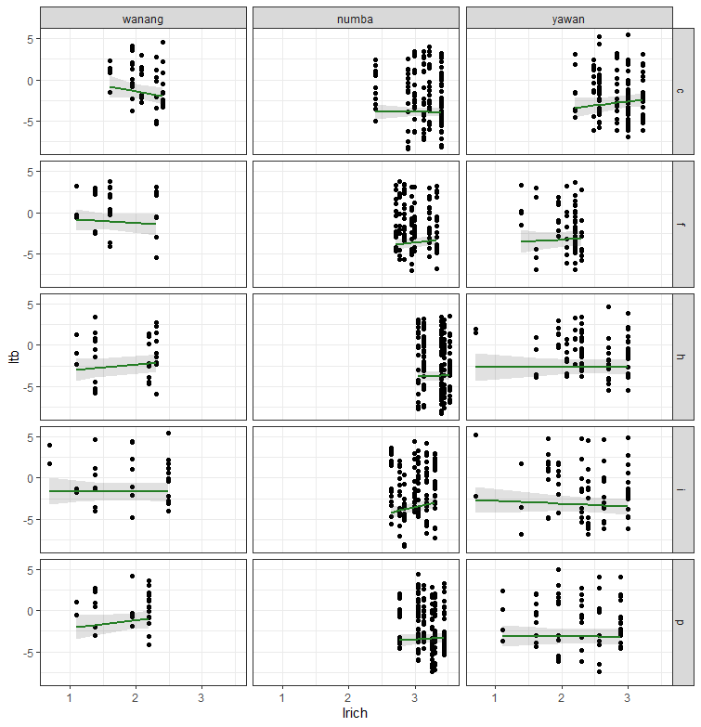
Figure SX: Total biomass in relation to richness of a plot.
Table SX: GLS results for the tot_bio ~richness correltaions

Predictors | Estimates | CI | p
(Intercept) | 1.61 | -2.81 – 6.03 | 0.475
lrich | -1.50 | -3.53 – 0.54 | 0.150
fsite x [numba] | -5.40 | -10.78 – -0.02 | 0.049
fsite x [yawan] | -7.26 | -12.81 – -1.72 | 0.010
treatment x [f] | -2.04 | -6.74 – 2.67 | 0.396
treatment x [h] | -5.32 | -9.92 – -0.73 | 0.023
treatment x [i] | -3.15 | -8.08 – 1.78 | 0.210
treatment x [p] | -4.52 | -9.54 – 0.49 | 0.077
lrich * fsite x [numba] | 1.45 | -0.81 – 3.70 | 0.209
lrich * fsite x [yawan] | 2.50 | 0.19 – 4.82 | 0.034
lrich * treatment x [f] | 1.07 | -1.28 – 3.42 | 0.370
lrich * treatment x [h] | 2.16 | -0.04 – 4.36 | 0.055
lrich * treatment x [i] | 1.44 | -0.97 – 3.85 | 0.243
lrich * treatment x [p] | 2.36 | -0.14 – 4.86 | 0.064
fsite x [numba] *treatment x [f] | -0.45 | -7.28 – 6.38 | 0.898
fsite x [yawan] *treatment x [f] | 3.60 | -2.92 – 10.12 | 0.279
fsite x [numba] *treatment x [h] | 4.56 | -2.95 – 12.08 | 0.234
fsite x [yawan] *treatment x [h] | 8.28 | 2.67 – 13.90 | 0.004
fsite x [numba] *treatment x [i] | -2.15 | -9.31 – 5.01 | 0.557
fsite x [yawan] *treatment x [i] | 6.39 | 0.39 – 12.39 | 0.037
fsite x [numba] *treatment x [p] | 3.47 | -3.71 – 10.66 | 0.343
fsite x [yawan] *treatment x [p] | 7.24 | 1.21 – 13.27 | 0.019
(lrich * fsite x [numba])* treatment x [f] | -0.16 | -3.01 – 2.69 | 0.914
(lrich * fsite x [yawan])* treatment x [f] | -1.68 | -4.73 – 1.37 | 0.280
(lrich * fsite x [numba])* treatment x [h] | -1.86 | -4.71 – 1.00 | 0.202
(lrich * fsite x [yawan])* treatment x [h] | -3.14 | -5.63 – -0.64 | 0.014
(lrich * fsite x [numba])* treatment x [i] | 0.46 | -2.49 – 3.42 | 0.759
(lrich * fsite x [yawan])* treatment x [i] | -2.80 | -5.52 – -0.07 | 0.044
(lrich * fsite x [numba])* treatment x [p] | -1.86 | -4.84 – 1.12 | 0.220
(lrich * fsite x [yawan])* treatment x [p] | -3.45 | -6.25 – -0.66 | 0.016

Table SX: LMER model for SLA changes with species richness for most prevalent species. Interestingly this correlation only turns-out positive at the funcgicide treated plots. This model assumes that the relationship is the same for each species. SLA is getting higher with richness at the fungicide treated plots.

Predictors | Estimates | CI | p
(Intercept) | 3.29 | 2.79 – 3.79 | <0.001
sp rich | -0.01 | -0.03 – 0.01 | 0.219
treatment x [f] | -0.53 | -0.93 – -0.12 | 0.011
treatment x [h] | 0.06 | -0.31 – 0.44 | 0.739
treatment x [i] | 0.00 | -0.41 – 0.41 | 0.997
treatment x [p] | -0.15 | -0.54 – 0.24 | 0.464
sp rich * treatment x [f] | 0.05 | 0.03 – 0.07 | <0.001
sp rich * treatment x [h] | 0.00 | -0.02 – 0.02 | 0.762
sp rich * treatment x [i] | 0.02 | -0.00 – 0.04 | 0.114
sp rich * treatment x [p] | 0.02 | -0.01 – 0.04 | 0.142

Random Effects
σ2 | 0.23
τ00 garden.x | 0.07
τ00 unified_names | 0.07
τ00 fsite | 0.04

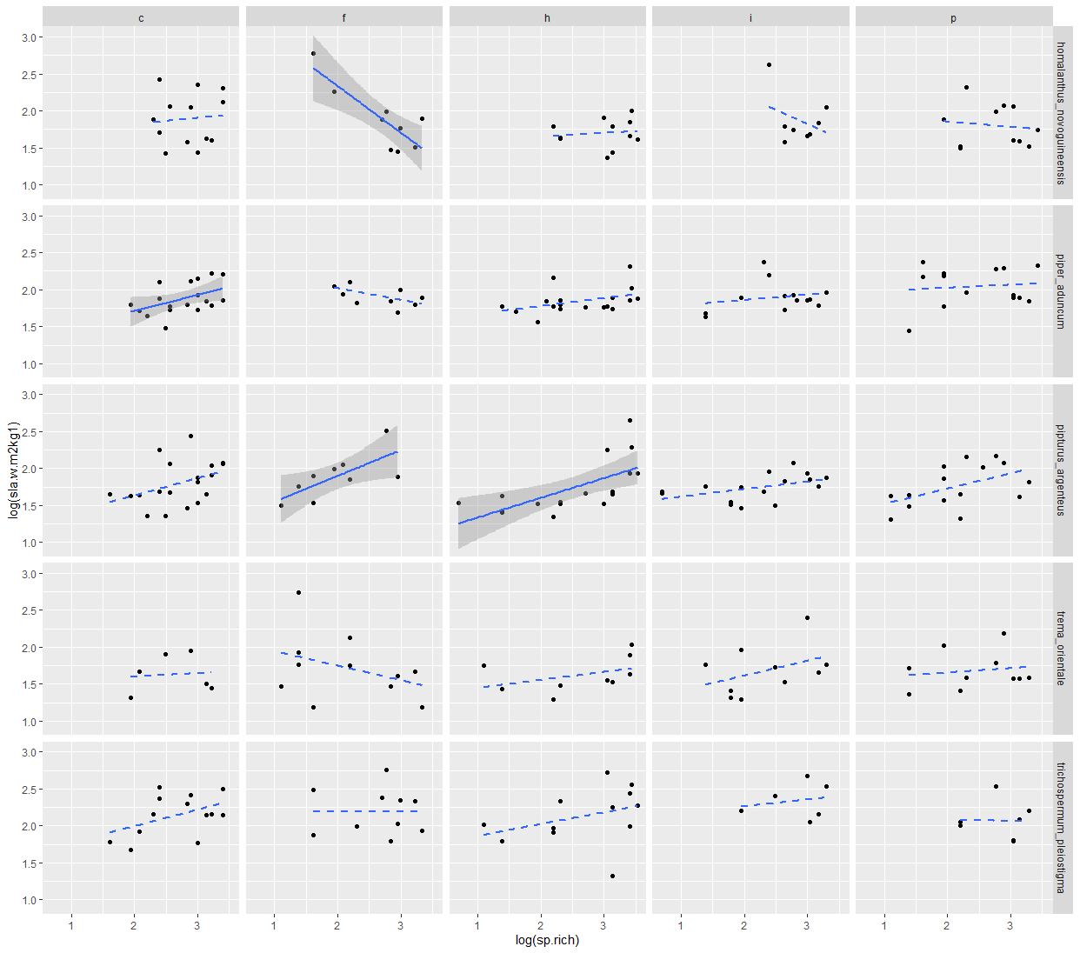
Figure SX. Relationship between species richness and SLA of most prevalent (more than 50 occurences in data set) woody plant species. Dashed lines indicate lack of statistical significance evaluated with lm.
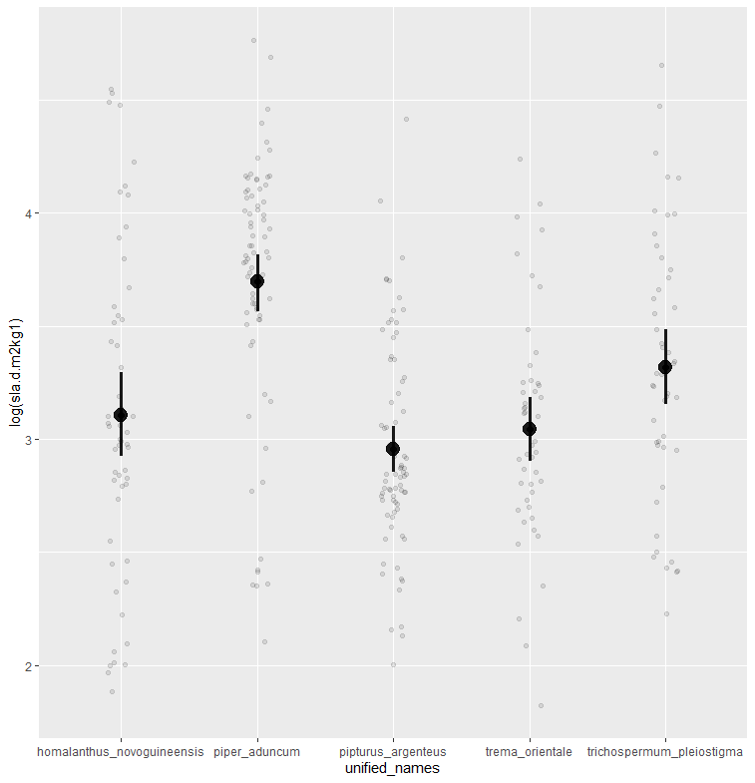
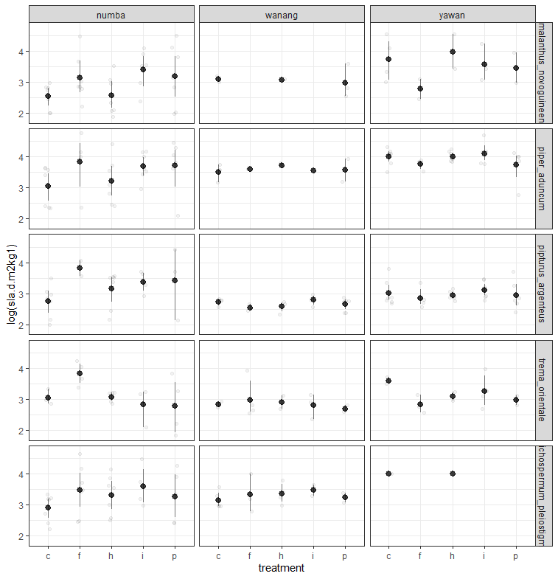
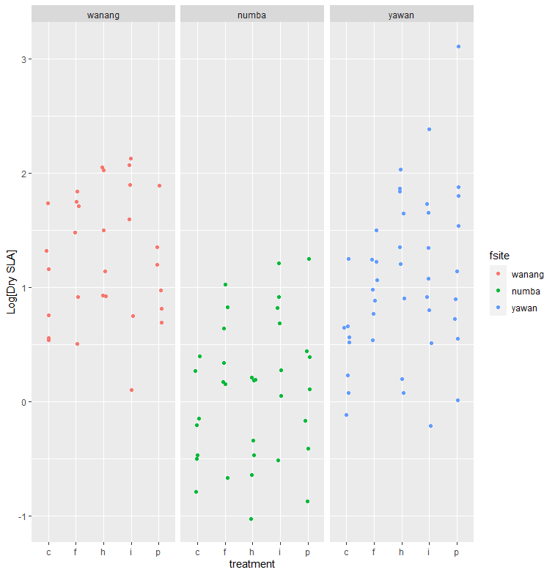
Figure S.CWM. Community weighted SLA for treatment and elevation.

This is for the dry SLA:
Estimate Std. Error df t value Pr(>|t|)
(Intercept) 1.01092 0.25049 73.73088 4.036 0.000132 ***
fsitenumba -1.21564 0.34137 73.73088 -3.561 0.000651 ***
fsiteyawan -0.48690 0.33025 75.71465 -1.474 0.144532
treatmentf 0.35628 0.30689 72.90812 1.161 0.249452
treatmenth 0.41799 0.30689 72.90812 1.362 0.177384
treatmenti 0.41390 0.30689 72.90812 1.349 0.181615
treatmentp 0.14324 0.30689 72.90812 0.467 0.642084
fsitenumba:treatmentf 0.20557 0.41822 72.90812 0.492 0.624526
fsiteyawan:treatmentf 0.07994 0.40756 73.74758 0.196 0.845045
fsitenumba:treatmenth -0.47928 0.41822 72.90812 -1.146 0.255551
fsiteyawan:treatmenth 0.29347 0.40182 73.28081 0.730 0.467497
fsitenumba:treatmenti 0.28264 0.41822 72.90812 0.676 0.501304
fsiteyawan:treatmenti 0.19781 0.40182 73.28081 0.492 0.623995
fsitenumba:treatmentp 0.16843 0.41822 72.90812 0.403 0.688335
fsiteyawan:treatmentp 0.62745 0.40182 73.28081 1.562 0.122710

And separated

log(cwm)
Predictors Estimates CI p
(Intercept) 1.01 0.53 – 1.49 <0.001
treatment [f] 0.36 -0.31 – 1.03 0.282
treatment [h] 0.42 -0.25 – 1.09 0.209
treatment [i] 0.41 -0.26 – 1.08 0.213
treatment [p] 0.14 -0.53 – 0.81 0.662
Random Effects
σ2 0.31
τ00 garden 0.01
ICC 0.04
N garden 6
Observations 30
Marginal R2 / Conditional R2 0.080 / 0.121

log(cwm)
Predictors Estimates CI p
(Intercept) -0.20 -0.63 – 0.22 0.337
treatment [f] 0.56 -0.04 – 1.17 0.068
treatment [h] -0.06 -0.67 – 0.54 0.838
treatment [i] 0.70 0.09 – 1.30 0.026
treatment [p] 0.31 -0.29 – 0.92 0.302
Observations 35
R2 / R2 adjusted 0.253 / 0.153

log(cwm)
Predictors Estimates CI p
(Intercept) 0.52 0.03 – 1.00 0.037
treatment [f] 0.45 -0.17 – 1.08 0.149
treatment [h] 0.72 0.12 – 1.32 0.021
treatment [i] 0.62 0.02 – 1.22 0.045
treatment [p] 0.78 0.17 – 1.38 0.013
Random Effects
σ2 0.37
τ00 garden 0.09
ICC 0.19
N garden 9
Observations 43
Marginal R2 / Conditional R2 0.144 / 0.306
Table S.CWM. Results of a lmer model.

log(cwm)
Predictors | Estimates | CI | p
(Intercept) | -0.33 | -0.71 – 0.05 | 0.086
fsite [numba] | -0.70 | -1.22 – -0.19 | 0.008
fsite [yawan] | -0.66 | -1.16 – -0.16 | 0.010
treatment [f] | 0.47 | -0.02 – 0.97 | 0.062
treatment [h] | 0.46 | -0.04 – 0.95 | 0.071
treatment [i] | 0.54 | 0.04 – 1.04 | 0.034
treatment [p] | 0.27 | -0.22 – 0.77 | 0.274
fsite [numba] * treatment[f] | -0.53 | -1.20 – 0.15 | 0.126
fsite [yawan] * treatment[f] | 0.41 | -0.25 – 1.07 | 0.216
fsite [numba] * treatment[h] | -0.66 | -1.33 – 0.02 | 0.057
fsite [yawan] * treatment[h] | 0.10 | -0.55 – 0.75 | 0.767
fsite [numba] * treatment[i] | -0.44 | -1.12 – 0.23 | 0.197
fsite [yawan] * treatment[i] | 0.19 | -0.46 – 0.84 | 0.560
fsite [numba] * treatment[p] | -0.50 | -1.17 – 0.18 | 0.149
fsite [yawan] * treatment[p] | 0.83 | 0.18 – 1.48 | 0.013

Random Effects
σ2 0.19
τ00 st.gard 0.03
ICC 0.14
N st.gard 22
Observations 108
Marginal R2 / Conditional R2 0.561 / 0.622

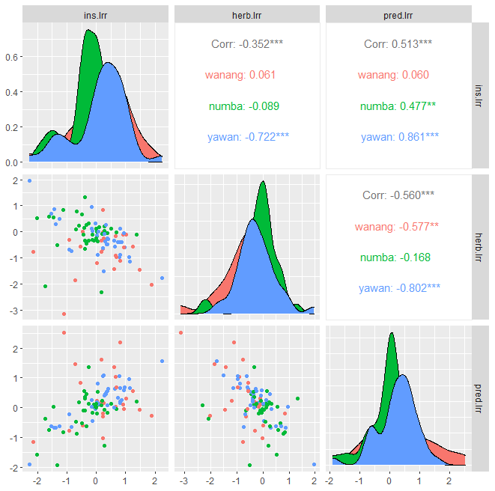
Figure ggpair corplot
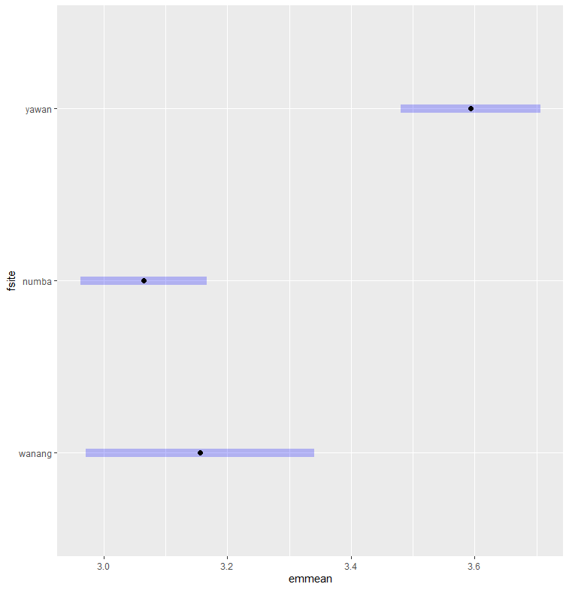
sla_hypothesis.R line 441. Average SLA per plant species at locations pairwise comparisons. Variances are equal.

