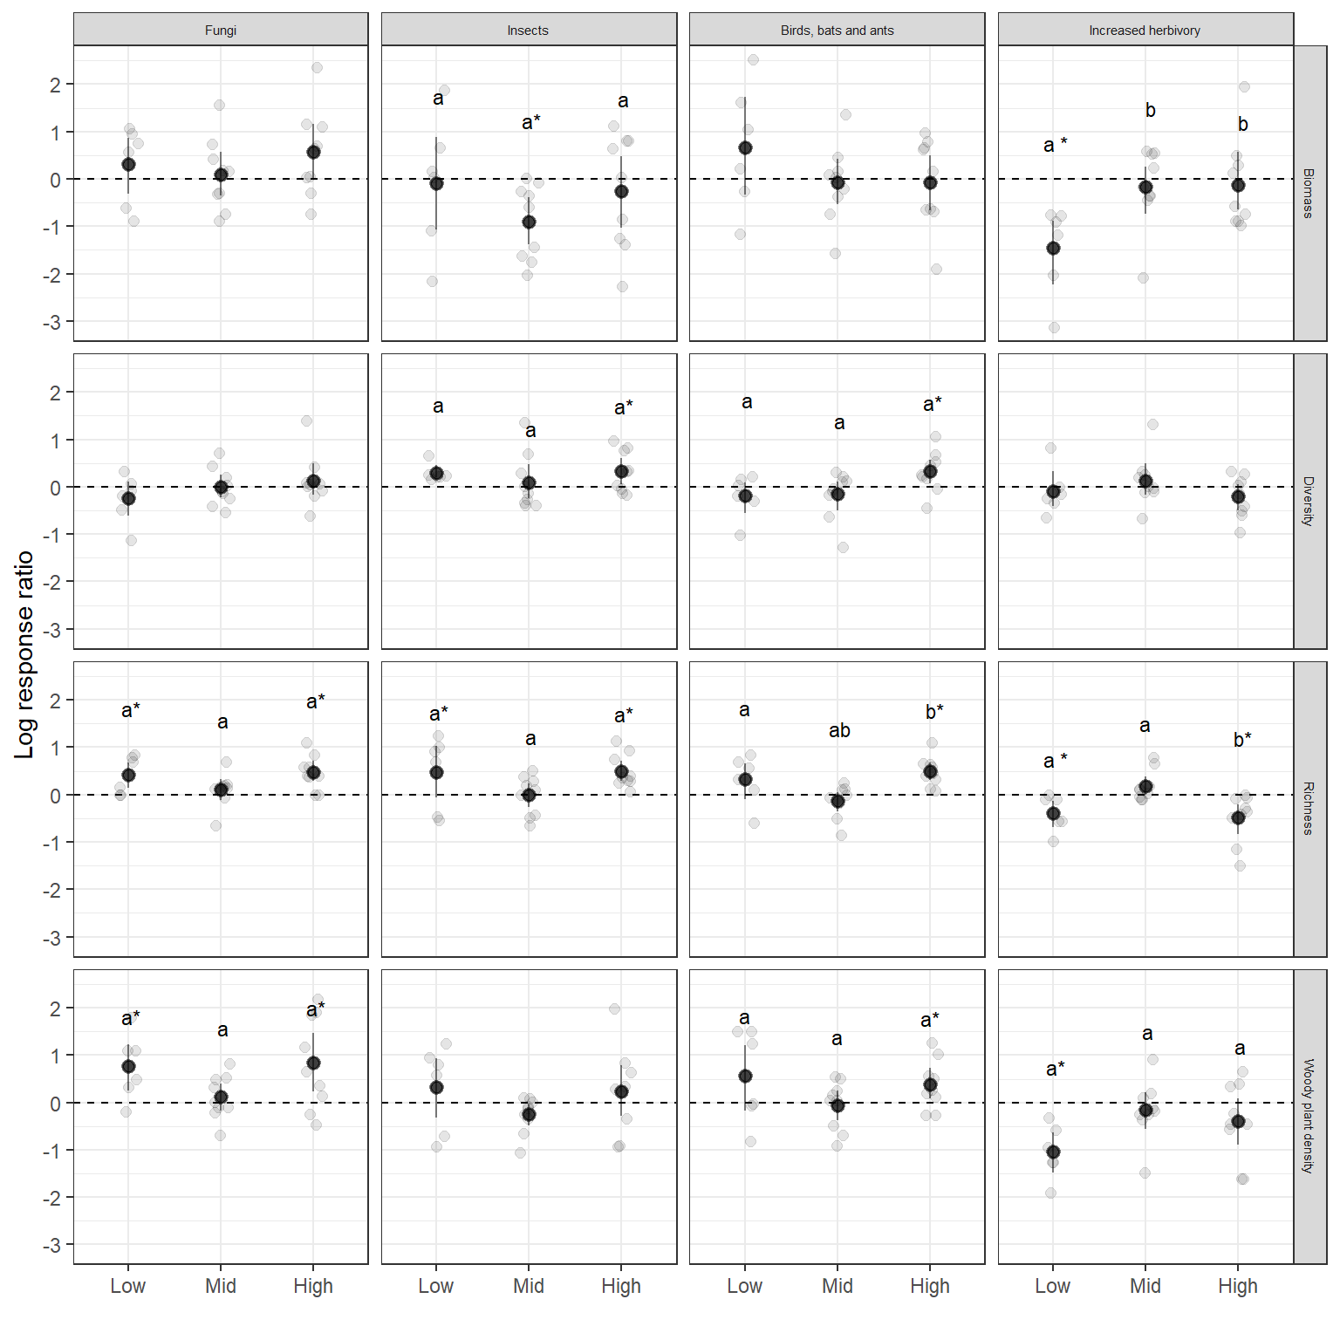
Figure 1. Estimated log-response ratios with 95% CI for four studied experimental treatments and three sites for four plant community characteristics. Dashed horizontal line denotes zero effect. Point indicate empirical value. Letters indicate significant differences in means evaluated with Tukey post-hoc test between elevations, and star indicates its significant difference from zero.
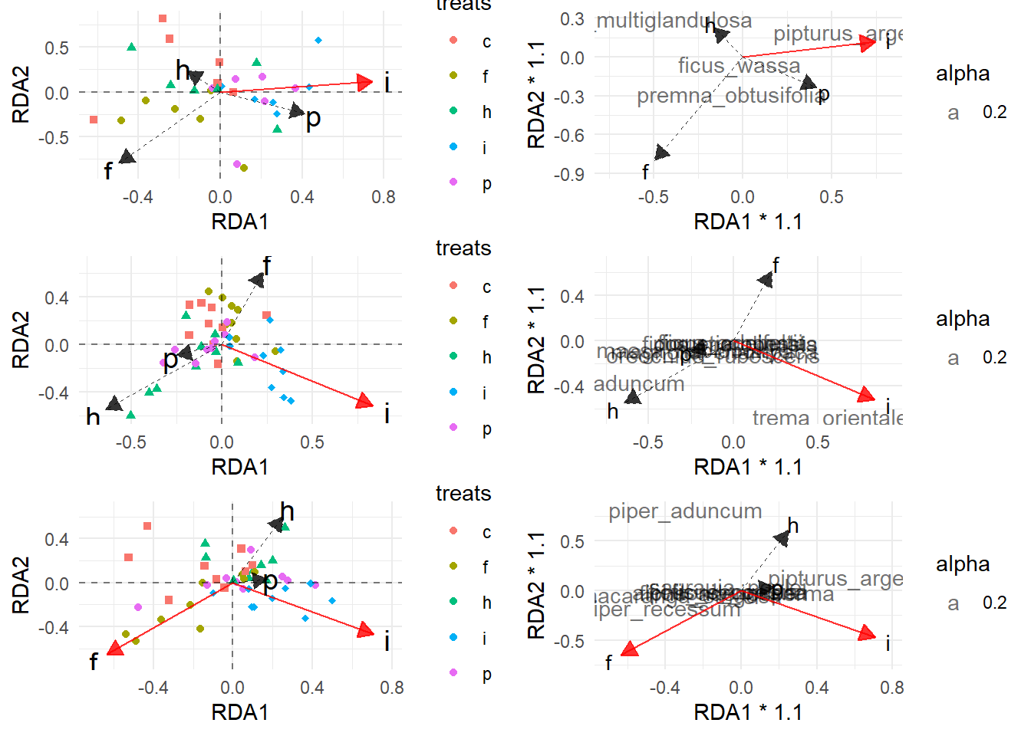
Figure 2. [Needs makeover] Results of pRDA for three studied elevations (top to bottom) with...

Figure 3. Bray-Curtis dissimilarity, and two components representing species turnover (balanced component) and changes in dominance structure (gradient component) for experimental treatments at three altitudes. Red color indicates statistical significance between control (dark gray) and a given treatment at the significance level α = 0.05.
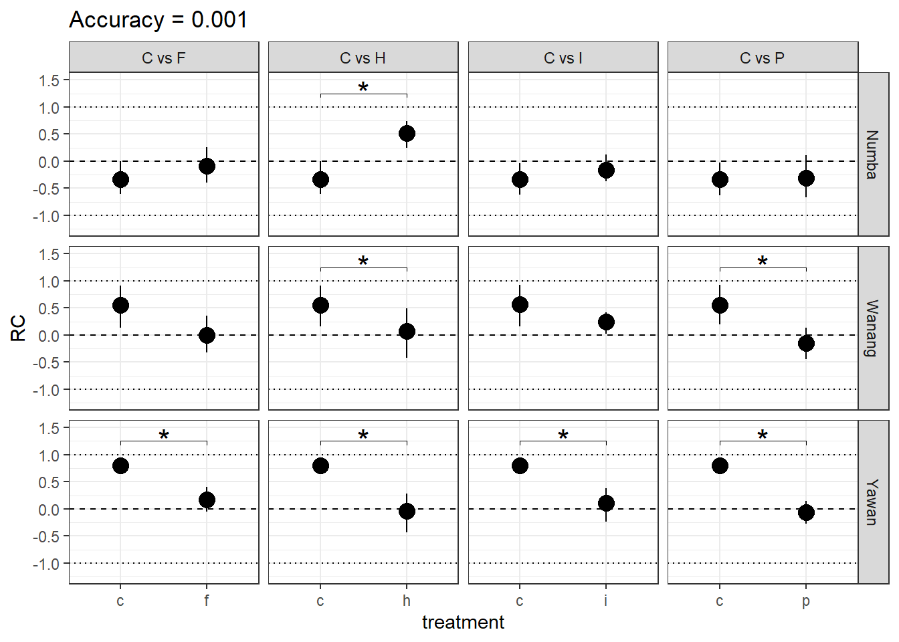
Fugure 4. Pairwise comparisons of the Raup-Crick index for control and treatment plant communities for four treatments at three sites with distinct elevation from lowest to highest (top to bottom). RC index summarizes the results of a replicated randomized assembly and indicates whether community is more random (RC ≈ 1), random (RC ≈ 0) or less random (RC ≈ -1) than expected by chance. Braces with stars indicate statistically significant differences of RC means.
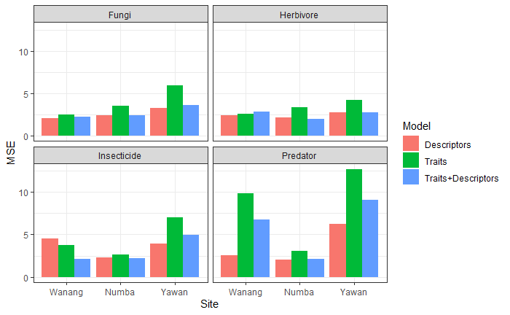
Figure 5. Mean Squared Errors for three types of models at three studied elevations. The models are: model with only traits (green); with only number of species and log-abundance evaluated at the control plots, log-change of Specific Leaf Area, and log-change of Water Content for individual species within experimental block (red), and combining the two (blue).
Figure 6. [Water content needs to be converted to fractions! Now it is simply the difference between wet and dry leaf mass!] Biomass change predicted by PGLS models from trait values of individual species in response to experimental treatments at low (red), mid (green) and high (blue) elevation sites.
Table 1. Results of the PGLS model that predicts biomass change (logarithm of the difference between the treatment and the control biomass) of a species in response to a treatment. Only the trait values were subjected to variable selection.
 | PREDATOR |  | INSECTICIDE |  | EXTRA HERBIVORY |  | FUNGICIDE
Predictors | Estimates | P-Value | Estimates | P-Value | Estimates | P-Value | Estimates | P-Value
Intercept | 119.71 | 0.004 | 100.58 | 0.014 | 0.24 | 0.731 | -1.53 | 0.089
Numba | -122.86 | 0.004 | -91.23 | 0.028 | 2.88 | <0.001 | -3.31 | 0.001
Yawan | -89.03 | 0.044 | -95.21 | 0.026 | 1.99 | 0.021 | -1.78 | 0.085
Log[SLA]-linear | -74.22 | 0.003 | -61.52 | 0.016
Log[SLA]-quadratic | 11.33 | 0.003 | 9.23 | 0.019
Water content - linear | -0.86 | 0.050
Water content - quadratic | 0.06 | 0.013
Species richness | 0.04 | 0.051 | -0.01 | 0.709 | -0.04 | 0.003 | 0.07 | <0.001
Abundance | 0.61 | 0.002 | 0.74 | <0.001 | -0.54 | 0.001 | 0.37 | 0.099
Plasticity in SLA | -1.21 | <0.001 | -0.47 | 0.097 | -1.66 | <0.001 | -0.55 | 0.021
Plasticity in WTR.C | 1.05 | <0.001 | 0.97 | <0.001 | 1.20 | <0.001 | 1.04 | <0.001
Log[SLA]-linear : Numba | 73.38 | 0.004 | 53.83 | 0.037
Log[SLA]-linear : Yawan | 58.62 | 0.027 | 59.99 | 0.024
Log[SLA]-quadratic : Numba | -11.15 | 0.004 | -7.83 | 0.049
Log[SLA]-quadratic : Yawan | -9.51 | 0.017 | -9.20 | 0.023
Water content-linear : Numba | 1.12 | 0.013
Water content-linear : Yawan | 0.56 | 0.234
Water content-quadratic : Numba | -0.08 | 0.002
Water content-quadratic : Yawan | -0.04 | 0.076
Observations | 148 |  | 145 |  | 180 |  | 128
R2 | 0.067 |  | 0.24 |  | 0.160 |  | 0.348

