Title: Positive effects of pathogenic fungi, herbivores, and predators on pioneer sucessional vegetation of tropical forests change with elevation.

Supplementary Information. Appendix I.

Piotr Szefer, Austin Sau, Kenneth Molem, Jonah Philip, Martin Volf, and Vojtech Novotny

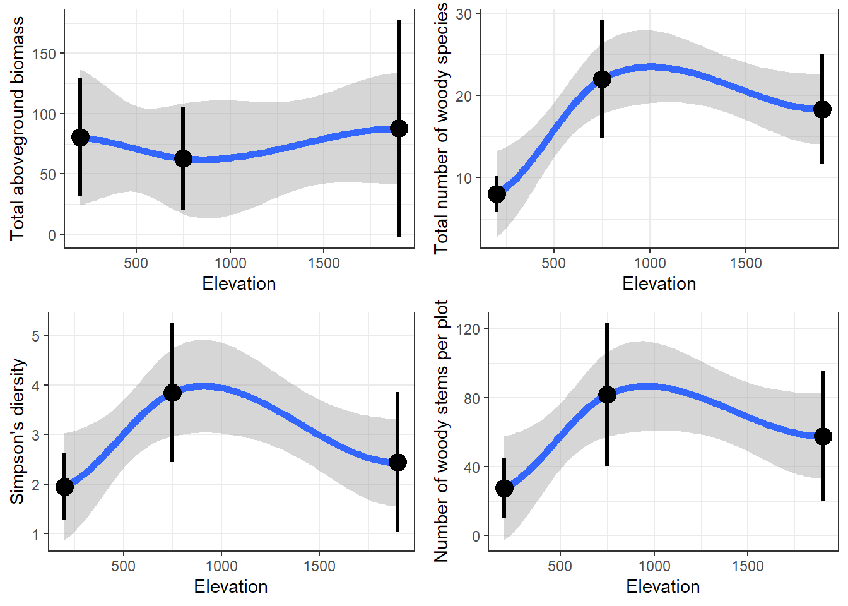
Figure S1. Characteristics along elevation with smoothed curve showing estimated peaks.
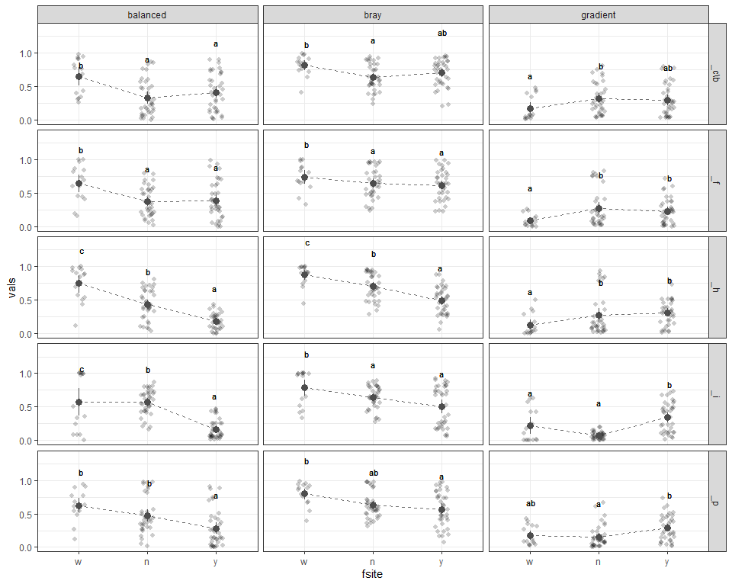

Figure S2. Pairwise, within treatment Bray-Curtis dissimilarities for control plot and four treatments at three studied sites at three distinct altitudes.
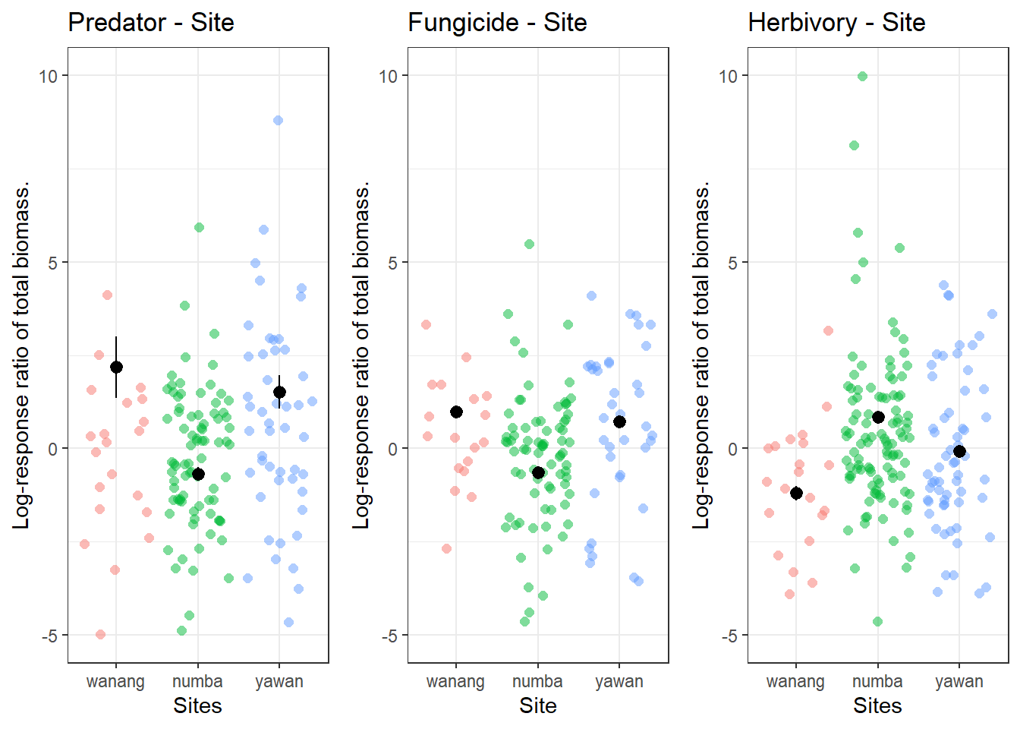
Figure SX.
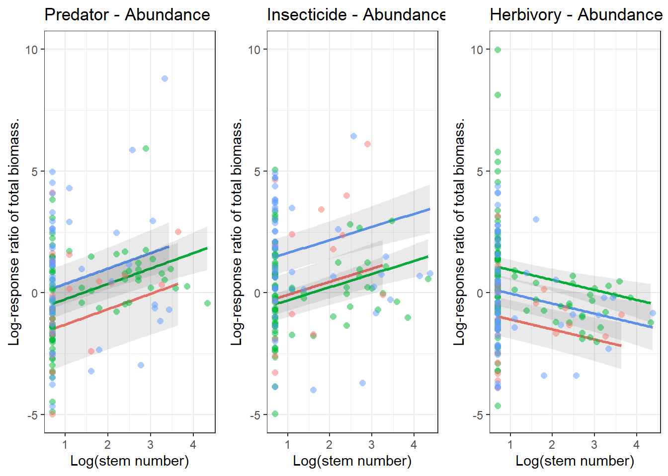
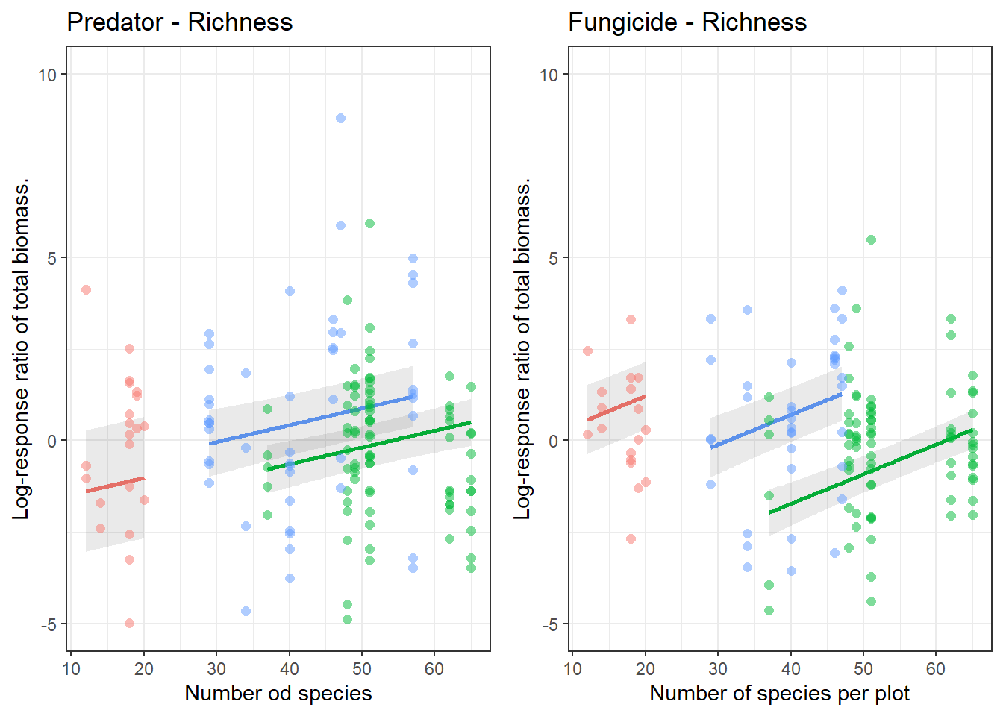
Figure SX

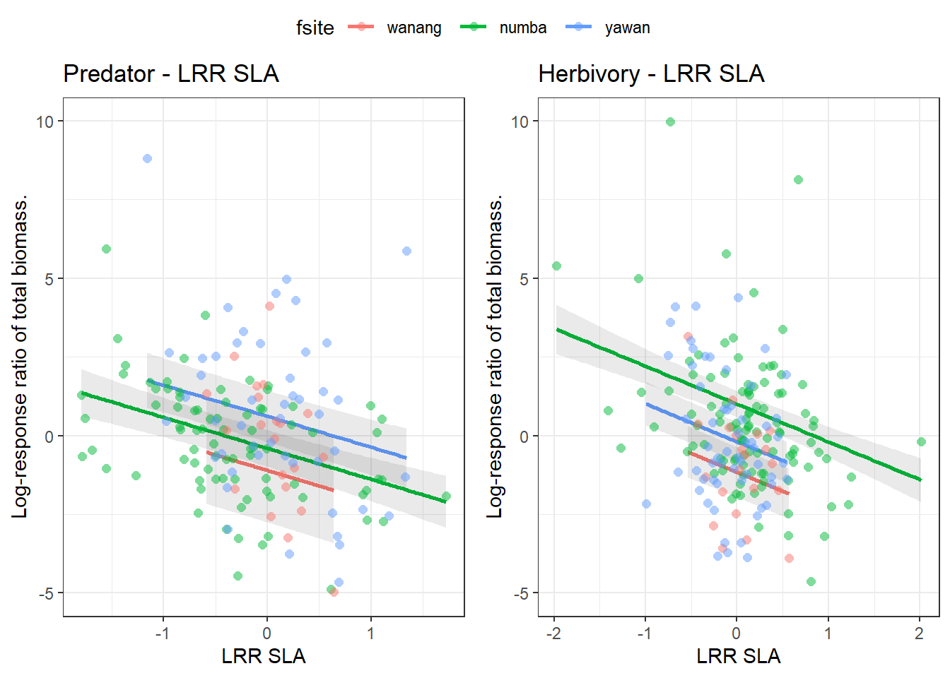
Figure SX
Figure S3.
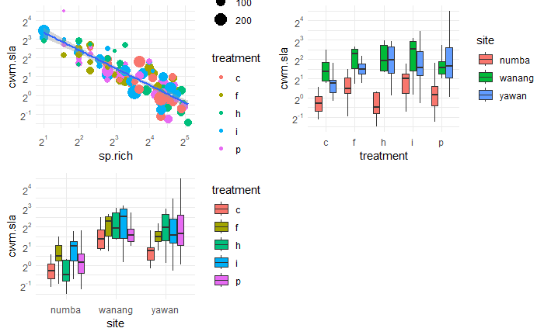Figure 1: Relationship between species richness and community weighted sla mean, that predicts also differences between sites and treatments better than the site or treatment id.
Table S1. Individual plot characteristics kg, species number min-max mean, totals

Table S2. Test results for over-dispersion all descriptors at three studied elevations. Why some have homogenous ANOVA while others non-homogenous ANOVA? If there was no evidence for nonhomgeneity of variances the non-homogenous ANOVA was used to evaluate whether there at least one pairwise contrast was different from zero (the difference in means of the effects was significant)

testType | statName | testStat | pVal | treatmentCode | caselabel
Levene Test | F-value | 0.12 | 0.89 | f | biomass
Bartlett Test | Bartlett’s K-squared | 0.28 | 0.87 | f | biomass
homogenous anova | F-value | 1.63 | 0.21 | f | biomass
Levene Test | F-value | 0.66 | 0.53 | i | biomass
Bartlett Test | Bartlett’s K-squared | 1.99 | 0.37 | i | biomass
homogenous anova | F-value | 2.08 | 0.13 | i | biomass
Levene Test | F-value | 1.36 | 0.28 | p | biomass
Bartlett Test | Bartlett’s K-squared | 1.55 | 0.46 | p | biomass
homogenous anova | F-value | 0.91 | 0.46 | p | biomass
Levene Test | F-value | 0.09 | 0.92 | h | biomass
Bartlett Test | Bartlett’s K-squared | 0.18 | 0.92 | h | biomass
homogenous anova | F-value | 5.33 | 0.01 | h | biomass
Levene Test | F-value | 0.04 | 0.96 | f | diversity
Bartlett Test | Bartlett’s K-squared | 0.73 | 0.69 | f | diversity
homogenous anova | F-value | 0.72 | 0.55 | f | diversity
Levene Test | F-value | 1.90 | 0.17 | i | diversity
Bartlett Test | Bartlett’s K-squared | 5.89 | 0.05 | i | diversity
homogenous anova | F-value | 2.43 | 0.09 | i | diversity
Levene Test | F-value | 0.00 | 1.00 | p | diversity
Bartlett Test | Bartlett’s K-squared | 0.16 | 0.92 | p | diversity
homogenous anova | F-value | 2.15 | 0.12 | p | diversity
Levene Test | F-value | 0.02 | 0.98 | h | diversity
Bartlett Test | Bartlett’s K-squared | 0.31 | 0.86 | h | diversity
homogenous anova | F-value | 0.81 | 0.50 | h | diversity
Levene Test | F-value | 0.95 | 0.40 | f | richness
Bartlett Test | Bartlett’s K-squared | 0.13 | 0.94 | f | richness
homogenous anova | F-value | 7.93 | 0.00 | f | richness
Levene Test | F-value | 1.52 | 0.24 | i | richness
Bartlett Test | Bartlett’s K-squared | 4.38 | 0.11 | i | richness
homogenous anova | F-value | 4.65 | 0.01 | i | richness
Levene Test | F-value | 0.74 | 0.49 | p | richness
Bartlett Test | Bartlett’s K-squared | 1.83 | 0.40 | p | richness
homogenous anova | F-value | 6.72 | 0.00 | p | richness
Levene Test | F-value | 0.47 | 0.63 | h | richness
Bartlett Test | Bartlett’s K-squared | 1.63 | 0.44 | h | richness
homogenous anova | F-value | 6.19 | 0.00 | h | richness
Levene Test | F-value | 2.96 | 0.07 | f | density
Bartlett Test | Bartlett’s K-squared | 3.98 | 0.14 | f | density
homogenous anova | F-value | 5.87 | 0.00 | f | density
Levene Test | F-value | 1.51 | 0.24 | i | density
Bartlett Test | Bartlett’s K-squared | 5.68 | 0.06 | i | density
homogenous anova | F-value | 1.01 | 0.41 | i | density
Levene Test | F-value | 4.66 | 0.02 | p | density
Bartlett Test | Bartlett’s K-squared | 3.50 | 0.17 | p | density
non-homogenous anova | F-value | 2.26 | 0.11 | p | density
Levene Test | F-value | 0.55 | 0.59 | h | density
Bartlett Test | Bartlett’s K-squared | 0.91 | 0.63 | h | density
homogenous anova | F-value | 5.67 | 0.01 | h | density

Table S3. Two models testing difference of LRR of predator exclosures from zero at each elevation. General Least Squares assumes over-dispersion in the data
Estimate | Standard.Error | T.value | P.value | Site | Model
0.56 | 0.27 | 2.06 | 0.05 | Wanang | LM
-0.06 | 0.22 | -0.27 | 0.79 | Numba | LM
0.38 | 0.22 | 1.71 | 0.10 | Yawan | LM
0.56 | 0.40 | 1.38 | 0.18 | Wanang | GLS
-0.06 | 0.17 | -0.34 | 0.74 | Numba | GLS
0.38 | 0.17 | 2.18 | 0.04 | Yawan | GLS

Table S4: Results of RDA

Table S5. Traits along treatment vectors.
wanang f
 | Dependent variable
Predictors | Estimates | CI | p
(Intercept) | 0.84 | -0.08 – 1.76 | 0.073
sla | -0.13 | -0.29 – 0.03 | 0.107
water | -0.00 | -0.01 – 0.01 | 0.786
herb | -1.00 | -8.96 – 6.97 | 0.800
Observations | 32
numba f
 | Dependent variable
Predictors | Estimates | CI | p
(Intercept) | 0.16 | -0.03 – 0.36 | 0.100
sla | -0.03 | -0.07 – 0.00 | 0.065
water | 0.02 | 0.02 – 0.03 | <0.001
herb | -0.22 | -0.75 – 0.30 | 0.399
Observations | 87
yawan f
 | Dependent variable
Predictors | Estimates | CI | p
(Intercept) | 0.31 | -0.23 – 0.85 | 0.255
sla | -0.05 | -0.15 – 0.04 | 0.240
water | 0.01 | 0.00 – 0.02 | 0.002
herb | 0.33 | -0.65 – 1.31 | 0.499
Observations | 44
wanang i
 | Dependent variable
Predictors | Estimates | CI | p
(Intercept) | 0.24 | -0.79 – 1.27 | 0.635
sla | -0.03 | -0.21 – 0.15 | 0.751
water | 0.00 | -0.01 – 0.01 | 0.881
herb | -2.20 | -11.13 – 6.73 | 0.618
Observations | 32
numba i
 | Dependent variable
Predictors | Estimates | CI | p
(Intercept) | 0.15 | -0.09 – 0.39 | 0.221
sla | -0.03 | -0.07 – 0.01 | 0.151
water | 0.02 | 0.01 – 0.03 | <0.001
herb | 0.05 | -0.60 – 0.69 | 0.884
Observations | 87
yawan i
 | Dependent variable
Predictors | Estimates | CI | p
(Intercept) | -0.02 | -0.53 – 0.49 | 0.941
sla | 0.00 | -0.08 – 0.09 | 0.931
water | 0.01 | 0.01 – 0.02 | <0.001
herb | 0.04 | -0.89 – 0.97 | 0.938
Observations | 44

