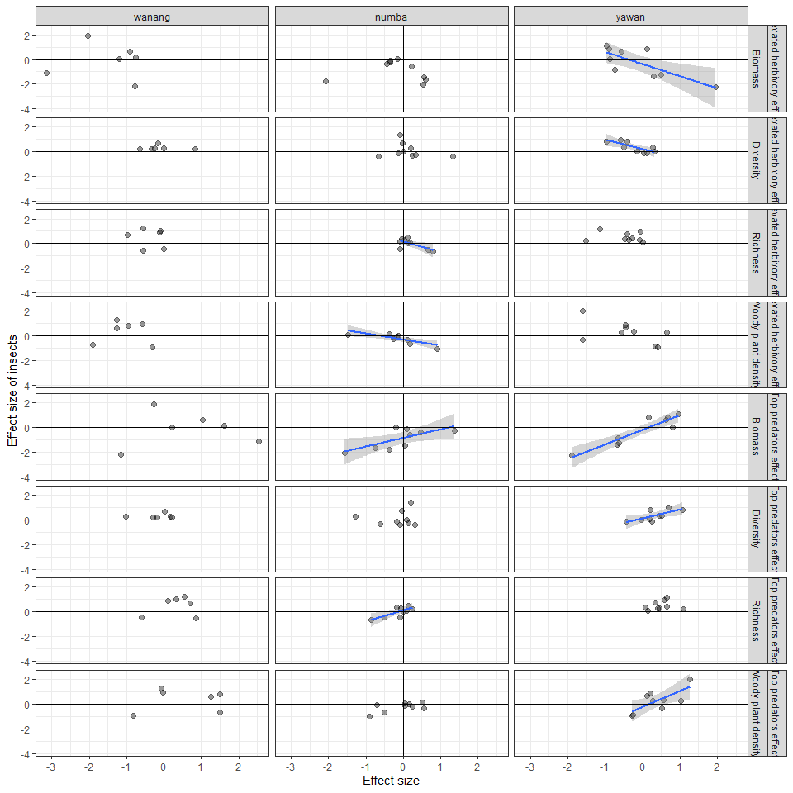
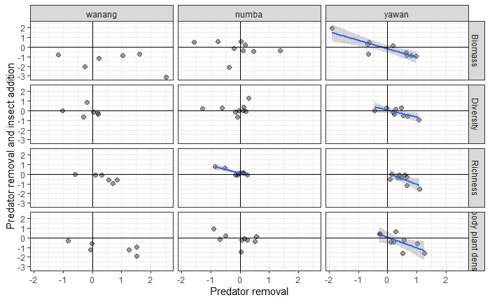

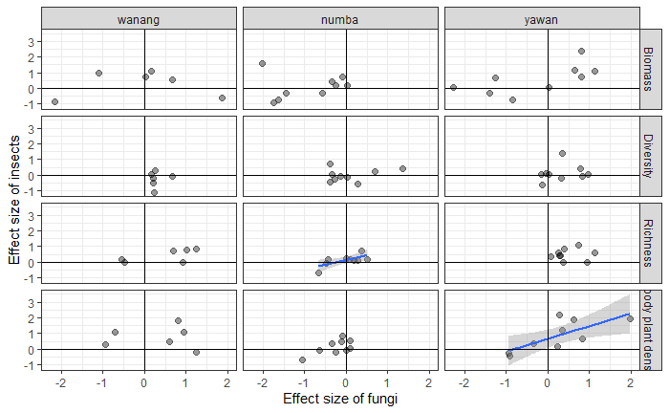

Table 1. Test results for over-dispersion all descriptors at three studied elevations.
testType | statName | testStat | pVal | treatmentCode | caselabel
Levene Test | F-value | 0.12 | 0.89 | f | biomass
Bartlett Test | Bartlett’s K-squared | 0.28 | 0.87 | f | biomass
homogenous anova | F-value | 1.63 | 0.21 | f | biomass
Levene Test | F-value | 0.66 | 0.53 | i | biomass
Bartlett Test | Bartlett’s K-squared | 1.99 | 0.37 | i | biomass
homogenous anova | F-value | 2.08 | 0.13 | i | biomass
Levene Test | F-value | 1.36 | 0.28 | p | biomass
Bartlett Test | Bartlett’s K-squared | 1.55 | 0.46 | p | biomass
homogenous anova | F-value | 0.91 | 0.46 | p | biomass
Levene Test | F-value | 0.09 | 0.92 | h | biomass
Bartlett Test | Bartlett’s K-squared | 0.18 | 0.92 | h | biomass
homogenous anova | F-value | 5.33 | 0.01 | h | biomass
Levene Test | F-value | 0.04 | 0.96 | f | diversity
Bartlett Test | Bartlett’s K-squared | 0.73 | 0.69 | f | diversity
homogenous anova | F-value | 0.72 | 0.55 | f | diversity
Levene Test | F-value | 1.90 | 0.17 | i | diversity
Bartlett Test | Bartlett’s K-squared | 5.89 | 0.05 | i | diversity
homogenous anova | F-value | 2.43 | 0.09 | i | diversity
Levene Test | F-value | 0.00 | 1.00 | p | diversity
Bartlett Test | Bartlett’s K-squared | 0.16 | 0.92 | p | diversity
homogenous anova | F-value | 2.15 | 0.12 | p | diversity
Levene Test | F-value | 0.02 | 0.98 | h | diversity
Bartlett Test | Bartlett’s K-squared | 0.31 | 0.86 | h | diversity
homogenous anova | F-value | 0.81 | 0.50 | h | diversity
Levene Test | F-value | 0.95 | 0.40 | f | richness
Bartlett Test | Bartlett’s K-squared | 0.13 | 0.94 | f | richness
homogenous anova | F-value | 7.93 | 0.00 | f | richness
Levene Test | F-value | 1.52 | 0.24 | i | richness
Bartlett Test | Bartlett’s K-squared | 4.38 | 0.11 | i | richness
homogenous anova | F-value | 4.65 | 0.01 | i | richness
Levene Test | F-value | 0.74 | 0.49 | p | richness
Bartlett Test | Bartlett’s K-squared | 1.83 | 0.40 | p | richness
homogenous anova | F-value | 6.72 | 0.00 | p | richness
Levene Test | F-value | 0.47 | 0.63 | h | richness
Bartlett Test | Bartlett’s K-squared | 1.63 | 0.44 | h | richness
homogenous anova | F-value | 6.19 | 0.00 | h | richness
Levene Test | F-value | 2.96 | 0.07 | f | density
Bartlett Test | Bartlett’s K-squared | 3.98 | 0.14 | f | density
homogenous anova | F-value | 5.87 | 0.00 | f | density
Levene Test | F-value | 1.51 | 0.24 | i | density
Bartlett Test | Bartlett’s K-squared | 5.68 | 0.06 | i | density
homogenous anova | F-value | 1.01 | 0.41 | i | density
Levene Test | F-value | 4.66 | 0.02 | p | density
Bartlett Test | Bartlett’s K-squared | 3.50 | 0.17 | p | density
non-homogenous anova | F-value | 2.26 | 0.11 | p | density
Levene Test | F-value | 0.55 | 0.59 | h | density
Bartlett Test | Bartlett’s K-squared | 0.91 | 0.63 | h | density
homogenous anova | F-value | 5.67 | 0.01 | h | density

Table S2. Two models testing difference of LRR of predator exclosures from zero at each elevation. General Least Squares assumes over-dispersion in the data
Estimate | Standard.Error | T.value | P.value | Site | Model
0.56 | 0.27 | 2.06 | 0.05 | Wanang | LM
-0.06 | 0.22 | -0.27 | 0.79 | Numba | LM
0.38 | 0.22 | 1.71 | 0.10 | Yawan | LM
0.56 | 0.40 | 1.38 | 0.18 | Wanang | GLS
-0.06 | 0.17 | -0.34 | 0.74 | Numba | GLS
0.38 | 0.17 | 2.18 | 0.04 | Yawan | GLS

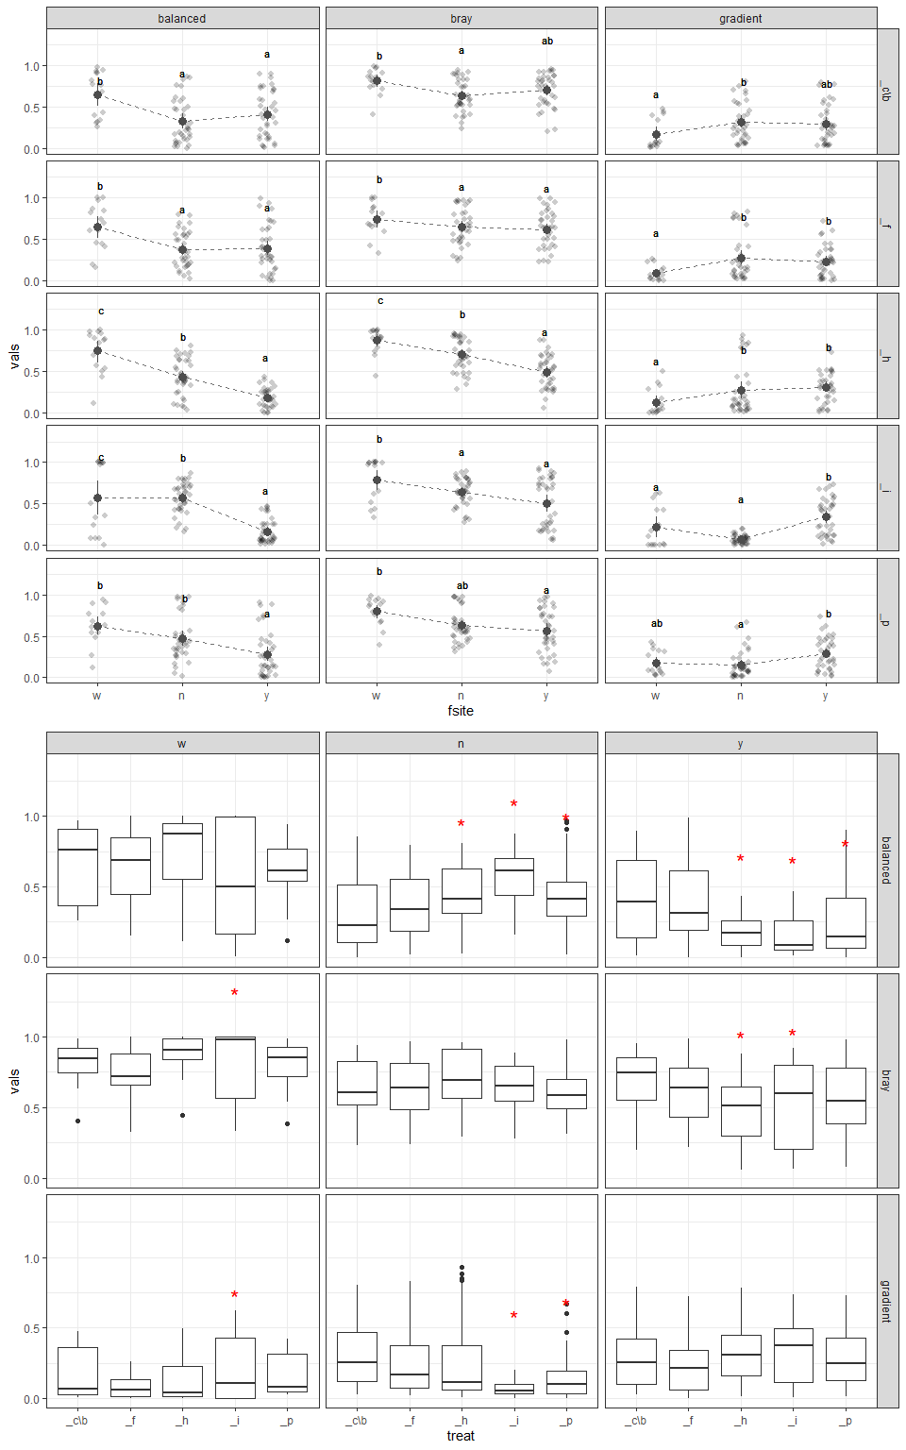
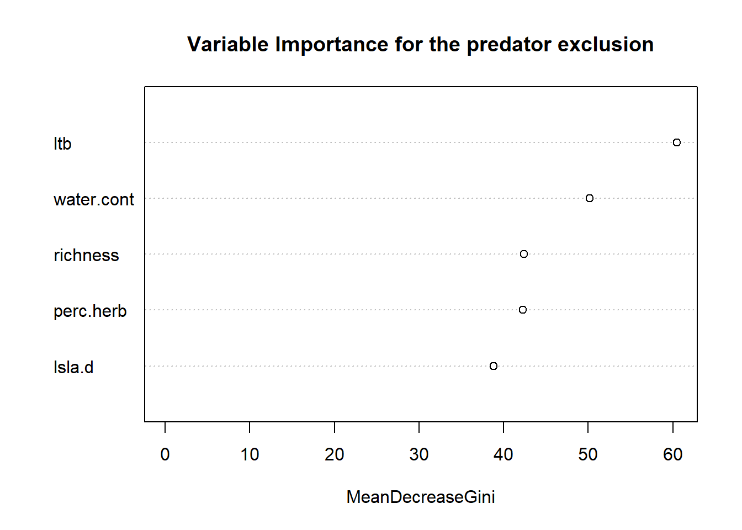
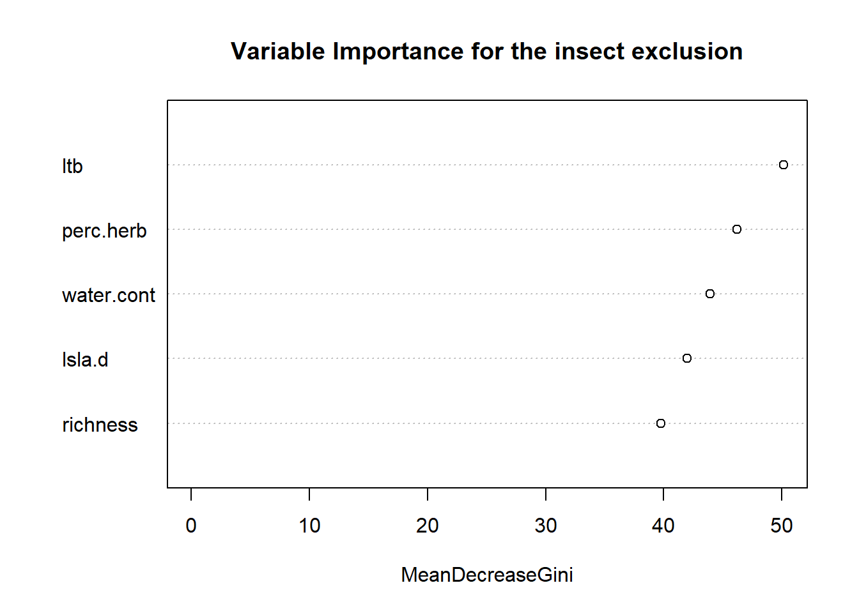

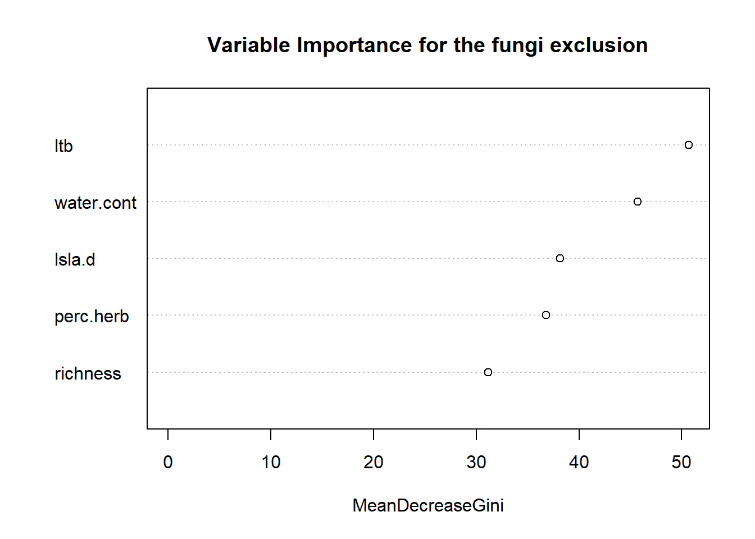
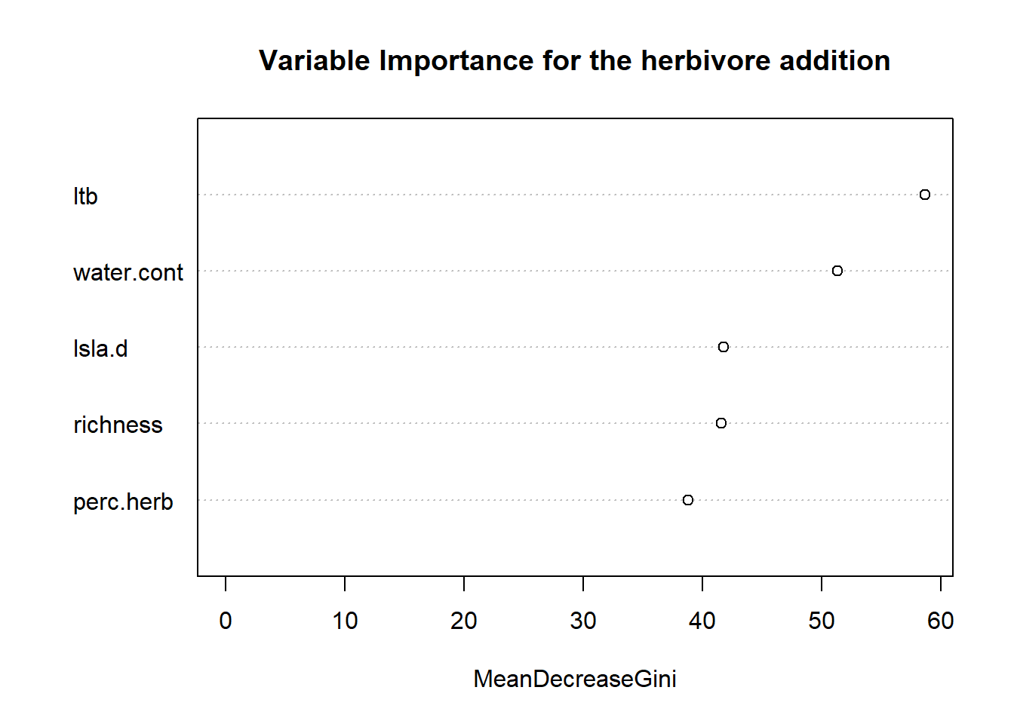

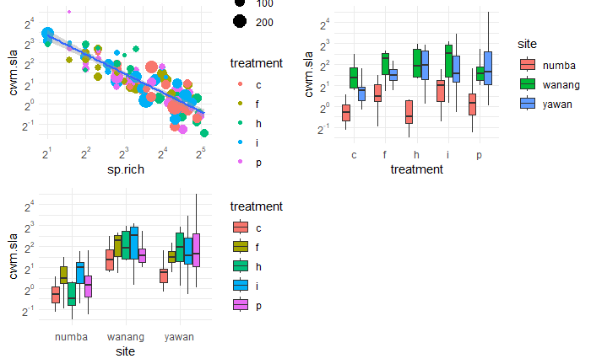Figure 1: Relationship between species richness and community weighted sla mean, that predicts also differences between sites and treatments better than the site or treatment id.

log(cwm.sla)
Predictors Estimates CI p
(Intercept) 2.97 2.72 – 3.23 <0.001
sp rich [log] -0.94 -1.04 – -0.83 <0.001
Observations 108
R2 / R2 adjusted 0.749 / 0.747

