**Running head:** Biotic factors and succession along tropical elevation gradient

**Title: The effects of pathogenic fungi, herbivores, and predators on pioneer vegetation of tropical forests change with elevation.**

Piotr Szefer, Austin Sau, Kenneth Molem, Jonah Philip, Martin Volf, and Vojtech Novotny

**Abstract**:

In the tropics pathogenic fungi, herbivores and their predators have a significant impact on plant community assembly processes. These plant-enemy interactions can be notably influenced by environmental gradients. In the context of regenerating tropical forest, this phenomenon can potentially affect the trajectory of succession at different elevations, and cause variation inflation in succession outcomes. Moreover, the relative significance of individual biotic factors can vary depending on elevation and may be differentially influenced by key plant traits. In this paper we present the results of a manipulative experiment replicated at three elevations to study the effect of focal predators (birds, bats, and ants), herbivorous insets and pathogenic fungi on plant communities on vegetation at the pioneer stage of tropical forest regeneration.

Fungi increased richness and density at low and high elevations. Insects reduced biomass at mid-elevation, increased diversity at high and richness at high and low elevations. Surprisingly predators were having a similar effects to those of insects except for the biomass, had no effect on richness at the low elevation but increase density at the high elevation. Increased herbivory had the expected, negative effect on biomass and density at the low elevation, reduced richness at the low and high elevation. Insects affected community composition by reducing the dominance of a few early succession woody plant species. Fungi influence composition and increase density of woody plants only at the highest elevation. At the low elevation insects increase dissimilarity by decreasing abundance differences between sites. Presence of insects, and presence of predators reduce the species turnover at the mid elevation and increase its rate at the high elevation. Assembly proces was deterministically divergent in Wanang and Yawan, but random Numba. Herbivore addition significantly changed the assembly process at all elevations shifting it to random in Wanang and Yawan and to deteministically divergent in Numba. In Yawan all treatments had the same effect, and predator treatment caused assembly to be more random. At the community level the site richness explained the CWM for SLA and water content. A**t the individual level trait had limited abilityto improve the model. W**hen abundance, species richness, location, species’ ability to change their SLA value, and phylogeny SLA significantly improved model for predator exclusion only. Water content of leaves was significantly in all models and significant for fungicide treatment. Percent herbivory improved models for predator and insecticide treatments.

The effect, that a treatment has on the community, depends on the specific biotic factor studied, as well as on the elevation. Effects on richness at the establishment level are visible for insects and fungi (?), but it seems that the further dynamics and community dominance structure (trait and species) are mostly determined by the bottom up factors, like potnential site richness and productivity. Despite some some predictable effects of fungi, insects and their predators, early stages of tropical forest succession remain divergent in their trajectories. Thus their end products remain difficult to predict, and we show that effect of natural enemies of plants is complex and context dependent, and forces us to perform focused and more controlled experiments.

**Key words**: tropical forest, pioneer succession, fungicide, insecticide herbivory, tri-trophic interactions, Papua New Guinea.

**Introduction**

**The pioneer stages of succession play a crucial role in determining pace, progression, and endpoint of succession**. Plants that are able to establish at initial stages of regeneration, will most likely determine the future trajectory of succession. General predictions based on recruitment, mortality … (FORMIX2) work well for biomass and density of a regenerating forests (Bossel and Krieger 1994), but the function of the ecosystem depends also on richness, diversity and functional trait composition, that may accumulate at different rates (Chazdon et al. 2010). For example, biomass canopy cover and leaf area index increase faster in high, than in low species rich replants (Veryard et al. 2023).

Multiple studies from tropical forests have demonstrated the importance of fungi and herbivorous insects as mortality factors (Gripenberg et al. 2014, Bagchi et al. 2014, … MORE). The magnitude and directions of their effect, however, depends on many factors: the type of interactions considered; whether it is above or below-ground interaction (); vertebrate or invertebrate top predator (Godschalx et al. 2019); or a possibility of compensation by another coexisting factor (Krishnadas et al. 2020, Williams et al. 2021). With changing ecological and landscape conditions, their importance may change as well. For example, the density-dependent effect of both pathogenic fungi and herbivorous insects on seedling survival in tropical rainforest decrease with increasing distance from the forest interior (Krishnadas et al. 2018). Trophic cascades are also sensitive to changes in ecological gradients [how?] (Kergunteuil et al. 2019).

Birds, bats and ants are considered to be the key predatory groups that control insects in tropical forest (ref). However, their effect along elevation may vary, and predation rates in the tropics are predicted to be weak at higher elevations (Roslin et al. 2017). Studies confirm an elevation-dependent strength of cascading effects of insectivorous birds on vegetation (Sam etc.). Similarly, the diversity and abundance of predatory ants, decreases and is nearly absent above 1500 m a.s.l. (ref).With reduced pressure from vertebrate predators, the top-down control may have a stron effect also on pioneer vegetation, and this effect can be weaker at the high elevations. However, at least in regenerating lowland tropical forest gaps bottom-up effects may dominate (Szefer et al. 2022). This may indicate that community assembly mechanisms in pioneering vegatation differ from those of primary forests. This may be due to the more acqusitive traits, shade intolerance, fast growth and resource management strategies of early successional plants that reduces the strength of density-dependence of fungi (Kobe and Vriesendorp 2011) and potentially increases that of insects (ref - some other paper more acquisitve the traits the more insects?).

For a pioneer woody plant, a success is to achieve canopy development despite competition from grasses and herbaceous plants (Charles 2020). Successful species should be able to have good gap colonization capabilities and strong competitive ability (Pywell et al. 2003). Wood density and proximity to the intact forest predicted survival of canopy trees (Charles et al. 2018), but it may be different for pioneer successional trees. Pioneer plants in tropical forests posses more acquisitive traits, such as high photosynthetic activity, rapid growth rate, high specific leaf area (SLA), low wood and tissue density, and low herbivore resistance. Although these traits make them more vulnerable to enemies, increase mortality rate, they also allow to cope with herbivory through compensation for leaf damage (Whitfeld et al. 2012, Chazdon 2014).

Traits are proven to be an effective in the restoration of specific targets defined by trait composition (Laughlin 2014) and have the potential to predict long-term survival and growth rates (Werden et al. 2018). What is notable is that species' long-term growth and survival rates in a regenerating community can be accurately predicted based on their traits and short-term dynamics **(Mart**ínez-Garza et al. 2013)**.** However, it is important not to overlook the influence of biotic interactions, which can affect trait expression in plants (Radny and Meyer 2018, Koprivnikar et al. 2021) and alter competitive outcomes between species (Kim et al. 2013)

**Tropical forest communities are characterized by a clear shift in trait values, with slower growing, better defended, and resource conservative plants at higher elevations** (Rasmann et al. 2014). This coupled with decreasing abundances at the consumer levels (herbivores and their predators) at higher elevations **may reduce insect effects and increase mortality caused by pathogenic fungi ().** Succession at higher elevation may, therefore, be more strongly affected by recruitment limitation and functional traits, particularly growth rate of individual plant species. Growth rates are well approximated by SLA (Osone et al. 2008, Kleinschmidt et al. 2020). If plants get tougher and better defended because of their natural enemies at higher elevations, plant traits related to growth rate and characteristic for the acquisitive resource use strategy (high leaf SLA and water content) should be better at predicting better species’ success in the absence of natural enemies, particularly fungi. Stronger tropic cascades are predicted for vertebrate predator and invertebrate herbivore (Borer et al. 2005). This would suggest that bird predation may be relatively more important at higher elevations for plant richness and diversity. According to Community Regulation Hypothesis, compensatory dynamisc within trophic levels may limit strength of trophic cascades, and potentially also aggregated effects of pplant-enemy interactions (Holt and Polis 1997, Pace et al. 1999). Therefore, ability of SLA to predict changes in biomass of individual species should increase with decreasing pressure from the top predators, which in turn is related to increase in elevation.

**The effects of natural enemies on plant communities can vary depending on specific plant traits (Jia et al. 2020)**. High competitive strategies, related to high shade-intolerance and resource acquisition, may confer resilience against natural enemies, but plants must strike a balance between resistance and competitiveness (Radny and Meyer 2018). For instance, resource-acquisitive strategies may be disadvantageous when natural enemy densities are high and hetero-specifics densities are low (Adler et al. 2013, Lasky et al. 2014). This can hinder facilitation process and slower down the succession (Fichtner et al. 2017). The expression and variation of traits during the assembly process of tropical forests are often influenced by biotic factor filters. In pioneer stages of regenerating lowland tropical forest insect herbivores have been found to improve the predictability of species and trait community composition (higher SLA and lower LDMC when insects are present), and increase diversity without negatively effecting plant biomass (Szefer et al. 2020). Additionally birds, bats, ants and other predators put constant pressure on herbivorous insects. Predator feeding mode affects the behavior of the herbivorous pray, which in turn may result in dominance of specific plant traits (Schmitz 2017). These cascading effects are strong in mature ecosystems of primary tropical forests (Letourneau et al. 2004, Barber and Marquis 2011, Sam et al. 2015, Roslin et al. 2017, Houska-Tahadlova et al. 2023), but may also be important for early stages of succession.

**Here we present results of an experimental exclusion of fungal pathogens, insects and spiders and their predators from pioneer (0-1.5 year) stages of regenerating gaps in tropical forest at three elevations.** We hypothesize that the strength of the plant-natural-enemy interactions **increases with elevation and drive changes in regenerating plant community assembly and dynamics. Specifically we predict, that natural enemies** (i.e. fungi, insect herbivores) will **increase** richness and diversity of the vegetation consistently along the elevation as more conservative and slow growing species are present. The biotic factors’ will have different effects on the community assembly processes, i.e. are filters that increase prediction of the future community composition. With a reduced control of predators, stronger effects of herbivorous insects and fungi, as well as stronger abiotic filters at higher elevations should in turn increase the predictability of the community composition. Finally, we attempt to evaluate how biotic factors filter palnts based on their traits (leaf water content, SLA) in regenerating community, and evaluate variation in this relationship along elevation.

**Materials and methods**

*Experimental design*

Experimental treatments (fungicide MANCOZEB …, Imidacloprid + Lambda cychalothrin, Exclosures, Herbivore addition, locally dominant generalist Curc001 in Wanang and CurcXXX in Numba and Yawan, Undisturbed growth and repeated treatments. P**lant species from three tropical forest sites: Wanang (200 m a.s.l.), Numba (700 m a.s.l.), and Yawan (1900 m a.s.l.). We refer to the sites as low, mid- and high elevations throughout the text.**

*Statistical analyses*

We used log-response ratios (LRRs) to compare the effect strengths between sites. We used Bray-Curtis dissimilarities between control plot and each of the four treatments (fungicide, herbivore, insecticide and exclusion of key predators) to test our prediction that some treatments may affect community composition more strongly at higher elevations.

*SLA analysis*

We modeled natural logarithm of total biomass at a given plot predicted with logarithm of SLA [m2/kg dry leaf mass] as a linear function using a phylogenetic generalised least square (assumption, both high and low values of SLA may not be the best option for plants **[explain in the intro why it is like that]**). We tested for the best modle of the trait evolution using the function fitContinuous. And we chose based on likelihood the OU model. For which we estimated the alpha parameter, that was later used to provide correlation structure for the model.

*LRR correlations*

If fungi can compensate for herbivorous insect mortality, then reduction of one of the effects in a manipulative experiment would cause an increase of the other. This can be partially evaluated using correlation of the effect ratios. If the compensation is complete, or in a sense affects the same ‘fitness components’ [functional redundancy] of a plant community then we would expect no correlation between positive LRR effects of the two factors. Additionally, all individual treatment effects should be around zero: because removal of any given natural enemies would be immediately and completely replaced by another. But in case where there is a correlation, this would exclude this type of compensation. We assume that the effects of the following factors: all herbivorous insects, Correlation of predators and herbivore exclusion and herbivore addition.

We calculated log-response ratios (LRR) for plant biomass, species richness, species diversity and stem density to be able to compare the effect sizes at individual elevations. LRR is generally calculated as the logarithm of ratio of values for present to not-present sites. Three treatments (netting, insecticide, and fungicide spraying) were exclusion treatments and for these LRR was calculated as *log(xc/xt)*. This gives the effect of a given biotic factor. For the addition of herbivores however the formula was modified to *log(xt/xc)*.

Bertellet’s and Levene’s homogeneity tests were performed for LRR of all descriptors comparisons between sites. If at least one test showed lack of homogeneity we accounted this in statistical model by providing *varIdent(form = ~1|site)* option as weights in the *gls* function.

Community composition … and Bray-Curtis analysis, Random vs deterministic changes (Raup-Crick).

We approached species success’ depandency on traits in two ways. First we used random forest method to evaluate importance of total sppecies biomass at a given plot, the plot richness, species SLA, water content and herbivory on their presence-absence dynamics when comparing control plot with a treeatment plot. I.e., how well traits predicted wether species werer lost, gained or remained on the treatment plot compared to the control. Algorithm…, hyperparameters?

CWM for different treatments we also evaluated whether treatments affected trait community composition, by calcualting community weighted means (CWM) for SLA, water content and herbivory [**i dont think I have performed these analyses yet**].

Phylogeny …

Response variable for the SLA effect …

Especially at pioneer stages of succession diversity-delta_biomass dynamics relationships are strong. IN order to study the effect of traits diversity effects need to be taken into account (this can be richness, or diversity).

We built multiple, competitive statistical models explaining relationship between species’ traits and their abilities to change biomass in response to a treatment. Those included linear and quadratic relationships, and site interactions while accounting for phylogenetical relationships between species. We used chi-square test of the log-likelihood ratio to compare models. If two models were not significantly different from each other then we would always go with a model with lower AIC. We compared model without traits (null model) and with traits, allowing for nonlinear (quadratic) trait vs Δbio relationship. If the model with the traits was better, we tested whether removal of a single trait would improve the quadratic model. With a two trait model we would try to reduce it further to only one trait. Final model would then be tested for the necessity of the quadratic terms, which will be removed in all combinations for two/three trait model. Test for the interaction. The final model co-variates were always plant species richness at the control plot, logarithm of abundance (number of stems >1 cm DBH in the plot); log-response of SLA for a species (to account for SLA plasticity for a given species and the location, All GLS models accountd for phylogeny. This ensures that we look only at the trait effect on the biomass change.

**Results**

We identified **157** (total of 8594 kg) **woody plant species**, with an average range from xxx to xxx per plot (Tab. SXX). Our data revealed that diversity at the 750 m location was significantly higher compared to other locations (Supplementary Information: Appendix I: Fig. S1). Additionally, based on a quadratic Poisson regression model applied to our data, we observed that richness peaked around 1250 m a.s.l. Elevations were similar in their baseline productivity (total biomass, **Fig. S1**). At the high elevation the plant abundance, richness and diversity was significantly higher than at the low elevation. Mid elevation had many outliers. However, no significant differences in variance between the sites were detected (**Tab. S1**).

Fungi exhibited a positive effect on woody plant richness at low and high elevations (Fig. 1), but this effect was not significant at the mid-elevation. At the high elevation the removal of fungi also had a positive effect on woody plant density. Insects only reduced biomass at mid-elevation. However, at the high elevation insects increased diversity and richness. Removal of insects caused increase in richness at low and high elevations. Predator removal resulted in an increase in diversity and richness, but only at the high elevation. The addition of herbivores reduced biomass and woody plant density at low elevation, as well as richness at both low and high elevations. In the GLS function) showed significant difference of LRR in Yawan, that was not observed for LM model (**Tab. S1**).

Correlation between LRR of the insect effects (i.e. insects vs additional insects, and insects vs predators) were observed in 37.5 % of cases. There were no correlation at the lowest elevation. Close number of correlations in mid and high elevations (four and five out of eight respectively) coincided only in the case of biomass for the insect vs predator effects comparison (**Fig. S2**). If we also include correlations between predator exclusion (P) and P+A this ratio gets significantly higher for Yawan (9 out of 12 correlations). All observed correlations of the **insects** with **top-predators** effects were positively correlated. In contrast, all insect effects and effects of herbivore addition were negatively correlated.

Insect exclusion had a significant impact on the community composition across all elevations. The application of fungicide treatment had a similar effect, but only at the highest elevation (Fig, 3; Appendix I, Tab. S1).

At the low elevation, the control group exhibited higher baseline dissimilarity compared to mid-elevation. Only the addition of herbivores resulted in a consistent decrease in dissimilarity with increasing elevation (Fig. 4).

At the low elevation, the species composition primarily changed through the turnover of species (high balanced component, low gradient component of dissimilarity). However, at the two other locations, the community underwent changed through shifts in the abundance structure were more pronounced than species turnover. Treatments affected this partition. At the low elevation insects reduced dissimilarity and by mainly reducing the gradient component (**Appendix I, Fig S4**). At the mid elevation reduction of the balanced component by insect and predator presence and increased levels of herbivory were leveled out by increase in the gradient components, but not in the herbivore addition treatment. This resulted in no changes to general dissimilarity. At the highest elevation increase in balanced component due to insects and presence of predators was reflected in the increase in dissimilarity. No change in the gradient component were observed.

At the highest studied elevation, all treatments caused a shift from deterministic in their divergence (predictably unpredictable to random) towards random community assembly (Fig. 3). Similar shift, but weaker in cases of insecticide and fungicide were observed at the lowest elevation. Opposite patterns were observed at the mid-elevation, where communities showed rather random assembly and only addition of herbivores significantly increased divergence of the community composition.

Plants with higher water content had more biomass per species in the absence of herbivores and fungi in mid and high elevation (**Tab. SXXX, Appendix I**). Species’ faith (i.e. wether they were lost, gained, or stayed compared to the control) was best predicted by individual species’ total biomass. In all cases water content was the second most important trait, while SLA and herbivory as the third most important trait only at the fungicide treatment.

Three studied traits varied in their importance in predicting the change in biomass (Δ biomass) in response to a treatment (Tab. XXX, Fig. XXX). SLA was significant, nonlinear only in the predator exclusion treatment. Species with higher water content tend to increase biomass in response to the fungicide treatment. Water content was a significant co-variate in all models. Most variation in the biomass change was explained by abundance, site identity, intra-specific shifts in SLA values.

**Discussion**

Our results show that biotic factors affect pioneer vegetation, but the direction and magnitude of their effects are elusive and vary depending on the properties of the studied plant community and the elevations. The biomass remained robust to experimental treatments, indicating a strong bottom-up biomass control. However, we observed that the effects of fungi, insects, and predators on richness, diversity, and density were generally positive at high and low elevations, while they were absent at the mid elevation. This pattern suggests a clear top-down forcing influence. At least for richness, density and diversity measures, patterns seem to be correlated with the local plant species richness at each sites: low species richness plots have stronger positive effects and high species richness site (Numba, mid elevation) has weak to no effects. However, species richness was a poor predictor of a LRR at the level of individual gardens. In case of strong bottom-up control, response of plant community to a treatment should not be correlated with its biomass or richness at the control (benchmark) plot. If under a treatment we see significant correlation this indicates that the effect of the treatment is correlated to initial community. This is a convoluted effect, meaning that it is top-down gets stronger with more biomass – which is also a definition of bottom-up… complicated.

where changes in community are driven by the initial community we should be able to explain much of the LRR effect based on the initial community composition (control plots). The direction and strength of the effects seems to be richness-related. **Turns out that the strength of the effect is directly related to the baseline biomass at the plot, regardless of the elevation… (and treatment?) [CHECK IT OUT]. Is high richness of a plot reduces the effect of top-down factors**. This is another evidence for bottom-up control.

Fungi and insects show similar effects at different elevations. High and low elevations exhibit increased richness and density, possibly due to negative density dependence and niche space expansion for plant species. At the mid elevation, fungi and insects can compensate for each other's effects, resulting in a nullification of individual treatments. [***COMPENSATION***] If compensation is present then this also affects the results of insects effects. Lets say that we remove insects from a plot, and there is a strong compensation by either fungi or other factors, like a fast recolonization, then the effect would not be noticeable for both of these treatements, and there will be no correlation between their effects. To be certain about the presence of these effects additional treatment combining insecticide and fungicide treatment should be added. Additionally, if top-down effects are strong, herbivores are strongly suppressed. In this situation, insecticide treatment may have negligible effect on vegetation (no effect of insects, but effect of predators sign? - density in Y). Of course we cannot exclude also other factors, like rhodents and soil communities. This calls for more thoughtful experimental designs. Lack of correlation does not necessarily imply lack of effects, and effects are often present without correlation. Mid elevation is the only exception where no effects or correlation are observed. The presence of effects without correlation suggests different underlying mechanisms.

Significant positive effects of top predators on richness and diversity of top-predators occurred more often at the highest elevation. In a classic, mechanistic model of the top-down control, when the effects of insects on vegetation biomass are negative/positive, then we would expect the effects of predators to be the opposite. The lack of a general effect does not necessarily mean that the **cascading effects** are not present. But at least, *negative correlation of the effects is expected*. Significant correlations of herbivororus insects and their predators effects on vegeation, *were either not significant or positive for biomass, diversity, richness, and density*. It means that the exclosure treatment has the same effect on vegatation, as the insecticide treatment. It is possible, that in the exclosure spiders are released from the predatory pressure and exert stronger pressure on herbivores. Limitations of surveying the plots for insects to see exactly what had happened. *Exclusion intensifies spider predation either by* ***creating conditions for web building spiders****, or by reducing predatory spider mortality, which intensifies predation on herbivores. At least in Wanang no cosistent increase in spider abundance was observed. But we concluded weak top-down control there (basically no effect of the exclosure). This might be different for N and Y (****evaluate using preliminary data****).*In conclusion: Presence of predators increases the total abundance of insects and decreases (although not always) the proportion of Arachnids. So there is some supprot for our claim that predatory birds in pioneer tropical forest vegetation may be feeding predominantly on Arachnids, which than cascades onto the insect herbivore community.]

In the case of a strong bottom-up control there should be no correlation between LRR effects. These positive correlations of insects and predator effects on biomass were absent at the lowest elevation studied. This could suggest weak effects of birds at these elevations. These exact patterns plays out in N and Y for richness, diversity and density, but more often at the highest elevation. This may suggest that top-down control and cascading effects of birds, bats and ants may be stronger at the highest elevations. [Exclusion of top predators has the same effect as insect exclusion on species turnover in Numba and Yawan. While in Wanang this may suggest compensation by fungi, at the high elevation the correlation of effects indicates some additional mechanins within the tritrophic interaction. Addition of generalist herbivores also correlated with the predator effects. If the effects of insects are mainly caused by specialists, then generalists interfering with their feeding could weaken their effects.

Only insects affected the plant species composition at all elevations, and fungi also at the highest elevation. The analysis of beta diversity components show that all insect related treatments (P, P+H, I) affect species turnover and dominance structure in very similar way. Insect herbivores acted as filters for species at the mid elevation, but they increased species turnover at the highest elevation. At the lowest elevation, only insects had an effect on dominance structure changes. These effects again may relate to humped-shaped patterns in regional species richness with a peak at the mid-elevation. In Numba species rich regional pool may increase the competitive landscape for plants, and it can be more difficult for species-specific natural enemies to accumulate, because the community composition is unpredictable. Assembly analysis confirms this idea. In Numba, plant community has a strong evidence that it assembles randomly. On the other hand, when species pool of pioneers is smaller, like at the high and low elevations, insects may increase richness most probably through apparent competition, and open up space for new species. What could be the reason for such stark differences? At the lowest elevation species composition changed mainly through turnover of species (balanced component), in contrast to two other sites, where community changed through a combination of both species turnover and the abundance structure (gradient component). *At the highest elevation, there was a shift in the proportions of beta diversity components. Balanced component was reduced and gradient component increased. This means that in the absence of insects, species turnover plays bigger role in the community processes at the highest elevation.* Reduction of dissimilarity means higher predictability of the plant community assembly. **At the high species turnover site, the effects of biotic factors may be weaker than at more stable sites**. If community is highly variable, contingent site effects can make detection of a biotic factor effect challenging. **Insect herbivores (P, I, H combined) can suppress plants in communities with low variability in species composition (Numba)**, which allows new species to establish. Moreover, insects reduce dissimilarity for highly variable communities.

We tried to investigate whether **SLA will become better predictor of plant success (fitness) with elevation. This would be the case if traits would become better at predicting the faith of an individual species.** CWM was negatively correlated with species richness, which means that dominant species in more rich communities had lower SLA and LDMC. This pattern was also observed by Zang et al. (2019) (CWM Among the eight measured traits, the SLA, LNC, and LPC were negatively associated with local species richness Zang et al 2013) for the old growth forest and was attributed to shifts from resource acquisitive to conservative strategies with accumulating species. Our result shows that this relationship is always present and it is not a result of trait value shifts by individual species. *One of interesting results from our study was a g*eneral negative correlation of CWMs of SLA and the leaf water content was **higher at low diversity plots**. This means that Higher SLA was a better strategy or was a result of a lack of competiton between plants at species poor sites. This relationship of CWM and species richnes was independent of elevation and treatment. C**WM change was due to having species with lower SLA to achieve higher abundances in the high richness plots (Supplement Figure SX), rather than species adjusting their SLA.** Plants showed **limited ability to change their SLA in response to treatments** and richness of the surrounding community [figure?] (Figure SX. SLA~richness).

At least in the case of **SLA richness does not correlate with variation in SLA** [what???], as it would be predicted by the limited similarity hypothesis. But it is difficult to make such broad statements based only on two traits. Species optima are better evaluated in a multi-variate trait space (Muscarella and Uriarte 2016). At species poor plots, plant species with higher SLA were able to dominate (and increase the overall weighted average of the SLA). Relying on higher SLA is not a good strategy in species rich communities. This might be caused by an increased competition between plants for some limited resource or resources. In Wanang none of the treatment had the ability to change the shape of this relationship.

If traits were better at predicting species success at higher elevations as predicted in case of weak top-down control we should see significant correlation between SLA and Log(TotBio) at the control plot and the R2 should increase with the elevation. This trend is not present at all. If a factor affects community composition SLA should be **even better predictor of success when the factor is removed**. This is not the case. What else can we get from the phylogenetic regression analysis? That the correlation seem to be present and stronger at some treatments. Insects select based on SLA. Plants with lower SLA tend to have higher biomass irrespective of the elevation. Numba is the most peculiar site: Lower intercept for both insecticide and fungicide treatment. In Numba the slope for the insecticide treatment is less steep.

**When we controlled for baseline abundance, richness, site identity, trait plasticity (LRR SLA), and phylogeny we found rather limited effect of studied traits. Differential effects of elevation found only for the SLA and water content, at predator an P+H sites.** It seems that the effects of insects are not trait mediated. At some circumstances however, like our hypothesized intermediate predation there seem to be a fair amount of variation explained by it. **SLA is a moderately good predictor of insect herbivory** (Whitfeld et al. 2012, Zhang et al. 2023). There are different optima for species at each elevations. In Wanang, plants with average SLA will respond positively, or at least non-negatively. When we add herbivores to the exclosure, their additional effect will affect water content, and not SLA, but it will promote high water content plants in the exclosure with herbivores, this was found also for fungi. This is different in Yawan and numba. For exclosure numba has the opposite effect to that found in Wanang for SLA and Yawan has a linearly decreasing effect with SLA.

Results of Lasky: Relationships between tree diversity and biomass dynamics: diversity-delta_biomass relationships should be stronger at the pioneer stages – no niche space saturation yet.

Fungi, insects and predators show differential effect with elevation on biomass, richness, diversity and density of pioneer succession forest. Surprisingly, elevated abundances of herbivores had no effect on plant biomass in Numba when there was a clear effect of insects at this elevation. This lack of consistency because the ability to reduce plant biomass is attributed mainly to highly specialized herbivores. That would, however result in some effects of insects on richness and diversity. These were not observed. Numba is the most species rich from our sites. These species have lowest SLA [SITE COMPARISON, SPECIES BASED SLA] from all sites. These species may have limited compensation abilities. When there are no insects plants with higher SLA tend to occupy the community [there should be no difference between ]. This cause the increase in biomass. For the natural communities lower SLA reduces ability of additional herbivores to impact the biomass. It can be tested in the second manuscript. But without morpho-species I would not be able to evaluate specialization.

Insects affect processes more. They change community composition but possibly not through density dependent effects. Insects have weaker effects at the mid elevation at richness, biomass and diversity but different mode of action [explain]. Selecting for higher SLA plants can be simply one of the mechanisms of the insect action. If biotic factors are not so important to the community processes then SLA relationship should be positive at least for the Numba site.

Keep in mind that we are probably are affecting mutualistic species more than necrotrophs (In our case Glomus AM, but it can be also parasitic). So first observation is that fungi increase species richness. The effect is not huge but consistently higher than zero at all elevations. Fungi increase density of woody plants at highest elevation. In addition, decrease diversity at the lowest. Mutualist should help plants to endure competition (“AM fungi significantly contribute to the uptake of soil nutrients, increase plant biomass and confer on the plant improved resistance to stress and pathogens” [Smith, S. E. & Read, D. J. *Mycorrhizal Symbiosis* (Academic Press, 2008)]).

**IN summary, the e**ffects of insects and other biotic factors are weak at the mid-elevation. The effects of herbivores and pathogenic fungi seem to affect trait community composition, but are absent at Numba (no relationship between SLA and tota biomass), which is surprising. Most complex was the situation in Yawan, where we got effects of fungi, insec herbivores (both addtion and removal) as well as tropic cascade of top-predators. High diversity of plants at the 750 reduces the effects of fungi and herbivores and cascades Herbivores may be more specialized there also because of the mid-range effects and thus reduce their feeding range. Also variation in species composition between gardens may be higher here [I can test that]. This definitely does something to the biotic factors. Only there insects had negative effect on biomass, but increase in generalist abundance did not. Could generalists induce compensation? Would that result in the change in SLA response it is definitely correlatied as only Numba had some significant relationship for the SLA ~ totbio. But that seems to be bottom up control of the effects? And possibly also the plant community is more strongly affected by the competitive processes at 750. We concluded that at 200 effects of birds and bats are weak. Cascades seem to increase in strength at the highest elevation (and affect richness and diversity). Birds bats and ants somehow can affect arthropod predators, that releases insects from the pressure of their arthropod predators and this may have positive effect on plants.

Only insect removal was able to change the plant community composition. Only at highest elevation fungi were also responsible for the change as well. Predictability of a species success based on their traits was limited. Some further questions: (1) Is stronger inter-species competition reduces the importance of the tropic cascades? (2) What are possible consequences of the **bottom-up regulated richness vs top-down regulated richness [SIMULATIONS?]**. What about the community composition? Insects, reduce conspecific densities near shade-intolerant species: “which natural enemies are responsible depends on the **mycorrhizal association** and **shade tolerance** of tree species” (Jia et al. 2020).

Adler, P. B., A. Fajardo, A. R. Kleinhesselink, and N. J. B. Kraft. 2013. Trait-based tests of coexistence mechanisms. Ecology Letters 16:1294–1306.

Bagchi, R., R. E. Gallery, S. Gripenberg, S. J. Gurr, L. Narayan, C. E. Addis, R. P. Freckleton, and O. T. Lewis. 2014. Pathogens and insect herbivores drive rainforest plant diversity and composition. Nature 506:85–88.

Barber, N. A., and R. J. Marquis. 2011. Light environment and the impacts of foliage quality on herbivorous insect attack and bird predation. Oecologia 166:401–409.

Becker, A., C. Körner, J.-J. Brun, A. Guisan, and U. Tappeiner. 2007. Ecological and Land Use Studies along Elevational Gradients. Mountain Research and Development 27:58–65.

Borer, E. T., E. W. Seabloom, J. B. Shurin, K. E. Anderson, C. A. Blanchette, B. Broitman, S. D. Cooper, and B. S. Halpern. 2005. What Determines the Strength of a Trophic Cascade? Ecology 86:528–537.

Charles, L. S. 2020. Plant Functional Traits and Species Selection in Tropical Forest Restoration. Tropical Conservation Science 11.

Charles, L. S., J. M. Dwyer, T. J. Smith, S. Connors, P. Marschner, and M. M. Mayfield. 2018. Species wood density and the location of planted seedlings drive early-stage seedling survival during tropical forest restoration. Journal of Applied Ecology 55:1009–1018.

Chazdon, R. L. 2008. Chance and determinism in tropical forest succession. Tropical forest community ecology 10:384–408.

Chazdon, R. L. 2014. Second Growth: The Promise of Tropical Forest Regeneration in an Age of Deforestation. Illustrated edition. University of Chicago Press, Chicago.

Comita, L. S., and S. M. Stump. 2020. Natural Enemies and the Maintenance of Tropical Tree Diversity: Recent Insights and Implications for the Future of Biodiversity in a Changing World1. Annals of the Missouri Botanical Garden 105:377–392.

Fichtner, A., W. Härdtle, Y. Li, H. Bruelheide, M. Kunz, and G. von Oheimb. 2017. From competition to facilitation: how tree species respond to neighbourhood diversity. Ecology Letters 20:892–900.

Gripenberg, S., R. Bagchi, R. E. Gallery, R. P. Freckleton, L. Narayan, and O. T. Lewis. 2014. Testing for enemy-mediated density-dependence in the mortality of seedlings: field experiments with five Neotropical tree species. Oikos 123:185–193.

Holt, R. D., and G. A. Polis. 1997. A Theoretical Framework for Intraguild Predation. The American Naturalist 149:745–764.

Houska Tahadlova, M., O. Mottl, L. R. Jorge, B. Koane, V. Novotny, and K. Sam. 2023. Trophic cascades in tropical rainforests: Effects of vertebrate predator exclusion on arthropods and plants in Papua New Guinea. Biotropica 55:70–80.

Jia, S., X. Wang, Z. Yuan, F. Lin, J. Ye, G. Lin, Z. Hao, and R. Bagchi. 2020. Tree species traits affect which natural enemies drive the Janzen-Connell effect in a temperate forest. Nature Communications 11:286.

Kim, T. N., N. Underwood, and B. D. Inouye. 2013. Insect herbivores change the outcome of plant competition through both inter- and intraspecific processes. Ecology 94:1753–1763.

Kleinschmidt, S., W. Wanek, F. Kreinecker, D. Hackl, D. Jenking, A. Weissenhofer, and P. Hietz. 2020. Successional habitat filtering of rainforest trees is explained by potential growth more than by functional traits. Functional Ecology 34:1438–1447.

Koprivnikar, J., A. Rochette, and M. R. Forbes. 2021. Risk-Induced Trait Responses and Non-consumptive Effects in Plants and Animals in Response to Their Invertebrate Herbivore and Parasite Natural Enemies. Frontiers in Ecology and Evolution 9.

Krishnadas, M., K. Agarwal, and L. S. Comita. 2020. Edge effects alter the role of fungi and insects in mediating functional composition and diversity of seedling recruits in a fragmented tropical forest. Annals of Botany 126:1181–1191.

Krishnadas, M., R. Bagchi, S. Sridhara, and L. S. Comita. 2018. Weaker plant-enemy interactions decrease tree seedling diversity with edge-effects in a fragmented tropical forest. Nature Communications 9:4523.

Lasky, J. R., M. Uriarte, V. K. Boukili, and R. L. Chazdon. 2014. Trait-mediated assembly processes predict successional changes in community diversity of tropical forests. Proceedings of the National Academy of Sciences 111:5616–5621.

Laughlin, D. C. 2014. Applying trait-based models to achieve functional targets for theory-driven ecological restoration. Ecology Letters 17:771–784.

Letourneau, D. K., L. A. Dyer, and C. G. Vega. 2004. Indirect Effects of a Top Predator on a Rain Forest Understory Plant Community. Ecology 85:2144–2152.

Martínez-Garza, C., F. Bongers, and L. Poorter. 2013. Are functional traits good predictors of species performance in restoration plantings in tropical abandoned pastures? Forest Ecology and Management 303:35–45.

Muscarella, R., and M. Uriarte. 2016. Do community-weighted mean functional traits reflect optimal strategies? Proceedings of the Royal Society B: Biological Sciences 283:20152434.

Norden, N., H. A. Angarita, F. Bongers, M. Martínez-Ramos, I. G. la Cerda, M. van Breugel, E. Lebrija-Trejos, J. A. Meave, J. Vandermeer, G. B. Williamson, B. Finegan, R. Mesquita, and R. L. Chazdon. 2015. Successional dynamics in Neotropical forests are as uncertain as they are predictable. Proceedings of the National Academy of Sciences 112:8013–8018.

Osone, Y., A. Ishida, and M. Tateno. 2008. Correlation between relative growth rate and specific leaf area requires associations of specific leaf area with nitrogen absorption rate of roots. The New Phytologist 179:417–427.

Pace, M. L., J. J. Cole, S. R. Carpenter, J. F. Kitchell, M. L. Pace, J. J. Cole, S. R. Carpenter, and J. F. Kitchell. 1999. Trophic cascades revealed in diverse ecosystems. Trends in Ecology & Evolution 14:483–488.

Prach, K., and L. R. Walker. 2011. Four opportunities for studies of ecological succession. Trends in Ecology & Evolution 26:119–123.

Pywell, R. F., J. M. Bullock, D. B. Roy, L. Warman, K. J. Walker, and P. Rothery. 2003. Plant traits as predictors of performance in ecological restoration. Journal of Applied Ecology 40:65–77.

Radny, J., and K. M. Meyer. 2018. The role of biotic factors during plant establishment in novel communities assessed with an agent-based simulation model. PeerJ 6:e5342.

Rasmann, S., L. Pellissier, E. Defossez, H. Jactel, and G. Kunstler. 2014. Climate-driven change in plant–insect interactions along elevation gradients. Functional Ecology 28:46–54.

Roslin, T., B. Hardwick, V. Novotny, W. K. Petry, N. R. Andrew, A. Asmus, I. C. Barrio, Y. Basset, A. L. Boesing, T. C. Bonebrake, E. K. Cameron, W. Dáttilo, D. A. Donoso, P. Drozd, C. L. Gray, D. S. Hik, S. J. Hill, T. Hopkins, S. Huang, B. Koane, B. Laird-Hopkins, L. Laukkanen, O. T. Lewis, S. Milne, I. Mwesige, A. Nakamura, C. S. Nell, E. Nichols, A. Prokurat, K. Sam, N. M. Schmidt, A. Slade, V. Slade, A. Suchanková, T. Teder, S. van Nouhuys, V. Vandvik, A. Weissflog, V. Zhukovich, and E. M. Slade. 2017. Higher predation risk for insect prey at low latitudes and elevations. Science 356:742–744.

Sam, K., B. Koane, and V. Novotny. 2015. Herbivore damage increases avian and ant predation of caterpillars on trees along a complete elevational forest gradient in Papua New Guinea. Ecography 38:293–300.

Schmitz, O. 2017. Predator and prey functional traits: understanding the adaptive machinery driving predator–prey interactions. F1000Research 6.

Szefer, P., K. Molem, A. Sau, and V. Novotny. 2020. Impact of pathogenic fungi, herbivores and predators on secondary succession of tropical rainforest vegetation. Journal of Ecology 108:1978–1988.

Szefer, P., K. Molem, A. Sau, and V. Novotny. 2022. Weak effects of birds, bats, and ants on their arthropod prey on pioneering tropical forest gap vegetation. Ecology n/a:e3690.

Werden, L. K., P. Alvarado J., S. Zarges, E. Calderón M., E. M. Schilling, M. Gutiérrez L., and J. S. Powers. 2018. Using soil amendments and plant functional traits to select native tropical dry forest species for the restoration of degraded Vertisols. Journal of Applied Ecology 55:1019–1028.

Whitfeld, T. J. S., V. Novotny, S. E. Miller, J. Hrcek, P. Klimes, and G. D. Weiblen. 2012. Predicting tropical insect herbivore abundance from host plant traits and phylogeny. Ecology 93:S211–S222.

Williams, P. J., R. C. Ong, J. F. Brodie, and M. S. Luskin. 2021. Fungi and insects compensate for lost vertebrate seed predation in an experimentally defaunated tropical forest. Nature Communications 12:1650.

Zang, L., H. Xu, M. Lin, and R. Zang. 2019. Patterns of local species richness and their associations with functional traits in a 60-ha tropical forest dynamics plot. Ecosphere 10:e02617.

Zhang, S., G.-R. Xu, Y.-X. Zhang, W.-F. Zhang, and M. Cao. 2023. Canopy height, rather than neighborhood effects, shapes leaf herbivory in a tropical rainforest. Ecology 104:e4028.

Adler, P. B., A. Fajardo, A. R. Kleinhesselink, and N. J. B. Kraft. 2013. Trait-based tests of coexistence mechanisms. Ecology Letters 16:1294–1306.

Bagchi, R., R. E. Gallery, S. Gripenberg, S. J. Gurr, L. Narayan, C. E. Addis, R. P. Freckleton, and O. T. Lewis. 2014. Pathogens and insect herbivores drive rainforest plant diversity and composition. Nature 506:85–88.

Barber, N. A., and R. J. Marquis. 2011. Light environment and the impacts of foliage quality on herbivorous insect attack and bird predation. Oecologia 166:401–409.

Becker, A., C. Körner, J.-J. Brun, A. Guisan, and U. Tappeiner. 2007. Ecological and Land Use Studies along Elevational Gradients. Mountain Research and Development 27:58–65.

Borer, E. T., E. W. Seabloom, J. B. Shurin, K. E. Anderson, C. A. Blanchette, B. Broitman, S. D. Cooper, and B. S. Halpern. 2005. What Determines the Strength of a Trophic Cascade? Ecology 86:528–537.

Charles, L. S. 2020. Plant Functional Traits and Species Selection in Tropical Forest Restoration. Tropical Conservation Science 11.

Charles, L. S., J. M. Dwyer, T. J. Smith, S. Connors, P. Marschner, and M. M. Mayfield. 2018. Species wood density and the location of planted seedlings drive early-stage seedling survival during tropical forest restoration. Journal of Applied Ecology 55:1009–1018.

Chazdon, R. L. 2008. Chance and determinism in tropical forest succession. Tropical forest community ecology 10:384–408.

Chazdon, R. L. 2014. Second Growth: The Promise of Tropical Forest Regeneration in an Age of Deforestation. Illustrated edition. University of Chicago Press, Chicago.

Comita, L. S., and S. M. Stump. 2020. Natural Enemies and the Maintenance of Tropical Tree Diversity: Recent Insights and Implications for the Future of Biodiversity in a Changing World1. Annals of the Missouri Botanical Garden 105:377–392.

Fichtner, A., W. Härdtle, Y. Li, H. Bruelheide, M. Kunz, and G. von Oheimb. 2017. From competition to facilitation: how tree species respond to neighbourhood diversity. Ecology Letters 20:892–900.

Gripenberg, S., R. Bagchi, R. E. Gallery, R. P. Freckleton, L. Narayan, and O. T. Lewis. 2014. Testing for enemy-mediated density-dependence in the mortality of seedlings: field experiments with five Neotropical tree species. Oikos 123:185–193.

Holt, R. D., and G. A. Polis. 1997. A Theoretical Framework for Intraguild Predation. The American Naturalist 149:745–764.

Houska Tahadlova, M., O. Mottl, L. R. Jorge, B. Koane, V. Novotny, and K. Sam. 2023. Trophic cascades in tropical rainforests: Effects of vertebrate predator exclusion on arthropods and plants in Papua New Guinea. Biotropica 55:70–80.

Jia, S., X. Wang, Z. Yuan, F. Lin, J. Ye, G. Lin, Z. Hao, and R. Bagchi. 2020. Tree species traits affect which natural enemies drive the Janzen-Connell effect in a temperate forest. Nature Communications 11:286.

Kim, T. N., N. Underwood, and B. D. Inouye. 2013. Insect herbivores change the outcome of plant competition through both inter- and intraspecific processes. Ecology 94:1753–1763.

Kleinschmidt, S., W. Wanek, F. Kreinecker, D. Hackl, D. Jenking, A. Weissenhofer, and P. Hietz. 2020. Successional habitat filtering of rainforest trees is explained by potential growth more than by functional traits. Functional Ecology 34:1438–1447.

Koprivnikar, J., A. Rochette, and M. R. Forbes. 2021. Risk-Induced Trait Responses and Non-consumptive Effects in Plants and Animals in Response to Their Invertebrate Herbivore and Parasite Natural Enemies. Frontiers in Ecology and Evolution 9.

Krishnadas, M., K. Agarwal, and L. S. Comita. 2020. Edge effects alter the role of fungi and insects in mediating functional composition and diversity of seedling recruits in a fragmented tropical forest. Annals of Botany 126:1181–1191.

Krishnadas, M., R. Bagchi, S. Sridhara, and L. S. Comita. 2018. Weaker plant-enemy interactions decrease tree seedling diversity with edge-effects in a fragmented tropical forest. Nature Communications 9:4523.

Lasky, J. R., M. Uriarte, V. K. Boukili, and R. L. Chazdon. 2014. Trait-mediated assembly processes predict successional changes in community diversity of tropical forests. Proceedings of the National Academy of Sciences 111:5616–5621.

Laughlin, D. C. 2014. Applying trait-based models to achieve functional targets for theory-driven ecological restoration. Ecology Letters 17:771–784.

Letourneau, D. K., L. A. Dyer, and C. G. Vega. 2004. Indirect Effects of a Top Predator on a Rain Forest Understory Plant Community. Ecology 85:2144–2152.

Martínez-Garza, C., F. Bongers, and L. Poorter. 2013. Are functional traits good predictors of species performance in restoration plantings in tropical abandoned pastures? Forest Ecology and Management 303:35–45.

Muscarella, R., and M. Uriarte. 2016. Do community-weighted mean functional traits reflect optimal strategies? Proceedings of the Royal Society B: Biological Sciences 283:20152434.

Norden, N., H. A. Angarita, F. Bongers, M. Martínez-Ramos, I. G. la Cerda, M. van Breugel, E. Lebrija-Trejos, J. A. Meave, J. Vandermeer, G. B. Williamson, B. Finegan, R. Mesquita, and R. L. Chazdon. 2015. Successional dynamics in Neotropical forests are as uncertain as they are predictable. Proceedings of the National Academy of Sciences 112:8013–8018.

Osone, Y., A. Ishida, and M. Tateno. 2008. Correlation between relative growth rate and specific leaf area requires associations of specific leaf area with nitrogen absorption rate of roots. The New Phytologist 179:417–427.

Pace, M. L., J. J. Cole, S. R. Carpenter, J. F. Kitchell, M. L. Pace, J. J. Cole, S. R. Carpenter, and J. F. Kitchell. 1999. Trophic cascades revealed in diverse ecosystems. Trends in Ecology & Evolution 14:483–488.

Prach, K., and L. R. Walker. 2011. Four opportunities for studies of ecological succession. Trends in Ecology & Evolution 26:119–123.

Pywell, R. F., J. M. Bullock, D. B. Roy, L. Warman, K. J. Walker, and P. Rothery. 2003. Plant traits as predictors of performance in ecological restoration. Journal of Applied Ecology 40:65–77.

Radny, J., and K. M. Meyer. 2018. The role of biotic factors during plant establishment in novel communities assessed with an agent-based simulation model. PeerJ 6:e5342.

Rasmann, S., L. Pellissier, E. Defossez, H. Jactel, and G. Kunstler. 2014. Climate-driven change in plant–insect interactions along elevation gradients. Functional Ecology 28:46–54.

Roslin, T., B. Hardwick, V. Novotny, W. K. Petry, N. R. Andrew, A. Asmus, I. C. Barrio, Y. Basset, A. L. Boesing, T. C. Bonebrake, E. K. Cameron, W. Dáttilo, D. A. Donoso, P. Drozd, C. L. Gray, D. S. Hik, S. J. Hill, T. Hopkins, S. Huang, B. Koane, B. Laird-Hopkins, L. Laukkanen, O. T. Lewis, S. Milne, I. Mwesige, A. Nakamura, C. S. Nell, E. Nichols, A. Prokurat, K. Sam, N. M. Schmidt, A. Slade, V. Slade, A. Suchanková, T. Teder, S. van Nouhuys, V. Vandvik, A. Weissflog, V. Zhukovich, and E. M. Slade. 2017. Higher predation risk for insect prey at low latitudes and elevations. Science 356:742–744.

Sam, K., B. Koane, and V. Novotny. 2015. Herbivore damage increases avian and ant predation of caterpillars on trees along a complete elevational forest gradient in Papua New Guinea. Ecography 38:293–300.

Schmitz, O. 2017. Predator and prey functional traits: understanding the adaptive machinery driving predator–prey interactions. F1000Research 6.

Szefer, P., K. Molem, A. Sau, and V. Novotny. 2020. Impact of pathogenic fungi, herbivores and predators on secondary succession of tropical rainforest vegetation. Journal of Ecology 108:1978–1988.

Szefer, P., K. Molem, A. Sau, and V. Novotny. 2022. Weak effects of birds, bats, and ants on their arthropod prey on pioneering tropical forest gap vegetation. Ecology n/a:e3690.

Werden, L. K., P. Alvarado J., S. Zarges, E. Calderón M., E. M. Schilling, M. Gutiérrez L., and J. S. Powers. 2018. Using soil amendments and plant functional traits to select native tropical dry forest species for the restoration of degraded Vertisols. Journal of Applied Ecology 55:1019–1028.

Whitfeld, T. J. S., V. Novotny, S. E. Miller, J. Hrcek, P. Klimes, and G. D. Weiblen. 2012. Predicting tropical insect herbivore abundance from host plant traits and phylogeny. Ecology 93:S211–S222.

Williams, P. J., R. C. Ong, J. F. Brodie, and M. S. Luskin. 2021. Fungi and insects compensate for lost vertebrate seed predation in an experimentally defaunated tropical forest. Nature Communications 12:1650.

Zang, L., H. Xu, M. Lin, and R. Zang. 2019. Patterns of local species richness and their associations with functional traits in a 60-ha tropical forest dynamics plot. Ecosphere 10:e02617.

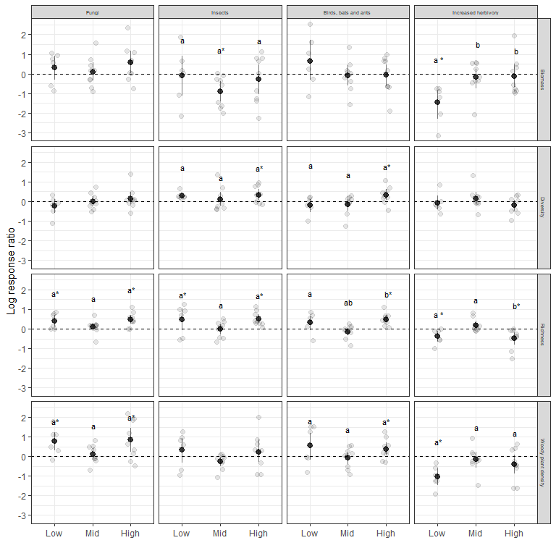Figure 1. Magnitude and direction of the effects of fungi, insects and their predators on biomass, richness, diversity and density of woody plants at low (Wanang, 200 m a.s.l.) mid (Numba, 750 m a.s.l.), and high (Yawan 1900 m a.s.l.) elevations. Log response ratio is a log-ratio of a given descriptor value from plots where a biotic factor was present to where it was absent. Grey points represent empirical values. Letters indicate statistically significant ($\\alpha$ = 0.05) differences for pairwise comparisons between elevations within a treatment-descriptor combination with Tukey correction for multiplicity. Letters are added only in cases where at least one mean-to-mean difference or mean-to-zero difference. Zero effect are indicated with a dashed line. Stars in the upper index indicate significant (ɑ = 0.05) differences of the effect mean from zero (significance of the effect at a given site)

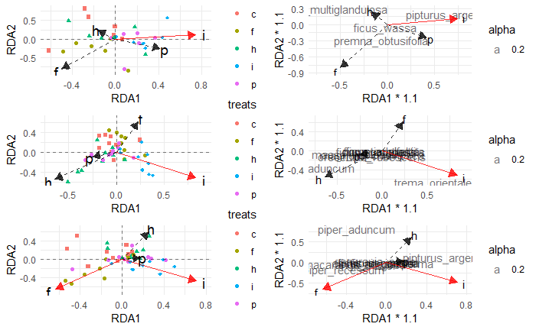Figure 2. Ordination diagrams

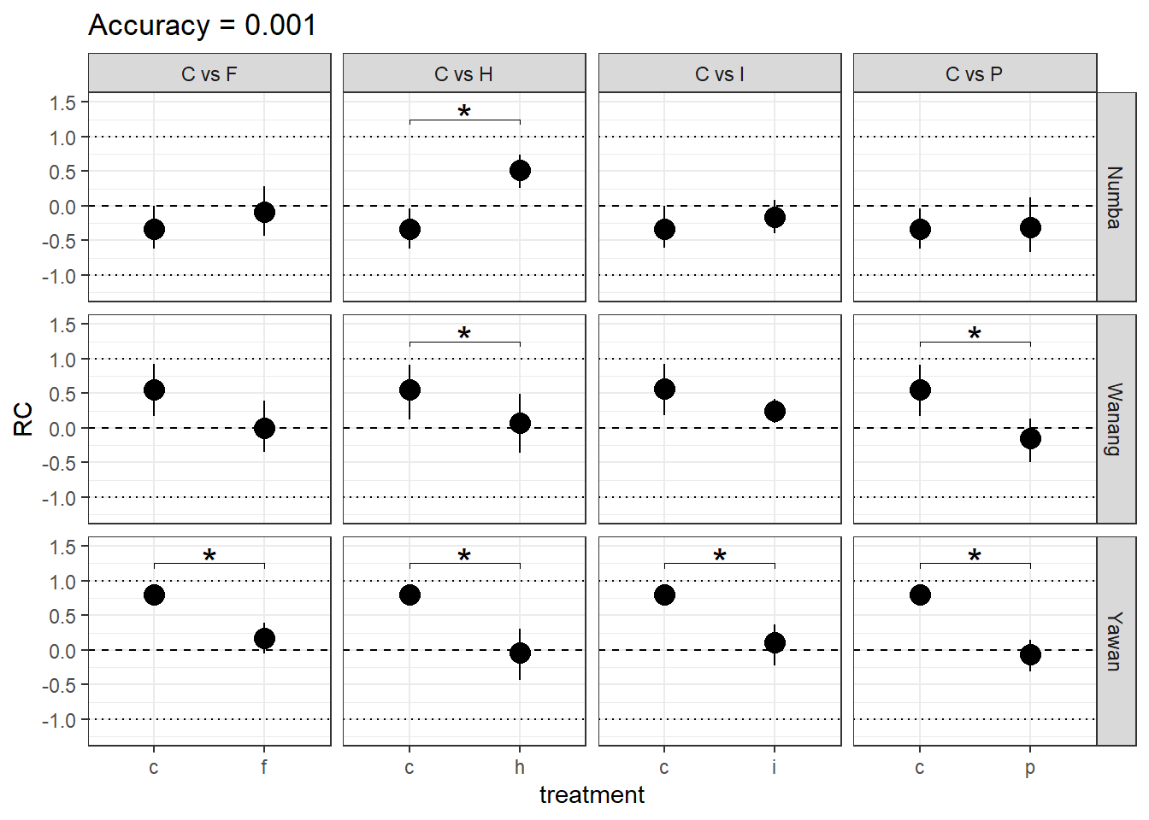Figure 3. Raup-Crick

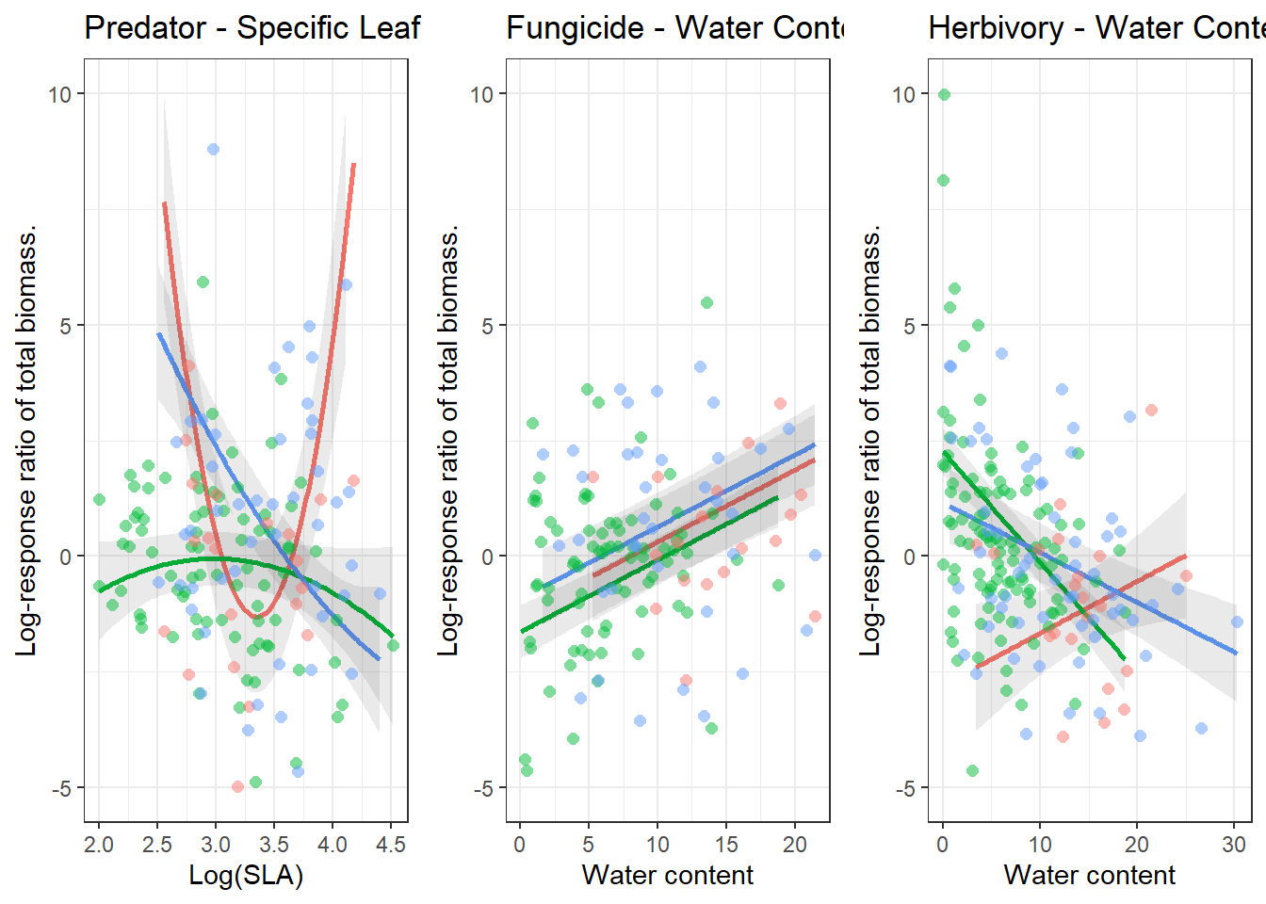Figure 3: Traits