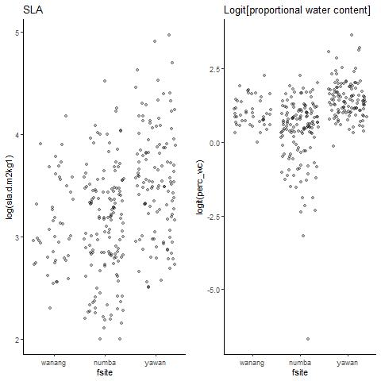

Yawan has highest SLA per species. Numba has the lowest Water content.