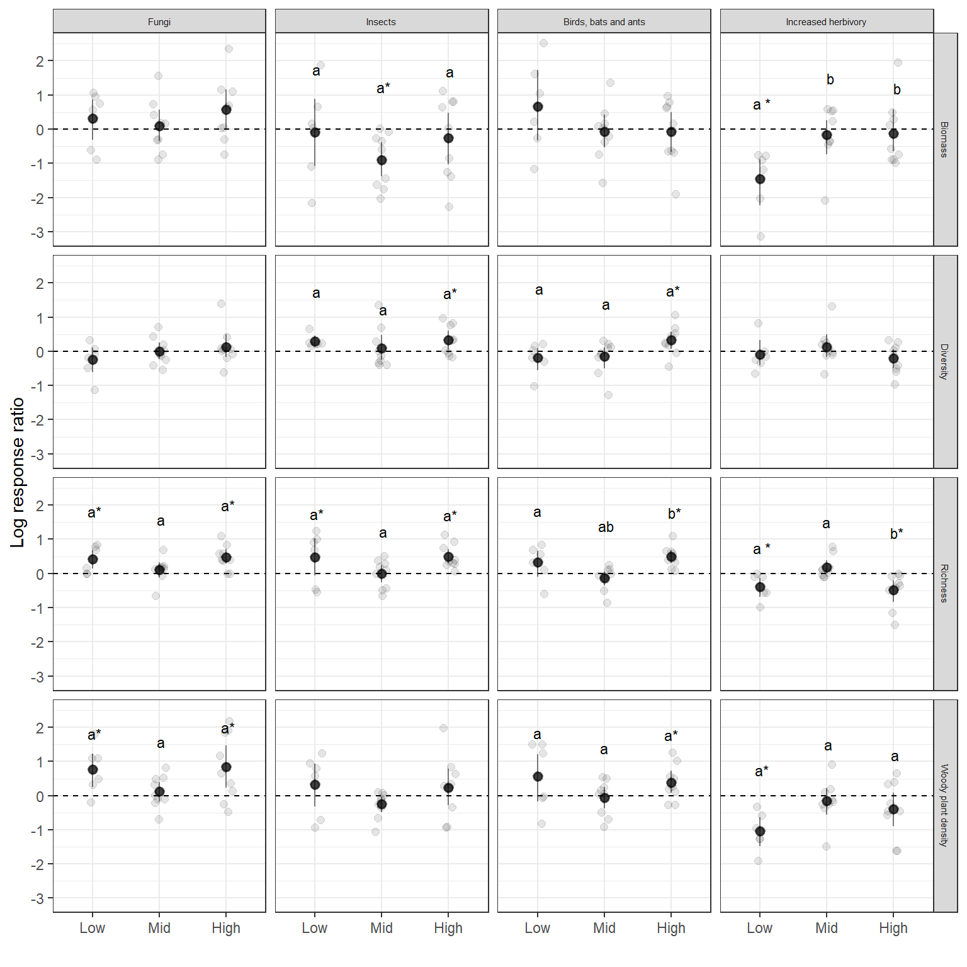Figure 1. Estimated log-response ratios with 95% CI for four studied experimental treatments and three sites for four plant community characteristics. Dashed horizontal line denotes zero effect. Points indicate values from individual replicated plots. Letters indicate significant differences in means evaluated with Tukey post-hoc test between elevations, and star indicates its significant difference from zero.

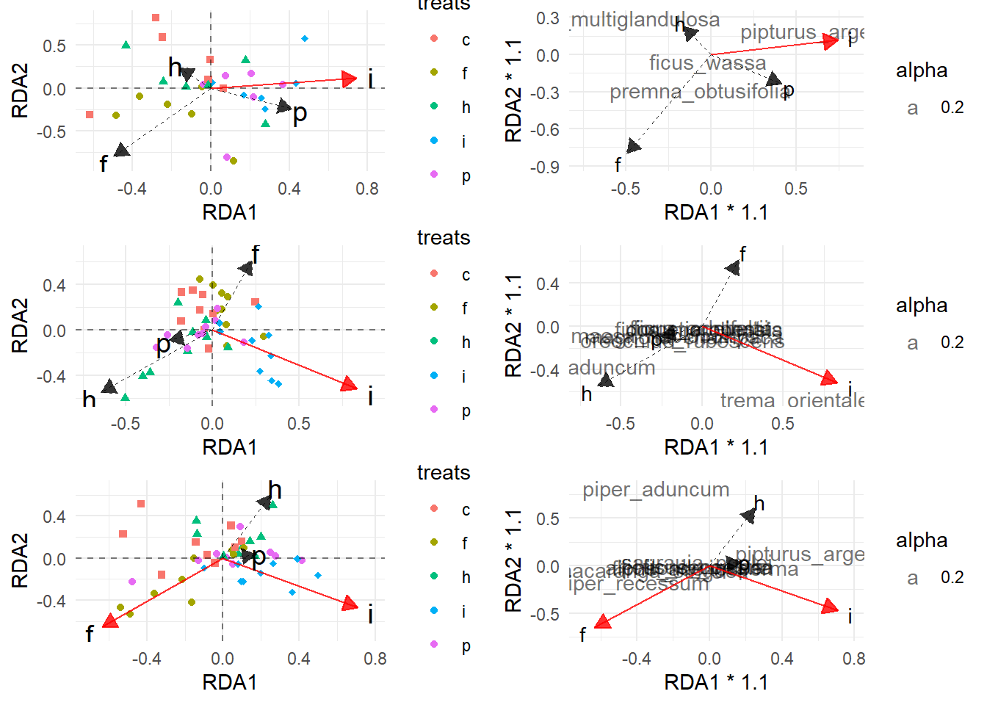

Figure 2. [Needs makeover] Results of pRDA for three studied elevations (top to bottom) with...

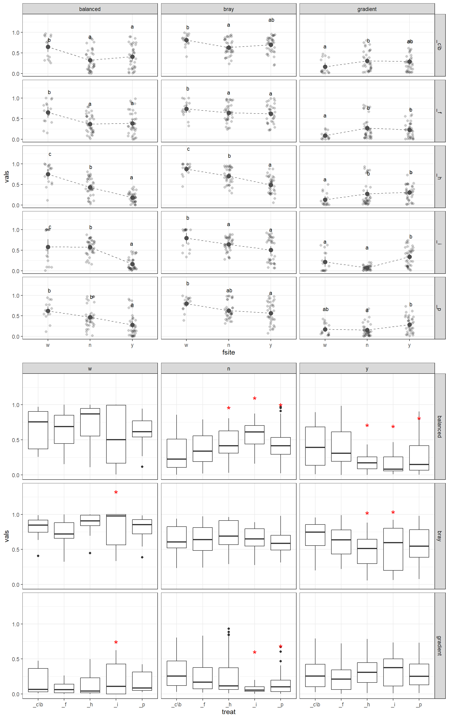Figure 3. [Needs makeover] Bray-Curtis dissimilarity for pairwise comparisons of plots with the same treatment between gardens.

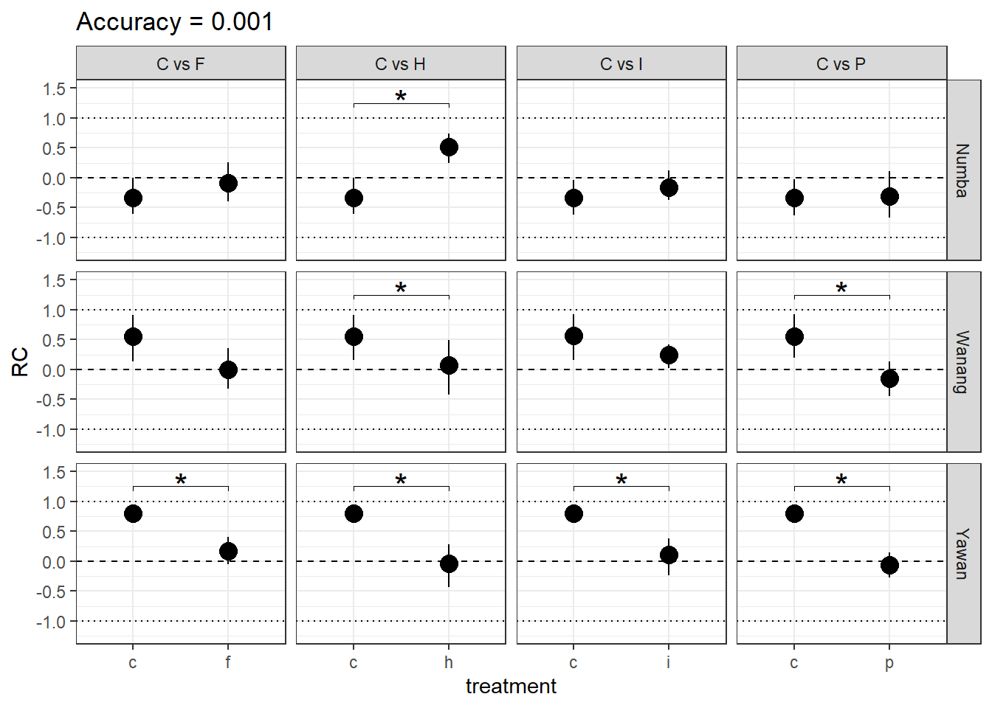Figure 4. Pairwise comparisons of the Raup-Crick index for control and treatment plant communities for four treatments at three sites with distinct elevation from lowest to highest (top to bottom). RC index summarizes the results of a replicated randomized assembly and indicates whether community is more random (RC ≈ 1), random (RC ≈ 0) or less random (RC ≈ -1) than expected by chance. Braces with stars indicate statistically significant differences of RC means.

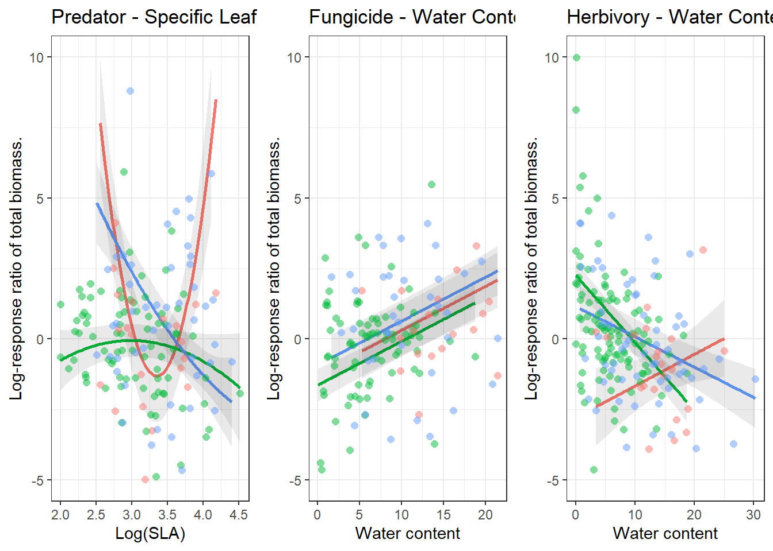Figure 5. Biomass change predicted by PGLS models from trait values of individual species in response to experimental treatments at low (red), mid (green) and high (blue) elevation sites.

Table 1. Results of the PGLS model that predicts biomass change of a species in response to a treatment. Models were subjected to backward selection of variables. Plant species richness at a site and log abundance were not subjected to selection process.

|  |  |  |  |  |  |  |  |  |
| --- | --- | --- | --- | --- | --- | --- | --- | --- |
|  | Predator | | **Insecticide** | | **Extra herbivory** | | Fungicide | |
| *Coeffcient* | *Estimates* | *P-Value* | *Estimates* | *P-Value* | *Estimates* | *P-Value* | *Estimates* | *P-Value* |
| Intercept | 153.63 | 0.001 | 303.07 | 0.102 | -1.82 | 0.297 | -3.15 | 0.008 |
| Log(SLA) | -95.55 | 0.001 |  |  |  |  |  |  |
| Numba | -166.69 | 0.001 | -306.20 | 0.099 | 6.05 | 0.001 | -3.50 | 0.002 |
| Yawan | -134.02 | 0.007 | -305.25 | 0.100 | 4.35 | 0.016 | -1.33 | 0.258 |
| Log(SLA) – quadratic term | 14.26 | 0.001 |  |  |  |  |  |  |
| Water content | 0.68 | 0.596 | -2.17 | 0.264 | 0.11 | 0.280 | 0.16 | <0.001 |
| Water content – quadratic term | 0.01 | 0.753 | 0.07 | 0.242 |  |  |  |  |
| Herbivory damage (%) | 8.35 | 0.259 | 946.54 | 0.115 |  |  |  |  |
| Herbivory damage (%) - quadratic term | -14.68 | 0.328 | 779.13 | 0.115 |  |  |  |  |
| Plant species richness | 0.05 | 0.031 | 0.00 | 0.950 | -0.02 | 0.161 | 0.08 | <0.001 |
| Log(Abundamce) | 0.63 | 0.004 | 0.54 | 0.004 | -0.41 | 0.045 | 0.36 | 0.149 |
| LRR(SLA) | -0.98 | 0.002 | -0.48 | 0.059 | -1.20 | <0.001 | -0.49 | 0.068 |
| LOG(SLA) x Numba | 99.85 | 0.001 |  |  |  |  |  |  |
| LOG(SLA) x Yawan | 85.62 | 0.004 |  |  |  |  |  |  |
| LOG(SLA)2 x Numba | -14.98 | 0.001 |  |  |  |  |  |  |
| LOG(SLA)2 x Yawan | -13.36 | 0.003 |  |  |  |  |  |  |
| Water Content x Numba | -0.07 | 0.959 | 2.57 | 0.187 | -0.35 | 0.003 |  |  |
| Water Content x Yawan | -0.52 | 0.688 | 2.54 | 0.197 | -0.22 | 0.051 |  |  |
| Water Content2 x Numba | -0.04 | 0.372 | -0.09 | 0.154 |  |  |  |  |
| Water Content2 x Yawan | -0.01 | 0.809 | -0.08 | 0.207 |  |  |  |  |
| Herbivory damage (%) x Numba | -8.43 | 0.257 | -947.54 | 0.115 |  |  |  |  |
| Herbivory damage (%) x Yawan | -9.85 | 0.187 | -947.14 | 0.115 |  |  |  |  |
| Herbivory damage (%)2 x Numba | 14.75 | 0.326 | -778.94 | 0.115 |  |  |  |  |
| fHerbivory damage (%)2 x Yawan | 14.83 | 0.323 | -778.80 | 0.115 |  |  |  |  |
| Observations | 148 | | 145 | | 180 | | 128 | |
| R2 | -0.317 | | -840.377 | | -0.616 | | 0.165 | |