Title: Positive effects of pathogenic fungi, herbivores, and predators on pioneer sucessional vegetation of tropical forests change with elevation.

Supplementary Information.

Piotr Szefer, Austin Sau, Kenneth Molem, Jonah Philip, Martin Volf, and Vojtech Novotny

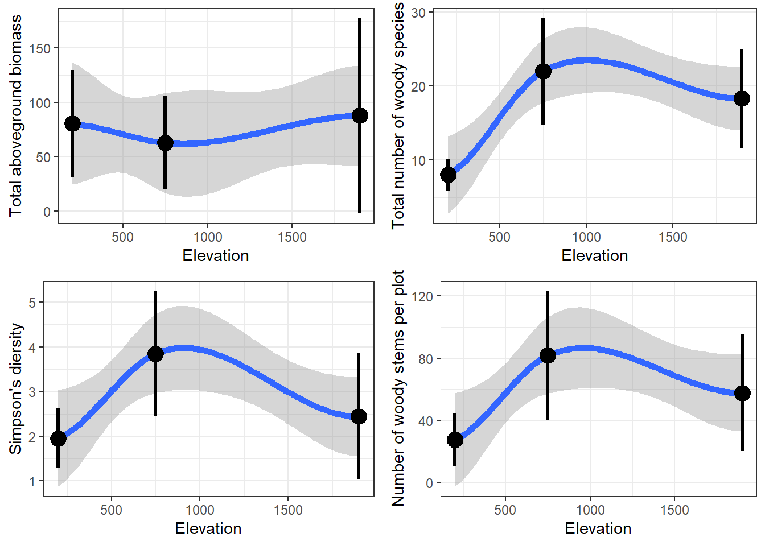Figure S1. Vegetation biomass, species richness and diversity and stem density for each site.

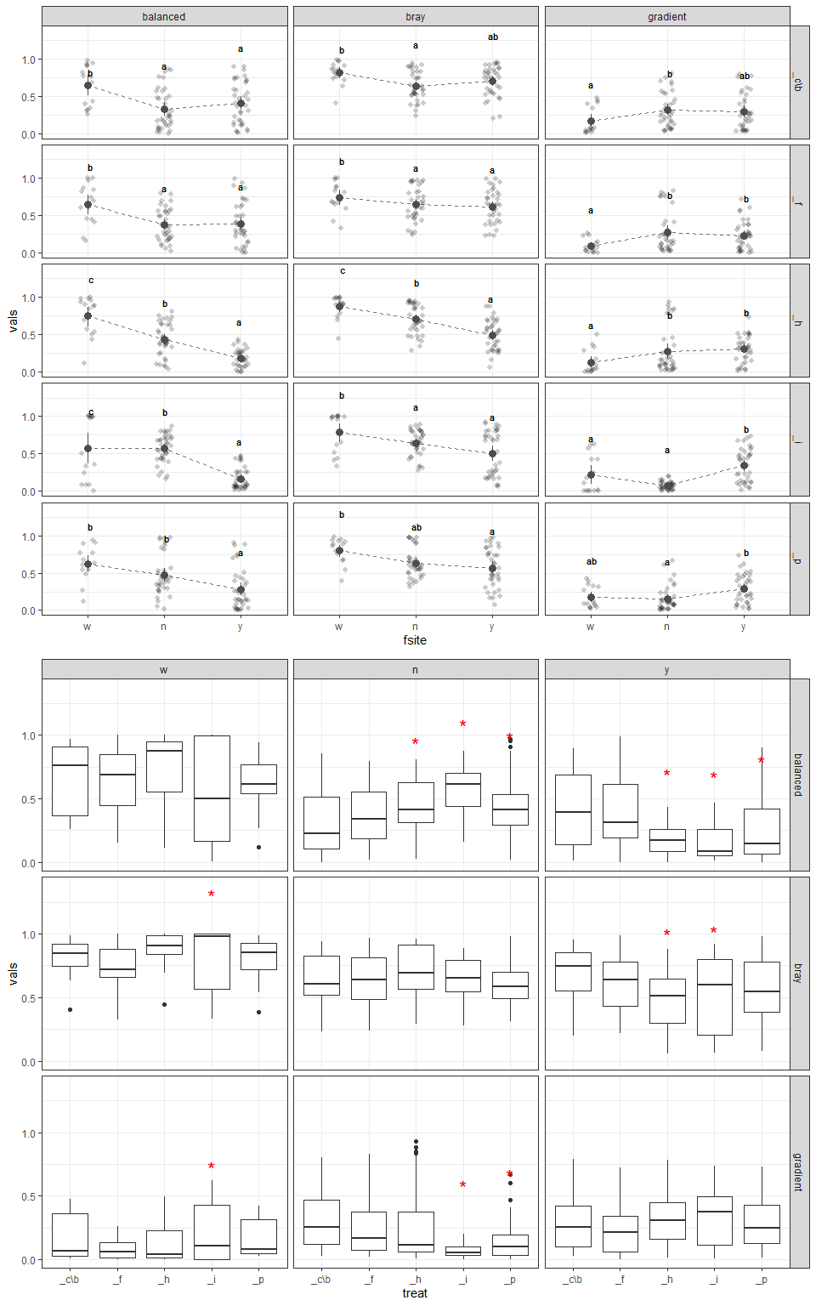

Figure S2. Pairwise, within treatment Bray-Curtis dissimilarities for control plot and four treatments at three elevations.

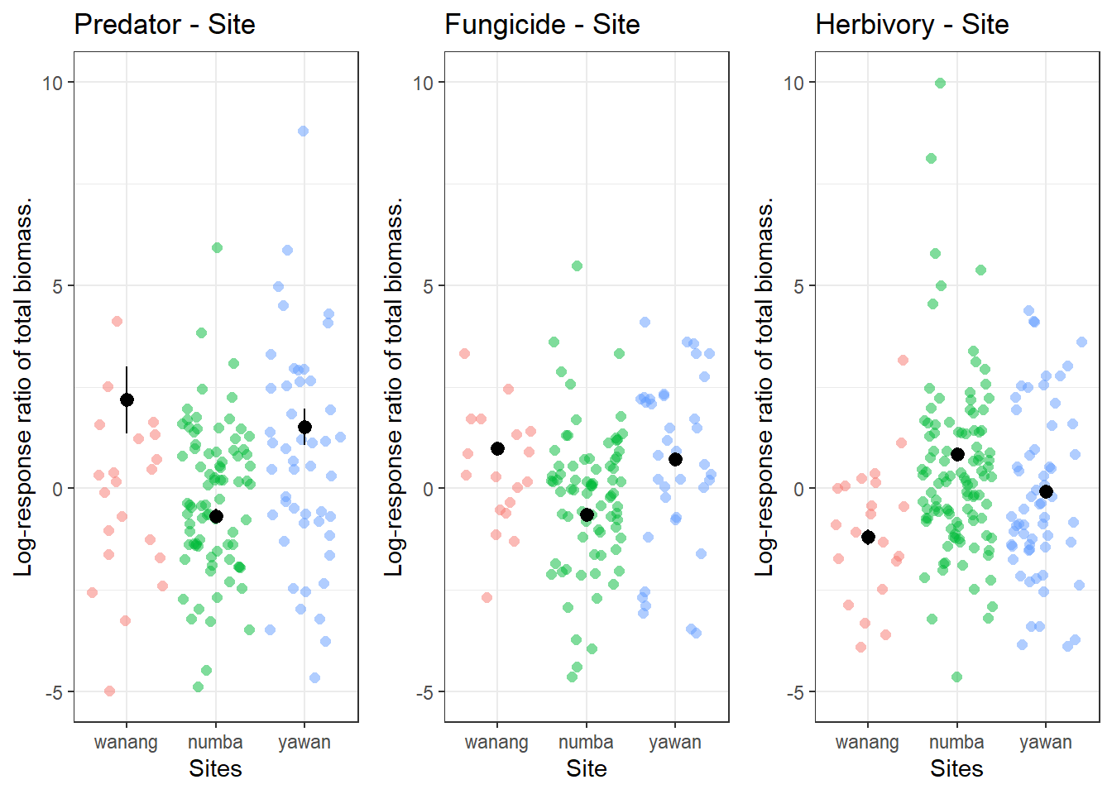Figure SX.

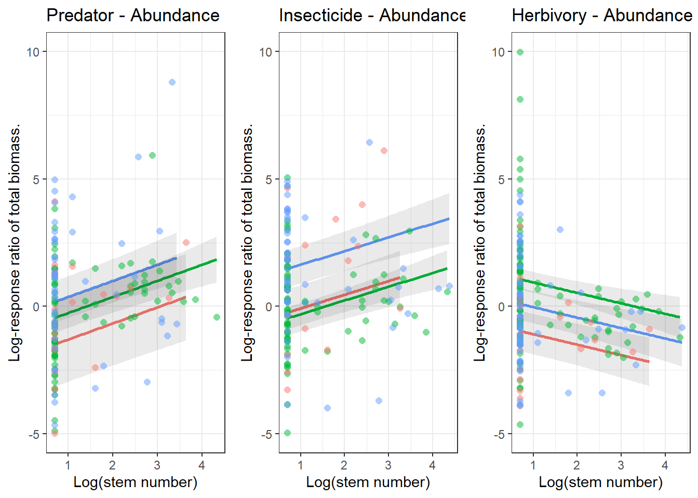

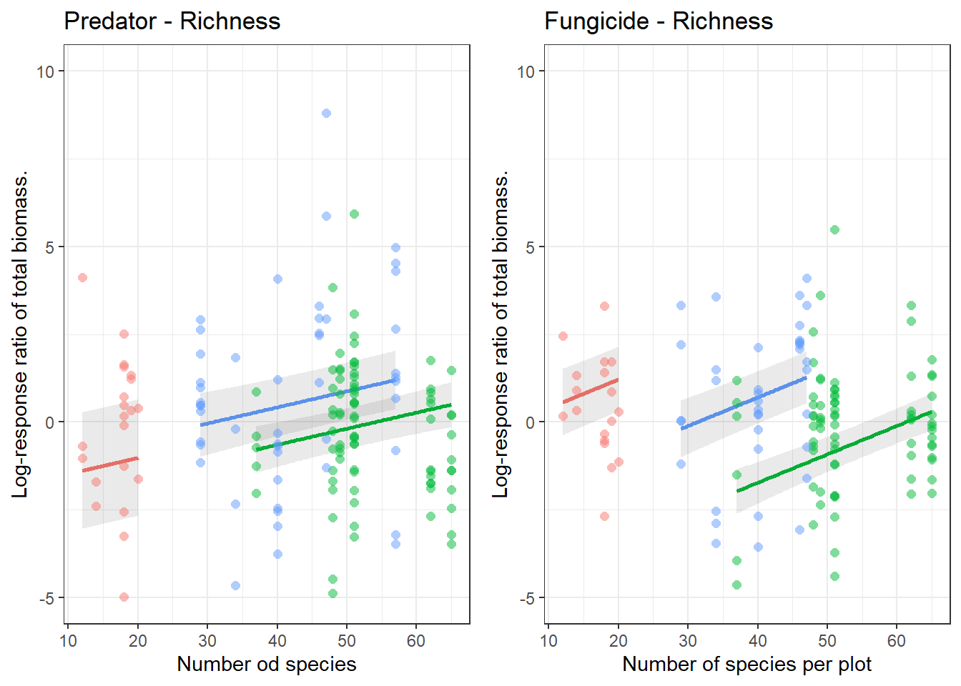Figure SX

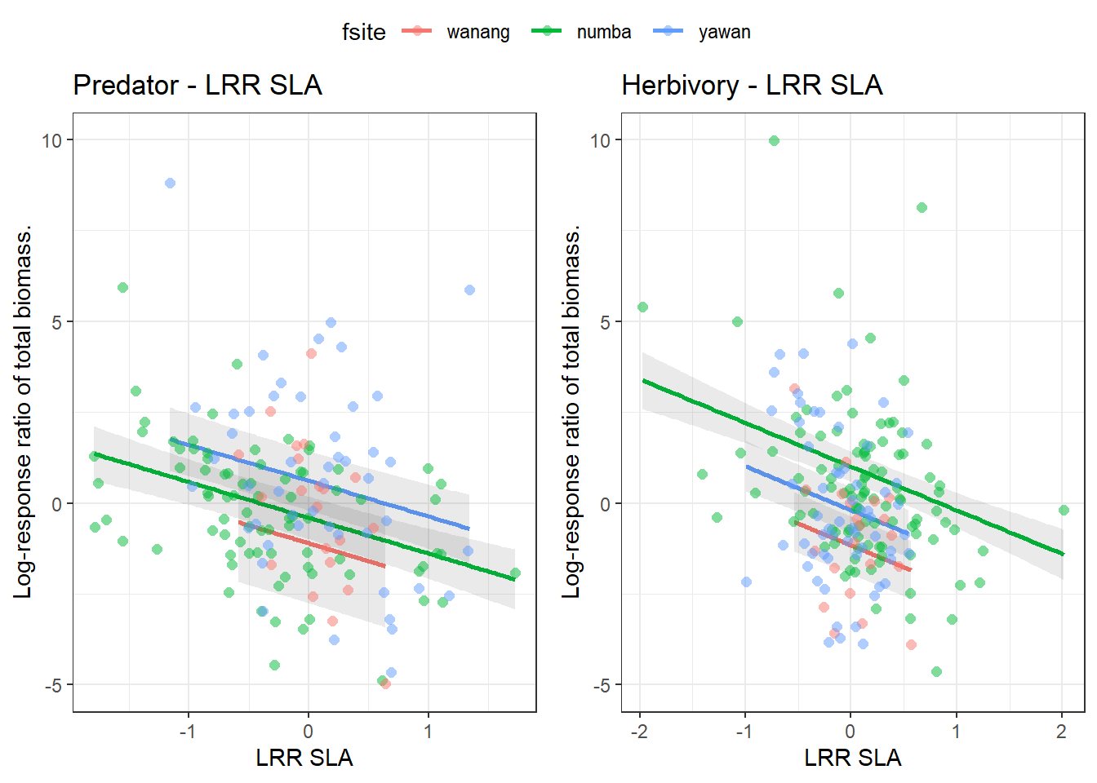Figure SX

Figure S3.

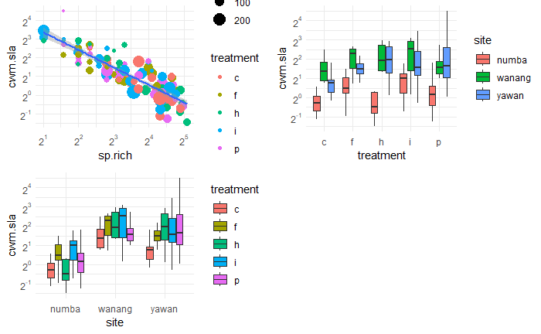Figure 1: Relationship between species richness and community weighted sla mean, that predicts also differences between sites and treatments better than the site or treatment id.

**Table S1. Individual plot characteristics kg, species number min-max mean, totals**

**Table S2.** Test results for over-dispersion all descriptors at three studied elevations. Why some have homogenous ANOVA while others non-homogenous ANOVA? If there was no evidence for nonhomgeneity of variances the non-homogenous ANOVA was used to evaluate whether there at least one pairwise contrast was different from zero (the difference in means of the effects was significant)

|  |  |  |  |  |  |
| --- | --- | --- | --- | --- | --- |
| testType | statName | testStat | pVal | treatmentCode | caselabel |
| Levene Test | F-value | 0.12 | 0.89 | f | biomass |
| Bartlett Test | Bartlett’s K-squared | 0.28 | 0.87 | f | biomass |
| homogenous anova | F-value | 1.63 | 0.21 | f | biomass |
| Levene Test | F-value | 0.66 | 0.53 | i | biomass |
| Bartlett Test | Bartlett’s K-squared | 1.99 | 0.37 | i | biomass |
| homogenous anova | F-value | 2.08 | 0.13 | i | biomass |
| Levene Test | F-value | 1.36 | 0.28 | p | biomass |
| Bartlett Test | Bartlett’s K-squared | 1.55 | 0.46 | p | biomass |
| homogenous anova | F-value | 0.91 | 0.46 | p | biomass |
| Levene Test | F-value | 0.09 | 0.92 | h | biomass |
| Bartlett Test | Bartlett’s K-squared | 0.18 | 0.92 | h | biomass |
| homogenous anova | F-value | 5.33 | 0.01 | h | biomass |
| Levene Test | F-value | 0.04 | 0.96 | f | diversity |
| Bartlett Test | Bartlett’s K-squared | 0.73 | 0.69 | f | diversity |
| homogenous anova | F-value | 0.72 | 0.55 | f | diversity |
| Levene Test | F-value | 1.90 | 0.17 | i | diversity |
| Bartlett Test | Bartlett’s K-squared | 5.89 | 0.05 | i | diversity |
| homogenous anova | F-value | 2.43 | 0.09 | i | diversity |
| Levene Test | F-value | 0.00 | 1.00 | p | diversity |
| Bartlett Test | Bartlett’s K-squared | 0.16 | 0.92 | p | diversity |
| homogenous anova | F-value | 2.15 | 0.12 | p | diversity |
| Levene Test | F-value | 0.02 | 0.98 | h | diversity |
| Bartlett Test | Bartlett’s K-squared | 0.31 | 0.86 | h | diversity |
| homogenous anova | F-value | 0.81 | 0.50 | h | diversity |
| Levene Test | F-value | 0.95 | 0.40 | f | richness |
| Bartlett Test | Bartlett’s K-squared | 0.13 | 0.94 | f | richness |
| homogenous anova | F-value | 7.93 | 0.00 | f | richness |
| Levene Test | F-value | 1.52 | 0.24 | i | richness |
| Bartlett Test | Bartlett’s K-squared | 4.38 | 0.11 | i | richness |
| homogenous anova | F-value | 4.65 | 0.01 | i | richness |
| Levene Test | F-value | 0.74 | 0.49 | p | richness |
| Bartlett Test | Bartlett’s K-squared | 1.83 | 0.40 | p | richness |
| homogenous anova | F-value | 6.72 | 0.00 | p | richness |
| Levene Test | F-value | 0.47 | 0.63 | h | richness |
| Bartlett Test | Bartlett’s K-squared | 1.63 | 0.44 | h | richness |
| homogenous anova | F-value | 6.19 | 0.00 | h | richness |
| Levene Test | F-value | 2.96 | 0.07 | f | density |
| Bartlett Test | Bartlett’s K-squared | 3.98 | 0.14 | f | density |
| homogenous anova | F-value | 5.87 | 0.00 | f | density |
| Levene Test | F-value | 1.51 | 0.24 | i | density |
| Bartlett Test | Bartlett’s K-squared | 5.68 | 0.06 | i | density |
| homogenous anova | F-value | 1.01 | 0.41 | i | density |
| Levene Test | F-value | 4.66 | 0.02 | p | density |
| Bartlett Test | Bartlett’s K-squared | 3.50 | 0.17 | p | density |
| non-homogenous anova | F-value | 2.26 | 0.11 | p | density |
| Levene Test | F-value | 0.55 | 0.59 | h | density |
| Bartlett Test | Bartlett’s K-squared | 0.91 | 0.63 | h | density |
| homogenous anova | F-value | 5.67 | 0.01 | h | density |

**Table S3.** Two models testing difference of LRR of predator exclosures from zero at each elevation. General Least Squares assumes over-dispersion in the data

|  |  |  |  |  |  |
| --- | --- | --- | --- | --- | --- |
| Estimate | Standard.Error | T.value | P.value | Site | Model |
| 0.56 | 0.27 | 2.06 | 0.05 | Wanang | LM |
| -0.06 | 0.22 | -0.27 | 0.79 | Numba | LM |
| 0.38 | 0.22 | 1.71 | 0.10 | Yawan | LM |
| 0.56 | 0.40 | 1.38 | 0.18 | Wanang | GLS |
| -0.06 | 0.17 | -0.34 | 0.74 | Numba | GLS |
| 0.38 | 0.17 | 2.18 | 0.04 | Yawan | GLS |

**Table S4: Results of RDA**

**Table S5.** Traits along treatment vectors.

wanang f

|  |  |  |  |
| --- | --- | --- | --- |
|  | Dependent variable | | |
| *Predictors* | *Estimates* | *CI* | *p* |
| (Intercept) | 0.84 | -0.08 – 1.76 | 0.073 |
| sla | -0.13 | -0.29 – 0.03 | 0.107 |
| water | -0.00 | -0.01 – 0.01 | 0.786 |
| herb | -1.00 | -8.96 – 6.97 | 0.800 |
| Observations | 32 | | |

numba f

|  |  |  |  |
| --- | --- | --- | --- |
|  | Dependent variable | | |
| *Predictors* | *Estimates* | *CI* | *p* |
| (Intercept) | 0.16 | -0.03 – 0.36 | 0.100 |
| sla | -0.03 | -0.07 – 0.00 | 0.065 |
| water | 0.02 | 0.02 – 0.03 | <0.001 |
| herb | -0.22 | -0.75 – 0.30 | 0.399 |
| Observations | 87 | | |

yawan f

|  |  |  |  |
| --- | --- | --- | --- |
|  | Dependent variable | | |
| *Predictors* | *Estimates* | *CI* | *p* |
| (Intercept) | 0.31 | -0.23 – 0.85 | 0.255 |
| sla | -0.05 | -0.15 – 0.04 | 0.240 |
| water | 0.01 | 0.00 – 0.02 | 0.002 |
| herb | 0.33 | -0.65 – 1.31 | 0.499 |
| Observations | 44 | | |

wanang i

|  |  |  |  |
| --- | --- | --- | --- |
|  | Dependent variable | | |
| *Predictors* | *Estimates* | *CI* | *p* |
| (Intercept) | 0.24 | -0.79 – 1.27 | 0.635 |
| sla | -0.03 | -0.21 – 0.15 | 0.751 |
| water | 0.00 | -0.01 – 0.01 | 0.881 |
| herb | -2.20 | -11.13 – 6.73 | 0.618 |
| Observations | 32 | | |

numba i

|  |  |  |  |
| --- | --- | --- | --- |
|  | Dependent variable | | |
| *Predictors* | *Estimates* | *CI* | *p* |
| (Intercept) | 0.15 | -0.09 – 0.39 | 0.221 |
| sla | -0.03 | -0.07 – 0.01 | 0.151 |
| water | 0.02 | 0.01 – 0.03 | <0.001 |
| herb | 0.05 | -0.60 – 0.69 | 0.884 |
| Observations | 87 | | |

yawan i

|  |  |  |  |
| --- | --- | --- | --- |
|  | Dependent variable | | |
| *Predictors* | *Estimates* | *CI* | *p* |
| (Intercept) | -0.02 | -0.53 – 0.49 | 0.941 |
| sla | 0.00 | -0.08 – 0.09 | 0.931 |
| water | 0.01 | 0.01 – 0.02 | <0.001 |
| herb | 0.04 | -0.89 – 0.97 | 0.938 |
| Observations | 44 | | |