Blind Drone Image Restoration Optimization with Real-ESRGAN

22077541d
Sze Sheung Hang
Computer Science
Supervisor: Dr. He Chen Hang
Date: 6th October, 2025

Table of Contents
1 Background -------------------------------------------------------------------------------------------3
2 Problem Statement-----------------------------------------------------------------------------------4
2.1 Motion blur in low-altitude aerial capture-----------------------------------------------4
2.2 Low-light underperformance and noise amplification---------------------------------4
3 Objectives and Outcome ----------------------------------------------------------------------------6
3.1 Motion deblurring---------------------------------------------------------------------------6
3.2 Low-light enhancement with controlled artifacts---------------------------------------6
4 Project Methodology --------------------------------------------------------------------------------6
4.1 Improved clarity and readability for downstream tasks--------------------------------6
4.2 Reproducible evaluation suite and ablation study--------------------------------------6
5 Project Schedule--------------------------------------------------------------------------------------7
5.1 System Diagram-----------------------------------------------------------------------------7
5.2 Data and Baselines--------------------------------------------------------------------------7
5.2.1 Degradation Synthesis and Image Pairs-----------------------------------------7
5.3 Model strategy using Real-ESRGAN----------------------------------------------------8
6 Project Schedule--------------------------------------------------------------------------------------9
7 Resource-----------------------------------------------------------------------------------------------9
8 Reference--------------------------------------------------------------------------------------------10

1 Background
Low-altitude economy is on the rise, and more drones will be used for inspection, mapping, monitoring, and situational awareness. The quality of drone images is becoming increasingly crucial, impacts both human decision-making and machine perception tasks such as OCR for signage/asset labels, defect detection, and object identification.
On the other hand, Real-ESRGAN has emerged as a widely adopted blind super-resolution (SR) method due to its robustness to mixed degradations: it uses ‘high-order degradation’ to create training data, to mimic complex real-world degradation factors, hence generating more realistic, higher quality, and sharper images. 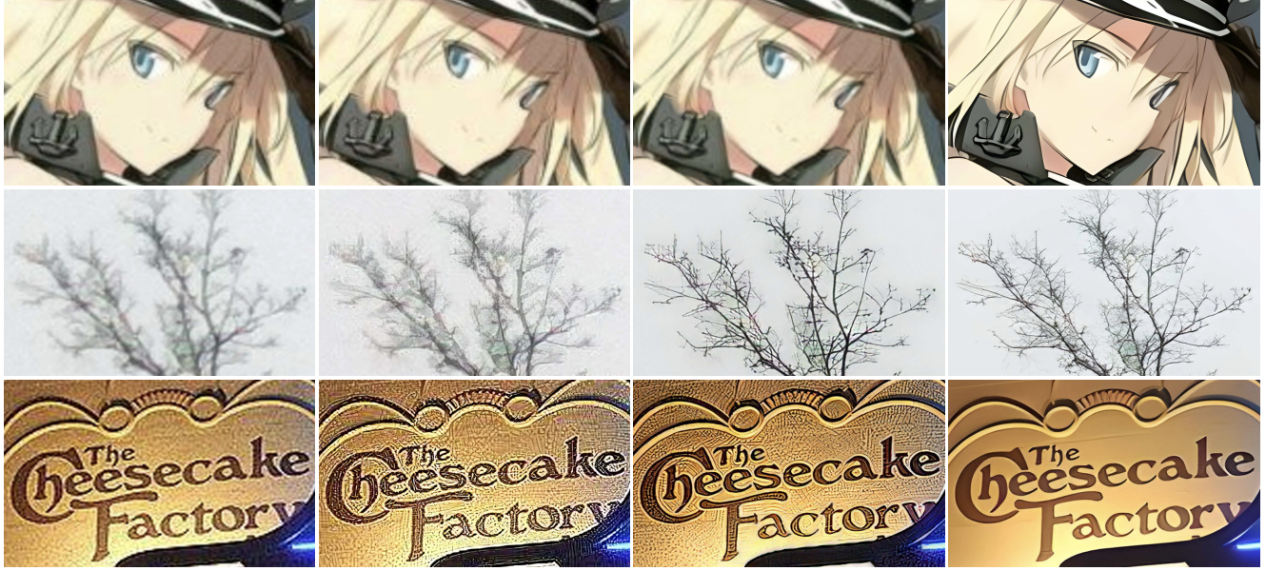

Figure 1: Comparisons of bicubic-upsampled, ESRGAN [48], RealSR [18], and Real-ESRGAN results on real-life images. The Real-ESRGAN model trained with pure synthetic data is capable of enhancing details while removing annoying artifacts for common real-world images. [1]
However, domain-specific characteristics of aerial capture (platform motion, vibration, low-light and high dynamic range, and large frames) expose limitations: persistent motion blur, difficulty processing large images efficiently and artifact-free, and underperformance in dark regions where signal-to-noise ratio (SNR) is low. Addressing these three challenges is essential to unlock reliable, high-quality enhancement for drone operations.

2 Problem Statement
2.1 Motion blur in low-altitude aerial capture
Cause: This uneven directional blur is a result of the motion of the drone and the motion of the moving objects, coupled with the exposure time, in other words, everything smudged, that is, the technical expression of all this. Geometry can be a problem with rolling-shutter effects, too, not only a blur issue, but a distortion issue.
Limit: Real-ESRGAN is not motion-aware, which means that the GAN will sharpen the image, but cannot consistently undo the blur. It frequently comes to hallucinate textures, and this is massive non-conformance in safety-critical applications in which you want the actual data.
Effects: The fact that the details are smudged (crack edges, wire strands, etc.) leads to a decrease in the interpretability of the imagery, and downstream tasks such as OCR or object detection are destroyed, in general the operational reliability is impaired.
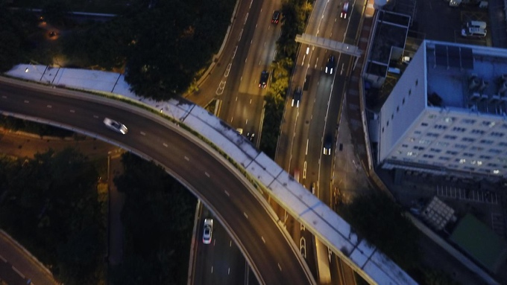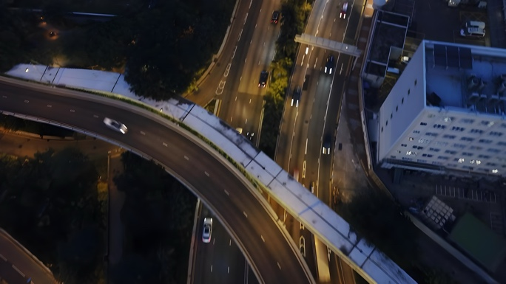
Figure 2: The image on the left is the original input image, image on the right is the output image after being processed by Real-ESRGAN. The right image still has motion blurs.
2.2 Low-light poor performance and amplification of noise.
Cause: Aerial shots (dusk, night, shadows) are low-light, with low SNR due to either shot/read noise or compression glitches; the contrast is so low that it is difficult to see textures.
Limit: Generic SR models have a tendency to enhance noises and form banding, or they over-smooth dark textures. The synthetic training data that real-ESRGAN works with does not even encompass those particular low-light sensor characteristics that are possessed by drones.
Impact: Dark areas remain fuzzy, OCR and defect detection is not reliable and analysts lose confidence due to the muddy or noisy outputs.
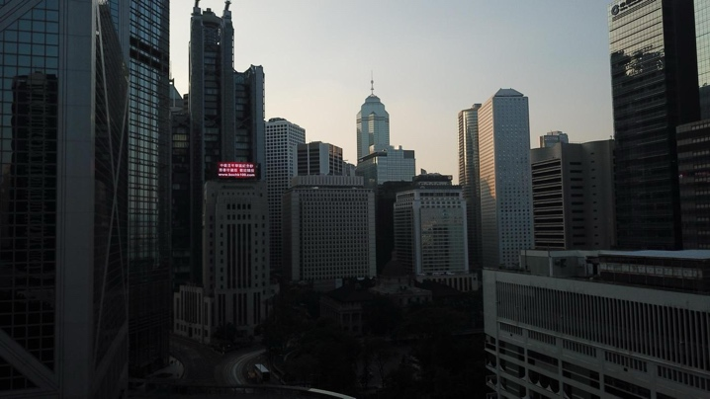
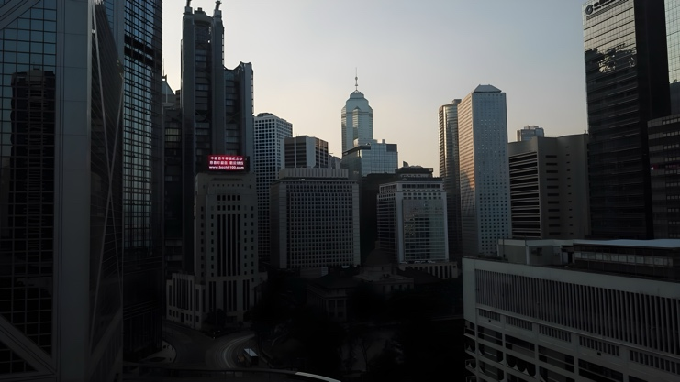
Figure 3: The image on the left is the original input image, image on the right is the output image after being processed by Real-ESRGAN. The right image shows indistinct in dark areas.

3 Objectives
This project aims to adapt and fine-tune Real-ESRGAN specifically for drone images, focusing on the following two measurable objectives.
3.1 Motion deblurring
Motion deblurring: ≥20% improvement in no-reference sharpness metrics, such as variance of Laplacian, it convolves the image with a 3 × 3 Laplacian operator and calculates the variance, which is the squared standard deviation [2], to measure the second derivative of intensity of the picture, and emphasizes the areas of intense changes of the intensity. [3] And Tenengrad gradient function to evaluate the sharpness of the images. [4]
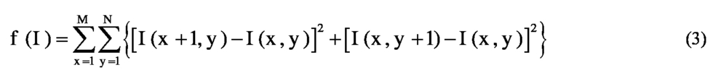
Figure 4: Tenengrad function calculates the square of the difference of gray value between adjacent pixels. Where I (x,y) is the gray value of iris image at pixel (x, y); M is the total row number of image; N is the total column number of image; f (I) is the value of definition evaluation function. [4]
3.2 Low-light enhancement with controlled artifacts
Low-light enhancement: +3 dB SNR improvement in dark regions (estimated via noise modeling or no-reference low-light metrics) and NIQE/BRISQUE improvements without visible halos/ringing. The NIQE calculates the no-reference image quality score for image A using the Naturalness Image Quality Evaluator, by comparing image A to a default model computed from images of natural scenes. A smaller score indicates better perceptual quality. [5]
4 Outcomes
4.1 Improved clarity and readability for downstream tasks
Sharper edges and restore details in previously blurred / motion-blurred areas. Improve OCR accuracy and visibility of objects, especially in motion and low-light conditions.
4.2 Reproducible evaluation suite and ablation study
PSNR/SSIM/LPIPS PSNR/SSIM (paired synthetic), NIQE/BRISQUE (real), sharpness, and OCR accuracy.
5 Project Methodology
5.1 System Diagram
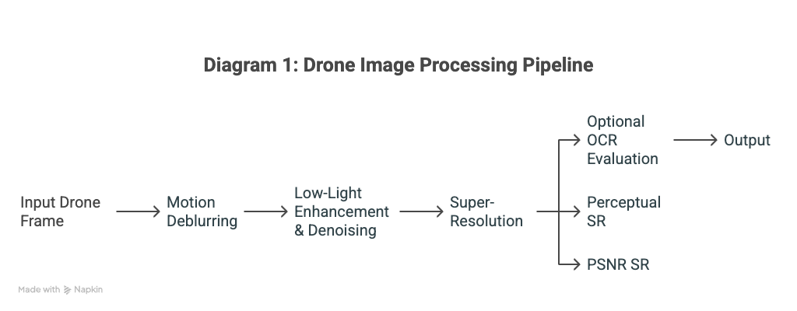
5.2 Data and Baselines
For data collection, collect diverse representative drone images surroundings, altitudes, and compressions. Then apply different degradations. Annotate subsets for motion severity, lighting, and presence of text.
This project will use two public UAV datasets that contain diverse aerial scenes. VisDrone2019 dataset is collected by the AISKYEYE team at the Lab of Machine Learning and Data Mining, Tianjin University, China. Images are captured by various drone-mounted cameras, covering a wide range of aspects including location (taken from 14 different cities separated by thousands of kilometers in China), environment (urban and country), objects (pedestrian, vehicles, bicycles, etc.), and density (sparse and crowded scenes). The diversity of the image dataset suits for different conditions of image captured by drones in different conditions and environments needed for training the motion deblurring and low-light enhancement models.
FloodNet provides high-resolution UAS imagery with detailed semantic annotation regarding the damage. With over 10 landcover categories (background, water, building flooded, building non-flooded, road-flooded, ...). [7] However, in this project, the flooded condition is not of our concern, so the images will be filtered and only extract non-flooded images. Out of these corpora, images will be manually filtered and screened to extract only images that are sharper(no motion blur), higher quality(low noise), and from reasonable drone viewpoints(not too high or low, objects can be observed clearly by human eyes).
5.2.1 Degradation Synthesis and Image Pairs
Images will then be creating two sets of degradations to give us input-target pairs.
Motion blur pairs. Generate two blur modes to depict both moving targets and drone motion. For drone motion, trajectory-based point spread functions are created from sampled 2D motion paths with variable length (e.g., 3–25 pixels scaled to resolution), orientation, and acceleration. The entire image is then convolved with the PSF using FFT convolution or differentiable kernels (e.g., Kornia’s motion_blur). For object motion, instance masks are obtained for target categories (e.g., vehicles) using an instance segmenter (YOLOv8-seg, Mask R-CNN, or SAM), and each object is isolated to apply motion blur within its mask. This process involves convolving the masked region with a directional PSF or simulating subframe object motion, which translates or wraps the object across several sub-steps with alpha-accumulation to produce a blur trail. The blurred object is then merged back into its sharp background with a feathered alpha to prevent halos and double edges. Alternatively, use OpenCV to synthesize both drone motion blur and object-only blur, with PSF generated, and extract the object region, apply motion blur only to that cutout, then alpha-composite back onto the sharp background, respectively. JPEG compression will be optionally applied at the end for a more realistic situation. These two blur modes synthesis allow training and evaluation under scenarios where only moving targets blur against a sharp scene, as well as scenarios where the entire frame is blurred by drone motion.
Low-light pairs. We simulate exposure reduction with a sampled gain factor, mild white-balance shifts, camera-like tone curves with black-level floor and highlight roll-off, and a noise model combining signal-dependent shot noise and signal-independent read noise. JPEG compression is applied at the end. This produces dark, noisy inputs while the original bright image serves as the target.

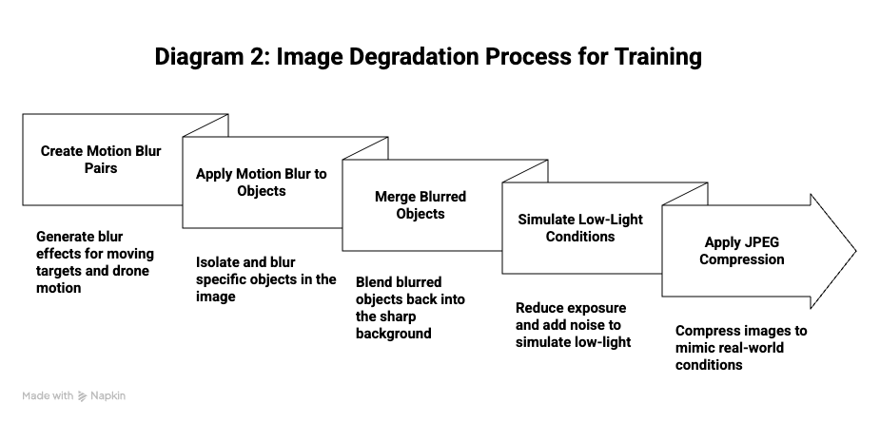
5.3 Model strategy using Real-ESRGAN
Real-ESRGAN’s RRDB/ESRGAN architecture with U-Net discriminator and GAN/perceptual losses will be used. Disable or reduce upscaling to 1× (restoration mode) or use 2× with down sampled supervision if needed. With two training modes, motion deblur–focused training, to train/fine-tune on motion-blur pairs, emphasizing edge and structure preservation (L1 + LPIPS + gradient losses) with moderate adversarial weight; and low-light–focused training, to train/fine-tune on low-light pairs using noise/contrast-aware losses and optional denoise prior (e.g., feed in a BM3D/DnCNN pre-pass during training as teacher or auxiliary loss). And 2 approach options, the first option is a single unified Real-ESRGAN model trained on a mixture (blur + low-light) with conditional tags, and the second option is two specialized Real-ESRGAN models or a two-stage pipeline (Deblur-ESRGAN → Low-light-ESRGAN).
6 Project Schedule
Task | Oct | Nov | Dec | Jan | Feb | Mar | Apr
Project setup
Data curation & split
Degradation synthesis
Real-ESRGAN Baselines check
Train motion deblurring model
Train low-light enhancement model
Full evaluation
Polishing and docs
Final report & prepare presentation

7 Resource
Dataset:
VisDrone2019 dataset is collected by the AISKYEYE team at the Lab of Machine Learning and Data Mining, Tianjin University, China: https://github.com/VisDrone/VisDrone-Dataset?tab=readme-ov-file [6]
Data collected with a small UAS platform, DJI Mavic Pro quadcopters, after Hurricane Harvey: https://github.com/BinaLab/FloodNet-Supervised_v1.0?tab=readme-ov-file [7]
Aerial Drone Traffic Dataset for Almaty City: https://www.kaggle.com/datasets/cihangiryiit/aerial-traffic-images [8]
A sequence of images on the UAV flight track:
https://github.com/IntelliSensing/UAV-VisLoc [9]

Hardware:
NVIDIA GPU, 64–128 GB RAM
Software:
Linux OS (Ubuntu 22.04 LTS), PyTorch with CUDA 12.x + cuDNN, Python 3.10/3.11, OpenCV, Real-ESRGAN / BasicSR, LPIPS for perceptual loss/metric, Kornia for motion blur kernels, DNN segmenters for synthesizing object-motion blur
Reference
[1] Wang, X., Xie, L., Dong, C., & Shan, Y. (2021). Real-ESRGAN: Training Real-World Blind Super-Resolution with Pure Synthetic Data. https://doi.org/10.48550/arxiv.2107.10833
[2] So, C. W., Yuen, E. L. H., Leung, E. H. F., & Pun, J. C. S. (2024). Solar Image Quality Assessment: A Proof of Concept Using Variance of Laplacian Method and its Application to Optical Atmospheric Condition Monitoring. Publications of the Astronomical Society of the Pacific, 136(4), 44504. https://doi.org/10.1088/1538-3873/ad3b39
[3] Xin Wang. (2007). Laplacian Operator-Based Edge Detectors. IEEE Transactions on Pattern Analysis and Machine Intelligence., 29(5), 886–890. https://doi.org/10.1109/TPAMI.2007.1027
[4] Gao, S., Han, M., & Cheng, X. (2018). The fast iris image clarity evaluation based on Tenengrad and ROI selection. In H. Yu & J. Dong (Eds.), NINTH INTERNATIONAL CONFERENCE ON GRAPHIC AND IMAGE PROCESSING (ICGIP 2017) (No. 106154X; Vol. 10615). SPIE. https://doi.org/10.1117/12.2302509
[5] “Calculate NIQE Score Using Default Feature Model.” Mathworks.cn, 2017, ww2.mathworks.cn/help/images/ref/niqe.html. Accessed 11 Oct. 2025.
[6] https://github.com/VisDrone/VisDrone-Dataset?tab=readme-ov-file
[7] https://github.com/BinaLab/FloodNet-Supervised_v1.0?tab=readme-ov-file
[8] https://www.kaggle.com/datasets/cihangiryiit/aerial-traffic-images
[9] https://github.com/IntelliSensing/UAV-VisLoc

