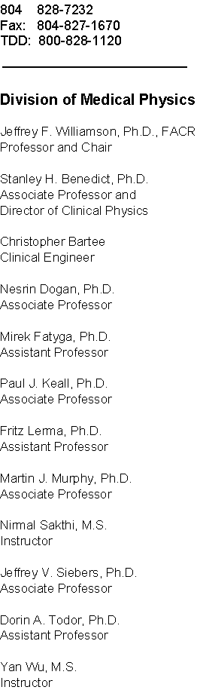

XXXXXXXX
XXXXXXXX
XXXXXXXX

Re: Post-doctoral position in Radiation Oncology XXXX 2006

Dear XXXX:

I am pleased to offer you a post-doctoral research fellowship in the Division of Medical Physics in the Department of Radiation Oncology at Virginia Commonwealth University. The position will start on or about XXXXXXX 2006. The term of appointment is for one year, and will be renewed thereafter at annual intervals pending the availability of funds and satisfactory performance. The starting salary will be $XXXX. Pending a successful performance review, you will be eligible for a salary increase in one year. Postdoctoral research positions at VCU do not have formal fringe benefits packages. However, we are pleased to offer you the following benefits: medical and dental insurance for yourself (up to an annual cost equivalent to Employee “High Option HMO” coverage: more expensive options are available at additional cost to yourself), up to 20 working days of vacation leave annually, and up to $3,000 to defray allowable moving costs (including travel from XXX to Richmond). Your position is funded by a research contract supported by XXXX and Departmental funds. Funding will be available for at least two years from your initial starting date.

Your position will be primarily a research position (80%). I will serve as your supervisor and mentor and will conduct your annual performance review including goal setting and assisting you with career planning. As discussed during your interview, your main area of concentration will be development and experimental validation of sinogram models for a cone-beam x-ray CT (CBCT) imaging system to support the improved image quality and organ segmentation accuracy needed for image-guided radiation therapy. Initial milestones include adapting an existing FORTRAN Monte Carlo code to scatter estimation, developing an accurate C++ forward projector, and CBCT and flat panel detector measurements to validate these simulations. Adhering to appropriate coding and documentation standards is important. Collaborators will include XXXXXX. A high level of effort, scientific rigor, and output in the form of useful publications and presentations is expected.

The successful completion of your post-doctoral training program is important both to your future career in medical physics and also to the productivity of the institution. We are offering this position to you with the understanding that you will you will commit at least two years to this position. Successfully completing this experience should make you eligible for an academic faculty position, clinical training position, or other types of medical physics positions in radiation oncology programs as outlined during your interview experience. My colleagues and I are committed to helping realize your scientific potential as a medical physicist and to aid you in any way possible to planning and realizing the next stage of your career.

As a non-U.S. citizen, this offer is contingent upon you obtaining appropriate visa status within 60 days. VCU and the Department of Radiation Oncology will support the cost of preparing and submitting routine visa applications, which includes premium processing ($1000) and other routine fees ($1200).

While your main responsibility is to realize the aims of the funding source supporting your salary, we encourage collaborations with other faculty and trainees. Provided that your research productivity is adequate, you may allocate up to 20% of your time to independent research, collaborative clinical research or development projects, or training in selected clinical activities. In particular, clinical training is an important part of a medical physicist’s career. Though clinical activity is not your primary responsibility, knowledge in this area will contribute both to your potential as a researcher and to planning for your career. We encourage you to attend lectures or classes, study clinical texts, and spend time with the clinical faculty, participating in clinical or developmental activities, provided these activities do not interfere with your research activities.

If you choose to accept this offer, please sign below, and keep one copy of this offer letter for yourself, and return the other copy to me via FAX and mail to Department of Radiation Oncology, Box 980058, Virginia Commonwealth University, Richmond, VA 23298. This offer is valid for two weeks from the date at the top of this letter.

My colleagues and I look forward to welcoming you to the exciting field of Radiation Oncology Physics. On a personal level, I look forward to a long and scientifically productive association with you.

Yours sincerely Offer accepted

Date Date______________

Jeffrey F. Williamson, Ph.D., FACR, FAAPM XXXXXXX, Ph.D.
Professor of Radiation Oncology and
Chair, Division of Medical Physics

cc M. Tony Mustain, MBA
Ms. Susan Kelly

