Fall 2009 Postdoctoral Survey Summary

All VCU postdoctoral scholars (N=242) were sent an e-mail invitation to participate in a web-based survey to solicit feedback on issues related to being a postdoc at VCU. The original invitation and 2 follow-up e-mails were sent to encourage participation. A total of 98 responses were received, providing us with a 41% response rate.

The survey included questions related to demographic information as well as questions asking how satisfied postdocs are on such topics as their scholarly productivity, opportunities for networking, career development activities, and services available at VCU. Below is a brief summary of the findings from the survey:

The Respondents: Below is information about the respondents compared to what we know about all postdocs at VCU. There appear to be minimal differences between respondents and all postdocs on the characteristics for which we have data. Exceptions are that the respondents were somewhat more likely to be U.S. citizens or permanent residents, and they were more likely to have held more than one postdoc position (36% of respondents having been in more than one position, compared to 20% of all postdocs).

Characteristics of Survey Respondents compared to all VCU postdoctoral scholars

 | Respondents  N = 98 | All postdoctoral scholars  N = 242
Citizenship | 40% U.S. citizen or permanent resident | 32% citizens or permanent resident
Gender | 49% female | 46% female
Age | <30 years = 25%  31–39 years = 60%  40+ years = 15% | NA
Marital Status | 70% married or w/partner | NA
Children <18 | 28% w/children | NA
Time as postdoc at VCU | <1 year = 42%  1-4 years = 53%  5+ years = 5% | <1 year = 41%  1-4 years = 55%  5+ years = 4%
Total # postdoc positions | 1 position = 64%  2 positions = 25%  3 or more = 11% | 1 position = 80%  2 positions = 15%  3 or more = 5%
School/College of Respondents | Medicine = 76%  H & S = 10%  Pharmacy = 7%  Engineering = 4%  Other = 3% | Medicine = 74%  H & S = 7%  Pharmacy = 7%  Engineering = 5%  Other = 7%

Career aspirations: 59% of the respondents indicated that their main career goal was to be a tenure-track faculty member (45%) or in some other type of academic position (14%). Another 17% were interested in working in industry, with the remaining respondents having main career goals in positions ranging from government (NIH, CDC, etc.) to science writing. Over 50% plan to actively start seeking their next position within 12 months.

Career preparation: Almost one-quarter of all respondents (24%) stated they were dissatisfied or very dissatisfied with their publication record, and 46% felt they had not presented their research at conferences often enough. Despite this level of satisfaction with opportunities for dissemination, most felt their research training and experience was good (49%) or excellent (23%); only 8% (7 respondents) perceived this training to be poor or very poor. Most postdocs also rated the mentoring they are receiving as good (40%) or excellent (34%), with only 8% again indicating it was poor or very poor. We also asked respondents how satisfied they were with their mentor and how engaged their mentor was in helping them plan their next career move. As can be seen below, most are satisfied and find the mentor helpful, however, there are a significant minority who do not find their mentor helpful in planning their next career move. When asked how often they meet with their mentor to discuss work and career, 10% indicated that they only met once or twice a year, whereas 70% meet daily (21%) or weekly (49%).

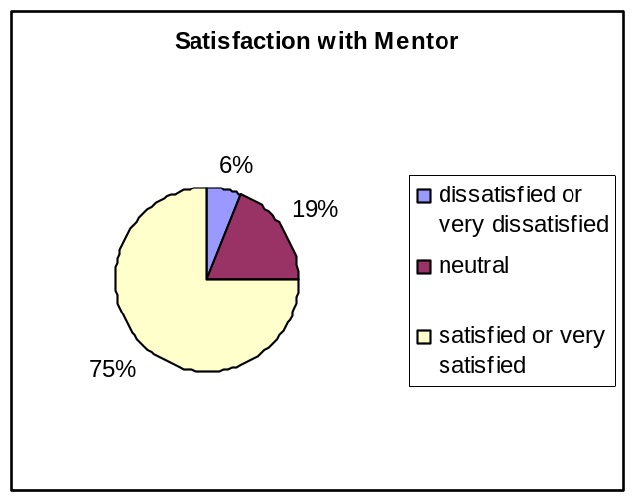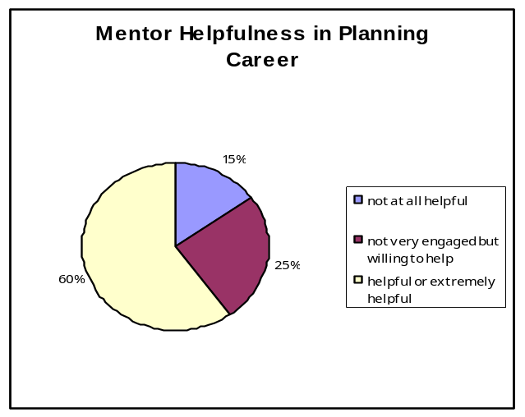

Networking: Postdocs were asked to assess the quality of various networking opportunities and social activities at VCU, and to rate how important these opportunities/activities were to them. On a scale of 1 (low) to high (5), the mean rating for the quality of networking and social activities at VCU is lower than the importance the respondents place on these activities.

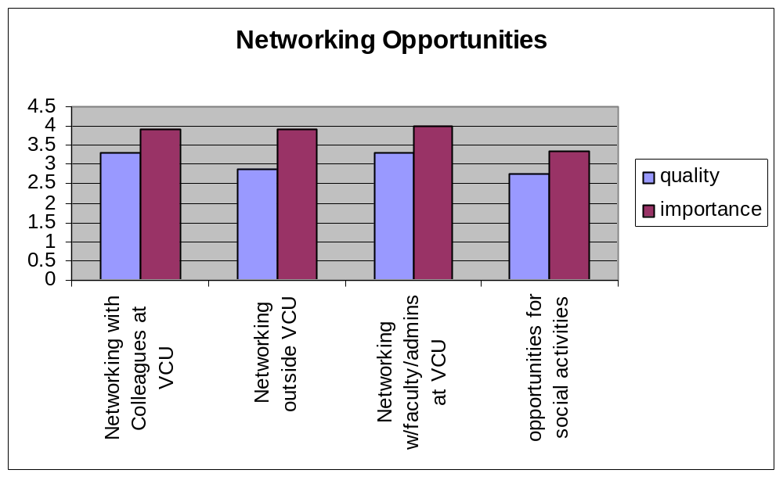

Career development activities: To help the Office of Postdoctoral Services in its planning, respondents were asked how important it is for them to receive training in a variety of areas. These responses will guide us in implementing programming for postdoctoral scholars in the coming year.

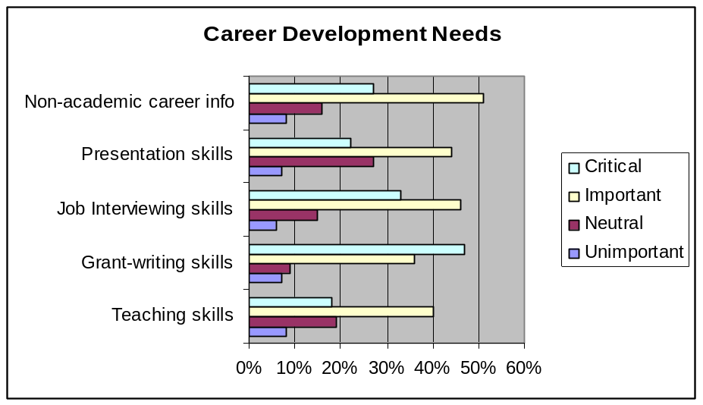

Services available to Postdocs: Respondents were asked to rate the quality and satisfaction of a variety of services available to them at VCU. In general, postdocs believed quality to be high and were satisfied with the level of services provided. The one exception was health care coverage, where 26% rated it as poor or very poor.
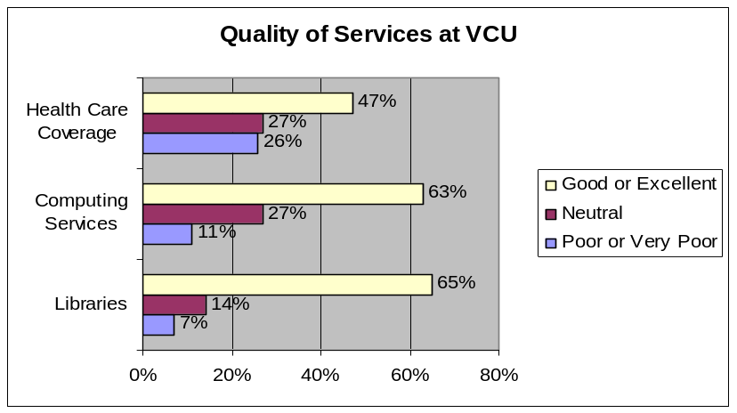
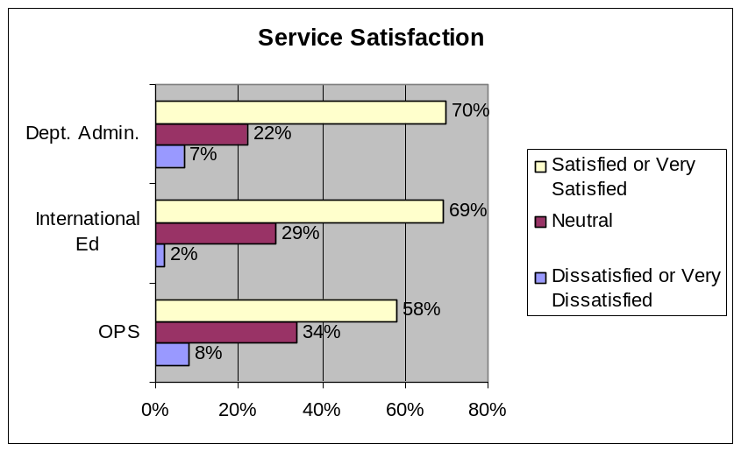

Overall satisfaction with postdoctoral experience at VCU: 65% of the respondents rated their experience at VCU as a postdoc as either satisfied (54%) of very satisfied (11%), whereas 14% were either dissatisfied (12%) or very dissatisfied (2%), and 21% were neutral.

When asked for additional comments, respondents noted such things as:

- Providing postdocs with better salaries
- Dealing with the politics of this place and getting out alive
- The need for a postdoctoral association
- PIs should have training on how to be a good mentor
- Postdocs must be encouraged to write grants while at VCU
- There is a need for an orientation session for new postdocs
- More information needed for female postdocs
- Difficulty in finding postdoctoral information on the VCU website
- Postdocs should have opportunity to rate mentors

