Fall 2010 Postdoctoral Survey Summary

All VCU postdoctoral scholars (N=247) were sent an e-mail invitation to participate in our 2nd annual web-based survey to solicit feedback on issues related to being a postdoc at VCU. The original invitation and 2 follow-up e-mails were sent to encourage participation. A total of 111 responses were received, providing us with a 45% response rate.

The survey included questions related to demographic information as well as questions asking how satisfied postdocs are on such topics as their scholarly productivity, opportunities for networking, career development activities, and services available at VCU. Below is a brief summary of the findings from the survey:

The Respondents: Below is information about the respondents compared to what we know about all postdocs at VCU. There appear to be minimal differences between respondents and all postdocs on the characteristics for which we have data. Exceptions are that the respondents were somewhat more likely to be U.S. citizens or permanent residents, they were more likely to have been at VCU for less than a year, and they were more likely to have held more than one postdoc position (36% of respondents having been in more than one position, compared to 17% of all postdocs).

Characteristics of Survey Respondents compared to all VCU postdoctoral scholars

 | Respondents  N = 111 | All postdoctoral scholars  N = 247
Citizenship | 47% U.S. citizen or permanent resident | 35% citizens or permanent resident
Gender | 50% female | 43% female
Age | <30 years = 40%  31–39 years = 49%  40+ years = 15% | NA
Marital Status | 68% married or w/partner | NA
Children <18 | 28% w/children | NA
Time as postdoc at VCU | <1 year = 47%  1-4 years = 47%  5+ years = 6% | <1 year = 34%  1-4 years = 61%  5+ years = 5%
Total # postdoc positions | 1 position = 64%  2 positions = 25%  3 or more = 11% | 1 position = 83%  2 positions = 13%  3 or more = 4%
School/College of Respondents | Medicine = 71%  H & S = 10%  Pharmacy = 8%  Engineering = 4%  Other = 7% | Medicine = 77%  H & S = 6%  Pharmacy = 7%  Engineering = 6%  Other = 4%

Career aspirations: 49% of the respondents indicated that their main career goal was to be a tenure-track faculty member (38%) or in some other type of academic position (11%). This is 10 percentage points lower than the 59% of 2009 respondents who indicated their career goal was a position in academia, suggesting there may be some concern about job opportunities in the academic setting. Among the 2010 respondents, another 18% were interested in working in industry, with the remaining respondents having main career goals in positions ranging from government (NIH, CDC, etc.) to science writing. Over 57% plan to actively start seeking their next position within 12 months.

Career preparation: Almost one-quarter of all respondents (24%) stated they were dissatisfied or very dissatisfied with their publication record, and 45% felt they had not presented their research at conferences often enough. Despite this level of satisfaction with opportunities for dissemination, most felt their research training and experience was good (57%) or excellent (9%); only 7% (8 respondents) perceived this training to be poor or very poor. Most postdocs also rated the mentoring they are receiving as good (38%) or excellent (26%), with only 7% again indicating it was poor or very poor. These ratings are very similar to those reported in last year’s survey. We also asked respondents how satisfied they were with their mentor and how engaged their mentor was in helping them plan their next career move. As can be seen below, most are satisfied and find the mentor helpful, however, there are a significant minority who do not find their mentor helpful in planning their next career move. When asked how often they meet with their mentor to discuss work and career, 12% indicated that they only met once or twice a year, whereas 73% meet daily (10%) or weekly (63%). Again, these responses were very similar to last year’s responses.

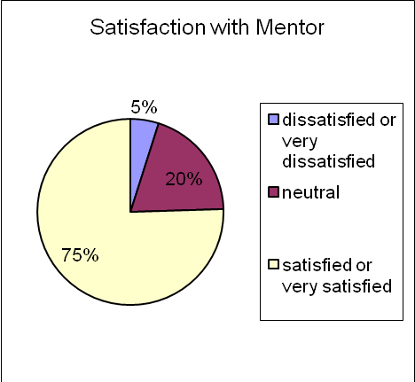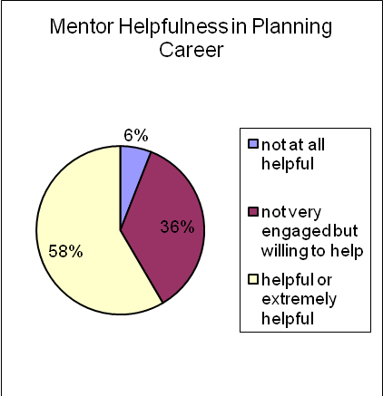

In this year’s survey we asked respondents if they had developed a written career plan for themselves and if they had shared that plan with their mentors. Only 30% of the respondents indicated they had completed a career plan. Of those who had done a plan, 85% had shared it with their mentor. A few postdocs commented that they would like to see the completion and discussion of a career plan mandatory.
Networking: Postdocs were asked to assess the quality of various networking opportunities and social activities at VCU, and to rate how important these opportunities/activities were to them. On a scale of 1 (low) to high (5), the mean rating for the quality of networking and social activities at VCU is lower than the importance the respondents place on these activities. The mean rating on the networking questions were similar to the ratings in 2009, however, the opportunities for social activities increased slightly from a mean of 2.8 to 3.1. This is likely a function of the social activities offered through the newly formed Postdoctoral Association during the past year.

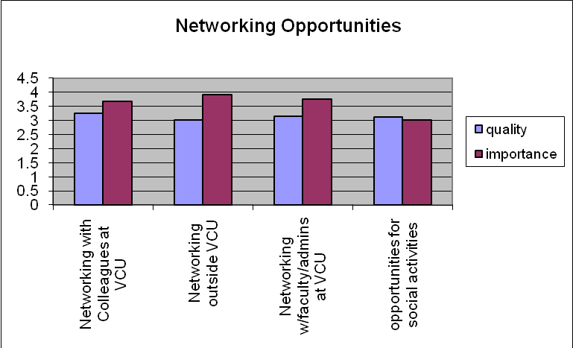

Career development activities: To help the Office of Postdoctoral Services in its planning, respondents were asked how important it is for them to receive training in a variety of areas. These responses will guide us in implementing programming for postdoctoral scholars in the coming year. Interestingly, an expressed need for non-academic career information is only second to their desire for training in grant-writing skills, with 81% indicating an interest in this career information.

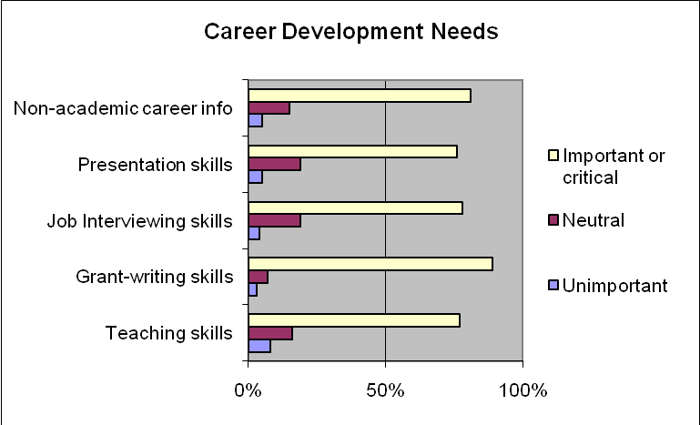
Services available to Postdocs: Respondents were asked to rate the quality and satisfaction of a variety of services available to them at VCU. We do see a substantial number of respondents who indicated they were “neutral” on these questions. This is likely a function of the large percentage who have been at VCU for less than a year (47%), and thus have had limited experience with the service. Of particular note is that the level of satisfaction for health care coverage increased from the previous year. In 2009, only 47% rated it as good or excellent and 26% rated it as poor or very poor. We instituted a new health plan in 2010, and the numbers changed to 61% and 15% respectively. Comments from postdocs, however, continue to focus on the high cost of health care for families. In general, postdocs believed quality to be high and were satisfied with the level of services provided in other service areas at VCU.

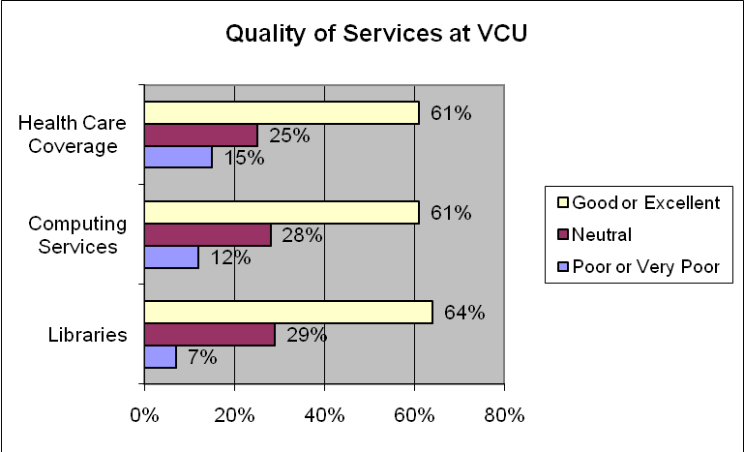

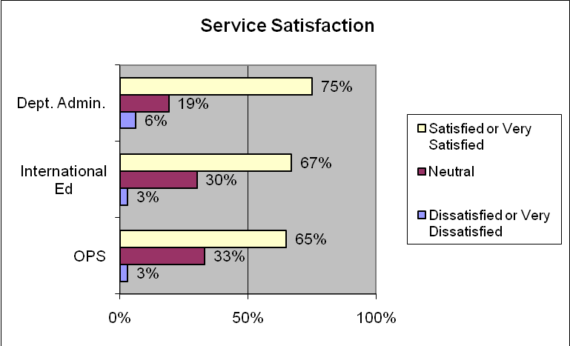

Overall satisfaction with postdoctoral experience at VCU: 62% of the respondents rated their experience at VCU as a postdoc as either satisfied (54%) of very satisfied (8%), whereas 7% were dissatisfied and 31% were neutral.

When asked for additional comments, respondents again noted such things as increased salary, reduced cost for family health care coverage, and improvement in the mentoring. There was also a request for more networking between departments and among investigators.

