**ONLINE VETERINARY APPOINTMENT SYSTEM**

**NG SZE JIN**

**A project report submitted in partial fulfilment of the**

**requirements for the award of Bachelor of Science**

**(Honours) Software Engineering**

**Lee Kong Chian Faculty of Engineering and Science**

**Universiti Tunku Abdul Rahman**

**September 2021**

TABLE OF CONTENTS

TABLE OF CONTENTS i

LIST OF TABLES v

LIST OF FIGURES vi

LIST OF APPENDICES vii

**CHAPTER**

1 INTRODUCTION 1

1.1 Introduction 1

1.2 Project Background 1

1.3 Importance of Study 2

1.4 Problem Statements 3

1.4.1 Time Consuming 3

1.4.2 Difficulty to Get Information 3

1.4.3 Less Attendance Rate 4

1.5 Proposed Solution 4

1.5.1 System Roles 4

1.5.2 System Flow 5

1.5.3 System Benefits 5

1.6 Proposed Approach 8

1.7 Project Objectives 9

1.8 Projcet Scope 9

1.9 Summary 11

1.10 Gantt Chart 12

2 LITERATURE REVIEW 13

2.1 Introduction 13

2.2 Online veterinary appointment system 13

2.2.1 Difference Between Paper Based Veterinary Appointment System and Online Veterinary Appointment System 13

2.2.2 Justification of Project Problem Statements 14

2.3 Existing Online Veterinary Appointment System 16

2.3.1 SuperSaas 16

2.3.2 TimeTap 19

2.4 Brief explanation between Three Different Software Development Life Cycle (SDLC) Methodologies 24

2.4.1 Waterfall Model 24

2.4.2 V-shaped Model 25

2.4.3 SCRUM Model 26

2.5 Summary 26

3 METHODOLOGY AND WORK PLAN 28

3.1 Introduction 28

3.2 Development Methodology 28

3.2.1 Waterfall 28

3.2.2 V-Shaped 29

3.2.3 SCRUM 31

3.2.4 Conclusion 32

3.3 Research Methodology 32

3.3.1 Introduction of the Questionnaire 32

3.3.2 Research Limitations 33

3.3.3 Questionnaires Results and Findings 33

3.4 Work Breakdown Structure 37

3.5 Development Tools and Technologies 39

3.5.1 WampServer 39

3.5.2 Visual Studio Code 39

3.5.3 phpMyAdmin 39

3.5.4 Enterprise Architect 39

4 PROJECT INITIAL SPECIFICATION 40

4.1 Requirements Specification 40

4.1.1 Functional Requirements 40

4.1.2 Non-functional Requirements 41

4.2 Use Case 42

4.2.1 Use Case Diagram 42

4.2.2 Use Case Description 43

4.3 Class Diagram 51

4.4 Database Design 51

4.4.1 Entity Relationship Diagram (ERD) 52

4.4.2 Data Dictionary 52

4.5 Activity Diagram 57

4.5.1 Log In 57

4.5.2 Book Appointment 58

4.5.3 Pay Deposit 59

4.5.4 Top-up E-Wallet 60

4.5.5 Sign Up 61

4.5.6 Edit Profile 62

4.5.7 Accept/Reject Appointment 63

4.5.8 View Appointment 63

4.5.9 Modify clinic operation address and contact 64

4.6 User Interface 65

4.6.1 Customer Home Page 65

4.6.2 Book Appointment Page 66

4.6.3 E-wallet Page 67

4.6.4 Profile Page 68

4.6.5 Edit Profile Page 69

4.6.6 Clinic Operation Information Page 70

4.6.7 Log In Page 71

4.6.8 Appointment List Page 72

4.6.9 Pending Appointment Page 72

4.6.10 Clinic Information Page 73

4.6.11 Edit Clinic Information Page 74

REFERENCES 75

APPENDICES 77

LIST OF TABLES

Table 2.1: Differences between Paper Based Appointment System and Online Appointment System 14

Table 2.2: Differences Between Waterfall, V-shaped, and SCRUM 24

Table 3.1: Pros and Cons of Waterfall Model (Mahalakshmi and Sundararajan, 2013) 29

Table 3.2: Pros and Cons of V-Model (Nugroho et at., 2017; Balaji and Murugaiyan, 2012) 30

Table 3.3: Pros and Cons of SCRUM model (Mahalakshmi and Sundararajan, 2013) 31

Table 4.1: Use case description – Log in 43

Table 4.2: Use case description – Sign up 43

Table 4.3: Use case description – Request appointment 44

Table 4.4: Use case description – Deposit transaction 44

Table 4.5: Use case description – Top-up E-wallet 45

Table 4.6: Use case description – Edit profile 46

Table 4.7: Use case description – Accept/Reject appointment request 46

Table 4.8: Use case description – View appointment 47

Table 4.9: Use case description – Modify user 47

Table 4.10: Use case description – Modify clinic info 48

Table 4.11: Use case description – 2 different vet appointment 48

Table 4.12: Use case description – Update appointment status 49

Table 4.13: Use case description – View own appointment 49

Table 4.14: Use case description – CRUD on customer, admin 50

Table 4.15: Use case description – Update vet 50

Table 4.11: Data dictionary – users table 52

Table 4.12: Data dictionary – role table 53

Table 4.13: Data dictionary – ewallet table 53

Table 4.14: Data dictionary –clinicop table 54

Table 4.15: Data dictionary – transacion table 54

Table 4.16: Data dictionary –bookings table 55

**LIST OF FIGURES**

Figure 1.1: Online veterinary appointment system user roles 4

Figure 1.2: Online veterinary appointment system general flow 5

Figure 1.3: Workflow of customer (pet owner) before adopting proposed solution 7

Figure 1.4: Workflow of customer (pet owner) after adopting the proposed solution 8

Figure 1.5: Gantt Chart (part 1) 12

Figure 1.6: Gantt Chart (part 2) 12

Figure 2.1: SuperSaas Dashboard 16

Figure 2.2: SuperSaas New Schedule 17

Figure 2.3: SuperSaas Configure Schedule 17

Figure 2.4: SuperSaas Appoint Customer to Schedule 18

Figure 2.5: SuperSaas Available Time Slot 18

Figure 2.6: SuperSaas Supervise Schedule 19

Figure 2.7: TimeTap New Appointment 20

Figure 2.8: TimeTap Scheduled Appointments 21

Figure 2.9: TimeTap Delete Confirmation 21

Figure 2.10: TimeTap Declaring Service 22

Figure 2.11: TimeTap Adding Customer 22

Figure 2.12: TimeTap Deleting Existing Customer 23

Figure 2.13: Waterfall model (Existek, 2017) 24

Figure 2.14: V-shaped model (Existek, 2017) 25

Figure 2.15: SCRUM model 26

Figure 3.1: Waterfall Model Life Cycle 28

Figure 3.2: V-Model Life Cycle (Balaji and Murugaiyan, 2012) 29

Figure 3.3: SCRUM methodology (Mahalakshmi and Sundararajan, 2013) 31

Figure 4.1: Use case diagram 42

Figure 4.2: Class diagram 51

Figure 4.3: Entity Relationship Diagram (ERD) 52

Figure 4.4: Activity Diagram – Log In 57

Figure 4.5: Activity Diagram – Book appointment 58

Figure 4.6: Activity Diagram – Pay deposit 59

Figure 4.7: Activity Diagram – Top-up E-wallet 60

Figure 4.8: Activity Diagram – Sign up 61

Figure 4.9: Activity Diagram – Edit profile 62

Figure 4.10: Activity Diagram – Accept/Reject appointment 63

Figure 4.11: Activity Diagram – View appointment 63

Figure 4.12: Activity Diagram – Modify clinic operation address and contact 64

Figure 4.14: UI Design – Customer Home Page 65

Figure 4.15: UI Design – Book Appointment Page 66

Figure 4.16: UI Design – E-wallet Page 67

Figure 4.17: UI Design – Profile Page 68

Figure 4.18: UI Design – Edit Profile Page 69

Figure 4.19: UI Design – Clinic Operation Information Page 70

Figure 4.20: UI Design – Log In Page 71

Figure 4.21: UI Design – Appointment List Page 72

Figure 4.22: UI Design – Pending Appointment Page 72

Figure 4.23: UI Design – Clinic Information Page 73

Figure 4.24: UI Design – Edit Clinic Information Page 74

LIST OF APPENDICES

Appendix A: Questionnaires 77

## INTRODUCTION

### Introduction

This chapter contains is to determine the project introduction, project objectives, problem statement, proposed solution, and project scope. Expected outcome of this project will be discussed in project scope. Hence, a brief idea of this project will be shown in this chapter.

### Project Background

Appointment booking field is definitely one of the biggest domains that received benefits from the advancement of internet. Walk-in appointment, phone call appointment, email appointment has been widely used in the past few decades. All the appointment methods mentioned has one important characteristic which is the admin has to key in the customer and appointment detail manually. Human have witnessed how successful manual booking system evolve to online booking system, for example, flight booking system, doctor appointment and so on. Hence, this project will bring pet care booking system to the current era, which is develop a, online veterinary appointment system to benefit both admin and customer.

As a pet owner or vet, it is obvious to find that current veterinary appointment system does not satisfy the need for both vet and customer in many aspects. Thus, the need for evolution of veterinary appointment system is unquestionable. This project seeks to produce a solution for the previously mentioned issue, which is to develop a web-based veterinary appointment system with automated system email and real time booking.

Accompanying the significant of information technology in this era, real time appointment booking and appointment details through email has been substantially demand by user. As manual appointment system has a lot of uncertainty, online real time booking and sending appointment details through email are more secure for user. Choices of diagnosed illness of pet can be chosen as reason of visiting the animal clinic is also convenience for vet as knowing problem earlier allow them to do more preparation.

The most obvious differences between manual veterinary appointment system and online veterinary appointment system is online vet appointment system allows customer to make appointment without spending a lot of waiting time (Truman, 2018).

### Importance of Study

At all times, online booking system has been expected by majority of adults as it is convenience for self-service through any device that can access to internet (Cort, 2018). As a result of its popularity, online booking system can be seen in many business platforms. In fact, many companies adopt e-booking as an investment to assist in the scope of expanding their marketing leadership (Agheorghiesei and Ineson, 2011). Manual appointment system cannot afford to satisfy majority of the users, it is no longer suitable for the needs of customer and admin of animal clinic especially in the growing demand of conveniency.

Therefore, it appeared necessary to simplify the process of manually making paper-based appointment through phone call or walk-in method, so that the record patient and upcoming appointment details can be easily retrieve through database, moreover, waiting time of customer and exaggerated work of front-desk admin can be ease. In this project, the most important features of real time online veterinary appointment system will be identified. One of the key advantages of this system is to bestow convenience so that admin can view upcoming appointment and customer can make appointment anytime, anywhere with any device with internet connection that can access to web browser. Furthermore, the online veterinary appointment system will be solving some issue such as attendance rate with the intention to help the vet, as well as motivate customer to not absent without reason for appointment.

The optimum goal that this project endeavour to achieve is to develop a user-friendly web-based veterinary appointment system that solves the problems encountered and reassure the demands in booking appointment conveniently for customer’s precious pet.

### Problem Statements

The current problems in manual appointment system in animal clinic are bringing inconvenience to pet owner and admin. For the problems pinpointed below are all the inconveniences issue faced by customer and admin of the pet clinic.

#### Time Consuming

Waiting time has always been a huge issue for customer when booking for an appointment. Customer needs to queue up for a long waiting time until their turn to make appointment during peak hour of the clinic. The main consequences of this are overload work for front-desk admin and dissatisfaction of customer thus causes a lot of complaints.

Dissatisfaction happens when the clinic cannot provide exact time slot to make appointment because of the unpleasant manual appointment system. Majority of the customer still need to queue for their turn even after making appointment through front-desk admin from the clinic. The precious time of customer can be spent more wisely on other way instead of queueing up to make an appointment without knowing the successful rate as there might be full booked in the end.

#### Difficulty to Get Information

Customer finds it difficult to obtain clinic’s information and vet information when the animal clinic does not adopt online platform. Some of the customer that need to drive far to the clinic would find this as inappropriate method for them to obtain information as it is very inconvenience.

On the other hand, paper-based patient record is also a troublesome issue for admin as it takes a long time to find a specific paper-based record within a large amount of records. In some cases, old paper-based record gets high probability to be damaged in unavoidable way such as by worms, catastrophe, accident and etc.

#### Less Attendance Rate

Irresponsible pet owner would suddenly cancel the appointment made in last minute without any reason. This causes bothersome to the vet and other customers as it does not just has wasted their time but also causes business loss to the clinic. Most of the animal clinic in Malaysia did not use deposit method on customer, so some of the customer will misuse the appointment system and causes inconveniences to the clinic.

### Proposed Solution

To productively solve the issue encountered in traditional manual paper-based veterinary appointment making as mentioned above, a web-based online veterinary appointment system is proposed. This solution is truly creating an official website of the animal clinic which enables admin to accept appointments and customer to make appointment conveniently. This brings the paper-based record to the website database, easier for admin to search for information.

#### System Roles

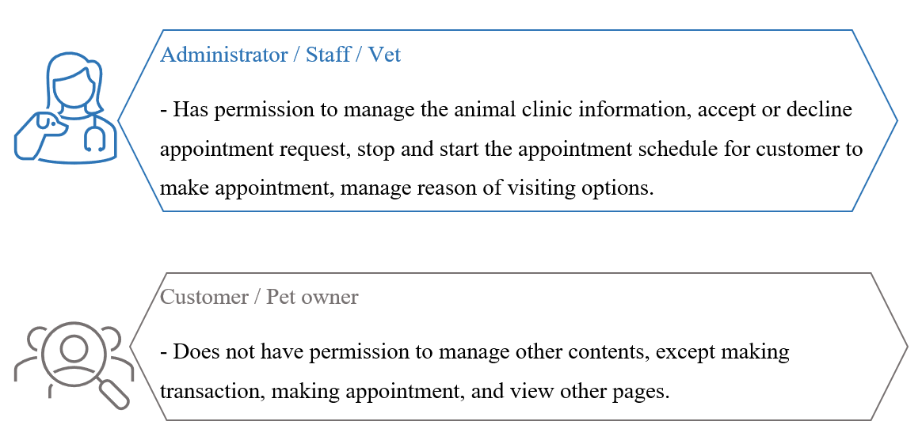

Figure 1.1: Online veterinary appointment system user roles

According to Figure 1.1, the users is divided into two categories, which are the administrator user and customer user.

#### System Flow

Diagram below shows the high-level process flow of the proposed online veterinary appointment system in the view of customer.

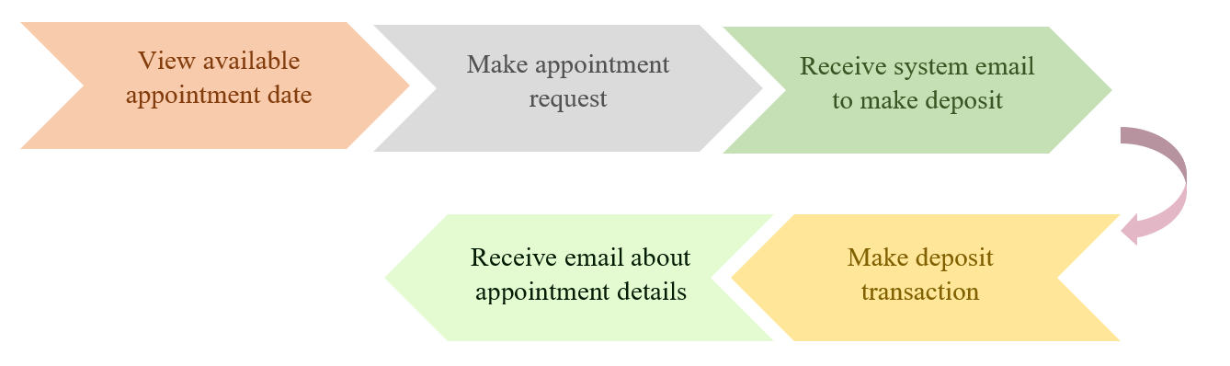

Figure 1.2: Online veterinary appointment system general flow

Figure 1.2 shows the flow of the project system, customer chooses available operating slots to make appointment and receive automated system email to make deposit within 24 hours when accepted by admin. Automated system email will be sent to customer after the deposit has made.

#### System Benefits

This proposed solution aim to improve the conveniency and effectiveness of animal clinic appointment making process for the target users which are pet owner and staff from the animal clinic. The expected benefits of the proposed online veterinary appointment system are as below.

1. **Decrease the need of third-party software**The proposed solution is a web-based application which include all the functions needed for making an appointment. Hence, the need to subscribe third-party software are minimized. It provides a platform for users to manage appointment with different permissions. Thus, this proposed solution helps in reducing cost, effort, and time as user only need web browser and internet to access the system.
2. **Effective on managing records**The proposedallows admin to manage patient records easily through database of the web application. Searching for patient record become convenient as everything store online tidily, instead of keeping a whole bunch of messy paper-based records which is harder to search when there is a huge amount of paper records. Hence, this proposed solution is space and cost efficient.
3. **Effortless way to make appointment**This proposed solution allows customer to make appointment at any time and place using only web browser. Which should benefit the customers that lives further from the animal clinic to obtain their needs. Thus, this proposed solution saves the time, cost, and effort of customers as they are not necessary to drive all the way to the animal clinic which could waste quite amount of fuel and time.

***1. Before adopting proposed solution***Figure1.3 show the process of customer making appointment before adopting proposed solution.

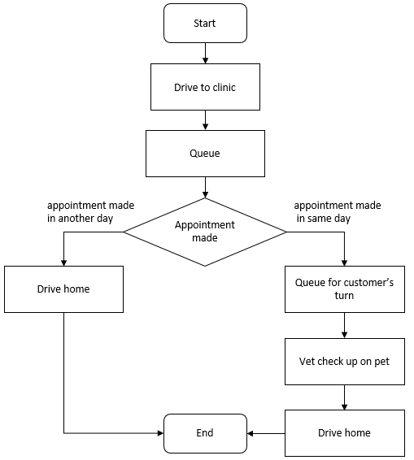

Figure 1.3: Workflow of customer (pet owner) before adopting proposed solution

***2. After adopting proposed solution***

Figure 1.4 shows the process of customer making appointment after adopting proposed solution. As it can been seen clearly, there process are less than before adopting the proposed solution as the time wasted on driving and waiting are reduced.

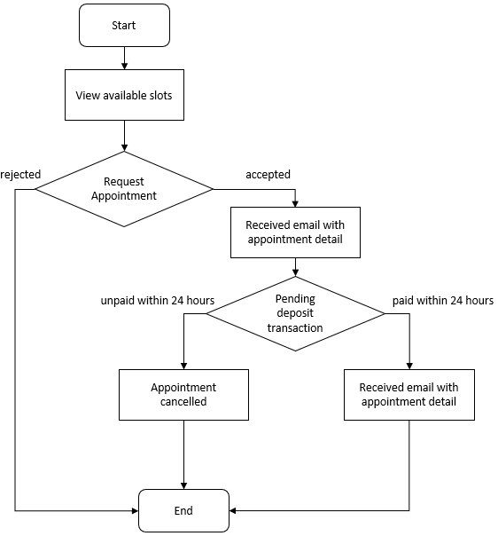

Figure 1.4: Workflow of customer (pet owner) after adopting the proposed solution

1. **Minimize the absent rate**  
   Receiving deposit from customer when they made an appointment can prevent customer from absent without proper reason. This proposed solution allows the animal clinic to receive customer deposit within 24 hours without the need of staffs to manage the transaction, unlike the traditional approach on making appointment.

### Proposed Approach

The proposed approach is SCRUM which is suitable for fast pace and complex project. Although this project is not as complex as others, SCRUM is still considering the most suitable approach for it because it can guide this project to work in faster pace and add any features and requirements in anytime. Whenever a sprint is completed, a conclusion will be made, and a new sprint starts immediately. This proposed approach allows to project to be more controlled in terms of schedule and state. As mentioned before, this is a small project, hence, SCRUM approach is suitable for rapid development and testing so that this project can be developed as earlier and can be tested more to ensure the quality of the software.

### Project Objectives

1. To investigate the existing current problem related to inconveniences for vet and customer without using online appointment system.
2. To propose the development of Online Veterinary Appointment System with the purpose of providing real time booking system that satisfy the current demands.
3. To evaluate whether the proposed system will be able to achieve a score of 70 and above based on the system usability scale (SUS).

### Projcet Scope

The project scope of the development of web-based online veterinary appointment system intend to focus on the real time booking module, e-wallet module, automated email module, and appointment management module. The software will be using as assistance on this project’s development are web browser, internet connection, Visual Studio Code, and Wampserver64. Hardware will be any computer. User scopes for this project will be pet owner as customer, and clinic staff including vet as administrator.

The fundamental functions of the proposed solution are real time booking and e-wallet for deposit transaction are the operations for customer. And create, retrieve, update, and delete operations are mainly for administrator to do changes on appointment management module. The expected outcome of this project involves the application of the following components:

1. **Dashboard**The system dashboard for admin user and customer is different. For administrator part, the dashboard allows admin user to search and view all the upcoming appointment, it also serves as the entrance before accessing to other entities after admin user log in. For customer part, the dashboard only shows the news and pet care articles link, serves as main page for the website.
2. **Navigation bar**For administrator part, navigation bar provides links that allows admin user to navigate between different pages of the website. Admin user can browse dashboard, patient record and appointment management. For customer, navigation bar provides links of dashboard, contact us, book appointment, about us, e-wallet, and pet care info.
3. **Appointment Management**This module is specifically a platform for admin to efficiently manage appointment details. The admin user can create, retrieve, update, and delete the diagnosed illness which act as the reason of visiting for the customer. Admin user can also block the appointment to stop getting appointment request until it is unblocked. Admin user can also accept and reject requested appointment in this module.
4. **Real time booking**This module is a platform for customer to make appointment on real time operating time slot. Requested appointment is not confirm until the admin accepted it. Pending appointment request will not show as booked. If the time slot of the day is not available, admin will reject the appointment and an email will be sent to the customer.
5. **E-wallet**This module operates as the transaction method for deposit of customer. Customers can top up their e-wallet through credit-debit card. This module will also show the pending transaction for accepted appointment for 24 hours after the appointment is accepted. Rejected appointment will not be showing. Pending transaction will be disappear once the transaction has been made.
6. **Automated email**The automated email act as prove for the appointment made. Email containing appointment detail will be sent to administrator and customer automatically after the appointment request has been accepted by administrator, as a reminder and evidence. Furthermore, automated email about pending deposit transaction will be sent to customer after the requested appointment has been accepted by administrator.

### Summary

This is the first chapter for the project. The project development will be as the mentioned functions regarding on the proposal of the project, the objectives, the problem statements, project scopes, and project background. As for the problem statements, there will be related details of the study and research that will be stated in chapter 2. The finding to achieve the goal of the project will be mentioned in chapter.

### Gantt Chart

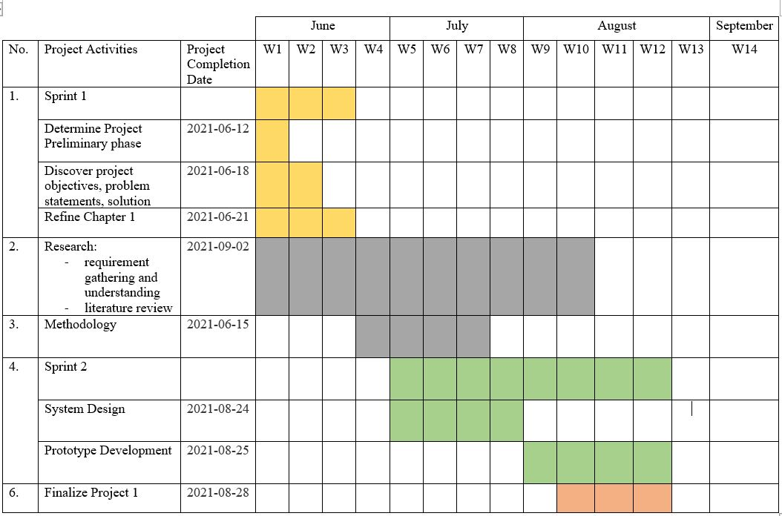

Figure 1.5: Gantt Chart (part 1)

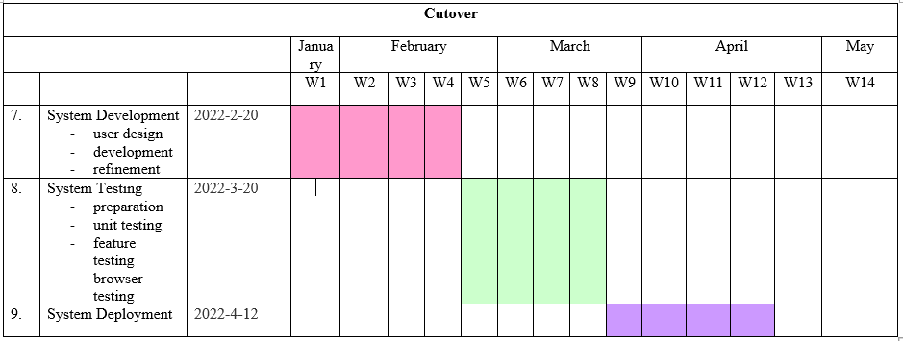

Figure 1.6: Gantt Chart (part 2)

## LITERATURE REVIEW

### Introduction

Literature review is determined to obtain deeper understanding on the areas related to web-based online veterinary appointment system. Hence, a series of reviews have been conducted on the online veterinary appointment system itself and its component, as well as the existing web-based appointment systems.

### Online veterinary appointment system

There are numbers of definitions for the term Online Appointment System, while the one stated in the following list are the most common definition for it.

* Allows user to avoid the hassle of queueing and filling out registration forms. Administrators can monitor and easy searching for records or personal information as it is available online. (Symey et al., 2013)
* Online scheduling has positive impacts in terms of reducing non-attendance rate, decreasing staff labour, decreasing waiting times, and improving satisfaction rate. (Yang et al., 2019)

#### Difference Between Paper Based Veterinary Appointment System and Online Veterinary Appointment System

As one of the common systems that are widely use within pet owners and animal clinic, the usage of traditional paper based veterinary appointment system are still being use in many animal clinics although web-based online veterinary appointment system is more efficient and convenient.

Symey et al. (2013) and Yang et al. (2019) has analysed the major characteristic that differentiate Online appointment system from Paper based appointment system. The differences will be shown in a table.

Table 2.1: Differences between Paper Based Appointment System and Online Appointment System

|  |  |  |
| --- | --- | --- |
|  | Paper Based Appointment System | Online Appointment System |
| Files and patient’s health record | Store in physical storage | Store in database |
| Queue time in clinic | Long | Short |
| Reminder for appointment | Yes, but not always | Yes |
| Complete registration in any location | No | Yes |
| Require deposit payment | Yes, in some cases | Yes |
| Available to all diagnosed symptoms | Yes | No |
| Time consumes to check availability of appointment | Long | Short |
| Customer able to check vet information in anytime | No | Yes |
| Non-attendance rate | High | Low |
| Staff labour needed | More | Less |
| Suitable for emergency cases | Yes | No, but will provide vet contact |

Through Table 2.1 above, Online Appointment System are more likely to bring conveniency for users than Paper Based Appointment System. However, Paper Based Appointment System are more precise on the diagnosed symptoms and emergency cases. Hence, different method has its own priority

#### Justification of Project Problem Statements

Waiting time is always the common topic that has been discussed in the appointment area, especially animal clinic appointment system. While there is very less online veterinary appointment system exist in Malaysia, time consuming will be longer as most of the animal clinic implement walk-in appointment system as known as paper-based appointment system. However, with the usage of online appointment system, waiting time will be dramatically decrease as customer will not have to go through many troubles to reach the animal clinic and the website of online veterinary appointment system are available 24 hours and 7 days per week (Mourshed, 2019; Yang et al., 2019; Symey et al., 2013; Idowu et al., 2014). According to Symey et al. (2013), the average waiting time for walk-in customer has increased 45 minutes yearly per patient. Hence, implementing online appointment system for veterinary area will be a great improvement on decreasing waiting time.

Retrieving clinic’s information such as operating hours, clinic operation time slots and vet information are a critical issue for customer. Walk-in customer has trouble on searching for the information they want, for example, customer only know the clinic is closed after they reached their destination which is a troublesome burden. Nevertheless, in an era of rapidly changing digital technologies, online appointment system can reduce all the troublesome to be gone through for walk-in customer and elicit general information of the clinic and availability of booking time slots require by customer (Symey et al., 2013; Mourshed, 2019; Zhang et al., 2012). Being able to access to the animal clinic website are said to be greatly improve customer satisfaction (Yang et al., 2019) and improve the quality of service in the area of animal health care (Idowu et al., 2014).

Attendance rate of customer are inconsistent for walk-in appointment system. This is because there is no penalty for the absent customer. However, by using deposit function in online veterinary appointment system, it will bring a positive impact in term of reducing non-attendance rate (Yang et al., 2019) as there will be penalty for absent customer. Deposit will still be charged even though customer absent on the booked appointment time. Hence, this system helps in managing customer and clinic operation flows by scheduling the appointments (Symey et al., 2013).

### Existing Online Veterinary Appointment System

The reviews of existing Online Veterinary Appointment System prioritize the functions that are relevant to the scopes of this project, which are the customer and admin modules. Evaluation on these systems will be based on their User Interface (UI), strengths, limitations, and workflows in managing appointment.

#### SuperSaas

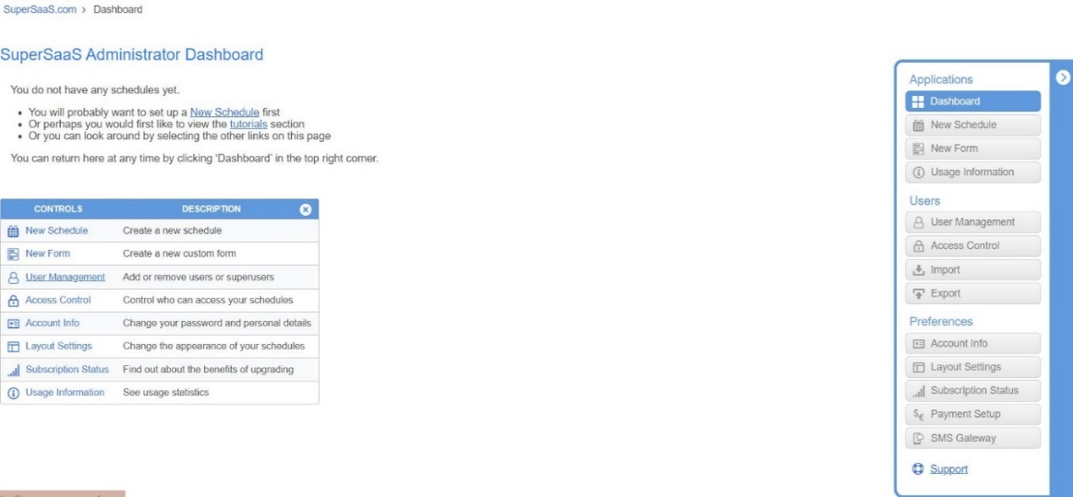SuperSaas is an online appointment system that allows admin to access multiple functions. In this section, the core functions of SuperSaas will be evaluated using the admin role.

Figure 2.1: SuperSaas Dashboard

Figure 2.1 show the dashboard after user logging in as administrator, the user will see a administer dashboard. The navigation bar at right side provides link for admin user to customize the website.

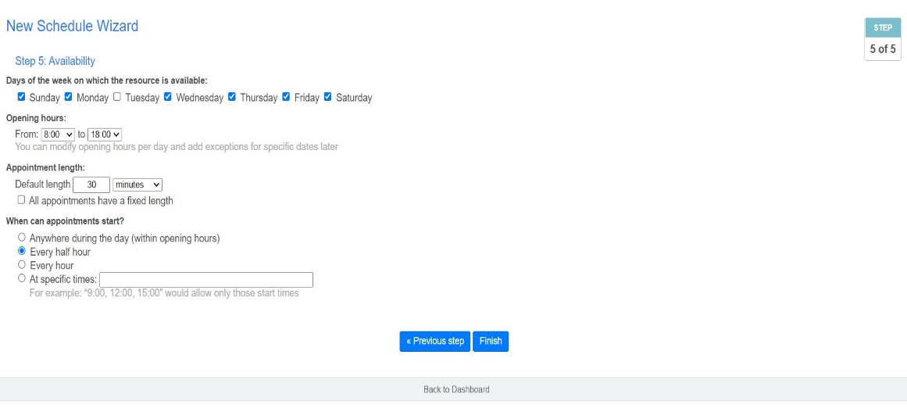 Figure 2.2: SuperSaas New Schedule

Figure 2.2 shows that administrator can create a new schedule. There is a few steps to start create a new schedule for customer to make appointment, which only can be done by administrator. After selecting the format of the schedule, admin user can set the name for the new schedule, fill up the operating hours of the clinic and choose the time available for customer make appointment.

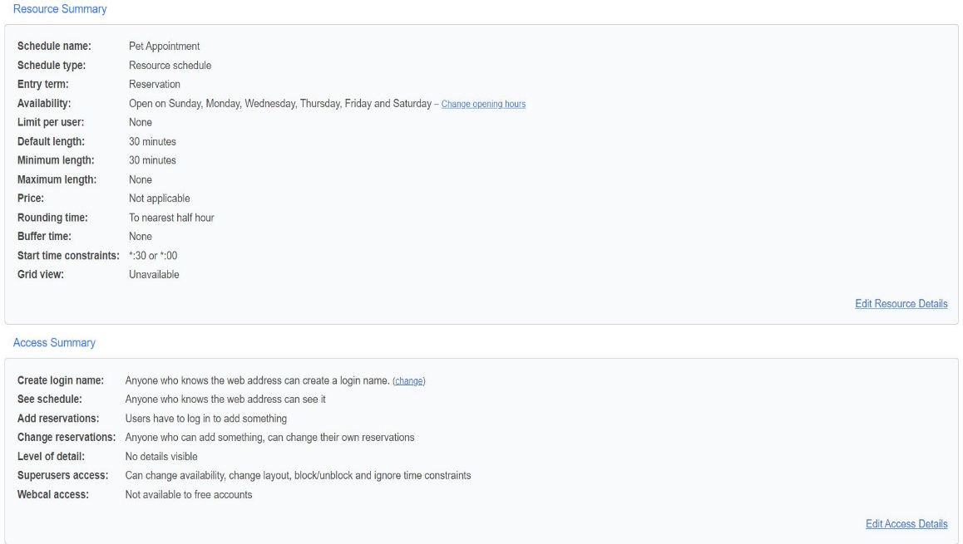

Figure 2.3: SuperSaas Configure Schedule

Figure 2.3 shows the configuration on schedule. When a schedule is created, administrator can modify the existing schedule by clicking “Configure” button on the schedule. Admin user can edit everything about the schedule such as changing the operation time, modify the default appointment duration etc.

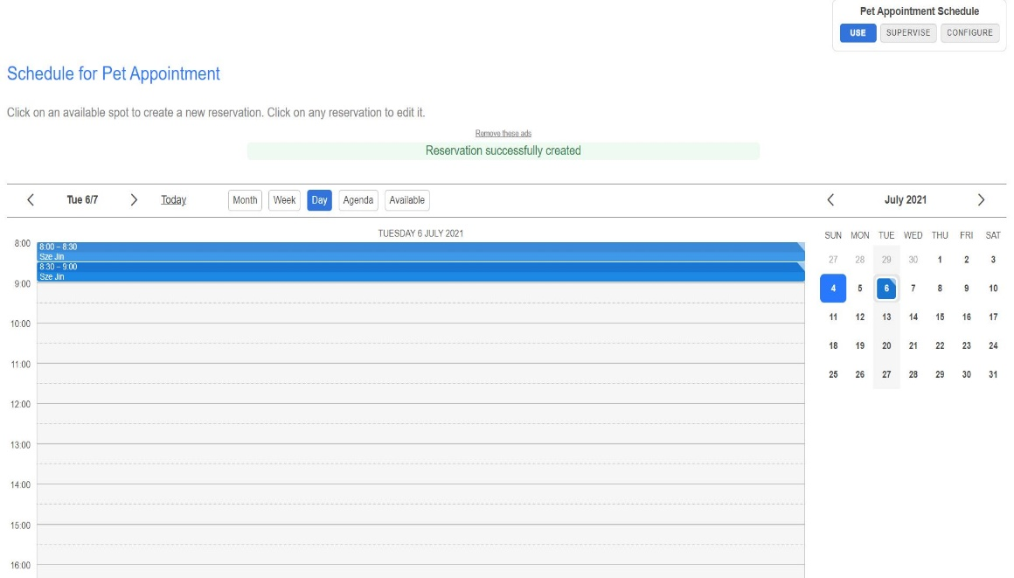

Figure 2.4: SuperSaas Appoint Customer to Schedule

Figure 2.4 shows that admin user are able to appointment customer to a time slot in the schedule by clicking “Use” button on the schedule. Admin user can assign the appointment by choosing the date from the calendar and click on the time.

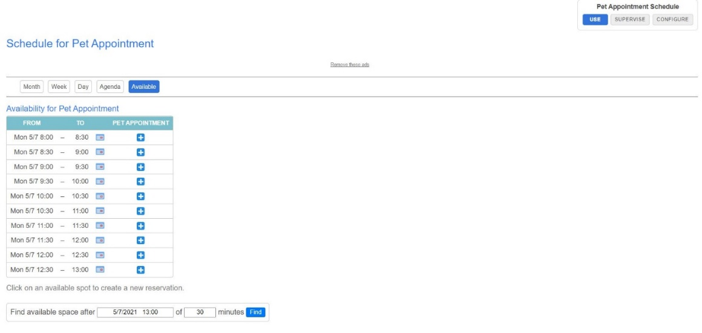Figure 2.5: SuperSaas Available Time Slot

Figure 2.5 shows that admin user can check the available time slot based on the date and search for availability by date and time.

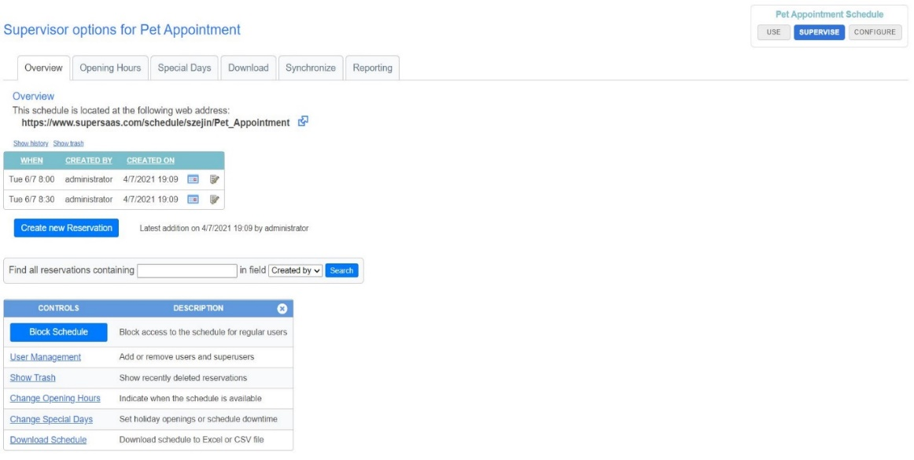Figure 2.6: SuperSaas Supervise Schedule

Figure 2.6 shows the supervise schedule page. In this supervise page, administrator are able to edit the settings for the schedule, and view all the booked appointment details.

***Strengths***

* Easy to use
* Detailed information of appointment
* Able to create various kind of schedules
* Tutorial provided

***Limitations***

* Limited number of registration of users for free version
* Less attractive user interface
* Pay to get ad free and larger storage

#### TimeTap

TimeTap, developed by Lumaverse Technologies (2006) is an appointment scheduling website, it is known for its versatility to be used in almost any industry. TimeTap have a record of users vary from one individual to medium sized businesses. The website allows their users to have a flexible calendar along with unlimited number of appointments per month, enable them to tweak their 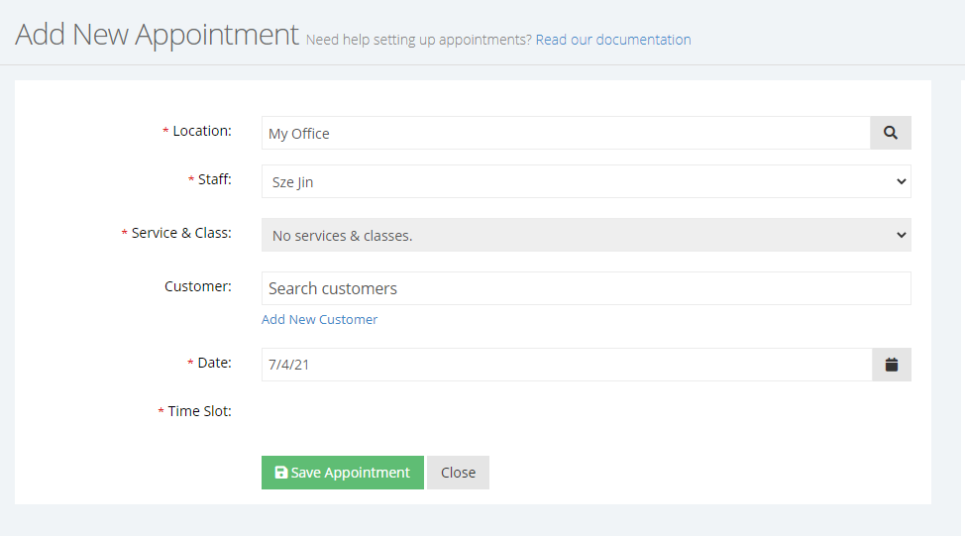schedules to suit their own needs.

Figure 2.7: TimeTap New Appointment

Figure 2.7 shows that administrator add new appointment for customer. When using TimeTap to add new appointment, the admin user will be able to fill in the information about the appointment according to the space labelled. Information such as customer name and date will be recorded down at this stage to ensure the clarity of the appointment. TimeTap also made sure information that is necessary to the creation of the appointment is highlighted with a red star beside the label.

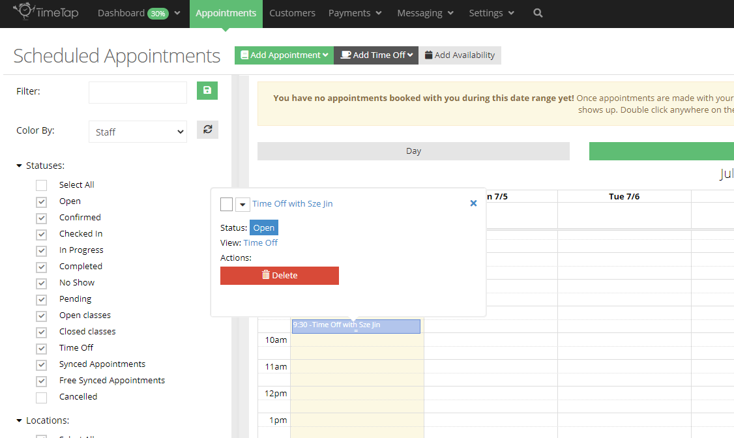 Figure 2.8: TimeTap Scheduled Appointments

Figure 2.8 shows the appointment list according to time and date.

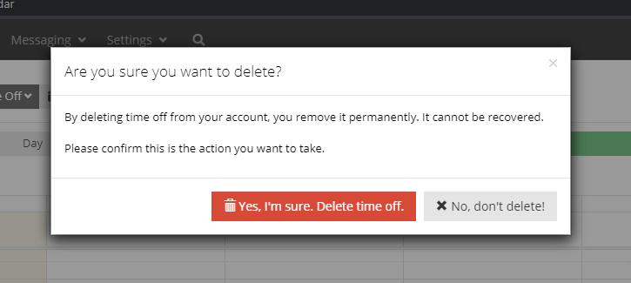

Figure 2.9: TimeTap Delete Confirmation

Figure 2.9 shows the delete confirmation of deleting an appointment. At TimeTap Scheduled Appointments module, the admin of the account has the permission to click on an appointment previously made and have the option to delete the schedule. An alert box will pop out after the delete button is clicked to prompt for confirmation from the admin. All delete button is in red color to increase the awareness of the admin on the decision.

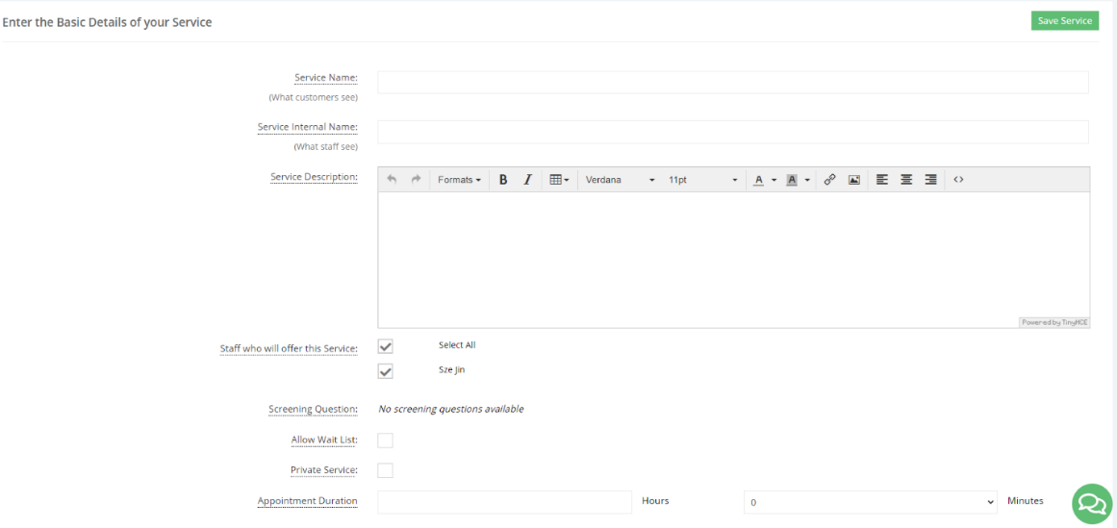

Figure 2.10: TimeTap Declaring Service

Figure 2.10 shows the services available. TimeTap allow the admin to declare and configure the service they provide that can later be added to appointment. Within this service declaration, information such as duration, description and staff involved can be setup to give their customer a better idea of what the service are.

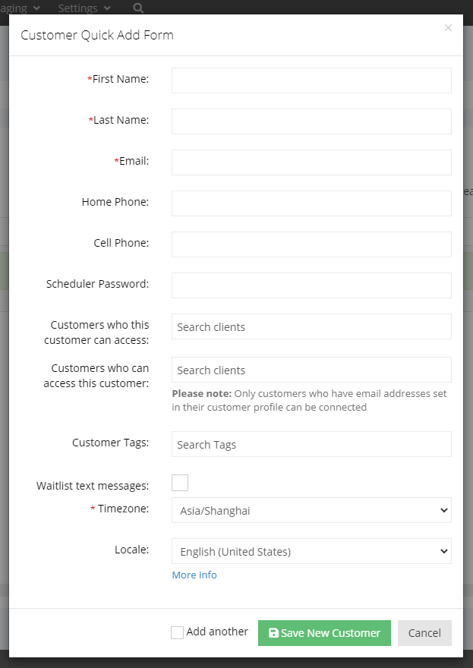

Figure 2.11: TimeTap Adding Customer

Figure 2.11 shows customer adding form for administrator. Admin user are able to add customer into their database for more efficient appointment making in the future. The information of the customer is stored securely in the database and can be used during the creation of a new appointment when needed, this would make sure the workflow is smooth.

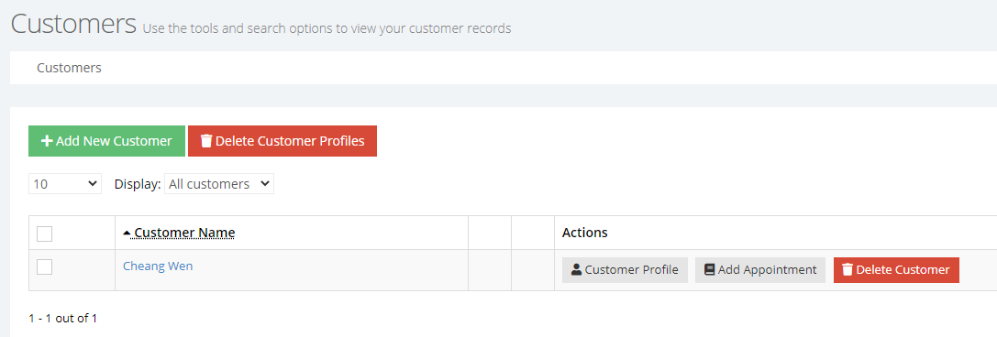

Figure 2.12: TimeTap Deleting Existing Customer

Figure 2.12 shows the customer deleting page. TimeTap has a customer page where all saved customer details are shown and admin will be able to take action from this page. Admin will have the option to configure customer profile, add appointment for that particular customer or delete the customer from database

***Strengths***

* Clear and direct user interface
* Appointment details can be easily viewed
* Service for each appointment can be configured in detailed
* Individual customer’s detail can be stored
* Provide documentation for ease of use

***Limitations***

* Costly monthly subscription
* Long loading time between modules

### Brief explanation between Three Different Software Development Life Cycle (SDLC) Methodologies

Table 2.2 below shows a brief characteristics of the three model.

Table 2.2: Differences Between Waterfall, V-shaped, and SCRUM

|  |  |  |
| --- | --- | --- |
| Waterfall Model | V-shaped model | SCRUM model |
| Development is sequential | Development is sequential | Development is overlapping |
| Rigid | Rigid | Very flexible |
| Cost is low | Cost is high | Cost is low |
| Not good for complex and object-oriented project | Not good for complex and object-oriented project | Good for complex and object-oriented project |
| Has defined stages | Has defined stages | No defined stages |
| Does not accept changes on requirement | Accept changes but requires documentations update | Accept changes easily and rapidly |

#### Waterfall Model

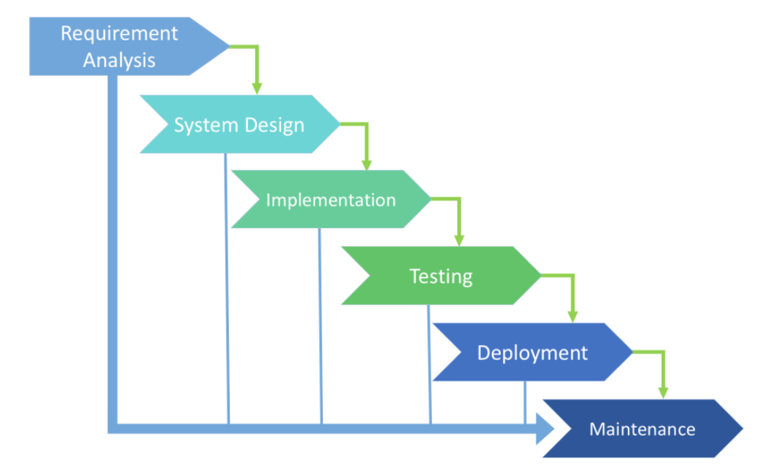

Figure 2.13: Waterfall model (Existek, 2017)

Figure 2.13 shows the overview of waterfall model. Waterfall model looks like a flow of water, step-by-step phases of development processes. Phases included “Requirement analysis”, “System Design”, “Implementation”, “Testing”, “Deployment”, and lastly “Maintenance”. This SDLC model strictly follow the flow of phases and needed the previous stage to be done to move on to the next phase. The requirements need to be precisely documented at the initial stage as it is not allowed to make changes in any stage.

#### V-shaped Model

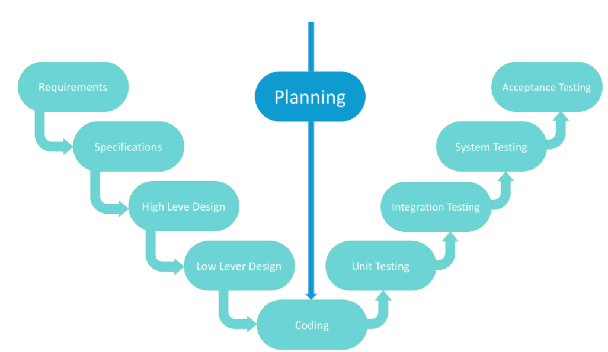

Figure 2.14: V-shaped model (Existek, 2017)

Figure 2.14 shows the overview of V-shaped model. V-shaped model is expanded from classic waterfall model. Every development stage has their own testing method. This is a strict model that requires previous stage to be done to start moving to next stage. V-shaped model is also called “Validation and verification model”. Accurate product testing is needed for a project using this model. Requirements strictly need to be predefined during the initial stage.

#### SCRUM Model

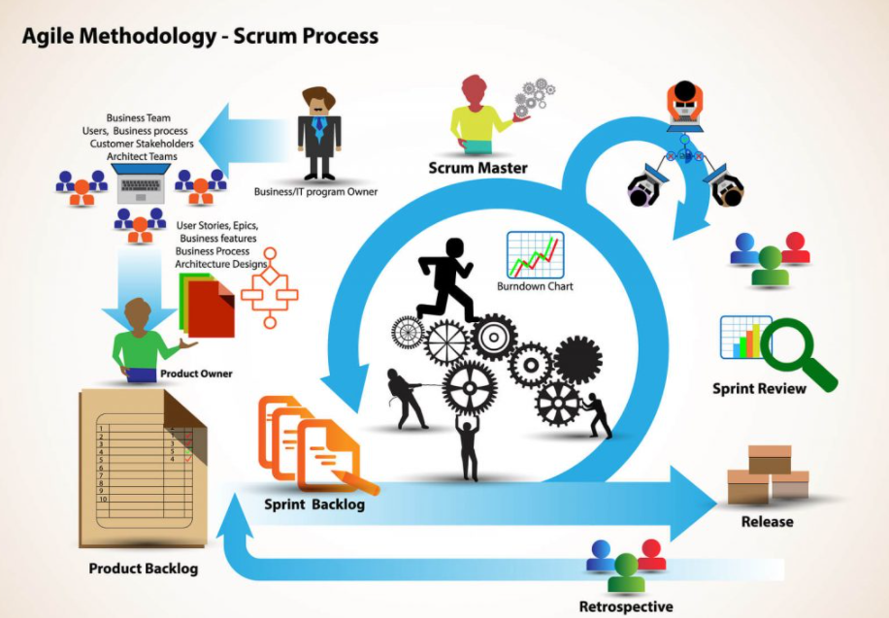

Figure 2.15: SCRUM model

Figure 2.15 shows the overview of SCRUM model. SCRUM model is an evolution of Agile model, it divided large work into smaller parts called “Sprint”. SCRUM is flexible on making changes in any stage as all the member inside a SCRUM team will be working simultaneously. There are three main role in this methodology, SCRUM Master is the leader of the SCRUM team, their responsibility is to guide the team to comply the rules and processes of the methodology. Product owner represent the stakeholders and customer who use the software to translate the vision of the project to the team. Lastly, a group of professionals gathered as a Team and develop the project and carry out their responsibilities in each Sprint.

### Summary

Based on the reviews of existing online veterinary appointment system, few useful features and functionalities were identified from those platforms. This includes attractive user-friendly UI, ability to search for booked appointment, ability to edit appointment schedule. On the other hand, after reviewing the five journal articles to justify the problem statements of this project, a major factor of conveniency and efficiency are greatly increase by using online veterinary appointment system are proved.

## METHODOLOGY AND WORK PLAN

### Introduction

Methodology to be followed in this project is important as it act as the backbone of this project. A brief image of the three methodologies has been discussed in the last chapter. Hence, the methodologies will be discussed deeper in this chapter and comparison will be made to find out the most suitable methodology for this project. Analysis of survey result and work plan will also be discussed in this chapter.

### Development Methodology

Laborious selection of methodology for the development of the system is the key to ensure the favourable outcome of a software project. The following methodologies, which include waterfall model, V-shaped model, and SCRUM model were evaluated based on their advantages, disadvantages, and characteristics.

#### Waterfall

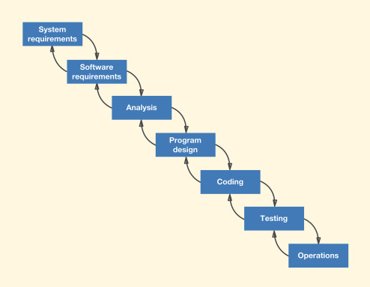

Figure 3.1: Waterfall Model Life Cycle

The waterfall model is a sequential development model, with each phase of development process move accordingly without overlapping (Balaji and Murugaiyan, 2012). Each phase ended with documentation and testing in order to maintain the quality of the project and also avoid heading back to the previous stage because of incomplete information. A deadline is given for each phase to complete the task within specific time. This model is not suitable for project that requires a lot of changes in requirements as the requirement phase should be freeze before moving on to analysis phase.

Table 3.1: Pros and Cons of Waterfall Model (Mahalakshmi and Sundararajan, 2013)

|  |  |
| --- | --- |
| Advantanges | disadvantages |
| Easy to implement because it is linear model. | Rework when problem happens in each phase is costly. |
| Minimal amount of resource is required. Less cost and save time. | Requirement cannot be change. |
| Proper documentation for each stage. | Long delivery time. |

#### V-Shaped

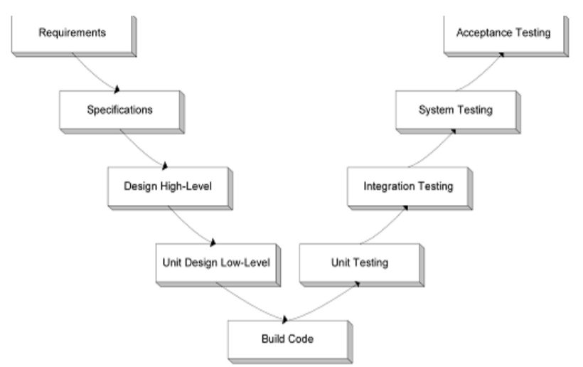

Figure 3.2: V-Model Life Cycle (Balaji and Murugaiyan, 2012)

V-model full name is “Validation and Verification Model”, it is an adapted version of waterfall model. It is different with waterfall model as it is not linear and after the coding phase, it turns upwards again. Left side of “V” represents “specification phase”, right side of “V” represents “testing phase”, they meet at the bottom which represents “development phase” (Balaji and Murugaiyan, 2012). This model relies on verification from the previous stage before moving to another stage, this shows the balancing of the development process. Developer and tester work simultaneously in this model. Different type of test cases is prepared based on the requirements, high-level documentation (HLD), and low-level documentation (LLD). Integration test cases are prepared based on HLD and LLD, system test cases are prepared based on requirements. Testing stages proceed in sequence once the coding phase is completed. Since V-shaped model requires large amount of resources, it is mostly used in large organization.

Table 3.2: Pros and Cons of V-Model (Nugroho et at., 2017; Balaji and Murugaiyan, 2012)

|  |  |
| --- | --- |
| Advantanges | disadvantages |
| Easy to implement, straight forward. | Rigid and less flexible. |
| Test is done from the beginning, higher succeed rate. | Test and requirement documentations requires update if changes happen in midway. |
| Requirement changes can be done in any phases | Long delivery time, requires review on each stage. |

#### SCRUM

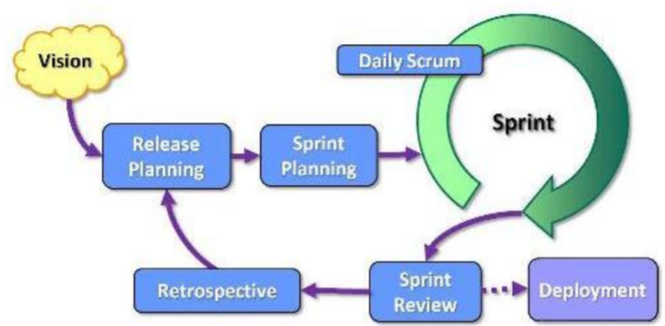

Figure 3.3: SCRUM methodology (Mahalakshmi and Sundararajan, 2013)

SCRUM was introduced by Ken Swaber in 1995. It is a team-based methodology, everyone in the team works together simultaneously. It was one of the agile methodologies as they both has the same concept. Comparing traditional Software Development Life Cycle (SDLC), SCRUM has very less documentation and simpler to adopt (Mahalakshmi and Sundararajan, 2013). Different SCRUM roles have their own responsibilities, product owner act as customer representative and middleman between the team and business. They have the responsibilities to evaluate the work result and adjust the features, in charge of product release date, profit, and content. SCRUM master is the leader of the team, they are responsible for the daily SCRUM and sprint planning meetings, managing work process, removing the obstacles during the work process, and maintain required documentations. SCRUM team is made up from developers, testers, UX/UI designers, etc. They are responsible to develop product by contributing their work in each sprint.

Table 3.3: Pros and Cons of SCRUM model (Mahalakshmi and Sundararajan, 2013)

|  |  |
| --- | --- |
| Advantanges | disadvantages |
| Responsive to customer requests. | Less documentation. |
| Accept changes easily, very flexible. | Needing of team members commitment. |
| Fast process. | Crucial teamwork. |

#### Conclusion

After a series of comparison between the three software development methodologies, SCRUM was decided to be adopted in the project “Online Veterinary Appointment System”. There are few reasons that finalized this decision. First of all, SCRUM is very flexible for requirement changes as this project might be adding some features during the development process. Its tolerance allows developer to refine the formerly stated requirements and work overlapping in the system. SCRUM model is suitable for any kind of project. As this project is considered in a tight schedule, SCRUM model assists the team in achieving milestones rapidly within deadlines. Each sprint in SCRUM is considered as a small project, shorter sprint is able to produce quality results and reach milestones in a short period. The key features of the project can be done in a sprint within a short period of time.

### Research Methodology

The research methodology has been adopted in this project is by using the questionnaire which is a type of quantitative research method. The questionnaire contains both closed-ended and open-ended questions. Due to the reason of this pandemic and for the respondents’ conveniency, internet questions method was adopted. Another two methodologies that has been adopted in this project are literature review as quality research method and SCRUM model.

Respondents are invited to participate in the questionnaire through email, internet questionnaire used in this project is Google Form. The benefits of using internet questionnaire are it can prevent bias from interviewer or conductor of the questionnaire, low cost and is easy to administer (Roopa and Rani, 2012). Questionnaire method was first introduced by Statistical Society of London in 1838.

#### Introduction of the Questionnaire

This research questionnaire is targeted to gain further comprehension on booking appointment through clinical website based on the respondents’ experiences. The purpose of developing this questionnaire is to justify the problem statements stated in chapter 1. The nature of the questionnaire is semi-structured where predefined yes/no questions and respondents’ opinion are asked. The development process of this questionnaire is selection of participants, development of questions regarding to the project software, and interpretation of responses collected.

The criteria on selection of respondents are quite simple, which is they need to have experienced on clinical appointment booking, either manually or through online. Since the online veterinary appointment system are quite similar with human clinical appointment system, respondent of this questionnaire can be either currently owning a pet or not. There is a total of 25 participant in this questionnaire. The involvement of respondents in this research questionnaire is absolutely voluntary and the information and answers gathered are to be used in this research anonymously.

#### Research Limitations

There were few limitations that restrained the research from acquiring preferable level of accuracy in the information. Due to this pandemic, it is unable to monitor the way of how respondents answered the questionnaire. Hence, there are quite few numbers of respondent who seriously answered the open-ended questions. Since there are not much who answered the open-ended questions seriously, the results of open-ended questions obtained may not be able to define a good analysis.

#### Questionnaires Results and Findings

***Experience on using Online Appointment System from any clinic/hospital website and the opinion.***

Majority of respondents did not experience using online appointment system for clinic/hospital. This is because most of the clinic/hospital in Malaysia does not apply web application or mobile application for their appointment system.

One of the respondents has experienced using Online Appointment System from clinic/hospital and are said to be having good impression with the system, as the system saves a lot of waiting time. People nowadays tend to be busy with different kind of work, hence, having an online web application that allows user to book appointment would help users to save up the blank time.

***Try new method on making appointment through clinic/hospital website and preferable interface design.***

A total of 60% of respondents would like to make appointment through clinic/hospital official website, as this type of system considered a new to them because Malaysia is lacking online appointment system in medical field.

Majority of respondents choses monochromatic interface design of the website as the design looks simple yet interesting. While 40% of respondents prefer minimalist interface design as minimalist design is simple and comfortable to look at. And a minority of respondent choses colourful interface design for the interface of the website as it is fun and easier to catch on user’s eyes.

***Waiting time spent for the process of making appointment manually. By email, walk-in, phone call, etc.***

Majority of respondents experienced waiting time for their appointment more than five minutes, as manually making appointment consumes a lot of waiting time. This could cause dissatisfactory for customers as they wasted their time to wait.

Over half of the respondents agreed that waiting time is long for manually making appointment. This is due to the consuming of time when trying to reach to the clinic/hospital to make an appointment and the time to wait for responses from the clinic/hospital. Unlike accessing to websites, where users can just click to choose available slots and get email reminder.

***Checking available appointment slots through animal clinic’s official website.***

All the respondents would prefer the animal clinic shows availability of slots for booking in their official website due to the reason of avoiding troublesome to contact with people. Many people nowadays have personality that would rather not to contact with others as much as possible as they think it is disturbing. Showing availability slots for booking in animal clinic official website would bring conveniency to customers as many customers can access and book the different available slots at the same time without the need of queueing and waiting others to complete their appointment booking process in the front desk.

***Dissatisfaction when being asked to wait after appointment made.***

Most of the respondents would feel dissatisfy when the animal clinic requests them to wait even after they have drove to there and made an appointment, while minority of the respondents would feel it is normal. Most of the customer would like the animal clinic to serve them as soon as possible after the appointment made based on time management principle. The animal clinic is irresponsible if the customer has to wait without a specific time after they have made an appointment, due to the waiting time might be long and pass the appointment time.

***Obtaining animal clinic information (operating hour, contact number, email, vet information, etc.) from internet.***

Customers tends to get information of animal clinic through internet as it is convenient. Most of the information can be searched through Google and the users would review and update information about the animal clinic. All of the respondents appears to be able to get animal clinic information through internet.

However, majority of the respondents did not get correct information about the animal clinic from the internet. Reason behind this is internet information can be modified by any user because it is not secure. Another reason is the animal clinic might not know or care about their profile being updated by the netizen. However, there are some who can get proper information they want from the animal clinic through the internet. Internet has the possibility to give false information.

Moreover, most of the respondents have experienced the animal clinic was closed after they have arrived their destination due to the animal clinic did not update their operation hour frequently. Another reason is the vet had emergency cases hence the animal clinic was forced to closed at that time. Emergency cases are unavoidable, but animal clinic should update their information frequently to the internet as it is concern about the safety of pets. Some of the respondents said they will call beforehand to make sure the animal clinic is operating at the time they go.

***Making appointment through animal clinic’s official website with reason(s) of visiting.***

All respondents would prefer to make appointment by themselves through the animal clinic’s official website as it could save a lot of time and reduce troublesome process. In fact, many people prefer to book appointment online through the available slots updated by the animal clinic as it is convenient and simple, checking and booking available slots through their official website would feel more secure and reliable.

Besides that, the respondents think the idea of choosing reason of visiting when booking appointment through the animal clinic’s official website is an excellent idea. Vets are able to prepare early hand if they get the information of the pet earlier. This would encourage the vets to diagnose the illness and issue of the pets more precisely if they roughly knew the condition of pets in beforehand. In some cases, some vets would simply diagnose their patients during peak hour as they just want to end the appointment as soon as possible. However, with this function of letting pet owner to choose the reason of visiting, cases of misdiagnose can be reduce.

***Obtaining animal clinic’s contact through their official website when having emergency cases.***

Majority of the respondents would prefer to search for animal clinic’s contact from their official website due to the information would be more accurate and safer if it is officially from the animal clinic’s website. Many of the animal clinic in Malaysia does not have their own official website, internet users might conduct pages for them in Facebook, Instagram, or uploading their information in Google. However, most of the pages are not updated by the animal clinic but the customers. Hence, it is more secure to conduct their own website and update their information there frequently as customers would feel more secure for them to retrieve the contact of animal clinic during emergencies.

The respondents agreed that it is more secure for them to obtain contact number of animal clinic through their official website during emergencies. This is because information from other non-official sources is not updated frequently and not secure as other users of internet could modify it anytime. And it is more convenient to get accurate information from official website rather than searching through a lot of sources with different accuracy of information about the animal clinic. During emergencies, pet owners are lack of time to search for accurate information, thus, accessing to animal clinic’s official website is the easiest way to get the most accurate contact.

***Deposit payment avoids decreasing of attendance rate.***

Majority of the respondents are not willing to pay deposit to make appointment through animal clinic’s official website. Indeed, customers or consumers would prefer saving cost than risking anything that would not benefit them. However, there are 92.9% of respondents who agrees that deposit on appointment would highly decrease the absence rate of customers as a kind of consumer’s psychological effect to not lose anything. By receiving deposit from customers, animal clinic could avoid losses.

### Work Breakdown Structure

1.0 Sprint 1 – Determine project preliminary phase

1.1 Project background investigation

1.2 Project problem study

1.3 Determine project objectives

1.4 Project solution proposal

1.5 Sprint 1 discovery – problem statements, objectives, solutions

1.6 Sprint 1 refining

2.0 Requirements Planning

2.1 Project scope definition

2.2 Literature review

2.2.1 Problem statements analysis

2.2.2 Review existing system

2.2.3 Methodologies research

2.3 Select system development approach

2.3.1 Analysis on methodologies

2.3.2 Determine quantitative approach

2.3.3 Determine development tools

2.4 Quantitative approach

2.4.1 Develop questionnaire

2.4.2 Collect respondent answer

2.4.3 Analysis on result

2.5 Define system requirements

2.5.1 Functional requirements

2.5.2 Non-functional requirements

3.0 Sprint 2 - System prototyping cycle

3.1 Create UML diagrams

3.2 System design

3.2.1 Analysis requirements

3.2.2 Prototype development

3.2.3 Prototype demonstration

3.2.4 Collect feedback on system

3.2.5 Analysis feedback

3.3 System development

3.3.1 Develop functions

3.3.2 Unit testing

3.3.3 System integration

3.4 Sprint 2 refining - System refinement

3.4.1 Analysis system improvement area

3.4.2 Refine system requirements

3.4.3 Refine system

3.5 Sprint 2 discovery – system requirements, user requirements

4.0 System implementation

4.1 Testing phase

4.1.1 Test planning

4.1.2 Unit testing

4.1.3 Feature testing

4.1.4 Browser testing

4.2 System deployment

### Development Tools and Technologies

#### WampServer

WampServer is a Windows web development platform that allows user to create dynamic web application with the following programming languages: PHP, Apache2, MySQL, HTML, CSS, JavaScript.

#### Visual Studio Code

Visual Studio Code is developed by Microsoft and its main features is debugging, IntelliSense code completion, and build-in Git. There is large number of extensions can be installed by user with easy installation steps, according to user’s needs.

#### phpMyAdmin

phpMyAdmin is a database browser that attached in WampServer. It allows user to create database, create table and other SQL query without coding. It is simple to use and easier to perform SQL operations.

#### Enterprise Architect

Enterprise Architect is a development tool that let users to illustrate many options of diagrams such as Activity diagram, Class diagram, Use case diagram, Sequence diagram and so on. It is simple to use and user friendly.

## PROJECT INITIAL SPECIFICATION

### Requirements Specification

#### Functional Requirements

1. User shall be able to log in with email and password.
2. User shall be able to log out.
3. Customer user shall be able to sign up new account with valid email and password.
4. Customer shall be able to update their profile.
5. System shall provide navigation bar that allows user to navigate between different pages of the website.
6. System shall provide pet care articles for user to gain more knowledge about pet caring.
7. System shall show different navigation link and pages with the log in of different user.
8. Customer shall be able to request appointment with the input of pet’s name, customer’s name, appointment date, appointment time, and reason of visiting.
9. Customer shall be able to make transaction for appointment deposit after requested appointment has been approved.
10. System shall send automated email for customer after appointment request has been accepted.
11. System shall send automated email for customer after appointment request has been rejected.
12. System shall send transaction details email to customer after customer top-up their e-wallet.
13. Admin shall be able to accept and reject customer’s requested appointment.
14. Admin shall be able to view approved appointment list.
15. Admin shall be able to edit animal clinic’s operating time.

#### Non-functional Requirements

1. Usability
   1. The user interface of the website shall be responsive to different screen size.
   2. The user interface shall be easy to use for public within the year of 16 to 60 without training.
2. Performance
   1. The system pages shall be able to load within 5 seconds.
   2. The system shall be able to store requested appointment into database and notify user the appointment has been requested within 10 seconds.
3. Security
   1. The system shall only allow administrator user to view appointment list stated with customer and pet details.
   2. The system shall only allow administrator to accept and reject customer appointment request.
   3. The system shall perform encryption for user password.
4. Availability
   1. The system shall be able to achieve at least 90% of the uptime every day.
5. Correctness
   1. The system shall be able to retrieve data in the database correctly.
   2. The system shall be able to store data into the database correctly,
   3. The system shall be able to display the correct information for user with the correct data retrieved from database.

### Use Case

Figure 4.1 illustrated the use case diagram of this project, showing the interaction between the users and the project system. Each use case is supported with a use case description for better understanding in the flow of the module and interaction with the users.

#### Use Case Diagram

Figure 4.1: Use case diagram

#### Use Case Description

Table 4.1: Use case description – Log in

|  |  |  |  |
| --- | --- | --- | --- |
| Use Case: | Log in | Use Case ID: | U01 |
| Primary Actor: | Customer, Admin | Use Case Type: | Detail, Essential |
| Brief Description: | This use case describes how admin, vet and customer log in to the system. | | |
| Trigger: | Admin/Customer/Vet want to log in to the system. | | |
| Relationships: | - | | |
| Flow of events: | 1. Admin/Vet/Customer access to veterinary appointment website. 2. Admin/Vet/Customer type their username and password into the text box. 3. Admin logged in to admin dashboard. 4. Vet logged in to vet dashboard. 5. Customer logged in to customer dashboard. | | |

Table 4.2: Use case description – Sign up

|  |  |  |  |
| --- | --- | --- | --- |
| Use Case: | Sign up | Use Case ID: | U02 |
| Primary Actor: | Customer | Use Case Type: | Detail, Essential |
| Brief Description: | This use case describes how customer sign up for a new account. | | |
| Trigger: | Customer wants to sign up for an account to make appointment. | | |
| Relationships: | - | | |
| Flow of events: | 1. Customer visits the home page of the website. 2. Customer click to access book appointment page. 3. System direct customer to log in/sign up new account before making appointment. 4. Customer who do not own an account sign up new account. 5. Customer can make new appointment. | | |

Table 4.3: Use case description – Request appointment

|  |  |  |  |
| --- | --- | --- | --- |
| Use Case: | Request appointment | Use Case ID: | U03 |
| Primary Actor: | Customer | Use Case Type: | Detail, Essential |
| Brief Description: | This use case describes how customer make an appointment to visit the animal clinic. | | |
| Trigger: | Customer wants to book appointment for their pet to visit the animal clinic. | | |
| Relationships: | - | | |
| Flow of events: | 1. Customer logged in. 2. Customer click on “Book Appointment” page. 3. Customer choose appointment date, vet, and timeslot to book. 4. Customer fill in the information required to book an appointment. 5. Customer click “Submit” to request appointment. | | |

Table 4.4: Use case description – Deposit transaction

|  |  |  |  |
| --- | --- | --- | --- |
| Use Case: | Deposit transaction | Use Case ID: | U04 |
| Primary Actor: | Customer | Use Case Type: | Detail, Essential |
| Brief Description: | This use case describes how customer pay deposit after appointment request being approved. | | |
| Trigger: | Customer wants to establish approved appointment. | | |
| Relationships: | - | | |
| Flow of events: | 1. Requested appointment approved. 2. Customer received automated email about approved appointment and reminder to pay deposit within 24 hours. 3. Customer click on “E-wallet”    1. If E-wallet amount less than 20, customer unable to pay deposit and required to top up.    2. If E-wallet amount is sufficient, customer pay deposit.   4. Customer receive transaction success email.  5. Customer receive appointment detail email. | | |

Table 4.5: Use case description – Top-up E-wallet

|  |  |  |  |
| --- | --- | --- | --- |
| Use Case: | Top-up E-wallet | Use Case ID: | U05 |
| Primary Actor: | Customer | Use Case Type: | Detail, Essential |
| Brief Description: | This use case describes how customer top-up their E-wallet with payment gateway. | | |
| Trigger: | Customer wants to top-up their E-wallet. | | |
| Relationships: | - | | |
| Flow of events: | 1. Customer click on “E-wallet”. 2. Customer click on “Top-up” 3. System redirect customer to payment gateway. 4. Customer enter amount to pay. 5. Payment gateway validate customer payment. 6. When payment success, system update customer’s E-wallet amount. | | |

Table 4.6: Use case description – Edit profile

|  |  |  |  |
| --- | --- | --- | --- |
| Use Case: | Edit profile | Use Case ID: | U06 |
| Primary Actor: | Customer, Vet | Use Case Type: | Detail, Essential |
| Brief Description: | This use case describes how customer and vet update user profile. | | |
| Trigger: | Customer/Vet wants to update their profile. | | |
| Relationships: | - | | |
| Flow of events: | 1. Customer/Vet click on “Profile”. 2. System display customer user profile. 3. Customer/Vet click on “Edit”. 4. System redirect customer to “Edit profile” page. 5. Customer/Vet edit details and click on “Update”. 6. System redirect customer/vet to “Profile” page and display updated profile. | | |

Table 4.7: Use case description – Accept/Reject appointment request

|  |  |  |  |
| --- | --- | --- | --- |
| Use Case: | Accept/Reject appointment request | Use Case ID: | U07 |
| Primary Actor: | Admin | Use Case Type: | Detail, Essential |
| Brief Description: | This use case describes how admin accept and reject customer’s request appointment. | | |
| Trigger: | 1. Admin wants to accept requested appointment.  2. Admin wants to reject requested appointment. | | |
| Relationships: | Extend: View appointment | | |
| Flow of events: | 1. Admin check on appointment list. 2. Admin check pending appointment list. 3. Admin check with vet for their availability and accept requested appointment. 4. Admin reject requested appointment when vet is not available for the requested appointment. 5. Automated email of appointment status (accepted/rejected) send to customer. | | |

Table 4.8: Use case description – View appointment

|  |  |  |  |
| --- | --- | --- | --- |
| Use Case: | View appointment | Use Case ID: | U08 |
| Primary Actor: | Admin | Use Case Type: | Detail, Essential |
| Brief Description: | This use case describes how admin view accepted appointment list. | | |
| Trigger: | Admin wants to check accepted appointment. | | |
| Relationships: | Extend: Accept/Reject appointment  Include: 2 different vet appoinment | | |
| Flow of events: | 1. Admin view vet appointment page. 2. System display appointment list on selected vet appointment page. | | |

Table 4.9: Use case description – Modify user

|  |  |  |  |
| --- | --- | --- | --- |
| Use Case: | Modify user | Use Case ID: | U09 |
| Primary Actor: | Admin | Use Case Type: | Detail, Essential |
| Brief Description: | This use case describes how admin perform CRUD operation on user. | | |
| Trigger: | Admin wants to perform CRUD operation on user. | | |
| Relationships: | Extend: CRUD on customer/admin, Update vet | | |
| Flow of events: | 1. Admin select user list on dashboard. 2. Admin create new customer/admin. 3. Admin update existing customer/admin. 4. Admin delete customer/admin. 5. Admin update vet. | | |

Table 4.10: Use case description – Modify clinic info

|  |  |  |  |
| --- | --- | --- | --- |
| Use Case: | Modify clinic info | Use Case ID: | U10 |
| Primary Actor: | Admin | Use Case Type: | Detail, Essential |
| Brief Description: | This use case describes how admin modify clinic address and contact. | | |
| Trigger: | Admin wants to edit clinic operation info. | | |
| Relationships: | - | | |
| Flow of events: | 1. Admin click on “Edit operation details” page. 2. Admin modify clinic address and contact. 3. Admin click on “Update info” button. 4. New clinic info updated in “Clinic operation” page. | | |

Table 4.11: Use case description – 2 different vet appointment

|  |  |  |  |
| --- | --- | --- | --- |
| Use Case: | 2 different vet appointment | Use Case ID: | U11 |
| Primary Actor: | Admin | Use Case Type: | Detail, Essential |
| Brief Description: | This use case describes how admin can view different appointment list for 2 different vet. | | |
| Trigger: | Admin wants to view one of the vet’s appointment list. | | |
| Relationships: | Include: View appointment | | |
| Flow of events: | 1. Admin click on one of the two vet appointment page.  2. Appointment of the selected vet displayed. | | |

Table 4.12: Use case description – Update appointment status

|  |  |  |  |
| --- | --- | --- | --- |
| Use Case: | Update appointment status | Use Case ID: | U12 |
| Primary Actor: | Admin/Vet | Use Case Type: | Detail, Essential |
| Brief Description: | This use case describes how admin/vet can update appointment status to “completed”. | | |
| Trigger: | Vet completed the appointment. | | |
| Relationships: | - | | |
| Flow of events: | 1. Admin click on one of the two vet appointment page.  2. Admin update the appointment status to “completed” by clicking the button.  3. Vet view their appointment.  4. Vet update the appointment status to “completed” by clicking the button. | | |

Table 4.13: Use case description – View own appointment

|  |  |  |  |
| --- | --- | --- | --- |
| Use Case: | View own appointment | Use Case ID: | U13 |
| Primary Actor: | Vet | Use Case Type: | Detail, Essential |
| Brief Description: | This use case describes how vet can view their appointment after they signed in. | | |
| Trigger: | Vet wants to view their appointment. | | |
| Relationships: | - | | |
| Flow of events: | 1. Vet logged in to their account.  2. Vet click on appointment page.  3. Vet can view all their appointment with different status. | | |

Table 4.14: Use case description – CRUD on customer, admin

|  |  |  |  |
| --- | --- | --- | --- |
| Use Case: | CRUD on customer, admin | Use Case ID: | U14 |
| Primary Actor: | Admin | Use Case Type: | Detail, Essential |
| Brief Description: | This use case describes how admin can manage (create, retrieve, update, and delete) admin and customer user. | | |
| Trigger: | Vet wants to modify customer/admin user. | | |
| Relationships: | Extend: Modify user | | |
| Flow of events: | 1. Admin logged in to their account.  2. Admin click on “Manage Customer Users”.  3. Admin create new customer account, or modify existing customer user.  4. Admin click on “Manage Admin Users”.  5. Admin create new admin account, or modify existing admin user. | | |

Table 4.15: Use case description – Update vet

|  |  |  |  |
| --- | --- | --- | --- |
| Use Case: | Update vet | Use Case ID: | U15 |
| Primary Actor: | Admin | Use Case Type: | Detail, Essential |
| Brief Description: | This use case describes how admin can update vet user details. | | |
| Trigger: | Vet wants to modify customer/admin user. | | |
| Relationships: | Extend: Modify user | | |
| Flow of events: | 1. Admin logged in to their account.  2. Admin click on “Manage Vet Users”.  3. Admin update vet user details. | | |

### Class Diagram

Figure 4.2 illustrated the project system structure by moulding the object classes involved in the proposed system with the attributes, operations and relationships of each classes.

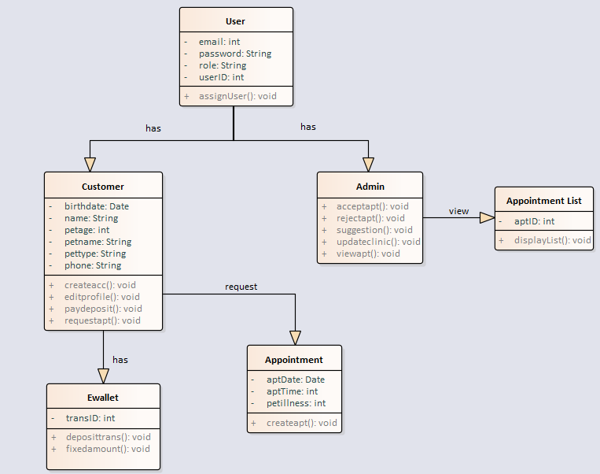 Figure 4.2: Class diagram

### Database Design

Entity Relationship Diagram (ERD) are being used to illustrate the database design of this proposed system. ERD in Figure 4.3 illustrates the relationship between entities of the proposed system. The description of the data of each table is stated in the data dictionary.

#### Entity Relationship Diagram (ERD)

Figure 4.3: Entity Relationship Diagram (ERD)

#### Data Dictionary

Table 4.11: Data dictionary – users table

|  |  |  |  |  |  |
| --- | --- | --- | --- | --- | --- |
| Attribute | Description | Data type | Nullable | PK/FK | Reference table |
| id | Unique identification for each user | INT (11) | NO | PK | - |
| role_id | The user role that identifies user type. | INT (11) | NO | FK | roles |
| username | The username of user account | VARCHAR (255) | NO | - | - |
| email | The email address of user | VARCHAR (255) | NO | - | - |
| password | The password of user | VARCHAR (255) | NO | - | - |
| created_at | The date and time when the user account was created | TIMESTAMP | NO | - | - |

Table 4.12: Data dictionary – role table

|  |  |  |  |  |  |
| --- | --- | --- | --- | --- | --- |
| Attribute | Description | Data type | Nullable | PK/FK | Reference table |
| id | Unique identification for each role | INT (11) | NO | PK | - |
| name | The name of the role | VARCHAR (255) | NO | - | - |
| description | The description of the role | TEXT | NO | - | - |

Table 4.13: Data dictionary – ewallet table

|  |  |  |  |  |  |
| --- | --- | --- | --- | --- | --- |
| Attribute | Description | Data type | Nullable | PK/FK | Reference table |
| id | Unique identification for each user’s e-wallet | INT (11) | NO | PK | - |
| user_id | The unique identification for user | INT (11) | NO | FK | users |
| total | The total amount in the user’s e-wallet | DOUBLE (10,2) | NO | - | - |

Table 4.14: Data dictionary –clinicop table

|  |  |  |  |  |  |
| --- | --- | --- | --- | --- | --- |
| Attribute | Description | Data type | Nullable | PK/FK | Reference table |
| id | Unique identification for clinic information | INT (11) | NO | PK | - |
| clinic_add | The address of the clinic | TEXT | NO | - | - |
| clinic_contact | The contact number of the clinic | TEXT | NO | - | - |

Table 4.15: Data dictionary – transacion table

|  |  |  |  |  |  |
| --- | --- | --- | --- | --- | --- |
| Attribute | Description | Data type | Nullable | PK/FK | Reference table |
| id | Unique identification for each transaction | INT (11) | NO | PK | - |
| amount | The transaction amount | DOUBLE (10,2) | NO | - | - |
| created_at | The date and time when the tracsaction is made | TIMESTAMP | NO | - | - |
| user_id | The unique identification of the user | INT (11) | NO | FK | users |

Table 4.16: Data dictionary –bookings table

|  |  |  |  |  |  |
| --- | --- | --- | --- | --- | --- |
| Attribute | Description | Data type | Nullable | PK/FK | Reference table |
| id | Unique identification for each appointment | INT (11) | NO | PK | - |
| user_id | The unique identification for user | INT (11) | NO | FK | users |
| name | The name of the pet owner | VARCHAR (25) | NO | - | - |
| petname | The name of the pet going for appointment | VARCHAR (20) | NO | - | - |
| pettype | The type of pet going for appointment | VARCHAR (25) | NO | - | - |
| reason | The reason of making appointment | VARCHAR (25) | NO | - | - |
| date | The date of appointment | VARCHAR (25) | NO | - | - |
| timeslot | The timeslot of the appointment | VARCHAR (50) | NO | - | - |
| vet | The chosen vet for appointment | VARCHAR (20) | NO | - | - |
| contact | The contact number of the pet owner | VARCHAR (20) | NO | - | - |
| approval | The status of the appointment | VARCHAR (10) | NO | - | - |
| created_at | The date and time when the appoitment is made | TIMESTAMP | NO | - | - |

### Activity Diagram

Each activity between the user and system is described using Activity Diagram. It illustrates the flow of interaction between the user and the system with processes link to each other.

#### Log In

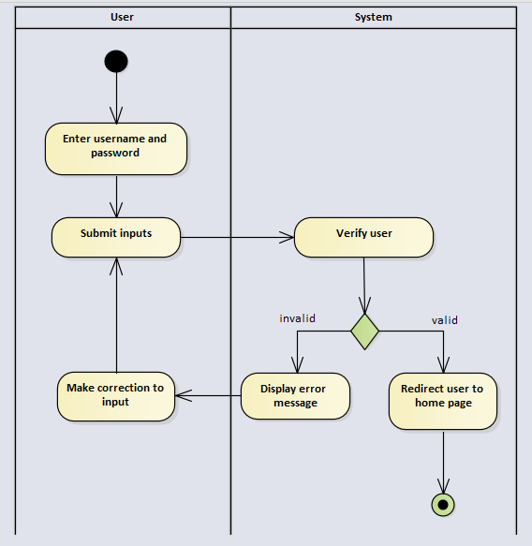

Figure 4.4: Activity Diagram – Log In

#### Book Appointment

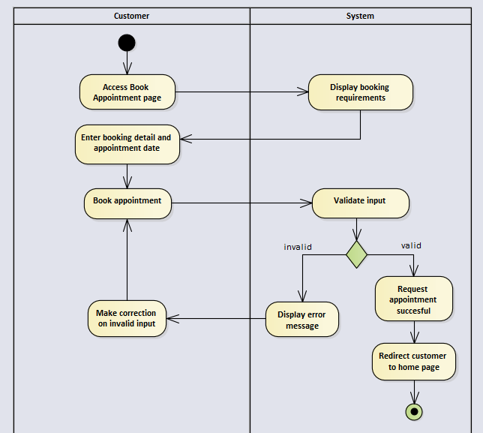

Figure 4.5: Activity Diagram – Book appointment

#### Pay Deposit

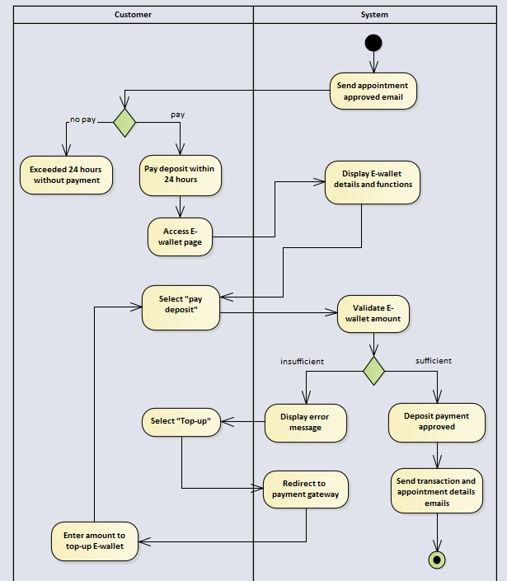

Figure 4.6: Activity Diagram – Pay deposit

#### Top-up E-Wallet

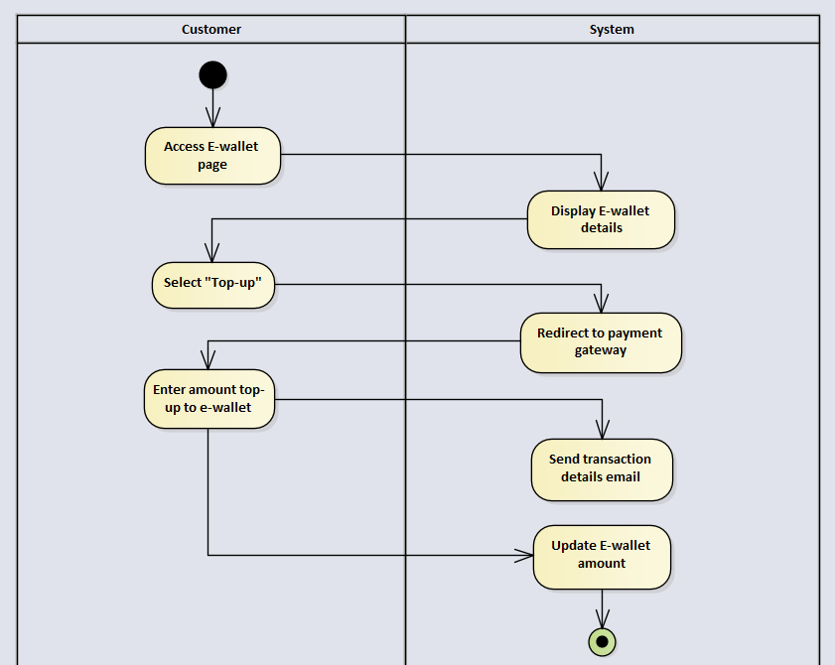

Figure 4.7: Activity Diagram – Top-up E-wallet

#### Sign Up

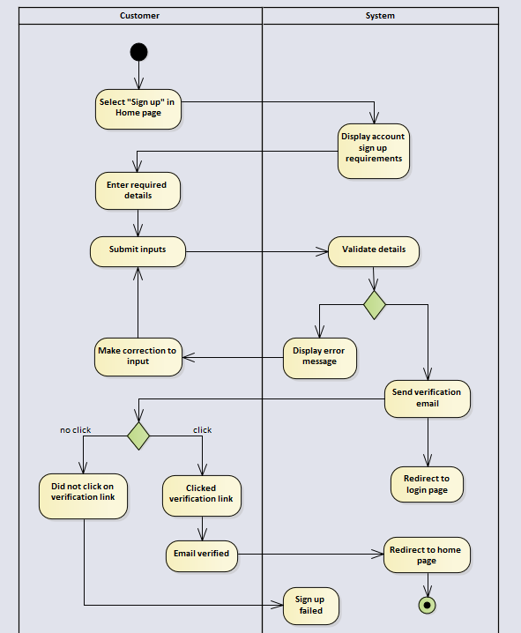

Figure 4.8: Activity Diagram – Sign up

#### Edit Profile

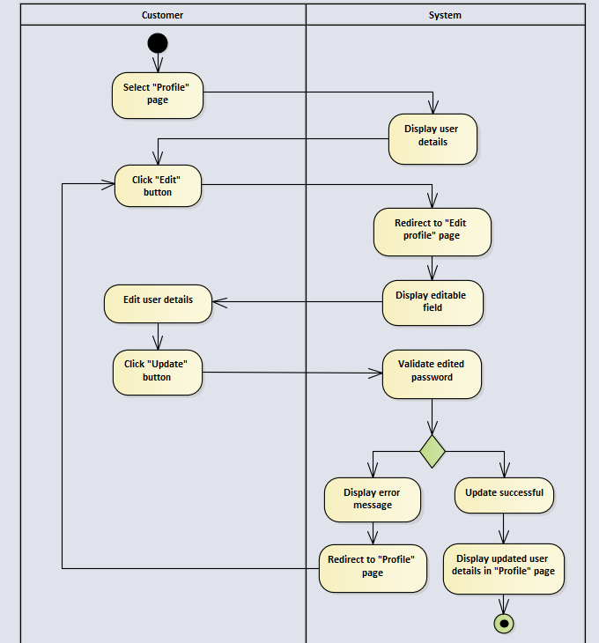

Figure 4.9: Activity Diagram – Edit profile

#### Accept/Reject Appointment

Figure 4.10: Activity Diagram – Accept/Reject appointment

#### View Appointment

Figure 4.11: Activity Diagram – View appointment

#### Modify clinic operation address and contact

Figure 4.12: Activity Diagram – Modify clinic operation address and contact

### User Interface

The user interface (UI) of the proposed system is designed by using Visual Studio Code and WampServer. Below images are just the concept of the system, implementation of proposed system will be done once the user interface design is confirmed.

#### Customer Home Page

User will be redirected to customer home page once logged in as customer. The customer home page provides the side navigation bar, overview of the animal clinic, and the system. Figure 4.14 briefly described the look of customer home page.

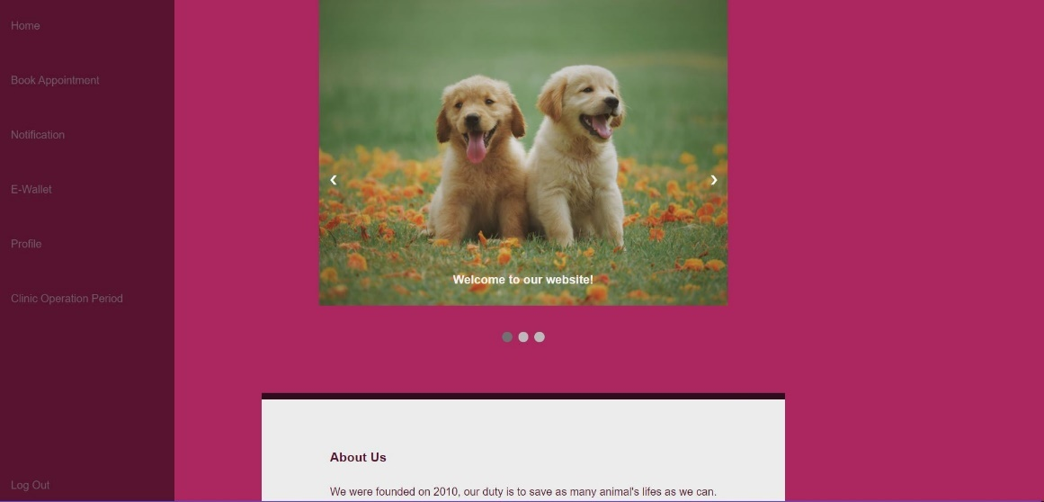

Figure 4.14: UI Design – Customer Home Page

#### Book Appointment Page

Customer can navigate to Book Appointment page and start to make reservation request for appointment once they have logged in their account. Customer details and pet details are required to make an appointment. Figure 4.15 illustrates the design of the Book Appointment Page.

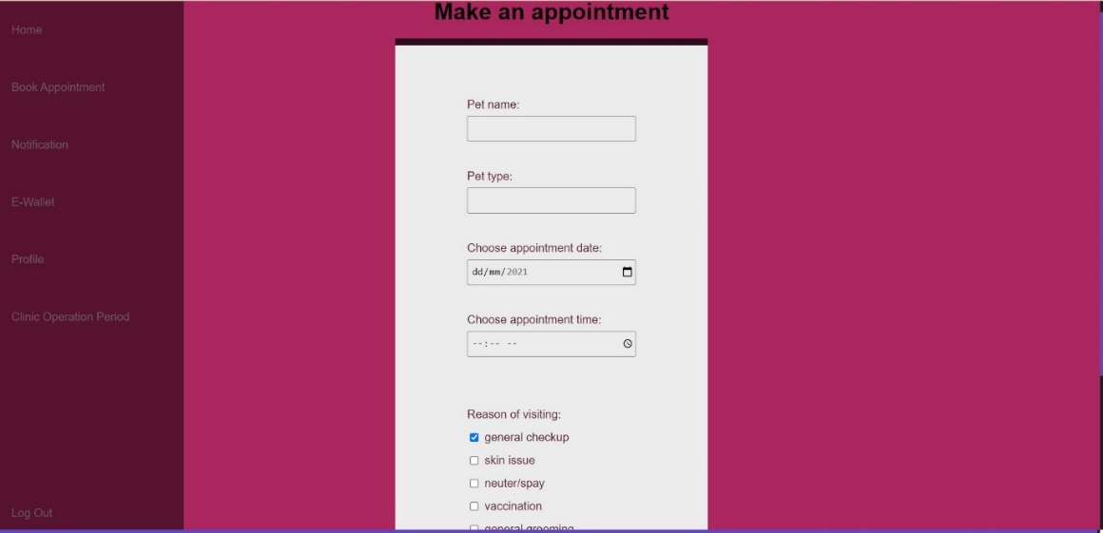

Figure 4.15: UI Design – Book Appointment Page

#### E-wallet Page

The E-wallet Page shows the appointment and transaction history of the customer. Customer can top-up or pay deposit when the appointment request has been approved. Figure 4.17 described the design of E-wallet page

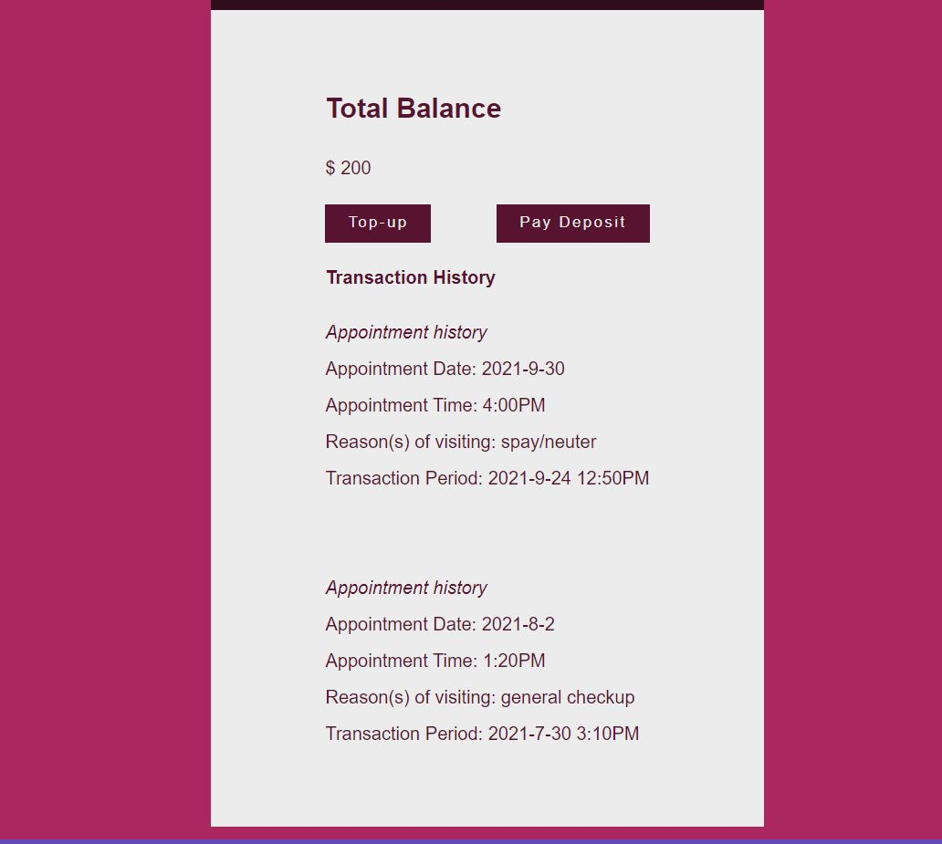

Figure 4.16: UI Design – E-wallet Page

#### Profile Page

Profile Page shows the customer’s name, user ID and birthdate. Figure 4.18 shows the design of customer Profile Page.

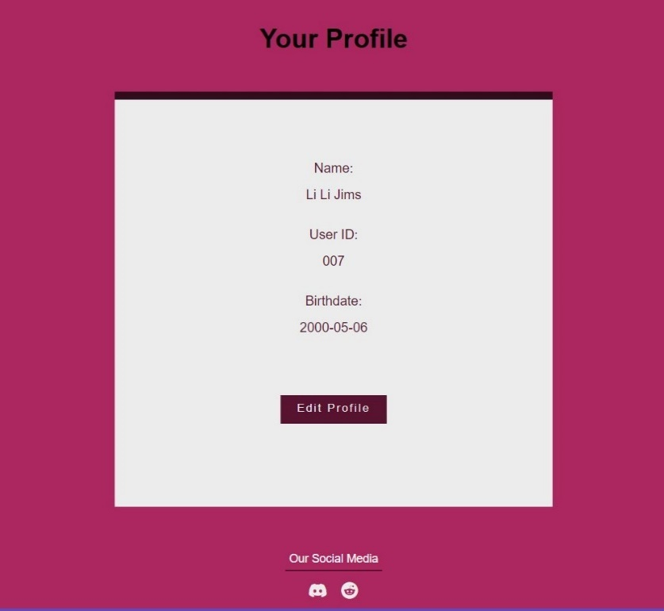

Figure 4.17: UI Design – Profile Page

#### Edit Profile Page

Edit Profile Page allows customer to edit their information such as name, birthdate, and passwords. Figure 4.19 illustrates the interface design of Edit Profile Page.

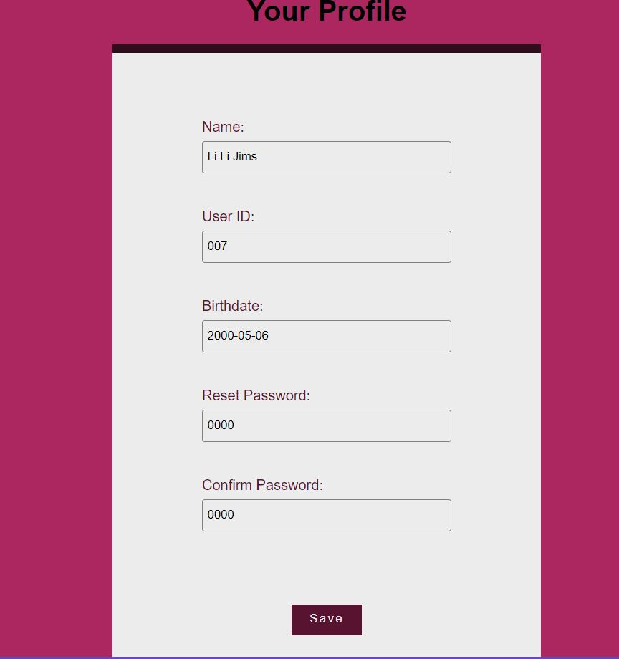

Figure 4.18: UI Design – Edit Profile Page

#### Clinic Operation Information Page

Clinic Operation Information Page shows the information of the clinic, working days and working hours, address, and contact number. Figure 4.20 shows the design of Clinic Operation Information Page.

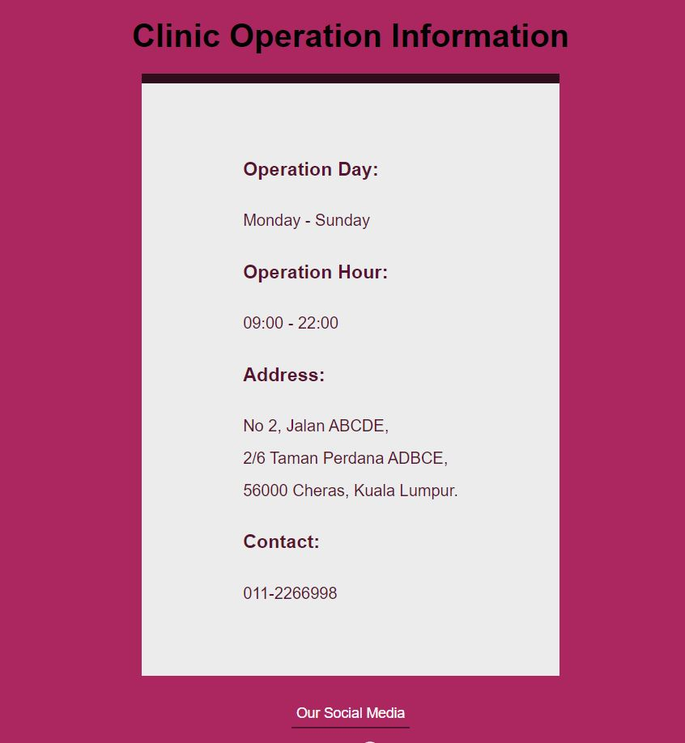

Figure 4.19: UI Design – Clinic Operation Information Page

#### Log In Page

The Log In Page displays the required fields for users to fill in their email and password. Different user will be led to different interfaces. New customers who wants to access to pages other than Customer Home Page will have to sign up new account. Pages described above are customer user interfaces, admin user interfaces will be shown on the below part. Figure 4.21 illustrated the design of Log In Page.

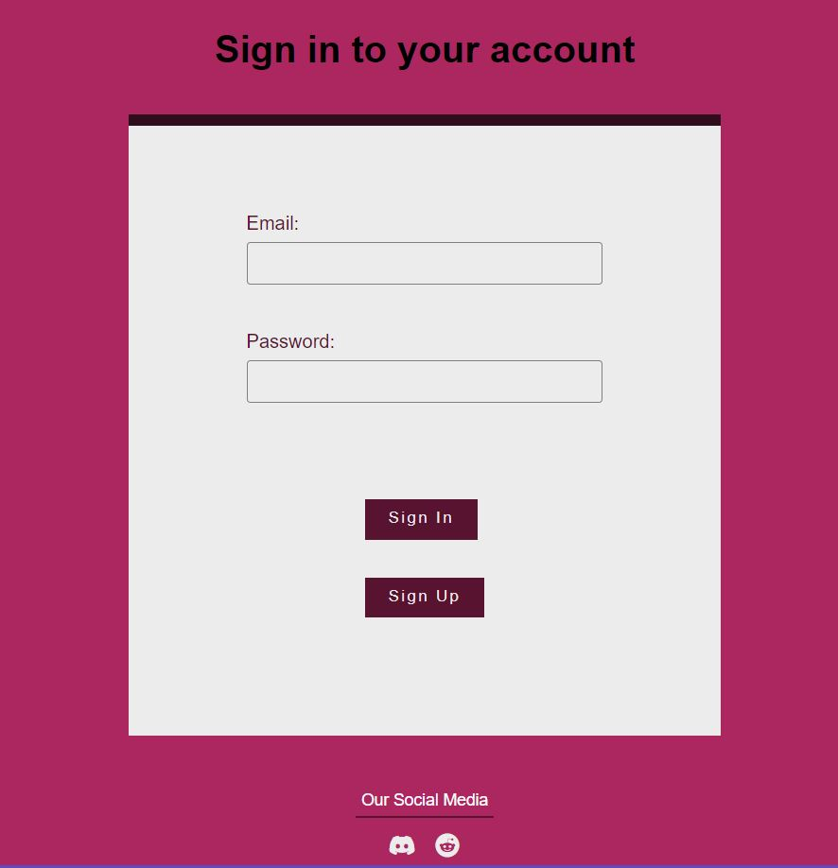

Figure 4.20: UI Design – Log In Page

#### Appointment List Page

The Appointment List Page shows the approved appointment. Administrator are allowed to clear the appointment in the list by clicking the “X” in “Clear” column. Figure 4.22 described the design of Appointment List Page

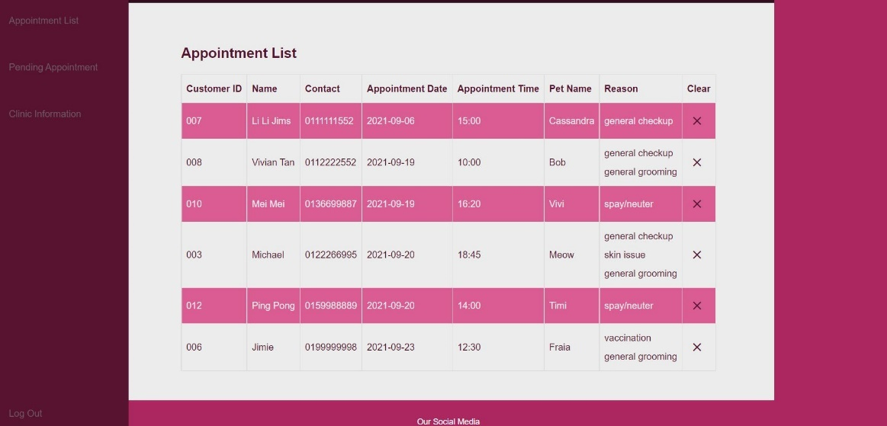

Figure 4.21: UI Design – Appointment List Page

#### Pending Appointment Page

The Pending Appointment Page shows the requested appointment. Several actions such as accept, suggest, and reject can be chosen by administrator in the “Action” column. Figure 4.23 shows the design of Pending Appointment Page.

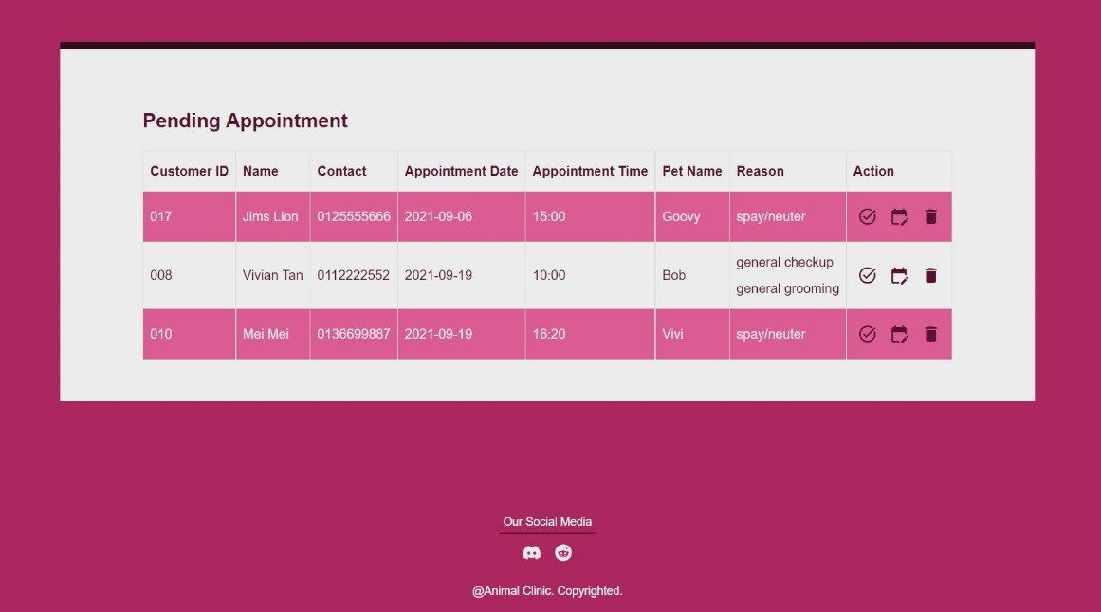

Figure 4.22: UI Design – Pending Appointment Page

#### Clinic Information Page

The Clinic Information Page listed the operation hour and operation day of the animal clinic. Figure 4.24 illustrates the design of Clinic Information Page.

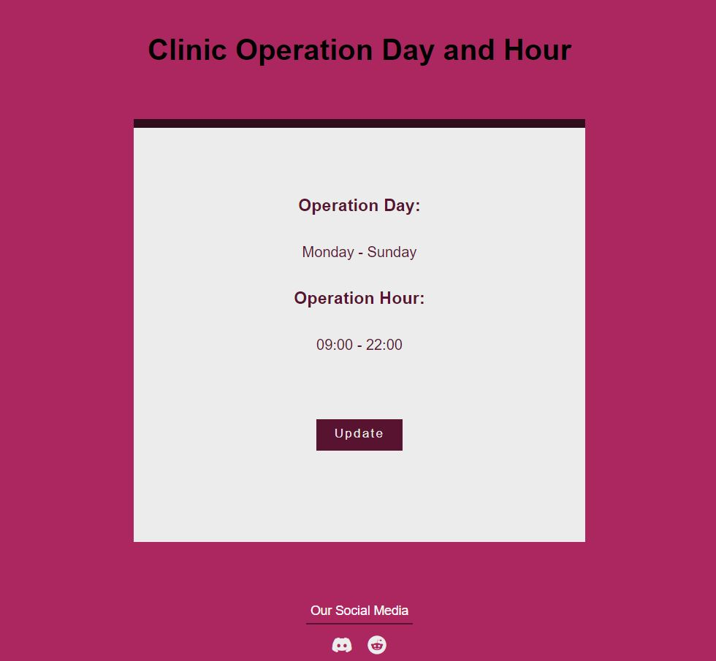

Figure 4.23: UI Design – Clinic Information Page

#### Edit Clinic Information Page

Administrator will be redirected to Edit Clinic Information Page after clicking the “Update” button on the page above. Administrator can modify the operation day and operation hour in this page. Figure 4.25 described the design of Edit Clinic Information Page.

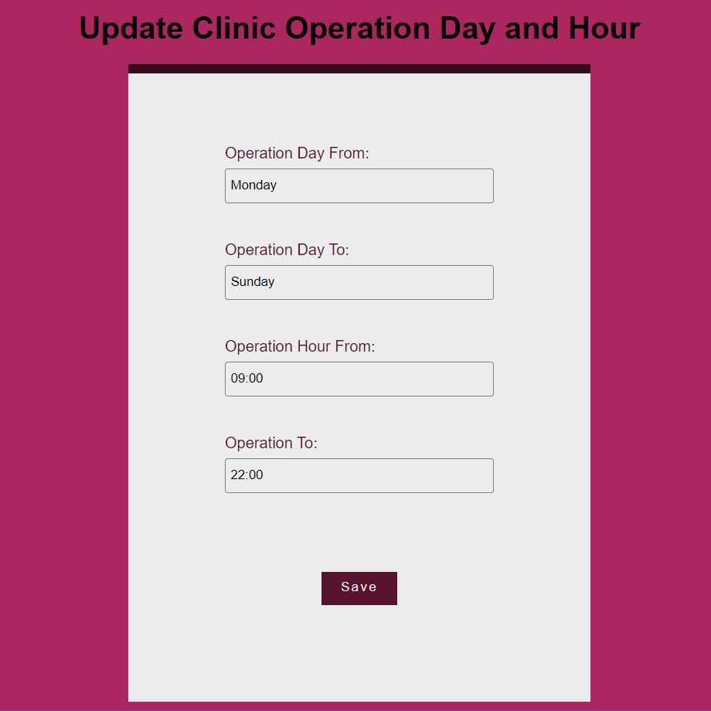

Figure 4.24: UI Design – Edit Clinic Information Page

# 

## SYSTEM IMPLEMENTATION

### Overview

The proposed online vet appointment system was given a simple and memorable name – AnimalClinic. According to the adopted development methodology, which is SCRUM, the system was continuously modifying according to discussion during the meeting until the system was ready for implementation. There was a total of three prototyping cycles where each of them results to the finalized version of the system.

As the core functionality of the online vet appointment system, real time booking module and appointment management module was implemented in the first prototype. As for the second protytype cycle, changes of design and enhancements were carried out for the core modules, followed by creating admin panel, created *User Management* model and *Profile* model, constructed automated email module, and made assumption of only two veterinarian, and adding operation appointment timeslot and normal appointment timeslot. Lastly, the third prototype cycle was constructed with the creation of vet panel, implementation of e-wallet module and enhancements on appointment management module and automated email module.

### Admin Panel

Only the user assigned with administrator role will be able to access the dashboard. From the dashboard, administrator user will be able to access the page that allow admin to book appointment for walk-in customer, know which vets are currently having account in the system, and other navigation which allow administrator user to access the corresponding pages.

Figure 5.1: Admin dashboard

Clicking any of the link in the administrator dashboard will lead user to the corresponding entity management panel. For example, when user select “Manage Admin Users”, “Manage Vet Users”, and “Manage Customer Users” will each bring administrator user to the corresponding user management panel.

Figure 5.2: Entity management panel

Entity management panel is where user with authorized abilities can manage the entity. User can perform CRUD operation on the entity panel, for example, in user management panel, administrator user can view all admin user, add new admin user, update admin user, and delete admin user.

### User management panel

The user management panel deals with authentication and authorization logic. Registration is available for customer user, and also new customer and admin user can be created through admin panel in the system, however, vet user cannot be created or deleted in the system according to the assumption of the system.

Figure 5.3: Admin user creation form

Figure 5.4: User sign up form

#### Authentication

The log in page is available and accessible in the left side navigation of the system. Existing user record in the database can log in to the system by using their email/username and password.

Figure 5.5: User log in page

When a log in attempt failed with the input of invalid credentials, system will display an error message as shown as the following Figure 5.6. On the other hand, when user did not enter required information such as username/email in the log in form, an error message will be displayed at the system as shown as Figure 5.7.

Figure 5.6: Invalid log in credentials

Figure 5.7: Empty log in credentials

## REFERENCES

Agheorghiesei, D. T. and Ineson, E., 2011. The Impact of Online Booking Systems on Customer Loyalty in Romania. *Journal of tourism.* 11, p. 45.

Balaji, S. and Murugaiyan, M., 2012. Wateerfall VS V-model VS Agile: A Comparative Study On SDLC. *International Journal of Information Technology and Business Management*, 2(1), pp.26-30.

Cort, F., 2018. Online Booking: Why Your Customers Demand Convenience. *Apptoto,* [online] Available at: <https://www.apptoto.com/scheduling/online-booking-why-your-customers-demand-convenience> [Accessed 1 July 2021].

Idowu, A., Adeosun, O. and Williams, K., 2014. Dependable Online Appointment Booking System for Nhis Outpatient in Nigerian Teaching Hospitals. *International Journal of Computer Science and Information Technology*, 6(4), pp.59-73.

Lumaverse. n.d. *Lumaverse*. [online] Available at: <https://lumaverse.com/> [Accessed 1 July 2021].

Mahalakshmi, M. and Sundararajan, M., 2013. Traditional SDLC Vs Scrum Methodology A Comparative Study. *International Journal of Emerging Technology and Advanced Engineering*, 3(6), pp.192-196.

Mallawaarachchi, V., 2017. 10 Common Software Architectural Pattern in a nutshell. *Towards data science,* [online] Available at: < https://towardsdatascience.com/10-common-software-architectural-patterns-in-a-nutshell-a0b47a1e9013> [Accessed 1 July 2021].

Mourshed, M., 2019. Online Pet Care. *Daffodil International University*, pp.1-12.

Nugroho, S., Hadi Waluyo, S. and Hakim, L., 2017. Comparative Analysis of Software Development Methods between Parallel, V-Shaped and Iterative. *International Journal of Computer Applications*, 169(11), pp.7-11.

Roopa, S. and Rani, M., 2012. Questionnaire Designing for a Survey. *The Journal of Indian Orthodontic Society*, 46(4), pp.273-277.

SuperSaaS. n.d. *SuperSaaS Appointment Scheduling*. [online] Available at: <https://www.supersaas.com/> [Accessed 1 July 2021].

Symey, Y., Sankaranarayanan, S. and Sait, S., 2013. Application of Smart Technologies for Mobile Patient Appointment System. *International Journal of Advanced Trends in Computer Science and Engineering*, [online] 2(4), pp.74-85. Available at: <http://warse.org/pdfs/2013/ijatcse01242013.pdf> [Accessed 1 August 2021].

Truman, B. L., 2018. The Benefits of Online Appointment Booking. [online] 3(7). Available at: <https://www.dvm360.com/view/the-benefits-of-online-appointment-booking> [Accessed 1 July 2021].

Yang, P., Chu, F., Liu, H., Shih, M., Chen, T., Chou, L. and Hwang, S., 2019. Features of Online Hospital Appointment Systems in Taiwan: A Nationwide Survey. *International Journal of Environmental Research and Public Health*, 16(2), pp.1-10.

Zhang, X., Yu, P., Yan, J., Hu, H. and Goureia, N., 2012. In: *Developing An Online Patient Appointment Scheduling System Based On Web Services Architecture*.

## APPENDICES

Appendix A: Questionnaires

1.

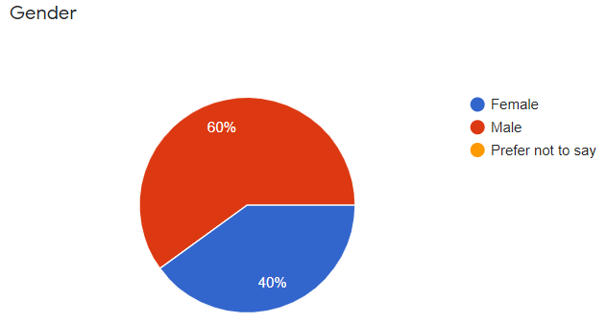

2.

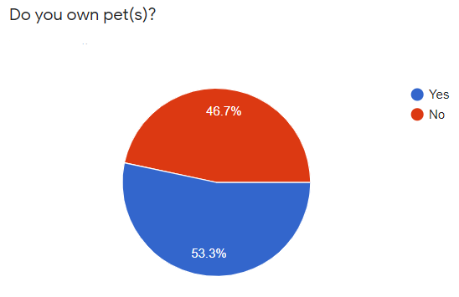

3.

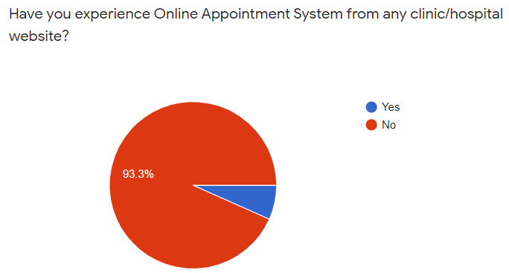

4. If yes, what is your opinion about the system?

5.

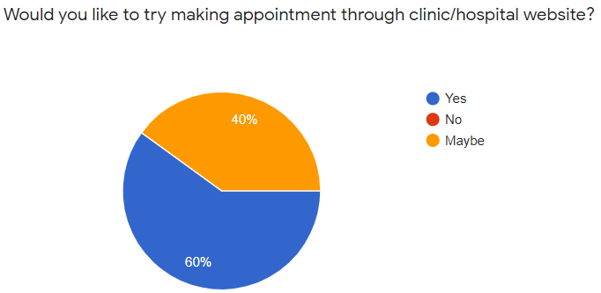

6.

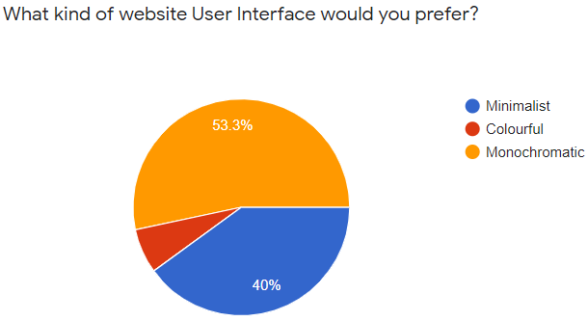

7.

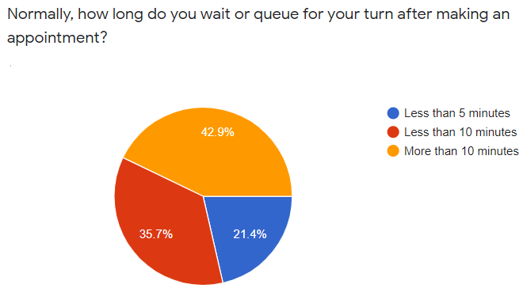

8.

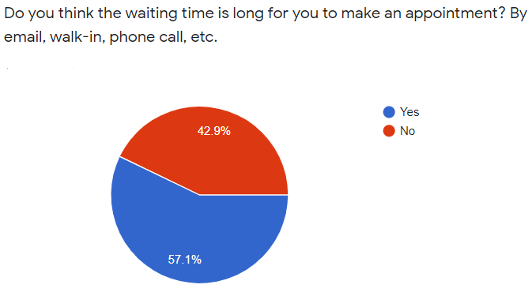

9.

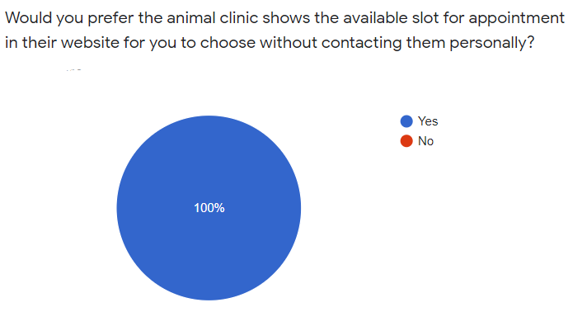

10.

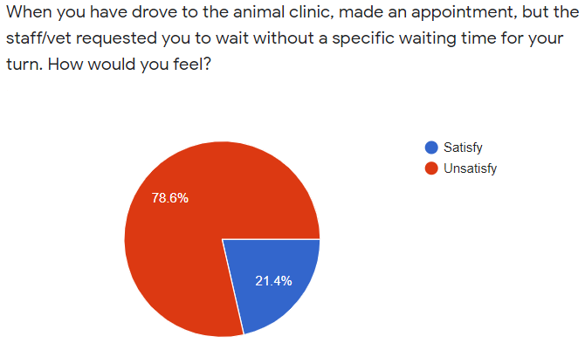

11.

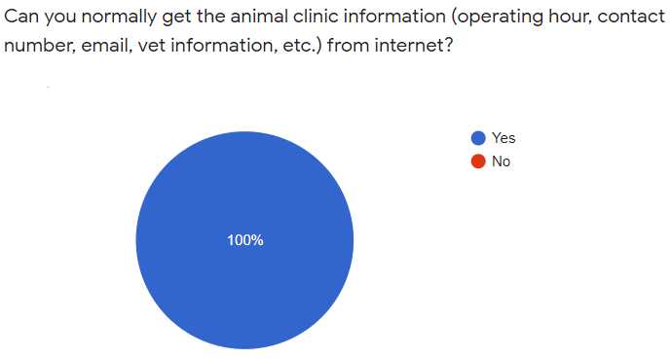

12.

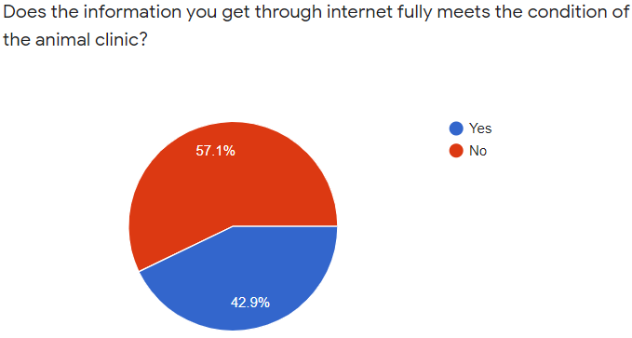

13. Have you experienced the animal clinic was closed when you reached the destination? Why?

14.

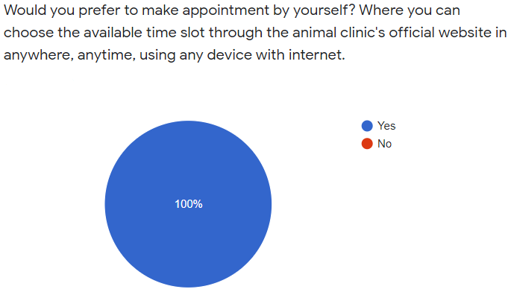

15.

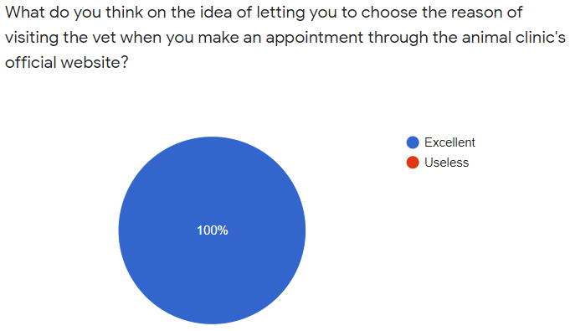

16. If your pet is in emergency situation, from where will you retrieve the animal clinic's contact number?

* Official website
* Facebook
* Instagram
* None of the above

17.

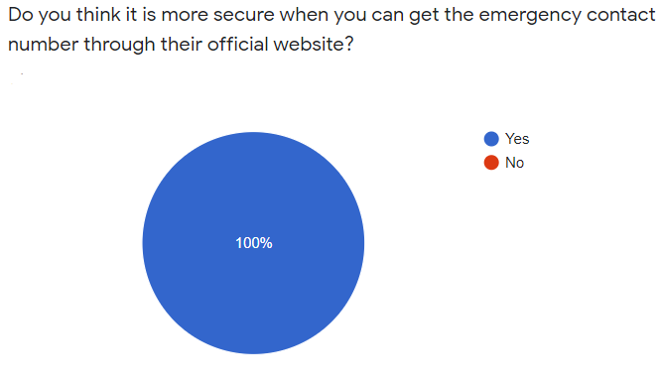

18.

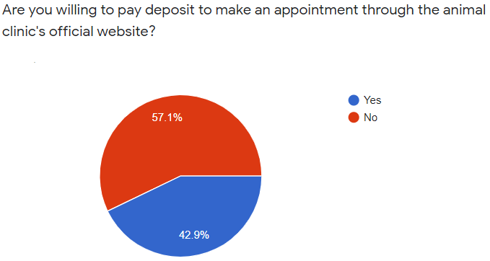

19.

