HUBS QUICK REFERENCE GUIDE

How do I…

- Sign into HUBS Page 2
- Open the Budgeting Tool Page 2
- Budget Income
  - Existing coding string Page 3
  - New coding string Page 3
- Budget Expense
  - Existing coding string Page 4
  - New coding string Page 5
- Budget non-employee compensation (LTHT, Overtime, Post-Doc, etc)
  - Existing coding string Page 6
  - New coding string Page 7
- Budget non-operating transactions Page 8
- Add a new object code to a webform Page 8
- Add a comment to a cell in a webform Page 10
- Budget to individual months Page 11
- Aggregate data for reports Page 13
- Export a report to excel Page 15
- Set default preferences Page 17
(new users or new computer since last using into HUBS)
- Set Internet Explorer default settings Page 18
(new users or new computer since last using into HUBS)

- Sign into HUBS
Hold the control button down and click on the following link:
https://hyp-workspace.cadm.harvard.edu:8080/workspace/
Click “Launch Application” and enter HUID and PIN

- Open the Budgeting Tool
Navigate > Applications > Planning > PLNG0011 (if PLNG0011 does not appear, complete the instructions to “Set Internet Explorer defaults” and try again).
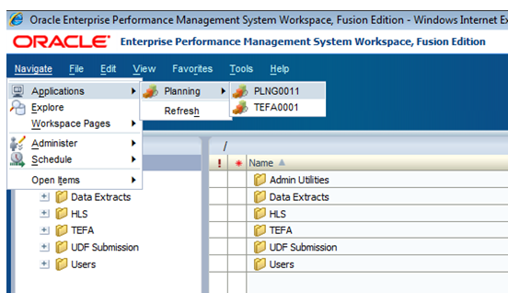

- BUDGETING Income

  - existing coding string
- Go to: Non-Employee Budgeting > Enter Income
- Choose coding segments in the dropdown menus (please leave root as 00000 for budget)
- Click “GO” over to the right of the screen

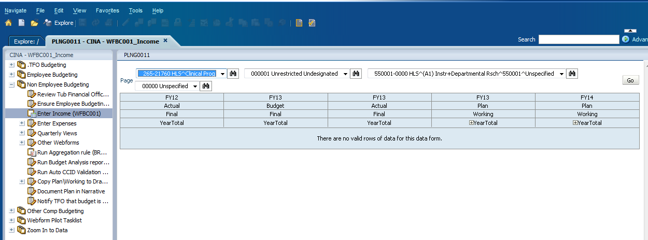
1
2
3

  - NEW coding string
Go to: Non-Employee Budgeting > Other Webforms > Create new Income intersection
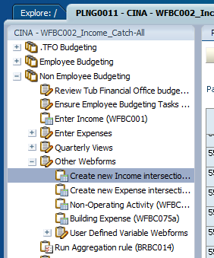

When the following message comes up, click “Yes”

Choose coding segments in the dropdown menus (please leave root as 00000 for budget) and click “Go”.
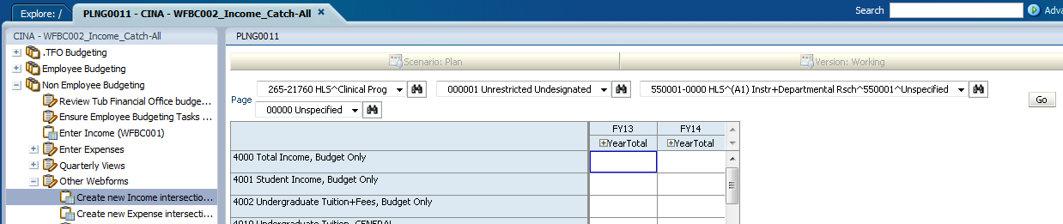
- All income object codes will be available for budgeting
- To search for a specific object codes, on your computer keyboard press the Ctrl and “F” keys at the same time and enter a number or word to search on
  - For example, if you wanted to find “Miscellaneous Income, External” you could type in “misc” and click “next” to scroll through all of the object codes that contain “misc” in the title until you find the one you want

- BUDGETING ExpenseS

  - existing coding string

- Go to: Non-Employee Budgeting > Enter Expenses > Any Expenses
- Choose coding segments in the dropdown menus (please leave root as 00000 for budget)
- Click “GO” over to the right of the screen

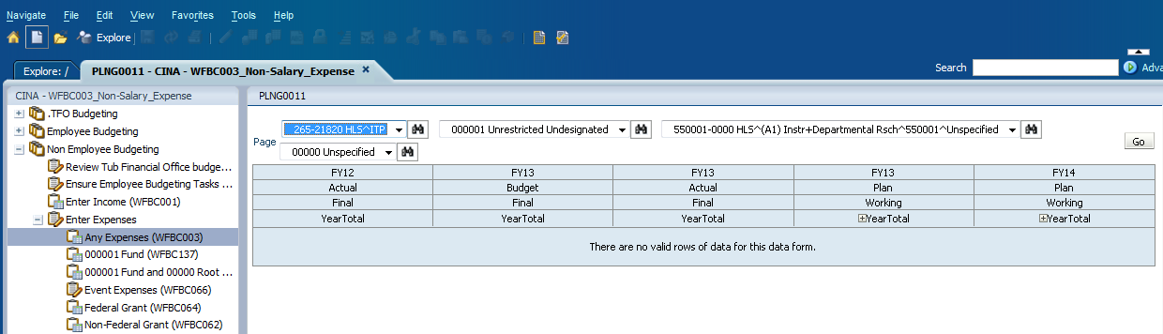

  - NEW coding string
- Go to: Non-Employee Budgeting > Other Webforms > Create new Expense intersection
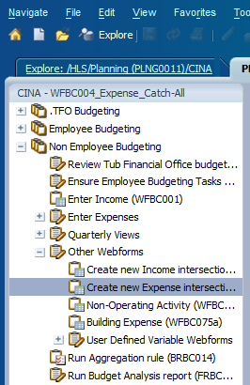

When the following message comes up, click “Yes”
Choose coding segments in the dropdown menus (please leave root as 00000 for budget) and click “Go”.
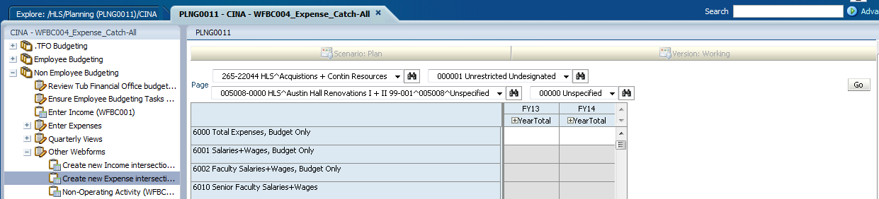
- All expense object codes will be visible – if the cell is white, you can budget to it. If the cell is gray, it is not available for budgeting using this webform.
- To search for a specific object codes, on your computer keyboard press the Ctrl and “F” keys at the same time and enter a number or word to search on
  - For example, if you wanted to find “Lodging^Domestic Travel” you could type in “travel” and click “next” to scroll through all of the object codes that contain “travel” in the title until you find the one you want

- Budget non-employee compensation (LTHT, Overtime, Post-Doc, etc)

  - existing coding string
Go to: Employee Budgeting > Edit Non-Empl Comp

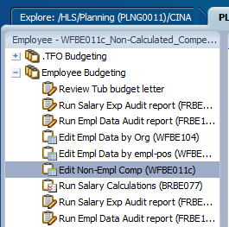

- Choose coding segments in the dropdown menus (please leave root as 00000 for budget)
- Click “GO”
- If the cell is white, you can budget to it. If the cell is gray, it is not available for budgeting using this webform.
- You should not need to budget fringe, even if the cells are white.
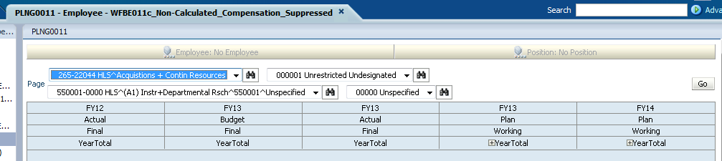

- NEW coding string
Go to: Employee Budgeting > Optional Empl Webforms
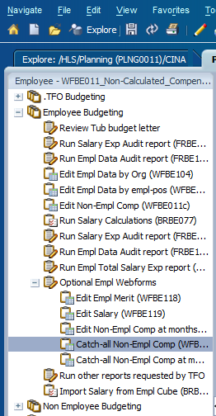

- Choose coding segments in dropdown menus (please leave root as 00000 for budget)
- Click “GO” over to the right of the screen
- All compensation and fringe object codes will be visible (no individual compensation data is shown). If the cell is white, you can budget to it. If the cell is gray, it is not available for budgeting using this webform.
- You should not need to budget fringe, even if the cells are white.

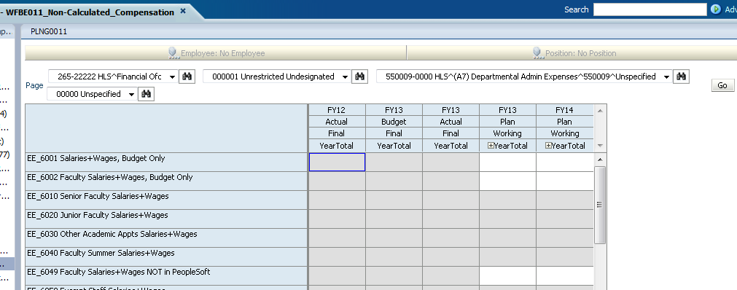

- Budget non-operating
Departments are not able to access the webform where non-operating transactions are budgeted. Please provide the information to Meaghan Dorsi or Scott Sarian in the Finance Office and they will enter this section of the budget for your department.

- Add a new object code to a webform

- In any of the webforms, place your cursor over the object code section on the left of the screen and right-click
- Click on “Enter Budget for New Object”
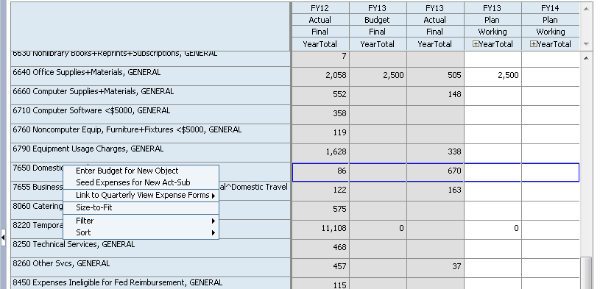
Place cursor anywhere in this general area below
There are 3 fields to fill out:
- Select the Year - Enter the year you want to budget (for example, FY13 or FY14)
- Select the Object – Enter the object code you want to budget to. If you know the object code number, you can type directly into this field (quotes are not needed). This field will accept, for example, 8510 but not Postage. You can search for the object code by clicking on the search icon to the right of the field (additional instructions provided below)
- Enter Budget Amount - Enter the amount you want to budget
Click on “Launch”
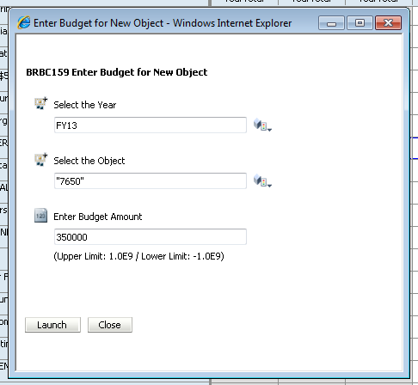
Search for Object Code
- Click on the search icon to the right of the Select Object Code field. The following screen will come up.
- You can search using the scroll bar or enter a word in the search field and click on the binoculars up/down to cycle through the object codes that contain the word entered
- Once the correct object code is located, click on the arrow to send the object code into the right window pane
- Click OK on the bottom right of the screen

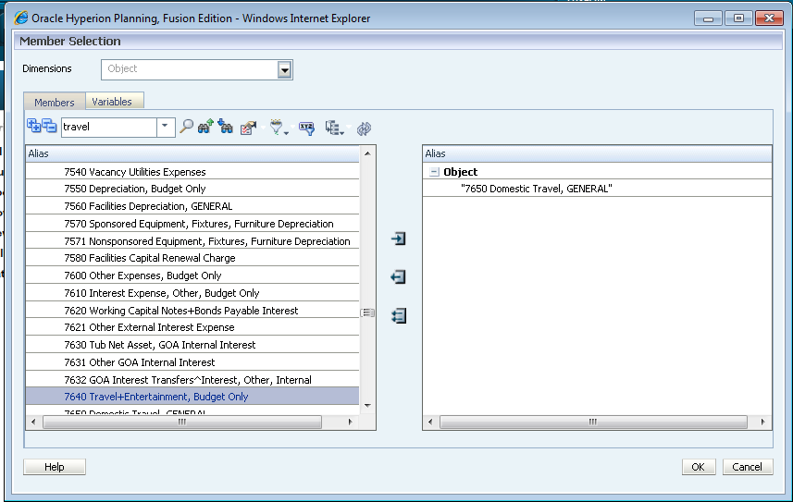
Search field - search on letter(s) or number(s)
Select the correct object code
Arrow to move the object code to the right window pane
Right window pane

- Add a comment
In all webforms you can add a comment to any of the cells (for example, if you want to make a note of why you budgeted a certain amount). Comments are only visible in the webforms.
- Right click on the cell that you want to add a comment to
- Select Insert Comment and type the comment into the screen that comes up
- Click Submit at the bottom of the screen
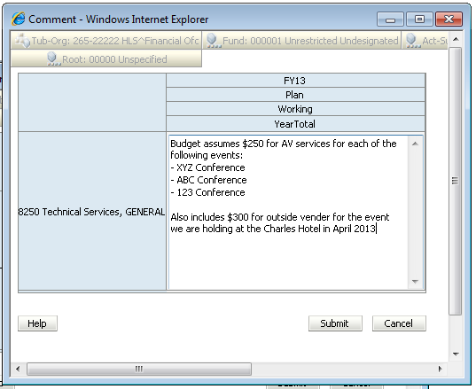
Sample Comment

- BUDGET INCOME OR EXPENSES TO INDIVIDUAL MONTHS
If you have expenses that are “lumpy”, in other words the expenses are not spent evenly throughout the year, you should budget them in the month (or quarter) you expect the expense to incur. For example, if you pay an annual fee of $12,000 to for a membership fee in one lump sum in March of each year, you would enter $12,000 in March. If you enter $12,000 in YearTotal, HUBS assumes you will spend $1,000 in each month.
Click on the “+” next to YearTotal of the Fiscal Year you want to enter a monthly budget for:
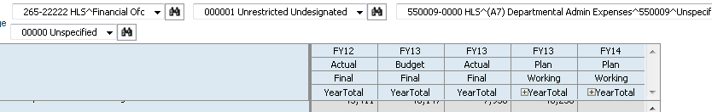

This will open up the budget to individual quarters (Q1, Q2, Q3, Q4). If you enter an amount into any of the quarterly cells, the amount will be evenly spread across the three months in that quarter. If you want to open up the individual months, click on the “+” next to the desired quarter. To collapse the month or quarter, click on the “-“ sign.
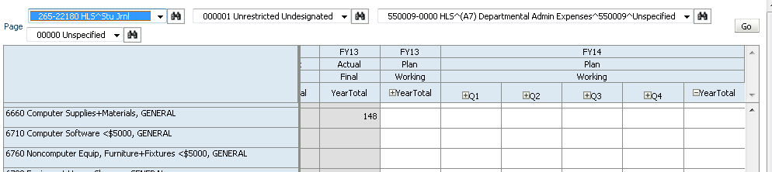
Click on “+” to expend the quarter down to the individual months
Click on “-“ to collapse the quarter or month view

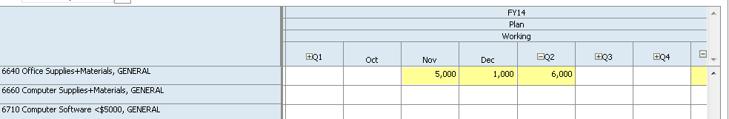
You can now enter amounts in individual months

- Aggregate data for reports
The system will automatically aggregate the data you entered overnight. If you would like to see the data reflected in the reports immediately, you need to run either one or three business tool(s), depending on the type of data you entered.
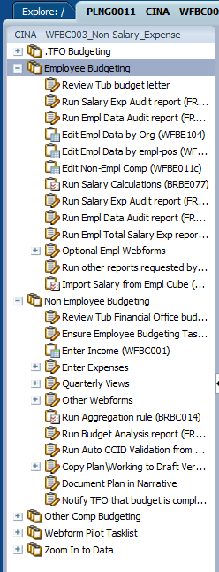
If you have entered any data in the Edit Non-Empl Comp webform, you need to run all three business rules in this order:
- Run Salary Calculation
- Import Salary from Empl Cube
- Run Aggregation rule
If you have entered only income and/or non-comp expenses, you need to run the last business tool:
- Run Aggregation rule
- Click on the business rule
- When the following screen comes up, click on Launch (do this for each business rule)
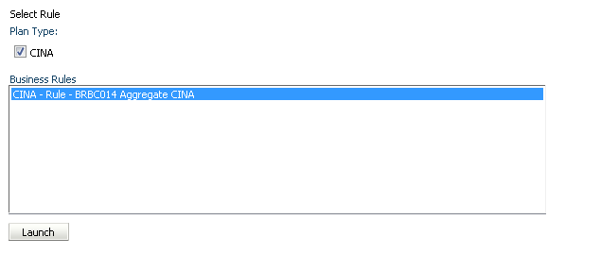
When the following screen comes up, type in your Tub-Org (quotes are not needed) and click Launch at the bottom of the screen.
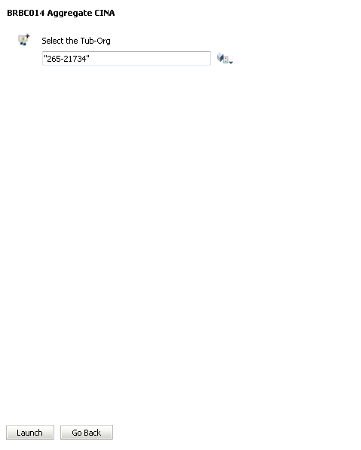
When the following message appears, the business rule has finished running
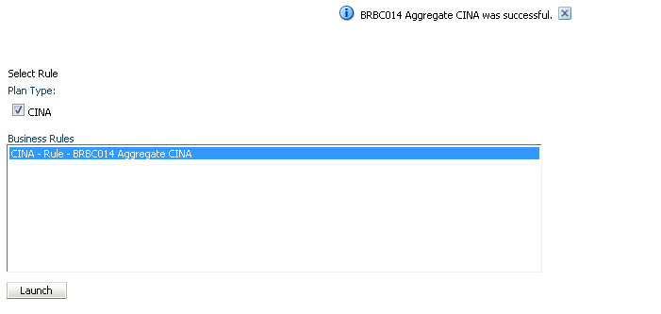

- Export a report to excel
After running the report, go to File > Export. When the next screen appears, choose “Open” then go to Excel and when asked if you want to open the file choose “Yes”.
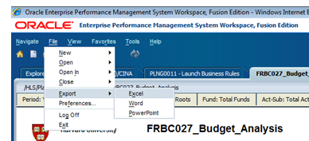

After the file opens, we suggest you make a small adjustment to the formatting. In Excel, choose the entire worksheet by clicking the upper right most cell
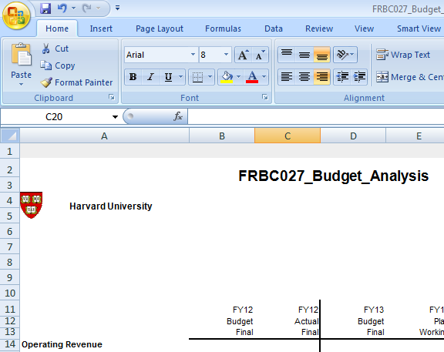

In the Home tab, open the Alignment toolbar
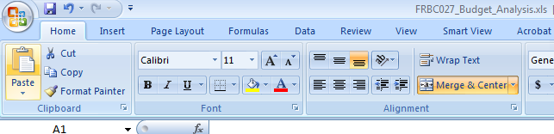

Uncheck the Wrap Text and Merge Cells boxes and click “OK” at the bottom of the screen
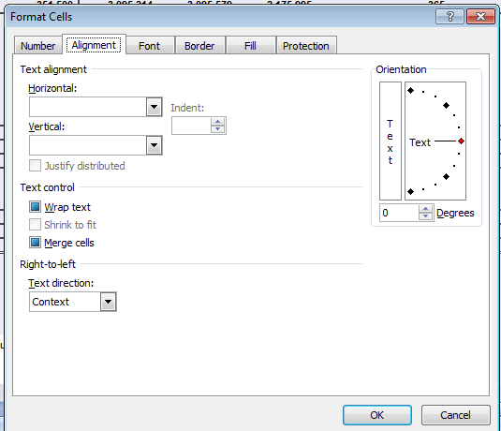

- Set default preferences
Go to File > Preferences
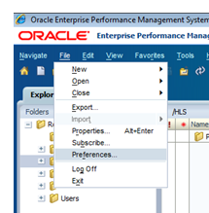

GENERAL – change Content field to “Explore” using dropdown and click OK at the bottom of the screen
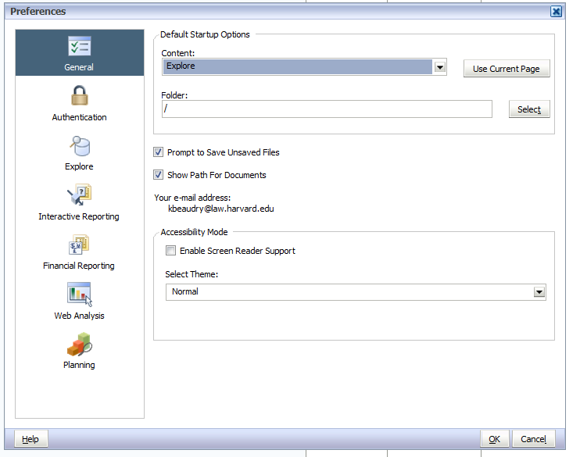

FINANCIAL REPORTING – Make sure User Point of View is “On” and click OK at bottom of screen
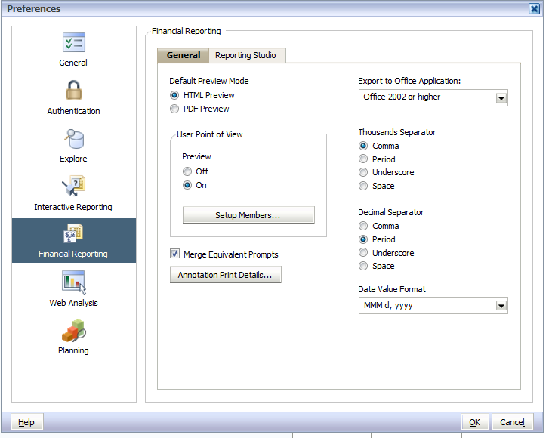

- Set Internet Explorer default
Go to Tools > Internet Options
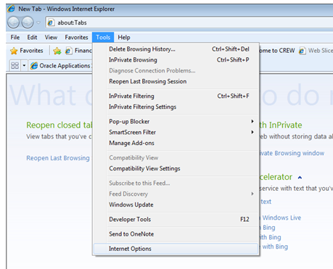
Click on the Security Tab, click on Trusted Sites and then click on Custom Level
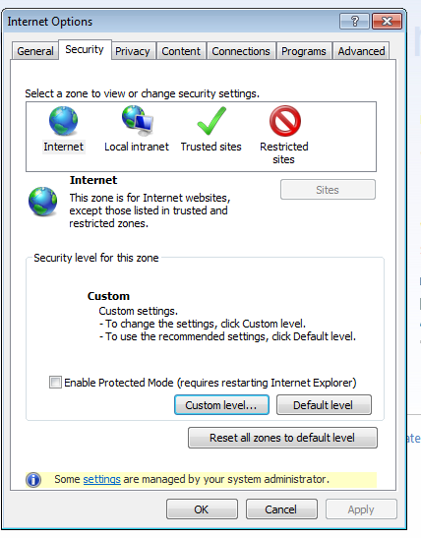
Scroll approximately halfway down and find “Allow script-initiated windows without size or position constraint. Select “Enable”
