Practical Steps: Reproducing the System
Preparations:
GitHub acc, AWS acc, VS Code(but can be vary), docker, python, git
1.step
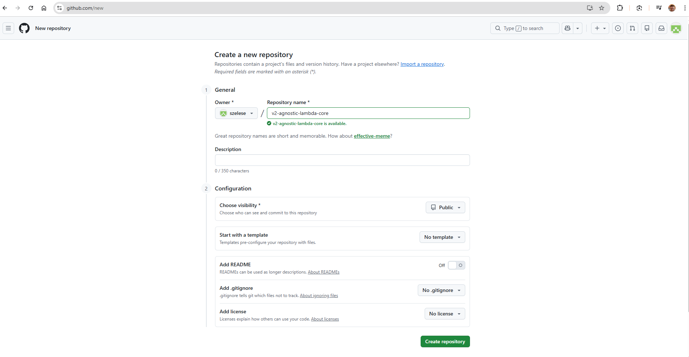
create a new repo: v2-agnostic-lambda-core //or what name you like
we will add a readme,gitignore,license later phase
2.step
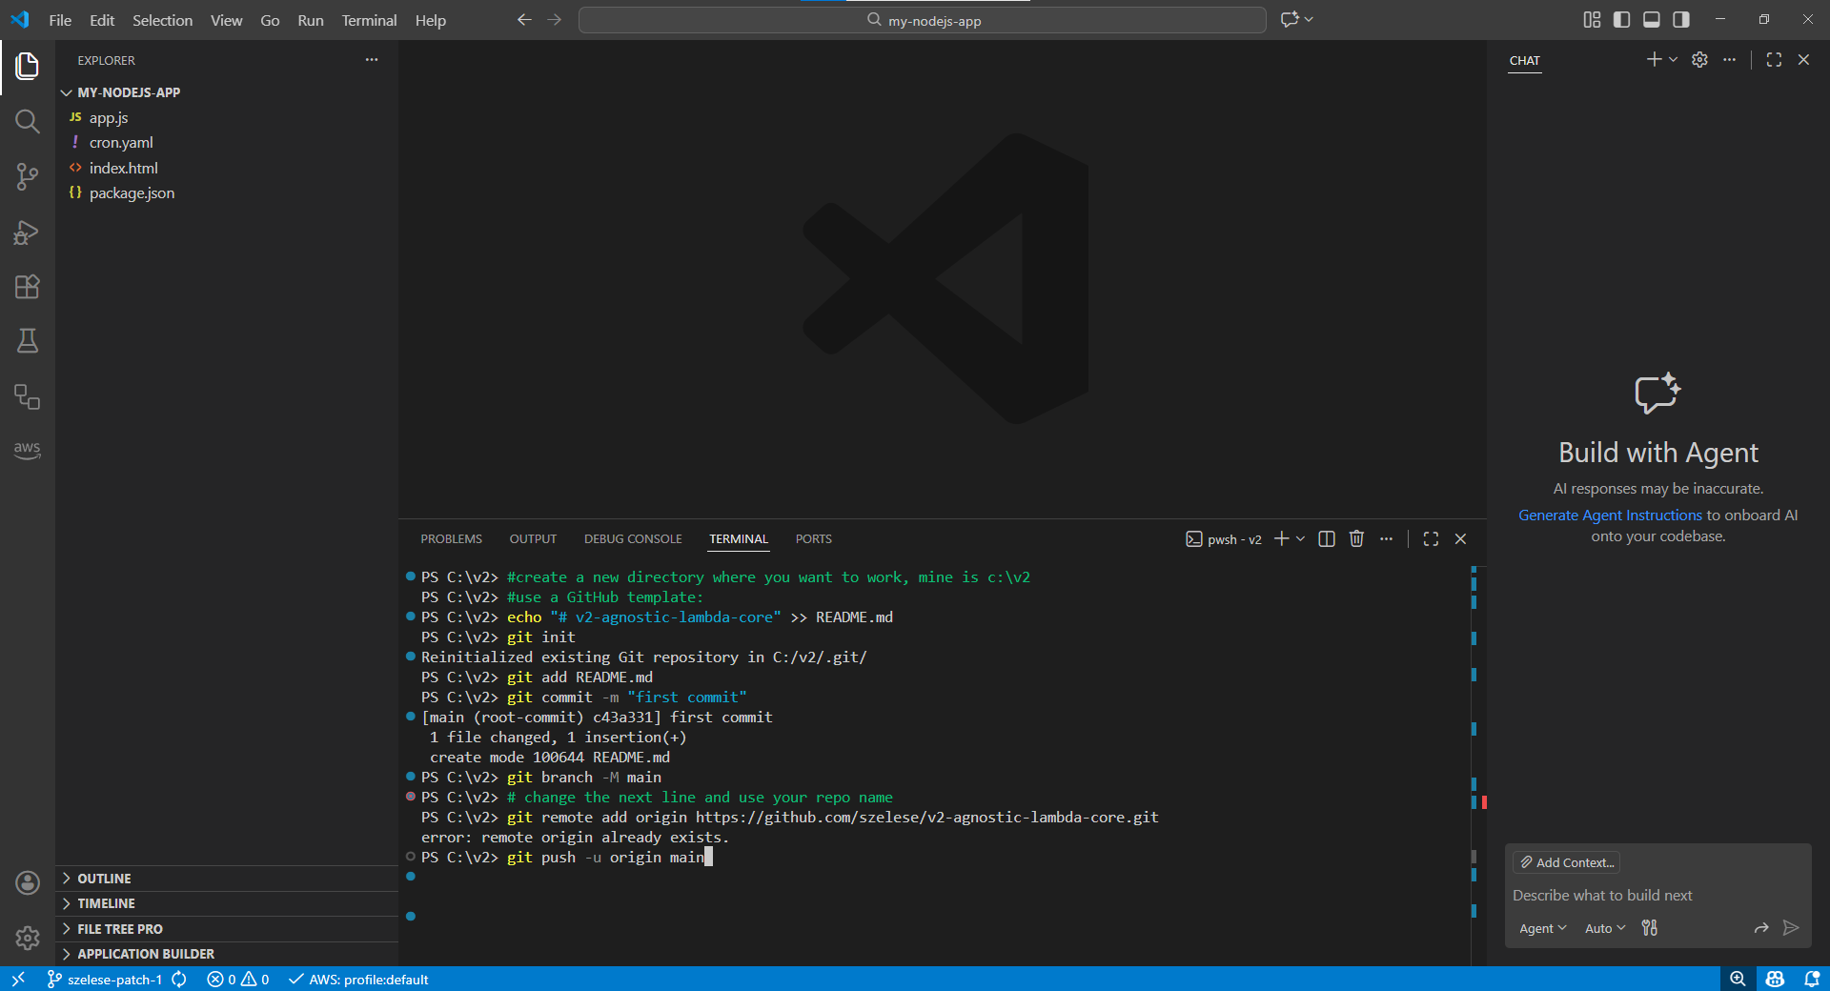
#create a new directory where you want to work, mine is c:\v2
#use a GitHub template:
echo "# v2-agnostic-lambda-core" >> README.md
git init
git add README.md
git commit -m "first commit"
git branch -M main
# change the next line and use your repo name
git remote add origin https://github.com/szelese/v2-agnostic-lambda-core.git
git push -u origin main
3.step
New file -> .gitignore (starter point is important!) :
.gitignore :
# =================================================================
# PYTHON ARTIFACTS
# =================================================================
__pycache__/
*.py[cod]
*$py.class
*.so
.Python
build/
develop-eggs/
dist/
downloads/
eggs/
.eggs/
lib/
lib64/
parts/
sdist/
var/
wheels/
*.egg-info/
.installed.cfg
*.egg
MANIFEST

# =================================================================
# VIRTUAL ENVIRONMENTS
# =================================================================
.venv/
venv/
ENV/
env/
pip-log.txt
pip-delete-this-directory.txt

# =================================================================
# SECURITY AND ENVIRONMENTAL VARIABLES (Security First)
# =================================================================
# Local environment variables files
.env
.env.local
.env.test
.env.production

# Secret keys and certificate files
*.pem
*.key
*.pub
*.crt
*.pfx

# AWS CLI local configuration (never leak account ID)
.aws/
credentials
config

# =================================================================
# IDE / EDITORS (VS Code, PyCharm, OS)
# =================================================================
.vscode/
!.vscode/settings.json
!.vscode/tasks.json
!.vscode/launch.json
!.vscode/extensions.json
.idea/
*.swp
*.swo
.DS_Store
Thumbs.db

# =================================================================
# DOCKER
# =================================================================
.docker/
*.log
docker-compose.override.yml

# =================================================================
# DATA AND DIAGNOSIS FILES
# =================================================================
# If you download data for testing, do not include it in the repository
data/*.csv
data/*.json
data/*.parquet
!data/.gitkeep

# Peroformance and test reports
reports/
locust_reports/
*.html
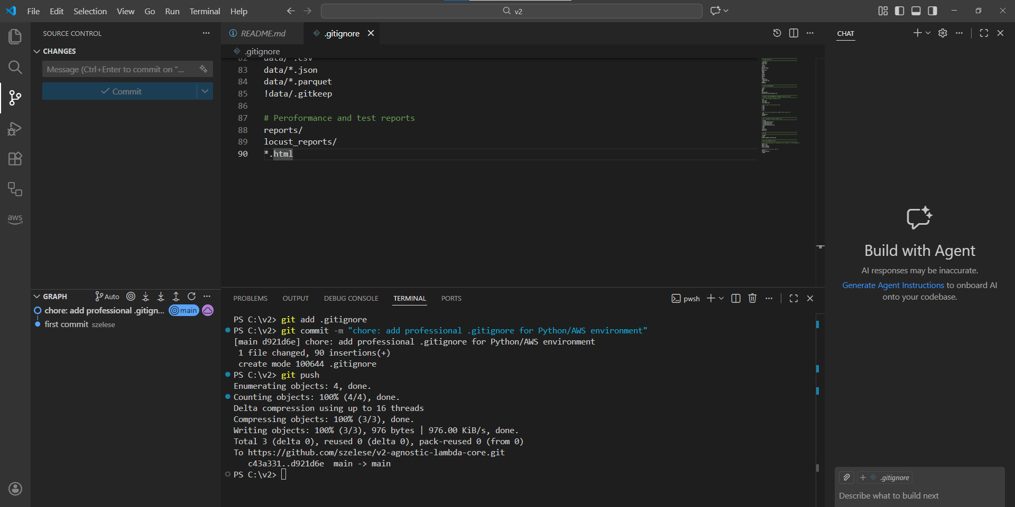
terminal:
git add .gitignore
git commit -m "chore: add professional .gitignore for Python/AWS environment"
git push
4.step
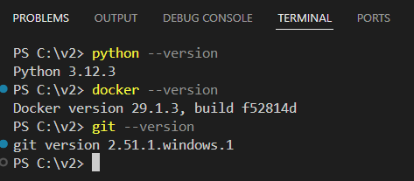
python --version
docker --version
git --version
just a last check to everything is working well
5.step
create files, making a local core logic
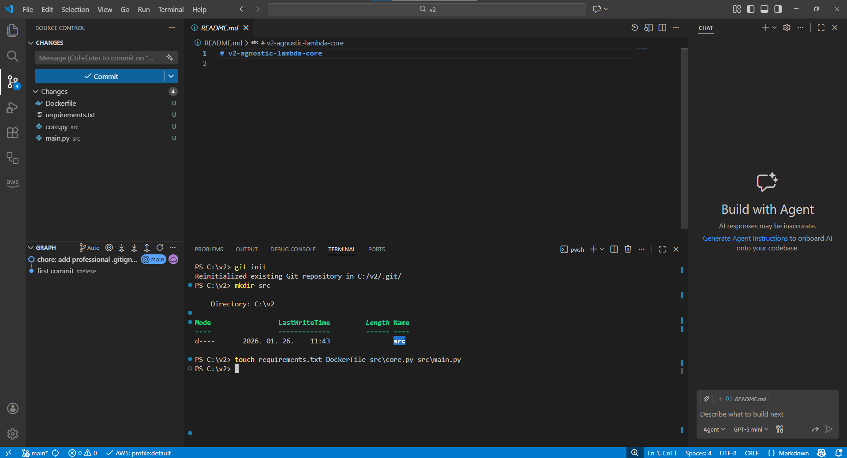
git init
mkdir src
touch requirements.txt Dockerfile src/core.py src/main.py
touch .dockerignore
6. step
fill the files with a next content:
requirements.txt : keep it blank we will modify it later

src/core.py :
def process_data(payload: dict) -> dict:
user = payload.get("user", "Pilot")
# environment-agnostic logic with no external dependencies
return {
"message": f"Hello {user}! System check complete.",
"status": "OPERATIONAL",
"engine_version": "3.12.3",
"subsystem": "agnostic-core-v2"
}

src/main.py :
import json
import logging
from .core import process_data

# Standard AWS Lambda logger configuration
logger = logging.getLogger()
logger.setLevel(logging.INFO)

def handler(event, context):
logger.info(f"Incoming event: {json.dumps(event)}")

try:
# 1. Intelleigent data load (Adapter logic)
if "body" in event:
if isinstance(event["body"], str):
payload = json.loads(event["body"])
else:
payload = event["body"]
else:
payload = event

# 2. Core logic call
result = process_data(payload)

# 3. Success response
return {
"statusCode": 200,
"headers": {"Content-Type": "application/json"},
"body": json.dumps(result)
}
# 4. Error handling
except json.JSONDecodeError as e:
logger.error(f"Invalid JSON received: {str(e)}")
return {
"statusCode": 400,
"body": json.dumps({
"error": "Invalid JSON input",
"details": "The provided input is not valid JSON."
})
}
except Exception as e:
logger.error(f"Unexpected system error: {str(e)}")
return {
"statusCode": 500,
"body": json.dumps({
"error": "Internal Server Error",
"details": "An unexpected error occurred. Please try again later. Check a CloudWatch logs for more details."
})
}

Dockerfile:
FROM public.ecr.aws/lambda/python:3.12

# Dependencies, changed infrequently=top layer
COPY requirements.txt ${LAMBDA_TASK_ROOT}
RUN pip install -r requirements.txt

# Source code, changed frequently=bottom layer
COPY src/ ${LAMBDA_TASK_ROOT}/src/

# Handler
CMD [ "src.main.handler" ]

.dockerignore
# =================================================================
# GIT - No need for history inside the image
# =================================================================
.git
.gitignore

# =================================================================
# PYTHON - Keep the image slim and clean
# =================================================================
__pycache__/
*.py[cod]
*$py.class
*.so
.Python
.venv/
venv/
ENV/
env/
pip-log.txt
pip-delete-this-directory.txt

# =================================================================
# SECURITY AND SECRETS (Security First!)
# =================================================================
.env
.env.*
*.pem
*.key
*.pub
*.crt
*.pfx
.aws/
credentials
config

# =================================================================
# DOCKER
# =================================================================
Dockerfile
.dockerignore
docker-compose*

# =================================================================
# IDE / EDITORS / OS
# =================================================================
.vscode/
.idea/
.DS_Store
Thumbs.db
*.swp
*.swo

# =================================================================
# DATA, DOCUMENTATION AND DIAGNOSIS
# =================================================================
README.md
docs/
data/
reports/
locust_reports/
*.log
*.pdf
*.md

terminal:
docker build --no-cache -t v2-agnostic-core .
docker images # check the image
open a docker and start your image and test:
curl -XPOST "http://localhost:8080/2015-03-31/functions/function/invocations" -d '{"user": "Ervin"}'
curl -XPOST "http://localhost:8080/2015-03-31/functions/function/invocations" -d '{"user": "YourName"}'
curl -XPOST "http://localhost:8080/2015-03-31/functions/function/invocations" -d "this is not JSON data" #RIE catched before reach our logic, fine double gate
curl -XPOST "http://localhost:8080/2015-03-31/functions/function/invocations" -d '{"body": "it will fail"}'
curl -XPOST "http://localhost:8080/2015-03-31/functions/function/invocations" -d "[1, 2, 3]"
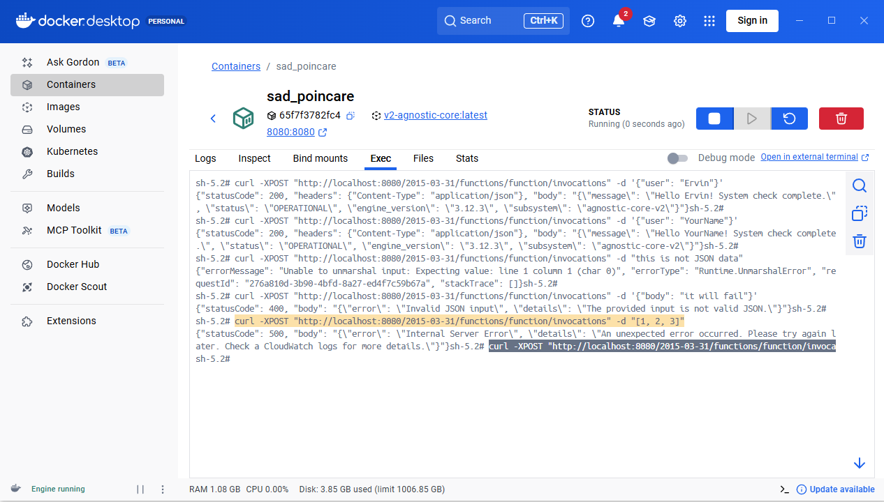
locally tested, stop docker image and commit and push a changes
git add .gitignore
git add .dockerignore
git add Dockerfile
git add requirements.txt
git add src/core.py
git add src/main.py
git status
CHECK! than next
git commit -m "feat: initial agnostic core architecture with docker support"
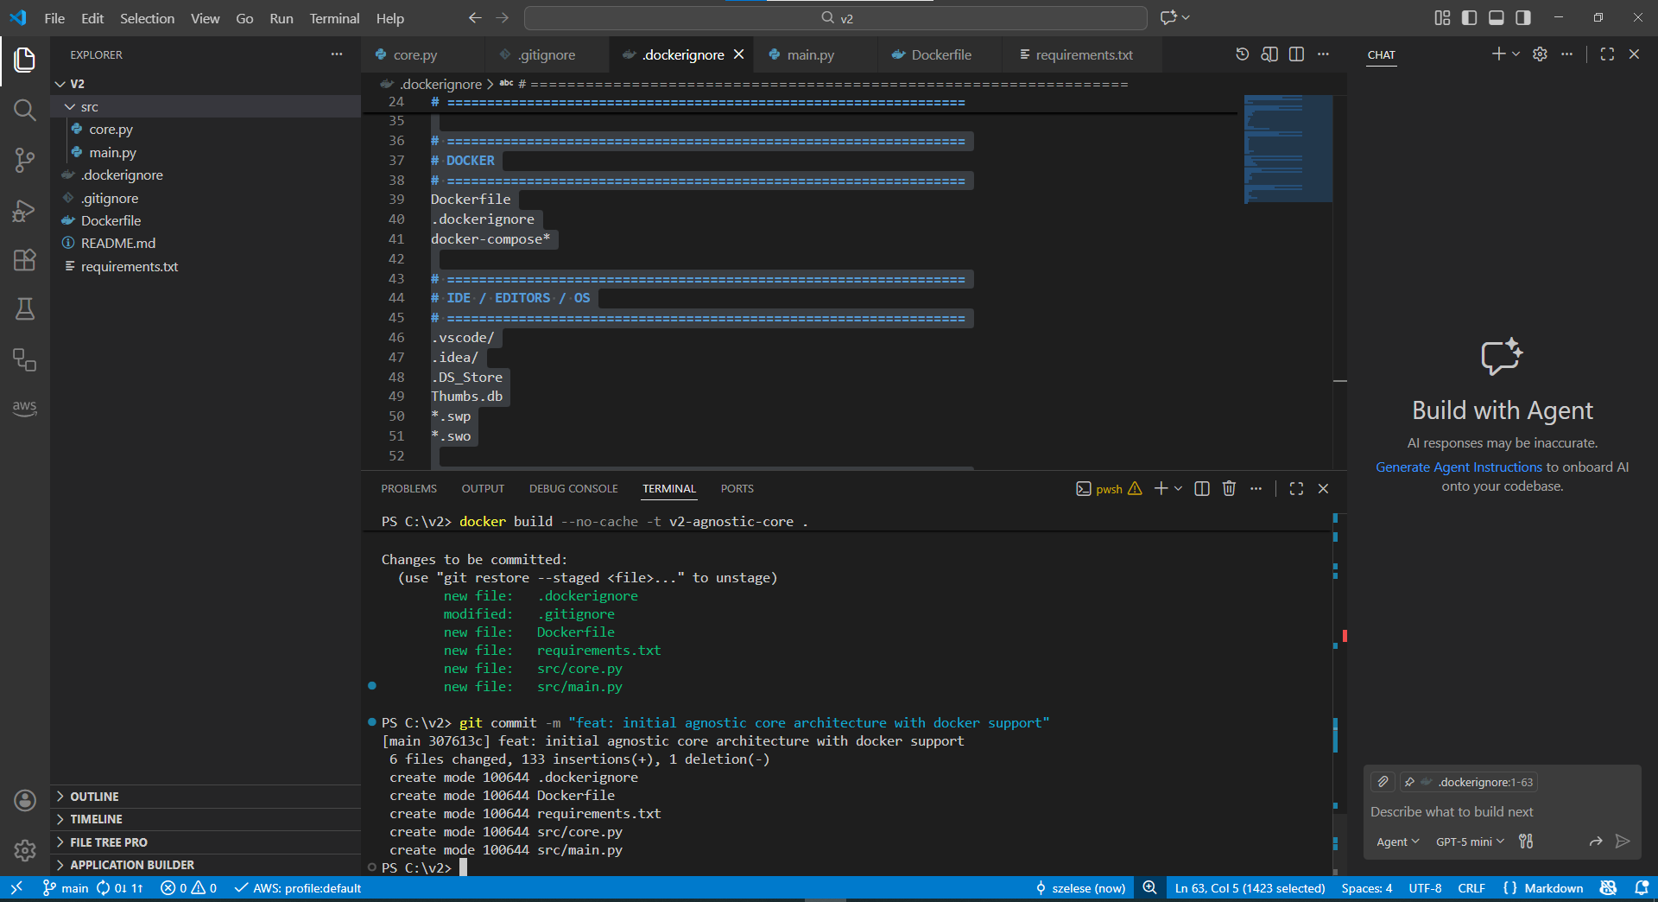
git push
7. step
We can use terminal or AWS GUI. I prefer terminal but if you want to click it is fine too.
aws sts get-caller-identity #check if it gets back your Account ID the connection is live
# I use this repo name and region but you can change it.
1. aws ecr create-repository --repository-name v2-agnostic-lambda-core --region eu-north-1
# change 123456789012 to your Account ID number
2. aws ecr get-login-password --region eu-north-1 | docker login --username AWS --password-stdin 123456789012.dkr.ecr.eu-north-1.amazonaws.com
# change 123456789012 to your Account ID number
3. docker tag v2-agnostic-core:latest 123456789012.dkr.ecr.eu-north-1.amazonaws.com/v2-agnostic-lambda-core:latest
# change 123456789012 to your Account ID number
4. docker push 123456789012.dkr.ecr.eu-north-1.amazonaws.com/v2-agnostic-lambda-core:latest
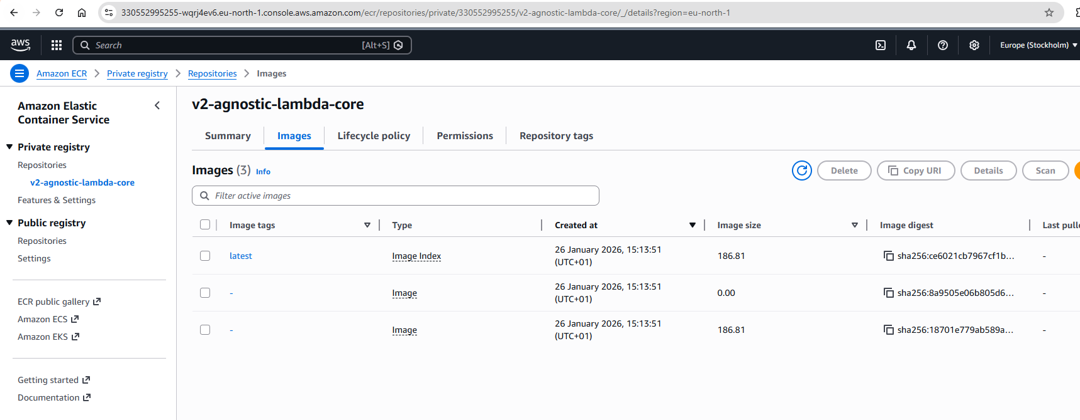
check in GUI
8. step
mkdir aws
touch aws/trust-policy.json
and file contains:
{
"Version": "2012-10-17",
"Statement": [
{
"Effect": "Allow",
"Principal": { "Service": "lambda.amazonaws.com" },
"Action": "sts:AssumeRole"
}
]
}
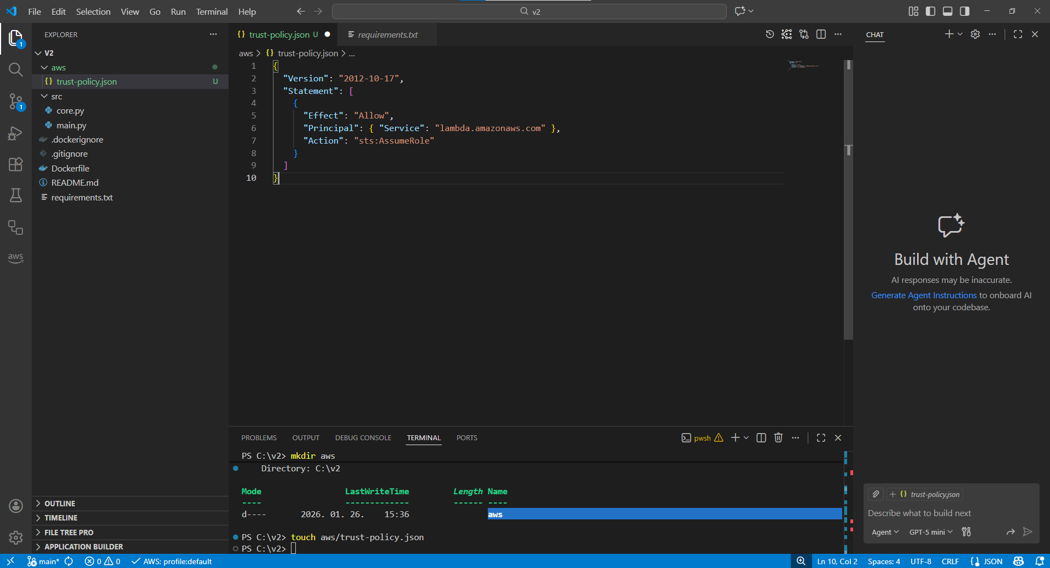
terminal:
8.1. aws iam create-role --role-name v2-lambda-ex-role --assume-role-policy-document file://aws/trust-policy.json
8.2. aws iam attach-role-policy --role-name v2-lambda-ex-role --policy-arn arn:aws:iam::aws:policy/service-role/AWSLambdaBasicExecutionRole
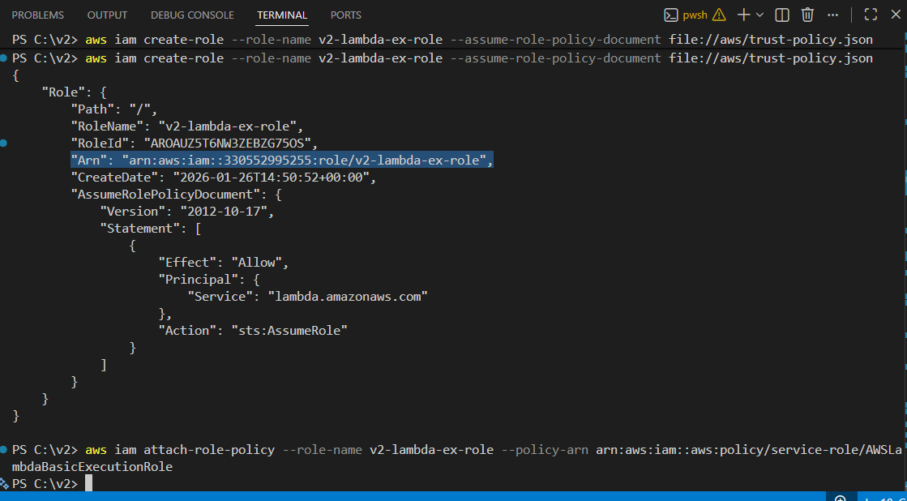
#check this marked row Arn ! you need to copy it to step 3
8.3.
aws lambda create-function `
--function-name v2-agnostic-lambda `
--package-type Image `
--code ImageUri=330552995255.dkr.ecr.eu-north-1.amazonaws.com/v2-agnostic-lambda-core:latest `
--role arn:aws:iam::123456789012:role/v2-lambda-ex-role ` #change this row to your Arn
--region eu-north-1 # please change it also if you choose another server
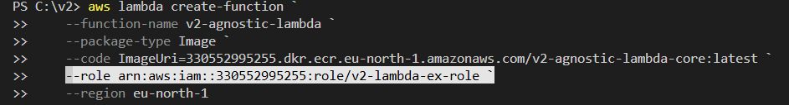
An error occurred (InvalidParameterValueException) when calling the CreateFunction operation: The image manifest, config or layer media type for the source image 330552995255.dkr.ecr.eu-north-1.amazonaws.com/v2-agnostic-lambda-core:latest is not supported.
If you have a same error message, than do not panic. We will fix it. If not just continue 8.4.
Shortly: common compatible problem. AWS Lambda is choosy. We need to rebuild a container to a correct format.
docker build --platform linux/amd64 -t v2-agnostic-core .
docker tag v2-agnostic-core:latest 330552995255.dkr.ecr.eu-north-1.amazonaws.com/v2-agnostic-lambda-core:latest
docker push YourAccounttIDHere.dkr.ecr.eu-north-1.amazonaws.com/v2-agnostic-lambda-core:latest
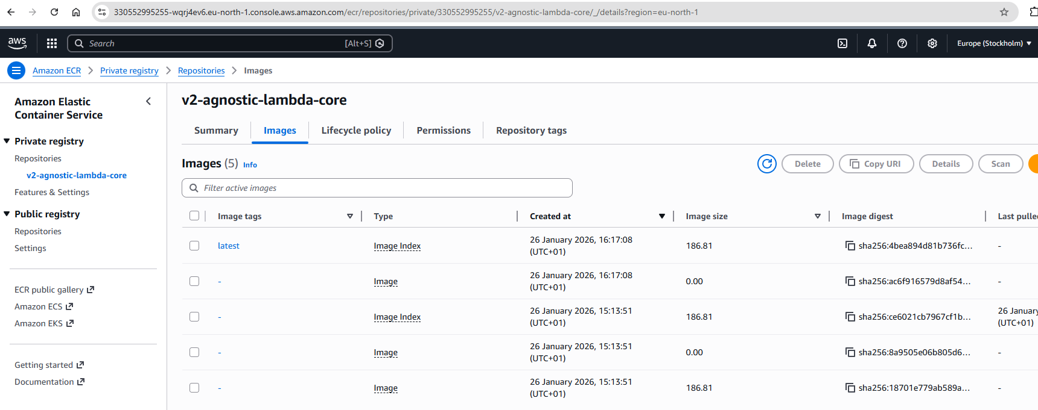
not working, but do not give up, you need to manually delete all images and rebuild that can fix everything. so fix the problem use this: --provenance=false the keyword! :
docker buildx build --platform linux/amd64 --provenance=false -t v2-agnostic-core .
docker tag v2-agnostic-core:latest YourAccounttIDHere.dkr.ecr.eu-north-1.amazonaws.com/v2-agnostic-lambda-core:latest
docker push YourAccounttIDHere.dkr.ecr.eu-north-1.amazonaws.com/v2-agnostic-lambda-core:latest
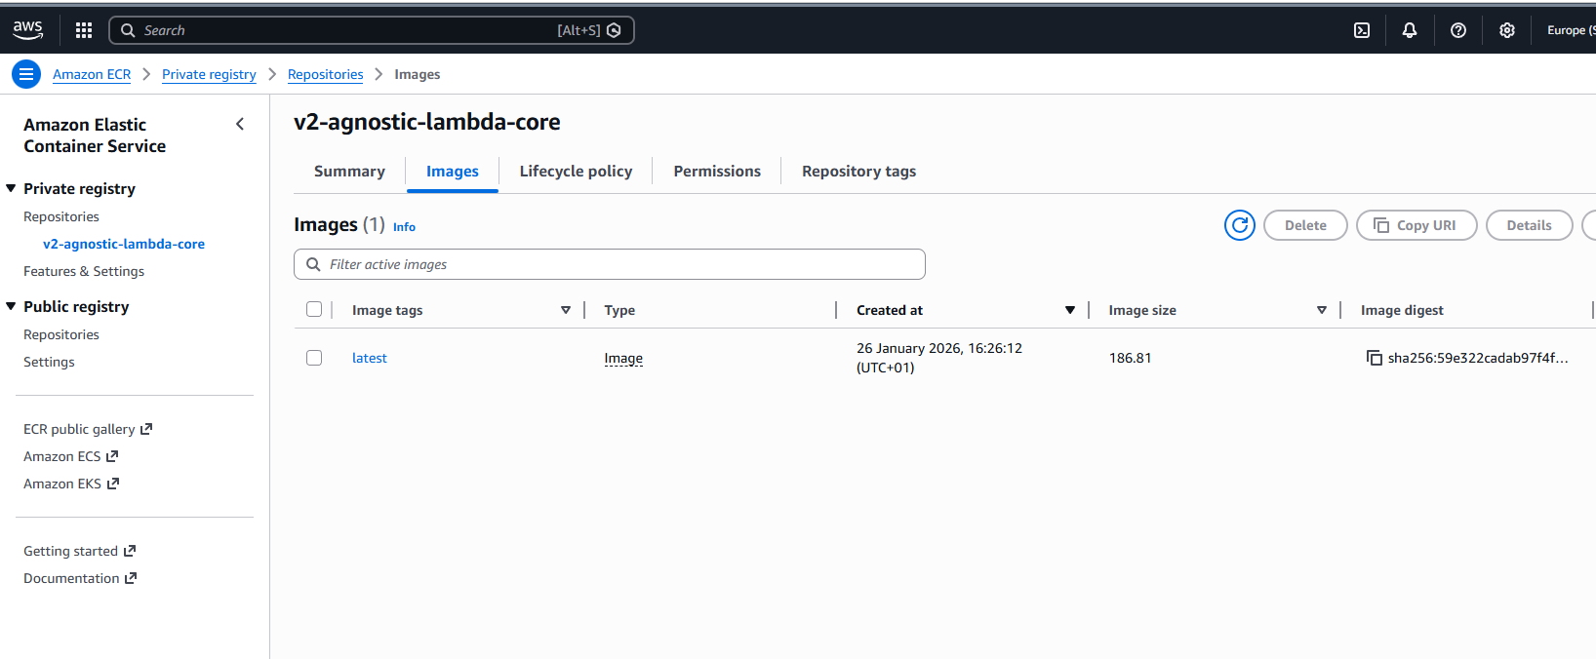
check a type if Image than all ok
8.5.
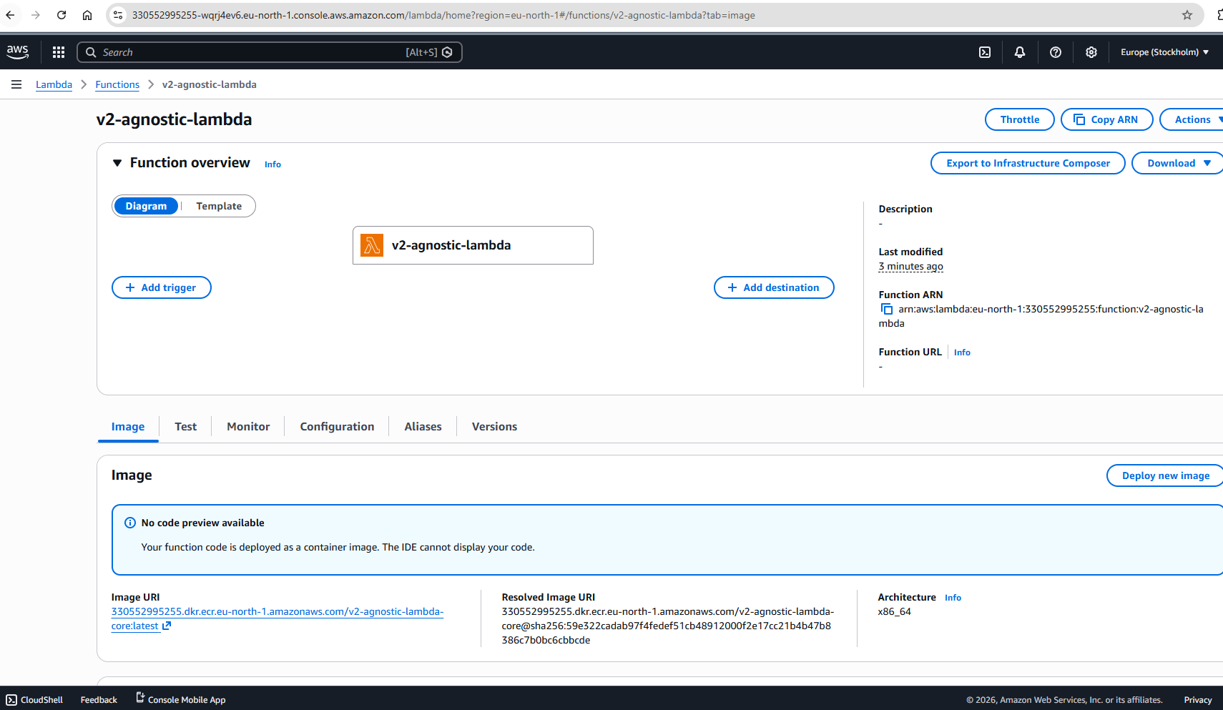
if everything fine you can check your lambda in AWS GUI
12. step
terminal:
12.1.
aws lambda create-function-url-config `
--function-name v2-agnostic-lambda `
--auth-type NONE `
--region eu-north-1
# create public url
12.2.
aws lambda add-permission `
--function-name v2-agnostic-lambda `
--statement-id FunctionURLPublicAccess `
--action lambda:InvokeFunctionUrl `
--principal "*" `
--function-url-auth-type NONE `
--region eu-north-1
#add a permission everybody to invoke a lambda
12.3. we can check endpoint now the 12.1.st command return value:
https://random-chars.lambda-url.eu-north-1.on.aws/
copy and paste the final test
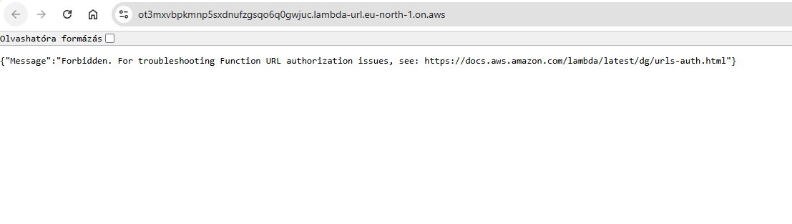
I have some error so time to fix it.
use this script to terminal if you have a same problem and wait 2 minutes let AWS refresh:
aws lambda update-function-url-config --function-name v2-agnostic-lambda --auth-type NONE --region eu-north-1
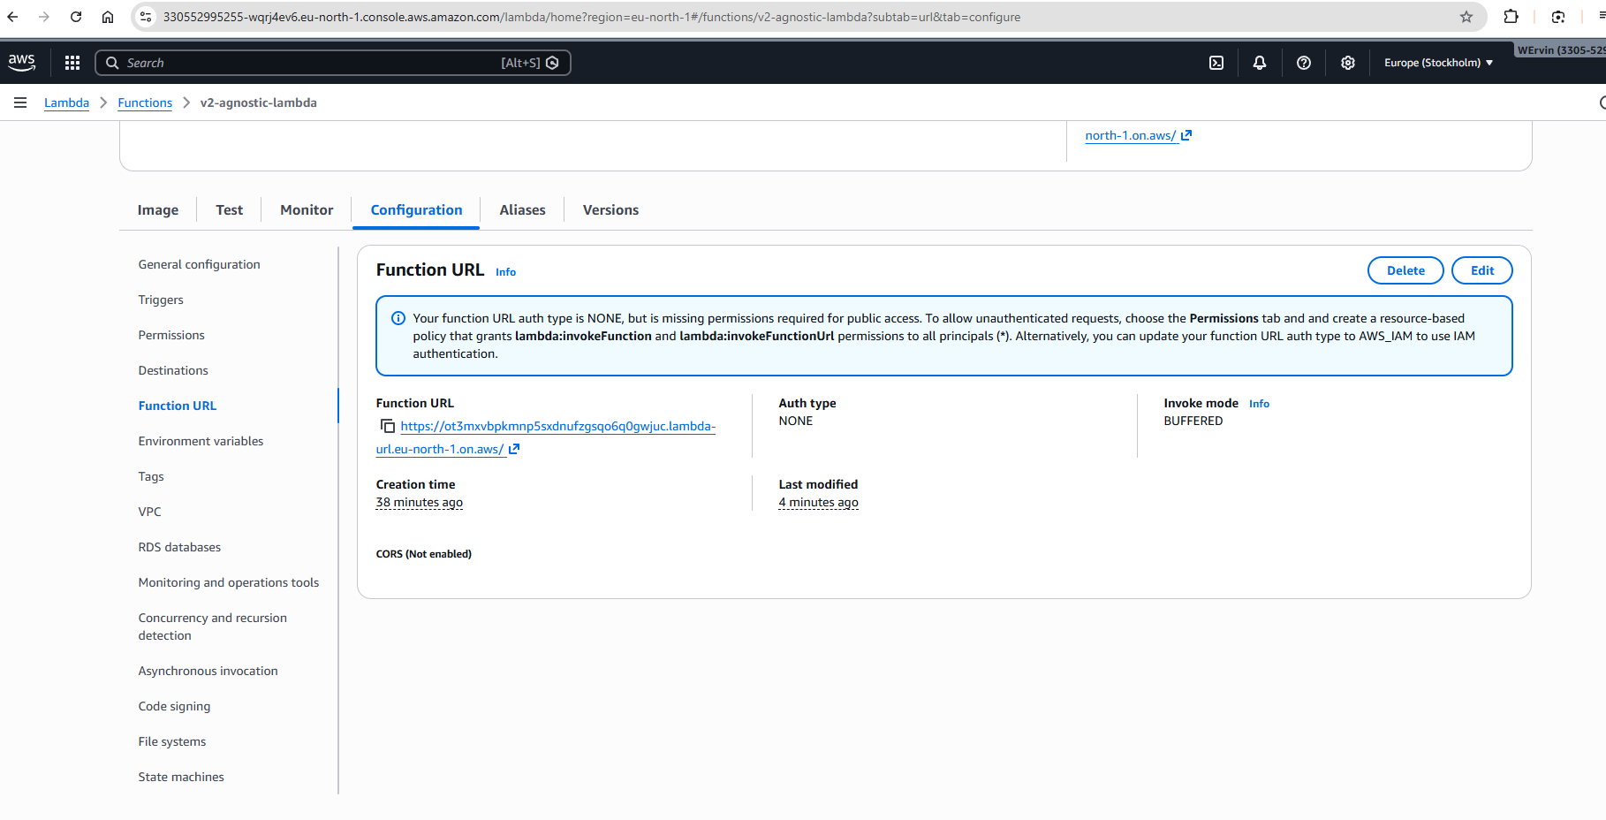
Not working. But if you enter the AWS GUI the blue box can help you what is the problem.
So my policies is to tight. I need to add more.
terminal:
aws lambda add-permission `
--function-name v2-agnostic-lambda `
--action lambda:invokeFunctionUrl `
--principal "*" `
--function-url-auth-type NONE `
--statement-id PublicAccessFix `
--region eu-north-1
aws lambda add-permission `
--function-name v2-agnostic-lambda `
--action lambda:invokeFunction `
--principal "*" `
--statement-id GlobalInvokeAccess `
--region eu-north-1
WAIT 2min let the Amazon refresh.
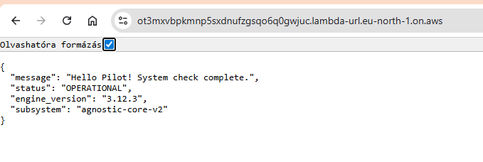
Everything fine! #but if not do not give up. Check steps again, permissions, terminal or GUI and AI can help a lot. I don’t want to show only a happy path. You need to calibrate a system.
# lessons learned: manifest resoluition: Overcoming docker new function comp. issues
security: dual-layer sec model: lambda role and resource based policy fix
architecture alignment: ensuring environment parity
commit & push:
git add aws/trust-policy.json
git commit -m "Add AWS trust policy for Lambda IAM role"
git push
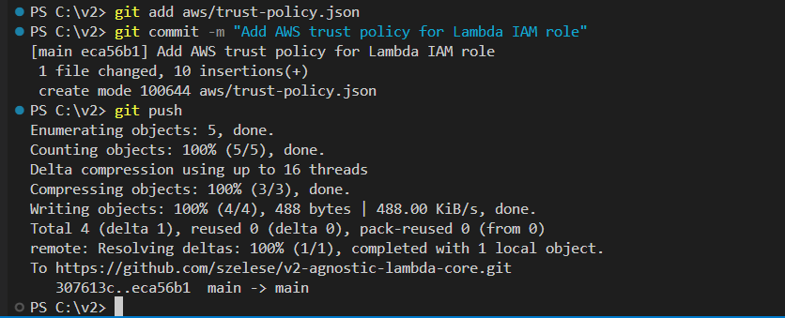
13. step GitHub<-OIDC->AWS create trust policy (v1 step 43,44)
if you don’t have the trust policy:
terminal:
aws iam create-open-id-connect-provider `
--url "https://token.actions.githubusercontent.com" `
--client-id-list "sts.amazonaws.com" `
--thumbprint-list "6938fd4d98bab03faadb97b34396831e3780aea1" "1c58a3a8518e8759bf075b76b750d4f2df264fcd"
14. step create project-specific trust policy
create file named: aws/gha-v2-trust-policy.json
{
"Version": "2012-10-17",
"Statement": [
{
"Effect": "Allow",
"Principal": {
"Federated": "arn:aws:iam::YourAccountID:oidc-provider/token.actions.githubusercontent.com"
},
"Action": "sts:AssumeRoleWithWebIdentity",
"Condition": {
"StringLike": {
"token.actions.githubusercontent.com:sub": "repo:ChangeToYourRepoName/v2-agnostic-lambda-core:*"
},
"StringEquals": {
"token.actions.githubusercontent.com:aud": "sts.amazonaws.com"
}
}
}
]
}
15. step provision a deployment role
terminal:
aws iam create-role `
--role-name v2-gha-deploy-role `
--assume-role-policy-document file://aws/gha-v2-trust-policy.json
16. step grant a minimum permissions
# Attach ECR PowerUser
aws iam attach-role-policy --role-name v2-gha-deploy-role --policy-arn arn:aws:iam::aws:policy/AmazonEC2ContainerRegistryPowerUser

# Create and Attach Lambda Update Policy
aws iam put-role-policy `
--role-name v2-gha-deploy-role `
--policy-name LambdaUpdateAccess `
--policy-document '{"Version":"2012-10-17","Statement":[{"Effect":"Allow","Action":"lambda:UpdateFunctionCode","Resource":"arn:aws:lambda:eu-north-1:YourAccountID:function:v2-agnostic-lambda"}]}'
CHECK:
aws iam list-attached-role-policies --role-name v2-gha-deploy-role
#need: AmazonEC2ContainerRegistryPowerUser
aws iam list-role-policies --role-name v2-gha-deploy-role
#need: LambdaUpdateAccess
17. step
create folders and file:
mkdir -p .github/workflows && touch .github/workflows/deploy.yml
change core.py return answer and you can see a change:
"message": f"Hello {user}! Hello, CI/CD GitHubActions, AWS! All OK!",

git add . # check 3 files need to push deploy.yml, core.py and
git commit -m "feat: implement OIDC-based GHA automation for v2"
git push
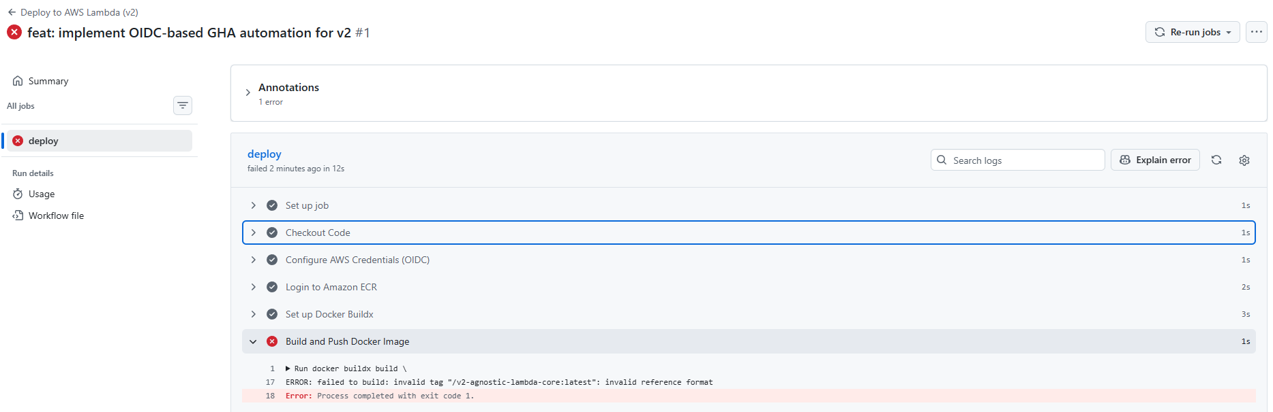
we have some problem with deploy.yaml but we can fix:
name: Deploy to AWS Lambda (v2)

on:
push:
branches: [ main ]

permissions:
id-token: write
contents: read

jobs:
deploy:
runs-on: ubuntu-latest
steps:
- name: Checkout Code
uses: actions/checkout@v4

- name: Configure AWS Credentials (OIDC)
uses: aws-actions/configure-aws-credentials@v4
with:
role-to-assume: arn:aws:iam::330552995255:role/v2-gha-deploy-role
aws-region: eu-north-1

- name: Login to Amazon ECR
uses: aws-actions/amazon-ecr-login@v2

- name: Set up Docker Buildx
uses: docker/setup-buildx-action@v3

- name: Build and Push Docker Image
env:
ECR_REGISTRY: 330552995255.dkr.ecr.eu-north-1.amazonaws.com
ECR_REPOSITORY: v2-agnostic-lambda-core
IMAGE_TAG: latest
run: |
docker buildx build \
--platform linux/amd64 \
--provenance=false \
-t $ECR_REGISTRY/$ECR_REPOSITORY:$IMAGE_TAG \
--push .

- name: Update Lambda Function
env:
ECR_REGISTRY: 330552995255.dkr.ecr.eu-north-1.amazonaws.com
ECR_REPOSITORY: v2-agnostic-lambda-core
IMAGE_TAG: latest
run: |
aws lambda update-function-code \
--function-name v2-agnostic-lambda \
--image-uri $ECR_REGISTRY/$ECR_REPOSITORY:$IMAGE_TAG
git add .github/workflows/deploy.yml
git commit -m "fix: explicit ECR registry URL for stable build"
git push
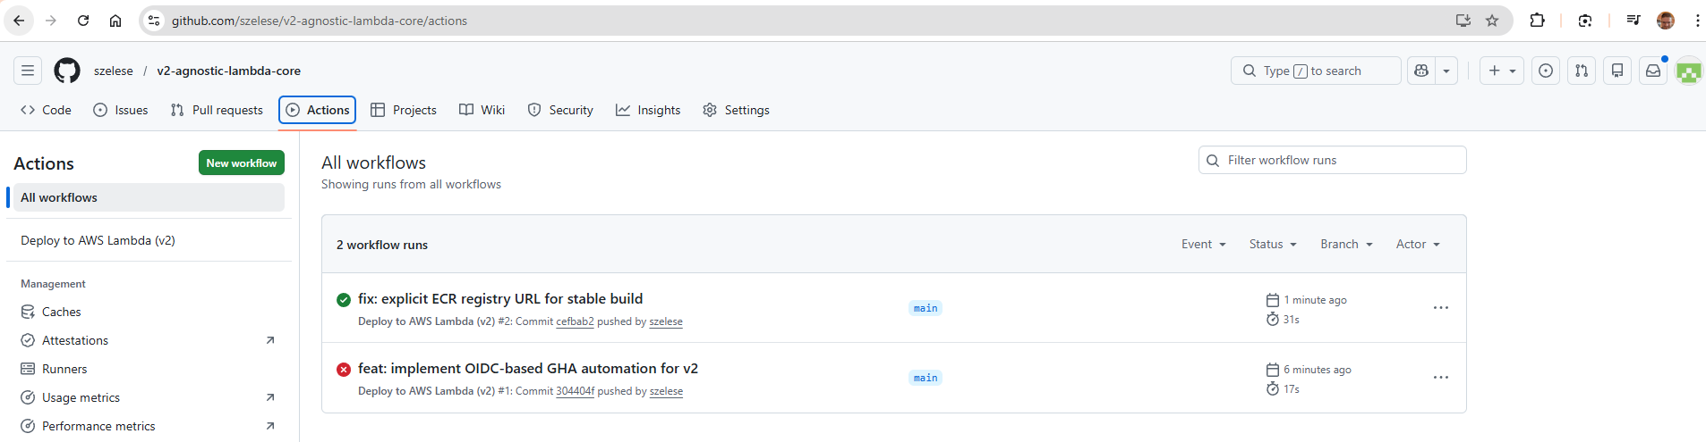
and 31sec
and i wanted to test it again:
git commit --allow-empty -m "Speed test: re-running deployment pipeline"
git push
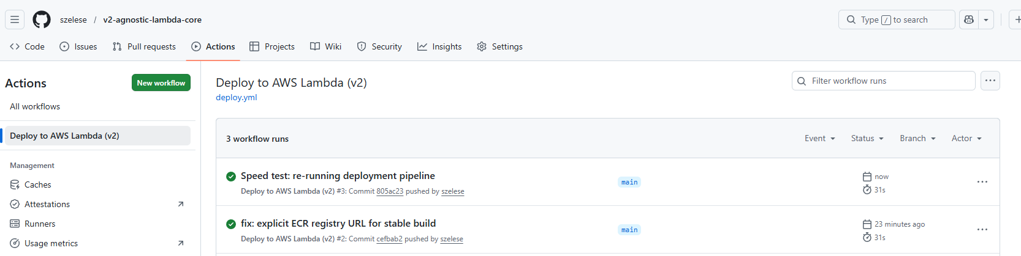
so checked again 31 sec
# Supersonic mode reached (31s). > Current state: maximum velocity, zero validation. Next step: transitioning to production-peady status. Sacrificing minor speed for reliability by implementing a CI Gate (flake8, bandit, pytest), post-deploy hook (smoke test, version check), and Secrets Manager. Security and validation over raw seconds.
18.step
CI gate, because this is mini project and keep it simple than we use sequential (but ofc parallel helps us to make improve a speed but it is raise a complexity. I don’t want overengineer it. KISS)
this code is put a CI:
- name: Quality and Security Gate
run: |
pip install flake8 bandit pytest
# 1. Style and syntax (flake8)-only "deadly fault"
flake8 . --count --select=E9,F63,F7,F82 --show-source --statistics
# 2. Security audit (bandit) - only Level High
bandit -r . -ll
# 3. Logic test (pytest)
pytest
terminal:
git add .
git commit -m "feat(ci): implement fail-fast quality gate"
git push
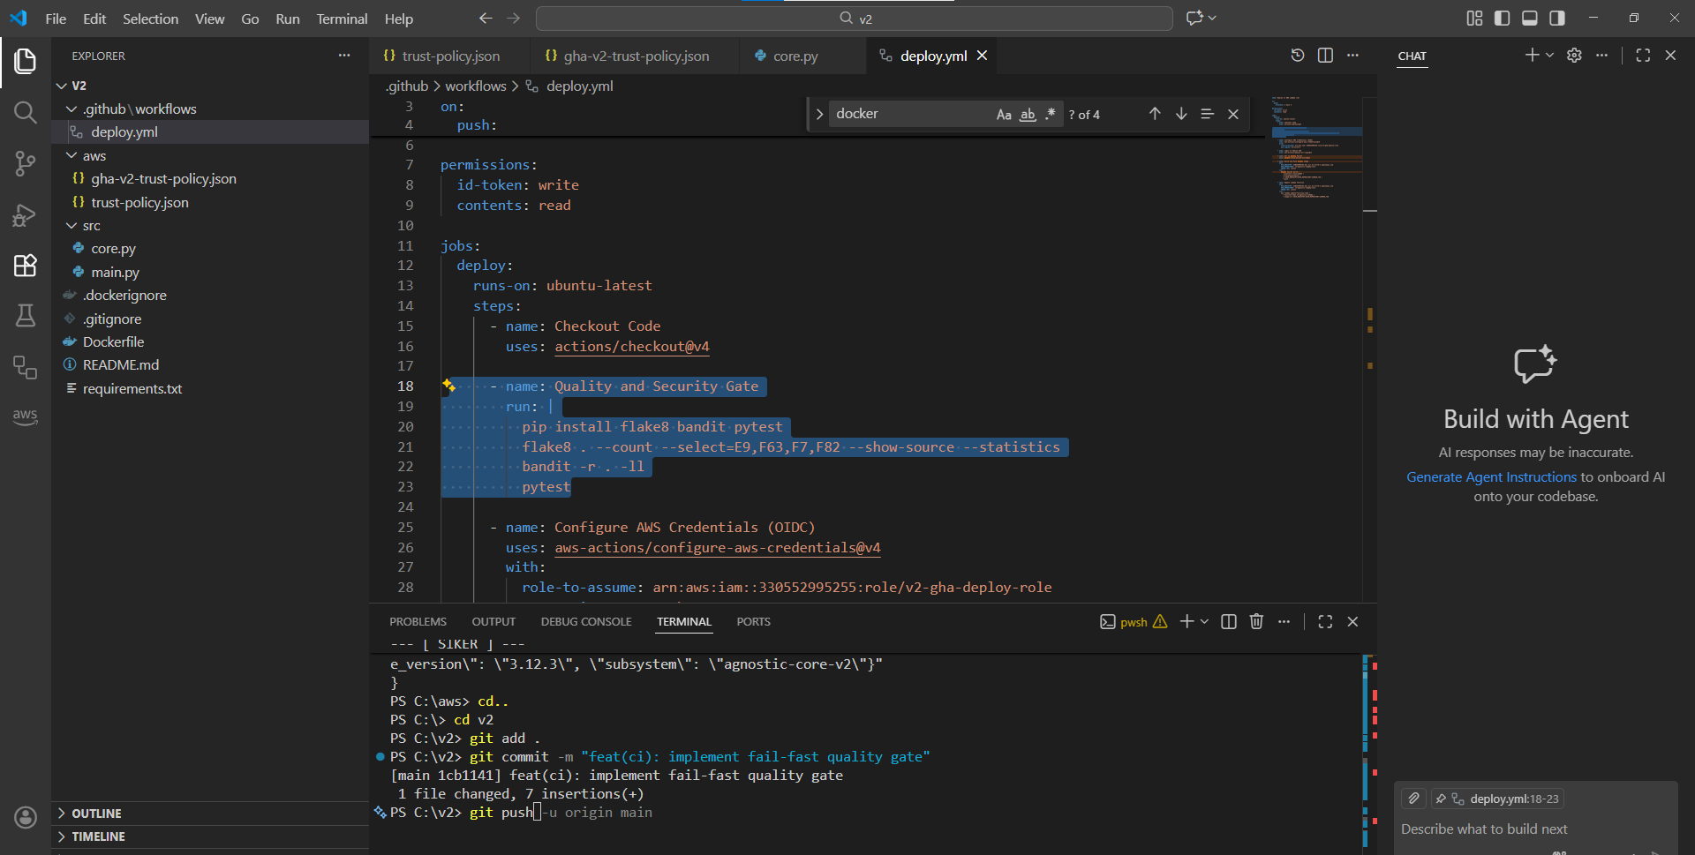
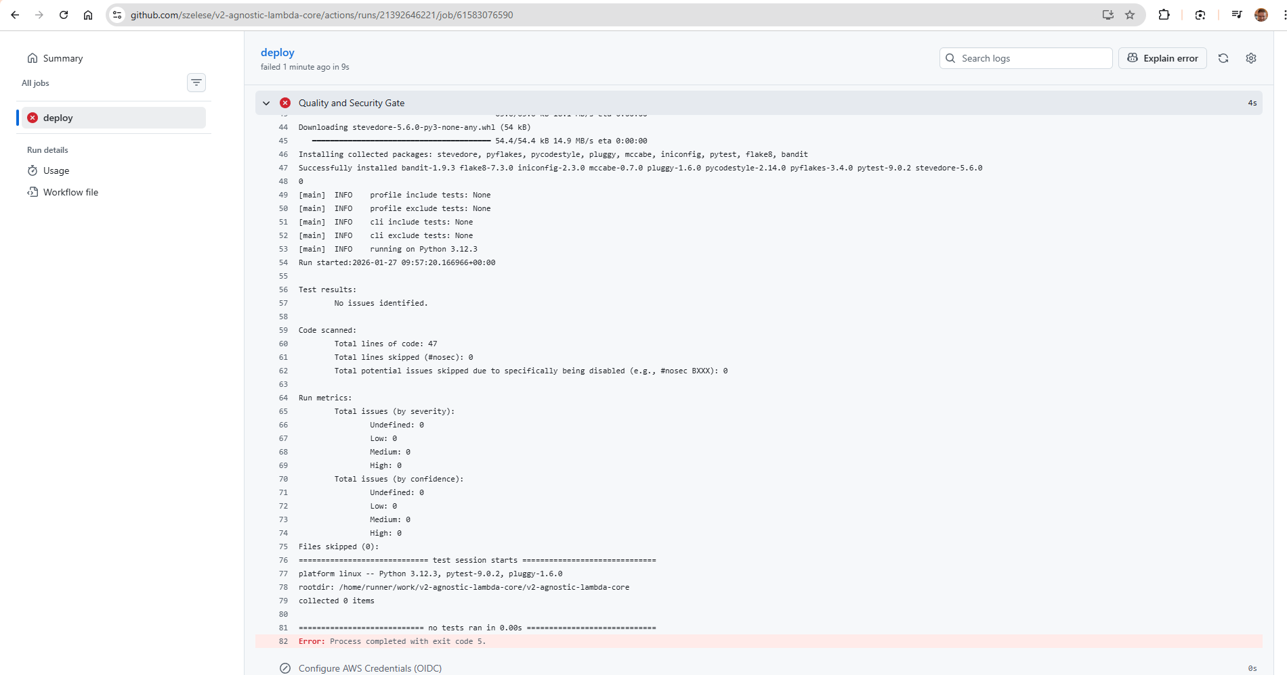
flake8 and bandit fine! We need to put some test file “environment” or file.
so terminal:
mkdir tests
printf 'def test_pipeline_gate():\n assert True\n' > tests/test_dummy.py
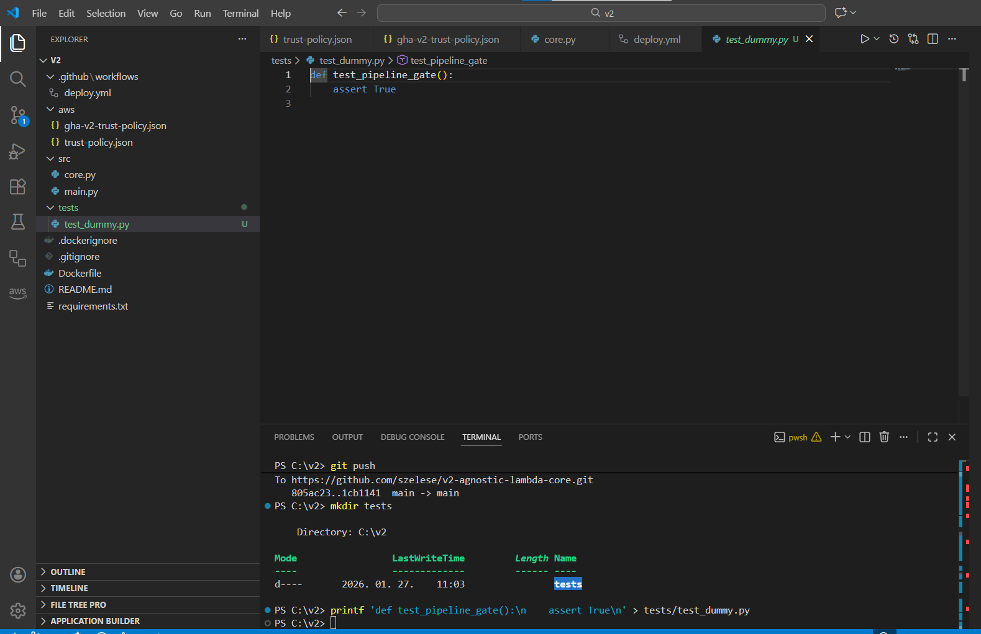
git add tests/test_dummy.py
git commit -m "test: add dummy test to satisfy quality gate"
git push
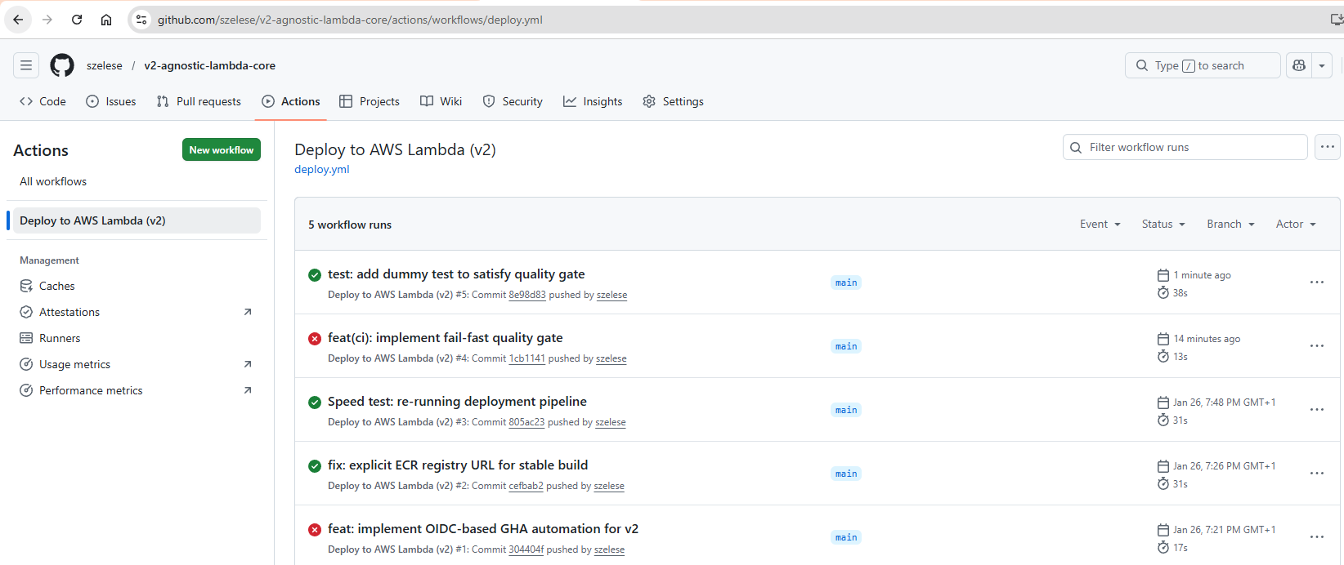
7sec sacrifice but now it has a good CI gate
19. step
Post deploy hook and version check
19.1. we need to change a main.py a bit to implement versioning
import os
def handler(event, context):
version = os.environ.get("VERSION", "dev-manual")
return {
"body": json.dumps({
…
"version": version,
…
})
}
the new main.py:
import os
import json
import logging
from .core import process_data

# Standard AWS Lambda logger configuration
logger = logging.getLogger()
logger.setLevel(logging.INFO)

def handler(event, context):
version=os.environ.get("VERSION", "dev-manual")
logger.info(f"Incoming event: {json.dumps(event)}")

try:
# 1. Intelleigent data load (Adapter logic)
if "body" in event:
if isinstance(event["body"], str):
payload = json.loads(event["body"])
else:
payload = event["body"]
else:
payload = event

# 2. Core logic call
result = process_data(payload)

# 3. Success response
return {
"statusCode": 200,
"headers": {"Content-Type": "application/json"},
"body": json.dumps({
"version": version,
"status": "success",
"message": "Request processed successfully.",
"result": result
})
}
# 4. Error handling
except json.JSONDecodeError as e:
logger.error(f"Invalid JSON received: {str(e)}")
return {
"statusCode": 400,
"body": json.dumps({
"error": "Invalid JSON input",
"details": "The provided input is not valid JSON.",
"version": version
})
}
except Exception as e:
logger.error(f"Unexpected system error: {str(e)}")
return {
"statusCode": 500,
"body": json.dumps({
"error": "Internal Server Error",
"details": "An unexpected error occurred. Please try again later. Check a CloudWatch logs for more details.",
"version": version
})
}

Modify now deploy.yml .
after docker image refresh but before a new smoke test:
- name: Deploy and Set Version
run: |
# 1. The code (container) refresh
aws lambda update-function-code \
--function-name v2-agnostic-lambda \
--image-uri ${{ steps.login-ecr.outputs.registry }}/v2-agnostic-lambda:latest

# 2. Wait 2 sec, let aws record a new code
sleep 2

# 3. A version (Commit SHA) setup environment variable
SHORT_SHA=$(echo ${{ github.sha }} | cut -c1-7)
aws lambda update-function-configuration \
--function-name v2-agnostic-lambda \
--environment "Variables={VERSION=$SHORT_SHA}"

Now add some smoke test:
- name: Smart Smoke Test (Version Validation)
run: |
EXPECTED_VERSION=$(echo ${{ github.sha }} | cut -c1-7)
echo "Waiting for version: $EXPECTED_VERSION"

# Maximum 20 try wtih 2sec wait
for i in {1..20}; do
RESPONSE=$(curl -s ${{ secrets.LAMBDA_URL }})
ACTUAL_VERSION=$(echo $RESPONSE | python3 -c "import sys, json; print(json.load(sys.stdin).get('version', ''))")

echo "Check $i: Actual version in cloud: '$ACTUAL_VERSION'"

if [ "$ACTUAL_VERSION" == "$EXPECTED_VERSION" ]; then
echo "Succes: The new version: ($ACTUAL_VERSION) is online!"
exit 0
fi

echo "Old version running, still waiting..."
sleep 2
done

echo "Error: Time-out. Lamba is not updated to $EXPECTED_VERSION version"
exit 1

new deploy.yml :
name: Deploy to AWS Lambda (v2)

on:
push:
branches: [ main ]

permissions:
id-token: write
contents: read

jobs:
deploy:
runs-on: ubuntu-latest
steps:
- name: Checkout Code
uses: actions/checkout@v4

- name: Quality and Security Gate
run: |
pip install flake8 bandit pytest
flake8 . --count --select=E9,F63,F7,F82 --show-source --statistics
bandit -r . -ll
pytest

- name: Configure AWS Credentials (OIDC)
uses: aws-actions/configure-aws-credentials@v4
with:
role-to-assume: arn:aws:iam::330552995255:role/v2-gha-deploy-role
aws-region: eu-north-1

- name: Login to Amazon ECR
id: login-ecr
uses: aws-actions/amazon-ecr-login@v2

- name: Set up Docker Buildx
uses: docker/setup-buildx-action@v3

- name: Build and Push Docker Image
env:
ECR_REGISTRY: 330552995255.dkr.ecr.eu-north-1.amazonaws.com
ECR_REPOSITORY: v2-agnostic-lambda-core
IMAGE_TAG: latest
run: |
docker buildx build \
--platform linux/amd64 \
--provenance=false \
-t $ECR_REGISTRY/$ECR_REPOSITORY:$IMAGE_TAG \
--push .

- name: Deploy and Set Version
run: |
# 1. The code (container) refresh
aws lambda update-function-code \
--function-name v2-agnostic-lambda-core \
--image-uri ${{ steps.login-ecr.outputs.registry }}/v2-agnostic-lambda-core:latest
# 2. Wait 2 sec, let aws record the new code
sleep 2
# 3. A version (Commit SHA) setup environment variable
SHORT_SHA=$(echo ${{ github.sha }} | cut -c1-7)
aws lambda update-function-configuration \
--function-name v2-agnostic-lambda-core \
--environment "Variables={VERSION=$SHORT_SHA}"

- name: Smart Smoke Test (Version Validation)
run: |
EXPECTED_VERSION=$(echo ${{ github.sha }} | cut -c1-7)
echo "Waiting for version: $EXPECTED_VERSION"

# Maximum 20 try wtih 2sec wait
for i in {1..20}; do
RESPONSE=$(curl -s ${{ secrets.LAMBDA_URL }})
ACTUAL_VERSION=$(echo $RESPONSE | python3 -c "import sys, json; print(json.load(sys.stdin).get('version', ''))")

echo "Check $i: Actual version in cloud: '$ACTUAL_VERSION'"

if [ "$ACTUAL_VERSION" == "$EXPECTED_VERSION" ]; then
echo "Succes: The new version: ($ACTUAL_VERSION) is online!"
exit 0
fi

echo "Old version running, still waiting..."
sleep 2
done

echo "Error: Time-out. Lamba is not updated to $EXPECTED_VERSION version"
exit 1

terminal:
git add .
git commit -m "feat: implement closed-loop deployment with versioning and smart smoke test"
git push
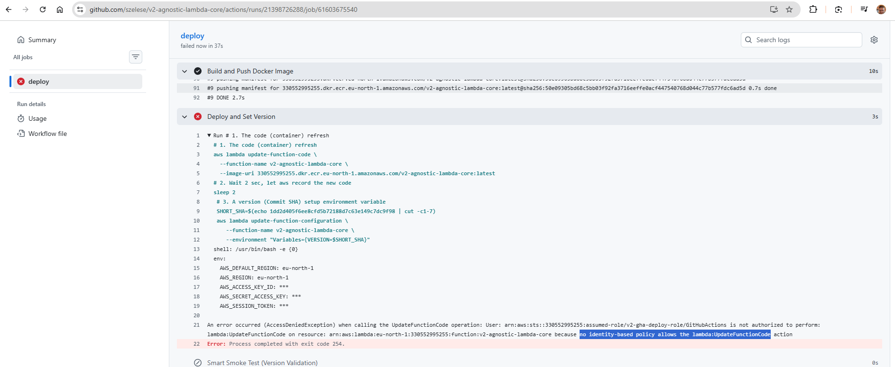
missing the marked policy, least privileged so only add this
terminal:
touch aws/lambda-update-policy.json
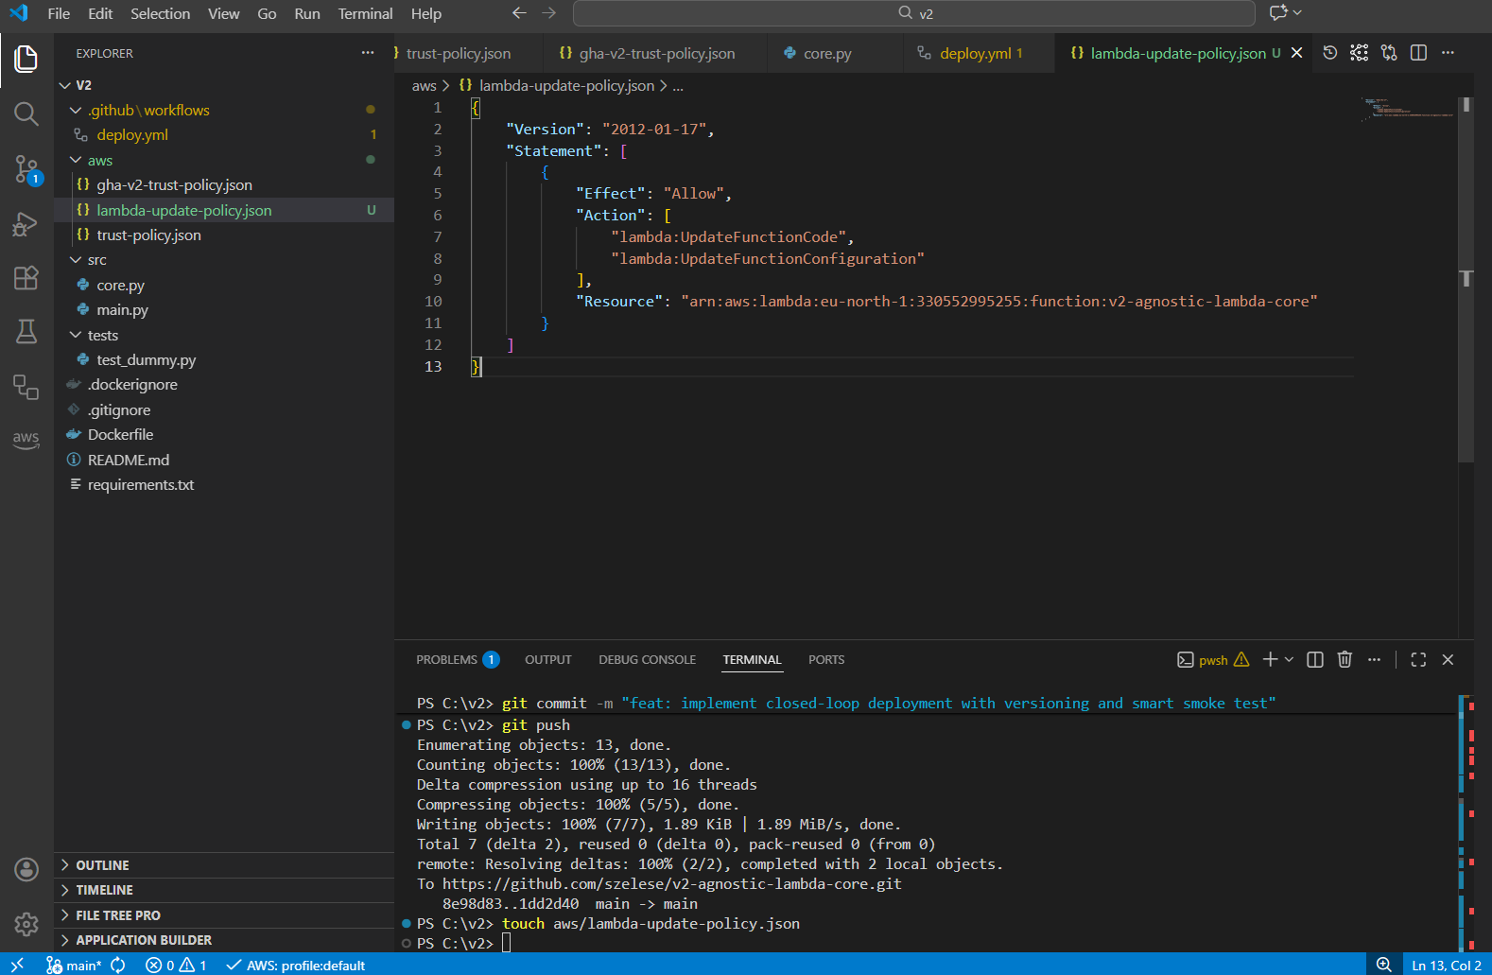
I have typo, in picture correct it:
{
"Version": "2012-10-17",
"Statement": [
{
"Effect": "Allow",
"Action": [
"lambda:UpdateFunctionCode",
"lambda:UpdateFunctionConfiguration"
],
"Resource": "arn:aws:lambda:eu-north-1:330552995255:function:v2-agnostic-lambda-core"
}
]
}
terminal adding this new policy:
aws iam put-role-policy --role-name v2-gha-deploy-role --policy-name GHALambdaUpdateAccess --policy-document file://aws/lambda-update-policy.json
git add aws/lambda-update-policy.json
git commit -m "sys: add lambda update policy for GHA"
git push
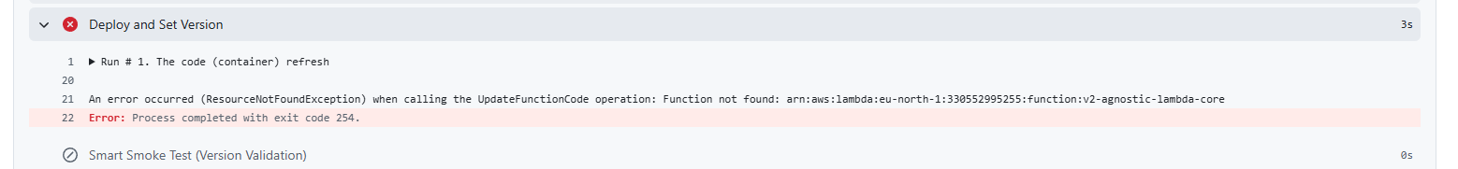
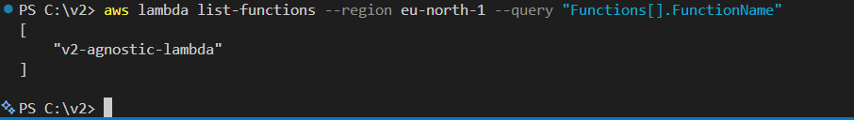
so just a bad name, need to fix everywhere. so just delete -core lambda-update-policy and deploy too
git add .
git commit -m "fix: correct lambda naming and update iam deployment policy"
git push
I am just deleted too much -core so I need to correct it. (the docker name is: ended -core)
git add . git commit -m "fix: use correct ecr repo name and fix line break syntax" git push
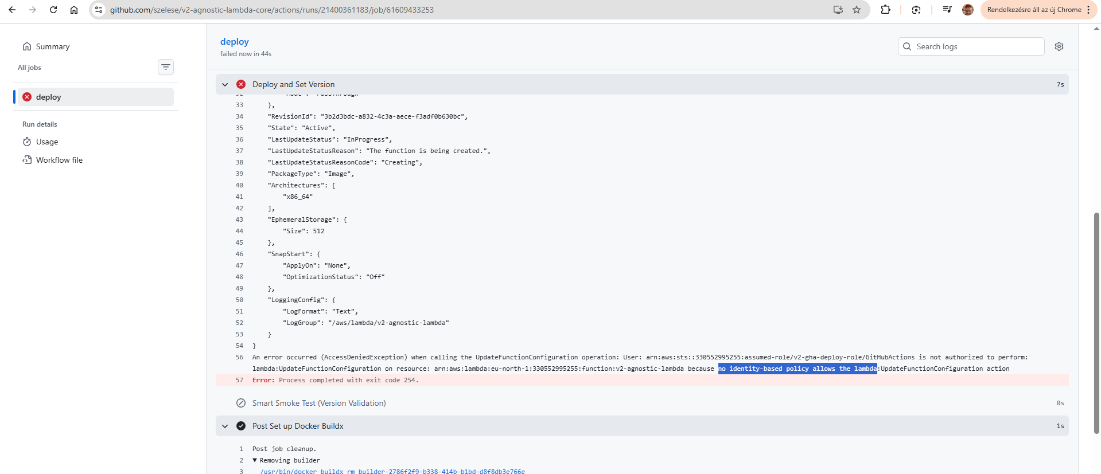
so missing 1 more policy, add it to :
aws/lambda-update-policy.json
"lambda:GetFunction"
terminal:
aws iam put-role-policy --role-name v2-gha-deploy-role --policy-name GHALambdaUpdateAccess --policy-document file://aws/lambda-update-policy.json
git add .
git commit -m "fix: add lambda:UpdateFunctionConfiguration permission"
git push
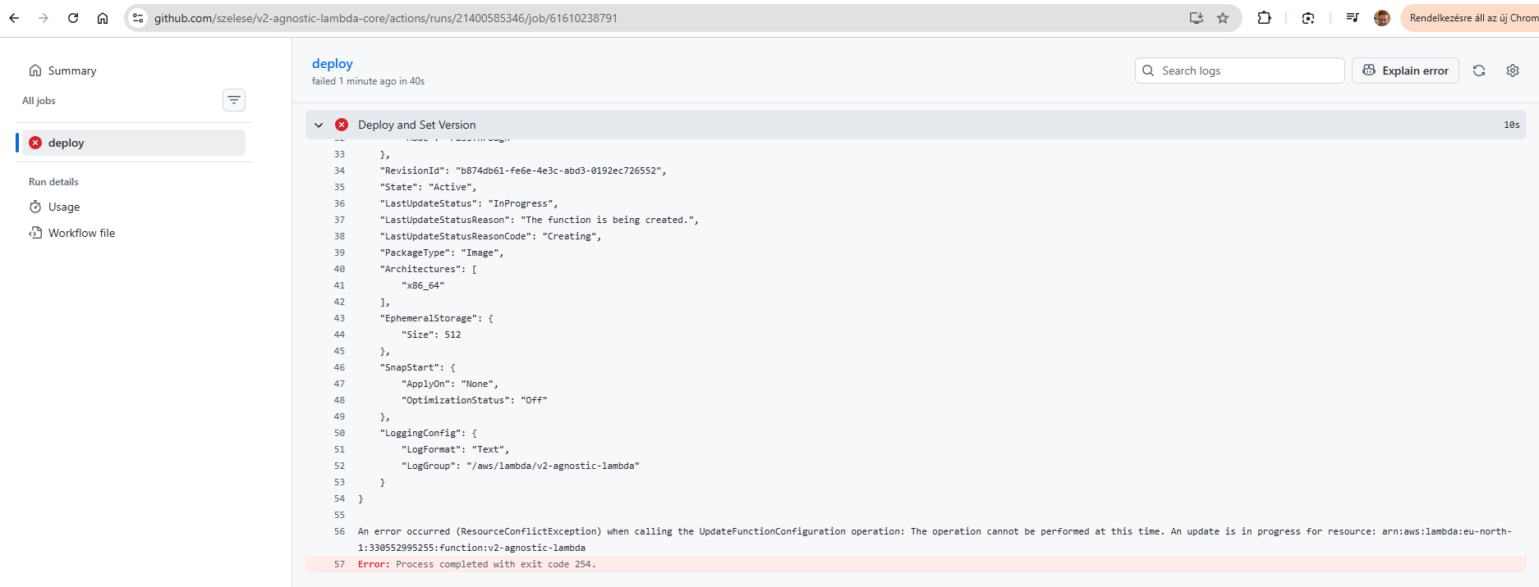
We was too fast. Give more time to AWS. So modify a deploy.yml.
change this:
# 2. Wait 2 sec, let aws record the new code
sleep 2
to this:
# 2. PRO: Wait for AWS to complete the code update
echo "Waiting for Lambda update to complete..."
aws lambda wait function-updated --function-name v2-agnostic-lambda
git add .
git commit -m "fix: resolve lambda update race condition using wait command"
git push
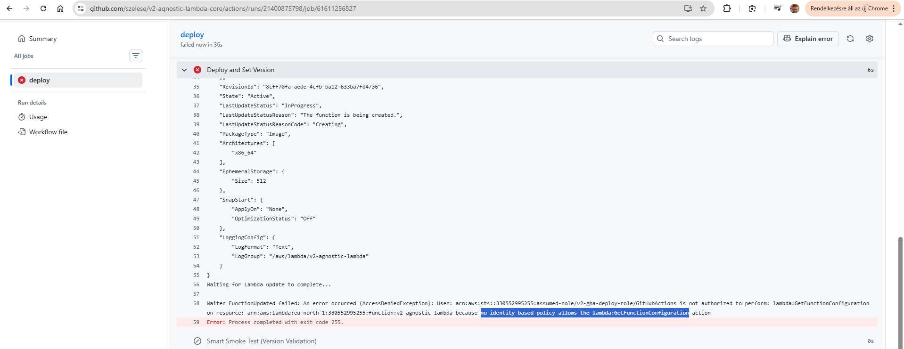
one more policy missing, this is a price to maximal security, least privilege
add one more row to aws/lambda-update-policy.json:
"lambda:GetFunctionConfiguration"

aws iam put-role-policy --role-name v2-gha-deploy-role --policy-name GHALambdaUpdateAccess --policy-document file://aws/lambda-update-policy.json
git add .
git commit -m "fix: add lambda:GetFunctionConfiguration permission for deployment waiter"
git push
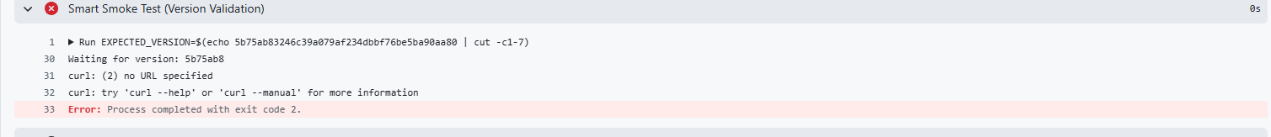
go to github your repo/settings/security/secrets and variables/new repositories secret/
NAME: LAMBDA_URL
Secret: search your url name in AWS/v2-agnostic-lambda/configuration/function url and copy here a full version like this: https://random-id.lambda-url.eu-north-1.on.aws/
go back to prev deployment and rerun all jobs
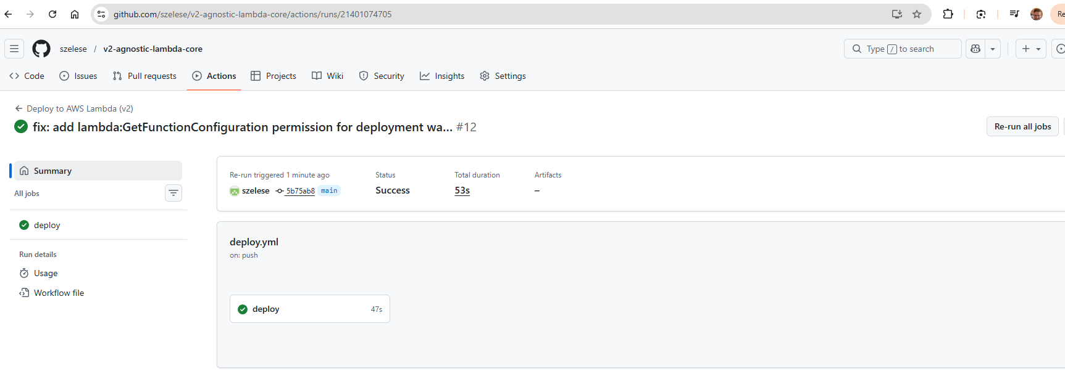
and I hope you have a same screen.

20. step
# 1. Create a topic
$TOPIC_ARN = aws sns create-topic --name v2-pipeline-notifications --query 'TopicArn' --output text
# Check:
echo $TOPIC_ARN
# 2. Subscribe (enter your email address and TOPIC_ARN)
aws sns subscribe --topic-arn $TOPIC_ARN --protocol email --notification-endpoint TE_EMAILDED@domain.com
check your email, spam also. u need to confirm a subscription:
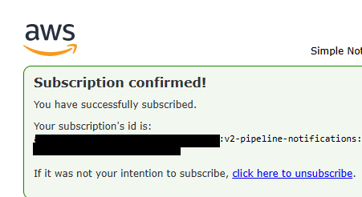
# 3. Note the TOPIC_ARN, and the name SNS_TOPIC_ARN should be in your GitHub Secrets!
github/your project/settings/security/secrets and variables/actions
Name: SNS_TOPIC_ARN
Secret: your TOPIC_ARN
4.
touch aws/sns-publish-policy.json
{
"Version": "2012-10-17",
"Statement": [
{
"Sid": "AllowSNSPublish",
"Effect": "Allow",
"Action": "sns:Publish",
"Resource": "arn:aws:sns:eu-north-1:330552995255:v2-pipeline-notifications"
}
]
}
than upload it a terminal:
aws iam put-role-policy `
--role-name gh-oidc-role `
--policy-name GHA-SNS-Publish-Access `
--policy-document file://aws/sns-publish-policy.json

i missed a role name so:
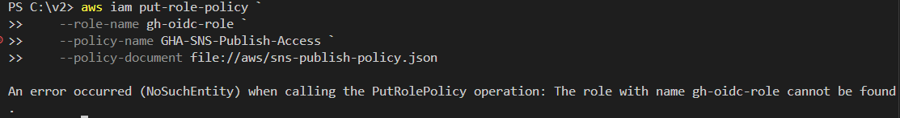
aws iam put-role-policy `
--role-name v2-gha-deploy-role `
--policy-name GHA-SNS-Publish-Access `
--policy-document file://aws/sns-publish-policy.json

check: aws iam list-role-policies --role-name v2-gha-deploy-role
if this than everything is OK:
PS C:\v2> aws iam list-role-policies --role-name v2-gha-deploy-role
{
"PolicyNames": [
"GHA-SNS-Publish-Access",
"GHALambdaUpdateAccess",
"LambdaUpdateAccess"
]
}
we need to modify a deploy several place but mainly in bottom
git add .
git commit -m "feat: add SNS notifications and pipeline duration tracking"
git push
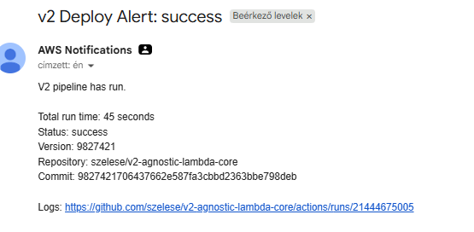
and the last thing: if we get an error than CloudWatch send it to SNS:
aws cloudwatch put-metric-alarm `
--alarm-name "v2-Lambda-Error-Alarm" `
--metric-name Errors `
--namespace AWS/Lambda `
--statistic Sum `
--period 60 `
--threshold 1 `
--comparison-operator GreaterThanOrEqualToThreshold `
--dimensions Name=FunctionName,Value=v2-agnostic-lambda `
--evaluation-periods 1 `
--alarm-actions PutYourSnsArnHere
check: aws cloudwatch describe-alarms --alarm-names "v2-Lambda-Error-Alarm"
main.py
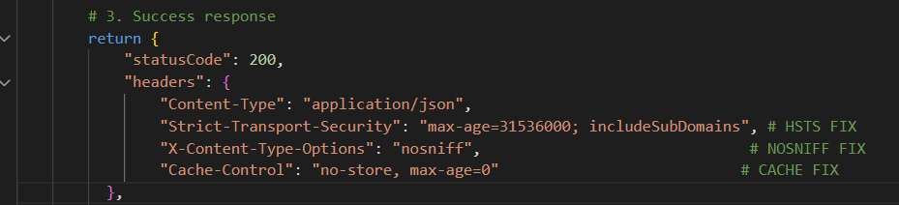
change this part to safety reasons
core.py: i was change this line:
"status": "OPERATIONAL" -> "status": "works" #to avoid false positive test
git add .
git commit -m "Refactor: apply security headers and update status logic"
git push
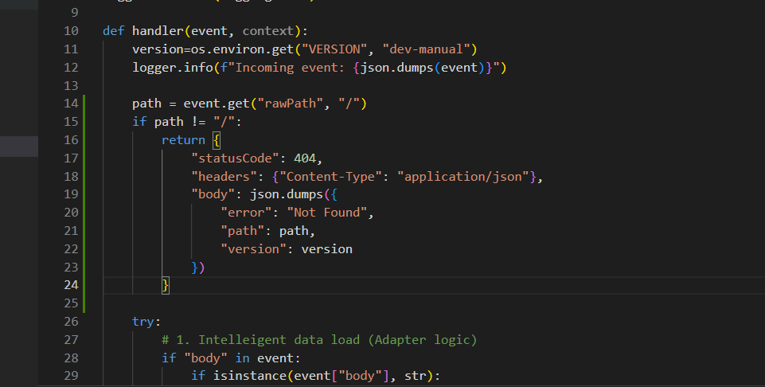
route protection
git add src/main.py
git commit -m "security: add route protection and hardened headers"
git push

just add a security header everywhere even error:
security_headers = {
"Content-Type": "application/json",
"Strict-Transport-Security": "max-age=31536000; includeSubDomains",
"X-Content-Type-Options": "nosniff",
"Cache-Control": "no-cache, no-store, must-revalidate, proxy-revalidate",
"Pragma": "no-cache",
"Expires": "0"
}

git add src/main.py git commit -m "security: harden headers and implement route protection" git push

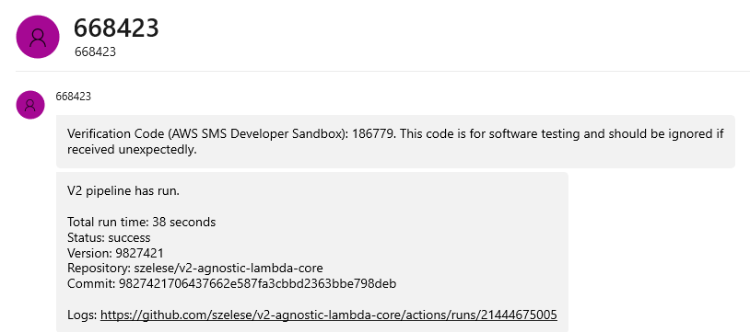
if u want to get an sms just subscribe to topic

The core architecture is now fully deployed and integrated with the AWS environment. The system follows the Hexagonal/Agnostic design principles, ensuring scalability and security from the start.
Next Step: Proceed to the Validation and Testing (v2-tests) document to verify performance metrics, security compliance (ZAP), and infrastructure limits (Locust).

