Readme

Prerequisites
In order to compile:
- nvcc >= 10
- cmake >= 3.10
- Python >= 3.6
External dependencies: pthread
In order to execute:
- cuda capable device with compute capability >= 3

How To Compile
From repo parent folder either
- execute run.sh bash script. This will compile libcore.so, libutil.so, tnspyapi, unit-tests & performance-test, as well as execute unit-tests,
or
- call cmake ./cu-src, this will build all libraries and executables without executing unit-tests.

Structural Overview
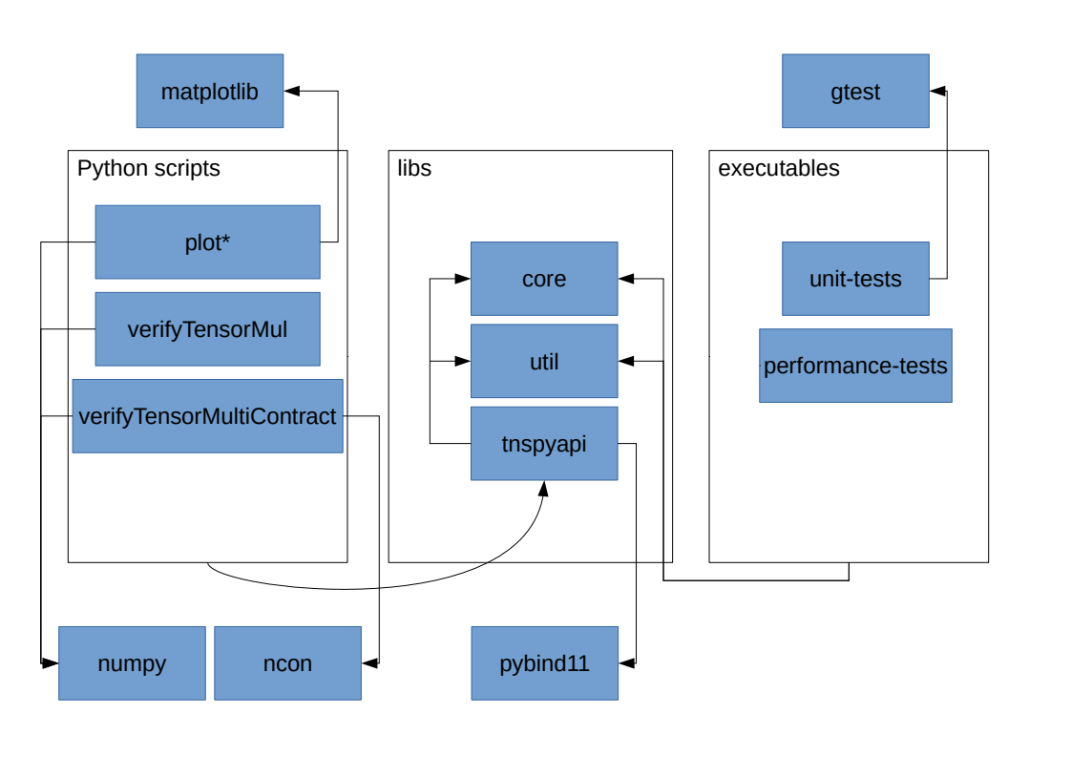
Upon compilation the static libraries, as well as the executables are written to bin/, tnspyapi is written to lib/. All python scripts can be found in py-src/ and must be executed from there.
On the C/C++ side the project refers to two 3rd party libraries: gtest for unit testing and pybind11 for the python interface. Due to data copying on the interface boundaries this api is currently not in fact to be used to boost actual python computation code.
Among the python scripts, the two most notable modules that are refered two are numpy and ncon. numpy is used to verify the results of libcore’s tensorMul, whereas ncon is used to verify the results of libcore’s contractMultipleIndices.

