Content Debugger – manual

Plugin | content_debugger (for Elgg 1.8)
Version | 1.1.0
Author | András Szepesházi
License | GNU GPL v2.0

Content Debugger – manual 1
Intended audience 2
Introduction 2
Requirements 3
Installation 3
Configuration 3
View hierarchy depth to display in tooltips 4
View names in tooltips 4
Included view .php files in tooltips 4
Profiling info on each view 5
Tabulator stop (in pixels) for aligning the view hierarchy 5
Magic marker (dimming and highlighting view areas upon hover) 5
CSS properties to apply on view areas upon hover 5
Using the Content Debugger 6
Troubleshooting and FAQ 7
Known bugs 8

Intended audience

This is a plugin for Elgg theme/plugin developers. Site owners, who do not customize their Elgg site other than downloading and installing plugins, will gain nothing from using this plugin.

Introduction

This plugin will give you on-screen information about the current page’s view hierarchy. Upon hovering over any part of the browser window, you’ll see a tooltip, displaying detailed information about what views were called - at the server side - to produce the currently visible output (see Figure 1).

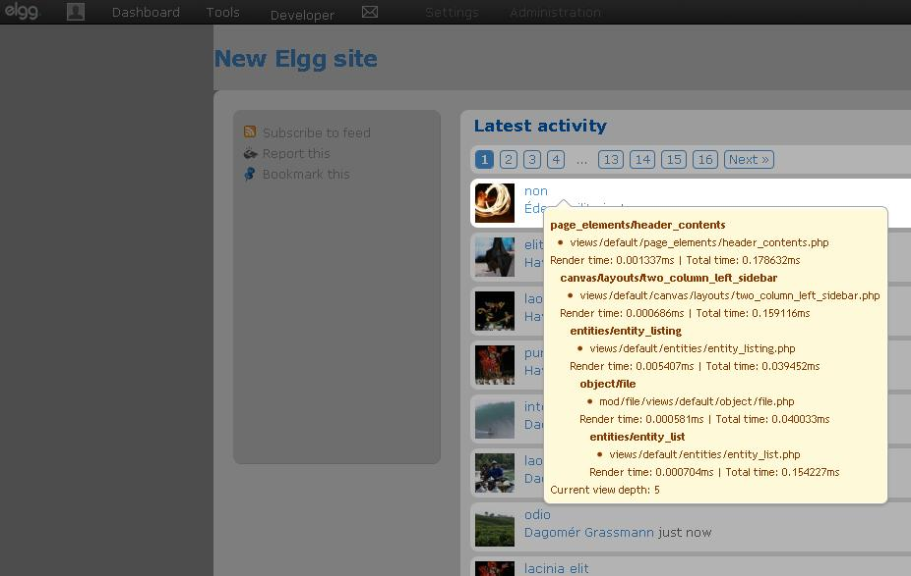
Figure 1 - Content Debugger in action

I think the plugin will provide the greatest benefits to those developers who need to work on a heavily customized site. With Elgg’s view override and view extension system, it is very easy to get lost among dozens of views that produce a given piece of output. The Content Debugger will put an end to your hair-pulling hours of trying to figure out which view was extended or overridden by which other view. You’ll get all this information, literally, at the tip of your mouse.

Requirements

- You’ll need the (preferably) latest release of the Elgg 1.8 branch for this plugin to work.

- You’ll need a CSS3 compliant, decent browser for this feature to work. I suggest the latest Firefox, Chrome or Safari.

Installation

Installing the plugin is pretty straightforward, as with all Elgg plugins. Please refer to the official Elgg documentation at http://docs.elgg.org/wiki/Configuration/Plugins

Configuration

After installing the plugin, you’ll have a number of configuration options to fine-tune the plugin’s behavior. You can access these options by going to Administration -> Configure -> Plugins -> Content Debugger 1.1.0 -> Settings (see Figure 2).

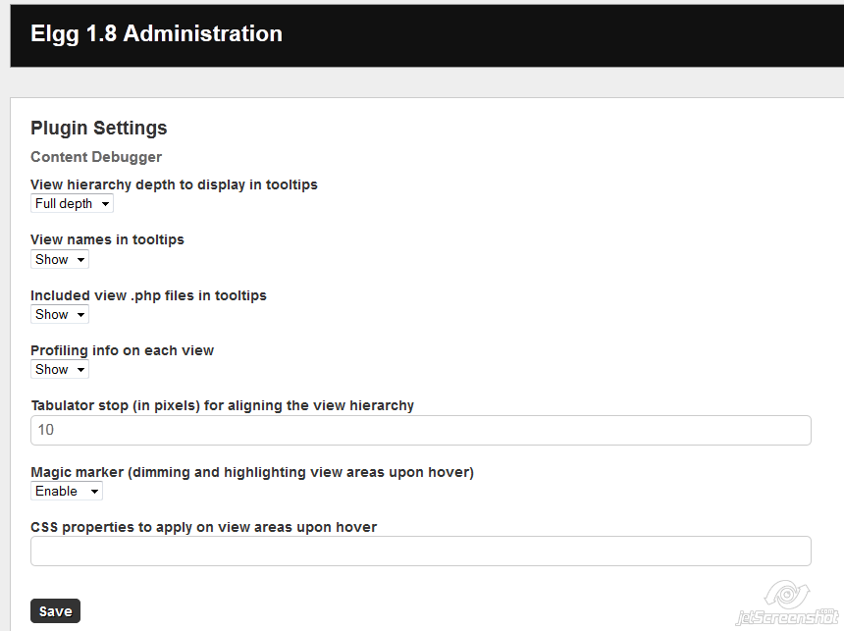
Figure 2 - Content Debugger configuration

View hierarchy depth to display in tooltips

Sometimes, when you have a really complex site, the view hierarchy tree can grow to a depth of 15-20, or even more views for certain visible blocks. That many level will simply not fit into the hovering tooltip, so this is your chance to reduce the number of view levels. If you limit the number of view levels to be displayed by the tooltip, it will always cut off the uppermost views, so you’ll still get the information you’re really interested in, for any given block.

View names in tooltips

All views in Elgg have a distinct name, like “object/file” or “entity/entity_list”. With this option you can decide if the view name would be displayed or not in the tool tip.

Included view .php files in tooltips

All views in Elgg are produced by view php files like “/mod/files/views/default/object/file.php”. With this option you can decide if the view file path would be displayed or not in the tool tip. When extending a certain view, the view extensions will be included by Elgg’s templating view system. In that case, a single view name will contain more than one actual view files. You’ll see all the included view extensions under the given view name. See Figure 3 for an example of displaying view extensions (the owner_block/extend view is extended by two different view files).

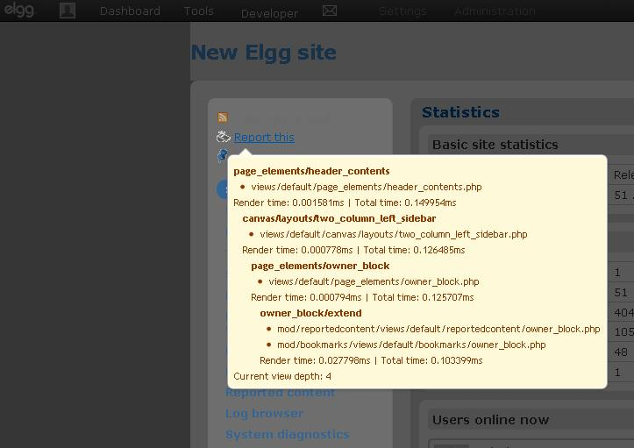
Figure 3 - Displaying view extensions

Profiling info on each view

For each displayed view, you can enable or disable profiling information with this option. Profiling will show you roughly how much time it took to produce a given view (this is the “Render time” value) and how much time took the Elgg engine to produce all the views up to the current view. These values are not entirely accurate for various reasons, but they should still give you a good indication which views are resource intense.

Tabulator stop (in pixels) for aligning the view hierarchy

This is to configure the tabbing of the view hierarchy in the displayed tooltip. Enter an integer value without any further additions (so no “px” or “point” after the number). Going down the view hierarchy, each view level will be shifted by the amount of pixels you enter here.

Magic marker (dimming and highlighting view areas upon hover)

Enabling this effect will dim all view areas that are currently out of focus. The dim is applied hierarchically, so the further down you go in the view hierarchy, the more the higher level view areas will get dimmed.

CSS properties to apply on view areas upon hover

You can enter here further css properties that will be applied to the current view area. For example, entering: border: #c04030 dashed 2px; background: #e0a090; for this option will result in what you can see at Figure 4. Please make sure you enter valid css options separated by semicolon – having an error in your css syntax can result in broken plugin functionality.

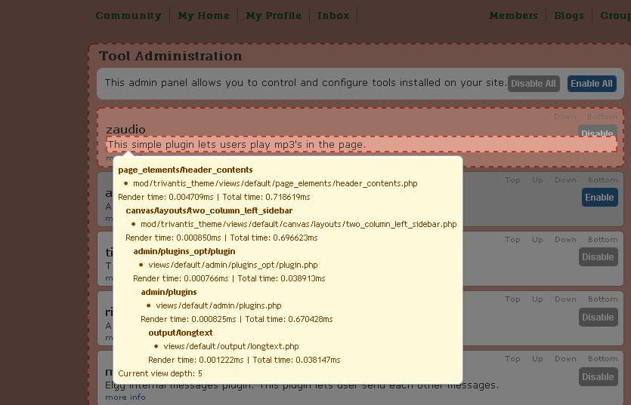
Figure 4 - Custom CSS for active view areas

Using the Content Debugger

Once you enabled the plugin, and are logged in as administrator, you’ll get an extra menu item in your Elgg topbar marked by an information (i) icon. Clicking on this icon will reload the current page and enable/disable the debugger (see Figure 5).

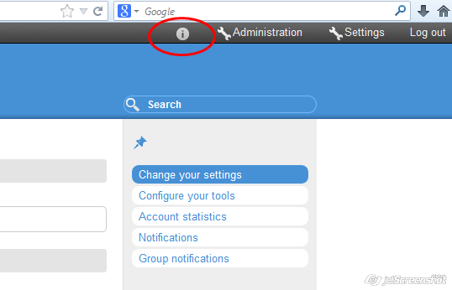
Figure 5 - Activating the Content Debugger
As of version 1.1.0, you can separately toggle the debugger for the admin interface. There is a side menu item under Develop -> Tools, which enables/disables the debugger for all admin pages (see Figure 6).

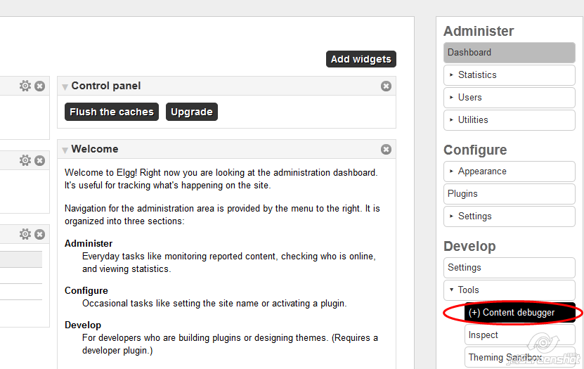
Figure 6 - Activating the Content Debugger for admin pages

Troubleshooting and FAQ

Q: I use a custom theme and I don’t see the toggle icon on my site. How can I turn on/off the debugger?

A: The toggle icon is display in the topbar menu, as a single menu item in the “alt” section. If your theme completely overrides or ignores the topbar view, then indeed you won’t see the toggle icon. However, once the plugin is enabled, you can always enter http://your-site-url/content_debugger/toggle. This will redirect to the same page, and will turn the debugger on and off, respectively.

Q: The plugin does not display the top level views (like page_elements/pageshell) and the views in the header (metatags, etc).

A: Unfortunately that is true. There doesn’t seem to be a cross browser way to parse and display view information that is beyond the document body level. However, if you look at your page’s source code, you’ll see that almost all view (including pageshell) information is there in forms of json encoded comments. Look for “content_debugger_view_start::” and “content_debugger_view_end::” patterns. What follows these markers is a json encoded string holding all the information of any given view. It’s a bit inconvenient, but if you really need the view hierarchy for elements outside the document body, you can figure it out from these comments.

Q: I added a css border value in the plugin configuration, and now the whole screen falls apart when I move around the mouse.

A: That is possible when you have fixed sized block elements in your template, and the current content already fills those containers exactly to the last pixel. When you add a border to that, the content size will increase, and you’ll get a broken layout. The default visualization works with overlays only, which leave the content size intact.

Known bugs

- The plugin does not give information about top level views that fall outside the document body.

