Entity Browser – manual

Plugin | entity_browser (for Elgg 1.7+)
Version | 1.1.0
Author | András Szepesházi
Licence | GNU GPL v2.0

Entity Browser – manual 1
Introduction 2
Features at a glance 2
Warnings 3
Installation 3
Using the Entity Browser 4
Left pane (entity hierarchy) 4
Right pane (viewing options) 4
Displayed properties 4
View type 5
Number of results on a page 5
Center pane (entity list) 5
Using “natural view” 5
Using “raw view” 5
Troubleshooting and FAQ 10
Known bugs 11
To-do list 11

Introduction

This plugin lets site administrators to conveniently manage all entities on their site. Entities can be browsed by types (and, in case of objects, subtypes), searched, sorted, filtered, displayed with different views, edited, enabled, disabled and deleted - all in one place. The plugin serves as an improved version of the old “guidtool” plugin.

This is a plugin for site administrators, ordinary community members will not benefit from it in any way – it will only be visible in the Administration panel.

Plugin developers will especially find this plugin useful – debugging entities and their property values has never been so easy with Elgg.

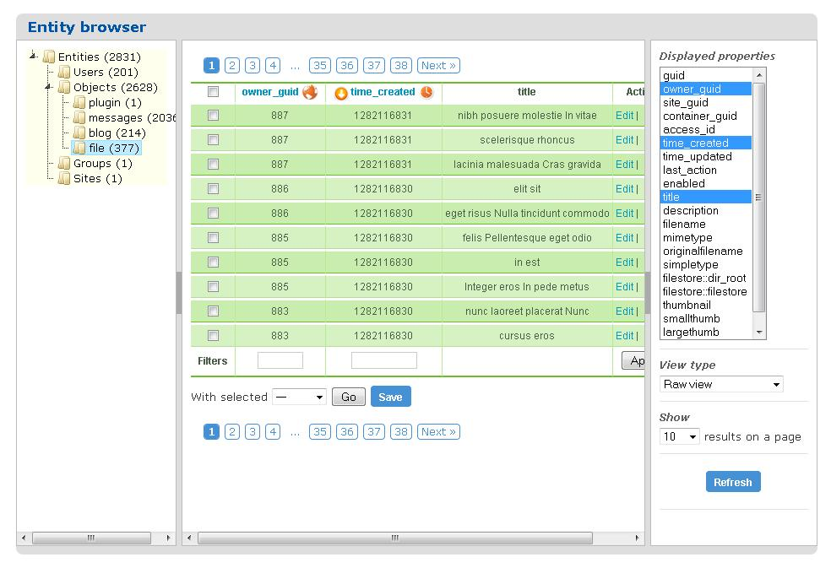
Figure 1

Features at a glance

- 100% Ajax driven queries for fast data load
- Type/subtype hierarchy displayed in an interactive javascript tree
- Selectable entity view types (natural view and raw view)
- Filterable entity properties (display only selected properties in the results)
- Filterable property values (display only entities matching certain property values)
- Sortable entity table based on any property values
- User configurable additional info tooltips on all table columns
- Edit entity properties, add/remove metadata to entities on the fly

Warnings

Using this plugin you can directly manipulate entities and their properties on your Elgg site. If you’re a site administrator, but not a seasoned Elgg developer, you should never try to edit entities via this plugin. Especially not on a live site, having real users and activities. It is very easy to screw up the site content by, let’s say, modifying owner_guid values without exactly knowing what you’re doing.

Even if you are an experienced Elgg developer, you should really be careful what kind of values you’ll enter when modifying entity properties. No syntax or semantics will be checked when you edit an entity and save your modifications. In other words you can enter invalid data for entity properties and save the entity, causing all sort of troubles on your site. Especially if you’re messing around with the owner_guid, container_guid, access_id, enabled, banned, etc. type of properties – in short, properties that control the visibility of entities.

I suggest before jumping into editing entity properties to create a backup of your database. It will save you a lot of troubles if you accidentaly save something you shouldn’t have.

Installation

Installing the plugin is pretty straightforward, as with all Elgg plugins.

1. Download the plugin into your Elgg installation’s “mod/” directory, and unzip it.

2. On UNIX/Linux systems, make sure that file ownership and access rights match the following requirement: the whole entity_browser directory and its content should be readable and executable for your web server user.

So, making it simple, you should do something like this in a standard LAMP environment:

cd /var/www/your-elgg-site-directory/mod
chown –R www-data:www-data entity_browser
chmod –R 755 entity_browser

3. Log in to your Elgg’s front end as administrator, and then go to the Administration / Tools Administration menu.

4. Enable the entity_browser plugin.

5. In the Administration menu, you will see a new item called “Entity Browser”. This is the place where you can manage all site entities.

Using the Entity Browser

In Figure 1, you can see the default screen of the Entity Browser. It has a 3-pane layout, where the left and right (or west and east, if you will, but I’ll use left and right) panes give you control over what entities and how will be displayed, while the center pane is a placeholder for displaying all those selected entities. When starting the plugin, you’ll see a paged view of all entities on your site (regardless of their type and subtype) in the center pane, displayed with “raw view”. More info on the view types comes later in this chapter.

The panes within the main layout are resizable and collapsable, thanks to the great plugin “jquery layout”. Once you selected what kind of entities you’d like to display, and how, you can collapse both the left and right pane, so you’ll have a lot more space for displaying the entities and their properties themselves.

Left pane (entity hierarchy)

The left pane will show you the full entity hierarchy of your site. Object subtypes are collapsed as default, but with a simple click you can explore all your objects by subtype. At each node in the entity tree, you’ll see a counter after the type/subtype label, representing the aggregated number of entities at that level of hierarchy.

Clicking on any tree node (entity type or subtype) will reload both the center and the right pane. The center pane entities will be now filtered by the selected type/subtype. The right pane needs to be reloaded as a newly selected entity type/subtype combination will have different set of metadata as the previously selected one, so the property filter list needs to be updated.

Right pane (viewing options)

The right pane provides a number of configuration options for displaying your entities. Once you changed any of these options, you’ll have to hit the refresh button at the bottom of the pane. Upon refresh, the center pain (containing the entity list) will be refreshed according to your newly selected options. In addition to that, the right pane will also be refreshed, as the list of available metadata names might change when more/less entities of the same type are listed on the same page.

Displayed properties

This is a multi-selection list where all properties of the currently visible entities are displayed. You can select multiple items from the list with the usual html form controls (holding shift for a range selection or holding ctrl for individual selection). If you don’t select any of the listed properties, all properties will be displayed (which is the default).

The best use of filtering displayed properties is to reduce the horizontal size of the resulting entities table, so you don’t have to scroll that much when browsing through entity properties.

View type

You can select two view types, “natural view” and “raw view”. Natural view is trying to display properties according to their defined Elgg view, while raw view (default) will give you a table displaying all properties of the listed entites. For entity sorting, filtering, debugging and editing you’ll want to use the raw view.

Number of results on a page

This is simply telling the views how many entities to display on a single page. Large values (over 50) may significantly slow down the refresh time, especially if you are using the natural view type.

Center pane (entity list)

The center pane is the placeholder for displaying all entities matching the selected types/subtypes, as regulated by the viewing options.

Using “natural view”

There is not much to explain here, the entities are displayed as defined by their Elgg view. Apart form paging among the selected entities, there is not much to do here. Note: following links displayed by this view will navigate away from the current page, displaying the link’s target in the current browser tab/window.

Using “raw view”

Raw view provides a table view of entities and their properties, that is very useful for entity debugging and has several features as listed below.

Sortable columns

Entities are sortable based on their different properties. All column headers (like guid, owner_guid, etc.) act as links, upon clicking them, all entities falling within the selected hierarchy node will be sorted based on the clicked property. An arrow, pointing upwards or downwards preceding the column name will indicate the sorting property and the sort direction. In Figure 2, you can see an example of sorting entities by owner_guid, in descending order. Clicking repeatedly the same column header will invert the sort direction, and the preceeding arrow will change it’s direction to reflect that.

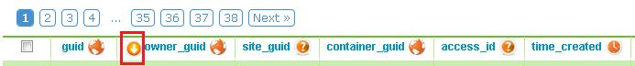
Figure 2

Tool tips on entity properties

There is a possibility to activate “on hover” tool tips for each table cell – as a matter of fact, you’ll notice that certain cells are already active and have custom tool tips associated with them. If you see a globe icon next to a column name, it means that each value in that column will be interpreted as an Elgg guid pointing to an entity. Upon hovering over a guid value, the represented entity will be loaded into a pop-up tool tip via an ajax call. In Figure 3 you can see that the “owner_guid” has a globe icon next to the column header, so all values in this column are interpreted as entity guids, and hovering over the “886” value will display the entity having guid 886, which is a user. When displayed in tool tips, all entities will use their natural Elgg view (with a compact view, meaning full_view = false).

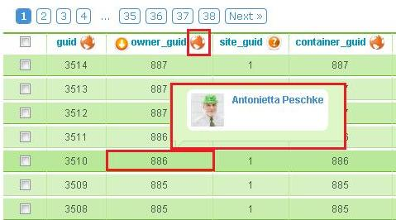
Figure 3

If you see a clock icon next to a column name, it means that each value in that column will be interpreted as a UNIX timestamp. Upon hovering over any timestamp, a tool tip will pop up showing the date/time value in human readable format (see Figure 4).

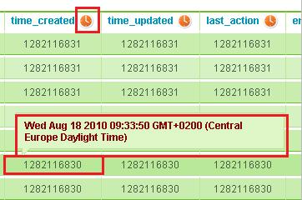
Figure 4

For those columns that represent neither an Elgg guid nor a timestamp, a question mark icon will be displayed after the column label. These columns will not have tool tips associated with their cells.

Clicking on the icon itself will change the column type immediately. Remember, do not click on the column name itself (as that will change sorting), but the icon following the column name. So if you have a custom object type that references other entities as metadata values, you can click the relevant column’s tooltip icon and change it from a “question mark” to a “globe”, and you’ll have the above described “entity tool tips” immediately. Same goes for, let’s say, the event_calendar objects, where you can have a meaningful tool tip for the event’s start and end date.

Tool tips for truncated properties

To preserve a relatively compact sized table for the raw entity view, all entity properties that exceed 25 characters will be truncated when displayed. You can recognize those truncated fields as the textual content will end with three dots. So if you’d have a blog entry with a “Really, really, reaaaally long title”, then it would be displayed as “Really, really, reaaaall…”. To view the full content of these truncated properties, you’ll have to hover your mouse over the given property – the full content will be loaded into a tool tip box. This will only work if other, type based tooltips were disabled on the column (see previous chapter).

Filtering entities

Filtering is a quick way to find entities that you are interested in. The entity table footer contains input fields for each column where you can enter any values that will filter the resulting list of entities. Filtering is done by partial matching both in case of textual and numeric values. If you enter the value “15” in the guid column’s filter box, then all entities that have the sequence of digits 1 and 5 in their guid will be returned (like 3115, 154, 8152).

To apply filtering, either scroll to the right end of the table end press click the “Apply” button, or simply press enter upon entering the filter value.

You can have multiple filters at the same time, these will be interpreted as an “AND” type of relationship – only those entities will be listed that match all defined filters. Figure 5 shows how to find entities that are owned by a certain user.

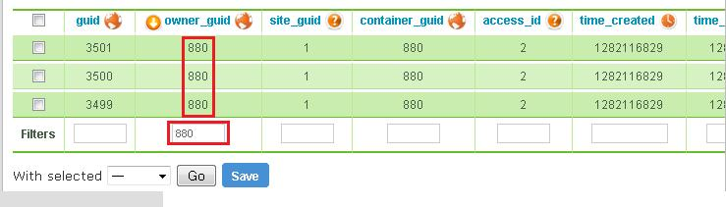
Figure 5

Selecting entities for bulk actions

At the very first column, you’ll see a checkbox before each entity in the table. You can individually select / deselect entities by clicking their respective checkbox, or select / deselect all displayed entity by clicking the checkbox at the table header. You’ll be able to perform some bulk actions on the selected entities.

Bulk actions

With the selected entities you can perform some bulk actions. As of this version, the following actions are defined in the plugin:

Action | Description
Enable | Enables selected entities
Disable | Disables selected entities
Touch | Selected entities will have their time_updated value set to the current time.
Delete | Delete selected entities. Warning: selecting the “Delete” option and clicking the “Go” button will delete the selected entities forever, without any confirmation!
Ban | Bans selected users. This option is only available when listing user entities.
Unban | Unbans selected users. This option is only available when listing user entities.

Edit entities

At the last column of the entity table, you’ll find an “Edit” link that will enable you to directly manipulate all properties of a given entity.

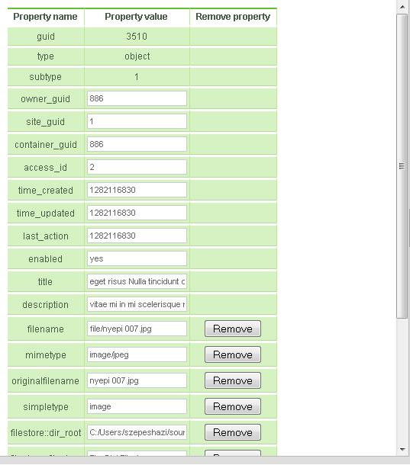
Figure 6

Figure 6 shows a typical edit entity screen. As you can see, some core entity properties (guid, type and subtype) are non-editable, simply as a safety measurement. All the other properties are editable, and those that are defined by metadata are removable as well. Let me emphasize again that all input fields are free-entry, non-validated type fields. You can enter any value for any property, delete some of the metadata and save the entity, but you’ll have to live with the consequences.

A useful addition to the edit form is the “[+] Add a new property” button at the bottom of the page (see Figure 7). It does what it says, simply adds a new, freely editable property to the entity, where you’ll have to provide both the property name and value. Porperties left with empty name or value will not be added to the entity upon saving. Watch out when entering the property name! If you enter an already existing property name (like owner_guid), the pervious value will be overwritten when saving the entity. Also, names containing funny characters might result in server side exception. Use your discretion and use only names that you would use as an object property in PHP itself. Remember: no validation whatsoever is done on these values.

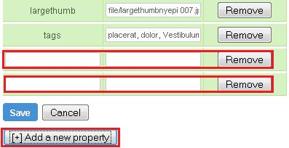
Figure 7

Troubleshooting and FAQ

Q: The tool tips that keep popping up when the mouse is over any table cell is very annoying. Is there any way to turn that off?

A: Sure, just look at the table header, you’ll see small icons next to each column name. Click on each of those until you’ll see the question mark icon. Tool tips will not bother you any longer.

Known bugs

- None at the moment

To-do list

- Create opendd export for selected entities
- Include annotations in the hierarchy tree, let them be browsed/editied the same way like entities
- Figure out a meaningful way to display entity relationships
- Create a new raw view with inline editing, where edit can be performed directly in the listed entities’ table cells
- Store all defaults (default tooltip types, default number of entities per page to display, default view type, etc) as plugin configuration values, adjustable by the admin user
- Introduce a minimum level of input validation

