Smart Files – manual

Plugin | smartfiles (for Elgg 1.7+)
Version | 1.0.0
Author | András Szepesházi
License | GNU GPL v2.0

Smart Files – manual 1
Introduction 2
Features at a glance 2
Warnings 3
Installation 3
Configuration 4
Using Smart Files 4
Advanced configuration 4
Managing supported MIME types 7
Managing embedded files 7
Access management 7
Troubleshooting and FAQ 8
Known bugs 9
To-do list 9

Introduction

This plugin will display most of user uploaded files as inline (embedded) content on your pages. The embedded object itself is rendered by the great service hosted at http://embedit.in – actually this plugin is nothing more than a wrapper around the embedit.in API for Elgg.

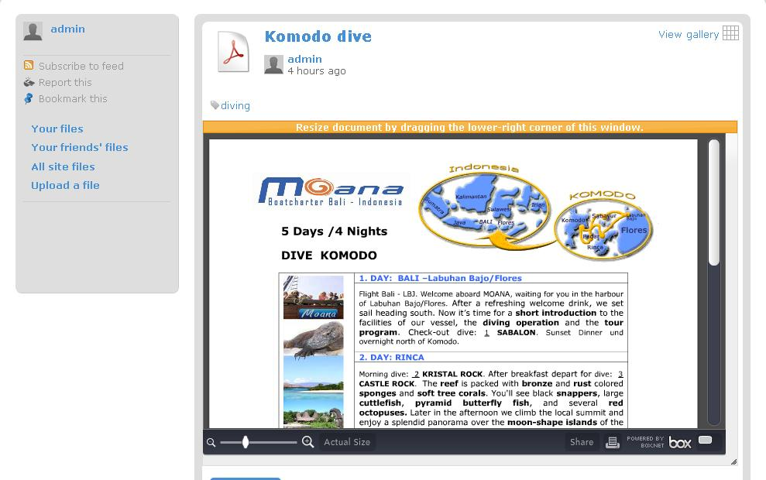
Figure 1

Figure 1 shows the Elgg page of a pdf file object, with an embedded view of the pdf file itself. The list of supported file types is really impressive, you’ll be able to display all MS Office documents (yes, including the new xlsx, docx and pptx formats), OpenOffice documents, various Adobe file formats and more. To use this plugin, you’ll have to visit the http://embedit.in site and log in with your openid account to get an API key and an embedit.in identifier. This is absolutely free, and the whole takes less then 30 seconds. See the Installation and Configuration chapters for more details.

Features at a glance

- Support for a wide range of file formats (check out the list of supported formats at http://embedit.in/faq)
- Resizable viewport with admin configurable default, minimum and maximum dimensions
- Extensive admin interface to fine tune the plugin’s behavior on your site
- Improved gallery view for your files – thumbnails will be created based on file content rather than having the generic, type-based icons (see Figure 2)

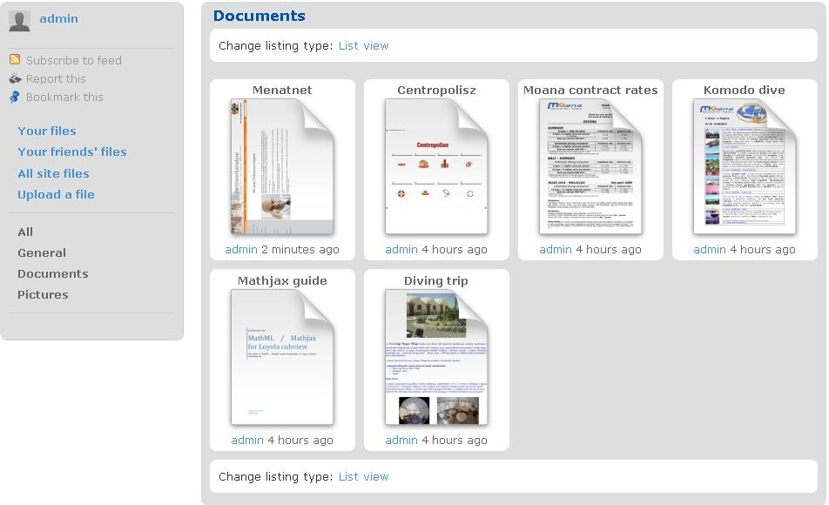
Figure 2

Warnings

Smart Files, depending on plugin settings, may expose your Elgg installation’s files regardless of their access settings. It means, that even files marked as “private” will theoretically be viewable by unauthorized users. To exactly understand the risk and to be able to make an informed decision on the configuration of the plugin, please read the “Access Management” chapter.

Installation

Installing the plugin is pretty straightforward, as with all Elgg plugins.

- Download the plugin into your Elgg installation’s “mod/” directory, and unzip it.

- On UNIX/Linux systems, make sure that file ownership and access rights match the following requirement: the whole smartfiles directory and its content should be readable and executable for your web server user.

So, making it simple, you should do something like this in a standard LAMP environment:

cd /var/www/your-elgg-site-directory/mod
chown –R www-data:www-data smartfiles
chmod –R 755 smartfiles

- Log in to your Elgg’s front end as administrator, then go to the Administration / Tool Administration menu.

- Enable the “smartfiles” plugin.

- Make sure the “smartfiles” plugin is somewhere below (and not above!) the core “files” plugin in the plugin list.

- Configure the plugin as described in the next section, and you’re good to go!

Configuration

Once you’re done with the plugin installation, you’ll need to enter an API key and an embedit.in identifier in the plugin’s settings menu.

- As an admin user, go to Administration / Tool Administration, and search for “smartfiles” in the plugin list.

- Click on “Settings” next to the plugins name.

- Open a new browser tab or window and go to http://embedit.in/api

- You’ll be notified to sign in with a third-party account, please do so.

- Once you’ve signed in, you’ll be forwarded to the API documentation page.

- At the top of that page, you’ll see an API key in the “Accessing the API” section. Copy this key, and paste it into the smartfiles plugin settings input field called “Your embedit.in API key”.

- In the embedit.in browser tab/window, just below the API key, you’ll see another value called “your personal identifier”. Copy this value, and paste it into the smartfiles plugin settings input field called “Your personal identifier”.

- Save your plugin settings. That was all you needed to get started with embedded files on your pages!

Using Smart Files

This is really simple, as once you’ve installed and successfully set up the plugin, there is nothing else to do, except enjoying the benefits of Smart Files. Go to Files / All site files, start browsing around among files, and you’ll notice that most of the files will get the cool embedded view automatically.

Advanced configuration

You’ve probably noticed when configuring the plugin, that there are a number of additional configuration options apart from the API key and personal identifier. These options are as follows.

Option label | Description
The embedded document’s default width | Default width in pixels when rendering the embedded object.
The embedded document’s default height | Default height in pixels when rendering the embedded object.
Enable resizing for the embedded document? | If set to “yes” (default), the user will be able to resize the embedded object by dragging the lower-right corner of the embed window. If set to “no”, the embedded object will have a fixed size (based on default width and height values).
The embedded document’s minimum width | Minimum width in pixels when resizing the embedded object.
The embedded document’s minimum height | Minimum height in pixels when resizing the embedded object.
The embedded document’s maximum width | Maximum width in pixels when resizing the embedded object.
The embedded document’s maximum height | Maximum height in pixels when resizing the embedded object.
Use embedit.in generated icons in gallery view | If set to yes, gallery thumbnails will be created based on file content rather than having the generic, type-based icons (see Figure 2)
Force thumbnail creation when viewing files in gallery view | If set to yes, when someone visits a gallery page, all potentially embeddable files, that have not been embedded yet, will be immediately uploaded to embedit.in. Enabling this option might slow down the gallery page generation a bit, and there is also a known bug when using this feature (see Known Bugs chapter).
Enable auto-create (file upload to site will also trigger embedit.in upload) | When a user uploads a file to your Elgg site, it will also be uploaded simultaneously to embedit.in.
Ignore Elgg access system when creating embeds | If set to yes, regardless of the file’s individual access rights (private, logged-in users, public, friends), the file will be uploaded to embedit.in and the embed object will be created.

To help you understand the above terms and descriptions in a bit more detail, here is the workflow how embedded content is rendered on your Elgg site. This will be a bit technical, so bear with me.

To have your files rendered on your Elgg pages, each rendered file will need to be uploaded to http://embedit.in. The Smart Files plugin overrides the default file object view of the Elgg system (object/file), and decides on the fly, when displaying an individual file page or a gallery page, if the embed (or embed thumbnail) should be displayed. Smart Files checks the following properties of a file and the following plugin settings to do that:

- Check if the mime type of the file is in the list of supported mime types of the plugin. (Supported mime types are admin configurable, by the way).
- Check if the file’s access is set to public or the plugin setting “Ignore Elgg access system when creating embeds” is set to “yes”.

If both of the above conditions are true, the plugin checks if the given file was already uploaded to embedit.in. If yes, it will simply insert the embed code referencing the embedded object url (provided earlier by embedit.in). If the file has not been uploaded yet, the plugin will upload it during the page rendering process, fetch the resulting embedded object url from embedit.in, and insert the embed into the page.

Your Elgg site should be hosted at a location where you have reasonable bandwidth and network speed, otherwise the upload procedure might slow down your page rendering, when viewing a file for the first time (because this is time when it gets uploaded to embedit.in).

For the gallery view, the situation is a bit more complicated. The fancy thumbnails shown in Figure 2 are also generated by embedit.in. A gallery page usually shows 12 files at a time. If none of these files were previously uploaded to embedit.in, overriding the default thumbnails with the cool individual ones mean that all 12 files will need to be uploaded immediately to embedit.in. Imagine a gallery page where you have 12 large PowerPoint files, each over 5M in size. You do the math. A page rendering like this might even result in a timeout error, or at least will be noticeably and significantly slower than normal page deliveries.

This speed issue is only present when viewing embeds (or their thumbnails) for the first time. Once a given individual file or gallery page was visited, the embeds and thumbnails will be available without the need for any further uploads.

If you already have a running Elgg installation and want to use Smart Files on your site, here is my suggestion on how to solve the above speed issues:

- Pick a time for the following actions when your site is the least busy. Make the following configuration changes in Smart Files settings:

  - “Use embedit.in generated icons in gallery view” => “yes”
  - “Force thumbnail creation when viewing icons in gallery view” => “yes”
  - “Enable auto-create (file upload to site will also trigger embedit.in upload)” => “yes”

- Go to Files / All site files, then select a file category like “General”, “Documents”, etc. Unfortunately due to a small bug in the files plugin, you won’t get gallery view for “All” types, and this is what we need now, so don’t choose the “All” category.

- In the selected category, change the listing type to “Gallery” from “List view”. Page through all pages of the given file category. You’ll get a lot of “question mark” type of thumbnails on the gallery pages for now, but don’t worry about that – this is a known issue (see Known Bugs chapter), and your files probably uploaded just fine anyway. If you want to make sure, just wait a couple of seconds and reload the same gallery page – thumbnails should be sorted out by now.

- Repeat the above step for each file category listed in the side menu.

- Make the following configuration change in Smart Files settings:

  - “Force thumbnail creation when viewing icons in gallery view” => “no”

With all these steps, you forced the upload of all eligible files to embedit.in, so uploads won’t present a bottleneck in the future. Furthermore, because you enabled the “auto-create” option, all future file uploads to your Elgg site will result in the automatic creation of the embedded object at embedit.in.

Managing supported MIME types

The plugin comes with a preset configuration of supported MIME types. Files having a MIME type that is a member of this list of supported types, will be eligible for embedding on Elgg pages. Files having other MIME type than those in the list will not be uploaded to embedit.in.

To configure the list of supported mime types, log in as administrator to your Elgg site, then go to Administration / Smart Files administration (that is a new item in the admin side-menu). You’ll get a tabbed interface, the first tab being called “Mime types to be handled by embedit.in API”.

You can remove any existing MIME type entry by clicking on the “Delete” link in the given MIME type’s row. You can also add new MIME types by filling out the “MIME type” and “File description” fields at the bottom of the table, and clicking the “Add MIME type” button.

So if you’d like to display the EPS type vector graphics as embedded objects on your site, you’d need to add the “application/postscript” mime type to this list.

Useful pages on MIME types:

http://www.w3schools.com/media/media_mimeref.asp
http://en.wikipedia.org/wiki/Mime_types

And of course to see what is supported by embedit.in, go to http://embedit.in/faq

Managing embedded files

If you are curious which files on your Elgg site have an embedded counterparts at embedit.in, select the other tab in the Smart Files administration called “Embedded files”. You’ll get a paged list of all files that were already uploaded to embedit.in. This list should be identical to the list of files available at http://embedit.in/my.

In the unlikely event of something going wrong with the file upload to embedit.in, you’ll need to come to this list and remove the embedit.in reference of the given file. Clicking on the “Remove embed” link next to any file will result in: a) removing the embedded object from embedit.in and b) removing the embed link from the Elgg file object.

This is what you should do if an embedded object seems to be broken, or if a user changes the privacy of one of his/her files, and requests that the embedded version should be removed from embedit.in.

Access management

Ok, here comes the main catch when using this plugin. Once a file is uploaded to embedit.in, it will be publicly available, so without having any credentials to your Elgg site, people theoretically will be able to view the file.

However, on the bright side, this should not be a huge concern, and here is why. Even though the file is available, it’s location is not advertised anywhere. The uploaded file will not be listed in any galleries, directories, will not be featured or linked to from other locations etc. – the only way to view this file for an outsider is to accidentally figure out the 10 character long unique identifier of the file, and enter an embedit.in url with that identifier in a browser.

To give you an example: I, John Doe, an Elgg user of your site decide that I want to share a funny slideshow with my friends, containing some sensitive pictures from a wild party. So I, John Doe, log in to your Elgg site, select “Upload a file”, choose the funny slideshow from my hard drive, set the access of the file to “friends only”, and hit upload.

Now if configured so by the administrator (“Ignore Elgg access system when creating embeds” => “yes”), this file will be uploaded to embedit.in, where it will get a unique 10 character identifier, like “7VmUSzo8Je”. From now on, anyone having a net connection and a web browser, will be able to visit the http://embedit.in/7VmUSzo8Je link and see my not-so-funny-any-more slideshow. However this anyone will have to be very, very intuitive to figure out the url above without explicitly knowing the unique identifier of the file. Because the Elgg file object is rightly protected by the preset access rights for the file, the link will not be exposed on your Elgg site anywhere. It will be only visible in the source of the file page, when visited by a logged in friend.

So you, as a site owner, will have to decide if this level of protection is sufficient for you and your community members. If you’re unsure, you can go for maximum safety and set “Ignore Elgg access system when creating embeds” => “no”. However, in that case only those files will get uploaded and will be embedded that are marked as public.

Troubleshooting and FAQ

Q: Isn’t this plugin the same as the file_viewer plugin? It does the same job, as I see.

A: Well, yes and no. Both plugins display files embedded on your pages. The file_viewer uses the Google Docs Viewer to display the embeds, Smart Files uses the embedit.in API for the same purposes. A clear advantage of the file_viewer plugin, that it doesn’t introduce security concerns when doing the embeds, while Smart Files exposes files that otherwise (based on access rights) should not be exposed (see the Access Management chapter). On the other hand, Smart Files supports a lot more file types, comes with a resizable viewport, and creates smart thumbnails. You decide which one is better for you.

Q: You claim that this plugin will embed docx / pptx / xlsx files, but it does not happen on my site.

A: Check the MIME type of the given file. You can do this by either digging into the Elgg entity, metadata and metastring database tables and hunt down the mimetype property of the given file object, or (shameless self advertisement follows!) download the Entity Browser plugin, which will display all object properties in raw mode. Once you established what is the MIME type of the file, check if it is included in the supported MIME types. If not, you might want to add the given MIME type to the list of supported types. But before doing that, read the next question.

Q: Damn, you’re right! The file is a perfectly valid MS Word 2007 document, but it’s MIME type is application/octet-stream (or application/zip or another inappropriate type). What now?

A: Unfortunately, I don’t have an all around solution for this. Elgg sets the uploaded file’s MIME type as it was sent by the client browser. Depending on the client OS and browser vendor and version, the provided MIME type might or might not be the real MIME type of the uploaded file. Unfortunately, not even server side MIME validation can help on that, at least there is no 100% bulletproof solution. You might want to try to use the AddType Apache config directive, but this is purely an extension based solution. A perfectly valid pptx file, if someone accidentally renames the file (before uploading it) to .pprx, will not have a valid MIME type using extension based MIME detection. Sniffing approaches, such as file_info tend to identify new versions of MS Office documents as zip files. Quite rightly so, as they are essentially zipped xml files, but that will not help you out in this case.

Q: Ok, I can hardly believe that there is no way to detect a file’s MIME type properly, but I’m not going to argue. Any suggestions how to fix the wrong MIME types for already uploaded files?

A: Well, I can hardly believe it either, I spent almost a full day researching this topic and trying different approaches, but I gave up at the end. As for fixing already uploaded files’ MIME types, you can either write a custom SQL statement, or (shameless self advertisement again!) download the Entity Browser plugin, which will let you edit object properties in raw mode. Filter your search on the mimetype property with “octet”, “zip”, and “download” values, go through the resulting files one-by-one and fix the MIME types based on file extensions. Either way, this is a painful exercise.

Q: Your plugin breaks another plugin’s functionality!

A: That is not really a question, but a statement, and it might actually be true. Smart Files overrides the object/file view in Elgg. If any other plugin you have enabled on your site does the same, then either Smart Files or the other plugin won’t work properly. Motto: there can be only one! I usually try not to globally override predefined views in Elgg, but in this case that was the most practical solution for implementing configurable MIME type support.

Known bugs

- When generating several embed thumbnails on a gallery type page at the same time, resulting thumbnails will show up as large “question mark” icons. This (I’m guessing here) is due to the delayed rendering of thumbnail images on embedit.in service’s side. Wait a little but, reload the page, and the thumbs should be correctly displayed now.

To-do list

- If embedit.in figures out a way how to restrict the file views to a certain domain, implement the new feature. That should get rid of the security problem described in the “Access Management” chapter
- If php file_info will ever evolve to a stage where it recognizes MS Office documents’ MIME type, implement a MIME post-fix utility.

