# Internal Review Document for Claim HURTX-2024-0456

Claim Summary:

Claimant: Contoso Electronics Inc.

Incident Type: Hurricane (Hurricane Alicia)

Date of Incident: May 15, 2024

Risk Assessment Metrics:

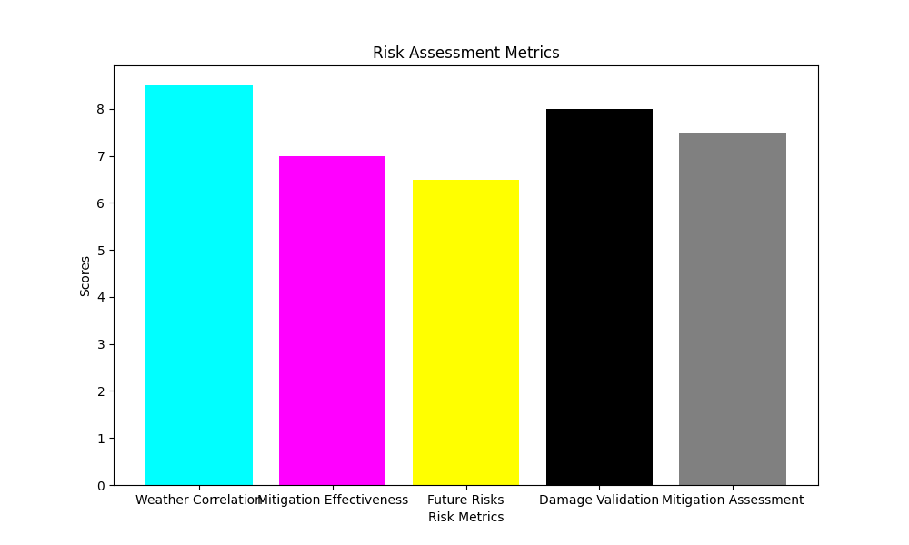

Final Recommendation: Partial Approval

Approved Amount: $480,000

Conditions: Further documentation required for business interruption claims.