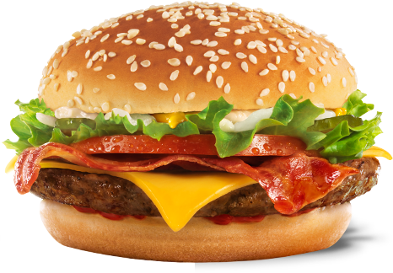

November 15, 2013

**Prepared bySzeYan Li,Menu Innovation Marketing ManagerMcDonald's Corp.**

**Prepared forCorbett Upton,Vice President of OperationsMcDonald's Corp.**

**Recommendations for the**

**“Taste of the World Campaign” in Oregon, USA**

**CONTENTS**

**vb**

PAGE

Replace this text with your own. You can also replace the pictures (on the previous page and at right) with your own.

Do not forget to update the Table of Contents on the next page after you have populated the