Q1 Reproduce the same output as below.
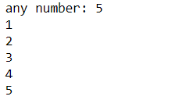
Ans:
num = int(input('any number: '))
start = int(0)

while num > 0:
start = start + 1
print(start)
num -= 1

Q2 Reproduce the same output as below.
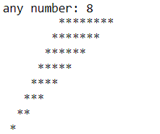
Ans:
num = int(input('any number: '))
while num > 0:
print(num*' ' + num*'*')
num -= 1

Q3 not 1 or 0 and 1 or 3 and 4 or 5 and 6 or 7 and 8 and 9
Ans:
4

Q4 print all odd number within 0 – 100
Ans:
i = 0
while i <= 100:
if i % 2 != 0: #odd number
print(i, end='\n')
i += 1
else:
i += 1

