Data resource:

API_EG.USE.ELEC.KH.PC_DS2_en_csv_v2_4251643.csv, API_NY.GDP.DEFL.KD.ZG_DS2_en_csv_v2_4250766.csv, API_NY.GDP.MKTP.CD_DS2_en_csv_v2_4251000.csv,

API_NY.GDP.PCAP.CD_DS2_en_csv_v2_4251004.csv,

API_NY.GDP.PCAP.KD.ZG_DS2_en_csv_v2_4250851.csv

And API_SP.POP.GROW_DS2_en_csv_v2_4251293.csv are public data from World Bank(https://data.worldbank.org/indicator). For example, the GDP growth data(API_NY.GDP.MKTP.CD_DS2_en_csv_v2_4251000.csv) is downloaded by <https://data.worldbank.org/indicator/NY.GDP.MKTP.CD?view=chart.>

The F-F_Research_Data_5_Factors_2x3_dail.csv and F-F_Research_Data_Factors_daily.csv are downloaded from the official website of Fama/French: <http://mba.tuck.dartmouth.edu/pages/faculty/ken.french/data_library.html>

The q5_factors_daily_2021_2.csv is originally downloaded from the official website of Hou-Xue-Zhang:

<http://global-q.org/factors.html>

and I modify the format of Date from “yyyymmdd” like “19670111” to “yyyy-mm-dd” like “1967-01-11” in convenience of data processing.

These nine .csv files should be put in the same directory of version2_type_2.py and plotly&dash.py as these .csv files will be input by API “pd.read_csv”. Some of them will be visualized like API_NY.GDP.MKTP.CD_DS2_en_csv_v2_4251000.csv, some of them will be the model parameter data like F-F_Research_Data_Factors_daily.csv.

dissertation.ico:

The dissertation.ico can be input as the icon parameter when using command like “pyinstaller.exe -F -w -i C:\Users\szf1998\Documents\UniversityOfEdinburghCS\dissertation\dissertation.ico C:\Users\szf1998\Documents\UniversityOfEdinburghCS\dissertation\test3.py” to adjust the icon of the output .exe file.

dissertation.yaml:

Environment and the requirements of Python Packages:

Please use: pip install dash, pip install plotly, pip install yfinance, pip install numpy, pip install pandas, pip install pyQt5, pip install pyQt5-tools, pip install mplfinance and other required Python packages I may forget to mention, or directly using the command “conda env create -f dissertation.yaml” to replicate the project runtime environment I exported in dissertation.yaml file.

version2_type_2.py:

This .py program will generate a windows GUI which has four buttons and relevant functions. All the figures present in the GUI will be downloaded and saved in the same directory of version2_type_2.py.

The GUI generated by version2_type_2.py has four parameters to input:

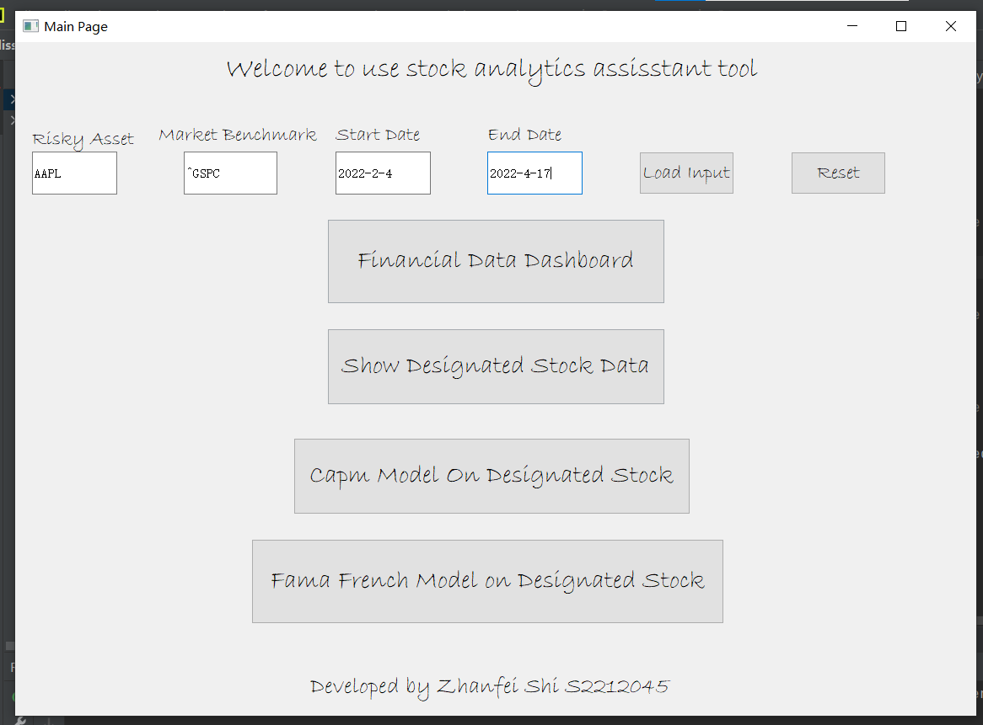

1: For Risky Asset please input stock code of the insteresting stock, like 'AAPL', 'MSFT' and 'AMZN',

2: For Market Benchmark please input the stock code of a popular market index, like '^GSPC'

3: For Start Date please input the specified start date in the format of yyyy-m-d

4: For End Date please input the specified end date in the format of yyyy-m-d. Due to data range limitation, for the forth button “Fama French Model on Designated Stock”, please input a date earlier than 2021-12-31

And the default value of the four parameters are shown below:

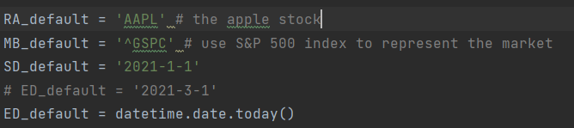

After click into a button and click to run the function, the GUI will generate relevant figures like shown below, and all the figures presented in the GUI will be saved in the same directory of PyQt5_GUI.py

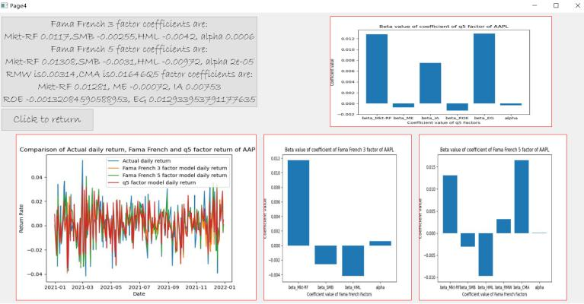

plotly&dash.py:

This .py program can generate a Dash webpage. The user can change the local running port in “app.run_server(port=8051)”. After plotly&dash.py is running, please click on the hyperlink “http://127.0.0.1:8051/” in line “Dash in running on http://127.0.0.1:8051/” in the terminal below to launch the Dash webpage in your local browser like shown below

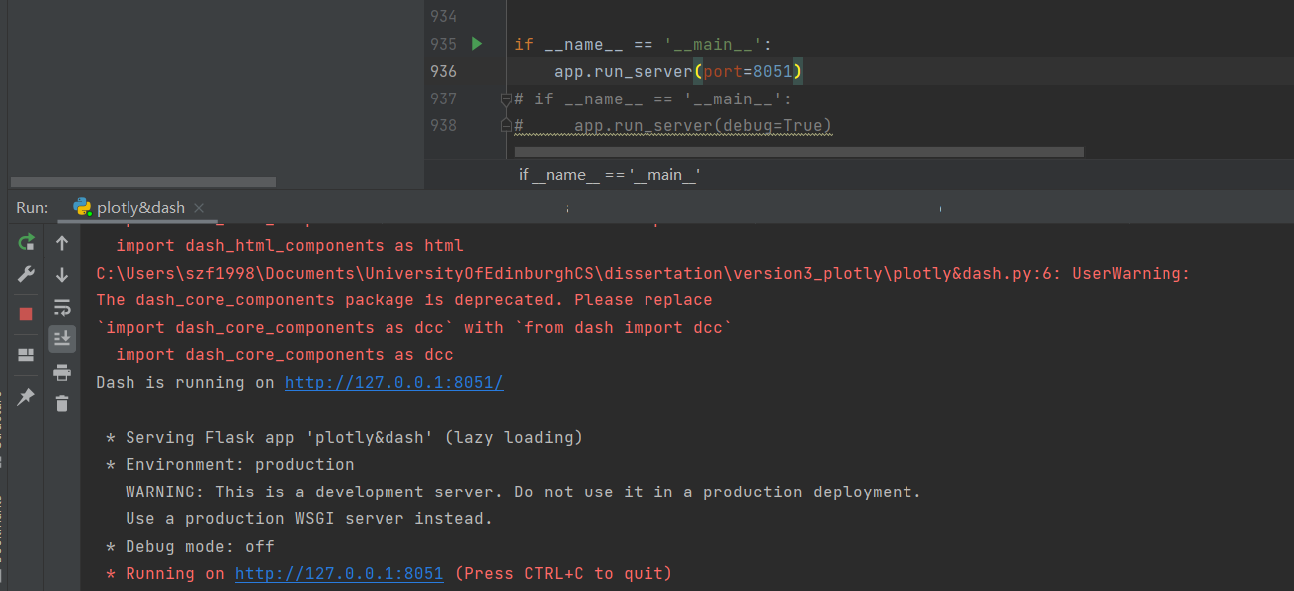

Then the user can click into five tabs and use relevant functions like shown below, and click the dropdowns to adjust parameters.

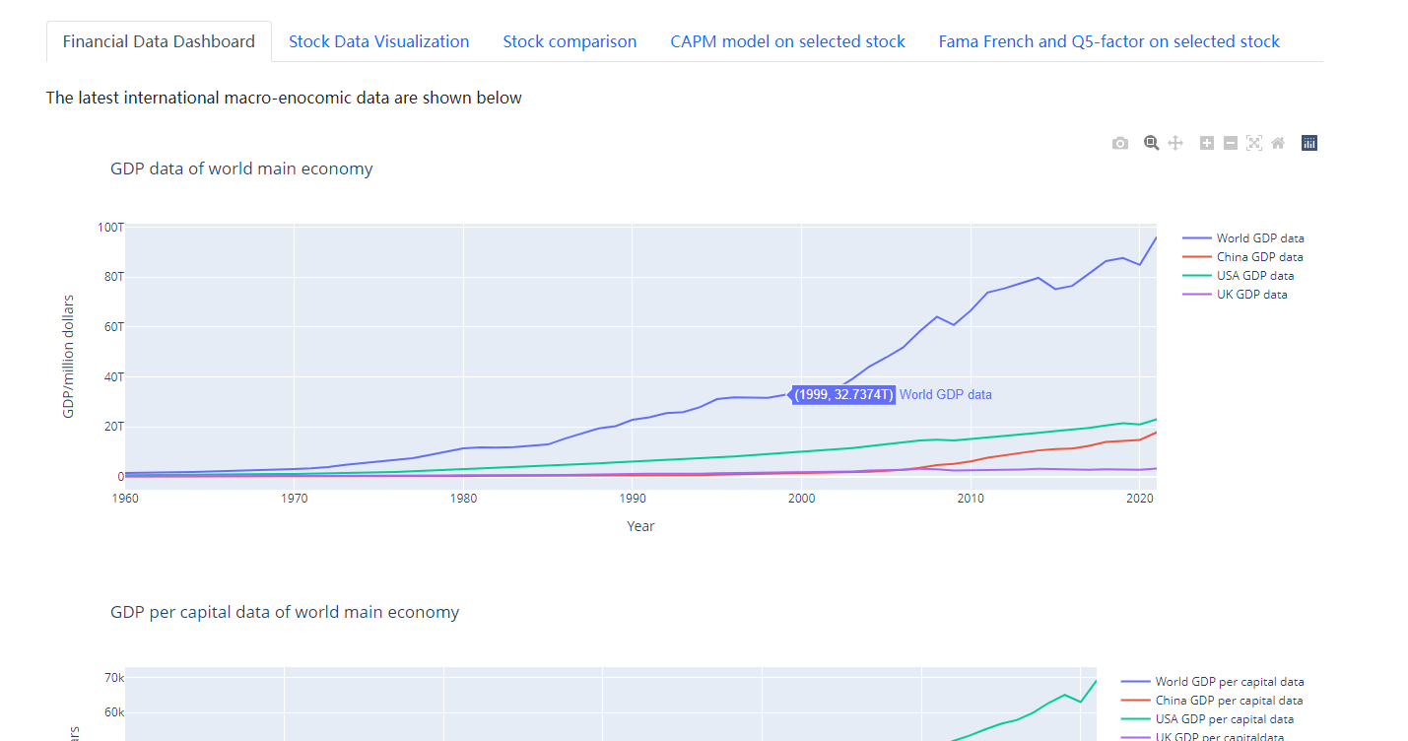

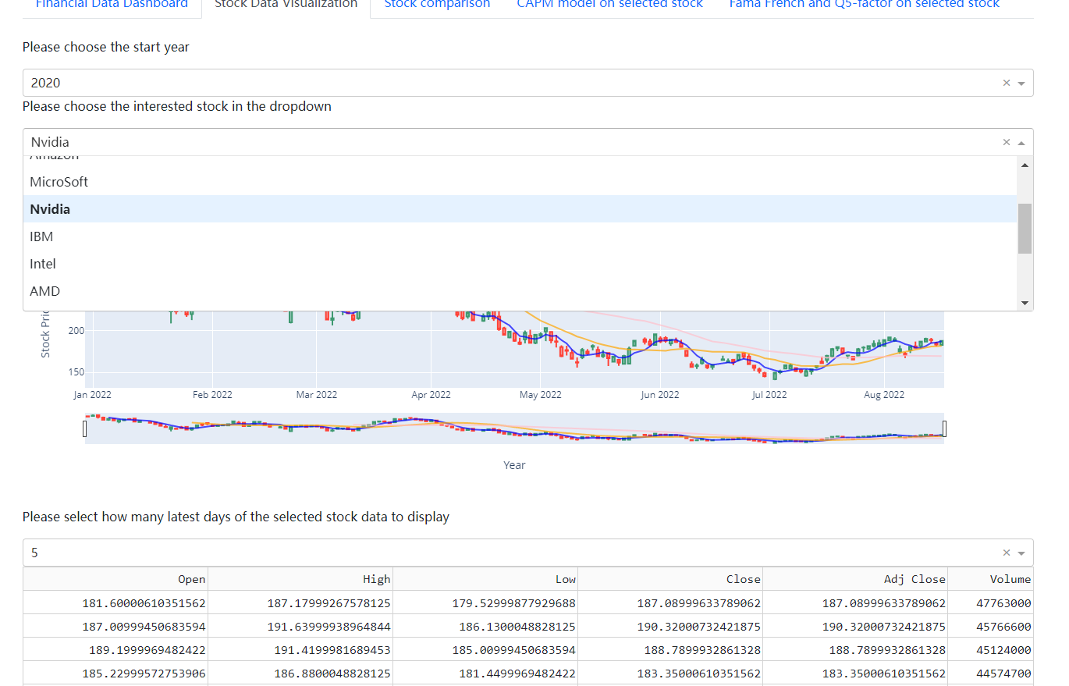

All the figures generated are interactive supported by Plotly, for example, the user can zoom in to focus on a specified period.