Model Template

1.1 Logical Scheme
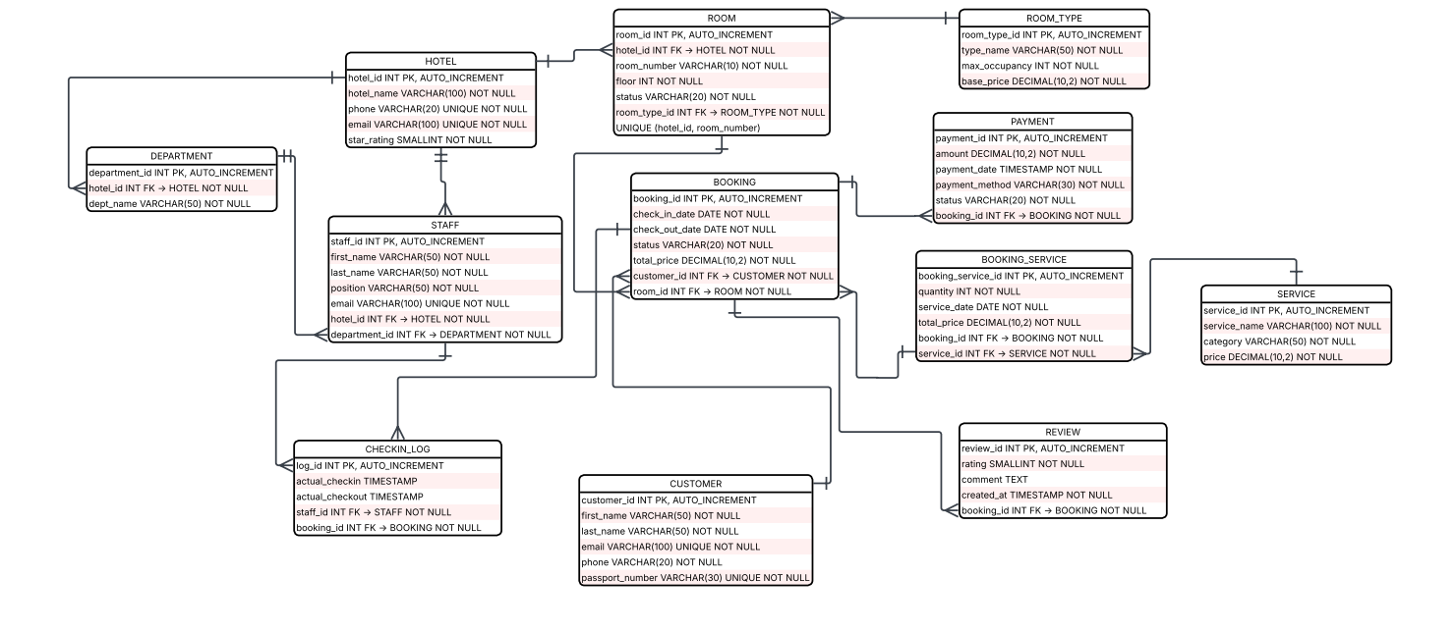
1.2 Objects
HOTEL
Table Name | Field Name | Field Description | Data Type / Constraints
Hotel | hotel_id | Hotel unique identifier | INT, PK, AUTO_INCREMENT
Hotel | hotel_name | Name of the hotel | VARCHAR(100), NOT NULL
Hotel | phone | Contact phone number | VARCHAR(20), UNIQUE, NOT NULL
Hotel | email | Contact email address | VARCHAR(100), UNIQUE, NOT NULL
Hotel | star_rating | Star rating of the hotel (1-5) | SMALLINT, NOT NULL

ROOM_TYPE
Table Name | Field Name | Field Description | Data Type / Constraints
Room_type | room_type_id | Room type unique identifier | INT, PK, AUTO_INCREMENT
Room_type | type_name | Name of the room type | VARCHAR(50), NOT NULL
Room_type | max_occupancy | Maximum number of guests | INT, NOT NULL
Room_type | base_price | Base price per night | DECIMAL(10,2), NOT NULL

ROOM
Table Name | Field Name | Field Description | Data Type / Constraints
Room | room_id | Room unique identifier | INT, PK, AUTO_INCREMENT
Room | hotel_id | Reference to hotel | INT, FK -> HOTEL, NOT NULL
Room | room_type_id | Reference to room type | INT, FK -> ROOM_TYPE, NOT NULL
Room | room_number | Room number within the hotel | VARCHAR(10), NOT NULL
Room | floor | Floor number | INT, NOT NULL
Room | status | Room status (available/occupied) | VARCHAR(20), NOT NULL

DEPARTMENT
Table Name | Field Name | Field Description | Data Type / Constraints
Departament | department_id | Department unique identifier | INT, PK, AUTO_INCREMENT
Departament | hotel_id | Reference to hotel | INT, FK -> HOTEL, NOT NULL
Departament | dept_name | Name of the department | VARCHAR(50), NOT NULL

STAFF
Table Name | Field Name | Field Description | Data Type / Constraints
Staff | staff_id | Staff unique identifier | INT, PK, AUTO_INCREMENT
Staff | first_name | Staff first name | VARCHAR(50), NOT NULL
Staff | last_name | Staff last name | VARCHAR(50), NOT NULL
Staff | position | Job position/title | VARCHAR(50), NOT NULL
Staff | email | Work email address | VARCHAR(100), UNIQUE, NOT NULL
Staff | hotel_id | Reference to hotel | INT, FK -> HOTEL, NOT NULL
Staff | department_id | Reference to department | INT, FK -> DEPARTMENT, NOT NULL

CUSTOMER
Table Name | Field Name | Field Description | Data Type / Constraints
Customer | customer_id | Customer unique identifier | INT, PK, AUTO_INCREMENT
Customer | first_name | Customer first name | VARCHAR(50), NOT NULL
Customer | last_name | Customer last name | VARCHAR(50), NOT NULL
Customer | email | Customer email address | VARCHAR(100), UNIQUE, NOT NULL
Customer | phone | Customer phone number | VARCHAR(20), NOT NULL
Customer | passport_number | Passport or ID number | VARCHAR(30), UNIQUE, NOT NULL

BOOKING
Table Name | Field Name | Field Description | Data Type / Constraints
Booking | booking_id | Booking unique identifier | INT, PK, AUTO_INCREMENT
Booking | customer_id | Reference to customer | INT, FK -> CUSTOMER, NOT NULL
Booking | room_id | Reference to room | INT, FK -> ROOM, NOT NULL
Booking | check_in_date | Planned check-in date | DATE, NOT NULL
Booking | check_out_date | Planned check-out date | DATE, NOT NULL
Booking | status | Booking status (confirmed/cancelled) | VARCHAR(20), NOT NULL
Booking | total_price | Total cost of the booking | DECIMAL(10,2), NOT NULL

PAYMENT
Table Name | Field Name | Field Description | Data Type / Constraints
Payment | payment_id | Payment unique identifier | INT, PK, AUTO_INCREMENT
Payment | booking_id | Reference to booking | INT, FK -> BOOKING, NOT NULL
Payment | amount | Payment amount | DECIMAL(10,2), NOT NULL
Payment | payment_date | Date and time of payment | TIMESTAMP, NOT NULL
Payment | payment_method | Payment method (card/cash/online) | VARCHAR(30), NOT NULL
Payment | status | Payment status (pending/completed) | VARCHAR(20), NOT NULL

SERVICE
Table Name | Field Name | Field Description | Data Type / Constraints
Service | service_id | Service unique identifier | INT, PK, AUTO_INCREMENT
Service | service_name | Name of the service | VARCHAR(100), NOT NULL
Service | category | Service category (Food/Wellness) | VARCHAR(50), NOT NULL
Service | price | Price per unit of service | DECIMAL(10,2), NOT NULL

BOOKING_SERVICE
Table Name | Field Name | Field Description | Data Type / Constraints
Booking_Service | booking_service_id | Unique identifier | INT, PK, AUTO_INCREMENT
Booking_Service | booking_id | Reference to booking | INT, FK -> BOOKING, NOT NULL
Booking_Service | service_id | Reference to service | INT, FK -> SERVICE, NOT NULL
Booking_Service | quantity | Number of service units ordered | INT, NOT NULL
Booking_Service | service_date | Date the service is provided | DATE, NOT NULL
Booking_Service | total_price | Total cost for this service line | DECIMAL(10,2), NOT NULL

REVIEW
Table Name | Field Name | Field Description | Data Type / Constraints
Review | review_id | Review unique identifier | INT, PK, AUTO_INCREMENT
Review | booking_id | Reference to booking | INT, FK -> BOOKING, NOT NULL
Review | customer_id | Reference to customer | INT, FK -> CUSTOMER, NOT NULL
Review | rating | Numeric rating from 1 to 5 | SMALLINT, NOT NULL
Review | comment | Written review text | TEXT
Review | created_at | Timestamp when review was submitted | TIMESTAMP, NOT NULL

CHECKIN_LOG
Table Name | Field Name | Field Description | Data Type / Constraints
Checking_Log | log_id | Log entry unique identifier | INT, PK, AUTO_INCREMENT
Checking_Log | booking_id | Reference to booking | INT, FK -> BOOKING, NOT NULL
Checking_Log | staff_id | Staff who processed check-in/out | INT, FK -> STAFF, NOT NULL
Checking_Log | actual_checkin | Actual check-in timestamp | TIMESTAMP
Checking_Log | actual_checkout | Actual check-out timestamp | TIMESTAMP

