Social Web Final Project Report

Shaopeng Zhang

# Project Introduction

The project is to develop an online system supporting local community to

* Integrate and disseminate useful information
* Encourage engagement in events
* Promote interaction among faculty, students and staffs
* Support real-time communication

This project is in conjunction with Shaopeng Zhang’s final project in Interactive System Design class. This part of the project focuses on the requirements, business logic, content extraction and social interaction aspects, whereas the other focuses on the interface and interaction of the application.

# System Introduction

## Purpose

The system tries to solve problems including

* A lot of different information systems being used, which makes integration of them hard
* Low iSchool member engagement into community events
* Relatively little interaction among faculty, students and staff

The system tries to solve these problems to facilitate information dissemination, promote engagement and interaction among IS members.

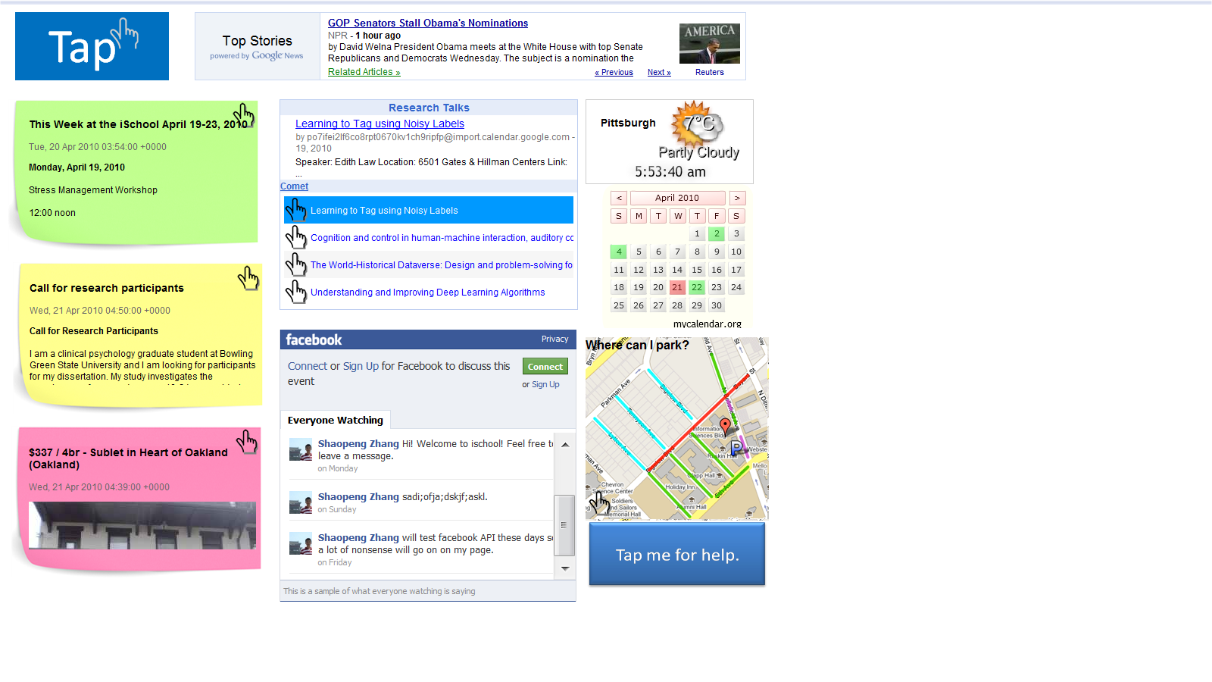

# Solution

## Using Blogs as Information Feeds

To make information posting easy to administer, we have to use unified information systems. Such systems must have following characteristics:

* Easy management: the administrator and the users must find it easy to post or edit information.
* Public access: all users in the community must be able to access the system.
* Easy to integrate with our system: there must be convenient interface for our system to extract information from the information system.

To meet all requirements above, the proposed system is blog. We use blogger, the blog system with the largest user base to be the information posting system. The blogger can set different blog account under one administrator account, and each blog account can have view/edit permission for multiple users. In current implementation, we have three blogs for the community: staff, faculty, and student.

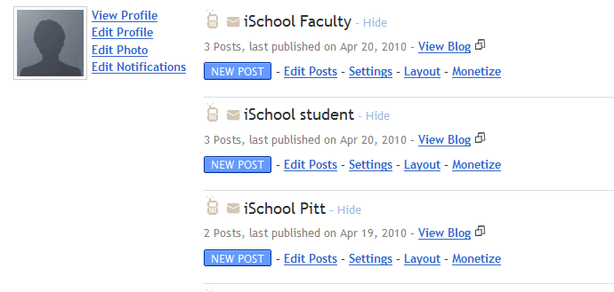

We use RSS feeds to link the blogs with TAP system. TAP system uses google feed API to read the feeds. Every time someone makes a post onto the blog. TAP system would update its content according to the update of the feed. (There is an about 10 minute delay between the posting and the update)

## Using rich and dynamic information feeds to encourage user engagement

We conducted a survey with prospect user to see what information they would like to see on the wall. Top requirements are:

* Research talks
* Faculty message (e.g. class arrangement, call for participants)
* Students request and post (e.g. help request, buy/sell/trade)
* IS Office schedule and events
* Local information (Weather, Places around IS)
* IS Field news

We provide research talks and IS field news using Ajax feed, which dynamically load latest events and news. For these two kinds of information, instead of displaying them in static way in which user tap them for details, we use “list + snippet” rolling view to display the information to the user, to attract their attention. This is in consideration of the display context, the touchscreen. A dynamic rolling view would attract more users to the touchscreen. We hope we can let more users know about different kinds of events by proactively provide information to them.

We also provide other information, for example weather, time, date and parking area around IS building.

## Promoting user interaction with facebook live stream box

Facebook live stream box is a widget provided by facebook to let the users visiting a page discuss with each other in a real-time fashion. The user doesn’t need to refresh the page to view message from others; it will display automatically. We choose this widget because facebook has the largest user base in the community. The user can share events information, chat with each other, or call for other’s help. This kind of chat is public to everyone visiting the page, so discussion should be on public topic. One caveat is that this widget is available only for online users visiting the site. Local user at the touchscreen would not be able to use this feature because in the survey, most users claim that they do not want to input any message using the touchscreen, either because it is not convenient, or because they are in a hurry.

# Future works

## Take full advantage of facebook platform

Facebook platform can have more contribution to promote information sharing and communication. Future works will set up a facebook page as the online information portal for iSchool members. Blog posts and events information can be automatically posted here and shared among the members.

## Basic bookmark and rating functionality on touchscreen

Although the user would like minimum input to the touchscreen, basic bookmark and rating functions can still promote communication among community members. For example, the system can set up a like button for every post. The user can simply tap the button to vote for the event, and other users can see this feedback.

## More effectively integrate and display information

The display context, the touchscreen, has only 1024*768 display area. To display all kinds of information of users’ interest become more difficult. Future works will determine the most useful information to the user and lay out different sections to serve them better.