**Test report for the software product**

**"OpenWeatherMap weather service"**

**How was the testing**

The testing of the software product began with a review of the documentation of this product. And based on the documentation, a test plan and an Acceptance Criteria were compiled. Based on the documentation, a checklist was drawn up.

The time spent on testing was 0.5 working days.

**What was verified**

* Getting the API key.
* Using the query API, the following functionality was checked:

1. Current weather data
2. 5 day / 3 hour forecast
3. 16 day / daily forecast
4. Historical data
5. Weather map layers
6. UV Index
7. Weather stations
8. Weather alerts

**Below is a table of the results of testing**

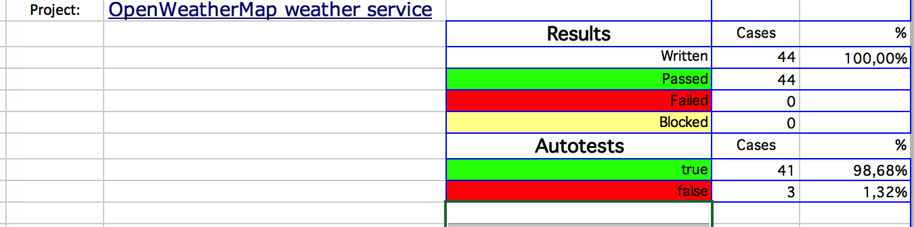

**Conclusion**

According to the tests performed, which showed no errors in the product, we can confidently say that the product is ready to be delivered to the customer.