**Test report for the software product**

**"** **https://tripmydream.com"**

**How was the testing**

The testing of the software product began with a review of the help documentation of this site. And based on the documentation, a test plan and an Acceptance Criteria were compiled. Based on the documentation, a checklist was drawn up.

The time spent on testing was 2 working hours.

**What was verified**

* User profile page
* Avia tickets page
* Avia discounts page
* Hotels page

**Below is a table of the results of testing**

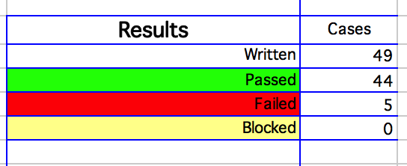

**Conclusion**

According to the tests conducted, which showed incorrect work in business-critical business cases, it is necessary to make a well-considered decision in order to release the product into production with existing errors.

We recommend that you correct errors before submitting this site to users.

**Access to the list of errors**

<https://devch12.atlassian.net/>

**Email:** [serg_broker@ukr.net](mailto:serg_broker@ukr.net)

**Pass:** 12345678

**Project:** devch12