# Mynd Sweeper Manual

**Description**

This application is a variant of the popular game of Mine Sweeper. In this game the player who finds the most mines wins. The application features two modes. The first mode is a console mode. If the user runs the wad_ms_run_01 file the game will start. In the first place the game will ask whether the players want to use a terminal to play the game or rather play it as a web game. In case it is a console game, the game will start in a console terminal. Otherwise the application will start up a local server on (normally) localhost:4567. By navigating there with a browser the user should see the main page with all menus displayed. For detailed instructions please read the relevant section.

**System requirements**

In order to use the application before it gets deployed onto a real publicly available server, the user/tester will need to have a text editor or IDE installed that can open ruby files and can run them. Ruby SDK and development environment will need to be installed too. This can be downloaded from their website (https://rubyinstaller.org/downloads/). In order to run the application a browser will be needed to be installed as well.

Once all the above are done, will need to add, sinatra and haml gems. Also for the web based games the user will need to have a web browser. The application was tested on Google Chrome only.

**Features and functionalities with illustration**

###### CONSOLE APPLICATION:

When the application starts it will as the users if they want to play in a console or in a browser

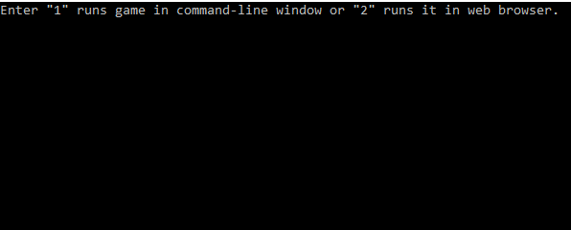

By selecting the console option the game will display a menu for the game

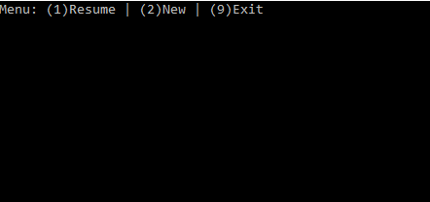

If there are players already set up from a previous game by selecting option 1 a new game will be started for those players. Else a message will be displayed prompting the players that no game is setup to resume.

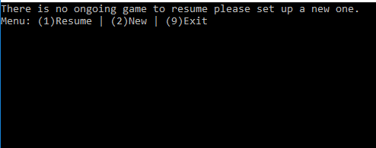

By selecting option 9 the game will display a friendly goodbye message and will exit the application

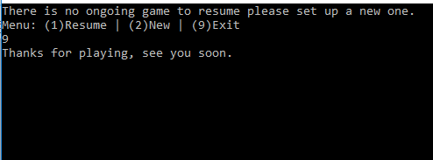

By selecting option 2 a new game will be setup and player names will be asked for

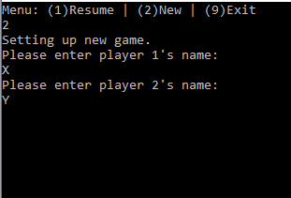

By adding the names the game will start

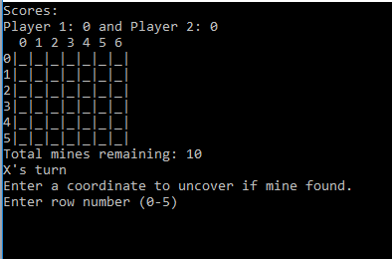

Each round the player will need to enter a row and column to see if a mine is there. The display will update each round accordingly and scores would be updated if a mine is found

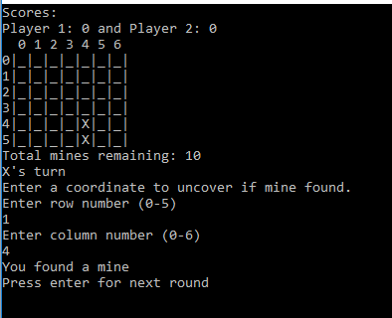

If the user is entering an invalid number a prompt will appear and the user can try another one

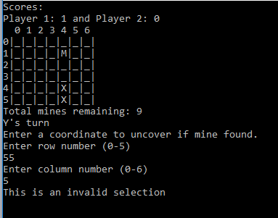

If the user enters a field that has already been checked a prompt will appear

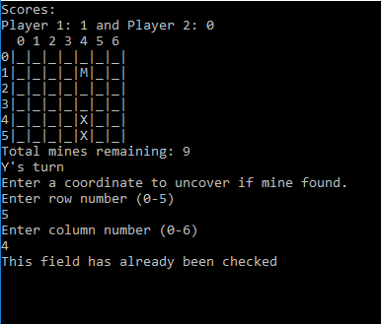

When all mines are found the console will display the winner and then return to the menu screen

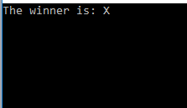

###### WEB BASED GAME

The game will be very similar to the console application but played through a browser

When the application is started and option 2 is selected then a browser will need to be started up on the appropriate port (normally port number 4567)

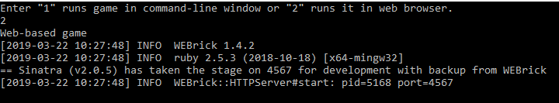

The main page will display a welcome message and a menu

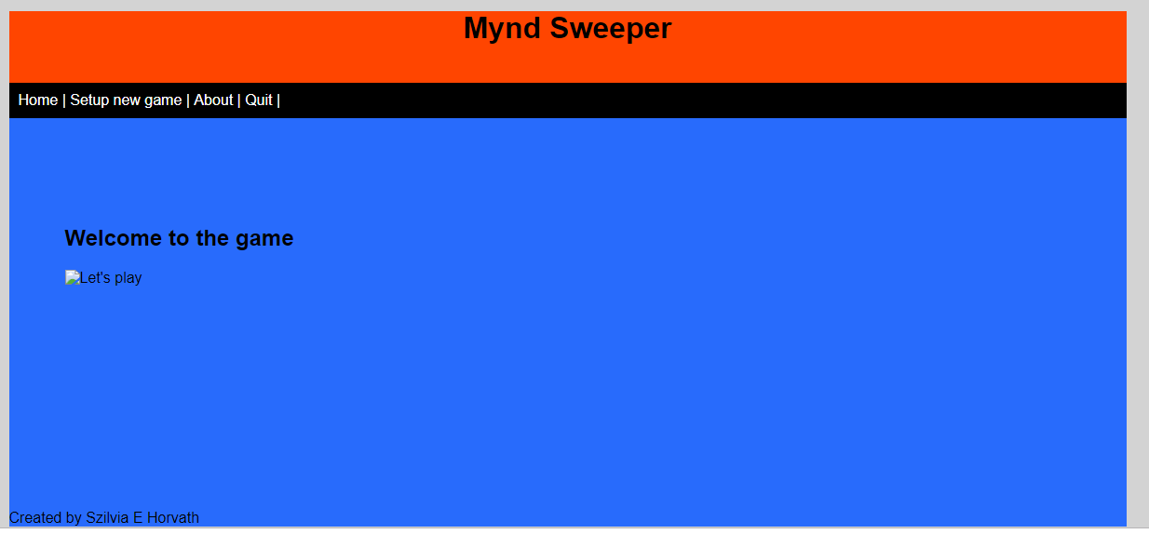

The about page will display some basic information about the game

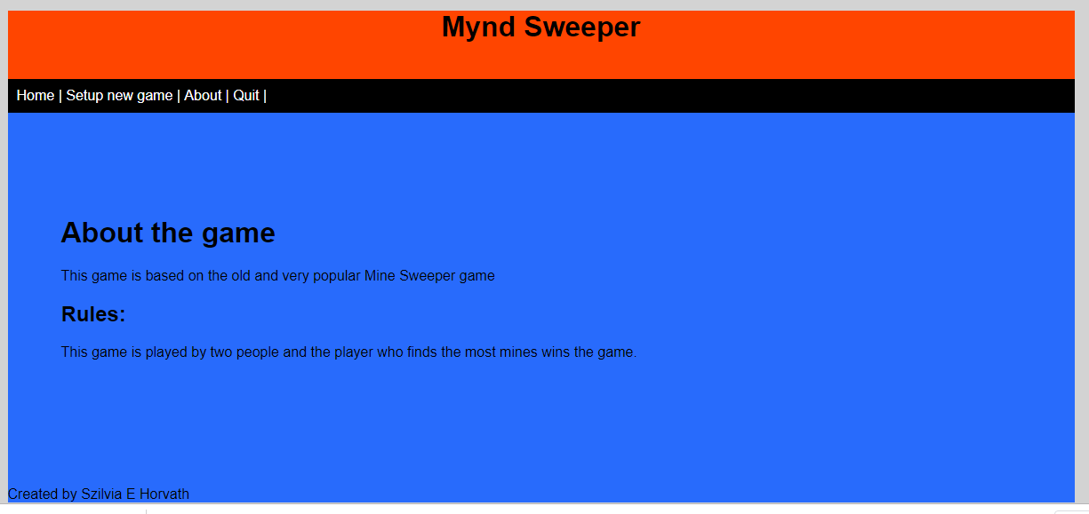

The quit option will clear all game data and will allow the users to set up a new game or to leave the application

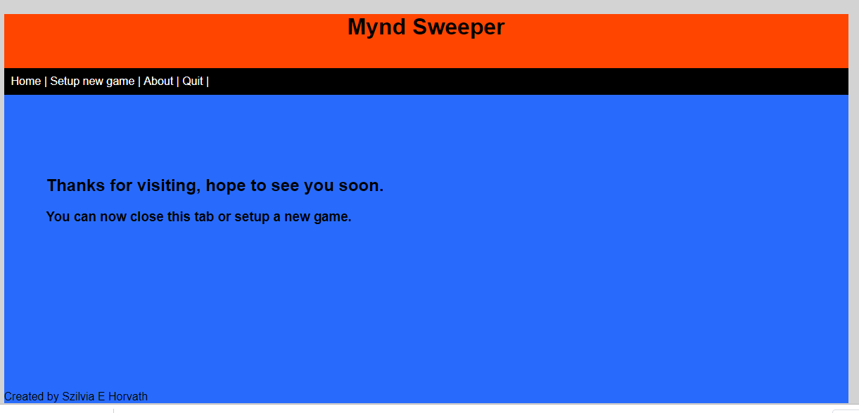

When no game is setup the options will display a setup new game option where players’ names can be set and also a new game will be initialised

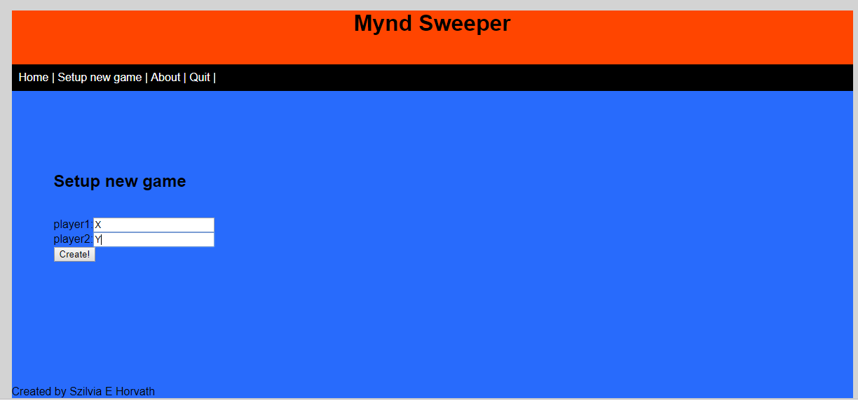

When this is set that option will disappear and a game arena option will appear

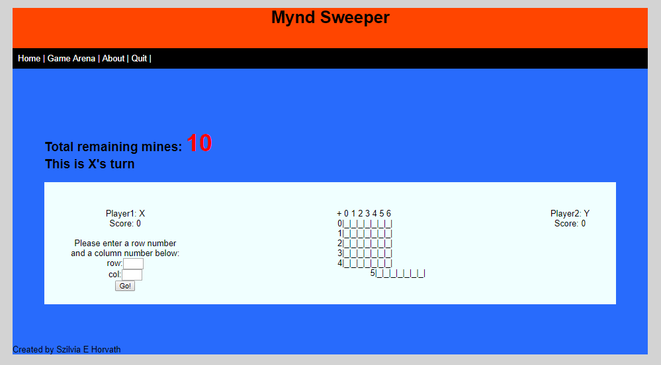

On the game arena screen total remaining mines will be displayed and also who’s turn it is. On the two sides the two players will be displayed with their scores. The player with the current turn will also have a form to enter row and column number just like in the console application. This will update the game board in the middle and will change the turn to the other player

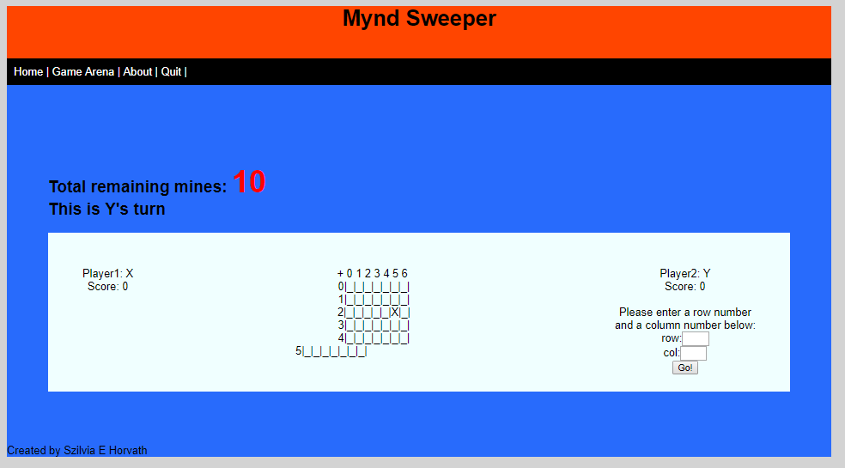

Checks for inputs happen here too for already checked fields or for non-existing fields

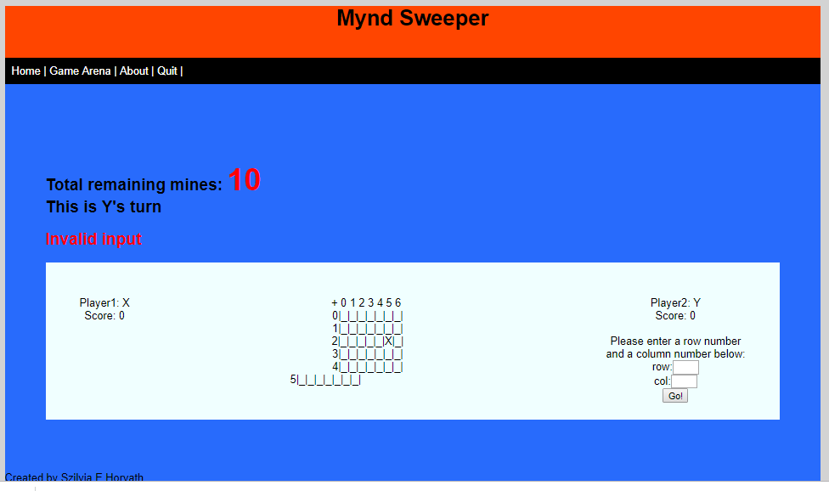

When all mines are found no forms will be displayed for players and the winner will be displayed

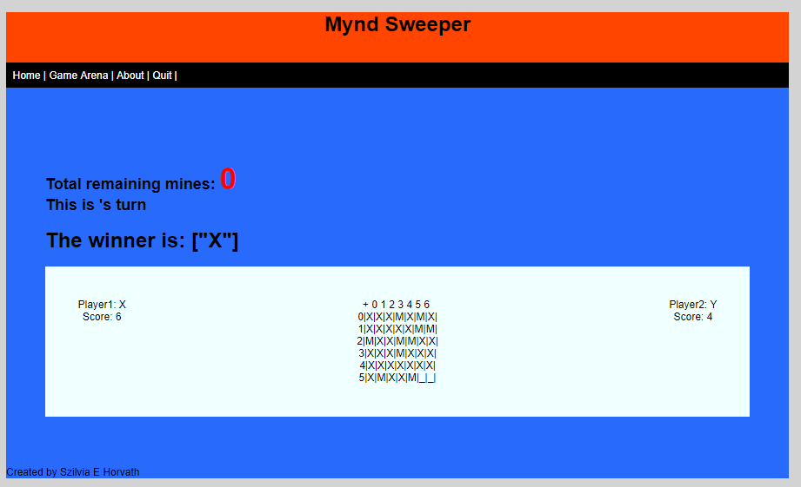

From here the players will need click on quit to set up a new game.