The California Department of Fish and Wildlife’s (CDFW) Bay Delta (Stockton) Sportfish Unit provides herein a detailed review of the adult Striped Bass population study. Such a review was requested by Interagency Ecological Program (IEP) management. This review chronicles the study’s history, evaluates original objectives with the needs of today, and provides recommenations for improvements.

March 02, 2020  
CDFW, Sportfish Unit

# Basic Information & Program Element Description

**Program Title**: Adult Striped Bass Population Estimates  
**Program Element Number (PEN)**: 002  
**Agency**: California Department of Fish & Wildlife (CDFW)

Principal Investigators:  
- [Andrew Danos, CDFW](mailto:andrew.danos@wildlife.ca.gov)  
- [Jason DuBois, CDFW](mailto:jason.dubois@wildlife.ca.gov)

## Project Description

Nearly annually since 1969, the CDFW has conducted a mark-recapture study on adult (i.e., ≥ age-3) Striped Bass (*Morone saxatilis*). Data collected provide estimates of abundance (absolute and relative), harvest rate (exploitation), survival rate, growth, harvest, and large-scale migration. Age compostion — as estimated from scale examination — allows for stratifying some metrics accordingly.

To collect Striped Bass, fyke traps and gill nets are deployed during peak spawning (Mar-Jul, more typically Apr-May). Fyke traps are set along the banks of the upper Sacramento River (e.g., Knights Landing), and gill nets are deployed typically at the confluence of the Sacramento and San Joaquin rivers. For both gear types, time set and time pulled are recorded per each deployment.

To most legal-sized Striped Bass, one disc tag is affixed just below the dorsal fin’s spiny section (typically between spines 3 and 4). Up to 10 scales are collected per fish for later age assessment. Fish are measured and sexed, and then released to the area nearest capture. Fish not tagged are enumerated and as time allows measured and (or) sexed. Recaptures (i.e., Striped Bass previously disc tagged) are recorded, noting length, sex, and tag number. Bycatch are identified to species and enumerated.

#### Research Problem

#### Research Objectives

Originally, this project’s main goal expressed supporting a robust recreational fishery through effective management. Data collected would establish and then monitor fishing regulations comensurate with said goal. Of further importance was understanding factors affecting abundance given recent and future environmental changes (e.g., water diversion).

Data collected using mark-recapture methods were analyzed to provide important population metrics (e.g., abundance; harvest rate; survival rate). Such metrics would guide appropriate management of the Striped Bass recreational fishery.

#### Research Questions

1. What are the population dynamics of Striped Bass in the Sacramento-San Joaquin Delta and San Francisco Estuary?
2. Do existing laws and regulations governing the fishery need to be changed?
3. Are there any regulatory recommendations needed to change the Striped Bass population?

# Program Element Historical Details

## Study Design & Objective

To collect Striped Bass, the CDFW deploys fyke traps and gill nets during peak spawning (Mar-Jul, more typically Apr-May). Fyke traps are set along the banks of the upper Sacramento River (e.g., Knights Landing), and gill nets are deployed typically at the confluence of the Sacramento and San Joaquin rivers. For both gear types, time set and time pulled are recorded per each deployment.

To most legal-sized Striped Bass, one disc tag is affixed just below the dorsal fin’s spiny section (typically between spines 3 and 4). Up to 10 scales are collected per fish for later age assessment. Fish are measured and sexed, and then released to the area nearest capture. Fish not tagged are enumerated and as time allows measured and (or) sexed. Recaptures (i.e., Striped Bass previously disc tagged) are recorded, noting length, sex, and tag number. Bycatch are identified to species and enumerated.

Currently, fyke traps fish 24 hours between inspections. We typically set fyke traps on Monday and handle and tag Striped Bass Tuesday through Friday. Field days typically begin at 0730 ending around 1730, varying according to catch and processing.

We record the following information for each fyke trap. Further, we note any unusual procedures (e.g., trap vandalism; debris load). We record water temperature (to nearest 0.5 degree Celsius) once at the start of each field day.

* trap number
* daily set & pull times
* bycatch (other species)
* pinnipeds (seals or sea lions) in or within 50 meters of the trap

We record the following information for each gill net set. Further, we note any unusual procedures (e.g., snags; other vessel interactions). We record water temperature (to nearest 0.5 degree Celsius) once at the start of each field day.

* set number
* amount of net fished
* net set & net pull times
* location fished
* bycatch (other species)[1]
* pinnipeds (seals or sea lions) in or within 50 meters of the trap[2]
* pinnipeds raiding the net (i.e., picking fish from the net)[3]

[1]: within the “remarks” section of the daily summary datasheet

On the tagging datasheet (same for both fyke trap and gill net), we record the following information. A datasheet has space for 25 tags.

* header: date, location, capture method (fyke or gill net), tagger name
* tag number (two numbers if double-tagging study)
* fork length (cm)
* sex (♂ = 1, ♀ = 2)
* tag description (i.e., tag value)
* condition upon release (good = 1, 2 otherwise)
* trap or set number (in “remarks” section)

## Sampling Methods

We (CDFW) use gill nets and fyke traps to catch mostly adult Striped Bass. Sampling occurs during the spawning run (Mar-Jul, more typcially Apr-May). We deploy gill nets daily mostly in or around the Sacramento-San Joaquin confluence. We deploy fyke traps along select stretches of the Sacramento River.

The objective is to catch and then disc tag as many Striped Bass as possible. We use the current legal size as the cutoff for fish receiving a tag. Fish less than such length are enumerated, and then measured and (or) sexed as time allows.

Striped Bass deemed “taggable” receive a single disc tag just below the dorsal fin on the right side. Disc tags are sequentially numbered with a 6-character alpha-numeric (i.e., the tag number). Along with tag number, fork length (in centimeters [cm]), mesh size(?), fish condition at release (good; fair; poor), set or trap number are recorded. Noted too is any evidence of a captured fish having shed a disc tag and (or) if a captured fish needed to be re-tagged.

Fyke trap sampling typically occurs Tuesday through Friday from roughly dawn until late afternoon. Traps are deployed on Monday to begin fishing, and thus no fish are handled. Using wire, cable, and rope, fyke traps are set in fixed positions on the levee. Traps are deployed to the water using a winch and pull cable. Trap locations are selected based on levee terrain and river depth (i.e., for complete submergence).

Gill net sampling typically occurs Monday through Friday from roughly dawn until mid afternoon. The gill net is set in locations selected by the boat operator to avoid known snags and unfavorable currents. The net is deployed cross current with the vessel downwind. On average, it takes approximately five minutes to set the net. We continuously monitor the deployed net to detect snags, tangles, marine mammal interactions, and to avoid conflicts with other vessels and hazards such as channel markers. The net is set as many times (usually 4-6) as possible each field day, with each set lasting up to ~55 minutes.

#### changes (come up with more descriptive section name)

## Gear Description

Herein, we briefly describe fishing gear as detailed in our Operating Manual (CDFW 1988). Historically, we have manufactured in-house our gill nets and fyke traps from purchased raw materials.

#### Gill Net

Gill net dimension and construction are detailed in Sportfish tagging protocol (CDFW 1988). The main components are a lead line, float (or cork) line, and webbing. A full net contains the mesh sizes below. All webbing is multifilament nylon, double knot & double selvage (top & bottom).

mesh size

* 4" (85 meshes deep; #104 twine)
* 4½" (74 meshes deep; #139 twine)
* 5" (66 meshes deep; #208 twine)
* 5½" (60 meshes deep; #208 twine)

#### Fyke Trap

Fyke trap design and construction was modeled after Hallock et al. (1957). Each cylindrical trap is 20’ L x 10’ D. Materials included 2-inch UV stabilized polyethelene netting and 11-gauge galvanized chain link.

## Effort

We deploy our gill net from the vessel’s stern using a hydraulic-powered net reel. Catch and weather (e.g., currents; wind) can dictate the number of daily deployments, but typically a vessel will set the net 5± times. Net set and net retrieval times are recorded to the nearest minute (as HH:MM).

We tether each fyke trap to the levee bank using wire, cable, and rope. We use an electric winch to slowly lower (or retrieve) each trap into (or from) the water. For optimal fishing, traps should be fully submerged, and we make every attempt to do so. Date & time set and date & time pulled are recorded for each trap (as MM/DD/YYYY HH:MM).

We use set and retrieval (pull) times to calculate fishing effort. Gill net sets are measured in minutes fished and fyke traps in hours fished.

## Required Resources

At minimum, this study requires the following “big ticket” items. Other items < see appendix ?? >.

* one or two research vessels with hydraulic net reel & two tagging cradles
* one research vessel with enough deck space for three tagging stations (cradles)
* at least two complete 4-panel gill nets (or raw materials to build one)
* 1-2 replacement gill net panels (in case of in-season damage)
* 8-9 fyke traps in good condition
* serially numbered disc tags (count: ~5000 to begin each season)
* 4-5 personnel (per research vessel)
  + Vessel Mate
  + Fish & Wildlife Technician (deck hand)
  + Environmental Scientist (or similar scientific staff)
  + Scientific Aide (1 or 2 depending on needs and availability)

## Initial Sampling Purpose

Concerns that water diversions might adversely affect the recreational Striped Bass fishery compelled CDFW researchers to develop this large scale mark-recapture study. The original sampling purpose was to catch and then disc tag (i.e., the “mark”) as many Striped Bass as possible. Population metrics calculated from available data would guide necessary actions for proper management of the Striped Bass fishery.

## Project History

Prior to 1950, only the general seasonal nature of California Striped bass migration were known (Orsi 1971). A steady decrease in sport fishing success for Striped bass in the late 1940s and early 1950s caused concern over the population’s status (Chadwick 1968). Primarily funded by the new Dingell-Johnson Act of 1950, a series of three different studies between 1950 and 1966 were conducted to assess Striped Bass migration and harvest in the Sacramento-San Joaquin Delta. These studies would be labeled and funded as California project F-9-R, “A Study of Sturgeon and Striped Bass,” which was supported by Federal Aid to Fish Restoration Funds.

The first of these was an adult tagging study that was the first of its kind for California Striped Bass (Calhoun 1952). Prior to Calhoun’s (1952) study, tagging of California Striped Bass was limited to mostly small fish that were under 12 inches in length. Adult Striped Bass 11-40+ inches were caught and tagged in the spring of 1950-1951 via gill net in an area that spanned from Chipps Island to Franc’s Tract in the Sacramento-San Joaquin Delta. Migration and abundance were estimated using disc tag returns received via mail from anglers. The results of Calhoun’s adult tagging study demonstrated Striped Bass had anadromous migration patterns in the Sacramento-San Joaquin Delta and few tagged fish were caught in San Francisco Bay or Pacific Ocean (Orsi 1971). With the help of Howard McCully from the Bureau of Marine Fisheries, this was also the first time commendation cards were sent out to anglers who returned a captured disc tag. The completion and mailing of commendation cards for tag returns is a practice that is still conducted by CDFW R3 to the time of this writing (2020).

Calhoun’s (1952) study did not produce satisfactory mortality estimates due most part to loss of tagged fish to commercial shad and salmon gill nets. These commercial fisheries were closed in 1957 and presented an opportunity for further adult Striped Bass research (Chadwick 1968). As part of a program to evaluate changes in the Striped Bass population and regulations, a 4-year tagging study was performed through years 1958-1961 to measure mortality rates and migration shifts of Striped Bass in the delta. Fish were primarily caught and tagged using gill nets around the confluence of the Sacramento and San-Joaquin rivers like in Calhoun’s experiment. Fish were also caught and tagged via fyke trap at Fremont Weir in the upper Sacramento in May 1958, as well as by angling in San Pablo Bay in the fall of 1958-1959. Results from this study indicated that more bass were entering SF Bay and the Pacific Ocean than in the early 1950s. This study also demonstrated that tag returns gave reasonably valid estimates for mortality and probably underestimated Striped Bass exploitation.

In 1965 the tagging program was renewed to evaluate changes in the population parameters of Striped Bass in the Sacramento-San Joaquin delta. (Miller 1974). Fish were tagged in 1965-66 using similar methods to the previous studies. This study determined that a recent decline in angler success and angler effort related to a declining population. This study also demonstrated that survival rates increased, and exploitation rates declined in response to reduced angling pressure.

Building upon these prior studies, CDFW (then CDFG) started their long-term mark-recapture study on legal sized Striped Bass age-3 and above in 1969 (Smith 1978). Fish tagged from 1969-2009 were captured and tagged primarily by gill net but were also tagged via fyke traps. Gill net operations formally ceased after the 2009 season due to availability and absence of experienced personnel.

Fyke traps have been fished continually since 1969, with a few years of non-sampling due to environmental and seasonal personnel issues. Fyke traps were not fished in 1959-61 and 1965-66 during the initial first 3 Striped Bass studies (White 1986). Fyke trapping sites have included Isleton, Courtland, Clarksberg, Colusa, Fremont Weir, Knights Landing, and other special areas since the early 1960s. The primary fyke location for tagging adult Striped Bass has been in Knights Landings since 1990 (CDFW R3 Sportfish data; Kohlhorst and Vu 2003).

A summer-fall creel census targeting Striped Bass anglers started in 1969 too. The first iteration of the Striped Bass creel survey aimed to increase angler tag returns from the San Francisco-San Pablo Bay area. CPFV logs and sampling had intermittently been used for Striped Bass sport fishery analysis, but formally started in 1969 as well. In 1977-78 creel census of private boats was not sampled and charter boat sampling was reduced 75-80%. Tagging effort was reduced from two gill nets and fyke trap to one gill net boat for 1977-78. In 1988 the Striped Bass creel survey added a ‘river’ creeling extension to further assess angling effort and increase tag returns in the Sacramento-San Joaquin Estuary. The Striped Bass creel census project in entirety was cancelled in 2009 due budgetary restrictions after the 2008 economic downturn in the US (CDFW-Jason DuBois).

## Fishing Regulation Changes

**1944-1954**: daily bag limit 5 fish; minimum total length 12 inches. (Chadwick 1962)

**1955**: daily bag limit 4 fish; minimum total length 12 inches. (Chadwick 1969)

**1956-1982**: daily bag limit 3 fish; minimum total length 16 inches (Chadwick 1962; Stevens et al.  1985)

**1982-present**: daily bag limit 2 fish; minimum total length 18 inches (Stevens et al.  1985)

# Current Resource Requirements

# Program Strengths & Weaknesses

## Sampling Timeline

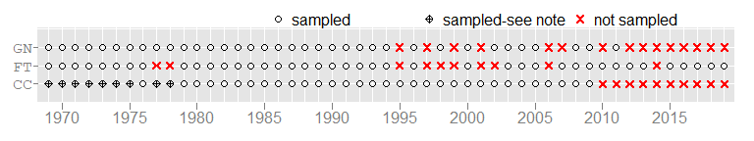

#### Creel Census (CC)

Staff reduction due to budget cuts essentially ended the creel census (October 2009). To the best of our knowledge, no attempts were made to reinstate such operation.

In 1977 and 1978, the creel census did not sample private boats and sampling of party (charter) boats was substantially reduced (White 1986). *Note*: Data from 1969-1975 and 1977-1978 currently not available electronically.

#### 2010s

We ceased gill netting operations due to reduced staffing and redirection of vessel operators to higher priority projects. Further, the prevailing mindset postulated fyke traps would catch more Striped Bass, and thus we would fish the gill nets “opportunistically.” *Note*: in 2011 we deployed gill nets for only one day (19-Apr).

We did not deploy fyke traps in 2014 due to extremely low flows (a drought year) and redirection of staff to higher priority projects. It remains the only year in the timeseries where no sampling occurred on any level (fyke trap, gill net, or creel census).

#### 2000s

It is not entirely clear why in 2007 we did not deploy gill nets and why in 2006 we did not sample (gill nets or fyke traps). For 2006, it is possible high flows played a role in the decision not to sample.

Analyses from the early 1990s (unpublished 2002) suggested tagging in alternate years would suffice for estimating populations metrics. Thus, sampling would occur in even-numbered years only (i.e., 2000 & 2002), not 2001. However, annual sampling was reinstated — for reasons not yet found — beginning with the 2003 field season.

“Logistical difficulties” were cited as the reason why fyke traps were not deployed in 2002 (unpublished 2002). Though not explicitly stated, logistical issues could include high river flows, personnel, and (or) equipment.

*Note*: unpublished (2002) does not specifically reference analysis (or analyses) that demonstrated alternate sampling would suffice. We are still investigating the reporting of such analytics.

*Note*: unpublished (2002) available as 30-1_02.doc in Sportfish Unit directory (Stockton, Bay Delta).

#### 1990s

Analyses from the early 1990s (unpublished 2002) suggested tagging in alternate years would suffice for estimating populations metrics. Thus, sampling would occur in even-numbered years only (i.e., 1994; 1996; & 1998), not 1995, 1997, and 1999.

“Logistical difficulties” were cited as the reason why fyke traps were not deployed in 1998 (unpublished 2002). Though not explicitly stated, logistical issues could include high river flows, personnel, and (or) equipment.

*Note*: see *Note*s in section 2000s.

#### 1970s

We did not deploy fyke traps in 1977 and 1978 (White 1986). It remains unclear as to *why* fyke traps did not fish in those years.

## Sampling Changes

#### Gear

*gill net material (changed over time?)*

*fyke trap material (changed over time?)*

#### Fishing Time

Most data for time set and time pulled (i.e., fishing effort) are not available electronically. Recently, we have entered into our current database some effort data. More field seasons — particularly the early ones — remain to be entered.

Based on available electronic data, it appears average daily fishing time for fyke traps reduced from 35± to 24± hours <reference to Appendix?>. Such a reduction was likely in response to concerns that ESA species (e.g., spring run Chinook Salmon) might be contained for too long. Thus, since roughly 2000, each fyke trap must be checked within 24 hours. (Checking a trap temporarily renders it not fishing, as this process requires removal from the water for inspection.)

#### Tagging

By original design, this project disc tagged only legal-sized Striped Bass. From 1969 to February 1982 legal size was 16 inches total length (the equivalent to 38 centimeters fork length [cm FL]). The current legal size — established March 1982 — is 18 inches total length (the equivalent to 42 cm FL). Beginning with the 1982 field season, CDFW field crews tallied all Striped Bass 38-41 cm FL and disc tagged Striped Bass 42 cm FL and above.

In 2010 — for reasons not well documented, we began disc tagging sub-legal sized Striped Bass. A minimum length was never clearly defined, but fish as small as 30 cm FL have received a disc tag. Likely this minimum size was dictacted by the minimum length caught by our fyke traps (i.e., very few fish < 30 cm FL are caught in our fyke traps).

#### Research Vessels

We used one pontoon boat for fyke trap operations.

Typically, we used two R/Vs for gill netting operations. Excecptions were for 1977 and 1978 when we used only one R/V.

## Evaluating Effort & Efficacy

In the recent two decades, this program has done very little in terms of self assessment and (or) self improvment. We have been plagued by personnel turnover, truncated field seasons due to vessel issues and (or) redirection of staff to higher priority projects, insufficient expertise in the fields of fishery management and mark-recapture, and limited exploratory analyses to guide new or revised research.

## Bycatch (Other Species)

Below, we display the top 10 in overall numbers bycatch species. We likely began recording bycatch early in this project’s hisotry, but electronic records are currently available from 1996. Count includes all sampling years since 1996. This project has caught very few Steelhead (n=17) (includes only from 1996-present). We have recorded — though not consistently — length, codition, coloration, and adipose fin (presence or absence) for all salmonids.

|  |  |
| --- | --- |
| Species | Count |
| American Shad | 10,548 |
| Channel Catfish | 1,008 |
| White Sturgeon | 472 |
| Chinook Salmon | 377 |
| White Catfish | 75 |
| Carp | 73 |
| Smallmouth Bass | 56 |
| Sacramento Sucker | 55 |
| Sacramento Pikeminnow | 49 |
| Black Crappie | 39 |

# Data Products

## Data Storage

Data are stored in a Tier 3 level server-based database (MS SQL Server; database name: BDASB). Data are accessed via two applications: Managed Access Login or ASB_Queries.accdb. These applications are accessible only on CDFW-Stockton based computers. Data backup is handled via methods established by the database administrator (of CDFW’s Data Technology Division).

## Data Collection & Data Management

Field data are recorded on one of six datasheets: (1) daily summary; (2) recaptures; (3) by-catch; (4) salmonids; (5) creel (as needed); and (6) effort. At the end of each sampling day, a crew member reviews each datasheet for completeness and accuracy. Field crew return all datasheets to CDFW’s Stockton Office, where an Environmental Scientist reviews for completeness and accuracy, editing as needed.

New data are entered via Managed Access Login, and quality assurance is enforced through line-by-line inspection of data printouts (i.e., hardcopies). We then randomly select 10% of data for a final line-by-line review.

<TODO: Data Management Plan can be included if it exists>

## Data Analysis

Currently, we use R & RStudio for all data analytics (R version 3.6.2 (2019-12-12) 2019; RStudio version 1.2.5033 2019). Data are queried through open database connectivity established with the server-based BDASB. We use SQL (structured query language) to extract desired data, and then save such extracts as .rds files for use in R & RStudio. We update each .rds file when appropriate (i.e., with new data).

*Note*: we completed and compiled this report using R packages sportfish (2018) and knitr (2020). File organization and R code can be found [here](https://github.com/jasondubois/StripedBassPopMetrics/tree/master/review). Find appropriate .Rmd (Rmarkdown) file.

#### Population Metrics

Detailing the steps and methods that produce various population metrics is beyond the scope of this report. Three such metrics are abundance, harvest rate, and survival rate, for which the algorithms can be found in Ricker (1975), see equations 3.9, 3.1, & 5.1.

Estimating abundance is a multi-step process that includes age and sex stratification. Because estimating abundance requires the number of recaptured marks (tags), it takes four years (i.e., seasons) before we consider estimates final. Estimating harvest rate includes adjusting for non-response all angler tag returns not collected during creel census operations (e.g., returned via mail). Ricker’s (1975) survival rate algorithm (5.1) requires two consecutive sampling seasons.

We calculate tagging catch-per-unit effort (CPUE) as a measure of relative abundance. Further, we can measure migration on a crude scale (i.e., tagging location versus recapture location). We can estimate annual growth rate given available length-at-age data.

## Data Dissemination

Raw data are available upon request. We can provide a standalone copy of BDASB with necessary queries. As needed or requested, we can provide data extracts in spreadsheet format (e.g., .xlsx or .csv files).

## Manuscripts | Newsletters | Memos | Reports

We have published — though nothing in 10+ years — in peer-reviewed journals (e.g., *California Fish & Game*; *Transactions of the American Fisheries Society*). Recent publications include IEP Newsletters and field season summary reports (from 2008 onward). Further, we have written memorandums as summaries of brief analytics or special projects.

We make most of these documents available through our bibliography page accessed at the link below. New documents are added or old documents are updated internally through the Department’s Document Library.

<https://wildlife.ca.gov/Conservation/Delta/Striped-Bass-Study/Bibliography>

## Current Deliverables

For 2019, we completed the following deliverables:

1. applied individually-numbered disc tags to Striped Bass (May-Jun)
2. reported on 2019 fieldwork (Jan 2020)
3. corresponded with angers who reported catching disc tagged Striped Bass (ongoing)
4. managed associated databases (ongoing)

# Data Customers

## Primary Users

Mostly, we are the primary users. Over the last decade, a few entities have requested data subsets but none have done so at regular intervals (e.g., annually). We supply (or should supply) annual estimates of harvest rate, survival rate, abundance (absolute & relative), and harvest. Alas, we have fallen short in our timeliness of calculating such metrics.

<more here, other users?>

## Customer (User) Needs

Loboschefsky et al. (citation) used abundance estimates to develop a bioenergetics model.

# Recommendations

## Recommendations

Herein, we outline recommendations for consideration. We feel such recommendations (1) provide a clear path forward for the Adult Striped Bass Population Estimates study, (2) establish and ensure robustness in data collection and analytics, and (3) offer novel opportunities to further our understanding of California-based Striped Bass.

Sections Sampling and Analytics offer the most detail. We considered analytics from an operational standpoint. That is, analytics (and outcome) that could possibly improve sampling and (or) population metrics.

#### Population Metrics

Because we have not done so recently, calculate and then disseminate important population metrics (e.g., absolute abundance; harvest rate; survival rate). Provide detailed metadata and caveats as appropriate.

#### Sampling

The (citation here; Decision 1485?) mandates annual Striped Bass abundance estimates. To ensure the robustness of such estimates, we suggest implementing the following recommendations.

* **Fyke Traps**: purchase a suitable vessel. CDFW staff tend fyke traps from the river side using a pontoon boat. Such a vessel affords easy access to each fyke trap, a large flat workspace (deck), and up to three (3) tagging or processing stations. The *Kayot* (a pontoon boat manufactured in 1969) serviced this study since 1976. Age and moderate vessel and trailer damage rendered R/V *Kayot* decommissioned upon completing 2019 fieldwork. To replace the *Kayot*, $50,000 was initially allocated but eventually rescinded because the IEP would not fund single-purpose vessels. We currently have no tagging vessel slated for the 2021 season but are exploring options on a possible “loaner” vessel. Further, the IEP Fleet Resiliency Team is currently investigation whether a custom low-draft and low-freeboard power catamaran can replace an open-deck area workspace that a pontoon boat provides. The estimated cost of this type of catamaran is $450,000 (CDFW-Andrew Danos, USGS cost for similar vessel).
* **Gill Nets**: re-instate gill net operations. From 1969-2002, gill nets accounted for 60-80% of total catch. We likely would increase the number of tags at large by expending even nominal gill netting effort. Further, we would increase our sampling “footprint,” as we would deploy such gear in the lower Sacramento-San Joaquin Delta. Traditionally, we have simultaneously used two research vessels. Two vessels affords increased effort and back-up should one vessel become inundated with fish. Below is a rough estimate of operating cost.
  1. Personnel
     + Historic data suggest ~35 days of gill netting per season
     + Field-Lead-Enivronmental Scientist (1) to act as deckhand and take-permit holder on one vessel (35 days)
     + Mates (2) to operate and run both vessels (70 days)
     + Fish & Wildlife Technician (1) to act as deckhand on second vessel (35 days)
     + Fish & Wildlife Scientific Aids (2 per vessel) tagging (140 hours @ $15.35/hour)
  2. Equipment
     + One 36-40 ft low draft and low windage power catamaran tagging vessels outfitted with tagging cradles and necessary gear ~$500,000
     + Sufficient supply of disc tags for two vessels tagging ~35 days
     + $11,000 to lease two (2) trucks for 1 year (including $2,000 fuel estimates)
     + Sufficient supply of gill net panels, either purchased or CDFW fabricated ~$5,000
  3. Total Estimate Using 2019-2020 Salaries and Cost Estimates
     + Personnel: $78,000 for (1) ES-Range C, (2) Mates, (1) F&W Tech, and (4) F&W Scientific Aids working 35 days
     + Vehicles: $511,000. One 36-40 ft tagging vessels @ $500,000. $11,000 for leasing (2) trucks plus fuel
     + Nets and Tags: $9,000. $4,000 for disc tags (4,800 tags-Floy 2020 Quote). $5,000 rough estimate for gill nets
     + General Expenses and Training: $3,000
     + Direct Cost Recovery (Overhead): $30,000. DWR @ 24.32% and USBR @ 27.16%
  + **Total Estimate**: $631,000

*Note*: The proposed 36-40 ft vessel is versatile and can be used for other IEP surveys (e.g., sturgeon mark-recapture; sturgeon longline; Fall Midwater Trawl; Summer Townet; Smelt Larval Surve; Spring Kodial Trawl). The 28 ft class vessel for Striped Bass fyke trap operations could be used as a substitute if needed, but then fyke trap and gill net operations could not run simultaneously, as historically was the case.

* **Electrofishing**: use two available Smith-Root electrofishing boats (e-boats) to sample in absence (or in addtion to) gill net operations. We recommend a pilot study (at first) to assess logistics and catch-per-unit effort. Sampling could eventually include diet study (through gastric lavage) and (or) habitat study components. Such data could improve our understanding about predation on ESA-listed species. *Note*: Our e-boats have been in service for at least 25 years. One — but possibly both — would require upgrades totalling ~$5,000-$10,000 per boat. Staffing per vessel requires one Vessel Mate and two science staff (e.g., Envirnomental Scientist or Scientific Aid + Fish & Wildlife Tech).
* **Creel Census**: reinstate the Striped Bass Creel Census. Data collected from Region 3’s Creel Census integrally combined with fyke trap and gill net data to estimate abundance. The Department’s Fisheries Branch conducts the Central Valley Angler Survey (CVAS) July through December. Though focused on salmon, the CVAS does encounter Striped Bass and such data likely could be used in absence of Region 3’s Creel Census. However, to cover year-round (i.e., January through June), we supply the following approximated estimate.
  1. Personnel
     + One Field Lead (Fish & Wildlife Tech or Vessel Mate) ~120 days @ various rates
     + Four Fish & Wildlife Scientific Aids for ~480 days @ $15.35 hour
  2. Equipment
     + Two leased vehicles to transport crew to landings and marinas (if access surveys only)
     + (Optional) 1-2 small vessels if roving vessel surveys are desired. Could potentially use R/V *Warmouth*. Cost not factored in to estimate.
  3. Total Estimate Using 2019-2020 Salaries and Cost Estimates
     + Personnel: $160,000 for 6 months for (1) Mate and (4) Scientific Aids working full-time
     + Vehicles: $11,000 for leasing (2) trucks for 1 year and fuel estimate of ~$2,000
     + General Expenses & Training: $3,000
     + Direct Cost Recovery (Overhead): $45,000; DWR @ 24.32% and USBR @ 27.16%
* **Total Approximate Estimate**: $219,000 (6-month period)

#### Data

* **Older Data**: enter into the current database older effort, bycatch, tallies of sub-legal fish, and recapture data. Resolve any “odd” data (e.g., fork length = 9) by reviewing hardcopy datasheets. Perform all proper QAQC checks. *Note*: in 2011, we made the switch from dBase to Microsoft Access. The dBase database configuration precluded entry of all data (e.g., bycatch; effort).

#### Analytics

* **Sampling Locations**: understand effects of sampling location changes on catch-per-unit-effort, sex ratio, and growth rate (mean-length-at-age). This could guide recommendations for re-implementation of gill netting operations and (or) deployment of fyke traps in areas other than Knights Landing (*the* spot since 1990).
* **Sub-legal Abundance Estimates**: assess the relevance of marking sub-legal sized Striped Bass. Use 2010-2019 data to estimate abundance (certainly relative and if possible absolute). Also, look at tag return data of this subset to check the feasibility of estimating “harvest” rate.
* **Scale Samples**: assess the feasibility of aging a sub-sample of the decades-worth of un-aged scale samples. Complete the analysis we began a while ago for such assessment. The analysis should include annual growth rate estimates given available age-length data. If annual growth rate variance is not statistically significant, it may be possible to assign ages via an age-length key. Otherwise, we will need to assemble a team of preferably veteran scale readers. *Note*: we report age-sex stratified abundance estimates. So age assignment is (and has been) an important step in this process.
* **Disc Tags**: assuming we continue with external (visible) tags, then we need to evaluate our current reward structure $20-$50-$100. Ideally, we need a reward value high enough to achieve near-100% reporting.
* **Annual Sampling**: intuitively it might appear annual sampling is beneficial and needed, but currently we have not formally analyzed this notion. Kohlhorst unpublished (2002) mentioned “analysis” suggesting sampling every other year was sufficient, but we have yet to find such analysis. It is important to understand if we gained anything (e.g., improved population metrics; better understanding of the fishery) by sampling annually.
* **Population Estimator**: We are employing the analytical expertise of Dr. Jereme Gaeta to evaluate the sensitivity of our population estimator (Ricker 1975, eqn. 3.9) to the number sampling events and the number of catches per year. Preliminary results suggest recruitment of strong age-3 year-class (the minimum age recruiting to our gear) can drastically reduce the accuracy of our population estimator. However, limiting the population estimate analysis to ages 4+ (i.e., marking age-3 individuals, but not including them in the analysis) may circumvent strong year-class events, results in vastly improved population estimates. These preliminary analysis are a promising step toward improving our population estimates and identifying the best sampling regime. Furthermore, we are working with Dr. Gaeta to evaluate additional metrics to assess the effects of sampling regime on our ability to describe the Striped Bass population. One example of an alternative metric we are exploring is the probability of recapture at age given varying sampling regimes. For example, how many events and captures per event are necessary throughout the life of a year-class for 10% individuals at age-9 to be recaptures? What about 25%? Future efforts will confront theoretical models developed by Dr. Gaeta with existing CDFW data to help inform the best sampling regime moving forward.
* **Program MARK**: assess the utility of this computer program. From old files, it appears biologists attempted to make use of Program Mark, well known to mark-recapture researchers. It is not clear if such attempts were fruitful. Despite this program’s steep learning curve, we feel it is important to at least investigate possible employment of Program Mark on our mark-recapture data.

#### Data Availability

* **User-interface**: for nearly a decade now, Striped Bass mark-recapture data have been stored in a server-based database. We recommend developing a user interface to afford others (secure) access to our data in a format customed to their needs. We discourage the slap-happy practice of posting to an FTP or like website a stand-alone database copy or flatfile extracts.
* **Metadata**: improve documentation, including protocols. Make such documentation readily available and establish a plan to maintain and update (as needed) such documentation.

# References

Calhoun, A. J. 1952. Annual migrations of California striped bass. California Fish and Game 38:391–403.

CDFW. 1988. Sacramento-San Joaquin Delta Sport Fish Management Striped Bass Population Study Quality Control and Operating Manual. California Department of Fish & Wildlife, Sportfish Unit, Stockton, CA.

Chadwick, H. K. 1962. Catch records from the striped bass sportfishery in California. California Fish and Game 48(3):153–177.

Chadwick, H. K. 1968. Mortality rates in the California striped bass population. California Fish and Game 54:228–246.

Chadwick, H. K. 1969. An evaluation of striped bass angling regulations based on an equilibrium yield model. California Fish and Game 55(1):12–19.

DuBois, J. 2018. sportfish: Methods and Function for CDFW Sportfish Unit Data. <https://github.com/jasondubois/sportfish>.

Hallock, R. J., D. H. Fry, Jr., and D. A. LaFaunce. 1957. The use of wire fyke traps to estimate runs of adult salmon and steelhead in the Sacramento River. California Fish and Game 43(4):271–298.

Kohlhorst, D. W. 2002. Annual Performance Report Federal Aid in Sport Fish Restoration Act; F-51-R-14.

Kohlhorst, D. W. and Vu, S. H. 2003. Mark loss rate in hatchery-reared striped bass, *Morone saxatilis*, in the Sacramento-San Joaquin Estuary, California. California Fish and Game 89(3):128–138.

Miller, L. W. 1974. Mortality rates for California striped bass from 1965-1971. California Fish and Game 60:157–171.

Orsi, J. J. 1971. The 1965-67 migration of the Sacramento San Joaquin Estuary striped bass population. California Fish and Game 57:257–267.

R Core Team. 2019. R: A Language and Environment for Statistical Computing. R Foundation for Statistical Computing, Vienna, Austria.

Ricker, W. E. 1975. Computation and Interpretation of Biological Statistics of Fish Populations. Bulletin of the Fisheries Research Board of Canada, Bulletin 191:382 p. Ottawa, Canada.

RStudio Team. 2019. RStudio: Integrated Development Environment for R. RStudio, Inc., Boston, MA.

Smith, G. E. 1978. An evaluation of disk-dangler tag shedding by striped bass (*Morone saxatilis*) in the Sacramento-San Joaquin Estuary. California Fish and Game 64(2):93–97.

Stevens, D. E., Kohlhorst, D. W., Miller, L. W., Kelley, D. W. 1985. The Decline of Striped Bass in the Sacramento-San Joaquin Estuary, California. Transactions of the American Fisheries Society 114:12–30.

White, J. R. 1986. The Striped Bass Sport Fishery in the Sacramento-San Joaquin Estuary, 1969-1979. California Fish and Game 72(1):17–37.

Xie, Y. 2020. knitr: A General-Purpose Package for Dynamic Report Generation in R. <https://yihui.org/knitr/>.

# Appendix

## Effort

Effort data prior to mid-1990 are not available electronically. As time allows, we are entering these data into our current database. Below we summarized currently electronically available data.

#### Days Fished

Annual number of field days for fyke traps (FT) hovered around 20 (figure below, top panel). We fished gill nets (GN) only one day in the 2010s.

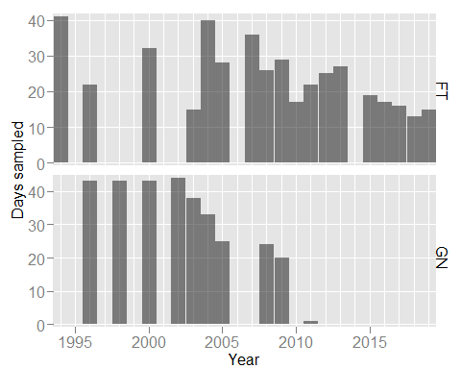

#### Hours Fished

We calculated average hours fished (±SD) given available effort data (figure below). Since roughly 2000, concerns over ESA catch limited fishing fyke traps (FT) to no more than 24 hours between checks. On average, gill nets (GN) fished between 30 and 55 minutes per set (0.5 to 0.9 hours).

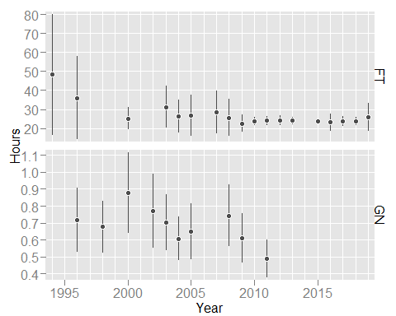

## Catch

Up unitl 2000 and for years when both gear types were fished, gill net (GN) contribution to total tagged was between 60% and 80% (figure below, top panel). As a general trend, the annual number of Striped Bass tagged declined.

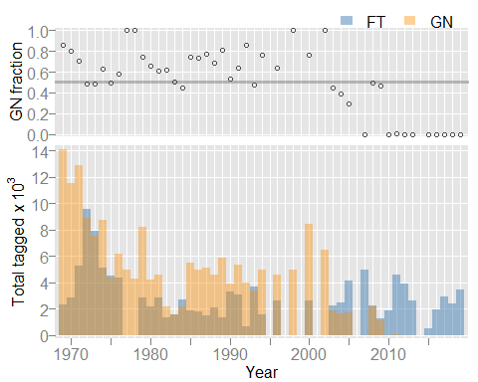

#### Sex Ratio

We assigned sex based on the presence (♂) or absence (♀) of milt. We calculated sex ratio as a fration of total caught (including unassigned; figure below). This is by no means a comprehensive look at sex ratio and more in-depth analyses are required, but it does demonstrate some shift over time. *Note*: n=17 Striped Bass for 2011 Gill net operations (one day of sampling).

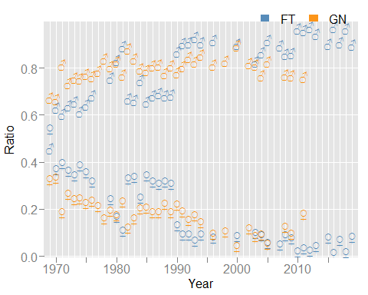

## Tag Returns

A major component of this mark-recapture study is angler tag returns. Every angler who returns a disc tag receives a commendation card and reward (separately and if applicable). A commendation card thanks the angler for contributing to the “betterment of fishing in California” and provides a bit of information about the fish (e.g., date and location tagged).

We tend to process angler tag returns in batches (i.e., several to half dozen at a time). Rewards are paid within six to eight weeks of processing. Total annual payments vary but for the last 10 years mostly have been between $1,000 and $2,000 (table below). Year represents period in which the tag was processed, not return or release year.

*Note1*: We only have tag processing data-time from ~October 2011 to present. Tags prior to which were processed but have no associated date-time stamp.

*Note2*: Data for 2011 may not include all tags processed that year.

*Note3*: We are still processing tags returned in 2020.

|  |  |  |  |  |  |
| --- | --- | --- | --- | --- | --- |
|  | $10 | $20 | $50 | $100 | Payment |
| 2011 | 0 | 5 | 2 | 6 | $ 800 |
| 2012 | 1 | 7 | 13 | 15 | $ 2,300 |
| 2013 | 0 | 12 | 10 | 14 | $ 2,140 |
| 2014 | 0 | 9 | 7 | 7 | $ 1,230 |
| 2015 | 0 | 3 | 5 | 8 | $ 1,110 |
| 2016 | 0 | 0 | 1 | 1 | $ 150 |
| 2017 | 0 | 5 | 12 | 7 | $ 1,400 |
| 2018 | 0 | 6 | 9 | 8 | $ 1,370 |
| 2019 | 0 | 4 | 9 | 7 | $ 1,230 |
| 2020 | 0 | 1 | 1 | 1 | $ 170 |

We classify tag returns based on a tag’s time at large. That is, a tag returned within a year of release (i.e., tagging) is a first-year return, a tag returned between one and two years of release is a second-year return, and so on. Primarly, we use first-year and second-year returns for some metrics to mitigate against bias (e.g., angler didn’t report or recall capture date; angler returned the tag many years after capture).

We calculate return rate simply by dividing number returned by number released. Below, we display first-year non-reward return rate. Here we do not correct for non-response — a process that uses reward return rates — but the trend is markedly downward over the study’s history.

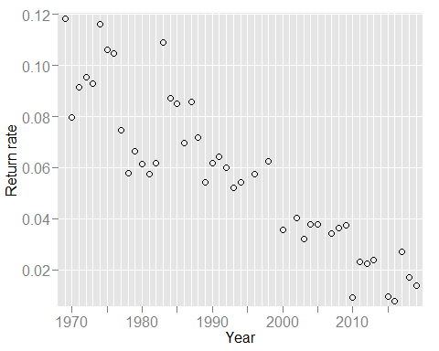

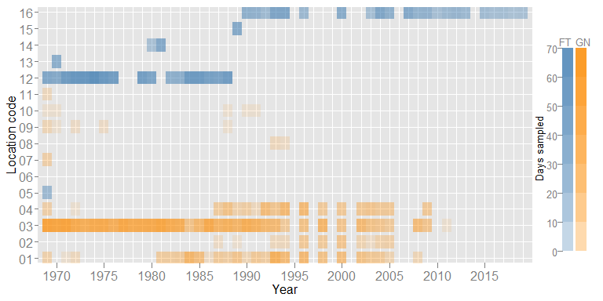

1. 1
2. 1
3. 1