2009年深圳市初中毕业生学业考试英语试卷
说明：
- 答题前，请将姓名、考生号、考场、试室号和座位号用规定的笔写在答题卡制定的位置上，将条形码粘贴好。
- 全卷分二部分，第一部分为选择题，第二部分为非选择题，共8页，考试时间90分钟，满分85分。
- 本卷试题，考生必须在答题卡上按规定作答；凡在试卷、草稿纸上作答的，其答案一律无效。答题卡必须保持清洁，不能折叠。
- 本卷选择题1-60，每小题选出答案后，用2B铅笔将答题卡选择题答题区内对应题目的答案标号涂黑，如需改动，用橡皮擦干净后，再选涂其它答案；非选择题61-71，答案必须用规定的笔，按作答题目的序号，写在答题卡非选择题答题区内。
- 考试结束，请将本试卷和答题卡一并交回。

第一部分 选择题 （60分）

I. 选择填空（15分）
从下面每小题的A、B、C、D四个选项中选出最佳选项，在答题卡选择题答题区将相应的字母编号涂黑。（共15小题，每小题1分）
1．---Hou do you go to________work?
--I ususlly take_________bus.
A．the,a B．/, a C. a, a D．the,／
2．---Two ________died in the accident．
--_________terrible it is!
A．policemen，How B.policeman,What C.police,What D.policemans,How
3．---Which would you like ,tea or coffee?
---Either______OK,but I prefer coffee_______milk.
A．is，has B。are,with C. is,with D．are，has
4．---Arthur is responsible_______the newspaper,isn’t he?
---___________,but Joyce is．She's the chief editor．
A．of．．．Yes，he isn't B. for．．．Yes，he is
C.of．．．No,he is D．for…No he isn’t
5.---The cake looks__________.
---Yes，and it tastes even________.
A．well，good B.nice，better C．good, worse D．better,best
6．---Do you know the boy_________is sitting next to Peter?
---Yes．He is Peter’s friend．They are celebrating this______birthday.
A.who,ninth B.that,nineth C,/, nineth D.which,ninth
7.---_______late for school again,Tim!
---Sorry, I promise that I_________.
A．Don’t，won’t B.Don't be,won’t C. Don’t he,don't D．Don’t, will
8.---_________is the library from our school?
---It’s quite near, Just go_____the road.
A．How far,cross B．How long，across C.How far,across D.How long,cross
9.---Dad．why should I stop__________computer games?
---For your health, my boy,I’m afraid you_________.
A．to play,must B。playing,have to C．to play,can D.playing,may
10．---I phoned you at six last night , but______answered.
---I _________a walk in the park at that time．
A．no one,was having B．anyone，was having
C.nobody,had D.somebody,had
11.---Could you tell me________?He is wanted by the head teacher．
---Sorry, I’ve no idea．But he________here just now．
A. where Tim was, was B．where is Tim，was
C. where Tim is，was D．where Tim is，is
12.---It’s raining, Daisy．Please________an umbrella with you.
---Thanks. I’ll return it to you when I______next week．
A．take, come B．take,will come C. bring，come D．bring,will come
13．---___________that new bike over there?
---I think it’s________.
A．Who’s, Sam B．Who’s, Sam’s C. Whose is，Sam D．Whose is，Sam’s
14. ---How about _______in the river with us?
—Sorry I can’t．My parents often tell me_________that．
A．swim, don’t do B. swim,to do
C.swimming,not do D．swimming, not to do
15．—David, turn off the TV________no one is watching it．
—But it_______off already！The music is from the radio．
A.so that , has been turned B．when．has turned
C．if．has been turned D．because, has turned

II. 完型填空(10分)
阅读下面短文。从短文屠每小题所给的A、B、C、D匹个选项中选出最佳选项，在答题卡选择题答题区将相应的字母缠号涂黑。(共10小题，。每小题1分)
John，11 years old,was in bed in hospital．Several days before,while he was __16__in a baseball game, he fell and hit his head．The doctors believed that he might __17__get well.
“He seems to have given up hope. So medicines alone won’t __18__.Perhaps he needs something else,”said a doctor.“When I visit him,all he ever says is that he would like to meet Babe Ruth．”
To meet Babe Ruth，of course,was not __19__．In America,Babe Ruth was as __20__a man as the President himself,and he was the most famous baseball player．
The next day John’s father managed to tell Babe Ruth about the story of his son on the phone.Twenty-four hours later, as the boy __21__ in his hospital room,in walked __22__.Young John could hardlt believe his own eyes!
The great baseball player sat down at Jobn’s bedside,sang， “Now,listen，kid,you’ve got to get well. I’ve brought you a new American League baseball，__23___you must start throwing it．”
For John this was the beginning of a new life．__24__his doctors’surprise ,the boy walked out of the hospital on his own a few weeks later. How was able to live a healthy life---all because of the___25__ of Babe Ruth．
16. A．looking B．playing C.taking D．sitting
17．A.never B.ever C．always D．certainly
18．A．fit B．make C．go D．do
19．A.easy B．1ucky C .difficult D．successful
20．A.strong B.important C．kind D。clever
21．A.waited B．1ied C.prepared D.lay
22．A.his father B．his doctor C．Babe Ruth D.the president
23．A．though B．because C．or D.so
24.A.In B．To C At D．For
25. A.story B．basketball C.present D．1ife

III. 阅读理解（35分）
i. 阅读下列短文，从下面每小题的A、B、C、D四个选项中选出最佳选项，在答题卡选择题答题区将相应的字母编号涂黑。（共25小题，每小题1分）

A
A professor from New York University once went to a remote area to do some science research. One day, he ate something wrong and became sick, but it was too far to go back to the city. “I have to see a doctor,”he said to a local.”How can I be sure of getting a good one?”
“It’s easy,”was the reply. “Every time a doctor loses a patient, it’s our law that he must fly a balloon above his office.”
So he began his search. One doctor flew 20 balloons,another 30. Then the professor found an office that was flying only five, and went in.
“You have to wait. I’ve been very busy,”the young doctor told him. “I started my business only yesterday.”
26. The proffessor was from _______.
A. Australia B. Britain C. Japan D. America
27. The word “remote”in the first sentence means _________.
A. 遥远的 B. 繁华的 C. 附近的 D. 城市的
28. He wanted to find a doctor because _________.
A. he wanted to do science research B. he wanted to fly a balloon
C. he wanted to speak to a local D. he became sick
29. The young doctor was the ______ doctor the professor found.
A. first B. second C. third D. fourth
30. Which of the following statements is true according to the passage?
A. The professor went to the remote area to see a doctor.
B. The doctor who had five balloons was the best one.
C. The doctor had five balloons because he had lost five patients.
D. The local told the professor to see the doctor with five balloons.

B
At the shopping mall，you probably think about spending, not saving．Think about all the lights that keep the mall bright．Think about all the water faucets(水龙头)in the toilet。Think about all the air conditioning in summer．Saving energy is a hot topic for such a big place!
Many things at the mall use energy．Electric lights，infrared(红外感应)faucets and air-conditioners need electrieity to work．One way to save energy is by keeping lights clean．More and more dust and dirt make the lights less bright．When malls keep lights clean, they can use fewer lights and keep the area just as bright ,Using fewer lights means using less energy.
You step up to the water faucet．The water starts to flow．You don't have to touch a thing．Why do malls have such fancy faucets?．The answer is simple．They save water．Sometimes people forget to turn the water off after they wash．Infrared faucets turn themselves off.
The……
31．________is a hot topic for a big mall．
A．To spend money B. To save energy
C．To keep the mall bright D．To buy things
32. Malls use infrared faucets mainly because________
A．they save water B.they are fancy
C. they are simple D.they turn themselves off
33．Which of the following cannot save energy?
A．Using fewer lights． B.Using infrared faucets．
C．Using air-conditioners D．Keeping lights clean．
34．What will the fourth paragraph probably talk about?
A. How to save water when using infrared faucets in the mall
B．How to save energy when using air-conditioners in the mall
C. How to save money when shopping in the mall．
D．How to spend money when shopping in the mall．
35．The best title for the passage is_________
A．Lights, faucets and air-eonditioners B．Spending less money
C. Energy saving at the mall D．A hot topic

C
One of the most famom scientists to study adaptations(适应能力)was Charles Darwin(达尔文)．He was born in England in 1809．He wasn’t the best student in his school,but when he was 16,his father sent him to a medical school． Charles liked spending time outdoors observing(观察)nature more than attending medical calsses．He dropped out without graduating．
Next, Charles’father sent him to school to become a minister（牧师）.This time he made it to graduation, But he didn’t want to do the work of a minister. His friends encouraged him to follow his interest in science．
After graduation,Charles was invited to sail on the Beagle as an unpaid scientist．He wasn’t the first choice．but he was the lucky one to go．The Beagle was to travel to Soulth America and then around the world．The crew’s task was to make maps of the places they visited.
On December 27th ,1831. Charles Darwin sailed from England on the Beagle。The trip was planned to last two years。In fact,it lasted five．During this time,he saw many amazing things．He collected lots of plants and animals and took them back to England to study．
Twenty-three years later , Darwin published an scientific paper with another man named Wallace．Darwin described how some animals have adaptations that help them survive. They are passed on to，offspring (后代)．Darwin’s ideas about adaptatioms to the study of living things．
36．Darwin was very interested in____________.
A．attending medical classes B. the work of a minister
C．sailing around the world D．science
37．The Beagle was a(an)___________．
A．ship B．plane C plant D-animal
38．When Darwin pubished the scientific paper, he was_____years old.
A.twenty-three B．twenty-two C．forty-five D．fifty
39. The underlined word “they” in the last paragraph refers to(指的是)_________.
A．adaptations B．Darwin and Wallace C.animals D．Darwin's ideas
40．Which of the following is true?
A.Darwin graduated from a medical school．
B．Some animals have adaptations so that they can survive.
C．Darwin imblislaeda seielatifiellll~rbyhimself．
D．Darwin was first chosen to sail on the Beagle。

D
Having Fun "Growing” and“Stealing”？
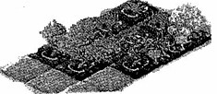 Recently,an Internet game has become a new fashion among young office workers and students．People can “farm” on a piece of “land” and“grow'’， “sell” or even“steal” “vegetables”.“flowers”．and‘'fruits"on the Net , They can earn some e-money and buy more “seeds”.“pets”and even “houses"．
Joyce interviewed some young people．Here are their opinions．
Harold：I don't quite understndd why they are so mad about the childish game, Maybe they are just not confident enough to face the real world.
Allan：I enjoy putting some "bugs” in my friends’ gardens and we’ve become closer because of the game．Having fun together is the most exciting thing about it．
Laura：You know, people in the city are longing for(渴望) the life in the ceotmtryside．It reduces my work pressure(压力)；besides, it gives me the exciting exoerince of being a “thief”．
Ivy： Well. it’s just a waste of time．Teenagers playing the game spend so many hours on it that they can not focus on (专注于)their study.
41．Aeeording to the passage, people can’t _______things in this game.
A．grow B. borrow C. steal D．sell
42．Among the people Joyce interviewed,______ likes the game while____dislikes the game.
A. Laura, Allan B．Allan，Harold C．Harold,Ivy D.Ivy, Allan
43. From Laura’s words．we can guess that she’s most probably _________.
A. a student B．an office worker C.a farmer D.a thief
44．Which is NOT the reason why people like the game?
A. They are longing for country life．
B．They can have fun with friends．
C. The game can relax people and give them a new experience．
D．They are confident enough to face the real world．
45. Where can you find this passage?
A. In a car magazinc． B．In an advenisement．
C．In a newspaper D-In a science book

E
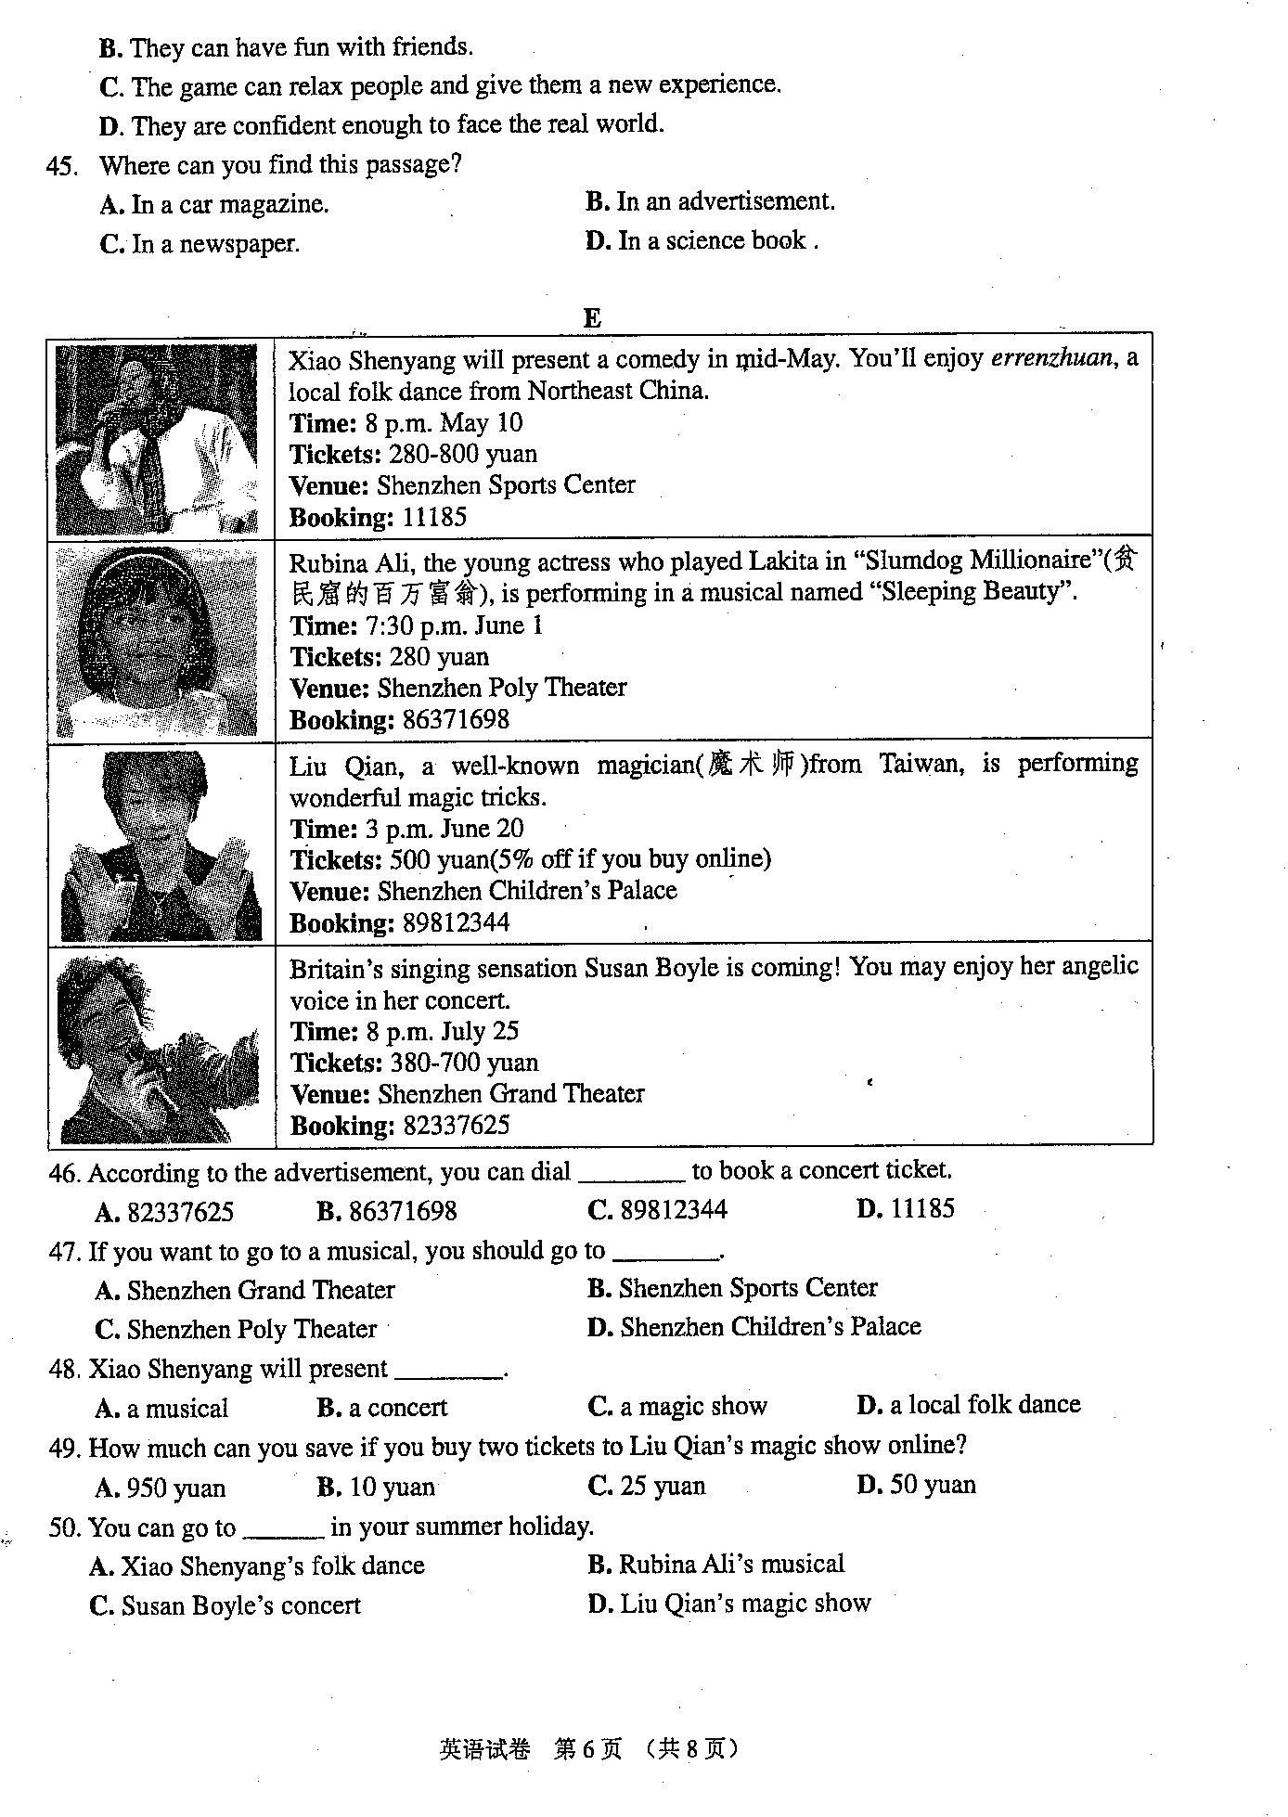
46. Acoording to the advertisement, you can dial _______ to book a concert ticket.
A. 82337625 B. 86371698 C. 89812344 D. 11185
47. If you want to go to a musical, you should go to _______.
A. Shenzhen Grand Theater B. Shenzhen Sports Center
C. Shenzhen Poly Theater D. Shenzhen Children’s Palace
48. Xiao Shenyang will present _________.
A. a musical B. a concert C. a magic show D. a local folk dance
49. How much can you save if you buy two tickets to Liu Qian’s magic show online?
A. 950 yuan B. 10 yuan C. 25 yuan D. 50 yuan
50. You can go to ______ in your summer holiday.
A. Xiao Shenyang’s folk dance B. Rubina Ali’s musical
C. Susan boyle’s concert D. Liu Qian’s magic show

ii，选择下列词汇或短语完成下面对话。并在答题卡上将相应的字母编号涂黑．(共5小题)
A. go shopping B. received C. attend D. idea E. sooner F. miss

Nina： Are you going to Jane’s birthday party, Wendy?

Wendy：Yes．I______(51)her invitation yesterday .Are you going tomorrow,Nina?
Nina： Yes，of course．I wouldn’t_________(52)her birthday party party for anything.
Wendy：Could you tell me what I should take as a birlthday present?
Nina： I was going to ask the same question．
Wendy：We must hurry．The________(53)，the better.
Nina： I can’t agree more．Well，I’ll tell you what．Let's_______(54) together right now and pick out what she may like．
Wendy：Good________(55)!

iii．选择下列句子完成下面对话。并在答题卡上将相应的字母编号涂黑。(共5小题)

A. I’ll watch it.
B. What are you doing?
C. I’d rather watch some other programs.
D. Don’t worry.
E. How was your science exam?
F. Which teams are playing?
G. Is there a football match on TV tonight?
Richard：Hi,Simon_________(56)
Simon：Not too good．
Richard：Well,the term exam is always more difficult．______(57)You’ll certainly do better next time
Simon： But unluckily, I've never done well in the science exam.
Richard: Come on, Simon! Let's talk about the football match tonight . It is much more interesting．
Simon： __________ (58)
Richard：Yes．It’s between the Chinese team and the Japanese Team.
Simon：Er … _________ (59)
Richard：Why?Everybody knows you are a football fan．
Simon：The Chinese team has always plyed badly in the important matches, just as I have done in the important exams.
Richard: Well，I think the team is making good progress_______(60)

Ⅳ. 解释句子(10分)
根据自己的理解，用已学过的英语解释下列句子。必颏将答案写在答题卡非选择题答题区相应的序号内。(共5小题，每小题2分)
要求：对画线部分做重点解释，写出的句子必须是对原句全句的解释，必须是完整的句子。
61．Long time no see．
62．People make fun of others on April Fool’s Day．
63．This book is less interesting than that one.
64．How do you like the song?
65. The meeting came to an end at 7 o'clock．

V. 书面表达(t5分)
必须将答案写在答题卡背面非选择题答题区相应的序号内•(共6小题)
请你根据某学校的一个广播通知，填写下面的海报。(共5小题，每小题1分)
May I have your attention, please? I have an announcement to make．
Since the A/H1Nl flu is around us, we should pay great attention to our health and get some knowledge about the terrible disease．Our school has invited Doctor Li to give us a talk about how to prevent(预防)the flu．It will start at 4：00 on Friday aftemoon in our school lecture hall. Students in Grade Seven are required to attend the talk．Please be there on time．
That’s all．Thank you.
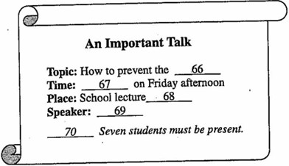

71．假设你是Doctor Li，请你用英文写一篇发言稿，从作息、饮食、运动、卫生习惯等方面谈谈如何预防甲型H1N1流感。(共1题，10分)
要求： 1)包含至少3点建议；
2)条理清楚，意思连贯，语句通顺．标点正确；
3)发言稿中不得出现真实的校名和姓名。
4)60－80个单词；发言稿的开头和结尾已经给出，不计入总词数。
How to Defend the H1N1 Swine Flu Virus
Ladies and gentlemen:
Hello,everyone, I’m Doctor Li, The Swine Flu virus,detected in Mexico is the H1N1 Swine Flu Virus strain that has killed more than 152 people in Mexico.

_______________________________________________________________________________
_______________________________________________________________________________
_______________________________________________________________________________
_______________________________________________________________________________
_______________________________________________________________________________
_______________________________________________________________________________
_______________________________________________________________________________

Doctor Li

参考答案

1－5 BACDB
6－10 ABCBA
11－15 CADDC
16-20 BADAB
21-25 DCDBC
26-30 DADCC
31-35 BACBC
36-40 DACAB
41-45 BBBDD
46-50 AADDC
51-55 BFEAD
56-60 EDGCA
Ⅳ、61.It’s a long time since we met last time.
62.People play tvicks on others on April Fool’s Day.
63.That book is more interesting than this one.
64.What do you think of the song.
65.The meeting ended at 7 o’clock

Ⅵ、 A/H1N1 flu; 4:00; hall; Doctor Li; Grade

71、
How to Defend the H1N1 Swine Flu Virus
Ladies and gentlemen:
Hello,everyone, I’m Doctor Li, The Swine Flu virus,detected in Mexico is the H1N1 Swine Flu Virus strain that has killed more than 152 people in Mexico.
But how to defend the H1N1 Swine Flu virus? We has been urging citizens increase in body temperature,headaches muscular pains and breathing problems to visit their nearest medical center as soon as possible, Then the city has been giving out face masks on public transport.and we should usually wash hands, ensure sufficient sleep, and moderate exercise will benefit you. I wish you all keep healthy.
Doctor Li

