中考真题训练（ 2010深圳市中考）
学生姓名
第一部分 选择题（60分）
- 选择填空
- —________ apple a day keeps the doctor away!
—What do you mean? I have never heard of ________ saying before.
- An, a B. An, the C. A, the D. A, a
- —What ________ you usually have for breakfast?
—________ and a cup of coffee.
- do, Three bread B. do, Three pieces of bread
C. are, Three breads D. are, Three piece of bread
3. —Your bag looks the same ________ mine.
—Oh, really? It’s a gift ________ my father.
- with, to B. with, from C. as, on D. as, from
4. —The weather report says there is going to ________ a typhoon tonight.
—So we had better ________ out.
- be, not go B. have, not go C. be, not to go D. have, not to go
5. —________ people are taking action to protect the environment now.
—Yes. ________ of my classmates come to school by bike now.
- More and more, Four fifth B. Less and less, Four fifth
C. More and more, Four fifths D. Less and less, Four fifths
6. —Mary, would you like to ________ this game?
—I’d love to, but I have to finish ________ the composition first.
- join in, to write B. attend, writing C. join, to write D. take part in, writing
- —The number of the students in our class ______ fifty-six.
—How many of ______ are girls?
- is, them B. are, them C. is, they D. are, they
- —Is Mr. Smith in his office now?
—No, he _______ there. I _______him in the library a minute ago.
- may be, saw B. can’t be, see C. mustn’t be, see D. can’t be, saw
- —________ is your opinion on the film “Avatar”?
—It’s amazing! I was ________ moved.
- What, deep B. How, deep C. What, deeply D. How, deeply
10. —Do you know _________ buy the book Harry Potter?
—The book is ________ popular that you can buy it at any bookshop.
- where can I, so B. where can I, such C. where I can, so D. where I can, such
- —Paper ______ wood. We should not waste paper.
—I agree. I always use ______ sides of paper.
- is made of, either B. is made from, both C. makes of, both D. makes from, either
- —Have you ever ______ Australia?
—Yes, I have. It’s really interesting _______ with kangaroos.
- been to, to play B. gone to, played C. been to, play D. gone to, playing
- —Let’s go to the zoo by taxi, ________?
—Maybe we can go there _________. It’s not far.
- won’t you, on foot B. won’t you, by foot C. shall we, by foot D. shall we, on foot
14. —Can you help me ________ my cat while I am away?
—No problem. Just bring it to my house _______ you leave.
- look after, before B. look for, until C. take care of, since D. take off, after
- —I am sorry for being late.
—________
- That’s right. B. You are welcome. C. It doesn’t matter. D. You should be sorry.
- 完形填空（10分）
Some inventions are very important. For example, the telephone allows people to communicate all over the world. The ____16____ lets people travel long distances in a short time. Life is much easier with these ____17____ inventions.
Some inventions are just fun. A company in Japan has invented ____18____ flowers. You can listen to music that comes through real flowers. Customers in restaurants can smell the beautiful roses ____19____ listen to pleasant music while eating. People in the dentist’s office can look at pretty lilies and listen to Mozart while having their ____20____ examined!
There is now a vehicle that gets you around with almost no effort ____21____. In fact, you drive this invention while standing on it! This vehicle runs by electricity. It ____22____ quite easily. When you lean forward, it moves forward, and when you lean ____23____, it moves backward!
A new kind of bubble liquid has been invented. If you blow bubbles ____24____ this liquid, they can last for several minutes! ____25____ are very strong. You can even pick them up and throw them around!
Do you have your own ideas about inventions now?
16. A. bike B. bus C. ship D. plane
17. A. important B. useless C. boring D. strange
18. A. dancing B. talking C. singing D. walking
19. A. but B. so C. nor D. and
20. A. ears B. eyes C. teeth D. nose
21. A. in all B. at all C. after all D. for all
22. A. carries B. makes C. works D. plays
23. A. forward B. backward C. towards D. afterwards
24. A. about B. at C. with D. for
25. A. They B. We C. You D. None
- 阅读理解（35分）
i. 阅读下列短文，从下面每小题的A、B、C、D四个选项中选择最佳选项。（共25小题，每小题1分）
A.
On a hot summer day, Holmes and Dr. Watson went on a camping trip. After a good meal and a bottle of wine, they lay down in a tent for the night and went to sleep.
Some hours later, Holmes woke up and pushed his friend. “Watson, look! What can you see in the sky?"
Watson replied, “I see millions and millions of stars.”
“What does that tell you?” asked Holmes.
Watson thought for a while. “First, it tells me that we will have a beautiful clear date tomorrow. Second, it tells me that the time is about twelve o’clock. And…”
“What else?” Holmes asked.
“Well, it also reminds me that the world is so big and we are so small. What does that tell you?”
Holmes said with a grin on his face, “You silly guy! It only tells me that someone has stolen our tent!”
26. One day, Holmes and Dr. Watson went ________.
A. swimming B. camping C. hiking D. rock-climbing
27. Holmes woke up ________.
A. in the middle of the night B. early in the morning
C. soon after he fell asleep D. after Watson pushed him
28. Watson thought of at least ________ things after he saw the stars.
A. two B. three C. four D. five
29. When Holmes saw the stars in the sky, he realized that ________.
A. it would be a beautiful clear day B. it was about twelve o’clock
C. the world was so big and they were so small D. someone had stolen their tent
30. Which of the following statements is TRUE according to the passage?
A. The story happened in the afternoon.
B. They had some wine before they went to sleep.
C. Holmes asked Watson questions because Holmes didn’t know what happened.
D. Holmes thought Watson was clever.
B
Venice  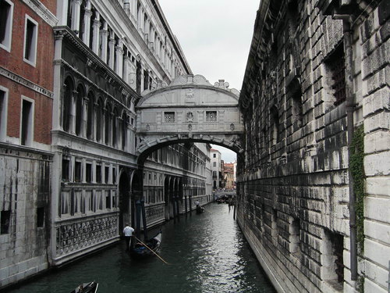 | Venice is in the northeast of Italy. It was built on small islands in saltwater lakes more than 1,500 years ago. Venice is a city with no cars and people travel by boat. There are 117 waterways and more than 400 bridges that can guide you where you want to go.
Auckland  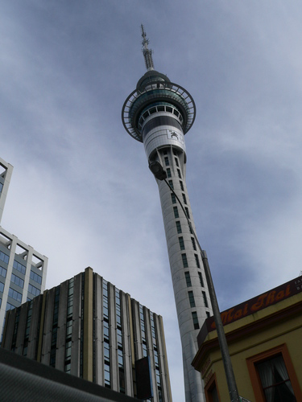 | Auckland is the largest city in New Zealand. In the seaside city, you can enjoy an amazing view from the city’s tallest tower—the Sky Tower. You can also see Maori traditional dances at the Auckland Museum. Auckland is called “The city of Sails” because it has more boats than anywhere else in the world.
Los Angeles  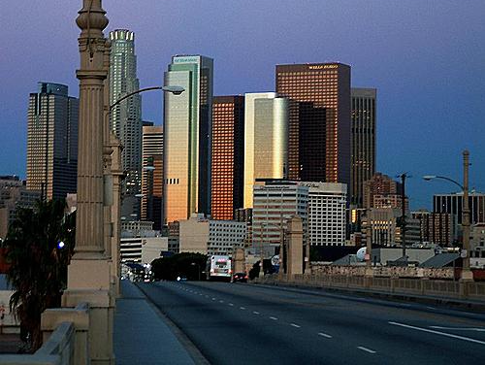 | Los Angeles was founded in 1781. It is now the second largest city in the United States. It is Famous for its modern highways and its movie stars of Hollywood. There are many beautiful beaches near the city.
Budapest  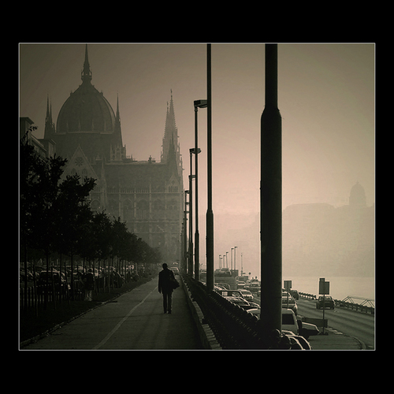 | The population of Budapest is about three million and the city is a very popular place for tourists. Visitors like to take boat rides along the Danube（多瑙河）. Budapest is also known for its exciting nightlife. The best time to visit Budapest is summer since it is very cold in winter.
31. People mostly travel ________ in Venice.
A. by ship B. by car C. by bus D. by boat
32. Which of the following is NOT mentioned about Auckland?
A. Modern highways. B. The Sky Tower
C. Maori traditional dances D. A lot of boats
33. Los Angeles has a history of ________.
A. more than 100 years B. more than 200 years
C. more than 300 years D. more than 400 years
34. If Mary wants to visit Budapest, the best season for her to go is ________.
A. spring B. summer C. autumn D. winter
35. The four cities are all ________ according to the passage.
A. modern cities with a short history B. in New Zealand
C. near lakes, rivers or seas D. large cities
C
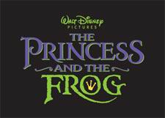
“The Princess and the Frog” is a warm and enjoyable cartoon by Disney. It tells the story about a girl who makes her dreams come true through hard work.
Tiana is a waitress. She has a dream of owning a restaurant. In order to realize the dream, she works hard. She knows that it is useless to wish on a star. She never sits in a castle waiting for a prince to come and save her. Tiana’s plans for success go wrong when she meets a talking frog. The frog happens to be a prince named Naveen. Hoping to become human again, Naveen regards Tiana as a princess by mistake. He tells her to kiss him. Then something worse happens. Tiana turns into a frog, too. Together they look for a way to become human again.
The story is easy enough for kids to understand and it provides us with beautiful hand-drawn pictures, songs and music. Besides, there’s a great lesson here: you should look for a way to make your dream come true. If there is any problem with the movie, it’s only that it doesn’t feel as splendid as some of Disney’s other films.
36. The writer introduces ________ to us in this passage.
A. song B. a Hollywood action movie C. a cartoon by Disney D. a historical story
37. Tiana’s dream is to ________.
A. kiss a frog B. own a restaurant C. sit in a castle D. find a prince
38. The lesson we can learn from “The Princess and the Frog” is that _______.
A. we should not kiss a frog B. we should believe ourselves
C. wishing on a star will be helpful D. we should look for a way to make our dream come true.
39. “The Princess and the Frog” is ________.
A. short of beautiful pictures, songs and music B. as splendid as some of Disney’s other films
C. too difficult to understand D. educational
40. You can probably find this article ________.
A. in a science book B. in a dictionary C. in a newspaper D. in a traveler’s guide
D
The opening ceremony of the 2010 Shanghai World Expo was held at 8:10p.m. on April 30th. The Expo is first hosted by a developing country. It is also the first time that cities participate（参加）in a World Expo independently. A total of 14 cities around the world have their own pavilions（展馆）. Shenzhen is one of the cities and it has taken the chance to show ideas of city development.
Shenzhen’s pavilion costs 30 million yuan. It is a two-floor project. Shenzhen shows films, photos, 16 paintings by Dafen artists, and multimedia installations （多媒体设施）in its pavilion. All these tell the story of Dafen Oil Painting Village from a small village into an art industry base.
Visitors to the pavilion are welcomed by 12 young volunteers from Shenzhen. They can speak both English and Chinese very well. The volunteers receive thousands of visitors each day.
One of the walls in the Shenzhen pavilion is decorated with thousands of postcards. Visitors can write down their dreams and wishes on the cards. Visitors are all interested in the exhibition. A Shanghai visitor wrote, “Through the changes of Dafen Village, I feel the city’s energy and see the hope of our country.”
41. The Expo is first hosted by _______.
A. a developed country B. a developing country C. a rich country D. a small country
42. Shenzhen wants to show visitors _______.
A. its scenic spot B. its delicious food C. ideas of city developmen D. its industry
43. Shenzhen shows ________ in its pavilion.
A. paintings, films, photos and multimedia installations B. industry, films, artists and multimedia installations
C. artists, industry, photos and volunteers D. artists, films, volunteers and paintings
44. The volunteers from Shenzhen can speak ________.
A. English and Cantonese B. Chinese and Cantonese
C. English and French D. English and Chinese
45. Visitors to the Shenzhen Pavilion ________.
A. don’t like the Shenzhen Pavilion B. can sing and dance in the Shenzhen Pavilion
C. can only watch the exhibition D. are fond of the Shenzhen Pavilion
E
Looking for a children’s book? Internet users can find hundreds of them. These books are from around the world. And they are free to readers. The United States has started a project called the International Children’s Digital Library. It is supported by the National Science Foundation, the Library of Congress and the institute of Museum and Library Services.
The goal of the project is to offer more than 10,000 children’s electronic books in at least 100 languages. Some of the books show the similarities and differences in ways of life around the world. They will enable children to have a better understanding of other people’s cultures. People working for this project have tried to design easy ways to search the collection and read the books. A picture of each page appears on the computer. Users can also print the pages on paper if they want to.
The project is for two main groups of users. The first group is children between the ages of three and thirteen, along with their teachers and parents. The second group is researchers of children’s literature（文学）. The books can help children understand more about the world.
46. The books in the project can make children better understand ________.
A. other people’s cultures B. their own culture
C. their teachers and parents D. researchers of children’s literature
47. In this project, the electronic books are ________.
A. expensive to readers B. from the U.S.A.
C. in different languages D. for children only
48. The underlined word “goal” probably means ________ in the passage.
A. 山羊 B. 煤炭 C. 进球得分 D. 目标
49. The third paragraph is mainly about ________.
A. the purpose of the project B. the users of the project
C. people working for the project D. museums and libraries
50. The best title of the passage is ________.
A. The International Children’s Digital Library B. How to Choose Books for Children
C. How to Search Books on the Internet D. Internet Users
ii. 选择下列词汇或短语完成下面对话。（共5小题，每小题1分）
A. music B. nervous C. advice D. because of E. happy F. fall
Tony: Good morning, Kevin! You look tired. What’s wrong?
Kevin: I couldn’t _________(51) asleep last night.
Tony: Why? Did you watch the World Cup last night?
Kevin: No, maybe it’s ________ (52) the coming final exam. I can’t sleep well before exams.
Tony: I think you are too ________(53) about exams. You should try to relax yourself.
Kevin: What should I do?
Tony: You can listen to some soft ________(54) before you go to bed. Or you can take a walk.
Kevin: Thanks for your ________(55). I will try it tonight.
Tony: You’re welcome.
iii. 选择下列句子完成下面的对话。（共5小题，每小题1分）
- What interesting places are you going to visit there?
- How are you going there?
- With my friends
- What are you going to do?
- Thank you!
- For about three weeks.
- I don’t like travelling.

Kate: Hello Alice
Alice: Hello, Kate.
Kate: The summer vacation is coming. ________(56)
Alice: I am planning to go on a summer camp to Canada. I want to improve my English.
Kate: That sounds great. ________(57)
Alice: I’d like to visit the Niagara Falls, CN Tower and some other places of interest.
Kate: Who will you go with?
Alice: ________(58)
Kate: How long will you stay there?
Alice: ________(59) We will be back at the end of July.
Kate: Have a good time!
Alice: ________(60)
第二部分（25分）
IV. 解释句子（10分）
根据自己的理解，用已学过的英语解释下列句子。必须将答案写在答题卡非选择题答题区相应的序号内。（共5小题，每小题2分）
要求：对划线部分做重点解释，写出的句子必须是对原句的全句的解释，必须是完整的句子。
61. What’s your address?
62. The waste water pollutes the river.
63. You must learn the new words by heart.
64. We can’t live if there is no air.
65. He has green fingers.
V. 书面表达（15分）必须将答案写在答题卡非选择题答题区相应的序号内。（共6小题）
请根据Amy和Bob的对话完成信息。（5小题，每小题1分）
Amy: Hi, Bob! What are you reading?
Bob: I am reading a book named “Success Stories.”
Amy: What is it about?
Bob: It’s about successful people. It records their success stories.
Amy: Is it written by a Chinese writer?
Bob: No. By an American writer in English.
Amy: What do you think of the book?
Bob: It is very good. The stories make a strong impression on me.
Amy: Oh, I am preparing for a talk about successful people. Can you lend me the book?
Bob: Sure.
Amy and Bob are talking about a 66 named “Success Stories”. It is written by an 67 . It is not written in Chinese but in 68 . The book contains success 69 of some people. The stories make a strong 70 on Bob.

71. 假如你们学校校报举行英语征文活动， 主题是“我心目中的成功人士”， 请你写一篇文章介绍一位你心目中的成功人士（可以使你身边熟悉的人或名人）。文章必须包含以下内容：1. 人物简介；2. 人物事迹；3. 给你的启发。（共1题，10分）
要求： 1）条理清楚，意思连贯，语句通顺，标点正确、逻辑清晰；
2）假如写的是你身边的人物，文中不能呢个出现真实的姓名和校名；
3）80词左右。

答案：
一． BBDAC DADCC BADAC
二． DACDC BCBCA
三． BABDB DABBC CBDDC BCADD ACDBA FDBAC DACFE
四． 61。 Where do you live? \ Where is your home\ house? \ What’s the location of your house?
62. The waste water makes the river dirty.
63. You must remember the new words. \ You must memorize the new words. \ You must keep the new words in mind.
64. We can’t live without water. \ We can’t live unless there is water.
65. He is good at planting. \ He does well in planting. \ He is good at planting.
五． 66。 book 67. American writer \ American 68. English 69. stories 70. impression

