SZL Holdings
X Launch Series — Plug & Play Playbook
April 2026 · Three threads · Governed Decision Infrastructure

Posting Schedule
Day | Thread | Tweets | Screenshots | Timing
Thursday | Intro — Who we are, what we built | 7 tweets | 2 images | 8am–12pm
Sunday | Deep Dive — The moat, the primitives | 8 tweets | 3 images | 9am–1pm
Monday | Screenshot Drop — Full platform tour | 13 tweets | 10 images | 8am–11am

Thursday — Intro Thread
Hook → Story → Proof → Close · 7 tweets · 2 screenshots · Confident founder voice

Screenshot Attachment Summary — Thursday
Tweet 2 → Attach: screenshots/thursday/01-szl-holdings-governed-infrastructure.jpg
Tweet 3 → Attach: screenshots/thursday/02-szl-holdings-platform-architecture.jpg

Thread Copy — Thursday
Tweet 1
We've been building quietly for 18 months.

Today we're showing you what we built.

SZL Holdings — governed decision infrastructure for enterprise operators.

One platform. Six domain packs. A single accountability loop.

Thread 🧵
231 characters
Tweet 2
Enterprise operations have a structural problem.

Dashboards show what happened.
AI copilots generate recommendations without accountability.
Decisions run in Slack threads — untracked, unattributed, unresolved.

When something goes wrong, no one can reconstruct the decision chain.

We built the layer that closes this gap.
324 characters
📎 Attach: screenshots/thursday/01-szl-holdings-governed-infrastructure.jpg
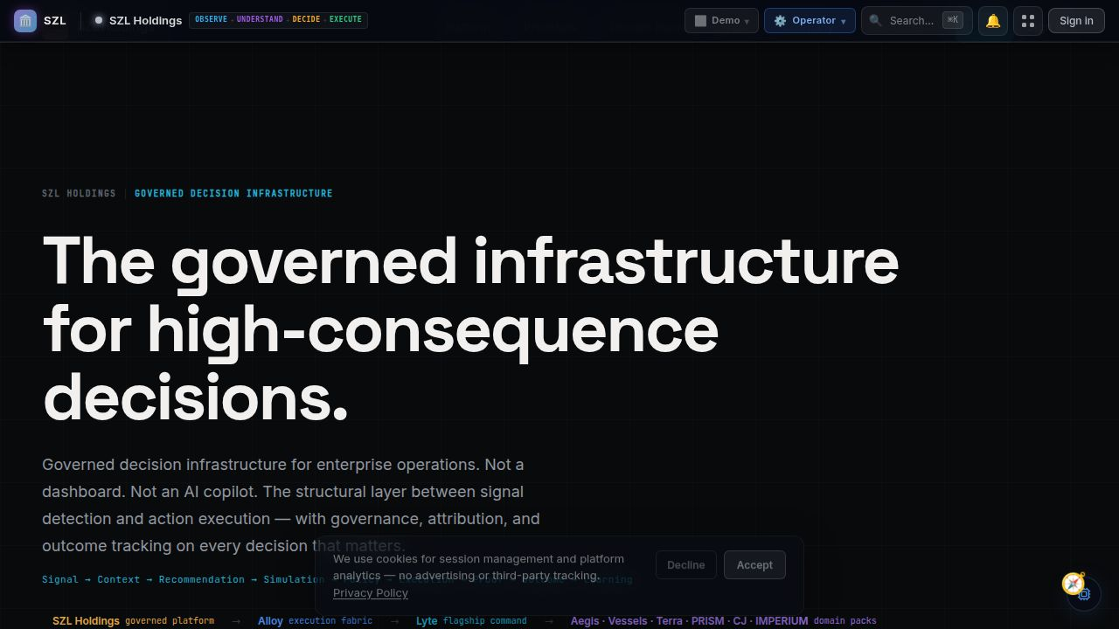
SZL Holdings — The governed infrastructure for high-consequence decisions
Tweet 3
The SZL platform is three layers:

→ Lyte — flagship operator command surface
→ Alloy — governance backbone (approval gates, audit trail)
→ Domain packs — Aegis, Vessels, Terra, PRISM Counsel, Carlota Jo, IMPERIUM

Every layer shares one governance model. One decision loop.

Signal → Context → Recommendation → Simulation → Policy → Execution → Proof → Outcome → Learning
372 characters
📎 Attach: screenshots/thursday/02-szl-holdings-platform-architecture.jpg
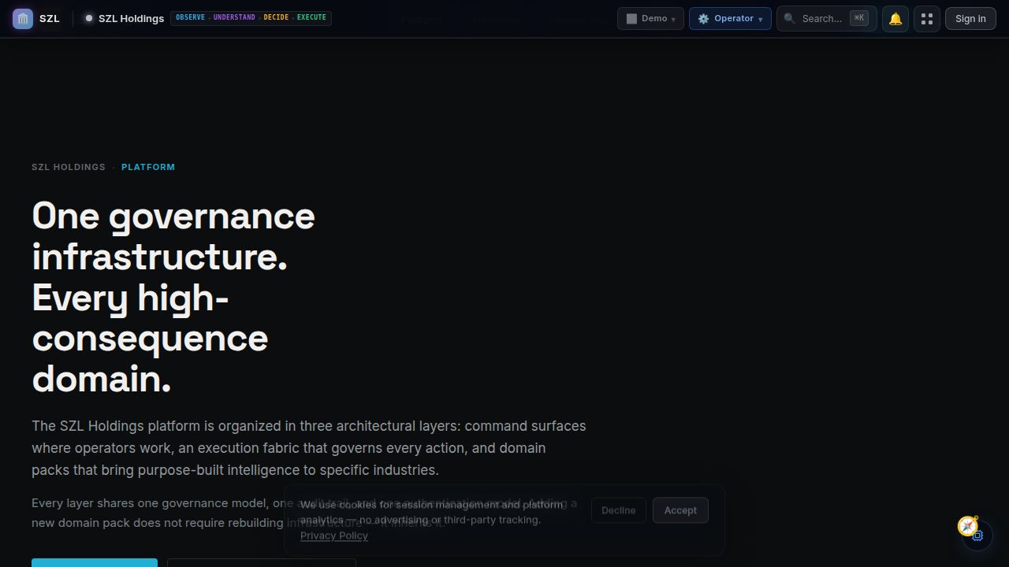
Platform architecture — one governance infrastructure, every high-consequence domain
Tweet 4
Six platform primitives make this structurally different from anything else:

1. Outcome Graph — closed-loop decision lifecycle tracking
2. Proof Chain — immutable audit trail on every AI output
3. Covenant Policy — enforced human-in-the-loop at the governance layer
4. Decision Simulation — probabilistic risk modeling before action
5. Workflow Engine — durable multi-step process orchestration
6. Event Fabric — cross-domain signal correlation

These run across every domain pack. Always.
490 characters
Tweet 5
Governance is not a feature. It's the architecture.

AI agents are advisory only — no consequential action without human approval.
Every recommendation carries source citations and confidence scores.
Every action is attributed to an actor.
Every outcome is recorded.

This is what makes it decision infrastructure — not a dashboard, not a copilot.
347 characters
Tweet 6
We built this across six operational domains:

🛡 Aegis — security & defense
⚓ Vessels — maritime fleet command
🏢 Terra — real estate intelligence
⚖️ PRISM Counsel — legal matter command
✦ Carlota Jo — private advisory
☁️ IMPERIUM — cloud sovereignty

All on the same infrastructure. All with the same governance model.

One alpha. Functional across every domain.
364 characters
Tweet 7
We are pre-seed and in design partner phase.

We are not looking for hype. We are looking for operators in security, maritime, real estate, or professional services who need a structured decision surface — not another dashboard.

If that's you: inquiries@szlholdings.com

Full platform tour drops Monday. 👇
307 characters

Sunday — Deep Dive Thread
The moat · The primitives · Anticipation build · 8 tweets · 3 screenshots

Screenshot Attachment Summary — Sunday
Tweet 4 → Attach: screenshots/sunday/01-command-unified-command-overview.jpg
Tweet 6 → Attach: screenshots/sunday/02-vessels-intelligence-layers.jpg
Tweet 7 → Attach: screenshots/sunday/03-carlota-jo-private-advisory.jpg

Thread Copy — Sunday
Tweet 1
Tomorrow we drop the full SZL Holdings platform tour.

Before that — the moat.

What makes governed decision infrastructure structurally defensible.

Thread 🧵
159 characters
Tweet 2
Most enterprise software solves the visibility problem.

Dashboards show what happened. Analytics explain it.

We solve the accountability problem.

Who made this decision? Based on what evidence? With what expected outcome? Was the action safe to take?

These are different questions. They require different infrastructure.
324 characters
Tweet 3
The accountability gap gets worse as AI adoption increases.

More recommendations. More automation. More decisions running in parallel — with no structured way to track who approved what, based on what evidence, with what expected outcome.

AI adoption without governance infrastructure is a liability waiting to materialize.
325 characters
Tweet 4
Our answer is the Unified Command layer.

Every domain pack — security, maritime, real estate, legal, advisory — connects through a single governed decision loop.

Operators work in their domain surface. Governance runs across all of them.

Cross-domain intelligence is possible because every signal shares the same Event Fabric.
329 characters
📎 Attach: screenshots/sunday/01-command-unified-command-overview.jpg
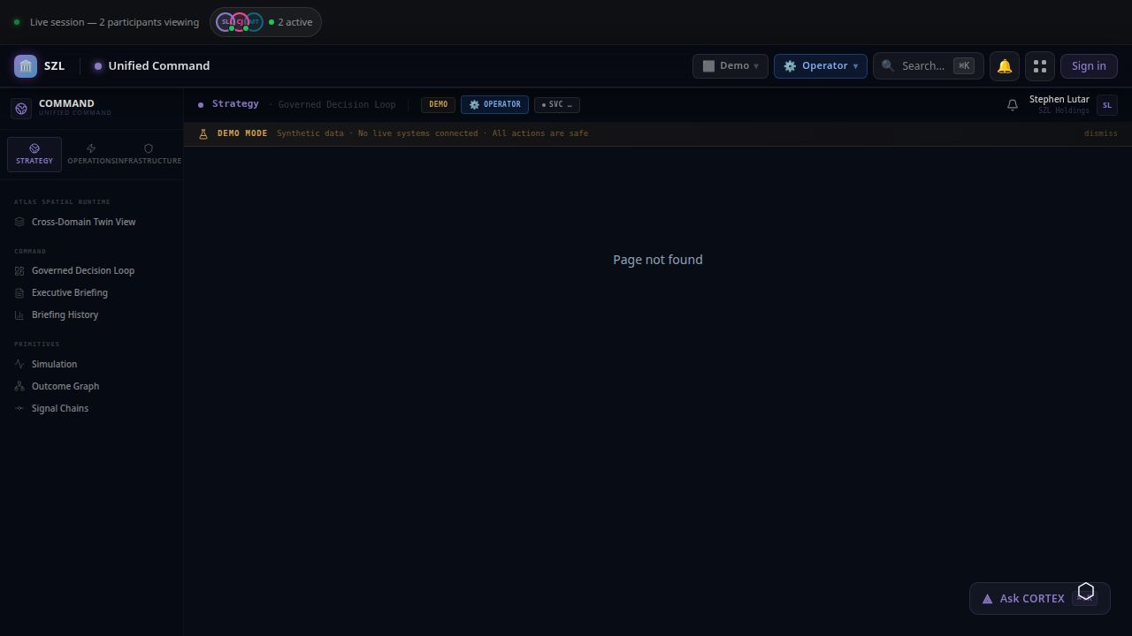
Unified Command — Governed Decision Loop, Simulation, Signal Chains, and Outcome Graph in one surface
Tweet 5
Pulse is the executive briefing layer.

Every morning, a multi-agent synthesis across all active signals — security posture, fleet exceptions, real estate portfolio movements, legal risk flags — distilled into one governed brief.

SZL-EXEC-RESTRICTED. Nuro Mesh v3.1. Multi-agent synthesis.

Not a report. A decision-ready intelligence document.
345 characters
Tweet 6
Domain depth is real.

Vessels covers the full maritime intelligence stack:
— Live AIS fleet map
— Dark vessel detection
— Signal monitoring
— Exception center with P&L impact
— ETA deviation alerts
— Sanctions screening
— Voyage P&L

All governed. All attributed. All audit-trailed.
283 characters
📎 Attach: screenshots/sunday/02-vessels-intelligence-layers.jpg
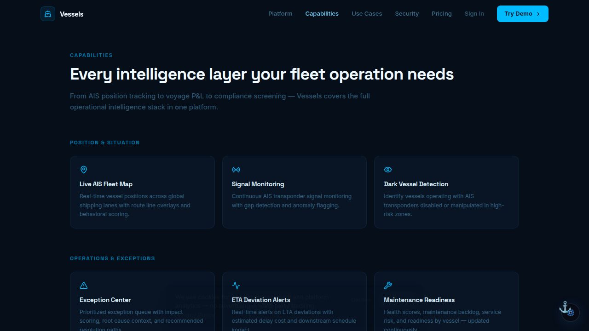
Vessels — Every intelligence layer your fleet operation needs
Tweet 7
And then there's Carlota Jo.

A private advisory practice — residence operations, household systems, lifestyle administration, estate transitions — built on the same governed infrastructure.

Different domain. Identical governance model.

That's the point of domain-pack extensibility.
285 characters
📎 Attach: screenshots/sunday/03-carlota-jo-private-advisory.jpg
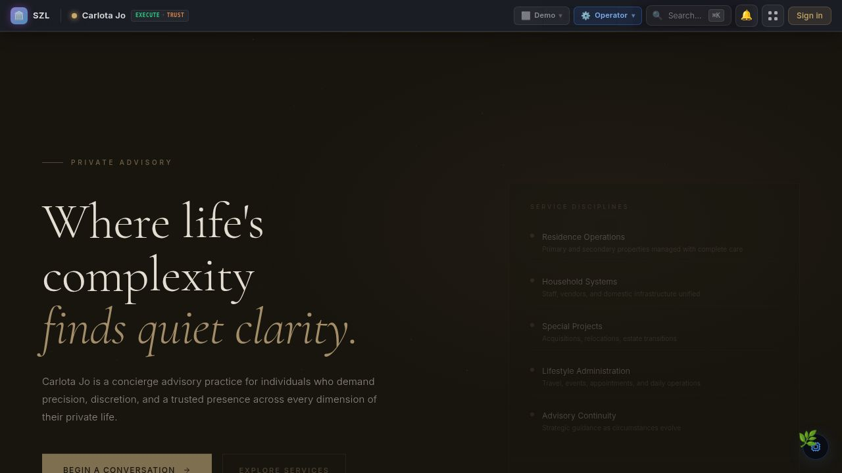
Carlota Jo — Where life's complexity finds quiet clarity
Tweet 8
Scale:

→ 10 canonical artifacts across 7 web and 2 mobile surfaces
→ 700+ database tables across 116 schema files
→ 40+ shared packages in pnpm monorepo
→ 11-role RBAC with org-scoped tenant isolation
→ 9 schema-validated AI decision types
→ 6 platform primitives shared by every surface
→ Immutable Proof Chain on every action

Full platform tour tomorrow. Every product, every surface.
388 characters

Monday — Full Screenshot Drop Thread
The full company tour · 13 tweets · 10 screenshots · One product per tweet

Screenshot Attachment Summary — Monday
Tweet 2 → Attach: screenshots/monday/01-szl-holdings-home.jpg
Tweet 3 → Attach: screenshots/monday/02-szl-holdings-platform.jpg
Tweet 4 → Attach: screenshots/monday/03-pulse-ai-briefing.jpg
Tweet 5 → Attach: screenshots/monday/04-vessels-fleet-command.jpg
Tweet 6 → Attach: screenshots/monday/05-vessels-capabilities.jpg
Tweet 7 → Attach: screenshots/monday/06-vessels-use-cases.jpg
Tweet 8 → Attach: screenshots/monday/07-terra-real-estate-intelligence.jpg
Tweet 9 → Attach: screenshots/monday/08-carlota-jo-home.jpg
Tweet 10 → Attach: screenshots/monday/09-carlota-jo-services.jpg
Tweet 11 → Attach: screenshots/monday/10-command-unified-command.jpg
Tweet 12 → Attach: screenshots/monday/13-aegis-defense-intelligence.jpg
Tweet 13 → Attach: screenshots/monday/11-mobile-cortex-home.jpg

Thread Copy — Monday
Tweet 1
The full SZL Holdings platform tour.

Every surface. Every domain pack. One governed infrastructure.

Thread 🧵
111 characters
Tweet 2
SZL Holdings — the platform layer.

"The governed infrastructure for high-consequence decisions."

Not a dashboard. Not an AI copilot. The structural layer between signal detection and action execution — with governance, attribution, and outcome tracking on every decision.

Signal → Context → Recommendation → Simulation → Policy → Execution → Proof → Outcome → Learning
371 characters
📎 Attach: screenshots/monday/01-szl-holdings-home.jpg

SZL Holdings — The governed infrastructure for high-consequence decisions
Tweet 3
Platform architecture.

Three layers: Lyte (flagship command surface), Alloy (execution fabric), domain packs.

Every layer inherits: Outcome Graph, Proof Chain, Covenant Policy, Decision Simulation, Workflow Engine, Event Fabric.

New domain = new intelligence. Same governance. Always.
287 characters
📎 Attach: screenshots/monday/02-szl-holdings-platform.jpg

One governance infrastructure. Every high-consequence domain.
Tweet 4
Pulse — AI Executive Briefing.

Every morning: a multi-agent synthesis across all signals — security, fleet, property, legal — distilled into one SZL-EXEC-RESTRICTED brief.

Nuro Mesh v3.1. Live brief active daily.

This is not a report. This is a decision-ready intelligence document with full provenance.
306 characters
📎 Attach: screenshots/monday/03-pulse-ai-briefing.jpg
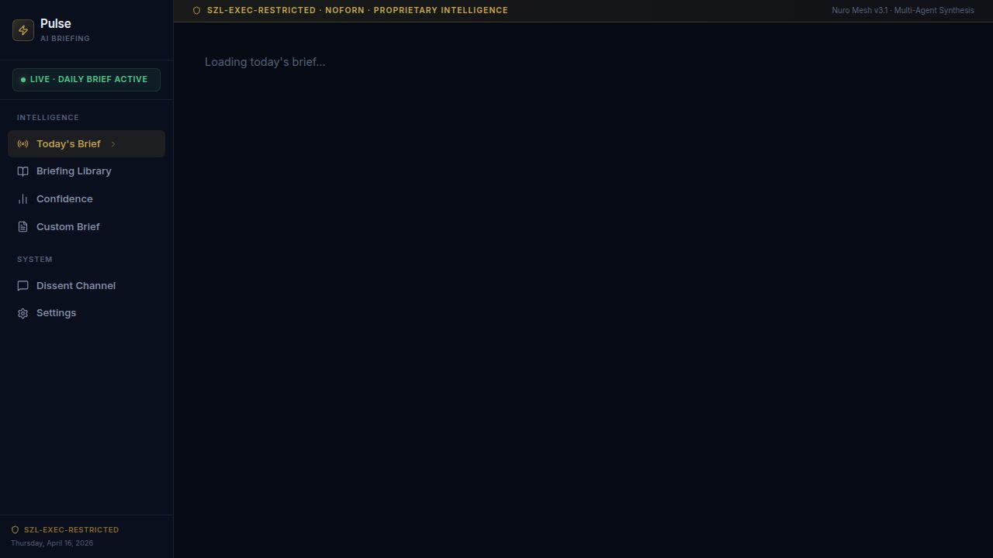
Pulse — AI Briefing — SZL-EXEC-RESTRICTED · NOFORN · PROPRIETARY INTELLIGENCE
Tweet 5
Vessels — Maritime Intelligence.

"Fleet operations. Decided faster."

Positions, voyage economics, compliance, and exception management — one command platform for maritime operators who need answers, not dashboards.

214 vessels tracked live. Every exception prioritized by P&L impact.
286 characters
📎 Attach: screenshots/monday/04-vessels-fleet-command.jpg
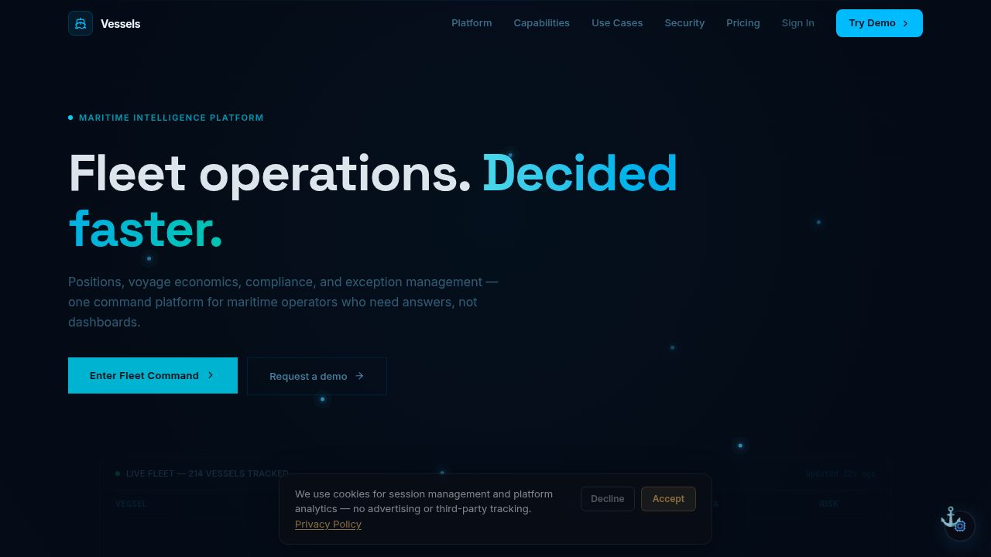
Vessels — Fleet Operations. Decided faster.
Tweet 6
Vessels goes deep.

Position & situation: Live AIS map, signal monitoring, dark vessel detection.
Operations & exceptions: Exception center, ETA alerts, maintenance readiness.
Economics: Voyage P&L, charter party compliance, freight rate benchmarking.
Compliance: Sanctions screening, port state control risk.

Every layer. One platform.
337 characters
📎 Attach: screenshots/monday/05-vessels-capabilities.jpg

Vessels capabilities — every intelligence layer your fleet operation needs
Tweet 7
Vessels serves three distinct operators — one platform.

Fleet executives: portfolio-level confidence, not status updates.
Commercial operators: voyage economics and margin management.
Operations: exception management and ETA fidelity.

Three personas. One governed command surface.
282 characters
📎 Attach: screenshots/monday/06-vessels-use-cases.jpg
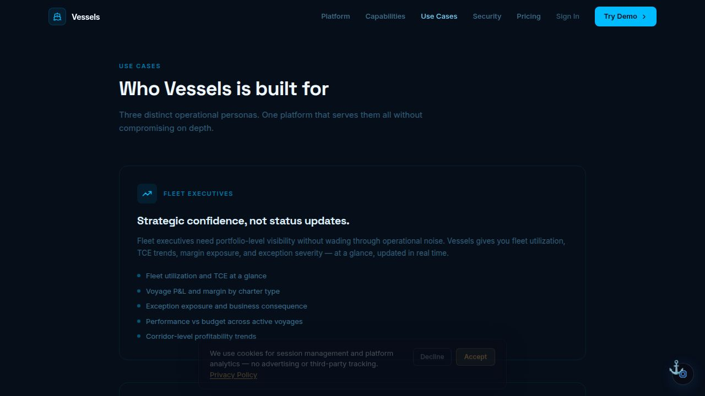
Vessels — Who it's built for: Fleet executives, commercial, and operations
Tweet 8
Terra — Real Estate Intelligence.

"The operating surface for serious real estate."

Investors, brokers, and portfolio teams in one surface — from distressed property discovery through ownership analysis, pipeline management, and deal execution.

Property / Portfolio / Broker intelligence. Built on the same governance infrastructure.
335 characters
📎 Attach: screenshots/monday/07-terra-real-estate-intelligence.jpg
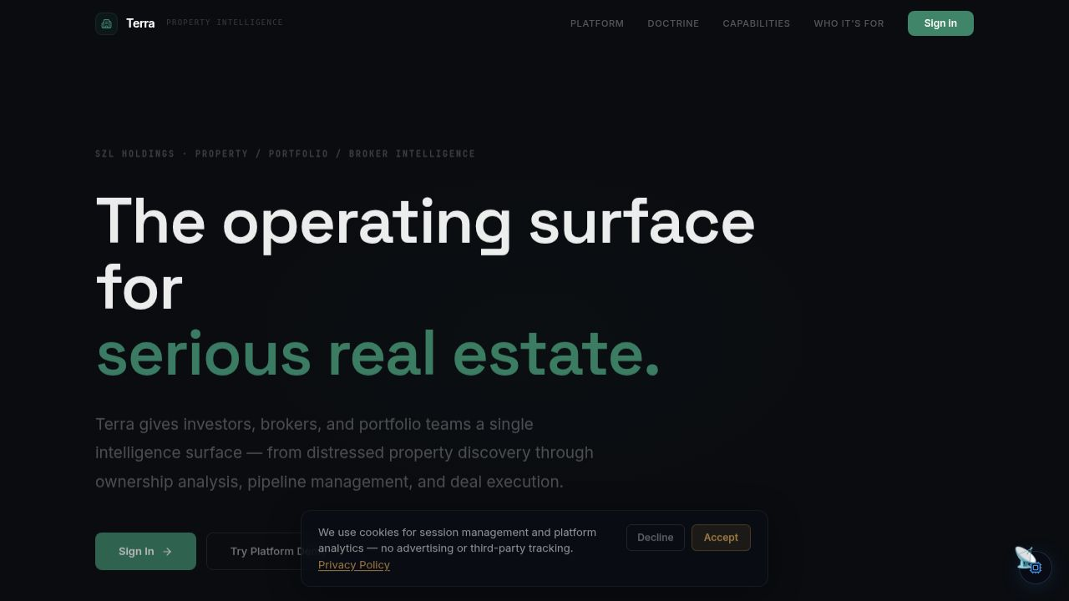
Terra — The operating surface for serious real estate
Tweet 9
Carlota Jo — Private Advisory.

"Where life's complexity finds quiet clarity."

A concierge advisory practice for individuals who demand precision, discretion, and a trusted presence across every dimension of their private life.

Six practice areas: Residence Operations, Household Systems, Special Projects, Lifestyle Administration, Advisory Continuity.
355 characters
📎 Attach: screenshots/monday/08-carlota-jo-home.jpg

Carlota Jo — Private Advisory — Where life's complexity finds quiet clarity
Tweet 10
Carlota Jo services.

Six practice areas. One uncompromising standard.

Every engagement is conducted through the principal directly. No associates, no handoffs, no templated service models.

Same Proof Chain. Same governance primitives. Different domain.
255 characters
📎 Attach: screenshots/monday/09-carlota-jo-services.jpg
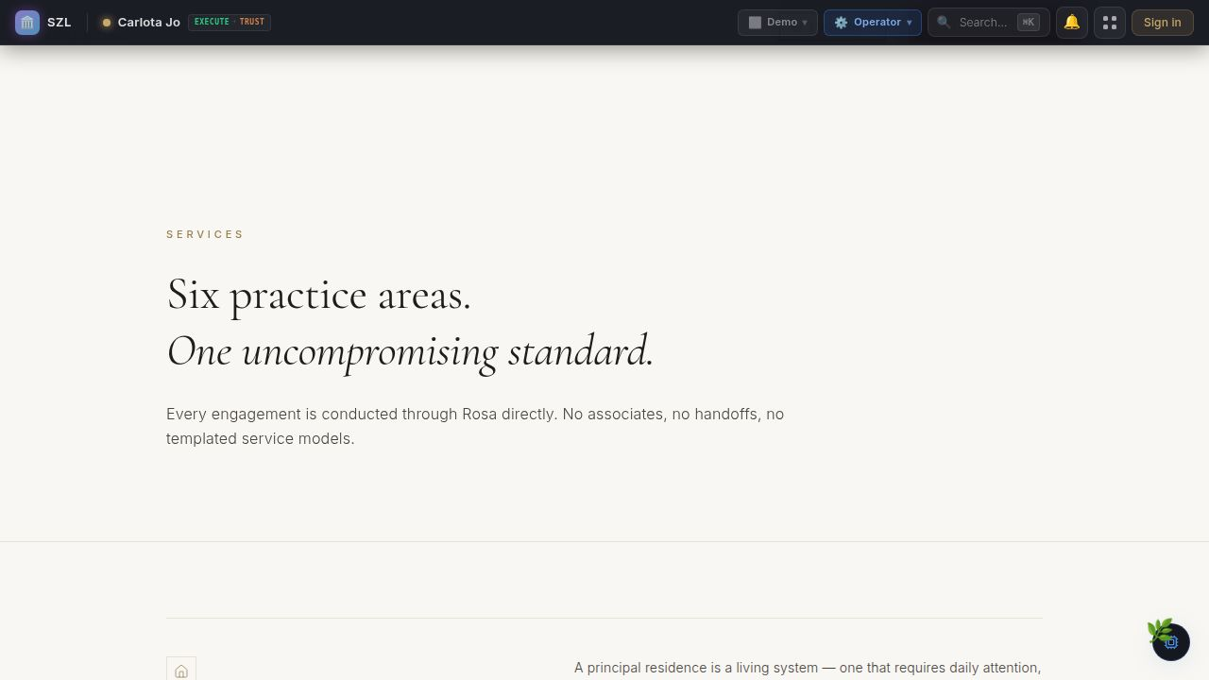
Carlota Jo — Six practice areas. One uncompromising standard.
Tweet 11
Unified Command — the cross-domain layer.

Strategy → Governed Decision Loop → Executive Briefing → Signal Chains → Outcome Graph → Simulation.

Every domain pack surfaces into Unified Command. One operator can see the full picture across security, fleet, real estate, legal, and advisory — in one governed surface.

ASK CORTEX — AI command assistant, always available.
369 characters
📎 Attach: screenshots/monday/10-command-unified-command.jpg

Unified Command — Cross-domain governed decision loop
Tweet 12
Aegis — Security & Defense domain pack.

Threat detection, incident command, OT/ICS security, adversary profiling, PRISM Counsel legal integration — all on the shared governance infrastructure.

Every alert → governed decision loop. Every action → Proof Chain. Every outcome → Outcome Graph.

(Functional alpha · design partners open)
334 characters
📎 Attach: screenshots/monday/13-aegis-defense-intelligence.jpg
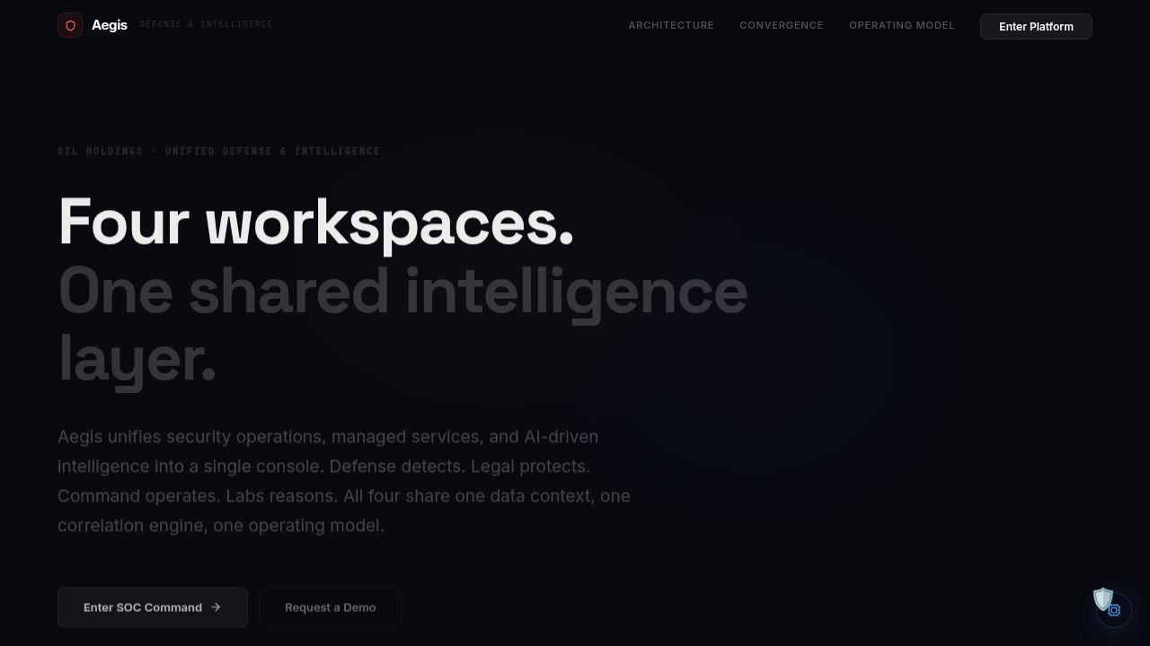
Aegis — Unified Defense & Intelligence Command
Tweet 13
This is one platform. One team. One alpha.

→ 7 web applications
→ 2 mobile apps (CORTEX)
→ 700+ database tables
→ 40+ shared packages
→ 6 platform primitives on every surface
→ Pre-seed · Design partner phase

We are not pitching a vision. We are showing you the product.

Design partners: inquiries@szlholdings.com
Founder: stephen@szlholdings.com
349 characters
📎 Attach: screenshots/monday/11-mobile-cortex-home.jpg
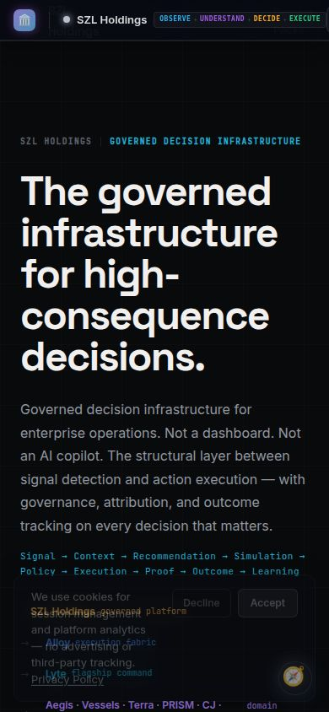
CORTEX Mobile — SZL Holdings mobile command surface (iOS + Android)

