使用方法:

clf = joblib.load(“modelname.joblib”)

clf.predict(x_test)

模型输入参数说明：

#标签类型：dis或con

labeltype = "dis"

#特征列表

featurelist=["sd","id","b","t","pnb","tsb","db","riu","bb","apb"]

#训练集比例

train_rate=0.5

测试结果：

polycom：

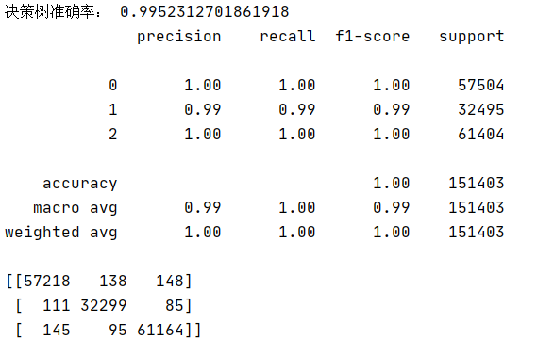

webrtc：

