GROUP 4
James Rosher (209390143), Samuel Moore(20503628), Callum Schofeild(20947475),
Justin Kruger(20767264), and Rowan Heinrich(20939081)

Work Done

1.Group Communication and Collaboration
- Organized availability for group meeting and set a weekly date (2PM – Monday)
- Used timetabling system: http://www.ucc.asn.au/cgi-bin/timetable.py
- Set up Git repository (version control) to keep track of files
- https://github.com/szmoore/MCTX3420
- Redundant Git repository at http://git.ucc.asn.au/?p=matches/MCTX3420.git
- Set up IRC channel #mctxuwa_softdev at irc.eversible.com
- Emails through UWA email

2. High level considerations of design
- Considered various methods of remote communication to the system
- Specify Raspberry Pi for main server hardware, considered Arduino for low level
  - JavaScript browser based GUI
- Initial testing on Raspberry Pi in streaming from USB web cam to a website
- Realized we will be working closely with electronics and sensors team
- Developed block diagram of high level design (see figure 1)

TODO:
- Research client side GUI in JavaScript
- Research server side code for interfacing between web and hardware
- Research low level sensors and interfacing with Arduino
- Investigate Image Processing and Data Analysis using OpenCV/Python
- Set up communication with other teams

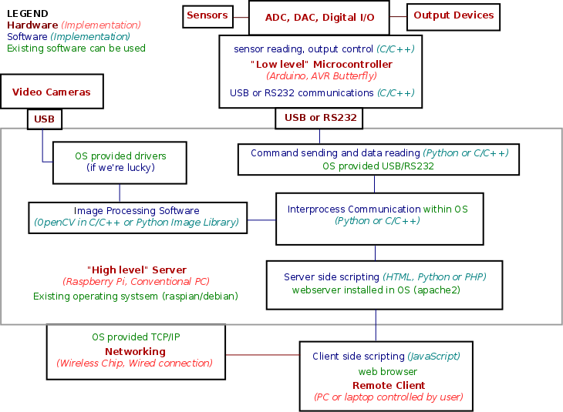Figure 1: High level block diagram

