Detailed Design

sco_bas

Python package for basics.

Revision History
Rev. | Comment | Author

Table of Contents
1 Introduction 4
2 sco_def.py 4
2.1 Sco_int 4
2.1.1 __init__ 4
2.2 Sco_str 4
2.2.1 __init__ 4
3 ScoEnum.py 5
3.1 ScoEnum 5
3.1.1 __new__ 5
3.1.2 __init__ 6
4 sco_bltin.py 7
4.1 sco_module_eval 7

Introduction
This is a detailed design document for Python package sco_bas. Table 1.1 shows reference materials.
Table 1.1: Reference materials.
Material | Reference
Functional Design sco_bas | fd_sco_bas.odt
Functional Design sco_log | fd_sco_log.odt
python-varname | https://github.com/pwwang/python-varname

In this document, the contents that overlap with the functional design document are not described as much as possible.

sco_def.py

Sco_int

__init__
Figure 2.1 shows activity diagram.

Figure 2.1: `Sco_int.__init__` activity diagram.

Sco_str

__init__
Figure 2.2 shows activity diagram.

Figure 2.2: `Sco_str.__init__` activity diagram.

ScoEnum.py
Table 3.1 shows imports.
Table 3.1: ScoEnum.py imports.
from | import | Reference
typing | Type, Any, Final | Built-in.

ScoEnum
Table 3.2 shows instance methods.
Table 3.2: `ScoEnum` instance methods.
Method | Use
__new__ | Create the instance propertiy `zbi`. Then set the zero-based index.
__init__ | Declare the instance propertiy `zbi`.

__new__
def __new__(cls: Type, *args: tuple) -> Any:
Parameters
cls | Type variable that stores the subclass.
args | Enumeration value.

Return values
`cls` instance.

Figure 3.1 shows activity diagram.
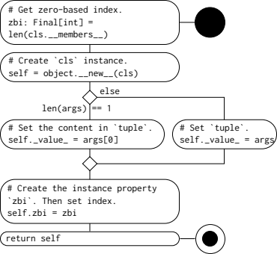
Figure 3.1: `ScoEnum.__new__` activity diagram.

__init__
def __init__(self, *args: tuple) -> None:
Parameters
args | Enumeration value.

Return values
Nothing.

Figure 3.2 shows activity diagram.

Figure 3.2: `ScoEnum.__init__` activity diagram.

sco_bltin.py
Table 4.1 shows imports.
Table 4.1: ScoRc.py imports.
from | import | Reference
typing | Final | Built-in.
types | ModuleType
logging | Logger
importlib | import_module
varname | nameof | Table 1.1
sco_log.sco_log | sco_log_get

sco_module_eval
Figure 4.1 shows activity diagram.
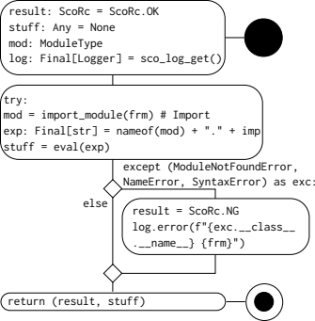
Figure 4.1: `sco_module_eval` activity diagram.

