Detailed Design

sco_log

Python package for log.

Revision History
Rev. | Comment | Author

Table of Contents
1 Introduction 4
2 sco_log.py 4
2.1 LOG_NAME 4
2.2 LOG_LEVEL 4
2.3 LOG_FORMAT 4
2.4 sco_log_get 5
2.5 sco_log_init 5

Introduction
This is a detailed design document for Python package sco_log. Table 1.1 shows reference materials.
Table 1.1: Reference materials.
Material | Reference
Functional Design sco_log | fd_sco_log.odt
typing — Support for type hints | typing — Support for type hints — Python documentation

In this document, the contents that overlap with the functional design are not described as much as possible.

sco_log.py
Table 2.1 shows imports.
Table 2.1: sco_log.py imports.
from | import | Reference
typing | Final | Built-in.
logging | Formatter, StreamHandler, DEBUG, getLogger

Table 2.2 shows constants.
Table 2.2: sco_log.py constants.
Constant | Use
LOG_NAME | Logger name.
LOG_LEVEL | Outputs a log with a level higher than `LOG_LEVEL`.
LOG_FORMAT | Log output format.

LOG_NAME
LOG_NAME: Final[str] = "sco_log"

LOG_LEVEL
LOG_LEVEL: Final[int] = DEBUG

LOG_FORMAT
LOG_FORMAT: Final[str] = \
"%(asctime)s - %(levelname)8s - %(pathname)s(%(lineno)4d) - " \
"%(funcName)s()\n" \
"%(message)s"

sco_log_get
Figure 2.1 shows activity diagram.
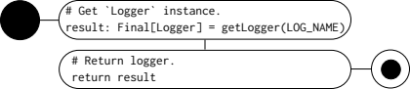
Figure 2.1: `sco_log_get` activity diagram.

sco_log_init
Figure 2.2 shows activity diagram.
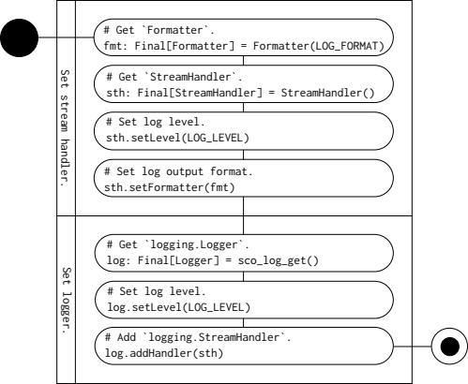
Figure 2.2: `sco_log_init` activity diagram.

