Unit test Design

ut_sco_log

Unit test design for Python package sco_log.

Revision History
Rev. | Comment | Author

Table of Contents
1 Introduction 4
2 Contents 4
3 ut_sco_log_main.py 4
3.1 UT_SCO_LOG_ODS 6
3.2 ut_sco_log_main 6
4 <ut_sco_log_get> 7
5 <ut_sco_log_init> 7

Introduction
This is a unit test design document for Python package sco_log. The test target is sco_log. Table 1.1 shows reference materials.
Table 1.1: Reference materials.
Material | Reference
Detailed Design sco_log | dd_sco_log.odt
Functional Design sco_bas | fd_sco_bas.odt
Functional Design sco_ods | fd_sco_ods.odt

Contents
ut_sco_log is made up of files under the directory <ut_sco_log>. Table 2.1 shows files.
Table 2.1: Files.
File | Use
ut_sco_log.ods | Spreadsheet with the expected outputs for the inputs of unit test target. The test target I/Os in one test are described in one row on the spreadsheet.
ut_sco_log_main.py | Define the main function in the unit test program.
<ut_sco_log_get> | Directory for storing the unit test program `ut_sco_log_get()`. `sco_log_get()` is tested.
<ut_sco_log_init> | Directory for storing the unit test program `ut_sco_log_init()`. `sco_log_init()` is tested.

ut_sco_log_main.py
Table 3.1 shows imports.
Table 3.1: ut_sco_log_main.py imports.
from | import | Reference
sys | exit | Built-in.
logging | Logger
typing | Final
sco_bas.sco_def | SCO_MODULE_NAME_MAIN | Table 1.1.
sco_bas.ScoRc | ScoRc
sco_ods.sco_ut | SCO_UT_AN_ITEM_T, sco_ut_run
sco_log.sco_log | sco_log_init, sco_log_get
ut_sco_log_get.ut_sco_log_get | ut_sco_log_get | See 4.
ut_sco_log_init.ut_sco_log_init | ut_sco_log_init | See 5.
Figure 3.1 shows component diagram.
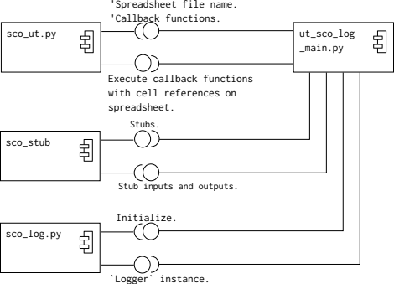
Figure 3.1: ut_sco_log_main.py component diagram.

Table 3.2 shows constants.
Table 3.2: ut_sco_log_main.py constants.
Constant | Use
UT_SCO_LOG_ODS | Spreadsheet file name.

Table 3.3 shows functions.
Table 3.3: ut_sco_log_main.py functions.
Function | Use
ut_sco_log_main | Execute `sco_ut_run()` passing the callback function corresponding to the sheet name.

Figure 3.2 shows activity diagram.
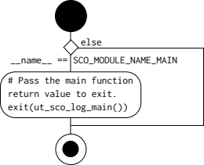
Figure 3.2: ut_sco_log_main.py activity diagram.

UT_SCO_LOG_ODS
UT_SCO_LOG_ODS: Final[str] = "ut_sco_log.ods"

ut_sco_log_main
def ut_sco_log_main() -> int:
Parameters
Nothing.

Retrun values
== 0 | Success.
!= 0 | Failure.

Figure 3.3, 3.4 shows activity diagram.
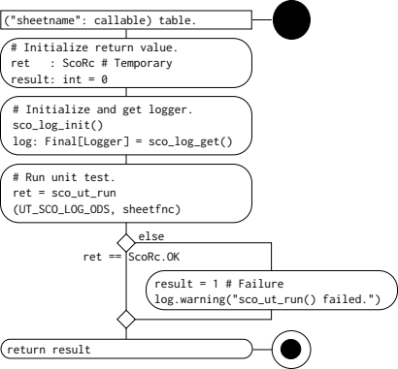
Figure 3.3: `ut_sco_log_main` activity diagram(1).

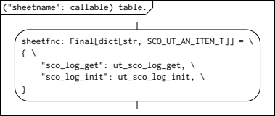
Figure 3.4: `ut_sco_log_main` activity diagram(2).

<ut_sco_log_get>
See the detailed design document in the directory <ut_sco_log_init>. How to uses the stub class and the stub function are described, so apply.

<ut_sco_log_init>
See detailed design document in the directory. Make that a representative one.

