Unit test Design

ut_sco_log_init

Unit test design for Python function sco_log_init.

Revision History
Rev. | Comment | Author

Table of Contents
1 Introduction 4
2 Contents 4
3 Spec_sco_log_init.py 4
3.1 Number_sco_log_init 5
3.1.1 __init__ 5
3.1.2 Number_sco_log_init_set 6
3.2 Input_sco_log_init 7
3.2.1 __init__ 7
3.2.2 Input_sco_log_init_set 8
3.3 Expect_sco_log_init 9
3.3.1 __init__ 9
3.3.2 __eq__ 10
3.3.3 Expect_sco_log_init_set 10
3.4 Output_sco_log_init 12
3.4.1 __init__ 13
3.4.2 Output_sco_log_init_set 13
3.4.3 Output_sco_log_init_write 15
3.5 Judge_sco_log_init 15
3.5.1 __init__ 16
3.5.2 Judge_sco_log_init_set 16
3.5.3 Judge_sco_log_init_write 17
4 Stub_sco_log_init.py 18
4.1 Stub_sco_log_init 19
4.1.1 __init__ 20
4.1.2 Stub_sco_log_init_set 21
4.1.3 Stub_sco_log_init_set_sth 22
4.1.4 Stub_sco_log_init_set_log 22
4.1.5 Stub_sco_log_init_get 23
4.1.6 Stub_sco_log_init_get_sth 24
4.1.7 Stub_sco_log_init_get_log 24
4.1.8 Stub_sco_log_init_start 25
4.1.9 Stub_sco_log_init_end 25
5 ut_sco_log_init.py 26
5.1 ut_sco_log_init 26

Introduction
This is a unit test design document for Python function sco_log_init. The test target is `sco_log_init()`. Table 1.1 shows reference materials.
Table 1.1: Reference materials.
Material | Reference
Detailed Design sco_log | dd_sco_log.odt
Detailed Design ut_sco_log | dd_ut_sco_log.odt
Functional Design sco_bas | fd_sco_bas.odt
Functional Design sco_ods | fd_sco_ods.odt

Contents
ut_sco_log_init is made up of files under the directory <ut_sco_log_init>. Table 2.1 shows files.
Table 2.1: Files.
File | Use
Spec_sco_log_init.py | Define classes to store the unit test specification.
Stub_sco_log_init.py | Define stubs used under the test target.
ut_sco_log_init.py | Define `ut_sco_log_init()` to test `sco_log_init()`.

Spec_sco_log_init.py
Table 3.1 shows imports.
Table 3.1: Spec_sco_log_init.py imports.
from | import | Reference
typing | Final | Built-in.
logging | Logger
ezodf.cells | Cell | Table 1.1.
sco_bas.ScoRc | ScoRc
sco_bas.sco_def | Sco_int
sco_log.sco_log | sco_log_get
sco_ods.ScoUtHead | ScoUtHead
sco_ods.ScoUtCols | ScoUtCols
sco_ods.sco_ut | sco_ut_cell_get_int,  sco_ut_cell_get_eval,  sco_ut_get_cells

Table 3.2 shows classes.
Table 3.2: Spec_sco_log_init.py classes.
Class | Use
Number_sco_log_init | Group the test number.
Input_sco_log_init | Group the test target inputs.
Expect_sco_log_init | Group the expected outputs of the test target.
Output_sco_log_init | Group `Cell`s to write the test target outputs.
Judge_sco_log_init | Group the test number and judgement.

Number_sco_log_init
Table 3.3 shows instance properties.
Table 3.3 `Number_sco_log_init` instance properties.
Property | Use
self.number: int = 0 | The test number.

Table 3.4 shows instance methods.
Table 3.4 `Number_sco_log_init` instance methods.
Method | Use
__init__ | Define the instance properties.
Number_sco_log_init_set | Set the instance properties.

__init__
def __init__(self) -> None:
Parameters
Nothing.

Return values
Nothing.
Figure 3.1 shows activity diagram.

Figure 3.1: `Number_sco_log_init.__init__` activity diagram.

Number_sco_log_init_set
def Number_sco_log_init_set(this: Number_sco_log_init, cell_list: list[Cell], ut_cols: ScoUtCols) -> int:
Parameters
this | Instance to set.
cell_list | The list of `Cell`s making up of one test, i.e. one row on the spreadsheet.
ut_cols | The column range information on `cell_list`.

Return values
int | Zero-based index of `ScoRc` instance. `ScoRc.OK.zbi` for normal, other than `ScoRc.OK.zbi` for abnormal.

Figure 3.2 shows activity diagram.
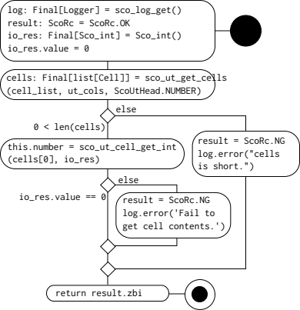
Figure 3.2: `Number_sco_log_init.set` activity diagram.

Input_sco_log_init
Table 3.5 shows instance properties.
Table 3.5 `Input_sco_log_init` instance properties.
Property | Use
self.Formatter_Formatter_ut_id: int = 0 | The user defined ID of `FormatterStub` instance.
self.StreamHandler_StreamHandler_ut_id: int = 0 | The user defined ID of `StreamHandlerStub` instance.
self.sco_log_get_Logger_ut_id: int = 0 | The user defined ID of `LoggerStub` instance.

Table 3.6 shows instance methods.
Table 3.6 `Input_sco_log_init` instance methods.
Method | Use
__init__ | Define the instance properties.
Input_sco_log_init_set | Set the instance properties.

__init__
def __init__(self) -> None:
Parameters
Nothing.

Return values
Nothing.
Figure 3.3 shows activity diagram.
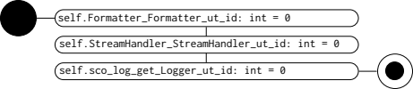
Figure 3.3: `Input_sco_log_init.__init__` activity diagram.

Input_sco_log_init_set
def Input_sco_log_init_set(this: Input_sco_log_init, cell_list: list[Cell], ut_cols: ScoUtCols) -> int:
Parameters
this | Instance to set.
cell_list | The list of `Cell`s making up of one test, i.e. one row on the spreadsheet.
ut_cols | The column range information on cell_list.

Return values
int | Zero-based index of `ScoRc` instance. `ScoRc.OK.zbi` for normal, other than `ScoRc.OK.zbi` for abnormal.

Figure 3.4 shows activity diagram.
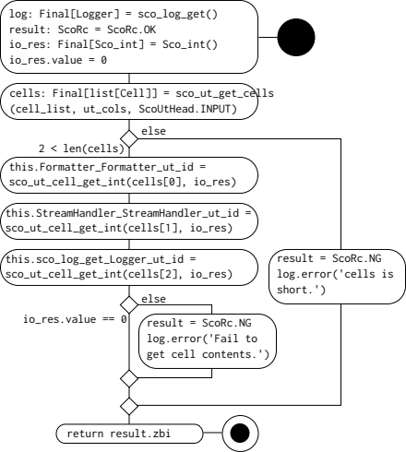
Figure 3.4: `Input_sco_log_init.set` activity diagram.

Expect_sco_log_init
Table 3.7 shows instance properties.
Table 3.7 `Expect_sco_log_init` instance properties.
Property | Use
self.Formatter_fmt: str = "" | `FormatterStub.__init__()` argument `fmt`.
self.StreamHandler_setLevel_level: int = 0 | `StreamHandlerStub.setLevel()` argument `level`.
self.StreamHandler_setFormatter_fmt_ut_id: int = 0 | `StreamHandlerStub.setFormatter()` argument `fmt`.
self.Logger_setLevel_level: int = 0 | `LoggerStub.setLevel()` argument `level`.
self.Logger_addHandler_hdlr_ut_id: int = 0 | The user defined ID of `LoggerStub.addHandler()` argument `hdlr`.

Table 3.8 shows instance methods.
Table 3.8 `Expect_sco_log_init` instance methods.
Method | Use
__init__ | Define the instance properties.
__eq__ | Compare self contents with those of other.
Expect_sco_log_init_set | Set the instance properties.

__init__
def __init__(self) -> None:
Parameters
Nothing.

Return values
Nothing.

Figure 3.5 shows activity diagram.
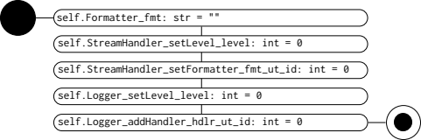
Figure 3.5: `Expect_sco_log_init.__init__` activity diagram.

__eq__
def __eq__(self, other: Expect_sco_log_init) -> bool:
Parameters
Nothing.

Return values
Nothing.
Figure 3.6 shows activity diagram.
Figure 3.6: `Expect_sco_log_init.__eq__` activity diagram.

Expect_sco_log_init_set
def Expect_sco_log_init_set(this: Expect_sco_log_init, cell_list: list[Cell], ut_cols: ScoUtCols) -> int:
Parameters
this | Instance to set.
cell_list | The list of `Cell`s making up of one test, i.e. one row on the spreadsheet.
ut_cols | The column range information on cell_list.

Return values
int | Zero-based index of `ScoRc` instance. `ScoRc.OK.zbi` for normal, other than `ScoRc.OK.zbi` for abnormal.

Figure 3.7 shows activity diagram.
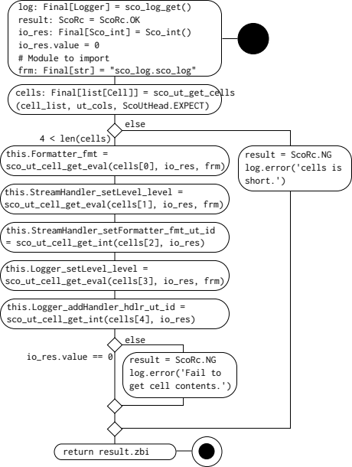
Figure 3.7: `Expect_sco_log_init.set` activity diagram.

Output_sco_log_init
Table 3.9 shows instance properties.
Table 3.9 `Output_sco_log_init` instance properties.
Property | Use
self.Formatter_fmt: Cell | `FormatterStub.__init__()` argument `fmt`.
self.StreamHandler_setLevel_level: Cell | `StreamHandlerStub.setLevel()` argument `level`.
self.StreamHandler_setFormatter_fmt_ut_id: Cell | `StreamHandlerStub.setFormatter()` argument `fmt`.
self.Logger_setLevel_level: Cell | `LoggerStub.setLevel()` argument `level`.
self.Logger_addHandler_hdlr_ut_id: Cell | The user defined ID of `LoggerStub.addHandler()` argument `hdlr`.

Table 3.10 shows instance methods.
Table 3.10 `Output_sco_log_init` instance methods.
Method | Use
__init__ | Define the instance properties.
Output_sco_log_init_set | Set the instance properties.
Output_sco_log_init_write | Write outputs of the test target on the cells.

__init__
def __init__(self) -> None:
Parameters
Nothing.

Return values
Nothing.
Figure 3.8 shows activity diagram.
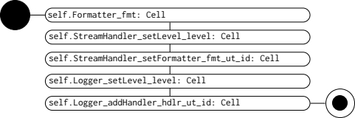
Figure 3.8: `Output_sco_log_init.__init__` activity diagram.

Output_sco_log_init_set
def Output_sco_log_init_set(this: Output_sco_log_init, cell_list: list[Cell], ut_cols: ScoUtCols) -> int:
Parameters
this | Instance to set.
cell_list | The list of `Cell`s making up of one test, i.e. one row on the spreadsheet.
ut_cols | The column range information on cell_list.

Return values
int | Zero-based index of `ScoRc` instance. `ScoRc.OK.zbi` for normal, other than `ScoRc.OK.zbi` for abnormal.

Figure 3.9 shows activity diagram.
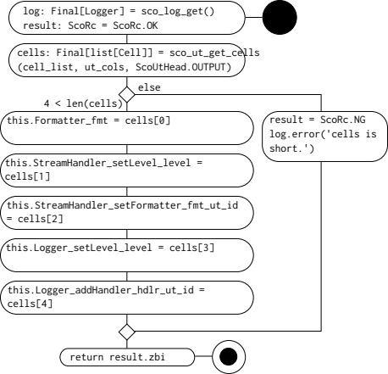
Figure 3.9: `Output_sco_log_init_set` activity diagram.

Output_sco_log_init_write
def Output_sco_log_init_write(this: Output_sco_log_init, output_real: Expect_sco_log_init) -> None:
Parameters
this | Instance to write.
output_real | Outputs of the test target.

Return values
Nothing.

Figure 3.10 shows activity diagram.
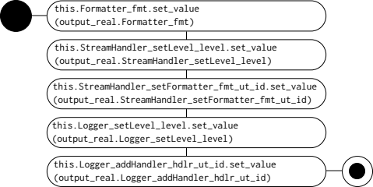
Figure 3.10: `Output_sco_log_init_write` activity diagram.

Judge_sco_log_init
Table 3.11 shows instance properties.
Table 3.11 `Judge_sco_log_init` instance properties.
Property | Use
self.judge: Cell | The `Cell` to write the test judgement.

Table 3.12 shows instance methods.
Table 3.12 `Judge_sco_log_init` instance methods.
Method | Use
__init__ | Declare the instance properties.
Judge_sco_log_init_set | Set the instance properties.
Judge_sco_log_init_write | Write test judgement on the cell.

__init__
def __init__(self) -> None:
Parameters
Nothing.

Return values
Nothing.
Figure 3.11 shows activity diagram.

Figure 3.11: `Judge_sco_log_init.__init__` activity diagram.

Judge_sco_log_init_set
def Judge_sco_log_init_set(this: Judge_sco_log_init, cell_list: list[Cell], ut_cols: ScoUtCols) -> int:
Parameters
this | Instance to set.
cell_list | The list of `Cell`s making up of one test, i.e. one row on the spreadsheet.
ut_cols | The column range information on `cell_list`.

Return values
int | Zero-based index of `ScoRc` instance. `ScoRc.OK.zbi` for normal, other than `ScoRc.OK.zbi` for abnormal.

Figure 3.12 shows activity diagram.
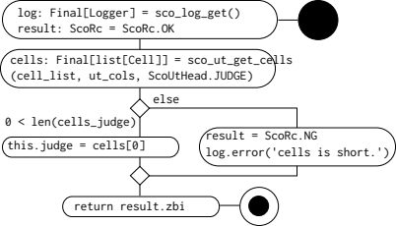
Figure 3.12: `Judge_sco_log_init.set` activity diagram.

Judge_sco_log_init_write
def Judge_sco_log_init_write(this: Judge_sco_log_init, expect: Expect_sco_log_init, output_real: Expect_sco_log_init) -> ScoRc:
Parameters
this | Instance to write.
expect | Expected outputs of the test target.
output_real | Outputs of the test target.

Return values
ScoRc | Test result.

Figure 3.13 shows activity diagram.
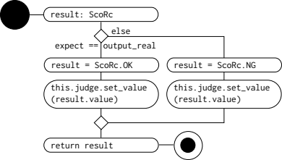
Figure 3.13: `Judge_sco_log_init_write` activity diagram.

Stub_sco_log_init.py
Table 4.1 shows imports.
Table 4.1: Stub_sco_log_init.py imports.
from | import | Reference
typing | Final, Callable | Built-in.
sco_log | sco_log | Table 1.1.
.Spec_sco_log_init | Input_sco_log_init,  Expect_sco_log_init
sco_stub.ScoStubComs | ScoStubComs_init
sco_stub.logging.Formatter | StubComs_Formatter,  FormatterStub,  Formatter_stub,  g_StubComs_Formatter_get
sco_stub.logging.StreamHandler | StubComs_StreamHandler,  StreamHandlerStub_setLevel,  StreamHandlerStub_setFormatter,  StreamHandlerStub,  StreamHandler_stub,  g_StubComs_StreamHandler_get
sco_stub.logging.Logger | LoggerStub,  LoggerStub_setLevel,  LoggerStub_addHandler
sco_stub.sco_log.sco_log_get | StubComs_sco_log_get,  StubCom_sco_log_get,  sco_log_get_stub,  g_StubComs_sco_log_get_get

Table 4.2 shows classes.
Table 4.2: Stub_sco_log_init.py classes.
Class | Use
Stub_sco_log_init | Group stubs used under the test target.

Stub_sco_log_init
Table 4.3 shows instance properties.
Table 4.3 `Stub_sco_log_init` instance properties.
Property | Use
self.fmt_coms: Final[StubComs_Formatter] = g_StubComs_Formatter_get() | Store the stub `Formatter_stub` I/Os.
self.fmt_src: Callable | Original callable before replacing with stub.
self.sth_coms: Final[StubComs_StreamHandler] = g_StubComs_StreamHandler_get() | Store the stub `StreamHandler_stub` I/Os.
self.sth_src: Callable | Original callable before replacing with stub.
self.log_coms: Final[StubComs_sco_log_get] = g_StubComs_sco_log_get_get() | Store the stub `sco_log_get_stub` I/Os.
self.log_src: Callable | Original callable before replacing with stub.

Table 4.4 shows instance methods.
Table 4.4 `Stub_sco_log_init` instance methods.
Method | Use
__init__ | Define or declare the instance properties.
Stub_sco_log_init_set | Set up stubs.
Stub_sco_log_init_set_sth | Set up stubs of methods.
Stub_sco_log_init_set_log | Set up stubs of methods.
Stub_sco_log_init_get | Get test target outputs from stubs.
Stub_sco_log_init_get_sth | Get test target outputs from stubs of methods.
Stub_sco_log_init_get_log | Get test target outputs from stubs of methods.
Stub_sco_log_init_start | Replace original callables with stubs.
Stub_sco_log_init_end | Restore original callables.

__init__
def __init__(self) -> None:
Parameters
Nothing.

Return values
Nothing.

Figure 4.1 shows activity diagram.
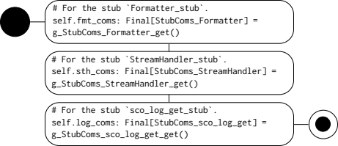
Figure 4.1: `Stub_sco_log_init.__init__` activity diagram.

Stub_sco_log_init_set
def Stub_sco_log_init_set(this: Stub_sco_log_init, set: Input_sco_log_init) -> None:
Parameters
Nothing.

Return values
Nothing.

Figure 4.2 shows activity diagram.
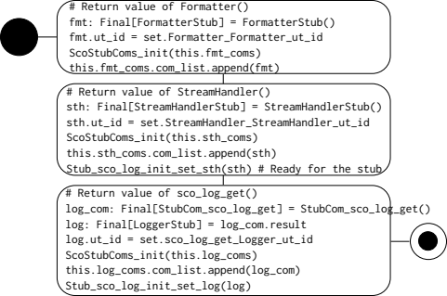
Figure 4.2: `Stub_sco_log_init_set` activity diagram.

Stub_sco_log_init_set_sth
def Stub_sco_log_init_set_sth(sth: StreamHandlerStub) -> None:
Parameters
Nothing.

Return values
Nothing.

Figure 4.3 shows activity diagram.
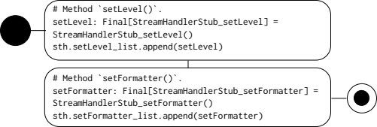
Figure 4.3: `Stub_sco_log_init_set_sth` activity diagram.

Stub_sco_log_init_set_log
def Stub_sco_log_init_set_log(log: LoggerStub) -> None:
Parameters
Nothing.

Return values
Nothing.

Figure 4.4 shows activity diagram.
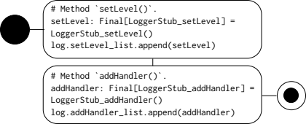
Figure 4.4: `Stub_sco_log_init_set_log` activity diagram.

Stub_sco_log_init_get
def Stub_sco_log_init_get(this: Stub_sco_log_init, get: Expect_sco_log_init) -> None:
Parameters
Nothing.

Return values
Nothing.

Figure 4.5 shows activity diagram.
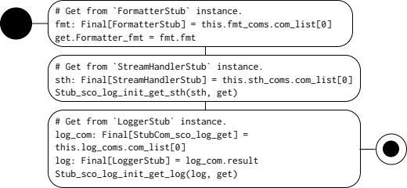
Figure 4.5: `Stub_sco_log_init_get` activity diagram.

Stub_sco_log_init_get_sth
def Stub_sco_log_init_get_sth(sth: StreamHanlderStub, get: Expect_sco_log_init) -> None:
Parameters
Nothing.

Return values
Nothing.

Figure 4.6 shows activity diagram.
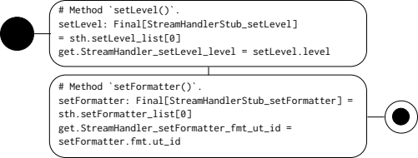
Figure 4.6: `Stub_sco_log_init_get_sth` activity diagram.

Stub_sco_log_init_get_log
def Stub_sco_log_init_get_log(log: LoggerStub, get: Expect_sco_log_init) -> None:
Parameters
Nothing.

Return values
Nothing.

Figure 4.7 shows activity diagram.
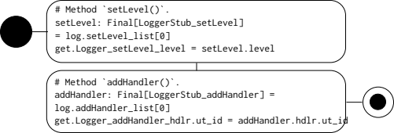
Figure 4.7: `Stub_sco_log_init_get_log` activity diagram.

Stub_sco_log_init_start
def Stub_sco_log_init_start(this: Stub_sco_log_init) -> None:
Parameters
Nothing.

Return values
Nothing.

Figure 4.8 shows activity diagram.
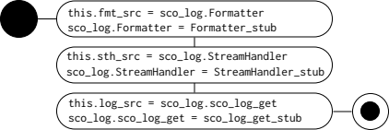
Figure 4.8: `Stub_sco_log_init_start` activity diagram.

Stub_sco_log_init_end
def Stub_sco_log_init_end(this: Stub_sco_log_init) -> None:
Parameters
Nothing.

Return values
Nothing.

Figure 4.9 shows activity diagram.
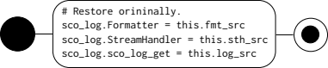
Figure 4.9: `Stub_sco_log_init_end` activity diagram.

ut_sco_log_init.py
Table 5.1 shows imports.
Table 5.1: ut_sco_log_init.py imports.
from | import | Reference
typing | Final | Built-in.
logging | Logger
ezodf.cells | Cell | Table 1.1.
sco_bas.ScoRc | ScoRc
sco_log.sco_log | sco_log_init,  sco_log_get
.Spec_sco_log_init | Number_sco_log_init,  Input_sco_log_init,  Expect_sco_log_init,  Output_sco_log_init,  Judge_sco_log_init,  Number_sco_log_init_set,  Input_sco_log_init_set,  Expect_sco_log_init_set,  Output_sco_log_init_set,  Judge_sco_log_init_set,  Output_sco_log_init_write,  Judge_sco_log_init_write
.Stub_sco_log_init | Stub_sco_log_init,  Stub_sco_log_init_set,  Stub_sco_log_init_start,  Stub_sco_log_init_end,  Stub_sco_log_init_get

Table 5.2 shows classes.
Table 5.2: Stub_sco_log_init.py classes.
Class | Use
Stub_sco_log_init | Group stubs used under the test target.

ut_sco_log_init
def ut_sco_log_init(cell_list: list[Cell], ut_cols: ScoUtCols) ->
tuple[ScoRc, ScoRc]:
Parameters
Nothing.

Return values
Nothing.

Figure 5.1 shows activity diagram.
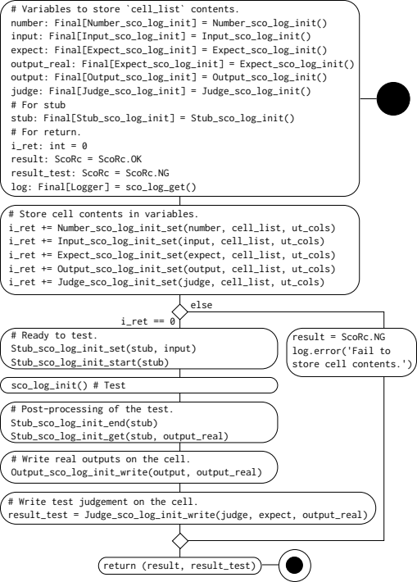
Figure 5.1: `ut_sco_log_init` activity diagram.

