Detailed Design

sco_ods

Python package for OpenDocument Spreadsheet.

Revision History
Rev. | Comment | Author

Table of Contents
1 Introduction 4
2 Contents 4
3 ScoOdsRng.py 4
3.1 ScoOdsRng 4
3.1.1 __init__ 5
3.1.2 ScoOdsRng_create 5
4 sco_ods.py 6
4.1.1 sco_ods_open 7
4.1.2 sco_ods_save 8
4.1.3 sco_ods_get_col_rng 8
5 ScoUtCols.py 10
5.1 ScoUtCols 10
5.1.1 __init__ 11
5.2 ScoUtCols_init 11
5.3 ScoUtCols_set 12
6 sco_ut.py 13
6.1 sco_ut_get_cells 14
6.2 sco_ut_cell_get_int 15
6.3 sco_ut_cell_get_eval 15
6.4 sco_ut_get_row_rng 16
6.5 sco_ut_run_matrix 18
6.6 sco_ut_run_sheet 20
6.7 sco_ut_run 22

Introduction
This is a detailed design document for Python package sco_ods. Table 1.1 shows reference materials.
Table 1.1: Reference materials.
Material | Reference
Functional Design sco_ods | fd_sco_ods.odt

In this document, the contents that overlap with the functional design document are not described as much as possible.

Contents
Table 2.1 shows files.
Table 2.1: Files.
File | Use
sco_ods.py | Define functions for .ods file.

ScoOdsRng.py
Table 3.1 shows imports.
Table 3.1: ScoOdsRng.py imports.
from | import | Reference
typing | Final | Built-in.

ScoOdsRng
Table 3.2 shows instance methods.
Table 3.2: `ScoOdsRng` instance methods.
Property | Use
__init__ | Declare instance properties.
ScoOdsRng_create | Create a `ScoOdsRng` instance and set properties.

__init__
def __init__(self) -> None:
Parameters
Nothing.

Return values
Nothing.

Figure 3.1 shows activity diagram.

Figure 3.1: `ScoOdsRng.__init__` activity diagram.

ScoOdsRng_create
def ScoOdsRng_create(start: int, length: int) -> ScoOdsRng:
Parameters
start | The setting value to `ScoOdsRng.start`.
length | The setting value to `ScoOdsRng.length`.

Return values
ScoOdsRng | The created instance.

Figure 3.2 shows activity diagram.
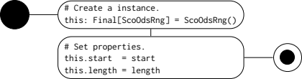
Figure 3.2: `ScoOdsRng_create` activity diagram.

sco_ods.py
Table 4.1 shows imports.
Table 4.1: sco_ods.py imports.
from | import | Reference
typing | Final, Optional | Built-in.
logging | Logger
ezodf.document | PackagedDocument | Table 1.1.
ezodf | opendoc
ezodf.cells | Cell
sco_bas.ScoEzodfCellSpan | ScoEzodfCellSpan
sco_ods.ScoOdsRng | ScoOdsRng,  ScoOdsRng_create | Table 1.1.  3.1
sco_log.sco_log | sco_log_get | Table 1.1.

Table 4.2 shows functions.
Table 4.2: sco_ods.py functions.
Function | Use
sco_ods_open | Open .ods file.
sco_ods_save | Save .ods file.
sco_ods_get_col_rng | Get the column range specified by the column header name.

sco_ods_open
def sco_ods_open(fname: str) -> Optional[PackagedDocument]:
Parameters
fname | .ods file name.

Return values
PackagedDocument | `PackageDocument' instance for success, `None` for failure.
Figure 4.1 shows activity diagram.
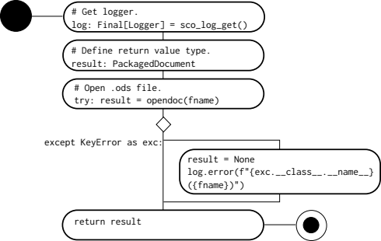
Figure 4.1: `sco_ods_open` activity diagram.

sco_ods_save
def sco_ods_save(ods: PackagedDocument) -> ScoRc:
Parameters
ods | Opened `PackagedDocument` instance.

Return values
ScoRc | ScoRc.OK for normal, other than ScoRc.OK for abnormal.
Figure 4.1 shows activity diagram.
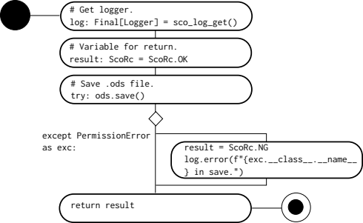
Figure 4.2: `sco_ods_save` activity diagram.

sco_ods_get_col_rng
def sco_ods_get_col_rng(mat: list[list[Cell]], col_name: str) -> tuple[int, ScoOdsRng]:
Parameters
mat | Cell matrix [row][column].
col_name | The column header name.

Return values
int | Row number of column header. - 1 for failure.
ScoOdsRng | Column range.
 | .start | Start column number.
 | .length | Column length. Length means number of columns.

Figure 5.1 shows activity diagram.
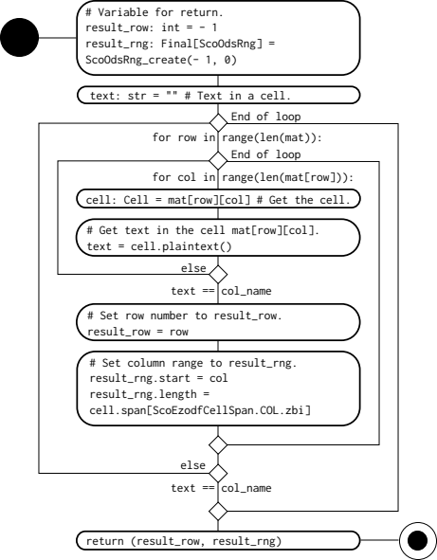
Figure 4.3: `sco_ods_get_col_rng` activity diagram.

ScoUtCols.py
Table 5.1 shows imports.
Table 5.1: ScoUtCols.py imports.
from | import | Reference
typing | Final | Built-in.
copy | copy
logging | Logger
ezodf.cells | Cell | Table 1.1.
.ScoOdsRng | ScoOdsRng_create | 3.1.2
.sco_ods | sco_ods_get_col_rng | 4.1.3.

Table 5.2 shows functions.
Table 5.2: ScoUtCols.py functions.
Function | Use
ScoUtCols_init | Initialize `ScoUtCols` instance properties.
ScoUtCols_set | Set `ScoUtCols` instance properties.

ScoUtCols
Table 5.3 shows instance properties.
Table 5.3: `ScoUtCols` inctance properties.
Property | Use
self.row_number:  int = - 1 | Row number of the cell whose content is `ScoUtHead.NUBER.value`.
self.cols: Final[list[ScoOdsRng]] = [] | `self.cols[ScoUtHead.*.zbi]` stores the column range of the column header `ScoUtHead.*`.

Table 5.4 shows instance methods.
Table 5.4: `ScoUtCols` instance methods.
Method | Use
__init__ | Define instance properties.
ScoUtCols_init | Initialize instance properties.
ScoUtCols_set | Set instance properties.

__init__
def __init__(self) -> None:
Parameters
Nothing.

Return values
Nothing.

Figure 5.1 shows activity diagram.
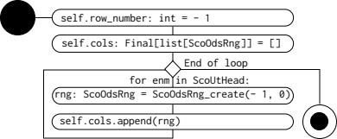
Figure 5.1: `ScoUtCols.__init__` activity diagram.

ScoUtCols_init
def ScoUtCols_init(this: ScoUtCols) -> None:
Parameters
this | Instance to initialize.

Return values
Nothing.

Figure 5.2 shows activity diagram.
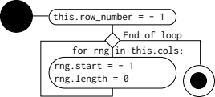
Figure 5.2: `ScoUtCols.init` activity diagram.

ScoUtCols_set
def ScoUtCols_set(this: ScoUtCols, mat: list[list[Cell]]) -> None:
Parameters
this | `ScoUtCols` instance.
mat | Cell matrix [row][col].

Return values
Nothing.

Figure 5.3 shows activity diagram.
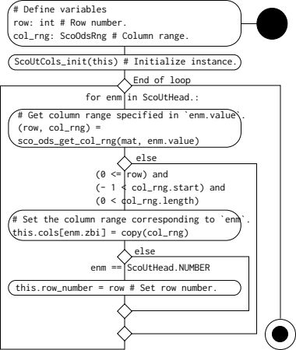
Figure 5.3: `ScoUtCols.set` activity diagram.

sco_ut.py
Table 6.1 shows sco_ut.py imports.
Table 6.1: sco_ut.py imports.
from | import | Reference
typing | Final | Built-in.
logging | Logger | Built-in.
ezodf.table | Table | Table 1.1.
ezodf.document | PackagedDocument
sco_bas.ScoEzodfCellValueType | ScoEzodfCellValueType
sco_bas.sco_bltin | sco_module_eval
sco_log.sco_log | sco_log_get
.ScoOdsRng | ScoOdsRng,  ScoOdsRng_create | Table 1.1.  3.1
.ScoUtCols | ScoUtCols_set | 5.3
sco_ods | sco_ods_open,  sco_ods_save | 4.1.1  4.1.2

Figure 6.1 shows component diagram.
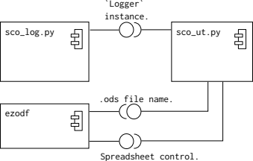
Figure 6.1: sco_ut.py component diagram.

Table 6.2 shows functions.
Table 6.2: sco_ut.py functions.
Function | Use
sco_ut_get_row_rng | Get the row range of the unit test matrix.
sco_ut_run_matrix | Run the unit test matrix. Matrix means cell block on the sheet.
sco_ut_run_sheet | Run the unit tests on the sheet.

sco_ut_get_cells
Figure 6.2 shows activity diagram.
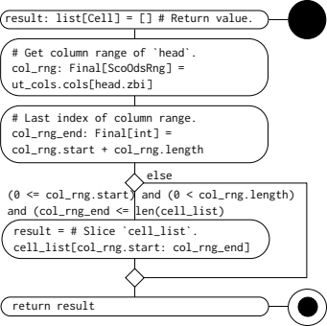
Figure 6.2: `sco_ut_get_cells` activity diagram.

sco_ut_cell_get_int
Figure 6.3 shows activity diagram.
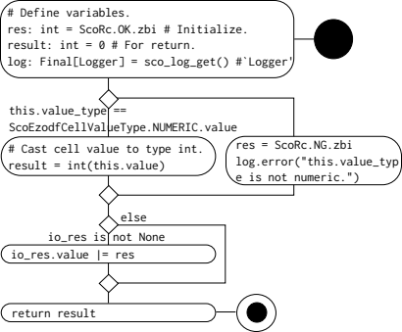
Figure 6.3: `sco_ut_cell_get_int` activity diagram.

sco_ut_cell_get_eval
Figure 6.4 shows activity diagram.
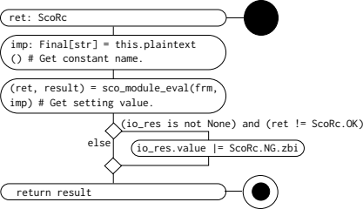
Figure 6.4: `sco_ut_cell_get_eval` activity diagram.

sco_ut_get_row_rng
def sco_ut_get_row_rng(mat: list[list[Cell]], row_start: int, col_rng: ScoOdsRng) -> ScoOdsRng:
Parameters
mat | Cell matrix [row][col].
row_start | The row number of the cell whose content is `ScoUtHead.NUBER`.
col_rng | The column range of the column header `ScoUtHead.NUBER`.

Return values
ScoOdsRng | The row range of the column `ScoUtHead.NUBER`.
 | .start | The start row number of the numeric cells below the column header `ScoUtHead.NUBER`.
 | .length | The row range of the continuous numeric cells from `start`. 0 for failure.

Figure 6.5 shows activity diagram.
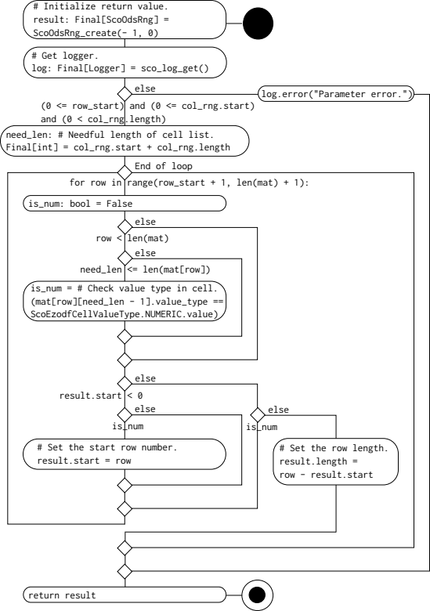
Figure 6.5: `sco_ut_get_row_rng` activity diagram.

sco_ut_run_matrix
def sco_ut_run_matrix(mat: list[list[Cell]], ut_cols: ScoUtCols, fnc: SCO_UT_AN_ITEM_T) -> ScoRc:
Parameters
mat | Cell matrix [row][col]. Element[0][] is the first test item.
fnc | Callback function called for each test item on the matrix.

Return values
ScoRc | `ScoRc.OK` for normal, other than `ScoRc.OK` for abnormal.

Figure 6.6 shows activity diagram.
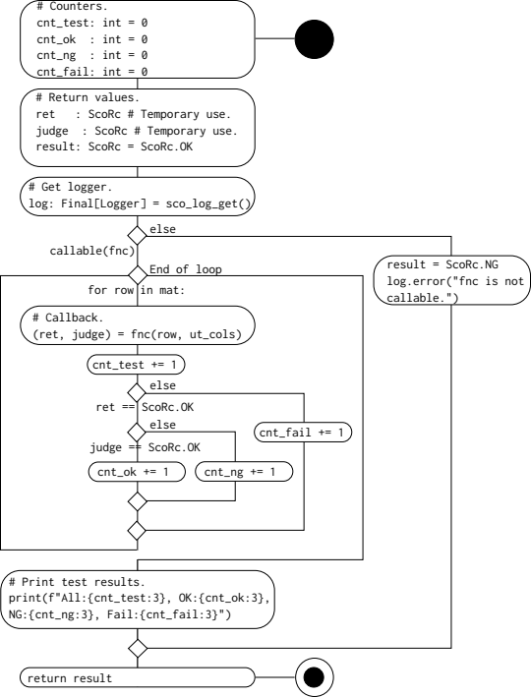
Figure 6.6: `sco_ut_run_matrix` activity diagram.

sco_ut_run_sheet
def sco_ut_run_sheet(sheet: Table, fnc: SCO_UT_AN_ITEM_T) -> ScoRc:
Parameters
sheet | The sheet in opened .ods file.
fnc | Callback function called for each test item on the sheet.

Return values
ScoRc | `ScoRc.OK` for normal, other than `ScoRc.OK` for abnormal.

Figure 6.7 shows activity diagram.
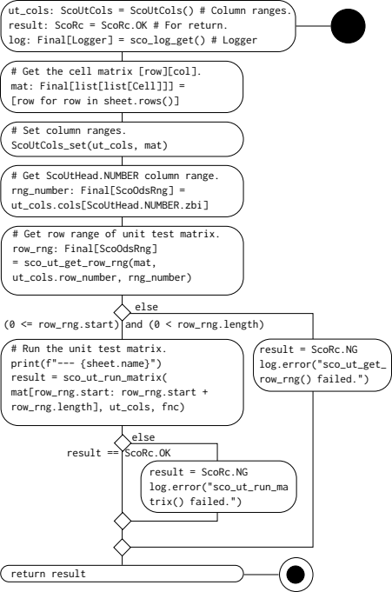
Figure 6.7: `sco_ut_run_sheet` activity diagram.

sco_ut_run
Figure 6.8 shows activity diagram.
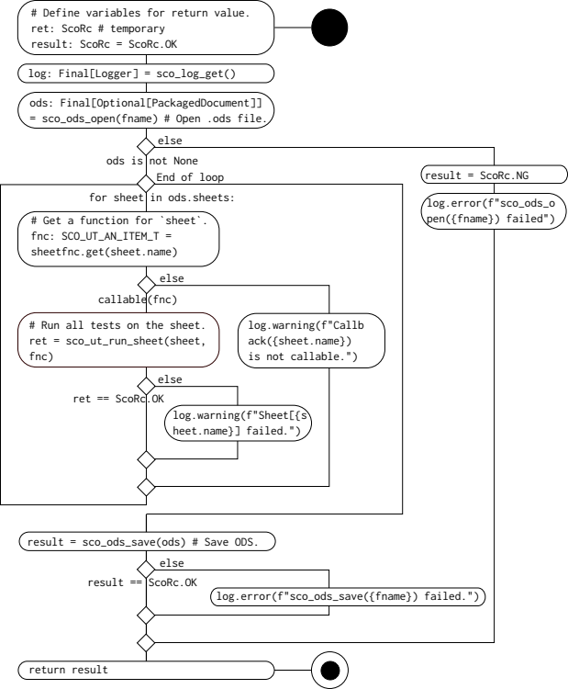
Figure 6.8: `sco_ut_run` activity diagram.

