Detailed Design

sco_stub

Python package for stubs.

Revision History
Rev. | Comment | Author

Table of Contents
1 Introduction 4
2 ScoStubComs.py 4
2.1 __init__ 4
2.2 ScoStubComs_init 4
3 logging/Formatter.py 5
3.1 FormatterStub 5
3.1.1 __init__ 5
3.2 g_StubComs_Formatter_get 5
3.3 Formatter_stub 6
4 logging/StreamHandler.py 6
4.1 StreamHandlerStub_setLevel 7
4.1.1 __init__ 7
4.2 StreamHandlerStub_setFormatter 7
4.2.1 __init__ 7
4.3 StreamHandlerStub 7
4.3.1 __init__ 7
4.3.2 setLevel 8
4.3.3 setFormatter 8
4.4 g_StubComs_StreamHandler_get 8
4.5 StreamHandler_stub 9
5 logging/Logger.py 9
5.1 LoggerStub_setLevel 10
5.1.1 __init__ 10
5.2 LoggerStub_addHandler 10
5.2.1 __init__ 10
5.3 LoggerStub 10
5.3.1 __init__ 10
5.3.2 setLevel 11
5.3.3 addHandler 11
5.4 g_StubComs_Logger_get 12
5.5 Logger_stub 12
6 logging/getLogger.py 12
6.1 StubCom_getLogger 13
6.1.1 __init__ 13
6.2 getLogger_stub 13
6.3 g_StubComs_getLogger_get 13
7 sco_log/sco_log_get.py 14
7.1 StubCom_sco_log_get 14
7.1.1 __init__ 14
7.2 sco_log_get_stub 14
7.3 g_StubComs_sco_log_get_get 15

Introduction
This is a detailed design document for Python package sco_stub. Table 1.1 shows reference materials.
Table 1.1: Reference materials.
Material | Reference
Functional Design sco_stub | fd_sco_stub.odt

In this document, the contents that overlap with the functional design document are not described as much as possible.

ScoStubComs.py
Table 2.1 shows imports.
Table 2.1: ScoOdsRng.py imports.
from | import | Reference
logging | Logger | Built-in.
sco_log.sco_log | sco_log_get | Table 1.1.

__init__
Figure 2.1 shows activity diagram.
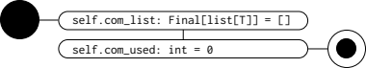
Figure 2.1: `ScoStubComs.__init__` activity diagram.

ScoStubComs_init
Figure 2.2 shows activity diagram.
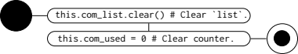
Figure 2.2: `ScoStubComs_init` activity diagram.

logging/Formatter.py
Table 3.1 shows imports.
Table 3.1: logging/Formatter.py imports.
from | import | Reference
logging | Logger | Built-in.
sco_log.sco_log | sco_log_get | Table 1.1.

Table 3.2 shows global variables.
Table 3.2: logging/Formatter.py global variables.
Global variable | Use
g_StubComs_Formatter | # The stores for the stub I/Os.  g_StubComs_Formatter: Final[StubComs_Formatter] = StubComs_Formatter()

FormatterStub

__init__
Figure 3.1 shows activity diagram.
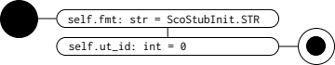
Figure 3.1: `FormatterStub.__init__` activity diagram.

g_StubComs_Formatter_get
Figure 3.2 shows activity diagram.

Figure 3.2: `g_StubComs_Formatter_get` activity diagram.

Formatter_stub
Figure 3.3 shows activity diagram.
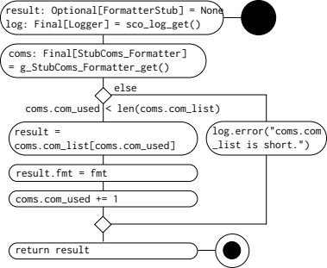
Figure 3.3: `Formatter_stub` activity diagram.

logging/StreamHandler.py
Table 4.1 shows imports.
Table 4.1: logging/StreamHandler.py imports.
from | import | Reference
logging | Logger, Formatter | Built-in.
sco_log.sco_log | sco_log_get | Table 1.1.

Table 4.2 shows global variables.
Table 4.2: logging/StreamHandler.py global variables.
Global variable | Use
g_StubComs_StreamHandler | # The stores for the stub I/Os.  g_StubComs_StreamHandler: Final[StubComs_StreamHandler] = StubComs_StreamHandler()

StreamHandlerStub_setLevel

__init__
Figure 4.1 shows activity diagram.
Figure 4.1: `StreamHandlerStub_setLevel.__init__` activity diagram.

StreamHandlerStub_setFormatter

__init__
Figure 4.2 shows activity diagram.

Figure 4.2: `StreamHandlerStub_setFormatter.__init__` activity diagram.

StreamHandlerStub

__init__
Figure 4.3 shows activity diagram.
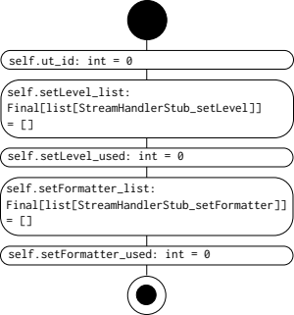
Figure 4.3: `StreamHandlerStub.__init__` activity diagram.

setLevel
Figure 4.4 shows activity diagram.
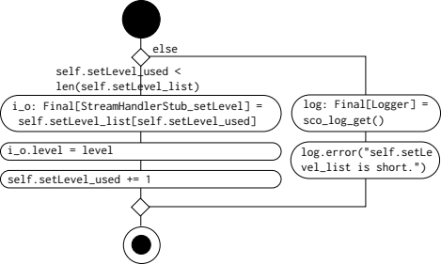
Figure 4.4: `StreamHandlerStub.setLevel` activity diagram.

setFormatter
Figure 4.5 shows activity diagram.
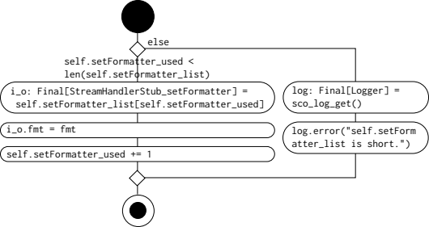
Figure 4.5: `StreamHandlerStub.setFormatter` activity diagram.

g_StubComs_StreamHandler_get
Figure 4.6 shows activity diagram.

Figure 4.6: `g_StubComs_StreamHandler_get` activity diagram.

StreamHandler_stub
Figure 4.7 shows activity diagram.
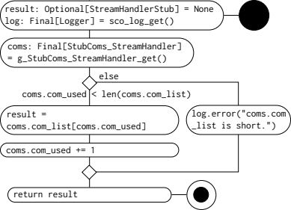
Figure 4.7: `StreamHandler_stub` activity diagram.

logging/Logger.py
Table 5.1 shows imports.
Table 5.1: logging/Logger.py imports.
from | import | Reference
logging | Logger, Handler | Built-in.
sco_log.sco_log | sco_log_get | Table 1.1.
sco_stub.ScoStubComs | ScoStubInit
.StreamHandler | StreamHandlerStub

Table 5.2 shows global variables.
Table 5.2: logging/Logger.py global variables.
Global variable | Use
g_StubComs_Logger | # The stores for the stub I/Os.  g_StubComs_Logger: Final[StubComs_Logger] = StubComs_Logger()

LoggerStub_setLevel

__init__
Figure 5.1 shows activity diagram.
Figure 5.1: `LoggerStub_setLevel.__init__` activity diagram.

LoggerStub_addHandler

__init__
Figure 5.2 shows activity diagram.

Figure 5.2: `LoggerStub_addHandler.__init__` activity diagram.

LoggerStub

__init__
Figure 5.3 shows activity diagram.
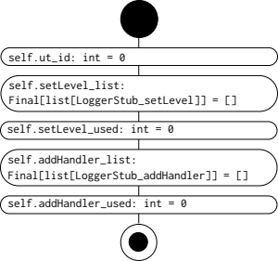
Figure 5.3: `LoggerStub.__init__` activity diagram.

setLevel
Figure 5.4 shows activity diagram.
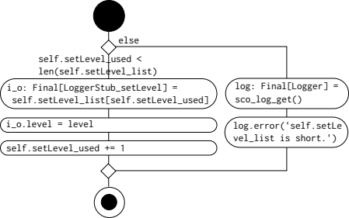
Figure 5.4: `LoggerStub.setLevel` activity diagram.

addHandler
Figure 5.5 shows activity diagram.
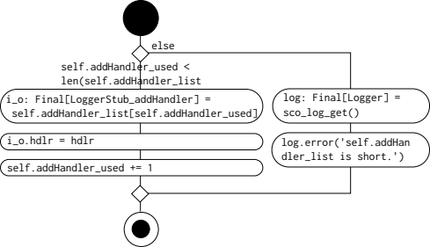
Figure 5.5: `LoggerStub.addHandler` activity diagram.

g_StubComs_Logger_get
Figure 5.6 shows activity diagram.

Figure 5.6: `g_StubComs_Logger_get` activity diagram.

Logger_stub
Figure 5.7 shows activity diagram.
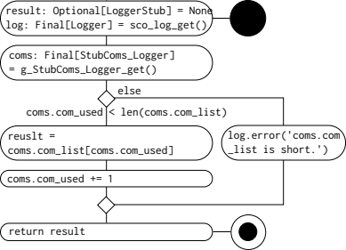
Figure 5.7: `Logger_stub` activity diagram.

logging/getLogger.py
Table 6.1 shows imports.
Table 6.1: logging/getLogger.py imports.
from | import | Reference
sco_log.sco_log | sco_log_get | Table 1.1.

Table 6.2 shows global variables.
Table 6.2: logging/getLogger.py global variables.
Global variable | Use
g_StubComs_getLogger | # The stores for the stub I/Os.  g_StubComs_getLogger: Final[StubComs_getLogger] = StubComs_getLogger()

StubCom_getLogger

__init__
Figure 6.1 shows activity diagram.
Figure 6.1: `StubCom_getLogger.__init__` activity diagram.

getLogger_stub
Don't call `sco_log_get()`. Because `sco_log_get()` calls `getLogger_stub()` in the unit test. Figure 6.2 shows activity diagram.
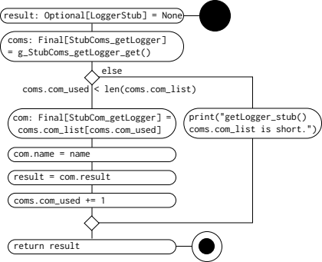
Figure 6.2: `getLogger_stub` activity diagram.

g_StubComs_getLogger_get
Figure 6.3 shows activity diagram.

Figure 6.3: `g_StubComs_getLogger_get` activity diagram.

sco_log/sco_log_get.py
Table 7.1 shows global variables.
Table 7.1: sco_log/sco_log_get.py global variables.
Global variable | Use
g_StubComs_sco_log_get | # The stores for the stub I/Os.  g_StubComs_sco_log_get: Final[StubComs_sco_log_get] = StubComs_sco_log_get()

StubCom_sco_log_get

__init__
Figure 7.1 shows activity diagram.
Figure 7.1: `StubCom_sco_log_get.__init__` activity diagram.

sco_log_get_stub
Figure 7.2 shows activity diagram.
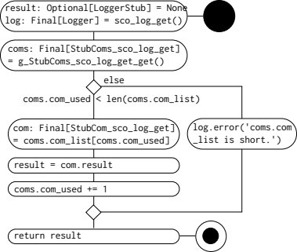
Figure 7.2: `sco_log_get_stub` activity diagram.

g_StubComs_sco_log_get_get
Figure 7.3 shows activity diagram.

Figure 7.3: `g_StubComs_sco_log_get_get` activity diagram.

