Thesis tables and figures
Tables and figures for the thesis draft of 2026-10-22, in the order of the planning list (T1–T10, F1–F13). Each item begins with a grey placement line (remove it after pasting). Captions use the thesis styles 'Table Title' and 'Caption' with SEQ fields, so the List of Tables and List of Figures pick them up; press F9 after pasting to renumber.
All values are read from the frozen Patch 22.4.3.2 records of the selected state (Candidate 1) and the committee package. Sizes in µm use the nominal, unvalidated 8 µm/px camera scale.
T1 · §3.2.1, after the paragraph on hatch spacing and spot diameter (end of the section)
Table 1. LPBF experimental setup and fixed process parameters
Parameter | Value
Machine | Aconity Mini laser powder bed fusion system
Laser wavelength | 1070 nm
Laser spot diameter (nominal) | 80 µm, all coupons
Feedstock | m4p 316L.03 stainless steel powder
Build plate | 316L stainless steel
Atmosphere | Argon, O₂ < 300 ppm
Fume extraction | Pump at 50% duty cycle
Coupon geometry (programmed) | ≈ 4 mm × 4 mm × 6.48 mm
Layers per coupon | 216
Layer thickness | 30 µm
Hatch spacing | 80 µm
Scan strategy | Contour pass, then hatch infill; hatch direction rotates by 45° between layers (0°, 45°, 90°, 135°)
Layer analysed | Layer 53 of every coupon; 54 laser-on scan tracks per coupon (track 1 = contour)
Laser power | 140–190 W
Scan speed | 600–1400 mm/s
Volumetric energy density | 41.7–125.0 J/mm³ (24 coupons, 18 conditions)
Process data acquisition | 200 kHz
Coaxial camera | Teledyne DALSA Genie Nano M640-NIR, 8-bit; 64 × 24 px region; ≈ 8 kHz; 40 µs exposure
Camera scale (nominal) | 8 µm/px, not independently calibrated

T2 · §3.2.2, first PLACEHOLDER (after the paragraph on the July and September campaigns)
Table 2. Experimental coupon matrix
Date (2026) | Part | P (W) | v (mm/s) | VED (J/mm³) | Campaign | Replicate | Analysis role
Jul 30 | 1 | 140 | 850 | 68.6 | repeated set | ×2 | Calibration
Jul 30 | 2 | 150 | 900 | 69.4 | repeated set | ×2 | Held out, in window
Jul 30 | 3 | 160 | 950 | 70.2 | repeated set | ×2 | Calibration
Jul 30 | 4 | 170 | 1000 | 70.8 | repeated set | ×2 | Held out, in window
Jul 30 | 5 | 180 | 1050 | 71.4 | repeated set | ×2 | Calibration
Jul 30 | 6 | 190 | 1100 | 72.0 | repeated set | ×2 | Calibration
Jul 31 | 1 | 140 | 850 | 68.6 | repeated set | ×2 | Calibration
Jul 31 | 2 | 150 | 900 | 69.4 | repeated set | ×2 | Held out, in window
Jul 31 | 3 | 160 | 950 | 70.2 | repeated set | ×2 | Calibration
Jul 31 | 4 | 170 | 1000 | 70.8 | repeated set | ×2 | Held out, in window
Jul 31 | 5 | 180 | 1050 | 71.4 | repeated set | ×2 | Calibration
Jul 31 | 6 | 190 | 1100 | 72.0 | repeated set | ×2 | Calibration
Sep 4 | 1 | 140 | 600 | 97.2 | speed sweep | – | Out of window, examined
Sep 4 | 2 | 140 | 1000 | 58.3 | speed sweep | – | Out of window, blind
Sep 4 | 3 | 140 | 1400 | 41.7 | speed sweep | – | Out of window, examined
Sep 4 | 4 | 180 | 600 | 125.0 | speed sweep | – | Out of window, examined
Sep 4 | 5 | 180 | 1000 | 75.0 | speed sweep | – | Held out, in window
Sep 4 | 6 | 180 | 1400 | 53.6 | speed sweep | – | Out of window, examined
Sep 10 | 1 | 140 | 700 | 83.3 | power sweep | – | Calibration
Sep 10 | 2 | 160 | 700 | 95.2 | power sweep | – | Out of window, blind
Sep 10 | 3 | 180 | 700 | 107.1 | power sweep | – | Out of window, examined
Sep 10 | 4 | 140 | 1200 | 48.6 | power sweep | – | Out of window, examined
Sep 10 | 5 | 160 | 1200 | 55.6 | power sweep | – | Out of window, blind
Sep 10 | 6 | 180 | 1200 | 62.5 | power sweep | – | Out of window, examined
Note. VED = P / (v h t) with h = 0.080 mm and t = 0.030 mm. ×2: the same condition was built on Jul 30 and Jul 31. Roles: calibration 9, held out in window 5, out of window examined 7, out of window blind 3 coupons.
F1 · §3.2.2, second PLACEHOLDER (after the paragraph on the four data roles)
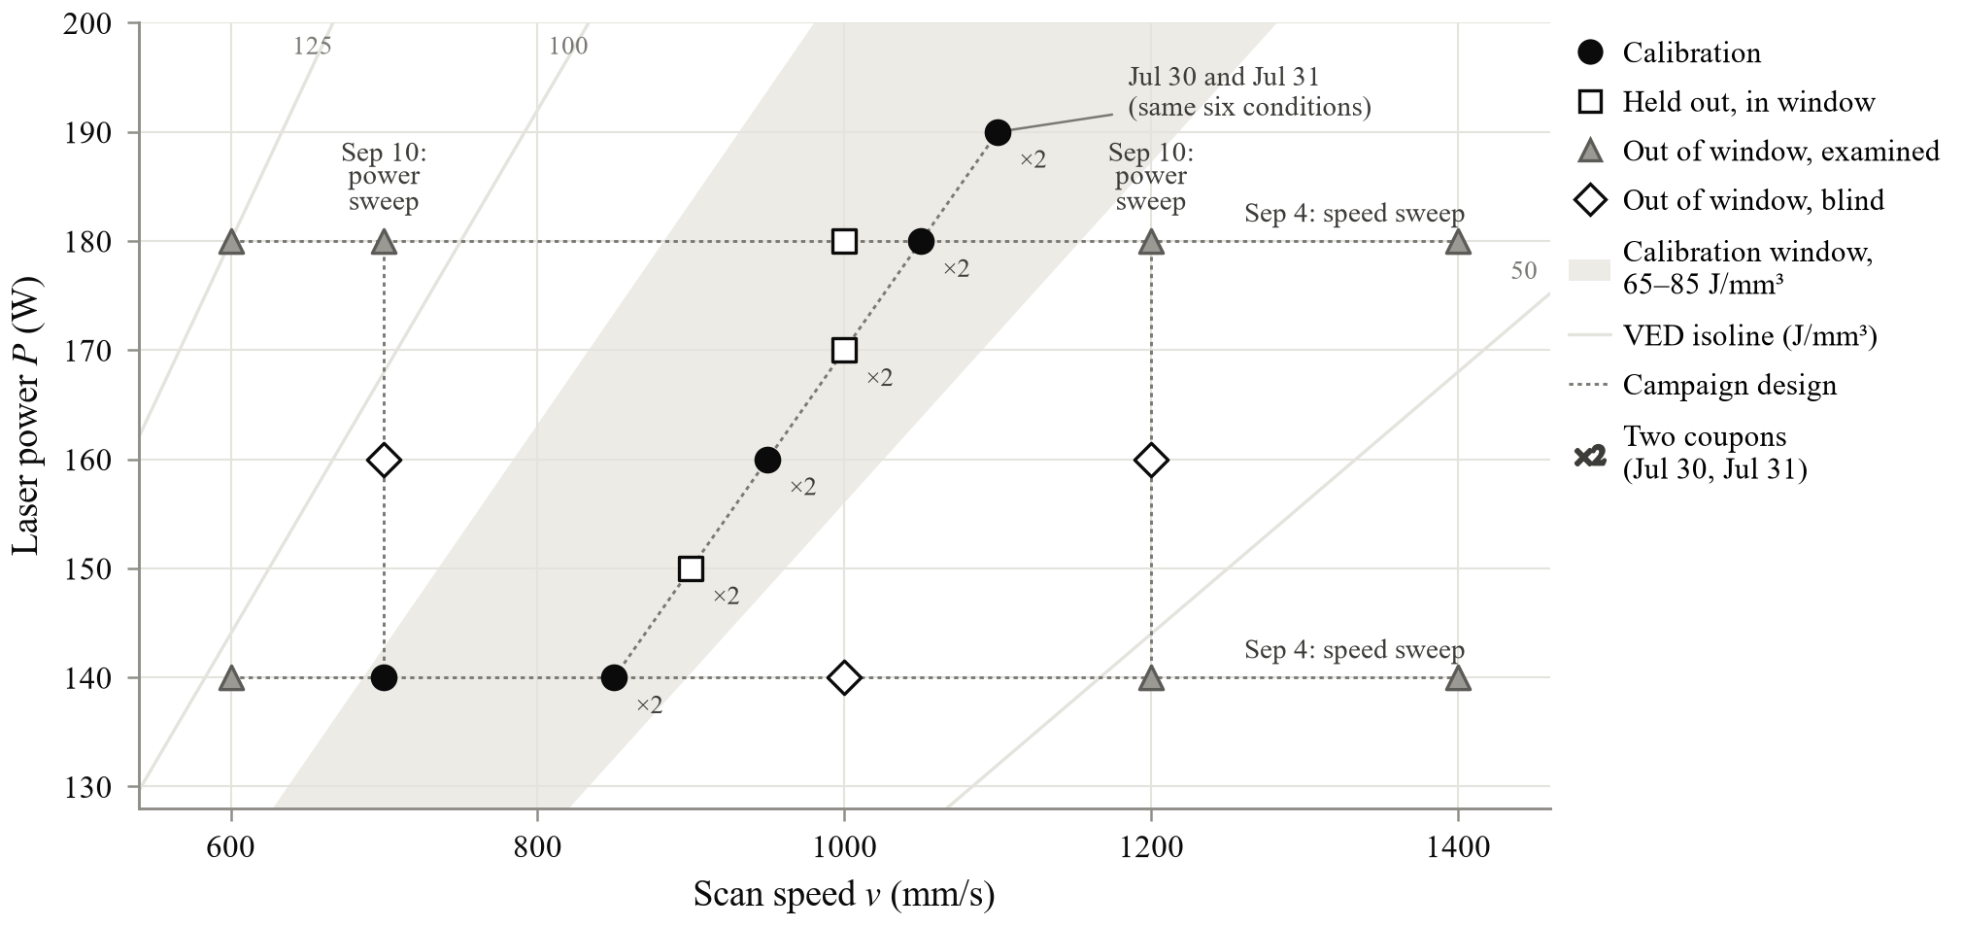
Figure 1. Experimental process space and data roles. Laser power against scan speed for the 18 process conditions (24 coupons). Marker shape and fill give the analysis role; ×2 marks the six conditions built on both July 30 and July 31. The shaded band is the 65–85 J/mm³ calibration window, thin lines are VED isolines and dotted lines show the campaign designs.
T3 · §3.2.3, replaces the existing channel table
Table 3. Recorded data channels and their roles
Process Channel | Description | Format | Acquisition Rate | Unit | Role in present study
Laser Drive | Laser drive/state | 64-bit float | 200 kHz | V | Laser-state determination; ≥ 2.5 V = laser on, < 2.5 V = laser off
Sync Pulse | Synchronization channel | 64-bit float | 200 kHz | — | Recorded synchronization channel; not directly used in present analysis
X-Machine | Mapped machine X coordinate | 64-bit float | 200 kHz | mm | Machine/build plate coordinate
Y-Machine | Mapped machine Y coordinate | 64-bit float | 200 kHz | mm | Machine/build plate coordinate
Coaxial GigE camera | Coaxial melt-pool image | 8-bit grayscale (uint8), 24 × 64 pixels | 8 kHz | Dimensionless intensity (0–255) | Source imagery for experimental melt-pool geometry
H | Threshold derived major axis dimension | 64-bit float | 8 kHz-Derived | pixels | Experimental melt pool major axis dimension
W | Threshold derived minor axis dimension | 64-bit float | 8 kHz-Derived | pixels | Experimental melt pool minor axis dimension

F2 · §3.2.4, first PLACEHOLDER (after 'Camera Image and H/W Definition')
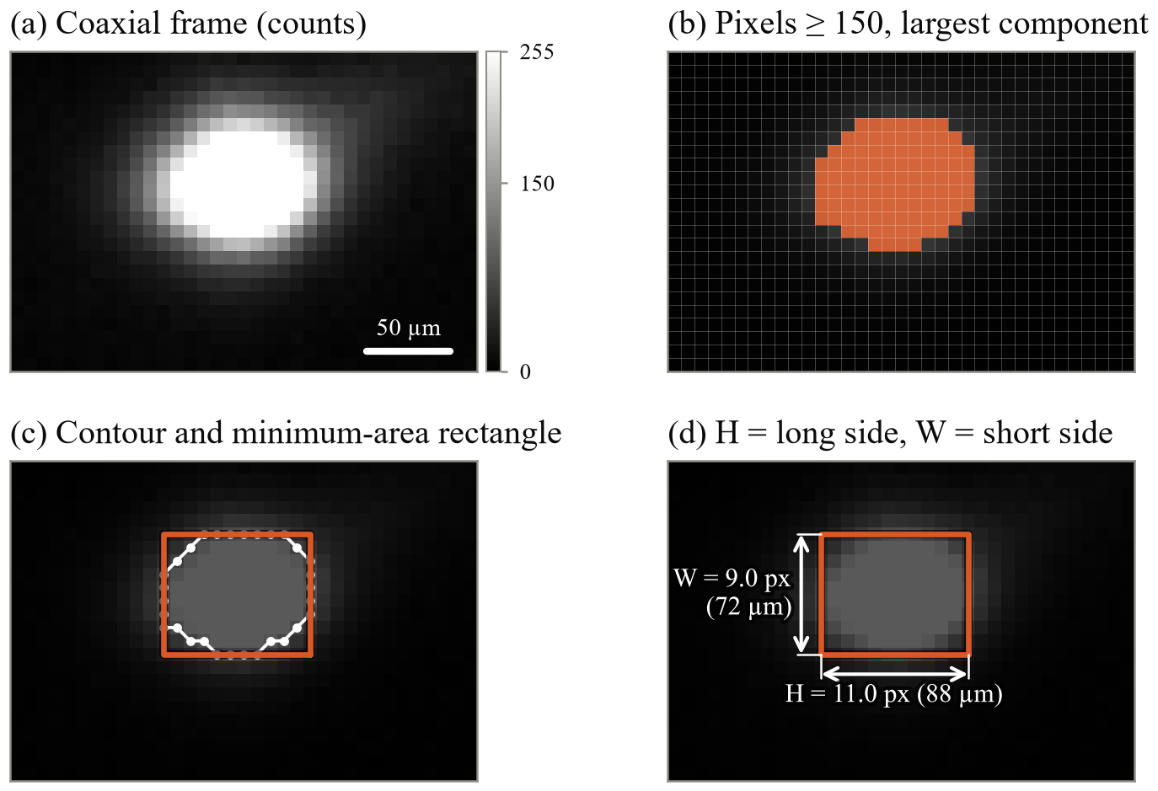
Figure 2. Extraction of the experimental melt-pool dimensions. (a) Coaxial frame 3298 of coupon 20260730:part_3 (160 W, 950 mm/s, 70.2 J/mm³), cropped from the 64 × 24 px image. (b) Pixels at or above 150 counts; the largest 8-connected component is the camera's melt pool. (c) Its external contour and minimum-area rectangle. (d) H and W are the rectangle's long and short sides, in µm at the nominal 8 µm/px. The frame is re-measured with the documented convention; its stored H × W is 11.1 × 9.1 px.
F3 · §3.2.5, PLACEHOLDER at the end of the section (or §3.2.4, after 'Scored Frame Selection')
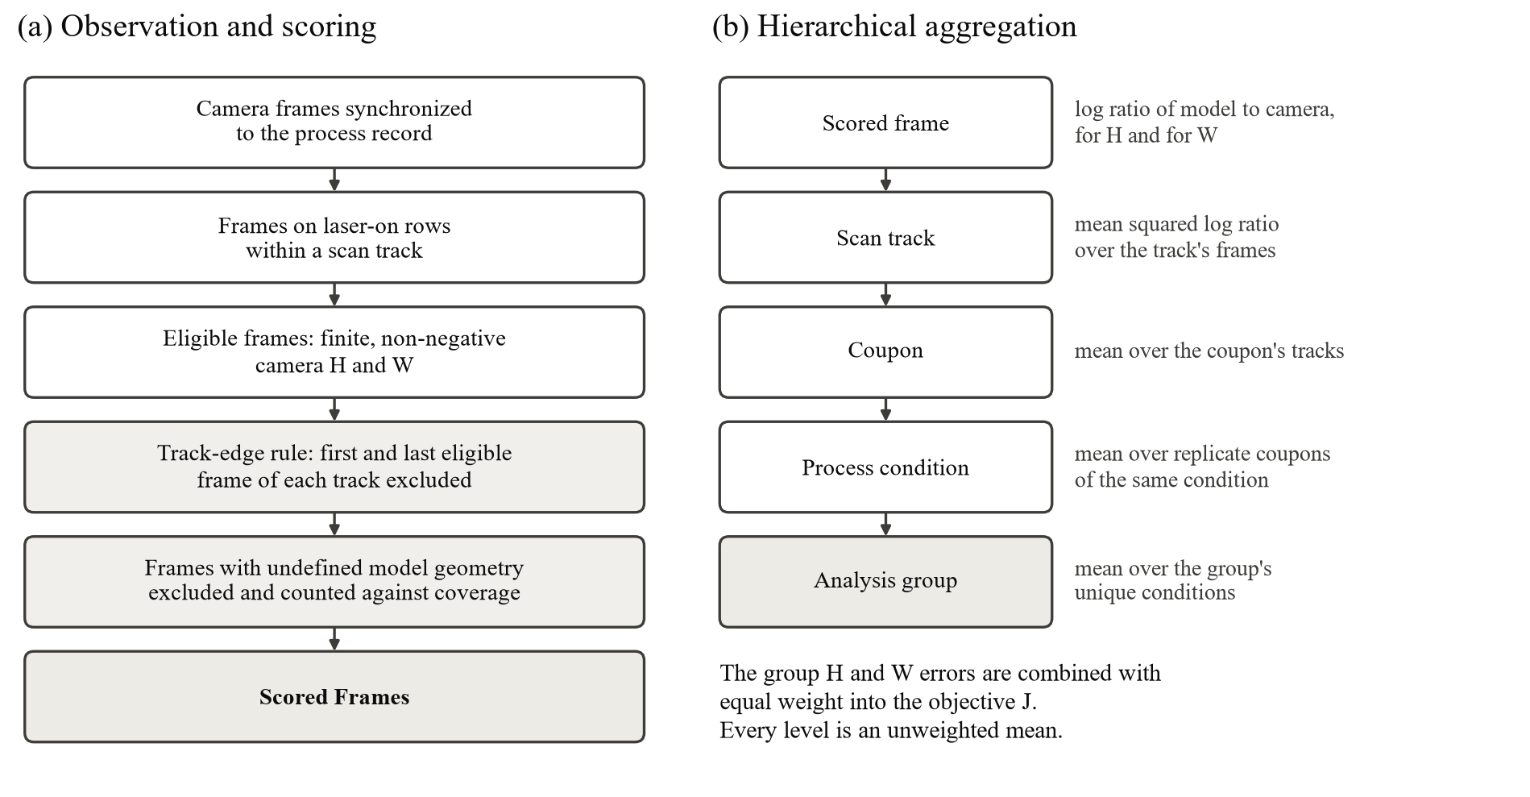
Figure 3. Observation, scoring and hierarchical aggregation. (a) The path of a camera frame from synchronization to scoring; shaded steps exclude frames, and excluded frames are recorded rather than deleted. (b) Squared log residuals are averaged from frame to scan track, coupon, process condition and analysis group, each level as an unweighted mean, so that densely sampled tracks, coupons or conditions receive no extra weight.
T4 · §3.3.4, PLACEHOLDER after the phase-dependent conductivity definition
Table 4. 316L material properties used by the model
Property | Symbol | Value | Units | Remark
Density | ρ | 7950 | kg/m³ | constant
Solidus temperature | T_{s} | 1648.15 | K | 1375 °C
Liquidus temperature | T_{l} | 1673.15 | K | 1400 °C
Boiling temperature | T_{b} | 3133.15 | K | threshold of the boiling regulator
Latent heat of fusion | L | 260,000 | J/kg | spread over the 25 K mushy interval
Specific heat, solid | c_{p,s} | 500 | J/(kg·K) | T ≤ T_{s}
Specific heat, mushy (sensible) | c_{p,m} | 650 | J/(kg·K) | T_{s} < T < T_{l}
Specific heat, mushy (effective) | c_{p,eff} | 11,050 | J/(kg·K) | c_{p,m} + L / (T_{l} − T_{s})
Specific heat, liquid | c_{p,l} | 820 | J/(kg·K) | T ≥ T_{l}
Conductivity, solid | k_{s} | 15 | W/(m·K) | T ≤ T_{s}
Conductivity, mushy | k_{m} | 22 | W/(m·K) | T_{s} < T < T_{l}
Conductivity, liquid | k_{l} | 30 | W/(m·K) | multiplied by c_{k} (calibrated; 2.418 × 30 = 72.5 W/(m·K) in the selected state)
Note. Phase-dependent first-pass engineering values; they were fixed and not calibrated. The directional term (η) multiplies the liquid conductivity along the scan by (1 + η); η = 0 in the selected state.
F4 · §3.3.1, after the paragraph on the moving local window (or the PLACEHOLDER at the end of §3.3.7)
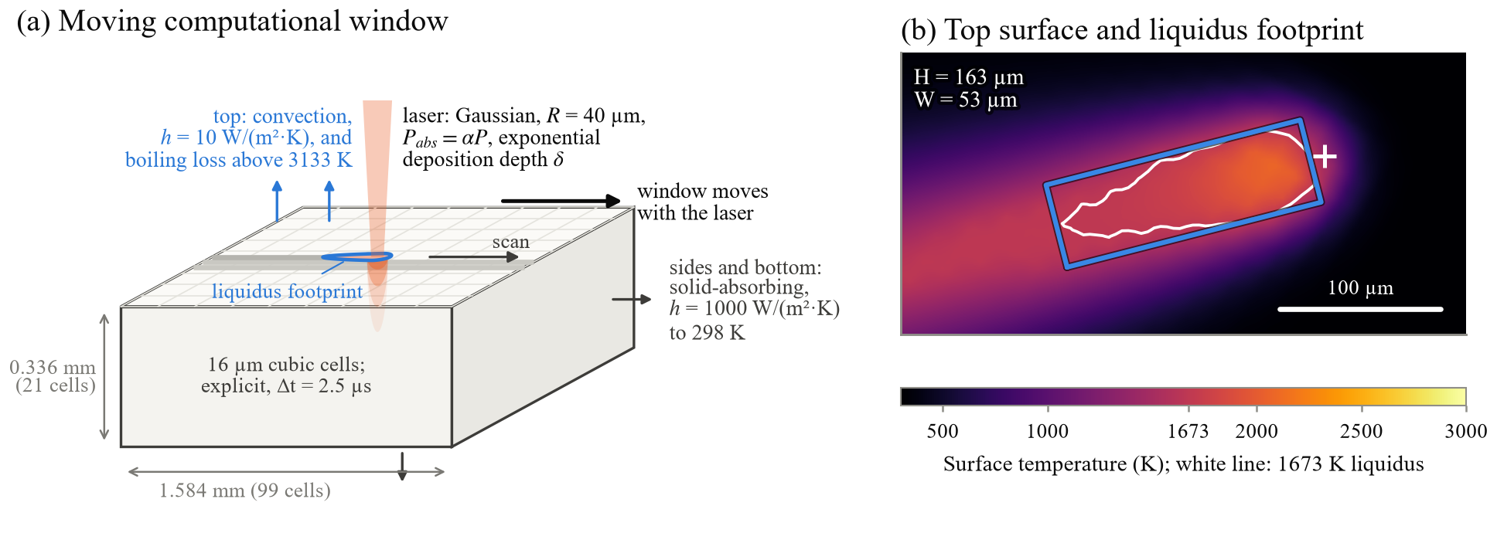
Figure 4. Reduced-order thermal model. (a) Schematic of the moving computational window (99 × 99 × 21 cubic cells of 16 µm; depth drawn twice its scale) with the Gaussian volumetric source, boundary treatments and the liquidus footprint. (b) Simulated top-surface temperature of the selected state at frame 3298 of 20260730:part_3 (70.2 J/mm³) with the liquidus contour of the laser-associated component (white) and its minimum-area rectangle (H = 163 µm, W = 53 µm); + marks the beam centre.
T5 · §3.3.10, PLACEHOLDER (replaces the note describing the intended table)
Table 5. Final numerical-model configuration
Quantity | Symbol | Role | Units | Value or treatment
Process inputs
Laser trajectory | x, y | prescribed | mm | X-Machine, Y-Machine at 200 kHz
Laser state | – | prescribed | – | on if Laser Drive > 2.5 V
Laser power | P | prescribed | W | nominal value per coupon (process record)
Process interval | Δt_{process} | prescribed | µs | 5
Discretization
Cell size | Δx | fixed | µm | 16 (cubic cells)
Moving window | N_{x} × N_{y} × N_{z} | fixed | cells | 99 × 99 × 21 (1.584 × 1.584 × 0.336 mm)
Thermal time step | Δt | fixed | µs | 2.5 (2 substeps per process row)
Explicit stability safety factor | s | fixed | – | 0.90
Transport stability guard | Δt / Δt_{safe} | fixed | – | ≤ 0.95 for every candidate
Boundary-loss stability | F_{boundary} | fixed | – | < 0.90 (audited to 7000 K)
Window motion | – | fixed | – | whole-cell field shifts; sub-cell offset kept in the source position
Window reset distance | d_{reset} | fixed | mm | 0.168 (field reset to 298.15 K)
Initial and bulk temperature | T_{bulk} | fixed | K | 298.15
Heat source
Lateral profile | R | fixed | mm | Gaussian, 1/e² radius 0.04
Depth profile | b(s; δ) | fixed | – | normalized truncated exponential
Absorbed power | P_{abs} | fixed | W | α P m_{TED} with m_{TED} = 1
Boundaries
Top surface | h_{conv}, T∞ | fixed | W/(m²·K), K | convection, 10, 298.15; radiation inactive
Sides and bottom | h_{solid}, T_{far} | fixed | W/(m²·K), K | solid-absorbing, 1000, 298.15
Boiling regulator
Threshold | T_{b} | fixed | K | 3133.15
Strength | b | fixed | – | 0.5
Reference conductance | h_{ref} | fixed | W/(m²·K) | 8.0 × 10⁶
Reference superheat | ΔT_{ref} | fixed | K | 1000
Transition width | – | fixed | K | 250 (smoothstep); energy sink, no cap
Observation
Liquid mask | T ≥ T_{l} | fixed | – | top-surface cells, 4-connected components
Laser association | B_{m} | fixed | – | largest beam share, at least 2%
Footprint geometry | H_{sim}, W_{sim} | fixed | px | interpolated liquidus contour, minimum-area rectangle; 8 µm/px nominal
Enclosure | – | fixed | – | component touching the window edge: undefined
Scoring
Scored frames | – | fixed | – | first and last eligible frame of each track excluded
Pixel floor and weights | – | fixed | px, – | 1 px; w_{H} = w_{W} = 0.5
Coverage floor | – | fixed | – | 95% per coupon (flag only)
Calibrated reduced-order parameters
Absorptivity | α | calibrated via t | – | α(t), t ∈ [−3, 3]; selected 0.490
Deposition depth | δ | calibrated via t | mm | δ(t), coupled to α; selected 0.0983
Liquid conductivity factor | c_{k} | calibrated | – | [1.5, 2.5]; selected 2.418
Directional transport | η | calibrated | – | [0, 1]; selected 0
Note. Material properties are listed separately. Absorptivity and deposition depth share one calibration coordinate, t.
T6 · §3.4.1, PLACEHOLDER after the bounds of c_k and η
Table 6. Calibration parameters and bounds
Quantity | Symbol | Bounds | Unit | Definition | Physical interpretation | Selected
Absorptivity–depth coordinate | t | [−3, 3] | – | calibration coordinate | One identifiable direction that moves α and δ together | −3 (lower bound)
Absorptivity | α(t) | 0.490–0.641 | – | α = 0.565625 + 0.0252194 t | Fraction of incident power absorbed | 0.490
Deposition depth | δ(t) | 0.0517–0.0983 | mm | δ = 0.075000 − 0.00776201 t | Decay length of the exponential depth profile | 0.0983
Liquid conductivity factor | c_{k} | [1.5, 2.5] | – | calibration coordinate | Multiplies the liquid conductivity (unresolved melt flow) | 2.418
Directional transport | η | [0, 1] | – | calibration coordinate | Extra liquid conductivity along the local scan direction, × (1 + η) | 0 (lower bound)
Stability guard | Δt / Δt_{safe} | ≤ 0.95 | – | constraint on (c_{k}, η) | Rejects numerically marginal states before any run | 0.724
Note. Selected: Candidate 1, the calibrated state. Increasing t raises α and shortens δ. The boiling-regulator strength (b = 0.5) and all other quantities were fixed and are not calibration coordinates.
F5 · §3.4.4, end of the section (before §3.5)
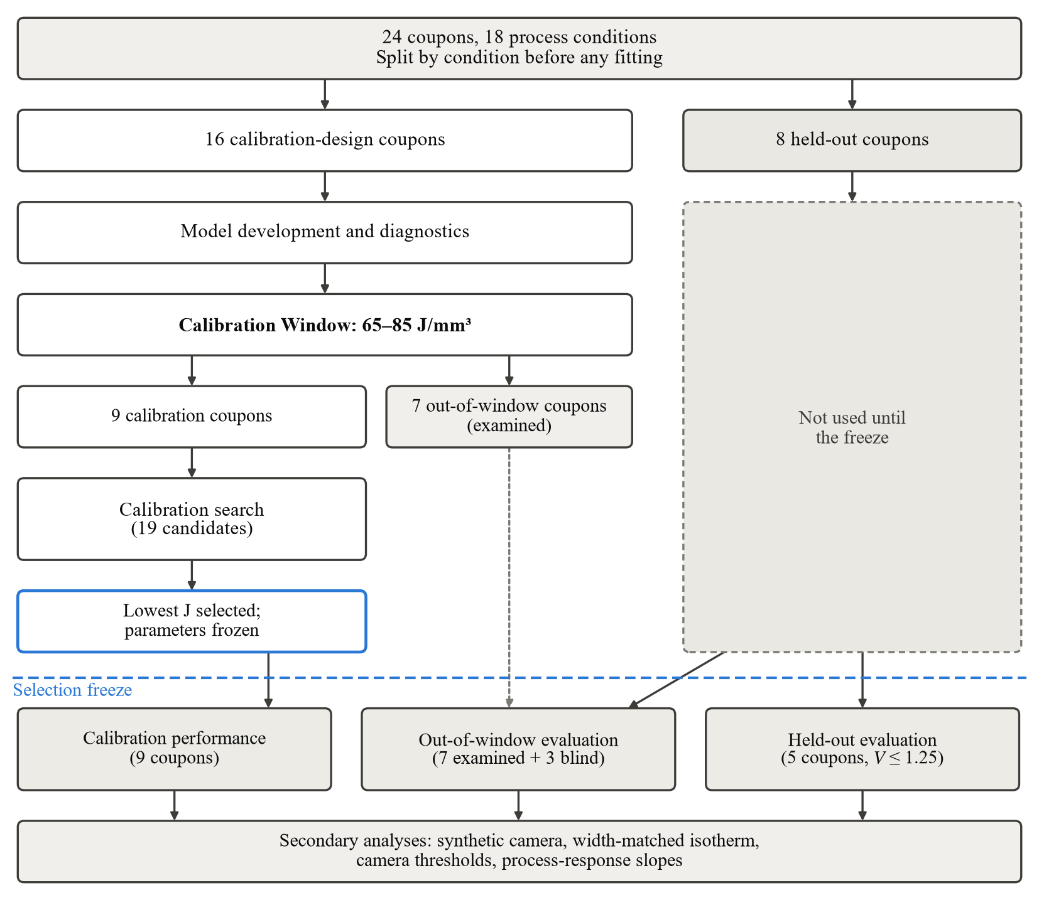
Figure 5. Calibration, data freeze and evaluation sequence. Calibration-design and held-out coupons were separated by process condition before any fitting. The held-out coupons were not compared with the model until the selection freeze; the out-of-window calibration-design coupons had been examined during model development (dashed arrow). The calibration search combined a predefined design of anchor and Halton points with confirmation candidates proposed by a quadratic surrogate, and the candidate with the lowest measured objective was selected.
F6 · §4.1, first PLACEHOLDER
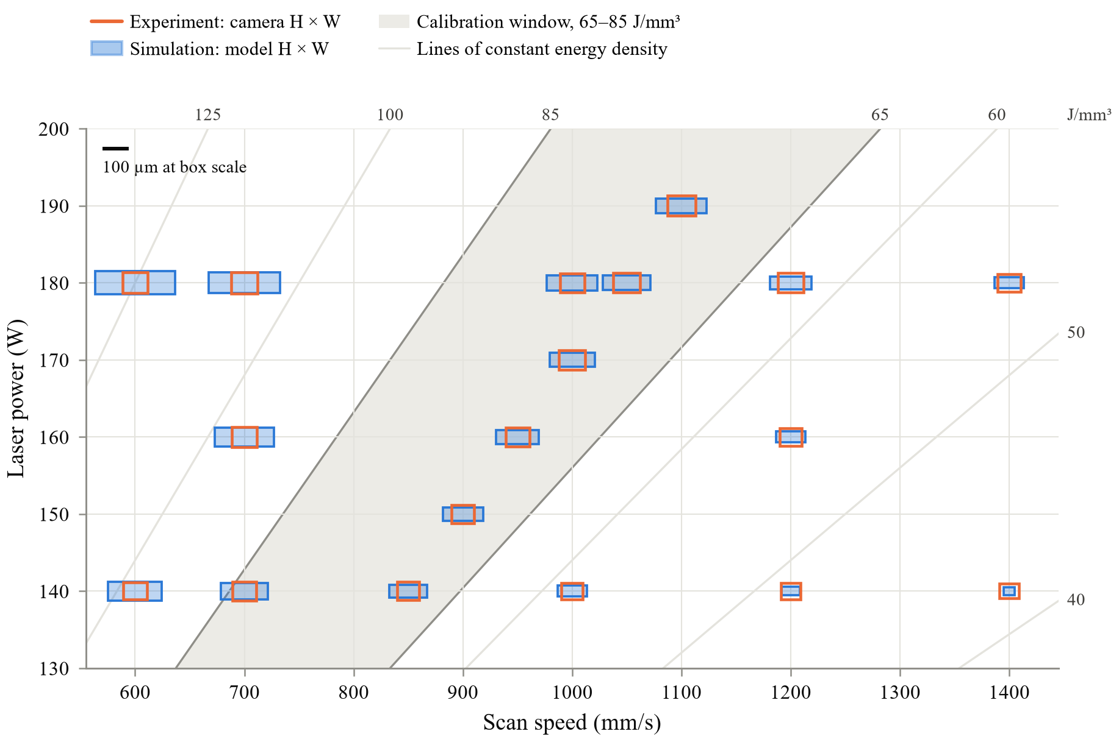
Figure 6. Melt-pool footprints over process space. Each pair of boxes sits at its process condition, with replicate coupons pooled. The orange outline is the camera's median melt-pool footprint and the blue box the calibrated model's, both drawn to one size scale with H horizontal and W vertical. The shaded band marks the calibration window and the thin lines are lines of constant volumetric energy density.
T7 · §4.1, second PLACEHOLDER
Table 7. Repeatability of the July replicate conditions
Condition | VED (J/mm³) | Role | H, Jul 30 (px) | H, Jul 31 (px) | ΔH (%) [95% CI] | W, Jul 30 (px) | W, Jul 31 (px) | ΔW (%) [95% CI]
140 W, 850 mm/s | 68.6 | Calibration | 10.29 | 10.24 | −0.5 [−4.1, +3.8] | 8.79 | 8.65 | −1.5 [−4.7, +2.1]
150 W, 900 mm/s | 69.4 | Held out | 10.63 | 10.59 | −0.4 [−5.2, +5.0] | 8.87 | 8.80 | −0.8 [−5.0, +4.9]
160 W, 950 mm/s | 70.2 | Calibration | 11.22 | 11.23 | +0.1 [−3.1, +4.4] | 9.00 | 9.00 | +0.0 [−1.1, +1.7]
170 W, 1000 mm/s | 70.8 | Held out | 12.20 | 12.28 | +0.7 [−3.9, +6.0] | 9.14 | 9.09 | −0.5 [−3.0, +1.8]
180 W, 1050 mm/s | 71.4 | Calibration | 12.63 | 12.56 | −0.5 [−5.3, +4.0] | 9.19 | 9.15 | −0.5 [−3.6, +2.6]
190 W, 1100 mm/s | 72.0 | Calibration | 13.34 | 13.44 | +0.7 [−3.5, +4.4] | 9.37 | 9.42 | +0.6 [−4.7, +4.2]
Note. Camera coupon medians of the scored frames. Δ = 100 ln(Jul 31 / Jul 30); 95% intervals from 4,000 track-bootstrap resamples within each coupon. Mean |ΔH| = 0.5%, mean |ΔW| = 0.7%; no interval excludes zero.
T8 · §4.2, first PLACEHOLDER
Table 8. Selected calibration state
Quantity | Candidate 1 (selected) | Candidate 2 (second best)
Origin | confirmation (surrogate minimizer) | confirmation (flat valley)
t | −3 | −3
c_{k} | 2.418 | 2.370
η | 0.000 | 0.401
α | 0.490 | 0.490
δ (mm) | 0.0983 | 0.0983
J | 0.2981 | 0.3154
e_{H} | 0.651 | 0.675
e_{W} | 0.416 | 0.418
½ Q_{H} / ½ Q_{W} | 0.212 / 0.086 | 0.228 / 0.088
Rank by J | 1 of 19 | 2 of 19
Stability guard value (≤ 0.95) | 0.724 | 0.900
Coverage | 1.000 | 1.000
Scored frames | 8,943 | 8,943
Frames without a pool | 16 | 15
Frames with peak above 3133 K | 3.4% | 3.5%
Median peak surface T (K) | 2117 | 2116
Note. Both on the 9 calibration coupons. Candidate 1 lies at the lower bounds of t and η; c_{k} is interior. The near-best set (J ≤ 1.10 J_{min}) contains only these two candidates.
F7 · §4.2, second PLACEHOLDER
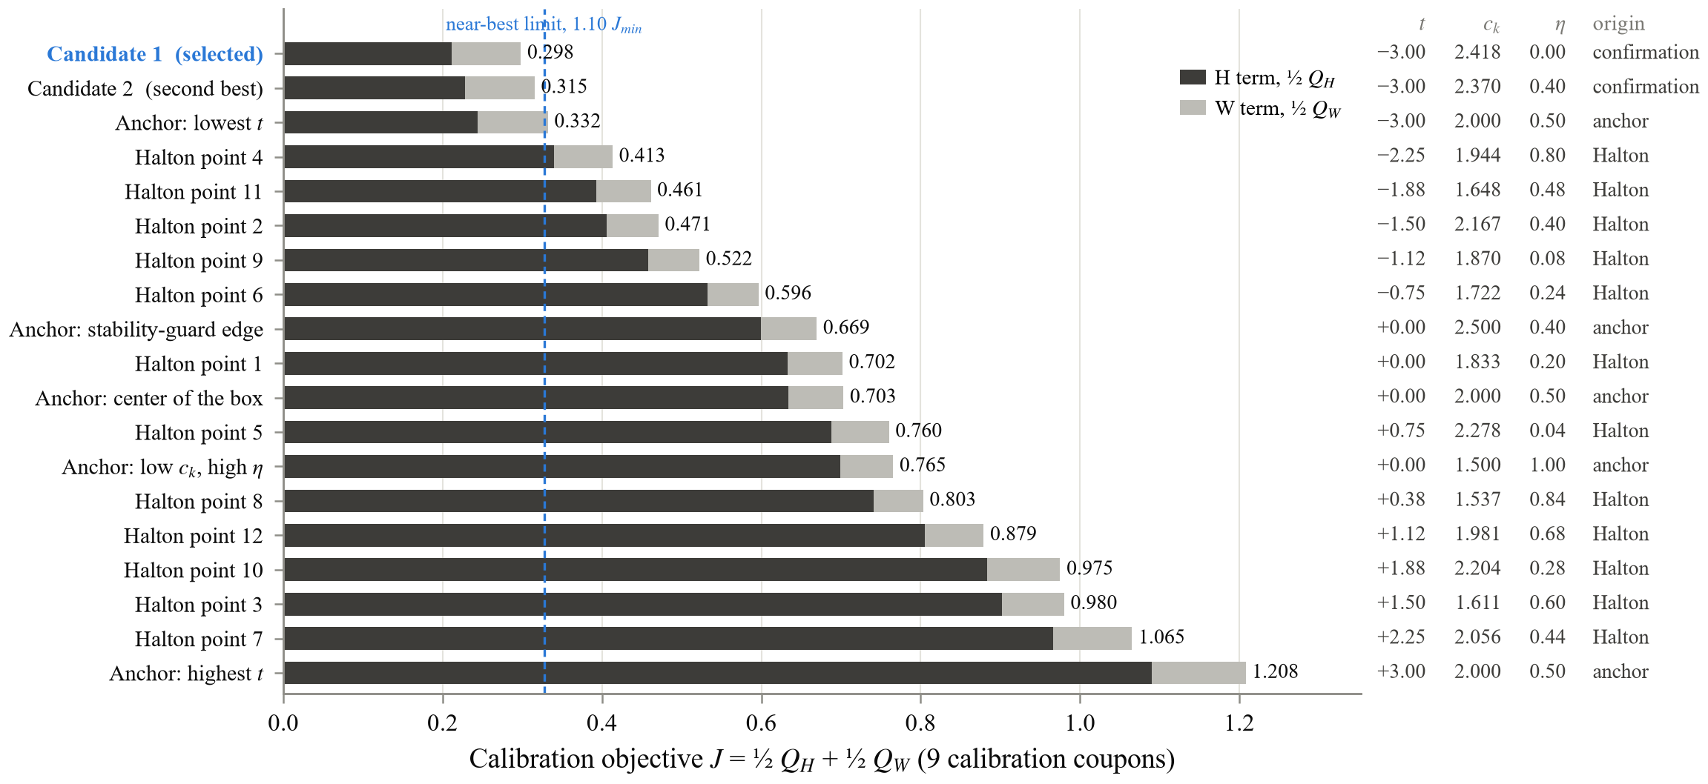
Figure 7. Calibration candidates ranked by the measured objective. Measured objective J on the calibration coupons for every directly evaluated parameter state, split into its H term (dark) and W term (light); the columns give each state's calibration coordinates. Anchor and Halton points form the predefined search design, and Candidates 1 and 2 are the confirmation states proposed by the quadratic surrogate. The dashed line marks the predefined near-best limit relative to the lowest J.
F8 · §4.3, first PLACEHOLDER
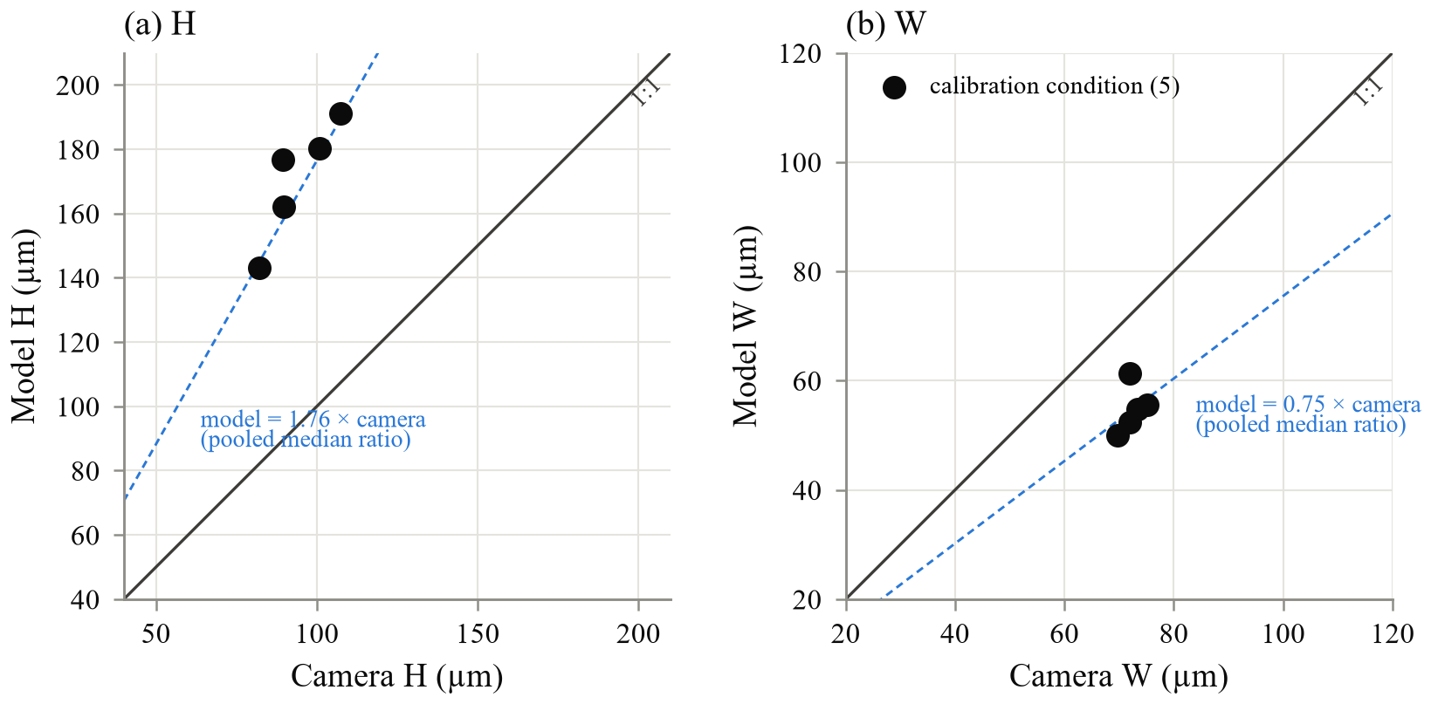
Figure 8. Observed and predicted melt-pool dimensions in the calibration window. Condition medians of camera and model H (a) and W (b) for the five calibration conditions; model medians over frames with a predicted pool. Solid line: 1:1; dashed line: pooled median ratio. Condition ratios range from 1.69 to 1.96 for H and from 0.73 to 0.88 for W.
T9 · §4.4, PLACEHOLDER (or §4.3, second PLACEHOLDER)
Table 9. Calibration and held-out performance
Quantity | Calibration | Held out, in window | Sep 4, 180 W, 1000 mm/s (held out)
Coupons (conditions) | 9 (5) | 5 (3) | 1 (1)
Scored frames | 8,943 | 4,796 | 884
e_{H} | 0.651 [0.594, 0.689] | 0.672 [0.575, 0.719] | 0.749 [0.712, 0.782]
e_{W} | 0.416 [0.353, 0.489] | 0.423 [0.353, 0.517] | 0.380 [0.351, 0.417]
J | 0.298 [0.246, 0.351] | 0.315 [0.228, 0.370] | 0.353 [0.322, 0.384]
H ratio, model / camera | 1.76 [1.72, 1.83] | 1.77 [1.71, 1.89] | 2.03 [1.95, 2.11]
W ratio, model / camera | 0.75 [0.73, 0.81] | 0.75 [0.74, 0.79] | 0.81 [0.80, 0.83]
Camera H × W (µm) | 93 × 72 | 91 × 72 | 93 × 72
Model H × W (µm) | 167 × 54 | 161 × 53 | 191 × 57
Coverage (lowest coupon) | 1.000 | 1.000 | 1.000
Frames without a pool | 16 | 11 | 0
V_{H} = e_{H} / e_{H,cal} | – | 1.033 [0.879, 1.155] | 1.151 [1.069, 1.272]
V_{W} = e_{W} / e_{W,cal} | – | 1.017 [0.772, 1.328] | 0.915 [0.760, 1.100]
Note. Errors are hierarchical log-RMSEs over the group's conditions; ratios are medians of the frame ratios, with frames without a pool scored as H = W = 0 (1 px floor). Brackets: 95% percentile bootstrap over coupons within the group (single coupon: over tracks). Model sizes are medians of the frames with a pool. Predefined criterion V ≤ 1.25 for H and W: met for both.
F9 · §4.4, PLACEHOLDER, after the table
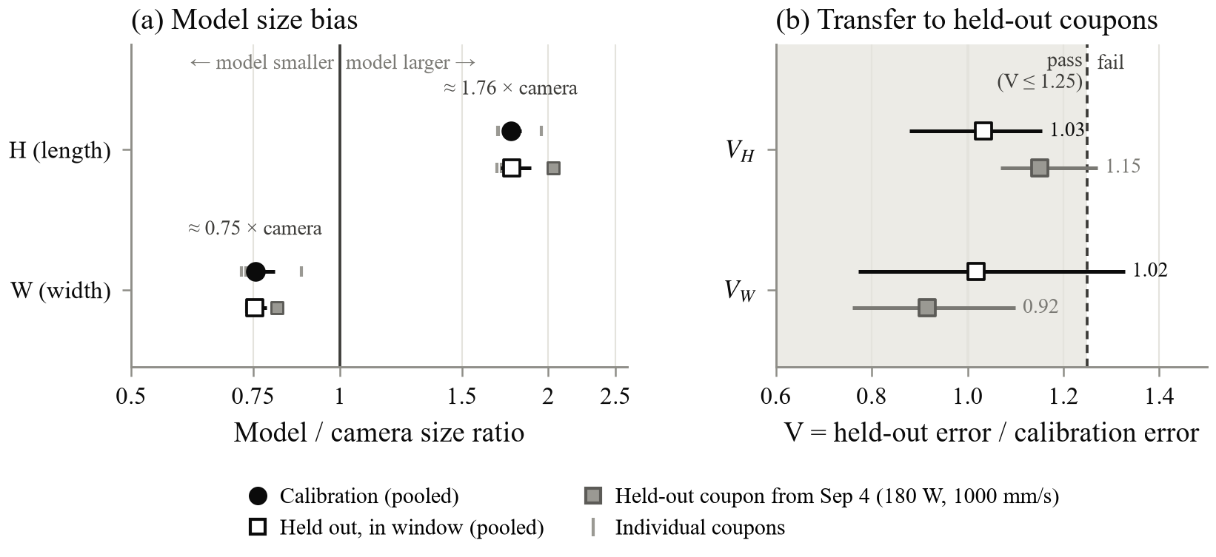
Figure 9. Calibration and in-window held-out comparison. (a) Pooled model-to-camera size ratios for the calibration and in-window held-out groups, with bootstrap intervals; tick marks are individual coupons. The model is longer and narrower than the camera footprint, by nearly the same factor in both groups. (b) Held-out error divided by calibration error, V, for H and W, with bootstrap intervals. Both pooled values lie close to equal error and inside the predefined pass criterion V ≤ 1.25. The grey square is the in-window held-out coupon from the speed-sweep campaign, shown alone.
F10 · §4.5, first PLACEHOLDER
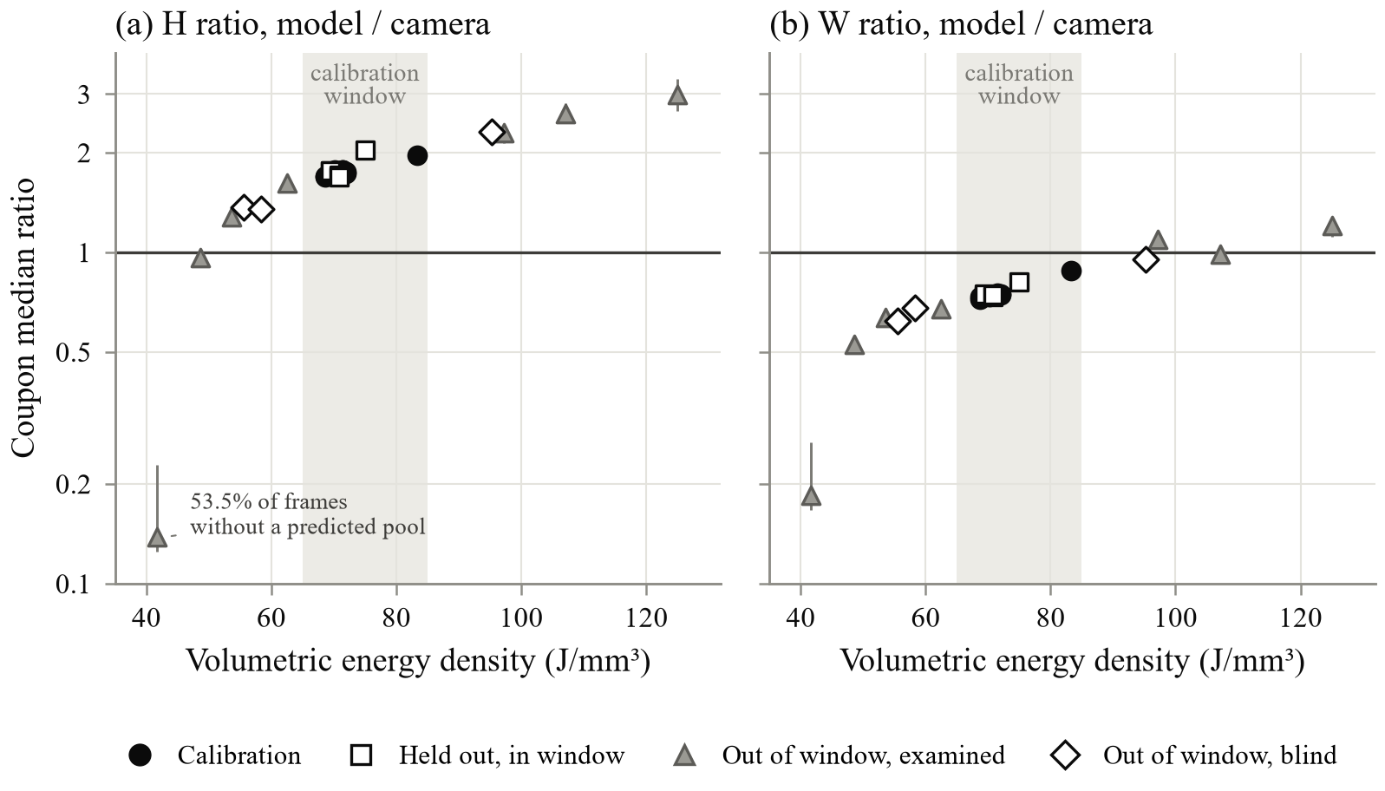
Figure 10. Model-to-camera ratios against volumetric energy density. Coupon median ratios of H (a) and W (b) on a log scale, with 95% track-bootstrap intervals; marker shape gives the data role and the shaded band the calibration window. Frames without a predicted pool are scored as H = W = 0 (1 px floor); they make up 53.5% of the scored frames at 41.7 J/mm³.
T10 · §4.5, second PLACEHOLDER
Table 10. Out-of-window performance by process condition
Condition | VED (J/mm³) | Status | H ratio [95% CI] | W ratio [95% CI] | No pool (%) | Coverage
140 W, 1400 mm/s | 41.7 | examined | 0.14 [0.13, 0.23] | 0.18 [0.17, 0.27] | 53.5 | 1.000
140 W, 1200 mm/s | 48.6 | examined | 0.96 [0.94, 0.99] | 0.53 [0.52, 0.54] | 11.0 | 1.000
180 W, 1400 mm/s | 53.6 | examined | 1.28 [1.24, 1.36] | 0.64 [0.62, 0.66] | 3.3 | 1.000
160 W, 1200 mm/s | 55.6 | blind | 1.36 [1.32, 1.42] | 0.62 [0.61, 0.63] | 0.0 | 1.000
140 W, 1000 mm/s | 58.3 | blind | 1.35 [1.31, 1.38] | 0.68 [0.67, 0.69] | 0.1 | 1.000
180 W, 1200 mm/s | 62.5 | examined | 1.61 [1.58, 1.66] | 0.67 [0.66, 0.68] | 0.1 | 1.000
160 W, 700 mm/s | 95.2 | blind | 2.31 [2.19, 2.47] | 0.95 [0.92, 0.98] | 0.0 | 1.000
140 W, 600 mm/s | 97.2 | examined | 2.30 [2.14, 2.44] | 1.10 [1.08, 1.10] | 0.0 | 1.000
180 W, 700 mm/s | 107.1 | examined | 2.62 [2.46, 2.81] | 0.99 [0.97, 1.04] | 0.0 | 1.000
180 W, 600 mm/s | 125.0 | examined | 2.98 [2.66, 3.33] | 1.20 [1.11, 1.23] | 0.0 | 1.000
Below the window (6) |  |  | 1.29 [0.99, 1.48] | 0.63 [0.55, 0.67] | 10.0 | 1.000
Above the window (4) |  |  | 2.50 [2.30, 2.78] | 1.07 [0.98, 1.15] | 0.0 | 1.000
All out of window (10) |  |  | 1.98 [1.34, 2.40] | 0.97 [0.67, 1.07] | 4.4 | 1.000
Note. Each out-of-window condition is one coupon. Ratios are medians of the frame ratios (model / camera); intervals from 4,000 track-bootstrap resamples (single coupon) or coupon-bootstrap resamples (groups). 'Examined' coupons were compared with the model during development; 'blind' coupons were first compared after the freeze. Spearman rank correlation of the coupon median log residual with VED: ρ = 0.976 (H), 0.964 (W). Below the window, H is still larger than the camera's for 4 of 6 coupons; W is smaller for all 6.
F11 · §4.6, first PLACEHOLDER
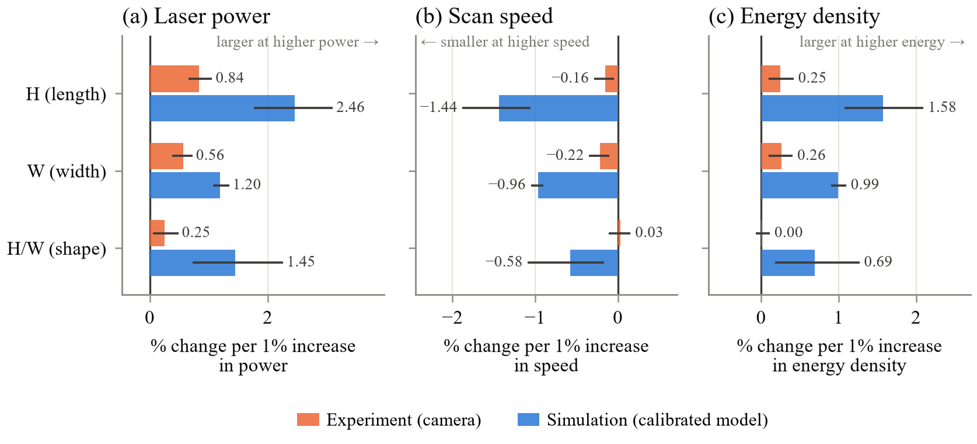
Figure 11. Sensitivity of melt-pool size to the process parameters. Fitted percentage change in melt-pool length H, width W and shape H/W for a one-percent increase in laser power (a), scan speed (b) and volumetric energy density (c), from log-log regressions over the coupon medians, for the camera (orange) and the calibrated model (blue); lines are coupon-bootstrap intervals. Camera and model change in the same direction, but the model responds several times more strongly in both length and width. The camera's shape barely changes with energy density, whereas the model's elongates. Leaving out the lowest-energy coupon does not change these conclusions.
F12 · §4.7, first PLACEHOLDER
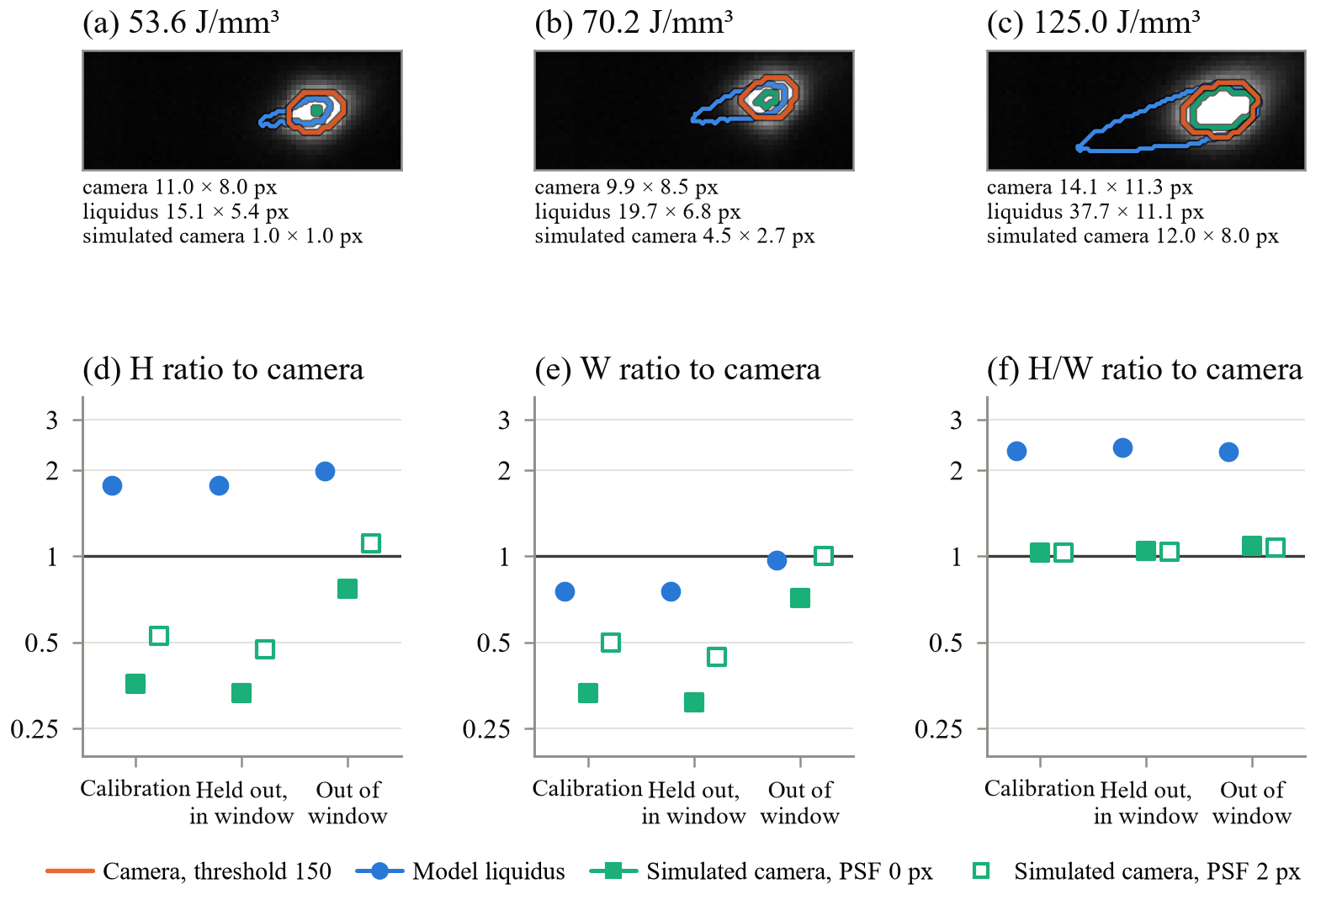
Figure 12. Observation operators compared. (a–c) One scored camera frame per energy-density level, with the camera threshold-150 outline (orange), the model liquidus outline (blue) and the simulated-camera threshold-150 outline (aqua; 850 nm, uniform emissivity, PSF 0 px, T150 = 1950 K) in camera pixels. (d–f) Group medians of the H, W and H/W ratios to the camera for the liquidus and the simulated camera (PSF 0 and 2 px). In the calibration group the H/W ratio is 2.34 for the liquidus and 1.03 for the simulated camera; simulated-camera coverage outside the window is 72% (PSF 0) and 69% (PSF 2).
F13 · §4.7, second PLACEHOLDER
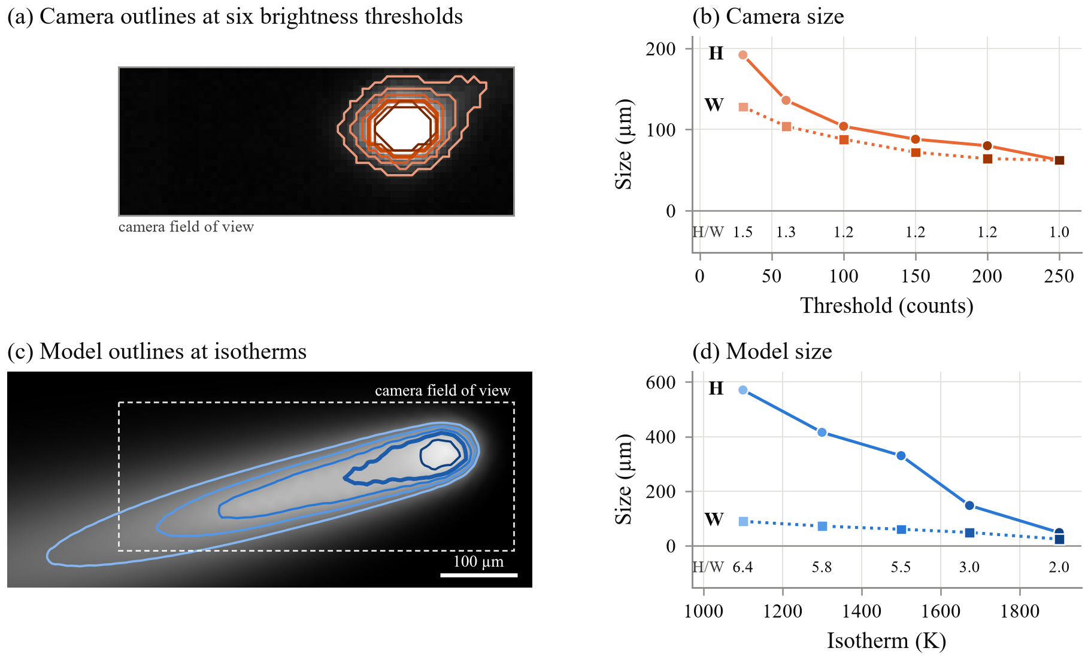
Figure 13. Camera thresholds and model isotherms. One scored frame of a calibration coupon, seen by the camera and by the calibrated model. (a) Camera melt-pool outlines at increasing brightness thresholds; the thick outline is the 150-count threshold used for scoring. (b) Camera H and W at each threshold, with H/W below. (c) Model outlines at increasing isotherms on the simulated top surface; the thick outline is the 1673 K liquidus used for scoring, the dashed frame marks the camera's field of view, and isotherms that leave the model window are not drawn. (d) Model H and W at each isotherm. Raising the threshold shrinks the camera footprint while it stays nearly round, whereas every model isotherm is more elongated than any camera outline, so changing the level does not bring the two shapes together.

