GEO503 by Adam

Fall 2017

Final Project Proposal

Shengyuan Zou

Vacancy rate change in Buffalo, NY, from 2011 to 2017

Introduction

Since 2007, City of Buffalo announced a demolition plan to remove large amount of vacant houses in the City. That published plan stated City of Buffalo was going to demolish 5,000 vacant houses in 5 years. However, this plan was completed in 2012. Several years ago, City of Buffalo announced another revitalization plan. They started to build up in downtown Buffalo. It would be a special perspective if we check the vacancy rate change during these years. Visualizing census vacancy rate data could provide us a new view of the urban change in Buffalo. In addition, from previous research, the change of vacancy rate could be correlated with other demographic data, like income, race and educated level. I would like to check the correlationship from new data in recent several years.

Inspiring Examples

<http://onlinelibrary.wiley.com/doi/10.1111/j.1467-9906.2012.00627.x/pdf>

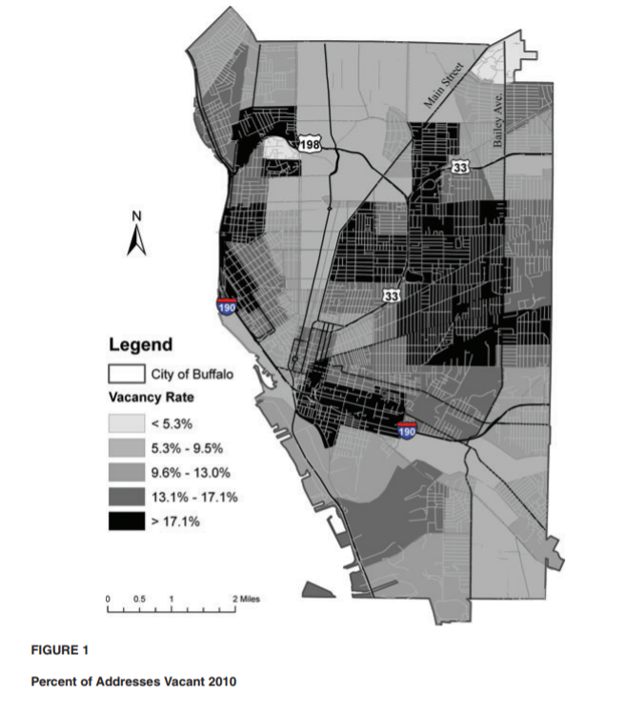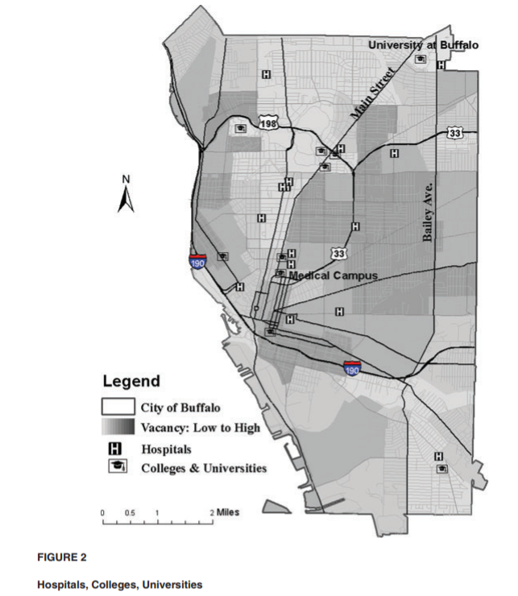

Distribution Visualization. (Change visualization)

<https://arxiv.org/pdf/1702.06683.pdf>

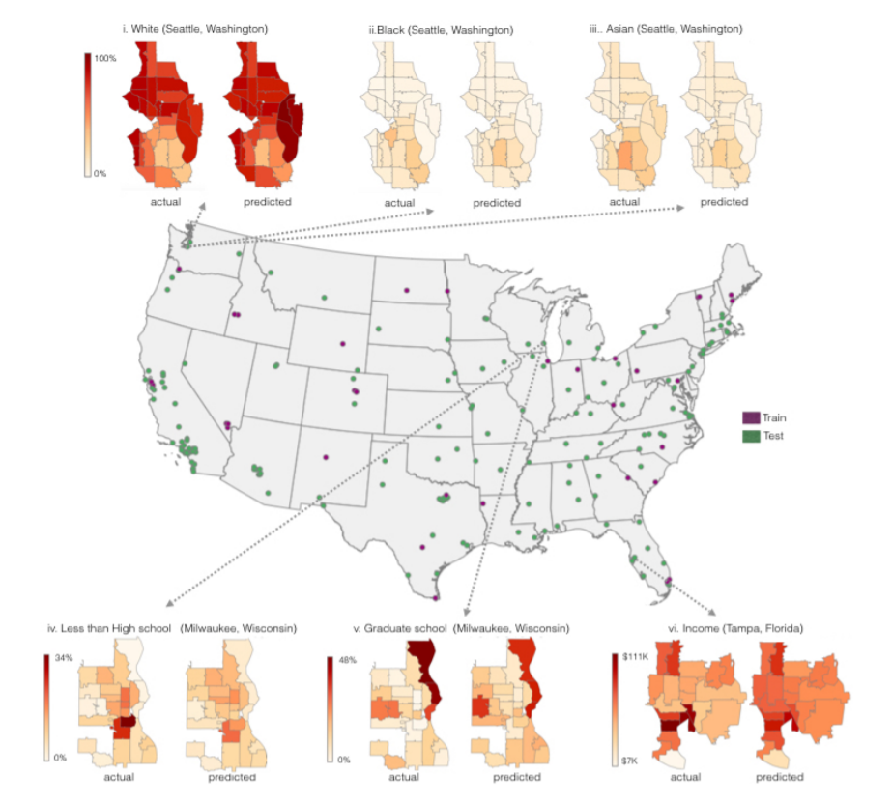

Correlated estimation from regression model.

Data Sources

Census demographic data: Vacancy rate, Income, Race etc.(block-group level) seven years, estimated data

TIGER data: census block group (278 in Buffalo) is used as unit in statistic and calculation.

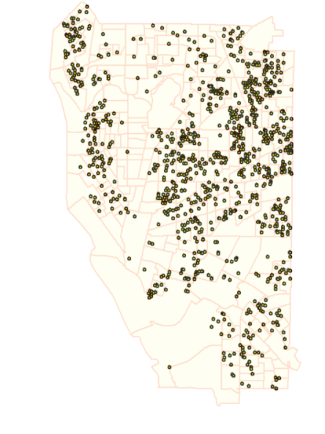

Methods:

Input data: shapefile, several excel file.

Data preprocessing: rearranging data tables

Spatial data visualization

Linear regression and display regression plot.

Coefficient interpretation.

Expected Result:

Visualize vacancy change in these years and help us understand what and where vacancy rate has changed.

Examine the change of vacancy rate and other factors in demographic data.

References:

Silverman, Robert, Li Yin, and Kelly L. Patterson. "Dawn of the dead city: An exploratory analysis of vacant addresses in Buffalo, NY 2008–2010." *Journal of Urban Affairs* 35.2 (2013): 131-152.

Gebru, Timnit, et al. "Using deep learning and google street view to estimate the demographic makeup of the us." *arXiv preprint arXiv:1702.06683* (2017).