EE6623 Sustainable Energy Systems
Unit 1 例题详细解答
对应《EE6623_Unit1_例题》。每问都写出公式、代入、单位和结果。讨论题另给可直接使用的英文句子。
数值约定
绿框是建议写入答卷的最终答案，由全精度计算后按工程位数写出。评分要点是复习用的给分结构，不是官方评分标准。

题 | 最终结果
1.a | 最高 10.5938 m/s，696.55 W/m²；最低 7.8073 m/s，281.84 W/m²
1.b | 比值 2.4714；不计密度时为 2.4984
1.c | 一台一天 11,642.93 kWh
1.d | 六台一年少排 22,948.22 tonne CO₂
2.d | 叶尖 54.6 m/s；风轮 17.38 rpm；速比 86.31；效率 31.54%
3.a–3.e | 轮毂 11.0282 m/s；16.55 rpm；Pm = 1,217.61 kW；s = -0.1584；变流器 166.52 kW 送向电网

Question 1 风资源、比功率、日电量和二氧化碳

1.a 叶尖最高点和最低点的风速与比功率（10 分）
题意：地面海拔 400 m，地表为高杆作物、树篱和灌木，α = 0.20。10 m 处风速 6.5 m/s。轮毂离地 70 m，直径 90 m，所以半径 45 m。气温 10 °C，不随高度变化。分别求叶尖最高点和最低点的风速和比功率，密度用各自的海拔。
先确定三个离地高度，再换成海拔。风速只取决于离地高度；密度取决于海拔和开尔文温度。
R = 90 / 2 = 45 m
H_top = 70 + 45 = 115 m，H_hub = 70 m，H_bottom = 70 − 45 = 25 m
h_top = 400 + 115 = 515 m
h_hub = 400 + 70 = 470 m
h_bottom = 400 + 25 = 425 m
T = 273.15 + 10 = 283.15 K
风速：v = 6.5 × (H / 10)^0.20
v_top = 6.5 × (115/10)^0.20 = 6.5 × 11.5^0.20
= 6.5 × 1.629820 = 10.5938 m/s
v_hub = 6.5 × 7^0.20 = 6.5 × 1.475773 = 9.5925 m/s
v_bottom = 6.5 × 2.5^0.20 = 6.5 × 1.201124 = 7.8073 m/s

密度公式 ρ = (353 / T) × exp(−0.0341 h / T)。三个高度温度相同，所以 353/T 是公共系数，只有指数不同。
353 / 283.15 = 1.246689
ρ_top = 1.246689 × exp(−0.0341 × 515 / 283.15) = 1.1717 kg/m³
ρ_hub = 1.246689 × exp(−0.0341 × 470 / 283.15) = 1.1781 kg/m³
ρ_bottom = 1.246689 × exp(−0.0341 × 425 / 283.15) = 1.1845 kg/m³
比功率 Pw/A = (1/2) ρ v³
最高点：0.5 × 1.1717 × 10.5938³ = 696.55 W/m²
轮毂： 0.5 × 1.1781 × 9.5925³ = 519.93 W/m²
最低点：0.5 × 1.1845 × 7.8073³ = 281.84 W/m²

最高点：v = 10.5938 m/s，比功率 696.55 W/m²。最低点：v = 7.8073 m/s，比功率 281.84 W/m²。轮毂风速 9.5925 m/s 供 1.c 使用。

评分要点：最高、最低高度各 1 分；两个风速各 2 分；两个密度和两个比功率共 4 分。漏掉场地海拔、用摄氏温度、或把直径当成半径，都会使后面的比功率一起错。轮毂处的数题目没有要，但 1.c 必须用它，写出来不扣分。

1.b 比功率之比，以及叶片上的后果（8 分）
P_top / P_bottom = 696.55 / 281.84 = 2.4714
密度不变时的公式：
(H_top / H_bottom)^(3α) = (115/25)^(0.60) = 4.6^0.60 = 2.4984
密度比 ρ_top / ρ_bottom = 1.1717 / 1.1845 = 0.9892
核对：2.4984 × 0.9892 = 2.4714
与直接相除的结果一致。
密度只变化了 1.08%。

计入密度的比值为 2.4714；只按风切变则为 2.4984。密度影响大约 1%，可以在性能估算里忽略；风切变不能忽略。

物理后果要写在数值后面。最高点的比功率大约是最低点的 2.47 倍。叶片每转一圈都经历一次这样的载荷变化，沿风向反复弯曲，长期引起疲劳，并增大气动噪声。
英文答句
The specific-power ratio is 2.471 when air density is included, compared with 2.498 from wind shear alone. The density change is only about 1 percent and has little effect. The shear itself does: the blade is loaded much more heavily at the top of each revolution than at the bottom, so it flexes cyclically. This causes fatigue and increases noise.

评分要点：比值 3 分，与 (H_top/H_bottom)^(3α) 的比较 2 分，密度影响和疲劳、噪声各约 1.5 分。只写“有影响”而没有指出疲劳或噪声，讨论分不完整。

1.c 一天的电能（8 分）
题意：轮毂风速用 t1 = 2 h 从 0 升到 V_hub，保持 t2 = 10 h，再用 2 h 降回 0，其余时间为 0。总效率 η = 32%，密度用轮毂处的密度。这个 η 是风功率到电能的总效率，不要再乘齿轮箱效率。
上升段 v = (V/t1)τ，∫v³ dτ = V³ t1/4。下降段的积分相同。平台贡献 V³ t2。所以
∫ v³ dt = V³ (t2 + t1/2) = V³ × 11 h
V = v_hub = 9.5925 m/s
A = π × 45² = 6361.73 m²
ρ_hub = 1.1781 kg/m³
Pw = 0.5 × 1.1781 × 6361.73 × 9.5925³
= 3,307,651.8 W = 3,307.65 kW
Pel = 0.32 × Pw = 1,058,448.6 W = 1,058.45 kW
等效满风速时间 = 10 + 2/2 = 11 h
E = 1,058.449 kW × 11 h = 11,642.934 kWh
检查：若只算 10 h 平台，电量会少 1/11；若把 14 h 的有风时间都当成满风速，电量会偏大。11 h 落在中间。

一台机组一天发电 11,642.93 kWh。

若把时间先换成秒再积分，上升段和下降段各贡献 V³×(2×3600)/4，平台贡献 V³×(10×3600)，总和是 V³×11×3600。再乘 (1/2)ρηA 得到焦耳，除以 3.6×10⁶ 得到 kWh，结果相同。不要在等效小时法上再乘一次 3600。
评分要点：写出两段斜坡使等效时间为 t2+t1/2，得 3 分；正确的轮毂风速、密度和面积得 3 分；数值和 kWh 得 2 分。等效时间写成 10 h 或 12 h 时，后面的数字按比例只给一部分过程分。

1.d 六台机组一年少排的二氧化碳（4 分）
一年一台：11,642.934 × 365 = 4,249,671.0 kWh
六台：× 6 = 25,498,026.0 kWh
CO₂ = 0.90 kg/kWh × 25,498,026.0 kWh = 22,948,223.4 kg
= 22,948.22 tonne

少排 22,948.22 tonne CO₂。

评分要点：乘 365 和 6 各 1 分，乘 0.90 得 1 分，kg 换成 tonne 得 1 分。1 tonne = 1000 kg。

Question 2 结构、机型、叶尖速比和一道转速题

2.a 八个部件，以及直驱的一个理由（8 分）
每个部件先给中文含义，再给可以直接写入英文答卷的一句。
- 叶片从风中取能。Blades extract kinetic energy from the wind.
- 变桨机构让叶片绕自身轴线转动，用来降低效率，或在风速过高、过低时停机。The pitch system rotates the blades about their axes to reduce efficiency, or to stop the rotor when the wind is too high or too low.
- 齿轮箱把风轮的低转速升高到发电机转速，又重又贵。The gearbox steps up the low rotor speed to the generator speed. It is heavy and costly.
- 发电机把轴功率变成交流电，大型机组常见 PMSG 或 DFIG。The generator converts the shaft power into AC electricity.
- 控制器在额定风速以下追踪最大功率，以上把功率限制在额定值，风速超出范围时停机。The controller tracks maximum power below rated wind speed, limits power above it, and stops the turbine outside the operating range.
- 风速仪测量风速，供控制器使用。The anemometer measures wind speed for the controller.
- 偏航驱动把上风向机舱转到对风方向；下风向机组可以不要。The yaw drive turns an upwind nacelle to face the wind. A downwind rotor does not need it.
- 塔架支承机舱。塔越高，风速越大，而功率按风速的立方增加。The tower supports the nacelle. A taller tower reaches faster wind and therefore much more power.
直驱：A direct-drive generator runs at the low rotor speed and removes the gearbox, which is a heavy, expensive and maintenance-heavy component.
评分要点：八个功能大约各 0.5–1 分，直驱理由 1 分。把 yaw 写成“测风向”会和 wind vane 混淆，wind vane 测方向，yaw drive 才执行转向。

2.b 上风向、下风向，以及垂直轴（8 分）
(i) 上风向与下风向
- An upwind rotor faces the wind, so the wind meets the blades before the tower. There is no tower shadow. It delivers more power and makes less noise, but it needs a yaw system.
- A downwind rotor sits behind the tower. The wind itself yaws the nacelle, so no yaw drive is required. As a blade passes the tower it enters the tower shadow, flexes, loses power and makes more noise. Repeated flexing causes fatigue.
(ii) 垂直轴相对水平轴。优点三条、缺点三条，和讲义对应。
- Advantage: no yaw control is required.
- Advantage: the gearbox and generator can be placed on the ground, so installation and maintenance are easier.
- Advantage: the tower does not carry the nacelle, and the blades are not subjected to the same cyclic flexing, so they can be lighter.
- Disadvantage: the rotor is close to the ground, where the wind is slower and more turbulent, so the output is smaller.
- Disadvantage: the starting torque is very small.
- Disadvantage: pitch control cannot be used to reduce power in high winds, as it can on a horizontal-axis turbine.
评分要点：(i) 写出塔影和偏航的差别得 4 分。(ii) 六条各约 0.5–0.7 分。优点里写出“不必偏航”和“重设备在地面”是最关键的两条。

2.c 多叶轮为什么不发电，以及要画的曲线（8 分）
文字部分：
英文答句
A rotor with many blades produces a large torque at a low rotational speed. Electrical generators then become large and expensive, because torque is power divided by angular speed. The blades also disturb one another, so the rotor cannot spin fast. An American multiblade rotor has an optimum tip-speed ratio below 1 and an efficiency only a little above 30 percent. A three-blade rotor reaches about 40 to 45 percent near a tip-speed ratio of 4. Multiblade rotors are suitable for pumping water and grinding grain, not for generating electricity.

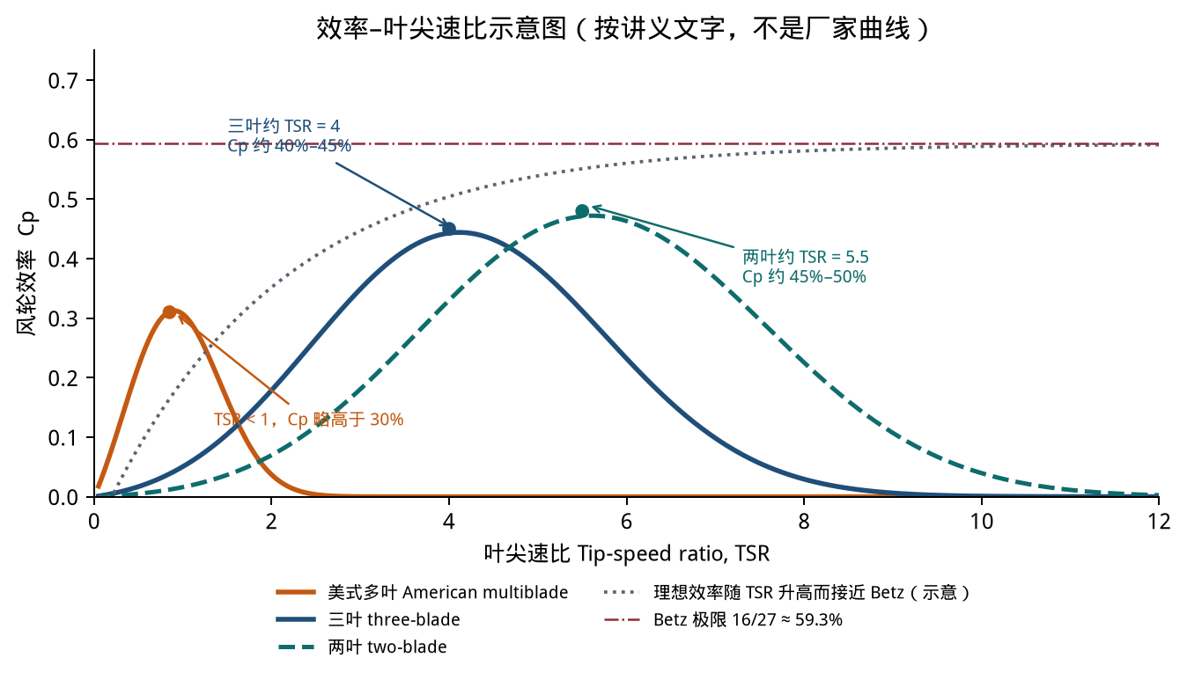
图 答卷上至少要有美式多叶和三叶两条曲线、各自的峰，以及 Betz = 59.3% 的水平线。两叶曲线可画可不画。
图上要能看出：多叶的峰在 TSR < 1、Cp 略高于 0.30；三叶的峰在 TSR ≈ 4、Cp 约 0.40–0.45；一条 Cp = 16/27 ≈ 0.593 的水平线。曲线在峰的两侧都下降：左侧是风直接穿过扫掠面，右侧是叶片间湍流。
评分要点：低转速导致发电机大，约 2 分；效率低并给出两个典型数字，约 2 分；草图形状和三个标注，约 4 分。

2.d 60 m 风轮的叶尖速度、转速、速比和总效率（6 分）
题意：D = 60 m，电功率 1.20 MW，v = 13 m/s，TSR = 4.2，ρ = 1.225 kg/m³，发电机 1500 rpm。这一问的效率是电功率除以风功率，是整机效率。
叶尖速度 = TSR × v = 4.2 × 13 = 54.6 m/s
R = 30 m
ωt = 54.6 / 30 = 1.8200 rad/s
Nt = 1.8200 × 60 / (2π) = 17.3797 rpm
齿轮箱速比 ag = 1500 / 17.3797 = 86.31
A = π × 30² = 2827.43 m²
Pw = 0.5 × 1.225 × A × 13³ = 3,804,771.1 W = 3,804.77 kW
总效率 = 1200 / 3,804.77 = 0.3154 = 31.54%

叶尖速度 54.6 m/s；风轮 17.38 rpm；速比 86.31；总效率 31.54%。

英文评论
The overall efficiency is 31.5 percent. This is well below the Betz limit of 59.3 percent. That is expected: Betz is a theoretical rotor limit, a practical rotor reaches only about 45 to 50 percent, and the overall plant efficiency is lower still because of gearbox and generator losses.

评分要点：四个数值各约 1 分，与贝茨极限的比较 2 分。把 31.5% 说成“超过贝茨极限所以算错了”是理解错误：31.5% 是整机效率，贝茨极限是风轮的理论上限。

Question 3 双馈感应发电机的一整套计算
计算顺序就是复习提纲第 14 节的十步。电机理想，所以最后的总上网功率等于轴功率。11 kV 和三角形接法说明定子的额定电压，本题不问电流，这两个数据不进入计算。定子功率因数为 1，表示励磁无功由转子侧提供；题目没有给励磁参数，无功也不计算。
已知量 | 数值
v0，H0，α | 8.0 m/s，10 m，0.15
轮毂离地高度，直径，TSR，ηt | 85 m，70 m，5.5，0.45
ηg，ag | 0.90，70
场地海拔，气温 | 200 m，20 °C
电网 | 50 Hz，6 极

3.a 轮毂风速（4 分）
v_hub = 8.0 × (85/10)^0.15
= 8.0 × 8.5^0.15
= 8.0 × 1.378519
= 11.0282 m/s

v_hub = 11.0282 m/s。

3.b 最佳效率时的风轮转速（4 分）
TSR = ωt × (D/2) / v = ωt × 35 / v
ωt = 2 × 11.0282 × 5.5 / 70 = 1.7330 rad/s
Nt = 1.7330 × 60 / (2π) = 16.5489 rpm

风轮转速 16.5489 rpm。

这里求出的是风轮低速轴，还没有乘齿轮箱。评分要点：公式 2 分，数值 2 分。

3.c 发电机轴上的机械功率（6 分）
h = 200 + 85 = 285 m，T = 273.15 + 20 = 293.15 K
ρ = (353 / 293.15) × exp(−0.0341 × 285 / 293.15) = 1.1649 kg/m³
A = π × 35² = 3848.45 m²
Pw = 0.5 × 1.1649 × 3848.45 × 11.0282³
= 3,006,433.0 W = 3,006.43 kW
Pm = ηt × ηg × Pw = 0.45 × 0.90 × 3,006.43
= 1,217.61 kW

Pm = 1,217.61 kW。这是进入发电机轴的机械功率。

评分要点：海拔和密度 2 分，风功率 2 分，两个效率都乘上 2 分。只用 0.45、漏掉 0.90，轴功率会偏大 1/0.90 倍。h 若写成 200 m 或 85 m，密度会略偏，通常仍可拿到大部分公式分。

3.d 转差，以及次同步还是超同步（6 分）
ωm = ag × ωt = 70 × 1.732996 = 121.3097 rad/s
Nm = 70 × 16.5489 = 1158.42 rpm
6 极、50 Hz：
Ns = 120 × 50 / 6 = 1000 rpm
ωs = 4π × 50 / 6 = 104.7198 rad/s
s = (ωs − ωm) / ωs = (104.719755 − 121.309695) / 104.719755
= -0.158422

s = -0.1584 < 0。发电机转速 1158.4 rpm，高于同步速 1000 rpm，是超同步发电。

英文答句
The slip is negative, so the generator runs above synchronous speed and operates in the super-synchronous generating mode. The rotor electrical frequency is |s|f, and the rotor supply has the opposite phase sequence to the stator.

转子电气频率 fr = |s| × f = 0.1584 × 50 = 7.92 Hz

fr 题目没有要求，写上可以说明“相反相序”不是空话。评分要点：同步速 2 分，转差数值 2 分，超同步及相序 2 分。把 6 极按成 4 极，会得到 1500 rpm 的同步速，转差符号可能整个反掉。

3.e 变流器功率和上网功率（4 分）
使用统一公式。Pm 取正。理想电机没有铜耗、铁耗，变流器损耗也不计。
Pconv = − s / (1 − s) × Pm
Pstator = Pm / (1 − s)
Pgrid = Pstator + Pconv = Pm
1 − s = 1 − (-0.158422) = 1.158422
Pconv = − (-0.158422) / 1.158422 × 1217.605 kW
= 166.52 kW
Pstator = 1217.605 / 1.158422 = 1,051.09 kW
Pgrid = 1,051.09 + 166.52 = 1,217.61 kW
变流器功率占轴功率的比例 = 13.7%

变流器处理 166.52 kW，符号为正，功率从转子经变流器送到电网。电网收到的总有功是 1,217.61 kW，其中定子送出 1,051.09 kW。

这个比例大约 14%，和讲义说的“变流器通常只处理全功率的 20%–30%”是同一类部分功率变流器，没有大到需要全功率变流器。评分要点：公式和正号方向 2 分，总上网功率等于 Pm 这句 2 分。若把总上网功率写成定子的 1051 kW，方向分还在，功率平衡分没有。

3.f 两张结构图，以及 PMSG 相对 DFIG 的一条优点、一条缺点（6 分）
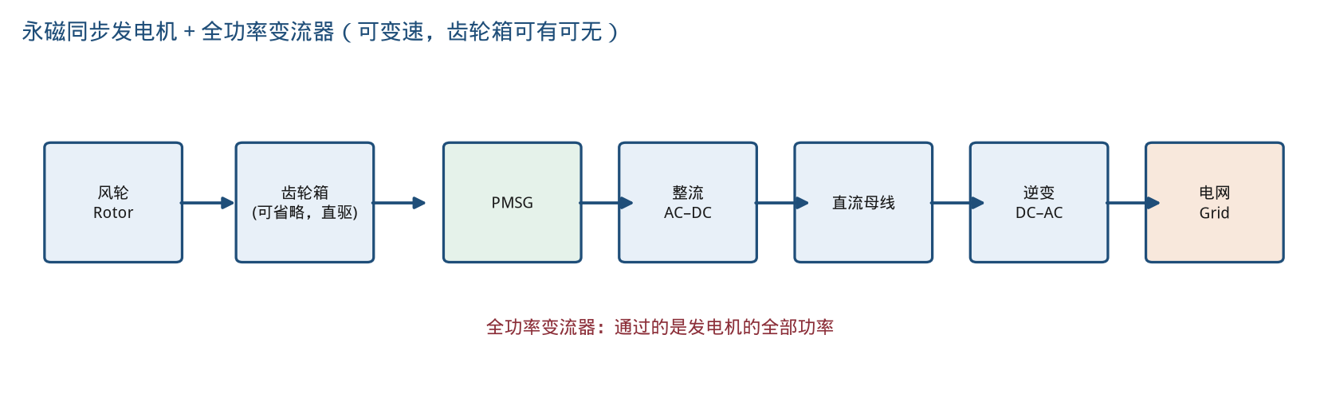
图 永磁同步发电机经全功率 AC–DC–AC 并网。齿轮箱可以保留，也可以取消。
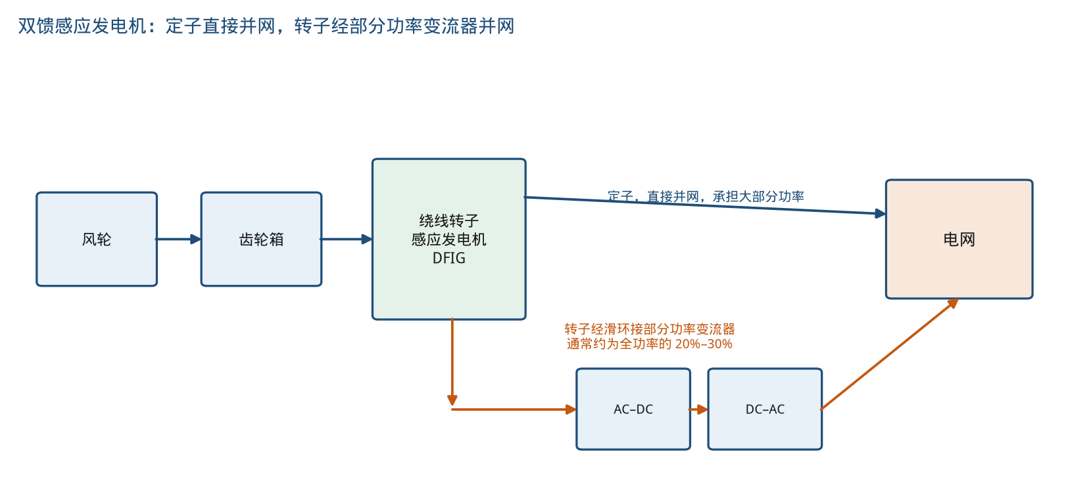
图 本题的 DFIG：定子直接并网，转子经滑环和部分功率变流器并网。
英文答句
Advantage: the full converter of the PMSG decouples the generator speed from the grid frequency, so the speed range is not limited by slip; the machine has no slip rings and can be direct-driven. Drawback: its converter must carry the full generated power, whereas the DFIG converter carries only the slip power and is therefore smaller and less expensive.

评分要点：两张图各 2 分，优点和缺点各 1 分。DFIG 的图若把转子也画成直接并网、没有变流器，这一张图的分没有。

Question 4 概念题

4.a 五个短语（6 分）
六个分给五个短语，每个短语大约一分多一点。定义和“是不是可再生资源”都要出现。下面每条都是两句英文。
- Carbon capture separates CO₂ from flue gas or air and stores or uses it. It is not a renewable resource; it is an emission-reduction technology that can be added to a fossil plant.
- Clean energy means energy with very low pollution and greenhouse-gas emissions in use. Renewable electricity is usually clean, but clean energy is a wider term and the two are not identical.
- CO₂ reduction is the act or the amount of reducing carbon-dioxide emissions. It is an outcome, not a resource; wind power produces this outcome when it replaces thermal generation.
- Electrical transportation means vehicles and railways driven by electricity. The vehicles are not a renewable resource; they reduce emissions only when their electricity comes from renewable generation.
- A flow battery stores energy in liquid electrolytes held in external tanks, so power and energy can be sized separately. It is storage, not a renewable resource; it moves wind energy from windy hours to the hours of demand.

4.b 三个特征风速，以及顺桨之后为什么还要刹车（4 分）
英文答句
Cut-in speed is the wind speed below which the converted power cannot cover the losses, so the rotor is stopped. Rated wind speed is the speed at which the generator delivers its rated power. Cut-out, or furling, speed is the speed above which operation is mechanically unsafe, so the turbine is shut down. Between rated and cut-out speed a large pitch-controlled turbine holds the power at the rated value by reducing the blade angle of attack. After the blades have been furled, a mechanical brake is still applied to the shaft to hold the rotor, including during maintenance.

评分要点：三个风速的定义约 2 分，变桨限功率 1 分，机械制动 1 分。被动失速是小机组的做法，本题问的是大型变桨机组，不要改答成被动失速。
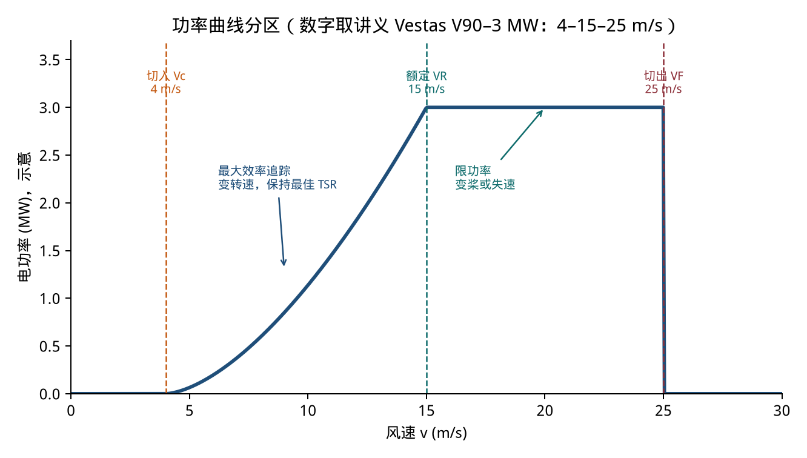
图 三个特征风速把功率曲线分成停机、最大功率追踪、限功率和再次停机。

做完之后的核对
- Question 1 的密度用了 400 m 的场地海拔，Question 3 的密度用了 200 m。两题的 h 不相同。
- Question 1 的 32% 是总效率，乘在风功率上得到电能。Question 3 的 45% 和 90% 要连乘，得到的是轴功率。
- Question 3 的转差是负数。变流器功率因此是正的，和教程 3 同号，和讲义那道次同步例题反号。
- Question 2.d 的 31.5% 低于 59.3%，这是正确结果，不是算术错误。
- Question 4 的五个短语都不是可再生能源本身。分点写在它们和发电的关系上。
满分 100。建议用时两小时。若 1.c 的等效小时或 3.d 的极数出错，先改这两处，再重算后面跟随变化的功率。

